Weather
(Grade 4, VA)
By Juliet M. Harris, Lori McAndrews,
and Sofía Meléndez Contreras

IDEA PAGES

- UNIT THEMES (VA SOL 4.4)
- Thermal energy transfer from the sun impacts air movement/pressure and weather conditions.
- Meteorologists use tools and data to measure and monitor patterns in the atmosphere to forecast the weather.
- The analysis of weather data is used to predict severe weather events. Such impacts include tornadoes, hurricanes, flooding, droughts, and blizzards.
- The atmosphere is a dynamic system, and changes in conditions cause weather phenomena that may affect an ecosystem and destroy habitats.

- FOCUS/MOTIVATION
- Cognitive Content Dictionary with signal words
- Big Book The Important Book About Weather
- Meteorologist Awards
- Inquiry Chart
- Observation Charts
- Read Alouds
- Hands-On Explorations and Experiments
- Guest Speakers
- Videos
- Picture File Cards/Exploration Report

- ASSESSMENT AND FEEDBACK
- On-going assessment
- Process all charts and learning
- Shared Team Tasks
- The Important Big Book of …. (student generated)
- Student Chants/ Poetry
- Portfolio/Learning Logs
- Writing Prompt with Rubric
- Personal Exploration – Weather tracking
- Teacher and Student Created Test
- State/District required assessment

- CONCEPTS

Science Standards of Learning for Virginia Public Schools - Grade 4
4.1 The student will demonstrate an understanding of scientific and engineering practices by
a) asking questions and defining problems
· identify scientific and non-scientific questions
· develop hypotheses as cause-and-effect relations
· define a simple design problem that can be solved through the development of an object, tool, process, or system
b) planning and carrying out investigations
· identify variables when planning an investigation
· collaboratively plan and conduct investigations
· use tools and/or materials to design and/or build a device that solves a specific problem
· take metric measurements using appropriate tools
· measure elapsed time
c) interpreting, analyzing, and evaluating data
· organize and represent data in bar graphs and line graphs
· interpret and analyze data represented in bar graphs and line graphs
· compare two different representations of the same data (e.g., a set of data displayed on a chart and a graph)
· analyze data from tests of an object or tool to determine whether it works as intended
d) constructing and critiquing conclusions and explanations
· use evidence (i.e., measurements, observations, patterns) to construct or support explanations and to make inferences
e) developing and using models
· develop and/or use models to explain natural phenomena
· identify limitations of models
f) obtaining, evaluating, and communicating information
· read and comprehend reading-level-appropriate texts and/or other reliable media
· communicate scientific information, design ideas, and/or solutions with others
4.4 The student will investigate and understand that weather conditions and phenomena affect ecosystems and can be predicted. Key ideas include
a) weather measurements create a record that can be used to make weather predictions;
b) common and extreme weather events affect ecosystems; and
c) long-term seasonal weather trends determine the climate of a region.

English Language Arts Standards of Learning

Communication and Multimodal Literacies
4.1 The student will use effective oral communication skills in a variety of settings.
a) Listen actively and speak using appropriate discussion rules.
b) Contribute to group discussions across content areas.
c) Orally summarize information expressing ideas clearly.
d) Ask specific questions to gather ideas and opinions from others.
e) Use evidence to support opinions and conclusions.
f) Connect comments to the remarks of others.
g) Use specific vocabulary to communicate ideas.
h) Demonstrate the ability to collaborate with diverse teams, while sharing responsibility for the work.
i) Work respectfully with others, and show value for individual contributions.
4.2 The student will create and deliver multimodal, interactive presentations.
a) Locate, organize, and analyze information from a variety of multimodal texts.
b) Speak audibly with appropriate pacing.
c) Use language and style appropriate to the audience, topic, and purpose.
d) Make eye contact with the audience.
e) Ask and answer questions to gather or clarify information presented orally.
4.3 The student will learn how media messages are constructed and for what purposes.
a) Differentiate between auditory, visual, and written media messages and their purposes.
b) Compare and contrast how ideas and topics are depicted in a variety of media and formats.

Reading
4.4 The student will expand vocabulary when reading.
a) Use context to clarify meanings of unfamiliar words.
b) Use knowledge of roots, affixes, synonyms, antonyms, and homophones to determine the meaning of new words.
c) Use word-reference materials.
d) Use vocabulary from other content areas.
e) Develop and use general and specialized vocabulary through speaking, listening, reading, and writing.

4.5 The student will read and demonstrate comprehension of fictional texts, literary nonfiction texts, and poetry.
a) Describe how the choice of language, setting, and characters contributes to the development of plot.
b) Identify the theme(s).
c) Summarize events in the plot.
d) Identify genres.
e) Identify the narrator of a story and the speaker of a poem.
f) Identify the conflict and resolution.
g) Identify sensory words.
h) Draw conclusions/make inferences about text using the text as support.
i) Compare/contrast details in literary and informational nonfiction texts.
j) Identify cause and effect relationships.
k) Use reading strategies throughout the reading process to monitor comprehension.
l) Read with fluency, accuracy, and meaningful expression.

4.6 The student will read and demonstrate comprehension of nonfiction texts.
a) Use text features such as type, headings, and graphics, to predict and categorize information.
b) Explain the author’s purpose.
c) Identify the main idea.
d) Summarize supporting details.
e) Draw conclusions and make inferences using textual information as support.
f) Distinguish between cause and effect.
g) Distinguish between fact and opinion.
h) Use reading strategies throughout the reading process to monitor comprehension.
i) Read with fluency, accuracy, and meaningful expression.

Writing
4.7 The student will write in a variety of forms to include narrative, descriptive, opinion, and expository.
a) Engage in writing as a process.
b) Select audience and purpose.
c) Narrow the topic.
d) Use a variety of prewriting strategies.
e) Recognize different forms of writing have different patterns of organization.
f) Organize writing to convey a central idea.
g) Write a clear topic sentence focusing on the main idea.
h) Write related paragraphs on the same topic.
i) Elaborate writing by including details to support the purpose.
j) Express an opinion about a topic and provide fact-based reasons for support.
k) Use transition words and prepositional phrases for sentence variety.
l) Utilize elements of style, including word choice and sentence variation.
m) Revise writing for clarity of content using specific vocabulary and information.

4.8 The student will self- and peer-edit writing for capitalization, spelling, punctuation, sentence structure, paragraphing, and Standard English.
a) Use subject-verb agreement.
b) Eliminate double negatives.
c) Use noun-pronoun agreement.
d) Use commas in series, dates, and addresses.
e) Correctly use adjectives and adverbs.
f) Use quotation marks with dialogue.
g) Use correct spelling including common homophones.
h) Use singular possessives.

Research
4.9 The student will demonstrate comprehension of information resources to create a research product.
a) Construct questions about a topic.
b) Collect and organize information from multiple resources.
c) Evaluate the relevance and reliability of information.
d) Give credit to sources used in research.
e) Avoid plagiarism and use your own words.
f) Demonstrate ethical use of the Internet.
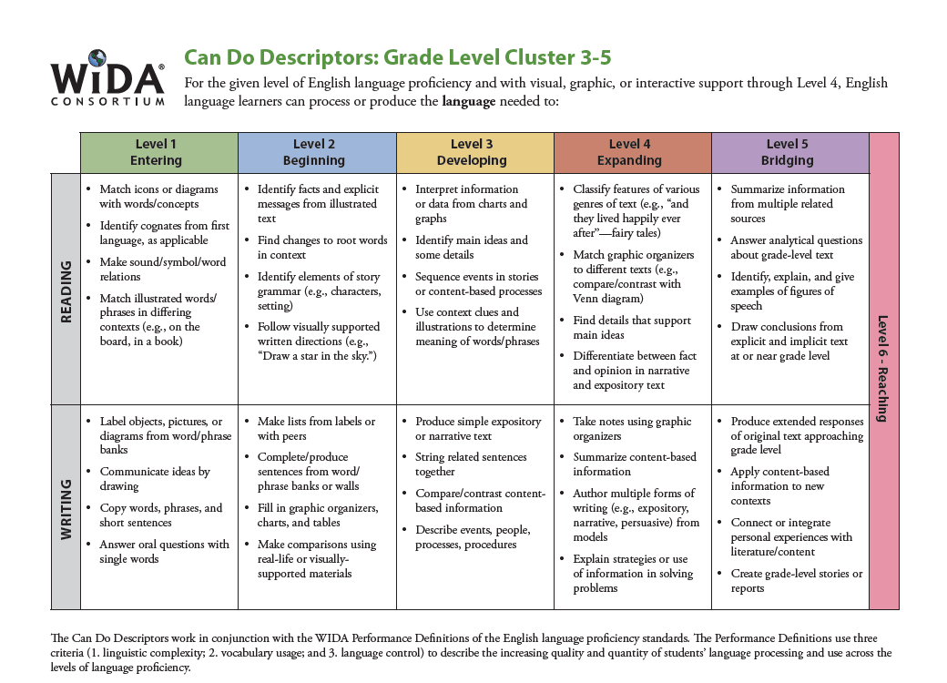
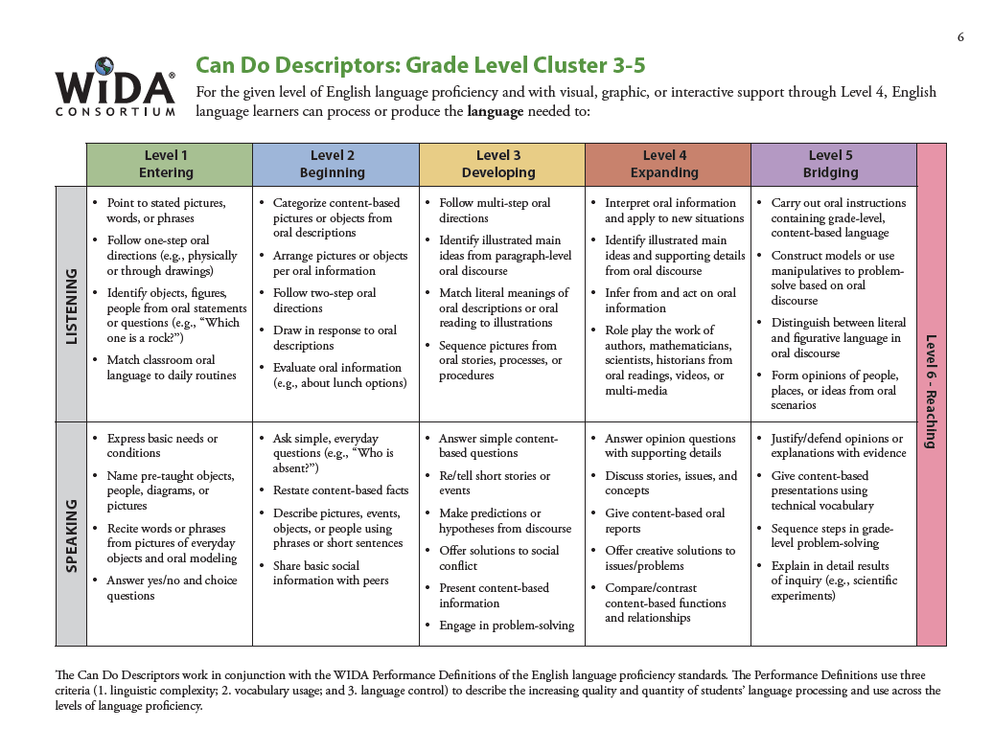
V. VOCABULARY

Tier 2 |  | Tier 3
clouds  weather  temperature  thermometer  direction  rotate  beach  wind  rain  snow  vegetation  destruction  food chain  relocate  drowning  disease | protection  categories  impact  farming  pollution  wildlife  crops  manage  threaten  adaptation  behavioral  physical  climate  characteristics  survive  shelter  locate  sustained  precipitation | tornado  hurricane  thunderstorm  flooding  drought  blizzard  stratus clouds  cumulus clouds  cumulonimbus clouds  cirrus clouds  fronts  air Pressure  air Masses  barometer  anemometer  meteorologist  rain gauge  tropical  cyclone  erosion  snowfall  hail  landslides  jet stream
Tier 1 Basic words that commonly appear in spoken language. Because they are heard frequently in numerous contexts and with nonverbal communication, Tier 1 words rarely require explicit instruction. Examples of Tier 1 words are clock, baby, happy and walk.
Tier 2 High frequency words used by mature language users across several content areas. Because of their lack of redundancy in oral language, Tier 2 words present challenges to students who primarily meet them in print. Examples of Tier 2 words are obvious, complex, establish and verify.
Tier 3 Words that are not frequently used except in specific content areas or domains. Tier 3 words are central to building knowledge and conceptual understanding within the various academic domains and should be integral to instruction of content. Medical, legal, biology and mathematics terms are all examples of these words.
Bringing Words To Life, Beck, Isabel L., McKeown, Margaret G., Kucan, Linda. The Gilford Press, 2002.

VI. RESOURCES AND MATERIALS
Books: English
- Sergio and the Hurricane by Alexandra Wallner
- 4th Grade Units of Study for Teaching Reading, By Lucy Calkins
UNIT 2: Reading the Weather, Reading the World: Purposeful Reading of Nonfiction
  - Book List (Below)
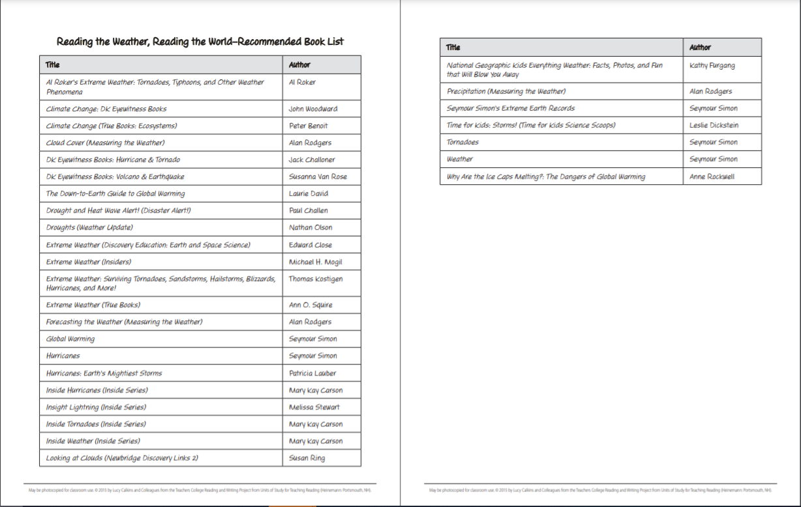
Informational Websites
Weather
AccuWeather: Local, National, & Global Daily Weather Forecast
https://www.accuweather.com/
National and Local Weather Radar, Daily Forecast, Hurricane & Information from The Weather Channel
https://weather.com/
Weather Underground: Local Weather Forecast, News and Conditions
https://www.wunderground.com/
WeatherBug: Local and National Weather Forecasts, Radar & News
https://www.weatherbug.com/
World Weather
https://www.worldweatheronline.com/lang/en-us/
Windy: Wind map & weather forecast
https://www.windy.com/?28.580,77.330,5
Ventusky - Wind, Rain and Temperature Maps
https://www.ventusky.com/

What is weather?
Weather
http://app.discoveryeducation.com/player/view/assetGuid/7F2D287C-3185-4407-A040-FE90B1A3934B
Weather Smart: Weather
http://app.discoveryeducation.com/player/view/assetGuid/29EE9CCE-96AE-4E80-9C35-8A4E4281C364
A First Look: Weather
http://app.discoveryeducation.com/player/view/assetGuid/5660F42F-3E5D-483F-99B7-B0EEED2AEB60
An Introduction to Weather
http://app.discoveryeducation.com/player/view/assetGuid/6E9A7AD6-55C3-42B3-8BE5-330978B9CAE0
Earth Science for Students: What Is Weather?
http://app.discoveryeducation.com/player/view/assetGuid/D116C6E8-FD84-41F2-88D7-98E4E7DB1A36

Do clouds really predict the weather?
Clouds, Weather, and Life
http://app.discoveryeducation.com/player/view/assetGuid/876E3388-75E0-4F28-8693-5919FA0ED6CF
Clouds
http://www.weatherwizkids.com/?page_id=64
Mystery Science Storm Guide: How Can We Predict That It's Going to Storm
https://mysteryscience.com/weather/mystery-2/local-weather-patterns-weather-prediction/47?r=13958666#slide-id-1303

Why does the air temperature change?
Air Makes Weather
http://app.discoveryeducation.com/player/view/assetGuid/328AB6D9-DDB0-4E61-9F4B-012E1679768F
Measuring Weather
http://app.discoveryeducation.com/player/view/assetGuid/967ADD5A-E476-4FC0-B157-C99C58B199B2
Weather: Changes and Measurement
http://app.discoveryeducation.com/player/view/assetGuid/691A2C16-B716-4C19-8C3B-BBF6F01DA8BC
How Maps, Graphs, and Charts Help Meteorologists Observe the Weather
http://app.discoveryeducation.com/player/view/assetGuid/376FE4BF-80CB-425D-B745-395A2D3597F5

Why does it rain, sleet, snow and hail?
Rain or Shine: Understanding the Weather
http://app.discoveryeducation.com/player/view/assetGuid/2CAB90DA-3C54-49D0-9847-AFACFBFD90CA

How does air pressure affect weather?
Weather Smart: Heat, Wind, and Pressure
http://app.discoveryeducation.com/player/view/assetGuid/B2B07925-15A4-4728-875D-B4369021CC65
Weather: Air in Action: Temperature, Pressure, and Humidity (2nd Edition)
http://app.discoveryeducation.com/player/view/assetGuid/CAB216DA-ACE0-4401-B46F-B4E05332175A

How can we use our own measurements to predict the weather?
Meteorology: The Science of Predicting Weather
http://app.discoveryeducation.com/player/view/assetGuid/50B3615E-59D5-4ED9-9416-2A809BF47A57
Meteorologists Use Scientific Instruments to Measure and Predict Weather
http://app.discoveryeducation.com/player/view/assetGuid/41B66827-27D8-4138-99C2-A956141FB2C5
Weather Smart: Forecasting and Weather Instruments
http://app.discoveryeducation.com/player/view/assetGuid/29340679-9632-44C6-B054-7A2E4DA551F2
Investigating Weather
http://app.discoveryeducation.com/player/view/assetGuid/31086FFA-B0E6-4177-970D-013827CD674F

What weather conditions lead to dangerous storms?
Types of Precipitation
https://www.youtube.com/watch?v=WWy9N9TA35g
Violent Weather
http://app.discoveryeducation.com/player/view/assetGuid/285CA310-F723-42D6-A522-B58E5C0C5DF9
Weather Smart: Hurricanes
http://app.discoveryeducation.com/player/view/assetGuid/E1BF7654-1495-4133-A016-A91390FDC173
Weather Smart: Tornadoes
http://app.discoveryeducation.com/player/view/assetGuid/B3C0DBEE-FB31-4DBE-94CC-F5381BE77817
Weather Smart: Thunderstorms
http://app.discoveryeducation.com/player/view/assetGuid/57889EF0-8B43-4850-8A4A-14A27B497E50
Video Quiz: Weather Smart: Thunderstorms
http://app.discoveryeducation.com/player/view/assetGuid/C84BB8D9-29DD-4717-A629-60D697141D40
What is the coldest place on Earth
https://mysteryscience.com/mini-lessons/coldest-place#slide-id-5422

Where do natural disasters happen in the USA?
How Drought Prone Is Your State?
https://www.drought.gov/drought/news/how-drought-prone-your-state-look-top-states-and-counties-drought-over-last-two-decades
Tracking Droughts Throughout Time: Visualization Tool
https://www.ncdc.noaa.gov/temp-and-precip/drought/historical-palmers/psi/201606-202005
Hazard Maps of Natural Disasters in the US
https://dynastypreppers.com/hazard-maps-us-natural-disaster-risk-maps/
Blizzards Are Becoming More Common in the US, Study Says
https://weather.com/science/weather-explainers/news/blizzards-more-common-study-bsu-jan-2017
States At Risk: America's Preparedness Report Card
https://reportcard.statesatrisk.org/#inland_flooding_grade
Terrifying map shows all the parts of America that might soon flood
https://grist.org/article/terrifying-map-shows-all-the-parts-of-america-that-might-soon-flood/

TAG Extension. How are climate and weather related?
Introduction to Weather and Climate
http://app.discoveryeducation.com/player/view/assetGuid/8FABD436-9411-4774-BAA4-7658ED30EA0E
Earth Science: Weather and Climate
http://app.discoveryeducation.com/player/view/assetGuid/E274E85E-BB04-4B95-A1D5-CAC5AB20D5B9

Weather Tools
Weather Wiz Kids weather information for kids
https://www.weatherwizkids.com/weather-instruments.htm
Tools Used to Measure Tornadoes
https://sciencing.com/tools-used-measure-tornadoes-8297640.html

Science Experiment Websites
Build a Rain Gauge
http://virginiafieldtrips.com/assets/files/Make%20a%20Rain%20Gauge.pdf
How to make a Barometer
https://sercc.com/education_files/barometer.pdf
Barometric Pressure: Good News – We're on the Rise! - Activity
https://www.teachengineering.org/activities/view/cub_air_lesson04_activity2
Marshmallow Masher | Science Experiment
https://www.stevespanglerscience.com/lab/experiments/marshmallow-masher/

Severe Weather Facts
Fun Hurricane Facts for Kids - Interesting Information about Cyclones & Typhoons
https://www.sciencekids.co.nz/sciencefacts/weather/hurricane.html
Flood Preparedness & Safety
https://www.ready.gov/floods
Blizzard: Its True Definition
https://www.weatherbug.com/news/Blizzard-Its-True-Definition
What Causes a Tornado?
https://youtu.be/LT7yRMLAkCY

ACPS Padlet: Severe Weather Resources
https://docs.google.com/presentation/d/1F-tHgrjHhk3nsCNErdfouqAbvjQ9Fecx5T8C31ubC5Y/edit?usp=sharing
PLANNING PAGES

I. FOCUS/MOTIVATION
- Cognitive Content Dictionary with Signal Word
- Meteorologist Awards
- Observation Charts
- Inquiry charts: What do you know about Weather? What do you want to know?
- Big book: The Most Important Book About Weather
- Fieldtrips
- Poetry
- Interest Pieces – guest speakers, videos, movies
- Prediction Reaction Guide

II. INPUT
- World Map Graphic Organizer – United States’ Natural Disasters *ELD Review
- Pictorial Input Chart – Tornado *ELD Review
- Narrative Input Chart – Sergio and the Hurricane *ELD Review
- Interest pieces – guest speakers, videos, movies

III. GUIDED ORAL PRACTICE
- 10/2 with primary language
- T-Graph for Social Skills: Cooperation
- Team co-op group evaluation
- Open sort – picture file cards
- Closed sort – picture file cards – classify, compare, order
- Mind mapping, list-group-label
- Team Tasks
- Poetry/Chants
- Exploration Report
- Sentence Patterning Chart
- Daily review and processing of charts
- Narrative Retell

IV. Reading/Writing Activities
Whole Class
  - Process Grid
  - Story Mapping
  - Expository Reading/Writing
  - Model Editing Process Using Group Frames (Teacher uses information from students to model appropriate writing)
- Big Book – The Important Book About Weather
- Cooperative strip paragraph
Plus supporting details (expository, metaphors)
- Poetry Frames
- Found Poetry
  - Listen and Sketch
Flexible and Cooperative Groupings
- Sentence Patterning Chart with Word Cards (read and trade games)
- Ear-to-Ear Reading
- Cooperative Strip Paragraph
- Team Tasks
- Expert Groups
- Flexible Grouping for ELD differentiation, primary language, reading instructions, skill reinforcement (ELD review/retell)
Individual Work
- Learning Logs
- Reading/Writing Choice
- Interactive Journals
- Individual tasks
- Reading/Writing choices: picture file cards, add to charts, make word cards, highlight poetry booklets, focused reading, poetry booklet, flip chants
Writer’s Workshop
- Mini-Lessons
- Plan, Share, Write, Revise, Edit, Publish
- Conferencing
- Author’s Chair
- Extended Activities for Integration
- Daily Activities
Read Aloud
Silent Sustained Reading/Book Sharing
Silent Sustained Writing
Listening Activities
Daily News/Interest Piece
Personal Interaction
Flexible group reading
- Occasional Activities
Guest speaker: Local News Meteorologist
Hands-on Explorations and Experiments
Team/Personal Exploration
Fieldtrip to wildlife open space
VI. Assessment and Feedback
- Re-visit Inquiry Chart
- Learning Logs
- Writing Prompt with Rubric
- Student Generated Tests
- Team Task Presentations
- Student Portfolio and Presentation
- Graffiti Wall
- Student Action Plan
- Vocabulary strips of “Where’s my answer?”
- Personal Exploration with Rubric
- Teacher-created Exams

SAMPLE DAILY LESSON PLAN
NOTE: Italicized strategies are used frequently in the classroom. Each day is the equivalent of 1 to 1 ½ weeks of instruction.

DAY 1:
FOCUS/MOTIVATION
- Cognitive Content Dictionary w/Signal Word
- Three Personal Standards and Literacy (Meteorologist) Awards
- Observation Charts
- Prediction Reaction Guide
- Inquiry Chart
- Teacher Made Big Book
- Portfolios
INPUT
- Graphic Organizer Input Chart - United States’ Natural Disasters (Big Picture)
- Pictorial Input Chart—Tornado Pictorial
GUIDED ORAL PRACTICE
- Chants
- T-graph for social skills – Team Points
- Picture File Cards
  - Free Exploration
  - Open sort – list, group, label
  - Closed sort – provide categories
- Process Graphic Organizer
  - 10/2 lecture, primary language groups
  - ELD Review
- Process Pictorial Input chart- Tornado
  - 10/2 lecture, primary language groups
  - ELD Review
- Exploration Report
READING/WRITING
- Listen & Sketch
- Interactive Journals
EXTENDED ACTIVITIES FOR INTEGRATION
- Hands-on Explorations and Experiments
- Guest Speaker
- Field Trip
ASSESSMENT/FEEDBACK
- Home/School Connection
- Process inquiry charts, chants and input charts
- Quiz
SAMPLE DAILY LESSON PLAN
NOTE: Italicized strategies are used frequently in the classroom. Each day is the equivalent of 1 to 1 ½ weeks of instruction.
DAY 2:
FOCUS/MOTIVATION
- Cognitive Content Dictionary w/Signal Word
- Process Home/School Connection
- Three Personal Standards and Literacy Awards
INPUT
- Narrative Input – Sergio and the Hurricane by Alexandra Wallner
GUIDED ORAL PRACTICE
- T Graph for Social Skills/Team Points Review
- Graphic Organizer and Pictorial Input Chart Review with word cards (differentiated cards)
- Chants (TPR, highlight, sketch, picture file cards)
- Team Tasks
- 10/2 lecture with primary language (Sergio and the Hurricane Narrative Input Chart)
- Narrative Input - Review with word cards and conversation bubbles
- ELD review & primary language preview/review
READING/WRITING
- Team Tasks
  - Inquiry Chart
  - Graphic Organizer
  - Pictorial Input
- Expert Group
  - Team Share & Process T-graph
- Learning Log

EXTENDED ACTIVITIES FOR INTEGRATION
- Hands-on Explorations and Experiments
- Guest Speaker
- Field Trip
ASSESSMENT/FEEDBACK
- Process charts/ chants
- Home/School Connection
- Learning Log
SAMPLE DAILY LESSON PLAN
NOTE: Italicized strategies are used frequently in the classroom. Each day is the equivalent of 1 to 1 ½ weeks of instruction.
DAY 3:
FOCUS/MOTIVATION
- Cognitive Content Dictionary w/Signal Word
- Process Home/School connection
- Three Standards and Literacy Awards
READING/WRITING
- Team Tasks
- Expert Group
- Team Share & Evaluation
GUIDED ORAL PRACTICE
- T-Graph/team points review
- Narrative Input - Review with story map/word cards/conversation bubbles
- Poems/Chants
- Sentence Patterning Chart (AKA Farmer-in-the-Dell) – change verb to –ing
- Reading Game
- Trading Games
- Flip Chant
- Mind Map
- Process Grid Game

READING/WRITING
- Flip Chant
- Read Aloud
- Interactive Journals
- Flexible Group Reading- leveled, skill, heterogeneous, homogeneous, ELD
  - Expert Groups
  - Team Tasks
- Cooperative Strip Paragraph (read,respond, revise and edit)
EXTENDED ACTIVITIES FOR INTEGRATION
- Hands-on Explorations and Experiments
- Guest Speaker
- Field Trip
ASSESSMENT/FEEDBACK
- Process Inquiry Chart
- Home School Connection
- Learning Log
- Quiz
SAMPLE DAILY LESSON PLAN
NOTE: Italicized strategies are used frequently in the classroom. Each day is the equivalent of 1 to 1 ½ weeks of instruction.
DAY 4:
FOCUS/MOTIVATION
- Cognitive Content Dictionary with “stumper word” (student self-selected vocabulary)
- Process Home School Connection
- Three Personal Standards and Literacy Awards
GUIDED ORAL PRACTICE
- Poetry/Chants
READING/WRITING
- Process T-Graph & Oral Evaluation
- Team tasks
- Flexible Groups Reading- leveled, skill, heterogeneous, homogeneous, ELD
- Coop Strip Paragraph group- struggling/emergent readers
- Clunker and Links- at or above grade level with SQ3R
- ELD Group Frame-- Story or Chart Retell
- Team Presentations
- Ear-to-Ear Reading with Poetry Booklet
- Read the Walls with individual CCD
- Team Writing Workshop, topic based on narrative input chart
- Personal Exploration Work
EXTENDED ACTIVITIES FOR INTEGRATION
- Hands-on Explorations and Experiments
- Guest Speaker
- Field Trip
- Team/Personal Exploration
ASSESSMENT/FEEDBACK
- Interactive Journals
- Process Inquiry Chart
- Graffiti Wall
- Writing Prompt with Rubric
- Personal Exploration – Weather Event Model
- Quiz

SAMPLE DAILY LESSON PLAN
NOTE: Italicized strategies are used frequently in the classroom. Each day is the equivalent of 1 to 1 ½ weeks of instruction.
DAY 5:

FOCUS/MOTIVATION
- Cognitive Content Dictionary with “stumper word” (student self-selected vocabulary)
- Process Home School Connection
- Three Personal Standards and Literacy Awards
- Poetry/Chants
READING/WRITING
- Action Plan
- Team Tasks
-Living Walls
-Individual tasks
-ELD Group Frame with Pictorial Input Chart
- Process T-graph
-Written Evaluation
-Team Presentation
- Interactive Journals
- Listen and Sketch
- Flexible group reading
- Guided reading
Team Tasks:
- Team Big Book Page "The Most Important Thing About…"
- Team Evaluation
- Team Presentation
EXTENDED ACTIVITIES FOR INTEGRATION
- Hands-on Explorations and Experiments
- Guest Speaker
- Field Trip
- Team/Personal Exploration
ASSESSMENT/FEEDBACK
- Personal Exploration w/the Inquiry Chart
- Expert Group Presentations
- Share Team Explorations
- Evaluate Week/Unit (letter)
- Jeopardy with Process Grid
- Metacognition of learning - Writing
- Teacher and Students Generated Test
- Summative Test

* When you print these for your class, add a picture to make it more comprehensible and engaging for students. Due to copyright, we don’t include them here.
🌟Meteorologists Award🌟

Drought
Nearly every part of the U.S. experiences periods of reduced rainfall. Planning in advance for a drought can protect us in dry years.
The best way to prepare for a drought is to conserve water. Make conserving water a part of your daily life.

Indoor Water Conservation Tips Before a Drought
- Never pour water down the drain when there may be another use for it. For example, use it to water your indoor plants or garden.
- Fix dripping faucets by replacing washers. One drop per second wastes 2,700 gallons of water a year.
- Check all plumbing for leaks and have any leaks repaired by a plumber.
- Retrofit all household faucets by installing aerators with flow restrictors.
- Install an instant hot water heater on your sink.
- Insulate your water pipes to reduce heat loss and prevent them from breaking.
- Install a water-softening system only when the minerals in the water would damage your pipes. Turn the softener off while on vacation.
- Choose appliances that are more energy and water efficient.
(Retrieved from: https://www.ready.gov/drought November 15, 2021)

----------------------------------------
Do you want to do more to help promote water conservation in your community?
Create a poster with tips to promote water conservation and share it with two or more people.

🌟Certificado Meteorólogo🌟

Tornado

Los tornados se manifiestan en todo tipo de formas y tamaños. Algunos son de un maravilloso color blanco brillante, otros son monstruos oscuros y horribles. La mayoría pasan por pastos inofensivos en tierras de cultivo rurales, otros son los peores escenarios.
Pecos Hank ha estado persiguiendo tornados desde 1999 y estos son sus diez mejores videos de tornados. Escanea el código QR para ver el video.

Utiliza el reverso de este certificado para escribir sobre tu parte favorita de este video.
Después de escribir sobre tu parte favorita, asegúrate de leer tus impresiones a otra persona.

🌟Meteorologists Award🌟

Tornado

Tornadoes manifest themselves in all sorts of shapes and sizes. Some are a wondrous bright white, others are dark, horrific, monsters. Most are harmless grazing over rural farmland, others are worst case scenarios. Pecos Hank has been chasing tornadoes since 1999 and these are his top ten best tornado videos. Scan the QR Code to see his video.

What was your favorite part of the video? Why was it your favorite?
Use the back of this award to write about it.
👏Meteorologists Award👏
I Survived The Biggest Tornado Ever!
According to Wikipedia, "Tornado Alley" is a term used by the media as a reference to areas that have higher numbers of tornadoes. A study of 1921–1995 tornadoes concluded almost one-fourth of all significant tornadoes occur in this area. Although the official boundaries of Tornado Alley are not clearly defined, its core extends from northern Texas, Louisiana, Oklahoma, Kansas, Nebraska, Iowa along with South Dakota.
Use this QR code to see “Where is Tornado Alley and Why Does it Exist?”
After watching the video sketch a map that includes Tornado Alley.

🌟Meteorologists Award🌟
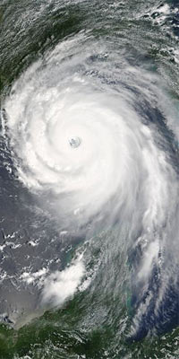
- A hurricane is an intense tropical storm with powerful winds and heavy rain.
- Other names for a hurricane include cyclone, typhoon and tropical storm.
Visit the website Science Kids: Fun Science & Technology for kids to learn more interesting facts about Hurricanes.
What are some of the new words you learned from this video?
Pick a word, write it, create a sketch that represents it and explain it in your words.
Word | Sketch | Definition

🌟Meteorologists Award🌟

Flood
Flooding is a temporary overflow of water onto land that is normally dry. Floods are the most common natural disaster in the United States. Failing to evacuate flooded areas or entering flood waters can lead to injury or death.
Floods may:
- Result from rain, snow, coastal storms, storm surges and overflows of dams and other water systems.
- Develop slowly or quickly. Flash floods can come with no warning.
- Cause power outages, disrupt transportation, damage buildings and create landslides.
IF YOU ARE UNDER A FLOOD WARNING, FIND SAFE SHELTER RIGHT AWAY
- Do not walk, swim or drive through flood waters. Turn Around, Don’t Drown!
- Just six inches of moving water can knock you down, and one foot of moving water can sweep your vehicle away.
- Stay off of bridges over fast-moving water.
- Depending on the type of flooding:
- Evacuate if told to do so.
- Move to higher ground or a higher floor.
- Stay where you are!
(Retrieved from: Floods Ready, https://www.ready.gov/floods, May 22, 2020)

Read each statement below carefully. If you think a statement is correct, circle TRUE. If you think the statement is incorrect, circle FALSE.

- Floods can cause power outages and create landslides.

TRUE FALSE

- Flooding is a temporary overflow of water.

TRUE FALSE

- If you are under a flood warning you should drive and get to the nearest bridge.

TRUE FALSE

🌟Certificado Meteorólogo🌟
Mira el siguiente video en español y completa las siguientes oraciones.
1. Las tornados son una gran tormenta que pueden

traer fuertes _____________, _____________ y _________.

2. Los tornados son muy raros en áreas _____________________

porque las _____________________ estarían en el camino y

causarían que la tormenta se debilite.

3. Los tornados son categorizados en ___________________ del 1 al ______.

🌟Certificado Meteorólogo🌟
Mira el siguiente video en español y completa las siguientes oraciones.
1. Las tornados son una gran tormenta que pueden

traer fuertes _____________, _____________ y _________.

2. Los tornados son muy raros en áreas _____________________

porque las _____________________ estarían en el camino y

causarían que la tormenta se debilite.

3. Los tornados son categorizados en ___________________ del 1 al ______.

Literacy Award: Bookmarks
🌟Meteorologists🌟 🌟Award🌟  Insert Photo/Coloring Picture HERE  Did you know…  THE EYE OF A HURRICANE IS VERY WARM.  The core of a hurricane is very warm—they are tropical, after all. The eye of a hurricane is formed by air rushing down from the upper levels of the atmosphere to fill the void left by the low air pressure at the surface. Air dries out and warms up as it rapidly descends through the eye toward the surface. This allows temperatures in the eye of a strong hurricane to exceed 80°F thousands of feet above the Earth's surface, where it’s typically much colder.  Name:_______________________ | 🌟Meteorologists🌟 🌟Award🌟  Insert Photo/Coloring Picture HERE  Did you know…  Tornadoes have touched down on every continent except Antarctica!  AND  The US experiences the highest number of tornado occurrences on Earth!  Share one fact with a friend!  Name:_______________________

🌟Meteorologists🌟 🌟Award🌟  Insert Photo/Coloring Picture HERE  Snowmageddon was a major blizzard that affected the majority of the Northeastern United States between February 5th and 6th in 2010. This massive winter storm brought historic snowfalls to every single Mid-Atlantic State. After the storm hit Washington, D.C. people were skiing in the streets!  Joke:  Q: What time is it when little white flakes fall past the classroom window?  A: Snow and Tell.  Name:_______________________ | 🌟Meteorologists🌟 🌟Award🌟  Insert Photo/Coloring Picture HERE  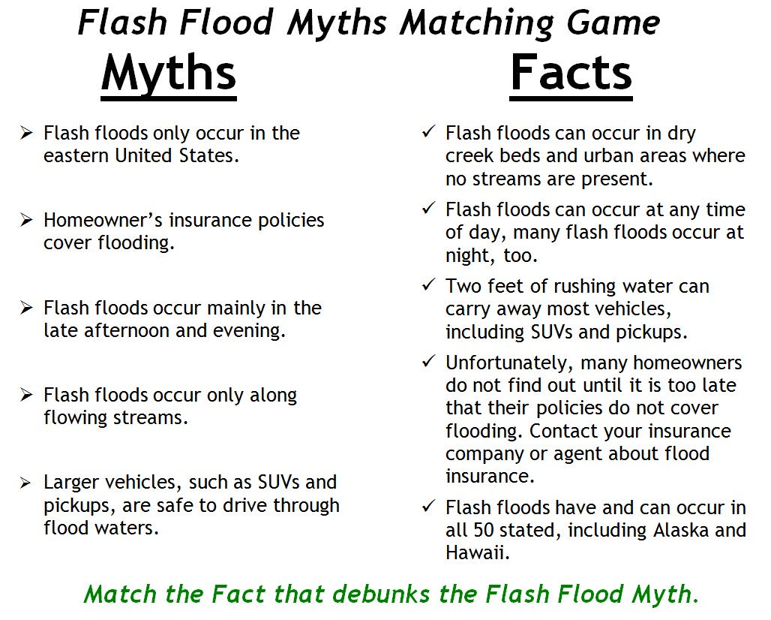  Name:_______________________

Prediction/Reaction Guide
Directions: Please respond by sketching and writing below.

- What does precipitation mean? Precipitation means___________________.
Prediction
Reaction
- What is an ecosystem? An ecosystem is ___________.
Prediction
Reaction

- What are some types of clouds associated with weather events? A ______is a type of cloud.
Reaction
Prediction

- How are humans affected by blizzards? A blizzard affects humans by _________________.

Prediction
Reaction

- Give an example of how tornadoes impact ecosystems. A tornado affects _______ by ___________.

Prediction
Reaction

Big Book: Teacher Made

Big Book: The Most Important Thing About Weather
Created by Lori McAndrews

Page 1: Table of Contents
- Weather vs Climate
- Water Cycle and Precipitation
- Clouds
- Temperature
- Air Pressure
- Wind
- Fronts
- Tornado
- Hurricanes
- Floods
- Droughts
- Blizzards
- Glossary

Page 2:
The most important thing about weather is that weather conditions and phenomena affect ecosystems and can be predicted.
Weather is the daily condition of the air, or the atmosphere. It is caused by heat from the sun, air pressure, air masses, and moisture. Weather is the minute-by-minute changes in the atmosphere.
The average weather data over at least 30 years determines a region’s climate. Some weather components that make up a region’s climate include the average temperature, humidity, wind, and amount of precipitation, the liquid and solid water that falls from clouds and reaches the ground.

But the most important thing about weather is that weather conditions and phenomena affect ecosystems and can be predicted.

Page 3:
The most important thing about weather is that weather conditions and phenomena affect ecosystems and can be predicted.
Heat from the sun causes water to evaporate . Evaporation occurs when liquid water turns into a gas and rises into the air, called water vapor.
This water vapor begins to cool as it rises and forms liquid water again. Millions of tiny water drops come together to form clouds. This is called condensation.

But the most important thing about weather is that weather conditions and phenomena affect ecosystems and can be predicted.

Page 4:
The most important thing about weather is that weather conditions and phenomena affect ecosystems and can be predicted.
Clouds are formed when water vapor rises, cools, and comes together.
There are many types of clouds. Clouds can look different from one another. Clouds can bring different types of weather.
Stratus Clouds are smooth, gray clouds that blanket the sky. These clouds cause rainy, wet weather.
Cirrus Clouds are high, thin, feathery clouds. They are made up of ice crystals. These clouds cause clear, sunny weather.
Cumulus Clouds are fluffy, white clouds with flat bottoms. These clouds cause fair, clear, or sunny weather.
Cumulonimbus Clouds are smooth, gray clouds that blanket the sky. These clouds cause rainy, wet weather.

But the most important thing about weather is that weather conditions and phenomena affect ecosystems and can be predicted.

Page 5:
The most important thing about weather is that weather conditions and phenomena affect ecosystems and can be predicted.
Weather is caused by heat from the sun. You can feel the warmth of the sun on our face on a hot, summer day. The amount of sunlight we receive on earth causes changes in the temperature.
We measure temperature using a thermometer. It is measured in degrees in both Fahrenheit and Celsius.
But the most important thing about weather is that weather conditions and phenomena affect ecosystems and can be predicted.

Page 6:
The most important thing about weather is that weather conditions and phenomena affect ecosystems and can be predicted.
Weather is caused by air pressure. We cannot see the air molecules around us but we can feel them when the wind blows.
The weight of the air molecules as gravity pulls it towards the ground is known as air pressure. When there is more air pushing down on the ground, we have high pressure. High pressure is caused by cold air sinking. When air is warm, it rises. This causes low pressure because there is less air pushing down on the ground.
A barometer is used to measure air pressure.

But the most important thing about weather is that weather conditions and phenomena affect ecosystems and can be predicted.

Page 7:
The most important thing about weather is that weather conditions and phenomena affect ecosystems and can be predicted.
Wind is air put into motion. An anemometer is used to measure wind speed and a weather vane is used to measure the direction the wind blows.
Wind can be a gentle breeze or it can be strong like in a tornado or hurricane.

But the most important thing about weather is that weather conditions and phenomena affect ecosystems and can be predicted.

Page 8:
The most important thing about weather is that weather conditions and phenomena affect ecosystems and can be predicted.
A front is a boundary separating two different masses of air.
When a front passes over an area, it means a change in the weather conditions.

But the most important thing about weather is that weather conditions and phenomena affect ecosystems and can be predicted.

Page 9:
The most important thing about weather is that weather conditions and phenomena affect ecosystems and can be predicted.
Tornados look like long tubes that stretch from the sky to the ground. They are spinning columns of air that can form in clouds during a thunderstorm. Since we cannot see air, what we see is the dust that is picked up by the wind.
Tornados can form at any time of the year but most of the time they form during the warm weather of spring and summer. There is a place in the United States referred to as Tornado Alley. More tornadoes happen here than anywhere else in the world!
A tornado can have a significant impact on human activities and communities. They can cause extreme damage to buildings and the land when they touch down. Since tornadoes are difficult to predict, many people have lost their lives due to tornadoes.

But the most important thing about weather is that weather conditions and phenomena affect ecosystems and can be predicted.

Page 10:
The most important thing about weather is that weather conditions and phenomena affect ecosystems and can be predicted.
Hurricanes are storms that begin over the oceans. They bring heavy rain and strong winds. The wind speeds can exceed 100 miles per hour. These winds can destroy houses and pull up trees.
Since hurricanes take some time to develop, weather forecasters are able to give people warning and opportunities to evacuate the areas they are predicted to hit. Hurricanes can cause millions of dollars worth of damage.

But the most important thing about weather is that weather conditions and phenomena affect ecosystems and can be predicted.

Page 11:
The most important thing about weather is that weather conditions and phenomena affect ecosystems and can be predicted.
Heavy rains can cause rivers and lakes to flood. When a river or lake overflows from too much water, it can sweep away anything in its path.
Floods can cause damage to buildings, severe erosion, and loss of human life.

But the most important thing about weather is that weather conditions and phenomena affect ecosystems and can be predicted.

Page 12:
The most important thing about weather is that weather conditions and phenomena affect ecosystems and can be predicted.
A drought is a prolonged period of little to no rain. Droughts can cause an extreme impact on an ecosystem. Crops can fail, wild fires could become more probable, drinking water for animals and humans could also be impacted.

But the most important thing about weather is that weather conditions and phenomena affect ecosystems and can be predicted.

Page 13:
The most important thing about weather is that weather conditions and phenomena affect ecosystems and can be predicted.
A blizzard is caused by several weather conditions. A blizzard’s characteristics include large amounts of snow, high winds, and freezing temperatures.
A blizzard can trap people in their cars and homes, it may be difficult for people to get the things they need. Power outages are possible. Animals may find it difficult to find food or shelter.

But the most important thing about weather is that weather conditions and phenomena affect ecosystems and can be predicted.

Page 14: Glossary
anemometer: an instrument used to measure wind speed and direction
atmosphere: the layer of gas that surrounds Earth
barometer: an instrument that measures air pressure
climate: the average measurements of temperature, wind, humidity, snow, and rain in a place over the course of a long time
condensation: a process by which water vapor turns to a liquid
evaporation: a process where liquids change to a gas or vapor
forecaster: a person who predicts the future in weather conditions
gravity: is a pulling force that works across space
humidity: the amount of water vapor that is in the air
precipitation: the liquid and solid water that falls from clouds and reach the ground; drizzle, rain, snow, sleet, hail
thermometer: an instrument used for measuring or showing temperature (how hot or cold something is)
water vapor: tiny particles of liquid or solid in a gas

Graphic Organizer: United States’ Natural Disasters

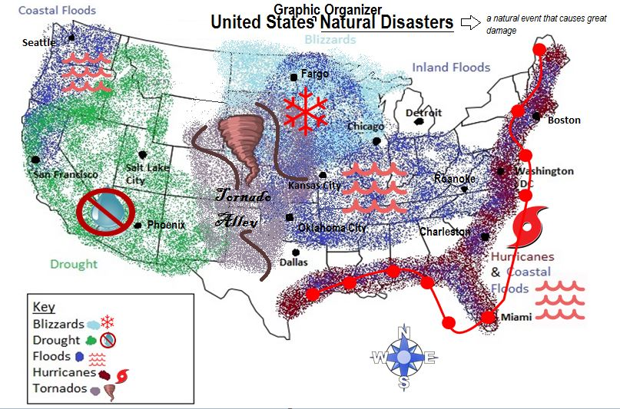
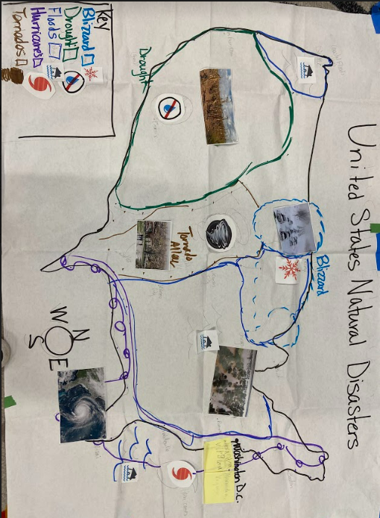

United States’ Natural Disasters Graphic Organizer: ELD Review

ELD QUESTION GRID -
Unit title: Weather Strategy name: Graphic Organizer – United States’ Extreme Weather
Thinking and  Language Grid | Level 1 Entering  Listening/  Speaking | Level 2 Beginning  Listening/  Speaking | Level 3 Developing  Listening/  Speaking | Level 4 Expanding  Listening/  Speaking | Level 5 Bridging  Listening/  Speaking
Level  of  Questioning | Point To,  Locate, Trace Yes/No Either/Or Open Ended
REMEMBER  Choose, define, fined, how, label, list, match, recall, show, tell, spell, relate, name, omit, select, who, what, when, where, why  UNDERSTAND  Classify, compare, demonstrate, explain, extend, illustrate, infer, interpret, outline, rephrase, summarize, translate | Show me Tornado Alley.  Locate the largest extreme weather. | Is this a flood? Is this a drought? (Pointing to a weather areas on the map)  Is this a hurricane?  (showing a picture) | I’m thinking of the cold north. Am I thinking of hurricanes or blizzards?  Is this (pics) an inland flood or a coastal flood? | Name two major kinds of extreme weather.  What extreme weather is found in the southwest? | Explain what extreme weather is.  How are they described or characterized?
APPLY  Apply, choose, construct, develop, experiment with, identify, interview, make use of, model, organize, plan, utilize  ANALYZE  Analyze, assume, categorize, classify, compare, conclusion, contrast, discover, dissect, distinguish, divide, examine, function, inspect, motive, relationships, simplify, survey, theme, test for | Show me a tornado with your body.  Which picture was taken in a blizzard?  Which extreme weather is hot and dry with no water?  Show me on the map. | Does Miami have hurricanes?  (Using an additional picture) Does this picture shows how plants are affected by droughts?  . | Does Chicago or Dallas have blizzards?  Since North America has lots of extreme weather, do you think that they use the same tools to measure all types of weather? | Explain the difference between a tornado and a flood.  What are some cities that have floods? | Compare hurricanes and tornadoes.  Use the information on the chart to explain how water affects land areas.
EVALUATE  Agree, assess, compare, conclude, criticize, deduct, defend, determine, disprove, evaluate, influence, judge, justify, opinion, prove, recommend, support  CREATE  Build, change, choose, construct, design, develop, elaborate, formulate, imagine, improve, plan, predict, propose, solve, test, theory | Point to the extreme weather that you would least like to have.  Choose the parts of this map that you would use to teach another student about coastal floods. | Justify, could people live in blizzards without shelter?  Which of these (pics) animals do you think live in Salt Lake City? | Which two extreme weather events are southeast?  What word would best describes hurricanes? | How would you survive in a drought?  Predict what would happen if the Earth did not have floods. | If you traveled to Kansas City, what would you need to do to survive?  How would Fargo’s weather change if it stopped getting blizzards and floods?

Background Information for Graphic Organizer
Background Information: United States’ Natural Disasters Graphic Organizer
Resourced from https://kids.kiddle.co/Natural_disaster
Adjust the amount of information you share based on your class and your focus areas.
- Add title and meaning of ‘natural disaster’
Natural disasters are major events that cause great damage through natural processes of the Earth. A natural disaster can cause a loss of life or property damage, and leaves some economic damage after it has been completed. Examples include floods, hurricanes,tornadoes, volcanic eruptions, earthquakes, tsunamis, and other geologic processes.
- Add a compass rose. (Optional: NW, NE, SW, SE)
- Sketch oceans Refer to cardinal directions and compass rose as you add each ocean (Pacific Ocean & Atlantic Ocean).
- Add map key.
Maps often use symbols or colors to represent things, and the map key explains what they mean. “On our map, these will help us identify our natural disasters. Our first natural disaster is blizzards, the symbol we will use to identify this will be a snowflake and the color blue.” (Add to key).
- Add each natural disaster (info below) to the key. Share a picture of the natural disaster and provide information about the natural disaster as you add it to the map. Allow turn and talk after each addition to provide student discourse and personal connections “One time I was in a hurricane…”
- Add pictures from expert groups, highlighting which natural event and where they are located in the United States.

Natural Disasters--Formation and Locational Reasoning

Drought
Drought is when there is a lot less precipitation, like rain or snow, than an area normally gets over a long period of time. Hot dry winds, a shortage of water, high temperatures and watering evaporating from the ground can contribute to conditions of drought. Droughts result in crops failing or dying and shortages of water.

Floods
A flood is an abundance or overflow of water. The overflow of water 'submerges' or overflows land. A flood is often identified as a temporary covering of the land with water which is usually not covered by water. The overflow of water can come from anywhere. For example a river, a lake or a reservoir. When the water escapes its usual boundaries, flooding occurs. In order to be considered a flood the water will cover land used by people like a village, city or a road.

Blizzards
Blizzards are severe winter storms characterized by heavy snow and strong winds. When high winds stir up snow that has already fallen, it is known as a ground blizzard. Blizzards can impact local economic activities, especially in regions where snowfall is rare. U.S. Wheat crops were destroyed by the Great Blizzard of 1888. More than 300 people died, 26 states and Canada were affected.

Tornados
A tornado is a violent and dangerous rotating column of air that is in contact with both the surface of the Earth and a cumulonimbus cloud, or the base of a cumulus cloud in rare cases. It is also referred to as a twister or a cyclone. Tornadoes come in many shapes and sizes, but are typically in the form of a visible funnel, whose narrow end touches the Earth and is often encircled by a cloud of debris and dust.
Hurricanes
Hurricanes or typhoons (sometimes called tropical cyclones) form when movement causes warm, moist air above the ocean to rise. Warm air rises quickly. Tropical cyclones are powered by warm, humid ocean air. When they go onto land, they weaken. They die when they spend a long time over land or cool ocean water.

Tornado Pictorial Input Chart
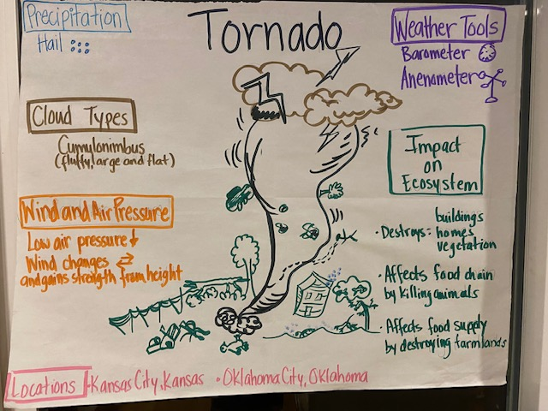
, Tornado Alley’

Tornado Pictorial Input - PIC - ELD Review Questions

ELD QUESTION GRID -

Unit title: Weather Strategy name: Pictorial Input Chart: Tornado
Thinking and  Language Grid | Level 1 Entering  Listening/  Speaking | Level 2 Beginning  Listening/  Speaking | Level 3 Developing  Listening/  Speaking | Level 4 Expanding  Listening/  Speaking | Level 5 Bridging  Listening/  Speaking
Level  of  Questioning | Point To,  Locate, Trace Yes/No Either/Or Open Ended
REMEMBER  Choose, define, fined, how, label, list, match, recall, show, tell, spell, relate, name, omit, select, who, what, when, where, why  UNDERSTAND  Classify, compare, demonstrate, explain, extend, illustrate, infer, interpret, outline, rephrase, summarize, translate | Show me the tornado  Locate the thunder storm.  Point to the picture that shows a tornado’s damage. | Is this cloud a cumulonimbus?  Does a tornado produce hail?  (showing a picture) | Does the anemometer measure wind or air pressure?  Does a tornado form with low or high air pressure? | Name the 2 weather tools meteorologists use to predict tornadoes.  What is the name of the US area prone to tornadoes? | What does a barometer measure?  How are tornadoes characterized?
APPLY  Apply, choose, construct, develop, experiment with, identify, interview, make use of, model, organize, plan, utilize  ANALYZE  Analyze, assume, categorize, classify, compare, conclusion, contrast, discover, dissect, distinguish, divide, examine, function, inspect, motive, relationships, simplify, survey, theme, test for | Show me a tornado with your body.  Which picture was taken in a tornado? | Does Kansas get tornadoes?  (Using an additional picture) Does this picture shows how plants and animals are affected by tornados?  . | What city gets tornadoes Alexandria or Oklahoma?  Since North America has lots of extreme weather, do you think that they use the same tools to measure? | As a meteorologist what weather tool would you choose first to measure a tornado?  Analyze the difference between a tornado and a thunderstorm. | Compare hurricanes and tornadoes.  Use the information on the chart to explain how tornadoes affect people.
EVALUATE  Agree, assess, compare, conclude, criticize, deduct, defend, determine, disprove, evaluate, influence, judge, justify, opinion, prove, recommend, support  CREATE  Build, change, choose, construct, design, develop, elaborate, formulate, imagine, improve, plan, predict, propose, solve, test, theory | Look at these pictures of the destruction from a tornado.  Choose the parts of this chart that you would use to teach another student about tornadoes. | Could people survive a tornado without shelter?  Which of these (pics) do you think show what precipitation comes with tornadoes? | Look at these two pictures. Would it be more important to find shelter or conserve water during a tornado warning?  What word would best describe tornados? | What would you do to survive a tornado?  Predict what would happen if Alexandria had a tornado. | If you heard a tornado warning on the TV, what would you do?  Develop a plan for yourself if you had a tornado at school.

Background Information for Pictorial Input

Background Information: Tornado Pictorial Input Chart

Precipitation
The Tornado is one of the many extreme weather events people experience. A tornado is a rapid column of air. A tornado typically begins with a thunderstorm that can bring precipitation. The type of precipitation that a tornado typically begins with is called hail. A tornado can also bring lightning and flash floods.

Cloud Types
As a rapid rotating column of air, a tornado makes contact with both the surface of Earth and a cumulonimbus cloud. A cumulonimbus cloud might look fluffy on the top but flat on the bottom. You will usually see cumulonimbus clouds before a storm.

Wind and Air Pressure
Tornados begin with a thunderstorm. When a thunderstorm moves air pressure drops. Therefore tornados are known to have low air pressure. Tornadoes have high wind speeds that can reach up to 300 miles per hour. These powerful winds can change and move in many directions. As the air rotates horizontally and then vertically, the tornado gains strength from its height. Tornados begin with a thunderstorm, but not just any thunderstorm, this special kind of thunderstorm is called a supercell and it creates tornadoes.

Weather Tools
Tornadoes are very difficult to measure because of their dangerous wind speeds, thunderstorms, and unpredictability. Meteorologists use various types of tools to help them measure and predict tornadoes.
A barometer is a weather tool or instrument used to measure air pressure.
An anemometer is an instrument that measures wind speed. The most common type of anemometer has three or four cups attached to horizontal arms. The arms are attached to a vertical rod. As the wind blows, the cups rotate, making the rod spin. The stronger the wind blows, the faster the rod spins. The anemometer counts the number of rotations, or turns, which is used to calculate wind speed.

Impact on the Ecosystem
A tornado is an extreme weather event that impacts our Ecosystem. A tornado moves as fast as 300 miles per hour and it can be up to 50 miles wide, so it can cause a lot of damage. As a tornado moves along the ground, the force of the wind in a tornado is so strong that it can lift up things in its path. A tornado can destroy buildings and trees. The loss of trees means animals lose their homes. Some tornadoes have even picked up cars and cows. When a tornado kills animals it affects the food chain. When tornadoes destroy the farmland and crops, our food supply is affected.

Locations
Tornadoes occur all over the world. In the United States, the central or middle part of the country has a large flat area where more than 500 tornadoes typically occur every year. This area is known as “Tornado Alley” and it includes states such as Texas, Nebraska, Missouri, Arkansas, Oklahoma, Missouri, Iowa, North and South Dakota. The two cities with the highest number of tornadoes each year are Kansas City, Kansas and Oklahoma City, Oklahoma.

Narrative Input Chart
Sergio and the Hurricane
By Alexander Wallner

Page 1
Sergio lived in Puerto Rico. He lives with his mama, papa, dog Peanut, and cat Misu in a cottage across the street from the ocean.

Page 2

Every morning he sat on the beach with Peanut, watching the wind-surfing boats sail on the turquoise water. But today the ocean was dark green and the waves were too high and choppy for small boats.

“A storm must be coming,” Sergio said, scratching Peanut’s ear.

Why does Sergio think a storm is coming?

Page 3
Sergio walked to the small park down the street. Usually the park was full of people. But today there was no one.

The air was hot, his skin felt sticky with sweat.

Why was the park empty? Where do you think everyone is?

Page 4
Sergio bought an ice cream cone at his friend Raffi’s stand.
“Hurricane weather,” Raffi said, frowning. “The TV says a huge storm is coming our way.”

“I hope you’re right!” Sergio said. He was too young to remember the last big hurricane that had hit San Juan, so he was excited.

“A hurricane is a very serious thing,” said Raffi, still frowning.

Why do Raffi and Sergio have different reactions to the possibility of a hurricane?

Page 5
Sergio ran home.

“Mama! Mama!” he cried. “Raffi says a hurricane is coming!”

“Yes, Sergio,” said mama. “I know. Hurry, we must go to the supermarket to get some supplies before the hurricane comes.”

The supermarket was crowded. Lots of people were preparing for the hurricane.

As they drove home, they saw people boarding up windows with sheets of plywood or crisscrossing masking tape over them.

“Why are they doing that?” Sergio asked.

“To keep the glass from shattering and hurting people,” Mama explained

Page 6
Hurricane reports blared from car radios. It’s so exciting! Sergio thought.

When they got home, Papa was putting metal shutters over the windows.

“Papa! Papa!” Sergio cried, jumping up and down. “Do you think it will be a big hurricane?”

“A hurricane is a very serious thing.” Papa said. “After you help Mama with the groceries, I will need your help outside.”

Papa and Sergio put the outdoor furniture in the garage. Then Sergio watched Papa cut the coconuts off the palm trees in the yard.

Why did Papa and Sergio cut the coconuts off the palm trees?

It was late in the afternoon when everything was done. Soon after dinner, rain began to drum on the roof. Sergio peeked through the crack in the shutters.

Page 7
Sand from the beach sliced across the road. Waves as tall as hills slammed the cement seawall across the street.

After the excitement of the day, Sergio was very tired. He fell asleep listening to the wind howl.

Page 8
Sometime later, Sergio woke suddenly. The howling wind was rattling the shutters like it wanted to break in.

Sergio saw a candle burning on his dresser. The electricity must have gone out! He felt afraid all by himself, so he went into his parents’ room and snuggled into bed with them.

Would you have been scared?

Page 9
They listened to a battery operated radio. “Wind is gusting up to 170 miles per hour,” a voice crackled. “Utility poles are snapping like matchsticks. Electricity is out all over San Juan and the east coast. Please, everyone, stay indoors until the hurricane is over!”

Page 10
The hurricane was wild and noisy. It wasn’t as much fun as Sergio had thought it was going to be.

“I’m scared,” Sergio admitted, so Papa told him a story.

The last time there was a really big hurricane like this was when your grandmother was young. She lived on a farm. The wind blew so hard that it scared the cow, who knocked over an oil lamp. The straw caught fire, but your grandmother used some big cans of milk to put it out just in time to save the barn.

Papa’s voice was warm and comforting and Sergio soon fell asleep. When he awoke, it was late morning.

What made Sergio change his mind about the storm?

Page 11
Sergio ran to the kitchen. His mother put her arms around Sergio, “the hurricane is over. Let’s go outside to see what happened.”

The sun was shining and the ocean was calm, almost as if there had never been a hurricane. But there was a lot of damage. Flying sand had blasted the pink paint off the front of the cottage. The palm trees had knocked some of the tiles off the roof.

Page 12
Sergio’s family would have to do a lot of work, but not as much as the neighbors. Old Mr. Gonzales’s banyan tree had uprooted and crashed into his house.

Page 13
Along the street, trees and utility poles had fallen and crashed into fences, houses, and cars. Water flooded the streets and where drain pipes were clogged.

What was some of the damage that the hurricane caused?

Page 14
Slowly, carefully, Sergio walked to the park. Most of the palm trees had lost their leaves and some had broken in half. Raffi was looking sadly at the heap of rubble that had been his stand. “It will take a lot of money to build a new one,” he said, sighing.

Page 15
That afternoon, Sergio went to the beach with Peanut and played in the water. The beach was full of people. Everyone in San Juan had the day off, but no one was smiling. It would take a lot of time and hard work to clean up the mess the hurricane had made.

Page 16
There was no electricity. The pumpls that brought water to the city were not working. Instead, a truck brought fresh water in big plastic bottles to Sergio’s street.

Have you ever had a time when you did not have electricity?

Page 17
“Help me carry fresh water from the truck,” said Mama.

Page 18
“Pick up the dead branches around the house,” said Mama.

Page 19
“Help me shovel the sand from the yard,” Papa said.

At the end of the day, Sergio felt very dirty. “May I take a bath?” he asked.

“No, dear, only a sponge bath,” Mama said. “We must only use this water for drinking and cooking.”

After all that work, how would you feel about not being able to take a bath or a shower?
Page 20
A few nights later it rained hard. Sergio and his parents ran to the backyard with soap and shampoo and took long showers. It felt good!

Page 21
For many weeks, men cut up the trees that had fallen into power lines. Then, one day, electricity flowed through the wires again.

A few days later, water came out of the faucets. School started, and Mrs. Hernandez, Sergio’s teacher, gave the class a science lesson on hurricanes.

Page 22
After many months, most people had repaired and painted their houses and cleaned up their streets. They were happy again and things were back to normal.

Page 23
One day, Papa asked, “Will you ever forget the hurricane, Sergio?”

“No, Papa,” he said. “And I’ll never wish for one again.”

Sergio and the Hurricane: ELD Review Questions

ELD QUESTION GRID -
Unit title: Weather Strategy name: Narrative Input Chart “Sergio and the Hurricane”
Thinking and  Language Grid | Level 1 Entering  Listening/  Speaking | Level 2 Beginning  Listening/  Speaking | Level 3 Developing  Listening/  Speaking | Level 4 Expanding  Listening/  Speaking | Level 5 Bridging  Listening/  Speaking
Level  of  Questioning | Point To,  Locate, Trace Yes/No Either/Or Open Ended
REMEMBER  Choose, define, fined, how, label, list, match, recall, show, tell, spell, relate, name, omit, select, who, what, when, where, why  UNDERSTAND  Classify, compare, demonstrate, explain, extend, illustrate, infer, interpret, outline, rephrase, summarize, translate | Point to where Sergio lives.  Locate the largest extreme weather. | Is there a storm coming?  Is this storm a hurricane? | Was Sergio excited or scared about the storm at first?  Compare how Sergio felt in the beginning and at the end of the story | Why was the supermarket busy?  Why did people put wood on their windows? | What did Sergio do to help his father prepare for the storm?  How does Sergio feel about helping his community after the hurricane hit?
APPLY  Apply, choose, construct, develop, experiment with, identify, interview, make use of, model, organize, plan, utilize  ANALYZE  Analyze, assume, categorize, classify, compare, conclusion, contrast, discover, dissect, distinguish, divide, examine, function, inspect, motive, relationships, simplify, survey, theme, test for | Point to the destruction made by the hurricane.  Locate a picture where you can see Sergios change his mind about the hurricane? | Is a hurricane a serious thing?  Was Sergio helpful at the end of the story?  Did the hurricane last for one day? | Compare Sergio’s feelings about the storm from the beginning to the end of the story.  Compare this storm to a storm you have been in. | How are people preparing for the hurricane?  How did people clean up after the storm? | How did people help at the end of the story?  Why wasn’t the storm as much fun as Sergio first thought?
EVALUATE  Agree, assess, compare, conclude, criticize, deduct, defend, determine, disprove, evaluate, influence, judge, justify, opinion, prove, recommend, support  CREATE  Build, change, choose, construct, design, develop, elaborate, formulate, imagine, improve, plan, predict, propose, solve, test, theory | Show a place where Sergio helped his community after the storm.  Show where Sergio’s father prepares the family home for the storm | Justify, is Sergio concerned about the storm later?  Can communities prepare for a big storm? | What word would best describes hurricanes?  What would you do to protect your house from a storm? | Why is the park empty?  Predict what would happen if Virginia got a strong hurricane. | If you traveled to Puerto Rico what would you need to do to survive?  How would Puerto Rico’s weather change if it stopped getting hurricanes?

Weather – El Clima
Poetry Booklet (Cover) – Librito de cantos y poesía (portada)

Insert authentic images of weather events from the unit here.

Name:________________________

Grade:____________

Meteorologists Here, Meteorologists There
By Sofía Meléndez Contreras

Meteorologists here, meteorologists there,
Meteorologists, meteorologists everywhere.

Ecstatic meteorologists reporting cheerfully,
Avid meteorologists predicting rapidly,
Studious meteorologists studying closely,
And joyous meteorologists analyzing eagerly.

Meteorologists in cold cities.
Meteorologists throughout hot countries.
Meteorologists on top of mountains.
And meteorologists from all states.

Meteorologists here, meteorologists there,
Meteorologists, meteorologists everywhere.
Meteorologists! Meteorologists! Meteorologists!

Weather Tools Yes Ma'am
Written by Rebecca Pittman 2016

Is this a thermometer? Yes ma'am.
Is this a thermometer? Yes ma'am.
How do you know? It has a number line.
How do you know? It has degrees.
What do you use it for? To measure temperature.
What do you use it for? To measure temperature.

Is this a rain gauge? Yes ma'am.
Is this a rain gauge? Yes ma'am.
How do you know? It has a container.
How do you know? It has a number line.
What do you use it for? To measure precipitation.
What do you use it for? To measure precipitation.

Is this a barometer? Yes ma'am.
Is this a barometer? Yes ma'am.
How do you know? It has a round dial.
How do you know? It has a pointer.
What do you use it for? To measure air pressure.
What do you use it for? To measure air pressure.

Is this a wind vane? Yes ma'am.
Is this a wind vane? Yes ma'am.
How do you know? It has arrows and directions.
How do you know? It spins with the wind.
What do you use it for? To measure wind direction.
What do you use it for? To measure wind direction.

Is this an anemometer? Yes ma'am.
Is this an anemometer? Yes ma'am.
How do you know? It has cups.
How do you know? It spins with the wind.
What do you use it for? To measure wind speed.
What do you use it for? To measure wind speed.

Weather Cadence
By Sofía Meléndez Contreras

I’m a meteorologist and I am here to say
I study weather everyday
Sometimes I study and I get wet
Weather events are everywhere

Sound off! Blizzard
Sound off! Hurricane
Sound off! 1-2-3 Weather events!

I am a blizzard and I am here to say
You could see me any day
Heavy snowfall comes with me
Weather events can happen anywhere

Sound off! Blizzard
Sound off! Hurricane
Sound off! 1-2-3 Weather events!

I am a hurricane and I am here to say
You could see me in the East
Wind and clouds are with me
Weather events can happen anywhere

Sound off! Blizzard
Sound off! Hurricane
Sound off! 1-2-3 Weather events!

Air Pressure
By Sofía Meléndez Contreras
Tune: I’m a nut

I am air pressure
Temperature and elevation
Can change my flow
I am air pressure (clap/clap)
I am air pressure 2x

I am low pressure
The cold moves up
I am present in a flood and a tornado
I’m low pressure (clap/clap)
I’m low pressure 2x

I am high pressure
The heat leads me down
Warmer is less dense than cooler air for sure
I’m high pressure (clap/clap)
I’m high pressure (clap/clap)2x

Weather Cadence II
By Sofía Meléndez Contreras

I’m a meteorologist and I am here to say
I study weather everyday
Sometimes I get wet here and there
Weather events are everywhere

Sound off! Flooding
Sound off! Hurricane
Sound off! Tornado
Sound off! 1-2-3 Weather events!

I am a blizzard and I am here to say
Heavy snowfall comes with me everyday
I’m a weather event that happens when is cold
I better bundle up so I am told

Sound off! Freezing cold
Sound off! Strong winds
Sound off! It can happen here!

I am drought and I am here to say
Water is gone when I come to stay
I bring famine and disease in my path
With me there is no water to take a bath

Sound off! Lack of rain
Sound off! Plants are dead
Sound off! We don’t want it in this place!

I am a tornado and I am here to say
Thunderstorms are always in my way
Low air pressure strengthens me and helps me stay
Watch for the things that are in my way

Sound off! Brings hail
Sound off! High wind speed
Sound off! Get out of here!

Student _______________________________Adult________________________
Project GLAD
Home/School Connection #1
Grade 4 - Weather Unit
Ask an adult in your family to share an experience they’ve had with any of the following: tornado, drought, flood, or hurricane. They can share a story that they have heard if they do not have an experience of their own. Sketch or write down what you learn from them.

Student _______________________________Adult________________________
Proyecto GLAD
Conección entre el Hogar y la Escuela # 1
Grado 4 - Unidad meteorológica

Pídele a un adulto de tu familia que comparta una experiencia que haya tenido con cualquiera de los siguientes: tornado, sequía, inundación o huracán. Pueden compartir una historia que hayan escuchado si no tienen una experiencia propia. Dibuja o escribe lo que aprendas de ellos.

Estudiante ___________________________Adulto________________________
Project GLAD
Home/School Connection #2
Grade 4 - Weather Unit
Ask a family member or another adult if they know any sayings, songs, superstitions, or stories about the weather? Sketch or write down what you learn from them.

Estudiante ___________________________Adulto________________________
Proyecto GLAD
Conección entre el Hogar y la Escuela # 2
Grado 4 - Unidad meteorológica

Pregúntale a un miembro de la familia u otro adulto si conocen dichos, canciones, supersticiones o historias sobre el clima. Dibuja o escribe sobre lo que aprendas.

Estudiante ___________________________Adulto_____________________________
Project GLAD
Home/School Connection #3
Grade 4 - Weather Unit

Sketch a picture of the different types of precipitation. Explain how the different types of precipitation are associated with different types of clouds and weather events. Remember to use the words hail, rain, and snow.

Student _______________________________Adult________________________
Project GLAD
Home/School Connection #4
Grade 4 - Weather Unit

Weather tools are utilized to measure different types of precipitation. Some of them are the barometer, anemometer, rain gauge, thermometer, meter stick, and weather balloon.

1. Sketch 2 of your favorite weather tools.
2. Write about these tools and when you would use them.
3. Read and show your sketches to an adult.

Remember to use words like tornado, blizzard, drought, flooding, and hurricane.

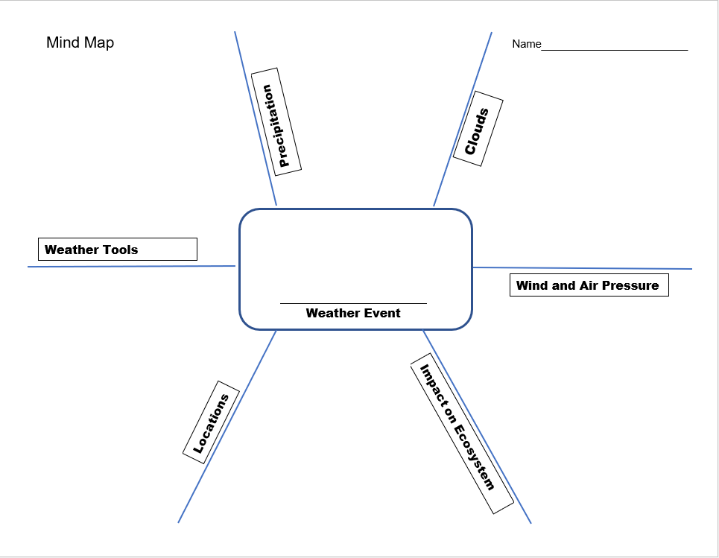
Expert Group 1 Name: _________________

Hurricane

Precipitation and Clouds

Hurricanes start as thunderstorms. Cumulonimbus clouds bring heavy rain. Warm ocean water helps increase the power of a hurricane. Hurricanes can cause flooding due to heavy rains and storm surge. These storms can be devastating since they can last from a few hours to multiple days.

Wind and Air Pressure

High winds can be associated with flooding. Hurricanes have strong winds and can cause
flooding in coastal areas due to heavy rains and when storm surges bring ocean water onto the land. Low air pressure systems can bring storms and heavy rainfall. When air pressure falls quickly or stays low over a period of time, lots of moisture rises into the atmosphere and creates rain clouds. With fast, intense precipitation, or extended precipitation, flooding can occur.

Location and Impact on Ecosystem

Hurricanes can damage homes, schools, stores, farms, animal habitats, and more. The high levels of water can cause flooding storm surges that are common in hurricanes can drown people and animals. People and animals may be forced to relocate, especially from diseases brought by dirty water. High winds that accompany hurricanes can cause damage to buildings and bridges. Hurricanes can strike any coastal areas but are most common on the eastern coast of the United States and in the Gulf of Mexico. Cities that are struck the most are Miami, Florida, and Charleston, South Carolina.

Weather Tools

The tool meteorologists use to measure precipitation levels is a rain gauge. A rain gauge is used to measure rainfall. Meteorologists use barometers to measure the air pressure in the atmosphere. A meteorologist uses satellites and radar to track these storms. They can warn people if a hurricane is headed their way.

Expert Group 2 Name: _________________

Flooding

Precipitation and Clouds

High levels of precipitation trigger flooding. Cumulonimbus clouds are associated with heavy rain. Most floods are caused by heavy rain and melted snow. When this excess water drains into rivers and streams quickly, the water levels rise. When rivers and streams overflow, cities, towns and farms are flooded.

Wind and Air Pressure

High winds can be associated with flooding. Hurricanes have strong winds and can cause
flooding in coastal areas due to heavy rains and when a storm surges bring ocean water onto the land. Low air pressure systems can bring storms and heavy rainfall. When air pressure falls quickly or stays low over a period of time, lots of moisture rises into the atmosphere and creates rain clouds. With fast, intense precipitation, or extended precipitation, flooding can occur.

Location and Impact on Ecosystem

Floods can damage homes, schools, stores, farms, animal habitats, and more. The high levels of water in a flood can kill plants that are not adapted to live in wet conditions. Swift currents that are common in flood waters can drown people and animals. People and animals may be forced to relocate, especially from diseases brought by dirty water. Landslides are another impact on our ecosystem from flooding. Flooding can happen anywhere. However, if you live near lakes, rivers or any water sources, you are at a higher risk. Areas such as Roanoke, Virginia, and Seattle, Washington, are often affected by floods.

Weather Tools

The tool meteorologists use to measure precipitation levels is a rain gauge. A rain gauge is used to measure rainfall. Meteorologists use barometers to measure the air pressure in the atmosphere. The data that is collected from both of these instruments can help us determine if a flood is in the forecast.

Expert Group 3 Name: _________________

Drought

Precipitation and Clouds

Droughts are long periods of very dry weather. This period of time could last for months or even years! During a drought, there are minimal clouds and less than normal precipitation, or moisture. Water levels get lower in ponds, lakes, and rivers. Water also evaporates from these bodies of water. During a drought, not enough rain or snowfall occurs to replenish water supplies.

Wind and Air Pressure

Fast-moving belts of wind take wavy, meandering paths around the planet called jet streams. Meteorologists worry whenever those swings and dips form omega-shaped curves that look like waves. When that happens, warm air travels further north and cold air moves further south. The result is a succession of unusually hot and cold weather systems along the same latitude. Under these conditions, winds often weaken and dangerous weather can remain stuck in the same place for days or weeks at a time—rather than just a few hours or a day—leading to prolonged heat waves or droughts.

Location and Impact on Ecosystem

Desert areas in the SouthWestern United States such as Phoenix, Arizona and Salt Lake City, Utah, are greatly affected by drought. This leads to other environmental hazards, including wildfire, flash floods, and landslides. Dry land leads to dry vegetation. Dry grass, plants, and trees can more easily die or catch fire. Then animals can’t find food to survive. When farmers can’t produce enough crops, there is a shortage of food. This means people have low food supply and can result in famine or starvation. Without a water supply in many living areas, deadly disease can also skyrocket!

Weather Tools

To measure a drought, meteorologists monitor levels of participation and moisture with a rain gauge, or udometer. Thermometers are used to track weather patterns of high heat. If low rain and snowfall are tracked for long periods of time with high temperatures, droughts are likely to occur.

Expert Group 4 Name: _________________

Blizzard

Precipitation and Clouds

A blizzard is a severe storm where heavy snow falls. This storm will also have freezing temperatures and strong, gusting winds. Clouds that produce precipitation as rain or snow are called frontal cirrostratus, altostratus and nimbostratus clouds. Nimbostratus clouds produce the most intense precipitation but don't produce all the elements that create a blizzard.

Wind and Air Pressure

Low air pressure currents are ideal for blizzards. Strong winds can cause blinding snow and whiteouts. Sustained strong winds (35 m/h for 3hrs or more) and wind gusts are an important factor in blizzard conditions.

Location and Impact on Ecosystem

Blizzards can damage homes, schools, stores, farms, animal habitats, and more. Heavy snow can cause roofs to collapse and buildings to cave in. Snow can be dangerous to travel, roads unsafe to travel. High winds can knock out power and cause trees to fall. Such cold temperatures and wind chill are very dangerous and even deadly for people and animals. Places in the northern United States such as Fargo, North Dakota & Chicago, Illinois tend to experience blizzard conditions.

Weather Tools

Meteorologists use tools to help them predict blizzards. Weather satellites high above the earth help them to track storms. They measure wind speed and temperature. Radar shows wind direction and precipitation.

Process Grid - Empty

Weather Events | Precipitation | Cloud Types | Wind and Air Pressure  (high pressure /low pressure) | Impact on Ecosystem | Locations | Weather Tools
Tornado
Hurricane
Flooding
Drought
Blizzard

Process Grid – Complete

Weather Events | Precipitation  and | Cloud Types | Wind and Air Pressure  (high pressure /low pressure) | Impact on Ecosystem | Locations | Weather Tools
Tornado | Thunderstorms  Hail | Cumulonimbus cloud- fluffy, large, flat-bottom | Low air pressure  Wind changes directions  Gains strength from the height  Air begins to rotate  High wind speed | Destroying buildings and trees  Loss of vegetation, trees, homes for animals  Kills animals, which affects the food chain  Destroys farm lands which affects food | Kansas City, Kansas & Oklahoma City, Oklahoma  “Tornado Alley”  (Official boundaries of Tornado Alley are not clearly defined; the main alley extends from northern Texas, through Oklahoma, Kansas, Nebraska, Iowa, and South Dakota.) | Barometer  Anemometer
Hurricane | Heavy rainfall can cause flooding | Cumulonimbus clouds | Type of tropical cyclone (circular motion)  Occur over warm water  Winds over 74mph  Measured in categories (1-5 w/ 5 strongest)  Low pressure system  “Eye” low pressure center | Property destruction (houses, roads, trees)  Erosion of beaches  Animals life (turtles)  Human life | Miami, Florida & Charleston, South Carolina | Rain gauge  Barometer  anemometer
Flooding | High precipitation (rain and/or snow) | Cumulonimbus clouds | Low pressure  Hurricanes can cause flooding | People and Animals need to relocate  Drowning of people and animals  Kills plants  Creates landslides  Disease from dirty water | Seattle, Washington & Roanoke, Virginia | Rain gauge  Barometer
Drought | Low precipitation from rain and snowfall | Minimal-null clouds | Jet stream pattern shifts clouds | Local water supply drops  Kills crops/plants and animals  Famine/Starvation  (low food supply)  Deadly diseases skyrocket | Salt Lake City, Utah & Phoenix, Arizona | Thermometer  Rain gauge (also known as an udometer, pluviometer, or an ombrometer)
Blizzard | Low temperatures below freezing  Heavy snowfall | frontal cirrostratus, altostratus and nimbostratus clouds | Sustained strong winds (35 m/h for 3hrs or more)  Drifting snow  Low air pressure | Local plants and animals die  Lack of food for animals  Loss of vegetation and trees/forests  Risk of flooding | Fargo, North Dakota & Chicago, Illinois | Weather balloon  “According to Georgia Public Broadcasting, these balloons are released into the air to measure atmospheric conditions such as wind pressure, wind direction, wind speed and temperature.’  Barometer  Anemometer  Meter Stick

Information to mention when teaching the unit:

- Tornado Alley is in the center of the country where land is flat.
- Hurricanes occur in coastal areas because they form over oceans.
- Floods occur Inland and Coastal--identify the difference.

SQ3R
SQ3R Study Method
Names: ________________________ ___________________________
Name of Text: _________________________________________________
Pages: _______________________ Date: __________________
S = Survey | Review text to gain initial meaning (headings, bolded text, charts, pictures, captions under pictures, graphs or maps). Read introduction and conclusion paragraphs.
Q = Question | Generate questions about the reading. Make predictions about what you will be reading. (What do I already know about this subject/topic?)
R = Read | As you read, look for answers to the questions from the preview. Re-read captions under pictures. Stop and re-read parts which are not clear.
R = Recite | Recite answers, take notes about answers. Summarize what you just read.
R = Review | Go back and review the text to find answers.
SQ3R Clunkers and Links
Name: ____________________________
Predictions:

Clunkers (?) | Links (!)

Writing Prompt
Writing Prompt
DIRECTIONS:

Think about all the types of severe weather we have studied in this unit including those you may have learned about during your team or individual research time. Choose one type of severe storm, and write a paragraph about how meteorologists predict the storm and what impact the storm has on people and the environment.

In your writing, be sure to clearly state a main idea through the use of a topic sentence. You must provide at least three supporting sentences that support your topic sentence. Write a conclusion that restates and expands on your topic sentence and supports your main idea.

This essay has 4 assignments due when submitting your final draft:

Prewriting Activities ________ 3. Rough Draft ________
Topic Sentence ________ 4. Final Draft ________

Writing Rubric
Paragraph Grading Rubric

Grading Scale
4 Exceeds Standards
3 Meets Standards
2 Approaching Standards
1 Below Standards
0 Nonexistent

Yes/No
- Prewriting Activities:
Are all prewriting activities included and attached to the final?
Score ________
- Topic Sentence:
Does it state the main idea of your essay?
Score ________
- Evidence Used:
Are there three or more details that support the main idea?
Score ________
- Information and organization:
Is the information explained correctly and coherently?
Score ________
- Conclusion:
Does your conclusion strengthen the main idea?
Score ________
- Conventions:
Does the writing include correct spelling, capitalization and punctuation?
Score _________

Score Total = ÷ 6 = ________________ Final Score
ACTION PLAN
Emergency Preparedness
Action Plan: Create an emergency plan in case of a severe weather
- As a class we have studied severe weather such as
thunderstorm, blizzard, flood, hurricane, and tornado
We will focus on:
- storm characteristics
- impact on the ecosystem
- possible situations
- With your team, brainstorm what you could do to get your family ready for a severe storm to strike your community. (think about storms common to your area)
- With your team, create an action plan presentation on emergency preparedness. (paper slides, video, power point, report, letter, play, poem, etc.)
- Present your action plan to the class.
- Revise and edit your action plan presentation based on class input.
- Find contact information for your school, neighborhood or community. Submit a formal request to share your presentation. Follow-up your request and await a response.

*Objective of Action Plan:
This action plan is a working graphic organizer to be constructed with the students as the topic develops.

*Assessment: Teacher should provide students with a rubric for Action Plan including grade level standards and school and/or classroom goals. (21st Centruy Goals) This could be created with student input.

Graffiti Wall Questions

True/False

Tornados do NOT have a big impact on the ecosystem. T F
Why is this true or false?

Match the word with its definition.

thermometer - a measure of the weight of air usually low or high
air pressure - instrument for collecting and measuring the amount of rainfall
jet stream - instrument for measuring temperature
rain gauge - currents of air high above the Earth

Pictorial Chart

Draw a picture of the USA and label “Tornado Alley”.

Sentence building

Write an interesting sentence about a weather event we studied and use all these parts of speech: adjective, noun, verb, adverb, prepositional phrase.
Narrative Input Chart

Sketch an important scene from Sergio and the Hurricane. Write a sentence describing what is happening in the scene.

Open Response

Explain how humans are affected by drought.

Fill in the blank

Blizzards have_____________________ that cause blinding snow and whiteouts.

Unit Assessment 1

Weather
End of Unit Check In
Name_______________ Date ____________

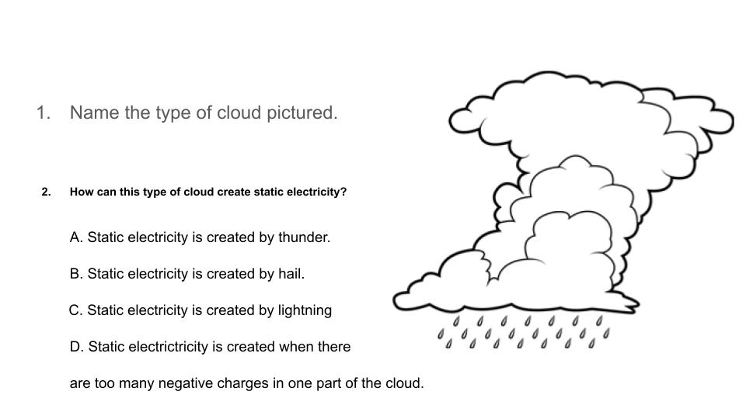
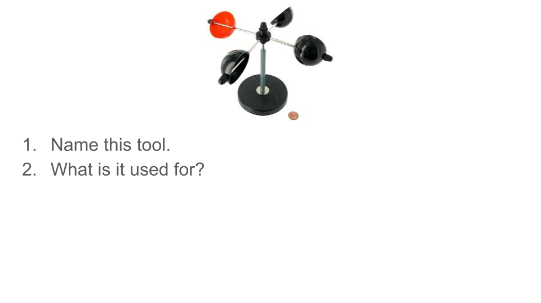
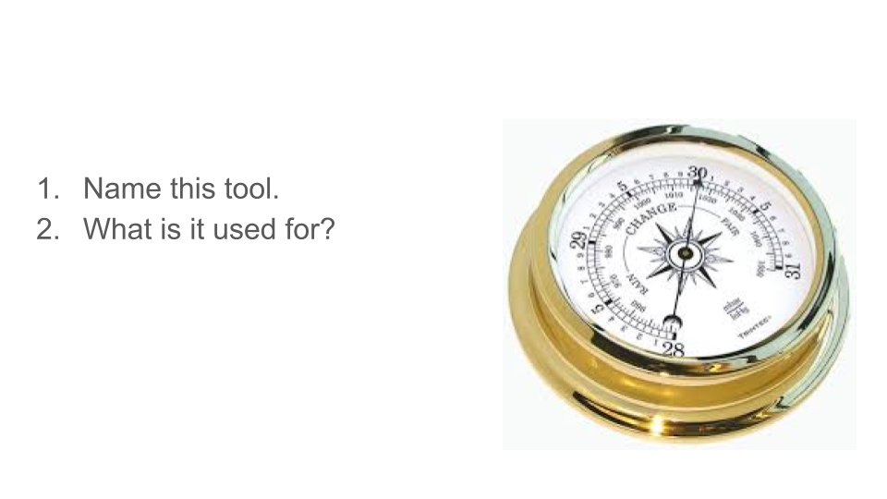
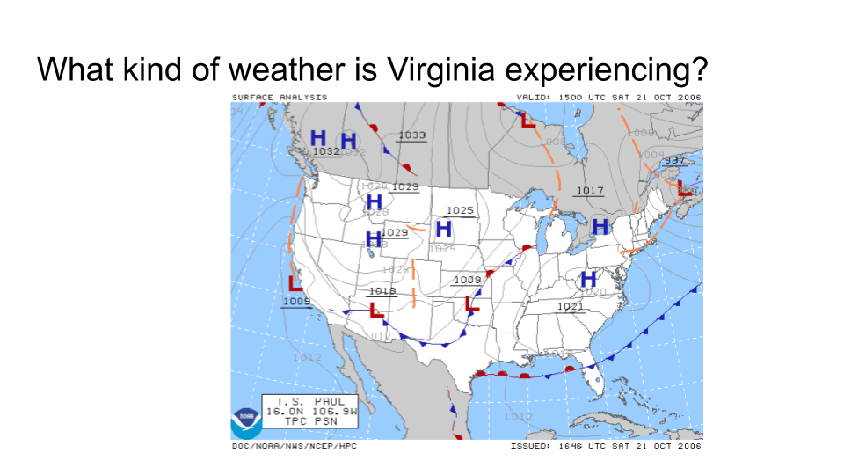
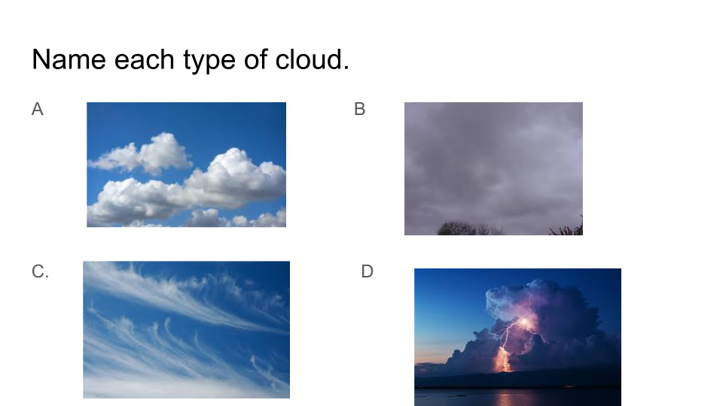
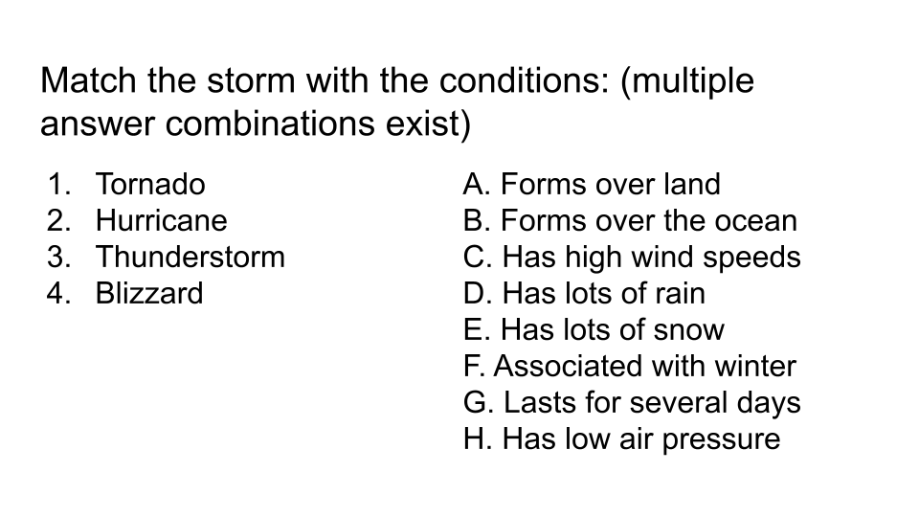
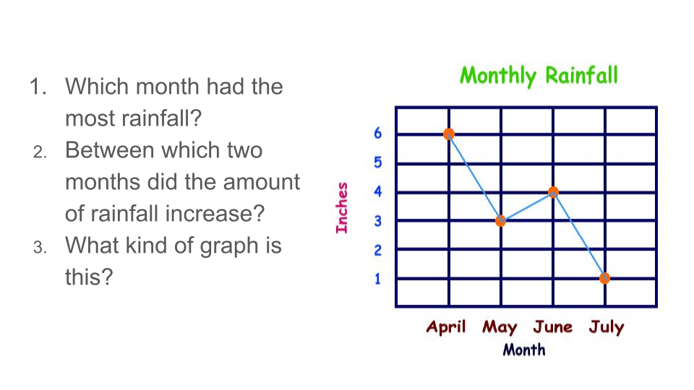
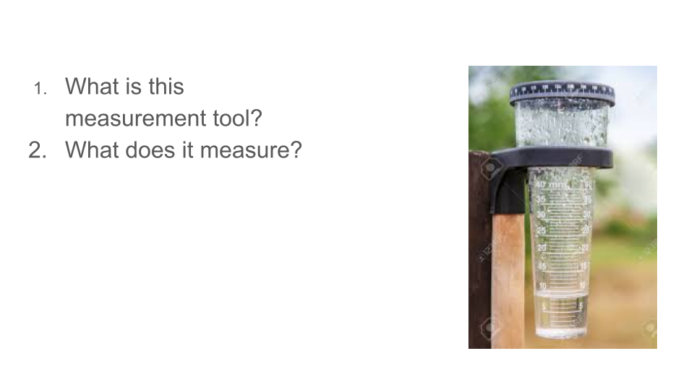

Unit Assessment 2
Severe Weather Formative Assessment

What do you already know?

Tornadoes | Hurricanes | Thunderstorms
Draw a picture: | Draw a picture: | Draw a picture:
What is the weather like during a tornado? | What is the weather like during a hurricane? | What is the weather like during a thunderstorm?

What do you already know?

Floods | Blizzards | Name a weather tool
Draw a picture: | Draw a picture: | Draw a picture:
What is the weather like during a flood? | What is the weather like during a blizzard? | What is the weather tool used for?

Unit Assessment 3
Name:
Cloud Types and Associated Weather
Draw a sky with clouds that show there is going to be a thunderstorm: | Draw a sky with clouds that show it is good weather right now, but there is probably going to be rain or snow in 3-4 hours:
Draw a sky with clouds that show we are going to have good weather: | Draw a sky with clouds that show we are having light rain or drizzle:

Draw a line to match these clouds to their names:
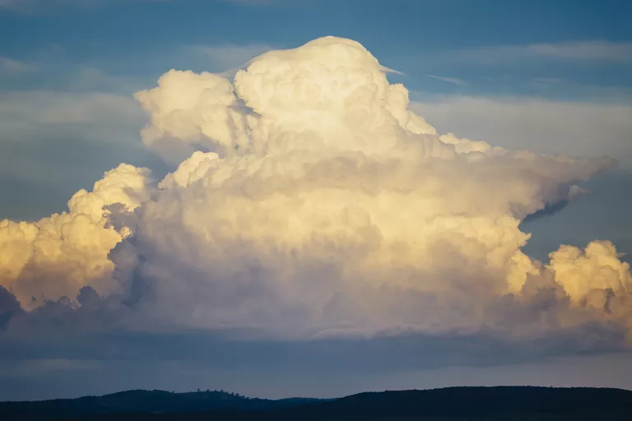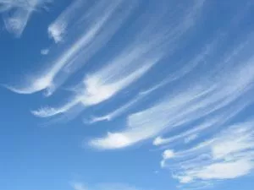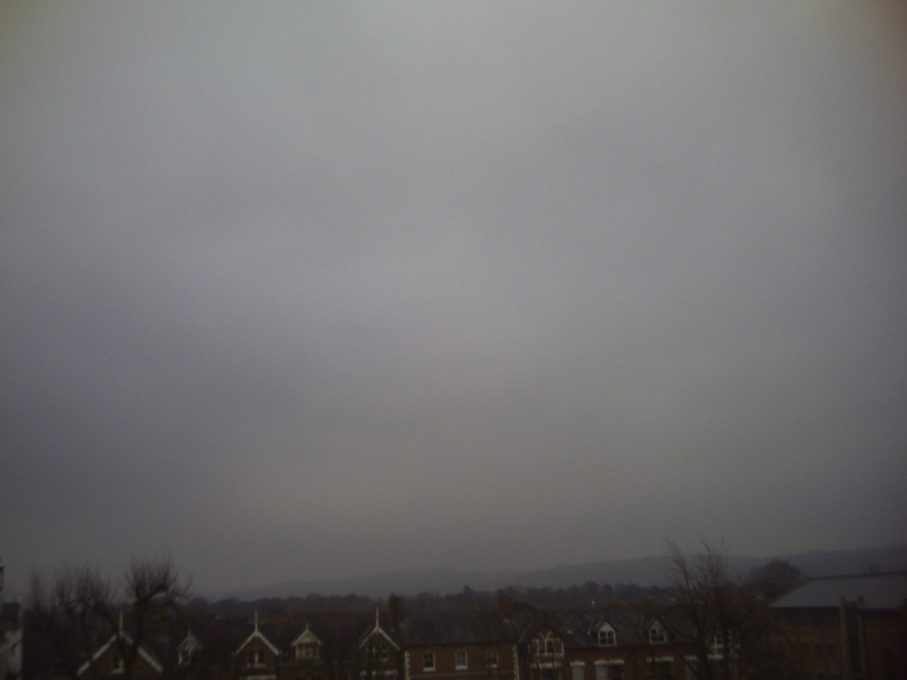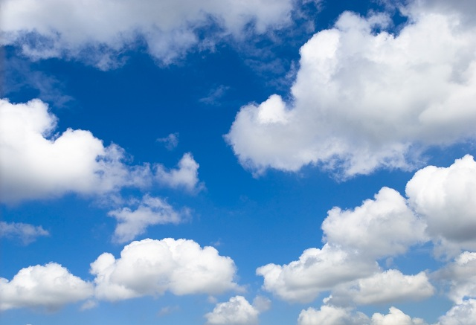
Stratus Cumulus Cumulonimbus Cirrus

Unit Assessment 4
Name:
What Weather Conditions Lead to Dangerous Storms?

Directions: Put an X in the boxes below to show which weather conditions lead to these types of dangerous storms.

This storm type forms... | Thunderstorm | Hurricane | Tornado
where there is warm air.
when warm air is covered by cool air.
when cool air is covered by warm air.
when the air is low pressure.
when the air is high pressure.

This storm type has... | Thunderstorm | Hurricane | Tornado
Strong Winds
Strong Whirling Winds
Heavy Rain
Lightning
Thunder
High Tides
Big Waves
A funnel cloud

Name:
What Weather Conditions Lead to Dangerous Storms?
Topic Check In

Directions: Put an X in the boxes below to show which weather conditions lead to these types of dangerous storms.

This storm type forms... | Thunderstorm | Hurricane | Tornado
where there is warm air. | X | X | X
when warm air is covered by cool air. | X |  | X
when cool air is covered by warm air. |  | X
when there is low pressure. | X | X | X
when there is high pressure.

This storm type has... | Thunderstorm | Hurricane | Tornado
Strong Winds |  | X | X
Strong Whirling Winds |  | X | X
Heavy Rain | X | X
Lightning | X
Thunder | X
High Tides |  | X
Big Waves |  | X
A funnel cloud |  |  | X

