Project GLAD
UNIQUELY NEW MEXICO: “The Land of Enchantment” (4th Grade)
IDEA PAGES
- UNIT THEME: New Mexico is a unique and beautiful state because of the diversity of its people, culture, and geography.
- Five regions of New Mexico
- Contemporary New Mexican history
- Contemporary New Mexican Economics
- The beauty of the geography of New Mexico
- NM is a multicultural state - largest percentages are Native American, Hispanic, and Anglo – also has African American, Asian as well as cultures from all over the world
- Little known interesting facts about New Mexico

- FOCUS & MOTIVATION
- Prediction-Reaction Guide
- Observation Charts
- Big Book: “The Important Book About New Mexico”
- Cognitive Content Dictionary
- Inquiry Chart
- Read Aloud
- Three Personal Standards and Scouts
- Literacy Awards

- CLOSURE & ASSESSMENTS
- Processing of All Charts
- Learning Log
- Home/School Connections
- Portfolios
- Individual Tasks
- Team Presentations
- Graffiti Wall
- Jeopardy Game
- Teacher-Student Made Tests
- Teacher-made Test
- Chapter Tests
- Prediction-Reaction Guide (post)
- Action Plan
- Writing and Portfolio Rubrics

- CONCEPTS
  - SCIENCE (New Mexico Standards – Grade 4)
  - SOCIAL STUDIES (New Mexico Standards – Grade 4)
SCIENCE STANDARDS (New Mexico Standards, Grade 4)
- SC I.I.B1: Use scientific methods to observe, collect, record, analyze, predict, interpret, and determine reasonableness of data.
  - Differentiate observation from interpretation and understand that a scientific explanation comes in part from what is observed and in part from how the observation is interpreted.
- Collect data in an investigation using multiple techniques, including control groups, and analyze those data to determine what other investigations could be conducted to validate findings.
- SC II.III.B2: Know the structure and formation of Earth and its atmosphere and the processes that shape them.
- Know that the properties of rocks and minerals reflect the processes that shaped them (i.e., igneous, metamorphic, and sedimentary rocks).
- Describe how weather patterns generally move from west to east in the United States.
- Know that local weather information describes patterns of change over a period of time (e.g., temperature, precipitation symbols, cloud conditions, wind speed/direction).
- SC III.I.B1: Describe how science influences decisions made by individuals and societies.
- Know that science has identified substances called pollutants that get into the environment and can be harmful to living things.
- Know that, through science and technology, a wide variety of materials not appearing in nature have become available (e.g., steel, plastic, nylon, fiber optics).
- Know that science has created ways to store and retrieve information (e.g., paper and ink, printing press, computers, CD ROMs) but that these are not perfect (e.g., faulty programming, defective hardware).
- Know that both men and women of all races and social backgrounds choose science as a career.

SOCIAL STUDIES STANDARDS (New Mexico Standards, Grade 4)
  - SS I-A: Describe how contemporary and historical people and events have influenced New Mexico communities and regions.
    - Identify important issues, events, and individuals from New Mexico pre-history to the present.
    - Describe the role of contemporary figures and how their contributions and perspectives are creating impact in New Mexico.
  - SS II-B: Distinguish between natural and human characteristics of places and use this knowledge to define regions, their relationships with other regions, and patterns of change.
    - Identify a region as an area with unifying characteristics (e.g., human, weather, agriculture, industry, natural characteristics).
    - Describe the regions of New Mexico, the United States, and the Western Hemisphere.
    - Identify ways in which different individuals and groups of people view and relate to places and regions.
  - SS II-C: Be familiar with aspects of human behavior and man-made and natural environments, in order to recognize their impact on the past and present.
    - Explain how geographic factors have influenced people, including settlement patterns and population distribution in New Mexico, past and present.
    - Describe how environments, both natural and man-made, have influenced people and events over time, and describe how places change.
    - Understand how visual data (e.g., maps, graphs, diagrams, tables, charts) organizes and presents geographic information.
  - SS II-D: Understand how physical processes shape the earth’s surface patterns and bio-systems.
    - Describe the four provinces (plains, mountains, plateau, and basin and range) that make up New Mexico’s land surface (geographic conditions).
  - SS II-E: Describe how economic, political, cultural and social processes interact to shape patterns of human populations and their interdependence, cooperation and conflict.
    - Describe how cultures change.
    - Describe how geographic factors influence the location and distribution of economic activities.
    - Describe types and patterns of settlements.
    - Identify the causes of human migration.
    - Describe how and why people create boundaries and describe types of boundaries.
  - SS II-F: Describe how natural and man-made changes affect the meaning, use, distribution and value of resources.
    - Identify the distributions of natural and man-made resources in New Mexico.
  - SS III-B: Identify and describe the symbols, icons, songs, traditions, and leaders of local, state, tribal, and national levels that exemplify ideals and provide continuity and a sense of community across time.
    - Describe various cultures and the communities they represent, and explain how they have evolved over time.
  - SS III-C: Become familiar with the basic purposes of government in New Mexico and the United States.
    - Compare and contrast how the various governments have applied rules/laws, majority rule, “public good,” and protections of the minority in different periods of New Mexico’s history
  - SS IV-B: Understand that individuals, households, businesses, governments, and societies make decisions that affect the distribution of resources and that these decisions are influenced by incentives (both economic and intrinsic).
    - Explain why there may be unequal distribution of resources (e.g., among people, communities, states, nations).
    - Understand and explain how conflict may arise between private and public incentives (e.g., new parks, parking structures).
  - SS IV-C: Understand the patterns and results of trade and exchange among individuals, households, businesses, governments, and societies, and their interdependent qualities.
    - Identify patterns of work and economic activity in New Mexico and their sustainability over time (e.g., farming, ranching, mining, retail, transportation, manufacturing, tourism, high tech).

ENGLISH LANGUAGE ARTS (Common Core, Grade 4)

ELA – LISTENING AND SPEAKING:

Comprehension and Collaboration
- SL.4.1. Engage effectively in a range of collaborative discussions (one-on-one, in groups, and teacher-led) with diverse partners on grade 4 topics and texts, building on others’ ideas and expressing their own clearly.
  - Come to discussions prepared, having read or studied required material; explicitly draw on that preparation and other information known about the topic to explore ideas under discussion.
  - Follow agreed-upon rules for discussions and carry out assigned roles.
  - Pose and respond to specific questions to clarify or follow up on information, and make comments that contribute to the discussion and link to the remarks of others.
  - Review the key ideas expressed and explain their own ideas and understanding in light of the discussion.
- SL.4.2. Paraphrase portions of a text read aloud or information presented in diverse media and formats, including visually, quantitatively, and orally.
- SL.4.3. Identify the reasons and evidence a speaker provides to support particular points.

Presentation of Knowledge and Ideas
- SL.4.4. Report on a topic or text, tell a story, or recount an experience in an organized manner, using appropriate facts and relevant, descriptive details to support main ideas or themes; speak clearly at an understandable pace.
- SL.4.5. Add audio recordings and visual displays to presentations when appropriate to enhance the development of main ideas or themes.
- SL.4.6. Differentiate between contexts that call for formal English (e.g., presenting ideas) and situations where informal discourse is appropriate (e.g., small-group discussion); use formal English when appropriate to task and situation.

ELA - READING: FOUNDATIONAL SKILLS
Phonics and Word Recognition
- RF.4.3. Know and apply grade-level phonics and word analysis skills in decoding words.
  - Use combined knowledge of all letter-sound correspondences, syllabication patterns, and morphology (e.g., roots and affixes) to read accurately unfamiliar multisyllabic words in context and out of context.
Fluency
- RF.4.4. Read with sufficient accuracy and fluency to support comprehension.
  - Read grade-level text with purpose and understanding.
  - Read grade-level prose and poetry orally with accuracy, appropriate rate, and expression.
  - Use context to confirm or self-correct word recognition and understanding, rereading as necessary.

ELA - READING: INFORMATIONAL TEXT

Key Ideas and Details
- RI.4.1. Refer to details and examples in a text when explaining what the text says explicitly and when drawing inferences from the text.
- RI.4.2. Determine the main idea of a text and explain how it is supported by key details; summarize the text.
- RI.4.3. Explain events, procedures, ideas, or concepts in a historical, scientific, or technical text, including what happened and why, based on specific information in the text.

Craft and Structure
- RI.4.4. Determine the meaning of general academic and domain-specific words or phrases in a text relevant to a grade 4 topic or subject area.
- RI.4.5. Describe the overall structure (e.g., chronology, comparison, cause/effect, problem/solution) of events, ideas, concepts, or information in a text or part of a text.
- RI.4.6. Compare and contrast a firsthand and secondhand account of the same event or topic; describe the differences in focus and the information provided.

Integration of Knowledge and Ideas
- RI.4.7. Interpret information presented visually, orally, or quantitatively (e.g., in charts, graphs, diagrams, time lines, animations, or interactive elements on Web pages) and explain how the information contributes to an understanding of the text in which it appears.
- RI.4.8. Explain how an author uses reasons and evidence to support particular points in a text.
- RI.4.9. Integrate information from two texts on the same topic in order to write or speak about the subject knowledgeably.

Range of Reading and Level of Text Complexity
- RI.4.10. By the end of year, read and comprehend informational texts, including history/social studies, science, and technical texts, in the grades 4–5 text complexity band proficiently, with scaffolding as needed at the high end of the range.

ELA - READING: LITERATURE
Key Ideas and Details
- RL.4.1. Refer to details and examples in a text when explaining what the text says explicitly and when drawing inferences from the text.
- RL.4.2. Determine a theme of a story, drama, or poem from details in the text; summarize the text.
- RL.4.3. Describe in depth a character, setting, or event in a story or drama, drawing on specific details in the text (e.g., a character’s thoughts, words, or actions).

Craft and Structure
- RL.4.4. Determine the meaning of words and phrases as they are used in a text, including those that allude to significant characters found in mythology (e.g., Herculean).
- RL.4.5. Explain major differences between poems, drama, and prose, and refer to the structural elements of poems (e.g., verse, rhythm, meter) and drama (e.g., casts of characters, settings, descriptions, dialogue, stage directions) when writing or speaking about a text.
- RL.4.6. Compare and contrast the point of view from which different stories are narrated, including the difference between first- and third-person narrations.

Integration of Knowledge and Ideas
- RL.4.7. Make connections between the text of a story or drama and a visual or oral presentation of the text, identifying where each version reflects specific descriptions and directions in the text.
- RL.4.9. Compare and contrast the treatment of similar themes and topics (e.g., opposition of good and evil) and patterns of events (e.g., the quest) in stories, myths, and traditional literature from different cultures.

Range of Reading and Complexity of Text
- RL.4.10. By the end of the year, read and comprehend literature, including stories, dramas, and poetry, in the grades 4–5 text complexity band proficiently, with scaffolding as needed at the high end of the range.

ELA – WRITING:

Text Types and Purposes
- W.4.1. Write opinion pieces on topics or texts, supporting a point of view with reasons and information.
  - Introduce a topic or text clearly, state an opinion, and create an organizational structure in which related ideas are grouped to support the writer’s purpose.
  - Provide reasons that are supported by facts and details.
  - Link opinion and reasons using words and phrases (e.g., for instance, in order to, in addition).
  - Provide a concluding statement or section related to the opinion presented.
- W.4.2. Write informative/explanatory texts to examine a topic and convey ideas and information clearly.
  - Introduce a topic clearly and group related information in paragraphs and sections; include formatting (e.g., headings), illustrations, and multimedia when useful to aiding comprehension.
  - Develop the topic with facts, definitions, concrete details, quotations, or other information and examples related to the topic.
  - Link ideas within categories of information using words and phrases (e.g., another, for example, also, because).
  - Use precise language and domain-specific vocabulary to inform about or explain the topic.
  - Provide a concluding statement or section related to the information or explanation presented.
- W.4.3. Write narratives to develop real or imagined experiences or events using effective technique, descriptive details, and clear event sequences.
  - Orient the reader by establishing a situation and introducing a narrator and/or characters; organize an event sequence that unfolds naturally.
  - Use dialogue and description to develop experiences and events or show the responses of characters to situations.
  - Use a variety of transitional words and phrases to manage the sequence of events.
  - Use concrete words and phrases and sensory details to convey experiences and events precisely.
  - Provide a conclusion that follows from the narrated experiences or events.

Production and Distribution of Writing
- W.4.4. Produce clear and coherent writing in which the development and organization are appropriate to task, purpose, and audience. (Grade-specific expectations for writing types are defined in standards 1–3 above.)
- W.4.5. With guidance and support from peers and adults, develop and strengthen writing as needed by planning, revising, and editing.
- W.4.6. With some guidance and support from adults, use technology, including the Internet, to produce and publish writing as well as to interact and collaborate with others; demonstrate sufficient command of keyboarding skills to type a minimum of one page in a single sitting.

Research to Build and Present Knowledge
- W.4.7. Conduct short research projects that build knowledge through investigation of different aspects of a topic.
- W.4.8. Recall relevant information from experiences or gather relevant information from print and digital sources; take notes and categorize information, and provide a list of sources.
- W.4.9. Draw evidence from literary or informational texts to support analysis, reflection, and research.
  - Apply grade 4 Reading standards to literature (e.g., “Describe in depth a character, setting, or event in a story or drama, drawing on specific details in the text [e.g., a character’s thoughts, words, or actions].”).
  - Apply grade 4 Reading standards to informational texts (e.g., “Explain how an author uses reasons and evidence to support particular points in a text”).

Range of Writing
- W.4.10. Write routinely over extended time frames (time for research, reflection, and revision) and shorter time frames (a single sitting or a day or two) for a range of discipline-specific tasks, purposes, and audiences.
ELA – LANGUAGE:

Conventions of Standard English
- L.4.1. Demonstrate command of the conventions of standard English grammar and usage when writing or speaking.
  - Use relative pronouns (who, whose, whom, which, that) and relative adverbs (where, when, why).
  - Form and use the progressive (e.g., I was walking; I am walking; I will be walking) verb tenses.
  - Use modal auxiliaries (e.g., can, may, must) to convey various conditions.
  - Order adjectives within sentences according to conventional patterns (e.g., a small red bag rather than a red small bag).
  - Form and use prepositional phrases.
  - Produce complete sentences, recognizing and correcting inappropriate fragments and run-ons.*
  - Correctly use frequently confused words (e.g., to, too, two; there, their).*
- L.4.2. Demonstrate command of the conventions of standard English capitalization, punctuation, and spelling when writing.
  - Use correct capitalization.
  - Use commas and quotation marks to mark direct speech and quotations from a text.
  - Use a comma before a coordinating conjunction in a compound sentence.
  - Spell grade-appropriate words correctly, consulting references as needed.

Knowledge of Language
- L.4.3. Use knowledge of language and its conventions when writing, speaking, reading, or listening.
  - Choose words and phrases to convey ideas precisely.*
  - Choose punctuation for effect.*
  - Differentiate between contexts that call for formal English (e.g., presenting ideas) and situations where informal discourse is appropriate (e.g., small-group discussion).

Vocabulary Acquisition and Use
- L.4.4. Determine or clarify the meaning of unknown and multiple-meaning words and phrases based on grade 4 reading and content, choosing flexibly from a range of strategies.
  - Use context (e.g., definitions, examples, or restatements in text) as a clue to the meaning of a word or phrase.
  - Use common, grade-appropriate Greek and Latin affixes and roots as clues to the meaning of a word (e.g., telegraph, photograph, autograph).
  - Consult reference materials (e.g., dictionaries, glossaries, thesauruses), both print and digital, to find the pronunciation and determine or clarify the precise meaning of key words and phrases.
- L.4.5. Demonstrate understanding of figurative language, word relationships, and nuances in word meanings.
  - Explain the meaning of simple similes and metaphors (e.g., as pretty as a picture) in context.
  - Recognize and explain the meaning of common idioms, adages, and proverbs.
  - Demonstrate understanding of words by relating them to their opposites (antonyms) and to words with similar but not identical meanings (synonyms).
- L.4.6. Acquire and use accurately grade-appropriate general academic and domain-specific words and phrases, including those that signal precise actions, emotions, or states of being (e.g., quizzed, whined, stammered) and that are basic to a particular topic (e.g., wildlife, conservation, and endangered when discussing animal preservation)

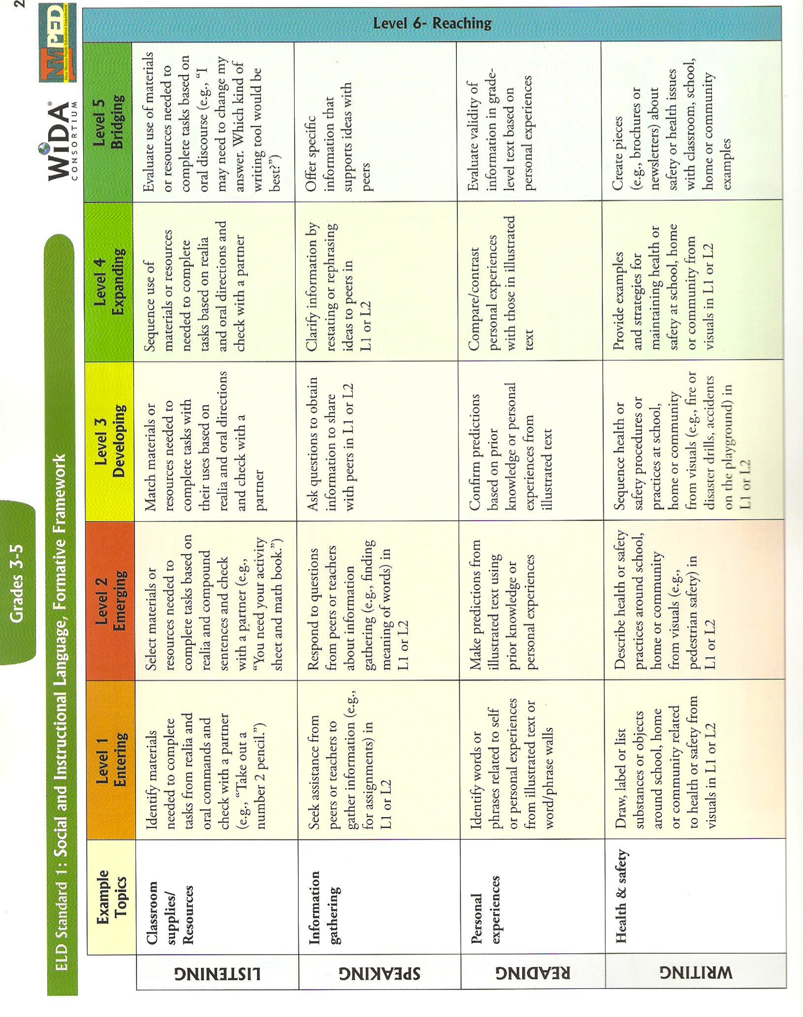
NM ENGLISH LANGUAGE DEVELOPMENT STANDARDS (Grade 4)

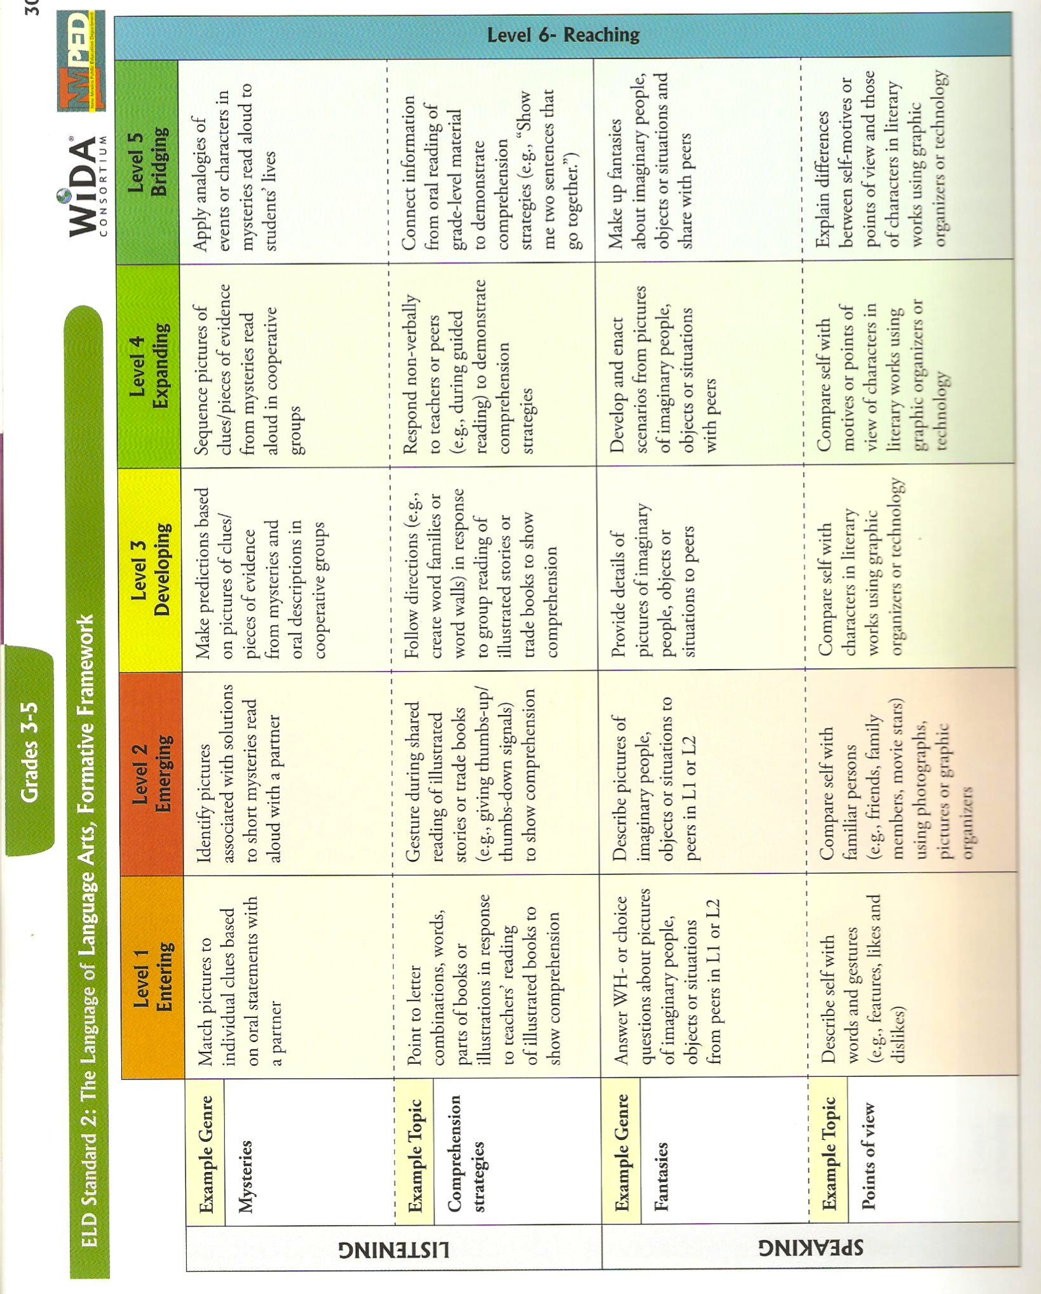

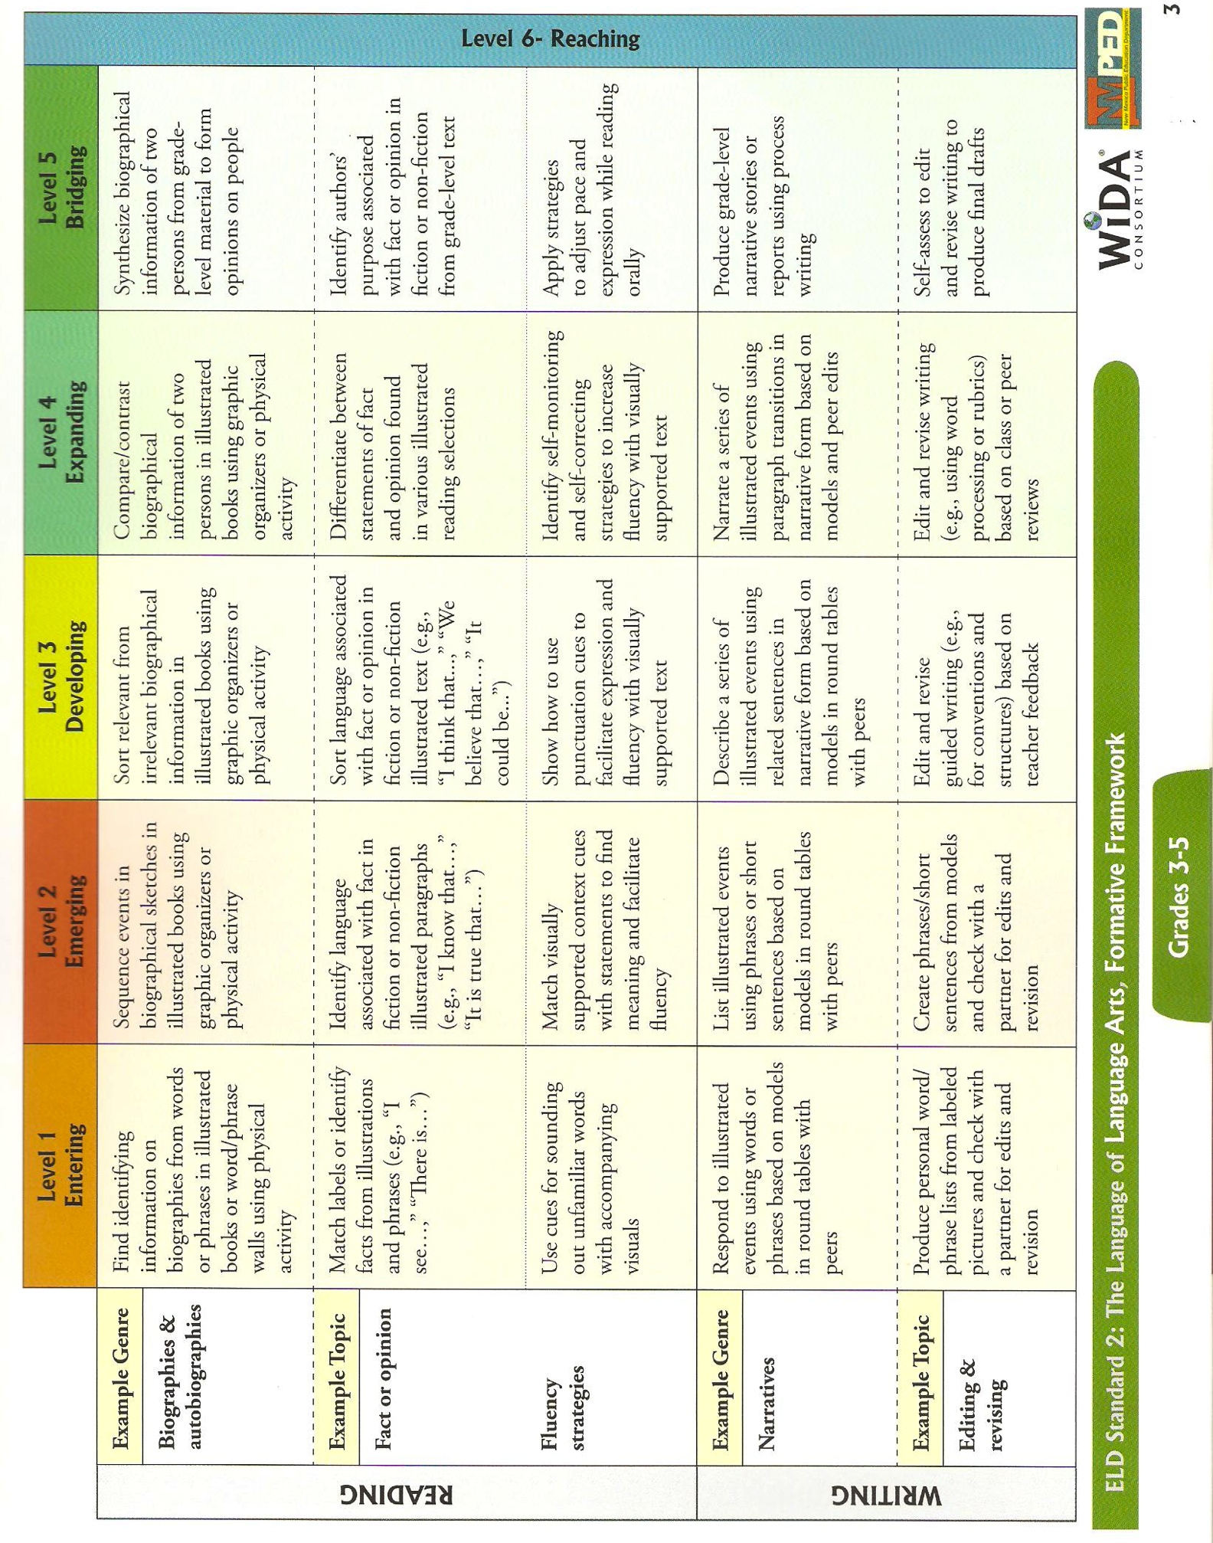

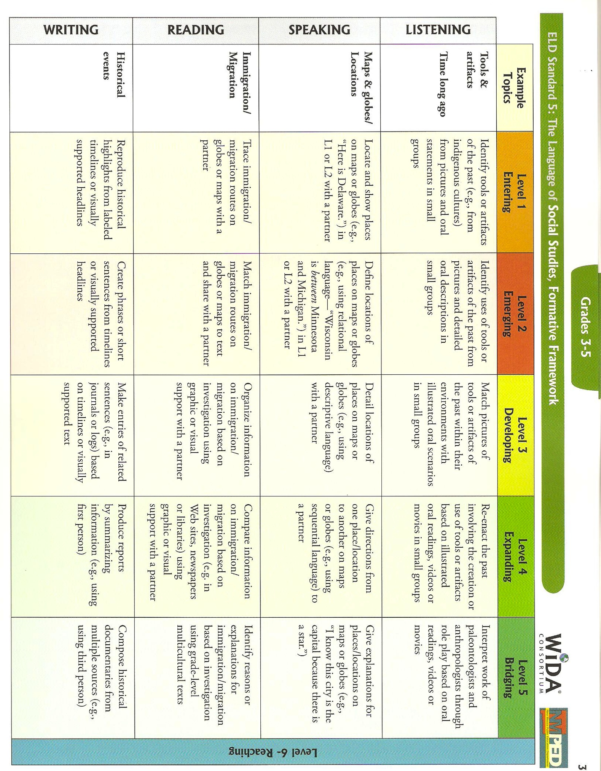

- VOCABULARY (Words in bold are suggestions for CCD words)
Tier II |  | Tier III
artist | environment | adobe | monsoon
basin | evaluate | African American | multicultural
border | explain | altitude | Native American
capital | geography | Anglo | natural gas
ceremony | history | aquifer | pasture
clarify | identify | arroyo | petroglyphs
climate | industry | atomic bomb | plateau
code talkers | interpret | balloonist | precipitation
compare | irrigation | bilingual | pueblo
compose | locate | bosque | retablo
conservation | majority | canyon | river valleys
constitution | mining | caverns | rural
contrast | minority | coal | sculptor
create | modern | crater | topography
culture | mountain | curandera | tourism
define | occupation | enchantment | tributary
detail | organize | epidemic | turquoise
demonstrate | produce | fiesta | uranium
describe | refer | heritage | vigas
determine | reproduce | Hispanic
discrimination | reservation | high sierra desert
distinguish | resource | kiva
diversity | technology | land grant
drought | treaty | mesa
economy | urban
elevation | wilderness

Tier 1: Basic words that commonly appear in spoken language. Because they are heard frequently in numerous contexts and with nonverbal communication, Tier 1 words rarely require explicit instruction. Examples of Tier 1 words are clock, baby, happy and walk.
Tier 2: High frequency words used by mature language users across several content areas. Because of their lack of redundancy in oral language, Tier 2 words present challenges to students who primarily meet them in print. Examples of Tier 2 words are obvious, complex, establish and verify.
Tier 3: Words that are not frequently used except in specific content areas or domains. Tier 3 words are central to building knowledge and conceptual understanding within the various academic domains and should be integral to instruction of content. Medical, legal, biology and mathematics terms are all examples of these words.
Bringing Words To Life, Beck, Isabel L., McKeown, Margaret G., Kucan, Linda. The Gilford Press, 2002.

- RESOURCES AND MATERIALS
Books
Barnhart, Jan D. (2006) Albuquerque, New Mexico, USA Resources and Research collections: A guide to selected published materials and archival resources. Albuquerque, New Mexico: Legacy Media, Inc.

Chávez, Thomas E. (2006). New Mexico: Past and Future. Albuquerque: University of New Mexico Press.

Chilton, L., Chilton, K., Arango, P., Dudley, J., Neary, N., Stelzner, P., (1984). New Mexico: A new guide to the colorful state. Albuquerque, New Mexico: University of New Mexico Press.

Early, Theresa S. (2003). Hello U.S.A.: New Mexico. Minneapolis, Minnesota: Lerner Publications

Etulain, Richard W. (2002). New Mexico Lives, Profiles & Historical Stories. New Mexico: UNM Press.

Franzwa, Gregory M. & Nelson, Gaylord (1988). Images of the Santa Fe Trail. St. Louis, Missouri: The Patrice Press.

García, Nasario and McCord, Richard. (2005). Albuquerque ¡Feliz cumpleaños! Three Centuries to Remember. Santa Fe, NM: La Herencia Publishing.

Gomez, Art, Niemeyer, Lucian, & Former Governor Bill Richardson (2004). Images of a Land & its People, New Mexico. New Mexico: UNM Press.

Harris, Richard K. (2010). Off the Beaten Path New Mexico. Guilford, CT: Morris Book Publishing, LLC.

Hillerman, Tony, Ed. (1984) The Spell of New Mexico. Albuquerque, New Mexico: University of New Mexico Press.

Jenkins, M.E., Schroeder, A.H. (1974). A Brief History of New Mexico. Albuquerque, New Mexico: University of New Mexico Press.

Keegan, Marcia: (1991). New Mexico. Santa Fe, New Mexico. Clear Light Books

Nelson, Dennis. (2004). Project Wet – Curriculum and Activity Guide. Bozeman, MT: Montana State University.

New Mexico, 100 Years of Statehood.( 2012). Walz, Kent, ed. Albuquerque: The Albuquerque Journal.

New Mexico Pictorial Souvenir Guide. Mesa, Arizona: Smith-Southwestern Inc.

Roberts, C. and Roberts, S. (1998). A History of New Mexico. Albuquerque, New Mexico: University of New Mexico Press.

Santa Fe, History of an Ancient City. (2008). Noble, David Grant, ed. Santa Fe, NM: School for Advanced Research Press.

Simmons, Marc. (2001). Spanish Pathways: Readings in the History of Hispanic New Mexico. Albuquerque: University of New Mexico Press.

Simmons, Marc. (1998). New Mexico! 2nd ed. Albuquerque: University of New Mexico Press.

Vigil, Arnold (2004). Forever New Mexico, Heartfelt Images from the Land of Enchantment. New Mexico: UNM Press.

Picture Books
Baca, A., (2011) Tia’s Tamales. Albuquerque, New Mexico: University of New Mexico Press.

Cordova, Amy (2008) Abuelita’s Heart. New York, New York: Aladdin.

Muench, David (2011). New Mexico: Portrait of a State. Portland, Oregon: Graphic Arts Books.

Tapahanso, L., Schick, E., (1999) Navajo ABC: A Diné Alphabet Book. New York, New York: Aladdin.

Children’s Non-fiction

A New True Book: Rodeos, James W. Fain. Childrens Press, Chicago.
Indigenous Peoples of North America: Native Americans of the Southwest, Stuart A. Kallen. Lucent Books, Inc.
The Apaches and Navajos, Craig A. Doherty and Katherine M. Doherty. Franklin Watts, New York.
A New True Book: The , David Petersen. Childrens Press.

Periodicals
“’Let’s Move On’: Stories of Internment Camp Recovered”. Oswald, Mark, ed. Santa Fe: Journal Santa Fe, January 15, 2012.
New Mexico: 100 Years of Statehood (2012). Albuquerque, New Mexico: Albuquerque Journal
New Mexico: 2012 Vacation Guide (2012). Santa Fe, New Mexico: New Mexico Tourism Department
Pasatiempo – 1912-2012 New Mexico Statehood Commemorative Issue. Melcher, Kristina, ed. Santa Fe: The Santa Fe New Mexican, January 6, 2012.
New Mexico Museums & Monuments, Centennial Edition, Summer Guide. Nelson, Kate, ed. Santa Fe: Journal Santa Fe, 2012.
“Works Born of Creative Survival, Internment Camp Inmates’ Art”. Oswald, Mark, ed. Santa Fe: Journal Santa Fe, July 5, 2012.

INTERNET RESOURCES FOR TEACHERS
http://www.worldatlas.com/webimage/countrys/namerica/usstates/nmland.htm:
Information on the four topographical regions of New Mexico

http://online.nmartmuseum.org/nmhistory/people-places-and-politics/new-mexicos-geography/history-geography.html : Information on the geography of New Mexico

http://www.history.com/topics/new-mexico: Information and video clips on the history of New Mexico

INTERNET RESOURCES FOR STUDENTS
Albuquerque Balloon Museum. (505) 768-6020; www.balloonmuseum.com
Albuquerque International Balloon Fiesta. www.balloonfiesta.com
Carlsbad Caverns National Park. (575) 785-2232; www.nps.gov/cave
El Rancho de las Golondrinas. (505) 473-4169; www.golondrinas.org
Farm and Ranch Heritage Museum. (575) 522-4100; www.nmfarmandranchmuseum.org
Fiesta de Santa Fe. (505) 204-1598; www.santafefiesta.org
Indian Pueblo Cultural Center. (505) 843-7270; www.indianpueblo.org
Museum of Indian Arts and Culture. (505) 476-1250; www.indianartsandculture.org
New Mexico Magazine. www.nmmagazine.com
New Mexico State Fair. (505) 265-1791; www.exponm.com/state-fair
New Mexico State Monuments. www.nmmonuments.org
New Mexico State Parks. www.nmparks.com
Roswell UFO Festival. www.ufofestivalroswell.com
Sandia Peak Aerial Tram. (505) 856-7325; www.sandiapeak.com
The Santa Fe Opera. (505) 986-5900; www.santafeopera.org
Smokey Bear Historical Park. www.emnrd.state.nm.us/fd/smokeybear/SmokeyBearPark.htm
Very Large Array. (575) 835-7243; www.vla.nrao.edu
White Sands National Monument. (575)479-6124; www.nps.gov/whsa/index.htm
http://www.worldatlas.com/webimage/countrys/namerica/usstates/nmland.htm: Information on the four topographical regions of New Mexico

http://online.nmartmuseum.org/nmhistory/people-places-and-politics/new-mexicos-geography/history-geography.html : Information on the geography of New Mexico

http://www.indianpueblo.org/19pueblos/pueblomap.html : Information on the 19 pueblos of NM

RESOURCES IN SPANISH
Internet:
http://lawlibrary.unm.edu/nrj/41/3/09_raish_mcsweeney_livestock.pdf
http://www.newmexicohistory.org
http://www.governor.state.nm.us
http://www.newmexico.gov

Spanish/English Fiction:
Albuquerque, Rudolfo Anaya. New Mexico: UNM Press
Bless Me Ultima, Rudolfo Anaya. New Mexico: UNM Press
Una Linda Raza, Angel Vigil. Childrens Press, Chicago.
The First Tortilla, Rudolfo Anaya, Amy Cordova, & Enrique Lamadrid. New Mexico: UNM Press
La Llorona. Rudolfo Anaya & Amy Cordova. New Mexico: UNM Press
The Santero’s Miracle. Rudolfo Anaya. New Mexico: UNM Press
El Cucuy: A Bogeman Cuento. Joe Hayes & Honorio Robledo

Project GLAD
UNIQUELY NEW MEXICO: “The Land of Enchantment” (4th Grade)
PLANNING PAGES
- FOCUS/MOTIVATION
  - Zero Noise Signal
  - Three Personal Standards
  - Literacy Awards: Super Historian Award, Golden Pen Award, Postcards
  - Cognitive Content Dictionary with Signal Word
  - Big Book: “The Important Book About New Mexico”
  - Observation Charts
  - Inquiry Chart
  - Poetry Chants
  - Prediction-Reaction Guide

- INPUT
  - Graphic Organizer: World Map
  - Pictorial Input: New Mexico
  - Comparative Input: Water Use
  - Narrative Input: “Juan the Bear and the Water of Life”
  - 10/2 Lecture with Primary Language

- GUIDED ORAL PRACTICE
  - Personal Interactions (10/2)
  - T-Graph for Social Skills, Team Points, Oral Processing, and Written Evaluation
  - Cooperative Groups – Team Tasks – Numbered Heads
  - Picture File Cards – free exploration, open & closed sorts, classifying/categorizing
  - Poetry – Chanting, Modeling, Highlighting
  - Sentence Patterning Chart
  - Mind Map
  - Expert Groups
  - Process Grid
  - Exploration Report – sorting, grouping, labeling
    - List, group, label

- READING/WRITING ACTIVITIES
- Whole Class Modeling
  - Cooperative Strip Paragraph
  - Sentence Patterning Chart
  - Poetry Frame
  - SPC - Flip Chant, Reading & Trading Game
  - Listen & Sketch
  - Story Map
  - Found Poetry

- Small/Flexible Group Practice
  - Expert Groups
  - Team Tasks
  - Focused Reading with Team CCD
  - Ear-to-Ear Reading
  - Flexible Reading Groups: ELD Group Frame, Clunkers & Links, SQ3R, DRTA
  - Cooperative Strip Paragraph Rebuild (emergent reader fluency work)
  - Mind Map
  - Flip Chants

- Individual Activities - Portfolios
  - Learning Logs
  - Interactive Journals
  - Focused Reading w/Personal CCD
  - Poetry Book
  - Personal Explorations
  - Individual Writing (Expository, Narrative, Poetry)

- Writer’s Workshop
  - Mini-Lesson
  - Write
  - Author’s Chair (questioning/listening)
  - Conferencing
  - Publish

- EXTENSIONS
  - Exploratory Fieldtrip within the region
  - Guest Speakers

- CLOSURE
  - Processing of All Charts
  - Learning Log
  - Home/School Connections
  - Prompted, Individual Expository, Narrative and Poetry pieces with prompts with rubrics
  - Portfolios with rubric
  - Team Presentations
  - Individual Tasks – Personal Explorations with Rubrics (ie: creation of tourism brochure)
  - Graffiti Wall
  - Teacher-Student Made Tests
  - Teacher-made Test
  - Jeopardy Game
  - Prediction-Reaction Guide (post)
  - Action Plan with rubric

Project GLAD
UNIQUELY NEW MEXICO: “The Land of Enchantment” (4th Grade)
SAMPLE DAILY LESSON PLAN (5 Day)
NOTE: Italicized Strategies are used daily in the classroom. Day 1 is the equivalent of 1 to 1 ½ weeks of instruction.

DAY 1 (1-1.5 weeks of instruction):

FOCUS/MOTIVATION
• Three Personal Standards with Literacy Awards
• Prediction/Reaction Guide
• Cognitive Content Dictionary (CCD) with Signal Word
• Observation Charts
• Inquiry Chart
• Big Book
• Poetry/Chants
• Portfolios

INPUT
• Graphic Organizer – World Map
- 10/2 lecture with primary language
- Learning Log
- ELD Review
• Pictorial Input Chart – Rocky Mountain or Central Basin and Range Region
- 10/2 lecture with primary language
- Learning Log
- ELD Review

GUIDED ORAL PRACTICE
• T-graph for Social Skills– Team points
• Picture File
- Free exploration
- List, Group, Label
- Exploration Report

READING/WRITING
• Interactive Journals
• Flexible Groups Reading-leveled, skill, heterogeneous, homogeneous, ELD

WRITER’S WORKSHOP
- Mini lesson
- Write/Plan
- Author’s Chair
- Conference

CLOSURE
• Home/School Connection

DAY 2(1-1.5 weeks of instruction)::

FOCUS/MOTIVATION
• Cognitive Content Dictionary with Signal Word
• Process Home/School Connection
• Three Personal Standards with Literacy Awards
• Process World Map Graphic Organizer with word cards
• Process Rocky Mountain Region Pictorial Input Chart with word cards and picture file cards
• Process Chant- highlighting, sketching, picture file cards
• Review Big Book

INPUT
• Narrative Input Chart – “Juan del Oso” or “How Coyote Brought Us Water”
- 10/2 lecture with primary language
- Learning Log
- ELD review

GUIDED ORAL PRACTICE
• Poetry and Chants
• Review T-Graph for Social Skills
• Team Tasks
- Key
- Menu
- Process T-Graph for Social Skills
- Team Share

READING/WRITING
• Expert Groups: Flexible Groups Reading- leveled, skill, heterogeneous, homogeneous, ELD

WRITER’S WORKSHOP
- Mini-lesson – Sketch to Write
- Write/Plan
- Author’s Chair
- Conference,
- Publish

CLOSURE
• Process all charts
• Poetry, chanting
• Read Aloud
• Journals
• Home/School Connection

DAY 3(1-1.5 weeks of instruction)::

FOCUS/MOTIVATION
• Cognitive Content Dictionary with Signal Word
• Process Home/School Connection
• Three Personal Standards with Literacy Awards
• Read Aloud (Picture Book)

INPUT
- Review Narrative Input charts with words cards and conversation bubbles
- Comparative Input Chart – Responsible/Irresponsible Water Use
- 10/2 lecture with primary language
- Learning Log
- ELD review

GUIDED ORAL PRACTICE
• Process Chants- highlight, sketch, add picture file cards
• Sentence Patterning Chart (Farmer and the Dell)
- Reading/Game
- Trading Games
- Flip Chant
• Expert Groups : Flexible Groups Reading- leveled, skill, heterogeneous, homogeneous, ELD
• Mind Map – whole group modeling of Central Basin and Range or Rocky Mountain Region Pictorial Input Chart
• Process Grid

READING/WRITING
• Team Tasks

GUIDED ORAL PRACTICE
• Process Grid – input from Expert Groups (numbered heads together)

READING/WRITING
• Cooperative Strip Paragraph- Read, respond, revise, edit
• Listen and Sketch

WRITER’S WORKSHOP
• Mini-lesson
• Write/Plan
• Author’s Chair
• Conference, Publish

CLOSURE
• Read Aloud – Expository Text
• Process charts
• Interactive Journal writing
• Home/School Connection

DAY 4:(1-1.5 weeks of instruction):

FOCUS/MOTIVATION
• Cognitive Content Dictionary with “Stumper Word” (student self- selected vocabulary)
• Process Home/School Connection
• Three Personal Standards with Literacy Awards
• Read Aloud – topic: water conservation
• Process Chants – highlight, sketch add picture file cards
• Review Narrative Input Chart with Story Map

GUIDED ORAL PRACTICE

READING/WRITING
• Strip book
• Poetry Frame
• Flexible Groups Reading- leveled, skill, heterogeneous, homogeneous, ELD
- Team Tasks with oral evaluation
- Clunker and Links- at or above grade level with SQ3R
- ELD Group Frame-- Story Retell based on narrative – “Juan the Bear and the Water of Life”
• DRTA- Non fiction

WRITER’S WORKSHOP
- Mini-lesson
- Write/Plan
- Author’s Chair
- Conferencing
- Publish

CLOSURE
• Home School Connection
• Interactive Journals
• Process Charts
• Action Plan (whole class first, then in teams, then individual) – “Water waste at home and school” based on the “Water Use Comparative Input Chart

DAY 5: (1-1.5 weeks of instruction):

FOCUS/MOTIVATION
• Cognitive Content Dictionary with “stumper word”, self-selected Vocabulary
• Process Home/School Connection
• Three Personal Standards with Literacy Awards
• Chants/Poetry

READING/WRITING
• Flexible Groups Reading- leveled, skill, heterogeneous, homogeneous, ELD
- Coop Strip Paragraph group- struggling/emergent readers
- Team Tasks- with team written evaluation of T-Graph
• Ear-to-Ear reading with Poetry Booklet
• Found Poetry
• Focused Reading with personal Cognitive Content Dictionary

WRITER’S WORKSHOP
• Mini-lesson
• Write, plan, share and teacher conferences
• Author’s Chair

CLOSURE
• Process charts, especially Inquiry Chart
• Read Aloud
• Action Plan – Whole Group, Team or Individual
• Team Big Book
• Team Explorations with rubric
• Individual Explorations with rubric
• Graffiti Wall
• Student generated tests
• Evaluate Week
• Letter Home
• Jeopardy/Family Feud

Uniquely New Mexico Unit: Name______________________________
PREDICTION/REACTION GUIDE Date______________________________

- How has water affected the way in which New Mexico was settled?
Prediction | Reaction

- Describe the major geographical features of New Mexico.
Prediction | Reaction

- In the past 100 years, what are some of the major events that have occurred in New Mexico?
Prediction | Reaction

- There are many cultures in New Mexico. Sketch or write about the ones that are familiar to you.
Prediction | Reaction

- Why is the nickname, “The Land of Enchantment,” appropriate for New Mexico?
Prediction | Reaction

Literacy Awards for Uniquely New Mexico Unit
CLIMATE
Temperatures in New Mexico vary greatly depending on location, season, and time of day. Average temperatures in July range from below 65° F to above 75° F. In January, the average temperatures vary from below 27° F to above 40° F.  Keep a log of the high and low temperatures in your community for two weeks. What are the average high and low temperatures for that time period? Share this information with 5 of your classmates. | “insert authentic graphics here”
   | MONDAY | TUESDAY | WEDNESDAY | THURSDAY | FRIDAY | SATURDAY | SUNDAY
  High
  Low
   | MONDAY | TUESDAY | WEDNESDAY | THURSDAY | FRIDAY | SATURDAY | SUNDAY
  High
  Low

OFFICIAL QUESTION
New Mexico has an official question: Red or green? It refers to the kind of chile a person likes best.  Ask ten of your classmates this question and record the results on a bar graph. | “insert authentic graphics here”

WATER USAGE
Think about what you did yesterday. Write a list of at least ten different ways you used water.  Share this list with five of your classmates. Ask them how they used water. Are their answers similar to or different from yours? | “insert authentic graphics here”

National Forest Protection in New Mexico
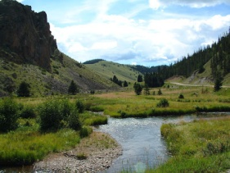
*The Valle Vidal is in the Carson National Forest.
*The Valle Vidal is a lush 100,00 acre mountain basin located in the heart of the Sangre de Cristo Mountains northwest of Cimarron, NM.
*The company Pennzoil donated the Valle Vidal to the American Public in 1982.
*Many animals, such as, elk, black bear, turkey, bobcat, & bison (buffalo) live in the Valle Vidal.
*People can hunt, hike, horseback ride, & fly-fish with a permit in the Valle Vidal.
*President George W. Bush signed a law in 2006, not allowing drilling & mining in the Valle Vidal.

In the space below, write a paragraph about a place you have seen like the Valle Vidal and tell us where it is located.

Original photo: Denise Balderas

Native Americans in New Mexico

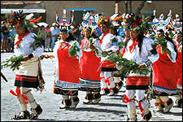

*New Mexico has 19 different Native American Pueblos throughout our state.

*The Pueblo names are: Acoma Pueblo, Cochiti Pueblo, Isleta Pueblo, Jemez Pueblo, Laguna Pueblo, Nambe Pueblo, Picuris Pueblo, Pojoaque Pueblo, San Felipe Pueblo, San Ildefonso Pueblo, Sandia Pueblo, Santa Ana Pueblo, Santa Clara Pueblo, & Santo Domingo Pueblo.

*Acoma, Laguna, Santa Ana, Zia, Kewa, Cochiti, & San Felipe Pueblos speak Keres.

*San Ildefonso, Santa Clara, Nambe, Pojoaque, Tesuque, & Ohkay Owingeh Pueblos speak Tewa.

*Isleta, Sandia, Picuris & Taos Pueblos speak Tiwa.

*Jemez Pueblo is the only to speak Towa.

*Zuni Pueblo is the only to speak Zuni.

Research where the Picuris Pueblo is located in New Mexico.

Original photo: Denise Balderas

Acequias (Ditches) & Protected Water in New Mexico

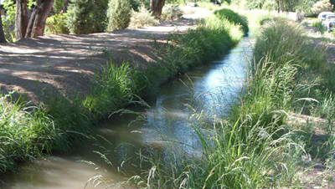
*The word Acequia is an Arabic word meaning “bearer of water.”
*Acequias began over 200 years ago to give people who had land water for farming & ranching.
*New Mexico’s Acequias have people like commissioners & mayordomos (ditch managers).
*The mayordomos are elected and watch over how much water each person uses and on which day they can use the water for farming & ranching.
*It is part of New Mexico’s peoples customs and traditions that water rights are attached to the land.
*The Acequia Associations still defend the people to make sure that the water does not get stolen by big companies.

Who is responsible for watching care of the Acequias?

Original photo: Denise Balderas
origi

The roadrunner is the state bird of New Mexico. They are specifically known for their swift movements and their star role in the Roadrunner and Coyote cartoon. They eat mostly small animals such as small birds and snakes, and can run fast enough to catch and eat rattlesnakes!
“insert authentic graphics here”
The roadrunner is an unusual looking bird. They have a long upright body with a long tail that sticks almost straight up. Their head is an oval shape with a long straight black beak. Their feathers are usually a brownish black with white stripes and spots. Roadrunners usually stand around 10-12 inches high. Their feet are zygodactyl, which means two toes point forward, and two point backwards.
On the back of this award, draw your own picture of a roadrunner. Make sure and draw the feet with two toes pointing forward and two pointing backward and label them!

The black bear was designated the official state animal of New Mexico in 1963 (also a state symbol in West Virginia and Louisiana). Black bears are very intelligent, shy, and secretive animals - actually seeing a bear in the wild is a very rare experience. Black bears are not always black - there are also cinnamon, white, beige, and "blue" (slate gray) black bears.
“insert authentic graphics here”
Adult black bears vary considerably in size, from 130 - 500 pounds (occasionally as much as 700). The black bear is omnivorous and will eat just about anything. While they prefer nuts, berries, grasses, and roots, they also eat insects and small mammals, and if nothing else is available, carrion. They can run up to 30 mph and are good swimmers.
On the back of this award, write about what you would do if you came across a black bear while walking in the mountains.
New Mexico designated turquoise as the official state gem in 1967. One of the oldest gemstones known, turquoise is an opaque, blue-to-green mineral. Only the prized robin's egg blue color is used to make gemstones. The majority of the world's finest-quality turquoise comes from western and southwestern United States, the largest producer of turquoise in the world.
“insert authentic graphics here”
Turquoise has been used extensively by both southwestern U.S. Native Americans and by many of the Indian tribes in Mexico since about 200 B.C. to make solid turquoise beads, carvings, and inlaid mosaics. Nearly all important deposits of turquoise are located near copper deposits in arid desert regions of the world.
On the back, design a piece of turquoise jewelry.

The colors on New Mexico's state flag are the red and yellow of old Spain. The center design is the ancient Zia sun symbol. The Zia Indians of New Mexico regard the Sun as sacred. Their symbol for the sun (a red circle with groups of rays pointing in four directions) is painted on ceremonial vases, and used to introduce newborns to the Sun.
“insert authentic graphics here”
Four is the sacred number of the Zia and is used in the four lines radiating to the four directions from the circle. To the Zia Indians, the number four represents:
• four points of the compass (east, west, north, and south);
• four seasons of the year (spring, summer, autumn, and winter);
• four periods of each day (morning, noon, evening, and night);
• four seasons of life (childhood, youth, middle years, and old age)
On the back, write the pledge to the state of New Mexico in English or in Spanish.

New Mexico designated the blossom of the desert yucca plant as the state flower in 1927. The yucca flower was selected by the schoolchildren of New Mexico.
“insert authentic graphics here”

Yuccas have a unique, specialized pollination system. They are pollinated by the yucca moth, which carefully and deliberately transfers the pollen from the stamens of one plant to the stigma of another, and at the same time lays an egg in the flower. The moth larvae then consumes a small amount of the developing seeds.

Many yuccas have edible parts, including fruits, seeds, flowers, stems, and sometimes the roots. Dried yucca wood has the lowest ignition temperature of any wood, which makes it desirable for starting fires. The roots of yucca glauca (or soapweed yucca) have been found to be an excellent substitute for soap and shampoo.

On the back, write about how you think it would feel like to wash your hair with shampoo made from the yucca plant.

The New Mexico whiptail lizard was designated the official state reptile of New Mexico in 2003. The New Mexico whiptail is a small lizard found primarily in the Rio Grande valley from northern New Mexico to northern Chihuahua, Mexico.

Whiptail lizards are constantly in motion. They often run upright on their hind legs, giving them the appearance of miniature dinosaurs. Whiptail lizards swivel their heads frequently from side to side, taste the air with slender forked tongues, and use their pointed snouts to probe the ground (foraging for termites, spiders, and other ground-dwelling insects).
“insert authentic graphics here”

The whiptail lizards' alertness, speed, and agility help it outmaneuver predators such as roadrunners. They can sprint up to fifteen miles per hour. Whiptail lizards can also escape capture by sacrificing their tails. When grasped, their tail breaks easily along a fracture plane in the vertebrae. The disembodied tail wriggles violently, which startles and distracts the predator while the lizard dashes to safety.

The New Mexico Whiptail Lizards play a part in one of the greatest mysteries of nature - they are all female! The New Mexico Whiptail reproduces by cloning - its eggs require no fertilization, and its offspring are exact and complete genetic duplicates of the mother.

On the back, write a short, descriptive paragraph about a whiptail lizard escaping from a roadrunner.

“insert authentic graphics here” | During World War I, in the southern NM community of Deming, Camp Cody was an army training camp for the National Guard units from North and South Dakota, Nebraska, Minnesota and Iowa. Soldiers received basic training there before leaving for the war in France. The different National Guard units together formed the 34th Division Infantry and were nicknamed the "Sandstorm Division," a name based on the camp's desert climate.  Camp Cody was open from 1916-1919  How did Camp Cody get its’ name?

CAMP CODY in DEMING, NM
“insert authentic graphics here” | Troops at Camp Cody in Deming, NM trained on this machine gun in preparation for The Great War.  Camp Cody was open from 1916-1919  How have weapons changed over the years?

SANTA FE TRAIL
“insert authentic graphics here” | The Santa Fe Trail was a trade route to the southwest United States extending about 1,287 km (800 mi) westward from Independence, Missouri, to Santa Fe, New Mexico. First traversed in 1821, it was the primary wagon and stage route to the Southwest until the coming of the railroad in 1880.
Look at the picture and how people travelled. List 5 things you want to make sure you brought with you if you had to travel this way.

GILA CLIFF DWELLINGS
“insert authentic graphics here” | A little more than seven hundred years ago, a peaceful people, called the "Mogollon"  (mug-ee-yone) sought protection from enemies and the weather. They built forty rooms in five spacious sandstone cliff caves, located in what is now the heart of western New Mexico’s Gila National Forest, on the edge of the Gila Wilderness. The ruins were designated as a national monument on November 16, 1907.  What would be the challenges of living high up inside a mountain?

WHITE SANDS NATIONAL MONUMENT

“insert authentic graphics here” | White Sands National Monument has the LARGEST gypsum dune fields in the world! It is located about 16 miles southwest of Alamogordo, NM and has an elevation of 4235 feet (1291 miles). The area is in the mountain-ringed Tularosa Basin and has 275 square miles of white sand dunes made up of gypsum crystals.

Go to: http://www.nps.gov/whsa/naturescience/index.htm and find out how the dunes are made. Be ready to share your findings.

VERY LARGE ARRAY

“insert authentic graphics here” | The Very Large Array is one of the world's premier astronomical radio observatories. It has 27 radio antennas in a Y-shaped configuration on the Plains of San Agustin fifty miles west of Socorro, New Mexico.  Each antenna is 82 feet wide. These large antennas are receiving radio waves from outer space so that scientists can study our universe.

Go to: http://images.nrao.edu/ to see pictures of outer space that were captured by some of these arrays. Choose an image, along with the information about it, print it, and place the information in our research station.

The Important Book about New Mexico

Table of Contents
People and Culture ……………………………………………………………. 1
Geography and Landforms ………………………………………………… 2
Weather ……………………………………………………………………………. 3
Water resources ……………………………………………………………….. 4
Food …………………………………………………………………………………. 5
Government …………………………………………………………………….. 6
Symbols ……………………………………………………………………………. 7
Glossary ……………………………………………………………………………. 8

Page 1
Refrain: The important thing about New Mexico is that it is a unique and beautiful state because of the diversity of its people, culture, and geography.
- The three dominant groups of people in New Mexico are Native Americans, Hispanics, and Anglos. Although there are fewer African Americans here, they still make important contributions to the state.
- Hispanics make up over 50 percent of the population. The state of New Mexico has the highest percentage of Hispanics in the United States. The NM Constitution guarantees that this is a bilingual state.
- People in New Mexico speak Spanish, English, and/or one of twelve Native American languages.
- The Native Americans in New Mexico come from nineteen pueblos, the Navajo Nation, or Apache tribes.
- New Mexico is known for its rich and varied culture. Culture is the things that people create and their ways of living. These include art, music, dance, literature, pottery, and weaving.
But, (refrain)
Page 2
Refrain
- New Mexico is in the southwestern part of the United States and is the 5th largest state in area in the country.
- Its landforms include mountains, plateaus, mesas, plains, deserts, rivers, and lakes.
- The highest mountain is Wheeler Peak near Taos. It is 13,160 feet above sea level.
- There are also many extinct volcanos in the state. The largest one is the Valle Grande in the Jemez Mountains.
- The major rivers in the state are the Rio Grande, the Pecos, the San Juan, and the Canadian Rivers. The Rio Grande is the 3rd longest river in the US.
But, (refrain)

Page 3
Refrain
- Many people love the climate and dry, clean air in New Mexico.
- Across the state, rainfall varies between 10 and 20 inches per year.
- Temperatures are usually cooler in the northern part of the state and at higher altitudes.
- The southern portion and lower elevations of New Mexico are usually warmer.
- The difference between daytime and nighttime temperatures can vary as much as 25 to 35 degrees.
- Drought has become a major problem in New Mexico. It is caused by little rainfall, high temperatures, wind, and increased demand for water.
But, (refrain)

Page 4
Refrain
- Water in New Mexico comes from rain and snow that drain into rivers and underground aquifers.
- Water is also stored in lakes and reservoirs for future use.
- Acequias, or ditches, have been used for centuries to irrigate crops. Acequia systems also help protect people’s rights to have and use water.
- Conservation of water is very important because of the dry climate, growing demand and years of drought.
But, (refrain)

Page 5
Refrain
- Food in New Mexico is interesting, colorful, and often quite spicy.
- Some people call this Mexican food but it is unique to this state. It has been influenced by the Native Americans and all of the people who settled in this area.
- The chile that is eaten here is either red or green. Red chile is green chile that has ripened.
- Hatch, in southern New Mexico is famous for its green chile. Chimayo, in the north, is known for its red chile.
But, (refrain)
Page 6
Refrain
- In 2012 New Mexico celebrated its centennial anniversary. It became America’s 47th state on January 6, 1912.
- In New Mexico there are state, local, and tribal governments.
- Each government can make laws (legislative), carry out the laws (executive), and provide justice for citizens (judicial).
- The state government is based in Santa Fe, the capital of New Mexico.
- Susana Martinez is the governor, the first Hispanic woman to be one in the United States.
- Local governments include counties, cities, and towns.
- Tribal governments include councils to make and enforce laws
But, (refrain)
Page 7
Refrain
- New Mexico’s official nickname is “The Land of Enchantment.”
- One of the best-known symbols in New Mexico is the Zia Sun symbol on the state flag.
- The state bird is the roadrunner, the state animal is the black bear, and the state fish is the cutthroat trout.
- The state flower is the yucca, the tree is the piñon, and the state vegetables are chile and pinto beans.
- A very famous national symbol came from New Mexico. This is Smokey the Bear, who has warned people for years, “Only You Can Prevent Forest Fires.”
But, (refrain)

Glossary
Acequia: A ditch that is owned by a community and used for irrigation
Altitude: The height of the land above sea level
Aquifer: A layer of rock or sand that can absorb and hold water
Centennial: The 100th anniversary of something, such as an important event
Conservation: The act of protecting or keeping something from being destroyed or used up
Constitution: A set of basic rules and laws for running a government
Council: A group of leaders or government officials
Culture: Everything created by people, such as beliefs, customs, language, and religion
Drought: A long period of dry weather; lack of rain or water
Enchantment: A quality that attracts and holds your attention by being interesting, pretty, etc.
Extinct: No longer active, as in a volcano; or no longer existing, as in an animal species
Governor: The person who is in charge of a state and head of the executive branch of the state government
Influence: The power to cause changes without directly forcing them to happen
Irrigate: To bring extra water to the land through ditches, pipes, or canals
Mesa: A flat table-shaped mountain or hill
Percentage: A part of a whole with the number 100 representing the whole
Plateau: An area of high, flat land
Pueblo: The name for a group of Native Americans in the Southwest; also a town or village in the Spanish language
Symbol: An object that represents a particular idea
Unique: Something that is unlike anything else

WORLD MAP
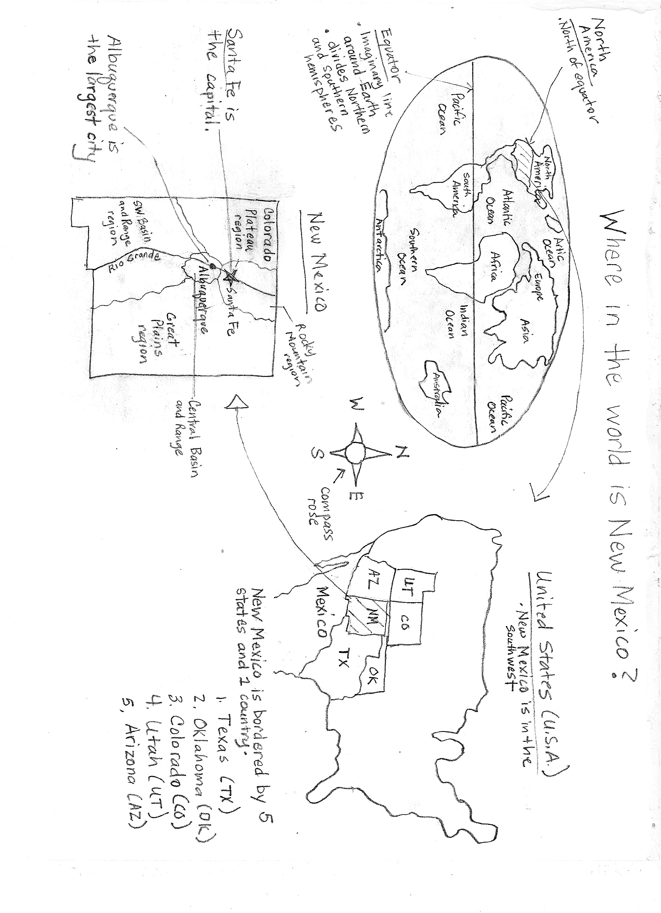

ELD Review Questions for “Where in the World is New Mexico?” Graphic Organizer

Point To:
- Find North America
- Point to the Equator
- Identify the Southwest portion of the United States
- (Show two pictures.) Which of these could be in the Southwest region?
- Where is Santa Fe on the state map?

Yes/No:
- Is New Mexico in South America?
- Is Albuquerque the largest city in New Mexico?
- Is New Mexico bordered by five states and one country?
- Is Santa Fe in the Rocky Mountain region of New Mexico?
- Does the Rio Grande flow through New Mexico?
Either/Or:
- Is Arizona east or west of New Mexico?
- Are there four or five geographic regions of New Mexico?
- Is New Mexico in the northern or southern hemisphere?
- Is Santa Fe or Albuquerque the capital of New Mexico?

Open Ended:
- What information do we get from the compass rose?
- What do you know about the weather in the southwest portion of the US?
- Is there another country, besides the US that you would like to visit? Why?
- Name the states and country that border New Mexico?
- Why do many people who live in New Mexico have relatives in Mexico?

PICTORIAL INPUT – Central Basin and Range Region of NM

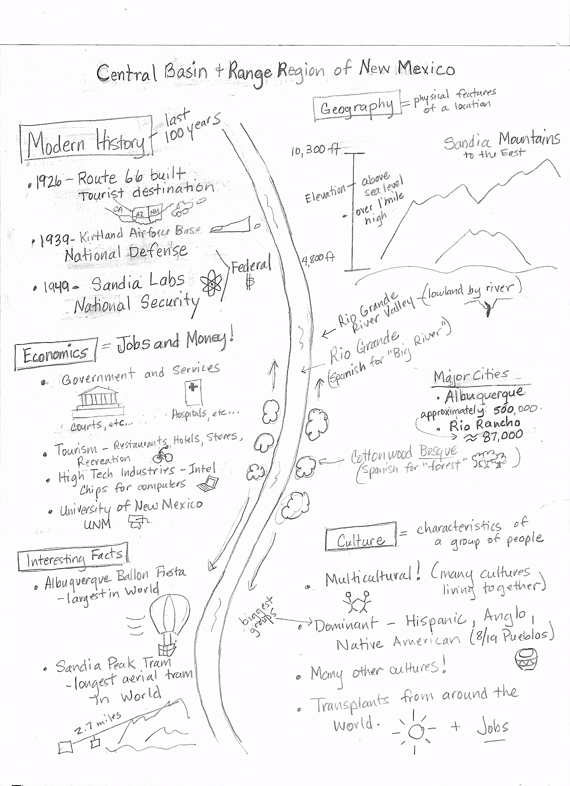

ELD Review Questions for Central Basin and Range Region of NM
Point To:
- Locate the Sandia Tram
- Point to Route 66.
- Identify the major cities.
- Look out the window, where are the Sandia Mountains?
- (Show two pictures.) Which of these could be in this region?
- (Show a picture of Albuquerque and one of Las Cruces.) Albuquerque is the largest city in New Mexico. Which one of these is Albuquerque?

Yes/No:
- Is the Albuquerque Balloon Fiesta the smallest hot air balloon festival in the world?
- Is the elevation ever higher than 5,800 feet?
- Is Sandia Labs a high tech industry?
- Would an ocean fisherman (show picture) be likely to live in Albuquerque? What about a scientist (show picture of scientist at Sandia Labs)?

Either/Or:
- Are the Sandia & Manzano Mountains to the East or West?
- Does Route 66 go through one state or many states?
- Is the Rio Grande Valley a town or a bosque?
- Is the City of Rio Rancho larger or smaller than Albuquerque?
- Does the category of economics or geography include information about tourism?
- Would you rather go to the Balloon Fiesta or ride the Sandia Peak Tram? (Point to pictures.)

Open Ended:
- Provide examples of why tourism is important.
- Why is Government and Services important?
- What plants grow in the Rio Grande Valley?
- Would you rather go to the Balloon Fiesta or ride the Sandia Peak Tram? Explain why.
- Would your (mom, brother…) rather go to the Balloon Fiesta or ride the Sandia Peak Tram? Explain why.
- From your experiences, why do you think people like to live in Albuquerque?
- What plants grown in the Rio Grande Valley?

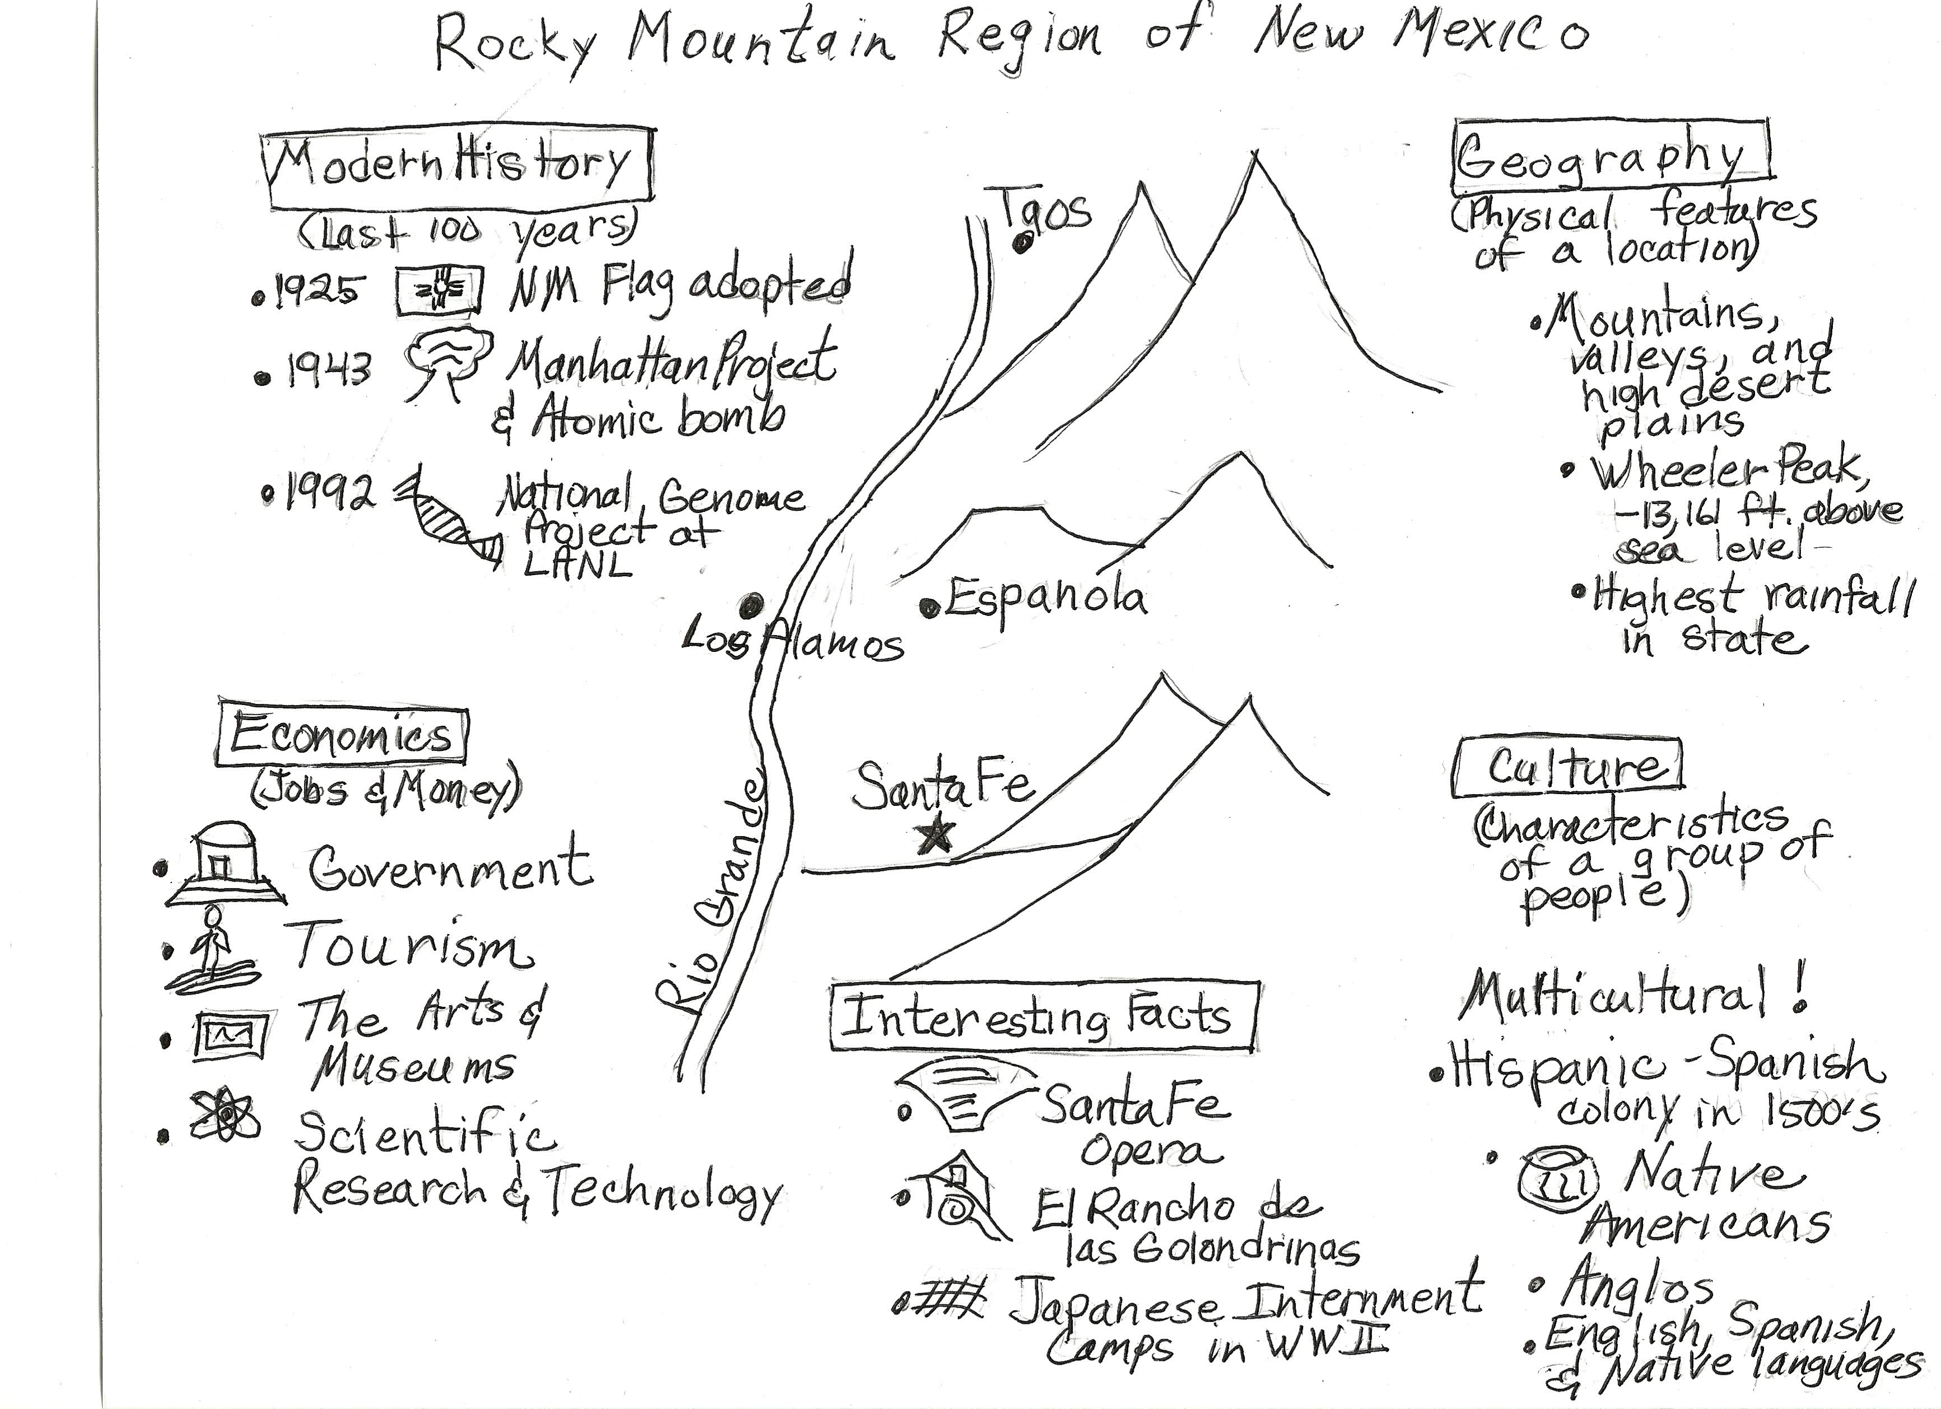

ELD Review Questions for Rocky Mountain Region of NM
Point To:
- Find the Santa Fe Opera
- Point to Wheeler Peak
- Identify the major cities.
- (Show two pictures.) Which of these could be in this region?
- (Show a picture of Santa Fe and Albuquerque.) Santa Fe is the capital New Mexico. Which one of these is Santa Fe?

Yes/No:
- Is Wheeler Peak the highest point in New Mexico?
- Is the elevation in this region ever lower than 7,000 feet?
- Does Los Alamos have scientific laboratories?
- Did New Mexico become the 47th state in 1912?
- Does this region normally have the highest rainfall in the state?

Either/Or:
- Is Espanola north or south of Santa Fe?
- Does the Rio Grande go through one state or many states?
- Is Taos larger or smaller than Santa Fe?
- Does the category of economics or geography include information about tourism?
- Would you rather visit El Rancho de las Golondrinas or the Capitol building?

Open Ended:
- Provide examples of why tourism is important.
- Why is government important?
- From your experiences, why do you think people like to live in Santa Fe?
- What landforms will you find in this region?
- Why do you think Japanese Americans were interred during WWII?

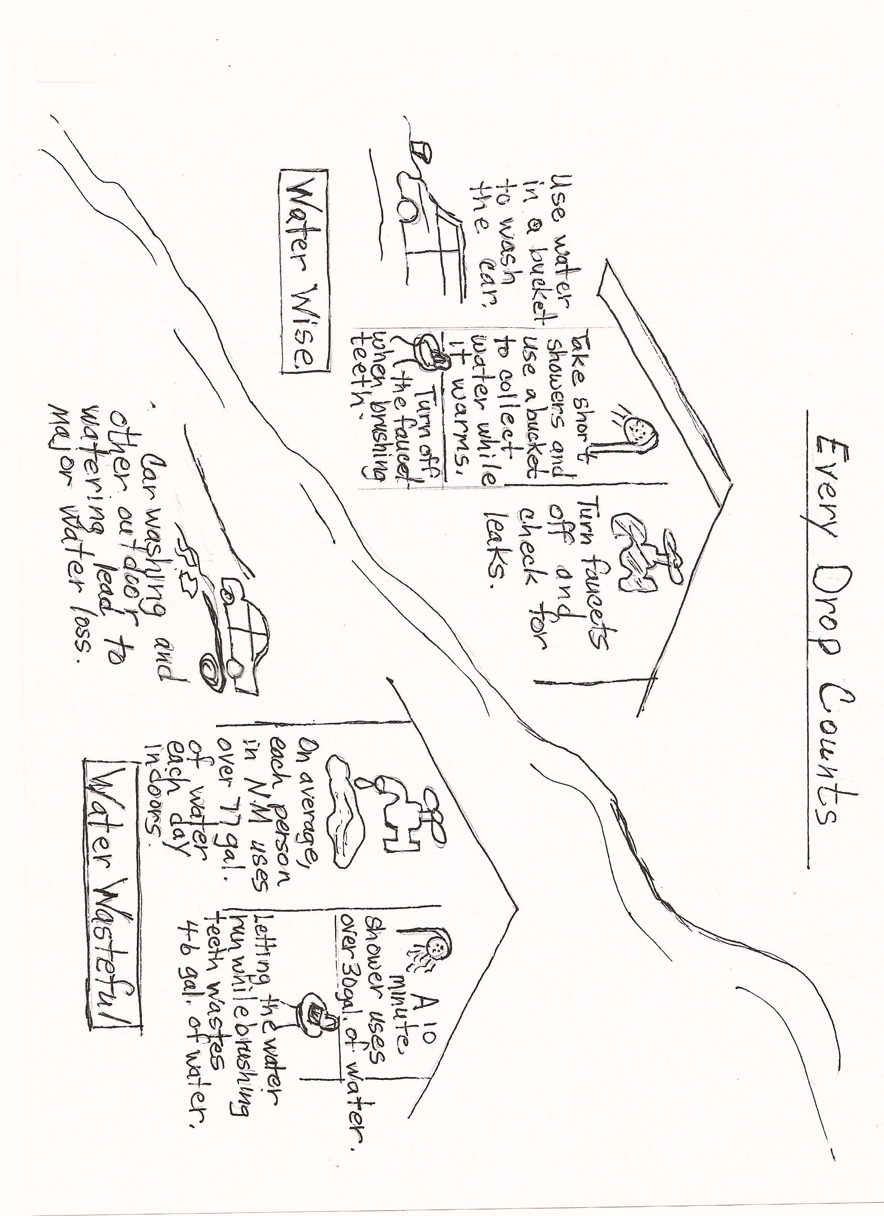
COMPARTIVE INPUT CHART – EVERY DROP COUNTS

ELD Review Questions for Comparative Input Chart

Point To:
- Find the water wise way to wash a car
- Point to water being wasted while water is running in a faucet
- Identify the water wise way to take a shower
- (Show two pictures.) Which of these would be an example of wasting water?

Yes/No:
- Is it a good idea to leave a faucet running?
- Does taking a long shower save water?
- Does letting the water run while brushing your teeth waste water?
- Is outdoor watering and car washing a way to save water?

Either/Or:
- Do short showers or long showers waste water?
- Does the average person in New Mexico use 10 gallons or over 77 gallons of water every day?
- Should we fix leaky faucets or let them drip?

Open Ended:
- What are two ways to save water when taking a shower?
- How much water can be wasted if we leave the faucet running when brushing our teeth??
- What ways do you save water at home?
- Why is it important for all of us to save water?

NARRATIVE INPUT CHART

How Coyote Brought Us Water
By Margaret L. Silbar and Connie Slocomb
Adapted by Barbara Ellis
Page 1
Not so many moons ago, but still while animals could talk, there was a time of great thirst. Clouds came and went, but there was never any rain. The animals knew they could not live very long without water. They came to talk to Coyote.
Page 2
Coyote said, “While I was in the North, I met the Frogs. They have a very large pond that is full of clean water. It was formed many years ago in a landslide.”
Page 3
Bobcat asked, “Do you think they might share some of their water with us? Could we offer them something so that they would be willing to share?”
Beaver said, “Perhaps we can send them some gifts! We can also share our culture, including our stories, music and dance.”
Javalina asked, “But how would we get the water down here? The Frogs live far away and we have no way to carry it that distance.”
“Trust me, I will think of a way,” said Coyote, as he started North with the gifts.
Page 4
Coyote found a warm welcome among the Frogs. He opened up his bag so the Frogs could see what he had brought them. He also told them of the stories, music, and dances that his friends wanted to share with them.
My friends and I are very thirsty,” Coyote said. “Would you be willing to share the water from your pond with us?”
Page 5
“Certainly,” said the frogs. “Go and open a hole in the dam so some of the water will flow out.”
So, Coyote jumped into the pond, taking his cane along with him. And, he poked a hole in the Frogs’ dam.

Page 6
Some of the water came flowing down a long, thin arroyo. (An arroyo is a broad ditch that is usually dry.)
The animals were very excited to see the water and came rushing to scoop it up.
Page 7
“But,” asked Squirrel, “How can we store the water? We have to keep it from evaporating into our dry air and from flowing away downstream. And, we want to keep it clean, so we can drink it.”
Coyote had a wonderful idea…
Page 8
“We’ll dig a hole and put it under the ground.”
So, Coyote and his friends created the first aquifer. (An aquifer, as you might guess from the Spanish word agua, is an area where water is stored underground.)
Once they finished, Coyote’s aquifer was used and enjoyed for many years by all the animals, including the Frogs.
Everyone came to believe there would never again be a time of thirst.
Page 9
Many years later, however, a clever bunny asked, “How do we know the water will last forever? If there are only a few of us drinking the water, everybody gets some. But, if many of us are drinking it, there may not be enough for everyone. And every day, there are more of us!”
“I know,” said Raccoon, “We’ll wash our vegetables in a bowl and not in running water. And, we won’t let the faucet run while doing the dishes.”
“Aha,” said Beaver, “And I can brush my teeth without letting the faucet run all the time, too.”
Page 10
Crow never got the message. When she waters the lawn, she also waters the street. But Bluejay and all the other animals are trying to get her to change her ways so that everyone has enough water for many years to come.

The Lexile level is of this selection 810. The CCSS Lexile recommendation for 4th grade is 740 – 875.

ELD Review Questions for “How Coyote Brought Us Water” Narrative Input Chart

Point To:
- Find the frogs playing in the pond.
- Show us where the water is flowing down the arroyo.
- Where is the picture that shows Coyote sharing gifts with the frogs?
- (Point to two pictures.) Which of these shows the animals working together?
- Where is the picture of an animal wasting water?

Yes/No:
- Did Coyote agree to help the animals find water?
- Did the frogs agree to share their water?
- Did the animals have to pay for the water they received?
- Did the animals find ways they could conserve water?
- According to the story, could animals talk a long time ago?

Either/Or:
- Was the Frogs’ pond formed by a landslide or did they build it?
- Did the animals want to keep the water cold or clean so they could drink it?
- Did the water flow to the animals in an arroyo or through a pipe?
- Does an aquifer store water underground or in a tank?

Open Ended:
- Why did Coyote ask the Frogs to share their water with the other animals?
- How did the animals cooperate with each other to get water?
- Why is it important for everyone to conserve water?
- What are ways you and your family save water in your home?

NARRATIVE INPUT CHART

Juan del Oso the Bear and the Water of Life
Retold by: Enrique R. Lamadrid,
Translated by: Juan del Oso Estevan Arellano,

Illustrated by: Amy Cordova

Adapted by Denise Balderas

Page 1
En los tiempos, a long time ago, a man named Juan del Oso Serreño and his daughter Silvia lived in their a little mud-plastered log house high up on the northeast slope of La Jucarita, right near Los Alamitos where the great forest meets the uppermost pastures and fields of the Mora Valley. They had moved over the mountain from the Pueblo of Picuris after an epidemic took Silvia’s mother from this world.

Page 2
Since they were newcomers, there was not really a place for them in the nearby village of Agua Negra because there was not quite enough water to grow everything the people needed, only some fields of winter wheat and a few cattle. Juan del Oso cut firewood and vigas that he traded for flour, beans, and other necessities like shoes and tools. Silvia took care of a small flock of sheep that gave them wool for weaving and a little meat. All winter she and her father wove beautiful blankets and rugs on their looms.

Page 3
One spring when the lambs came, the girl spent every day helping the ewes and guarding against the coyotes while her father was in the forest. She loved to sing to herself and her flock in the meadow:

“Flor de las flores
“Flower among flowers,
Flower of my love,
Come along with me,
Give me your love.”
Flor de mi amor,
Vente conmigo,
Dame tu amor.”

Page 4
What she did not notice was Oso Grande, the bear that lingered every day at the edge of the forest, who was fascinated by her song. By accident, she discovered him asleep, his fur was so thick and beautiful that she sat down to stare him, unafraid. Slowly he opened one of his eyes and said: “Cántame, Cántame, sing for me, sing for me.” Without thinking she sang, “Flor de las flores.” He sat up and said: “Más, más, more, more.”

Page 5
Silvia liked to visit Oso Grande’s comfortable and warm cave especially because the view was amazing. To the east Silvia could see the Mora Valley and the Great Llano, and to the west the Cerro Pedernal and round peaks of the Jemez volcano. Silvia enjoyed walking down to Mora & Las Vegas to see the people, stores, and plazas.
By the end of the summer, Silvia’s young cousin Juan del Oso came to live with them Silvia told the teacher and the villagers, “ This is my primo, my cousin, who has come from the other side of the mountain to live with us.” Juan del Oso began going to school and quickly grew to be a very large and powerful young man.

Page 6
One day while walking in the forest, Juan del Oso met two large and powerful young men about his age. He introduced himself, “Soy Juan del Oso”. One of the boys said, “Soy Mudacerros, my job is to move hills around,” as he pointed across the canyon to a huge fresh mound of dirt and rocks. The other boy said, “Soy Mudarrios, and my job is to change the course of rivers,” as he pointed toward an area where a muddy stream circled around the huge mound.” Juan del Oso worked every day with his new friends on many projects. They ate sacks and sacks of esquite or toasted corn to keep up their strength.

Page 7
The next day Juan del Oso began walking in the mountains when he met Oso Grande. To Juan del Oso’s surprise, he was not afraid, but felt a strong connection to the massive beast. He now knew why he was named “Juan del Oso ”. He spoke with Oso Grande about the drought and the future that the good people of the valley faced. Oso Grande pointed down to the canyon to the west, where the natural spring water of the cave joined the roiling river below. “There is the water for your people. If we could only get it to the other side of the mountain.”

Page 8
Juan del Oso could barely contain the hope and emotion in his heart because this is how he could help his family & the villagers. The next day, Oso Grande, Juan del Oso, Mudacerros and Mudarrios made a pressa or dam, a structure woven of trees and boulders to capture the flow of the river and make a deep pond, high up in the rocky canyon. The newly routed water cascaded down the mountainside like a waterfall into the acequias or ditches then into the village. All the people in the village cheered, “Here comes the water!” as they could not believe their eyes.

Page 9
Near the river by Holman, they planted orchards of apples, pears, apricots, cherries, plums, peas, havas or kidney beans, and cabalacitas or Spanish squash which the villagers would trade for chile with the people from the valleys west of La Jicarita. Strength channeled like the water in the acequia and brought life to all. The people of the acequias shouted together, “We will never forgot Juan del Oso and how he and his two friends changed the course of the water!” So the water still runs to this day into the beautiful valley of Mora.

ELD Review Questions for Narrative Input “ Juan del Oso and the Water of Life”
Level 1:
- What is the first thing that happened in the story?
- What do Juan del Oso Serreno and his daughter Silvia live in?
- What animals do you see?
- Tell me what were Silvia and her father weaving?
- What did Silvia love to do?
- Who was Silvia singing to?
- Where did Silvia go?
- Who came to live with Silvia and her father?
- What happened next?
Level 2:
- What is the first thing that happened in the story?
- What do Juan del Oso Serreno and his daughter Silvia live in?
- What was Juan del Oso Serreno’s daughter’s name?
- What did Silvia take care of?
- What was the name of the village?
- Tell me what were Silvia and her father weaving?
- Who was Silvia singing to?
- What happened next?
- Where did Silvia go?
- Who came to live with Silvia and her father?
Level 3:
- What was Silvia’s job with the sheep?
- What things did Juan del Oso cut?
- Why did he cut firewood & vigas?
- How did Oso Grande feel when he heard Silvia sing?
- What was Mudacerros’ main job?
- What was Mudarrios’ main job?
- How did Mudarrios’, Juan del Oso, & Mudacerros work together?
- Why did Oso Grande point down into the valley?
- What did the villagers say about Juan del Oso?
Level 4:
- Who lived in the Mora Valley?
- What can you tell me about Silvia’s mother?
- Why did Oso Grande linger at the edge of the forest?
- What did Silvia sing to Oso Grande?
- What did the Juan del Oso, Mudarrios, & Mudacerros make?
- What is a dam?
- How did they get the water into the village?
- What kinds of orchards did the villagers grow?
- What is an acequia?

Level 5:
- Why did Silvia enjoy walking down to Mora & Las Vegas?
- Who was Mudacerros?
- Who was Mudarrios?
- What was important about the natural spring water?
- What did Juan del Oso talk with Oso Grande about the water in the village?
- Why do the villagers make acequias?
- Why did the people cheer when the water flowed into their village?
- Where does the water still run today?

UNIQUELY NEW MEXICO

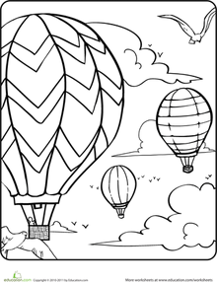
POETRY BOOKLET
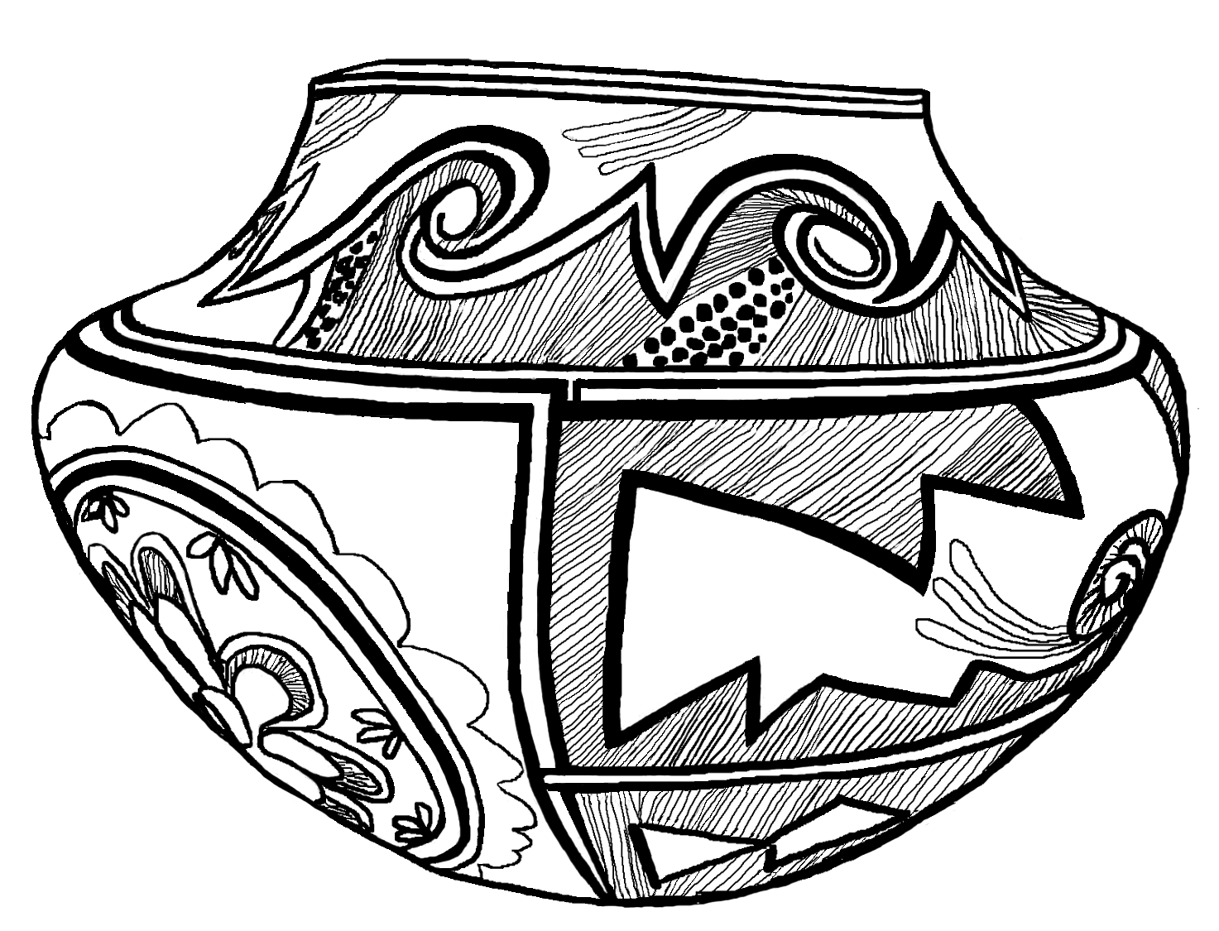

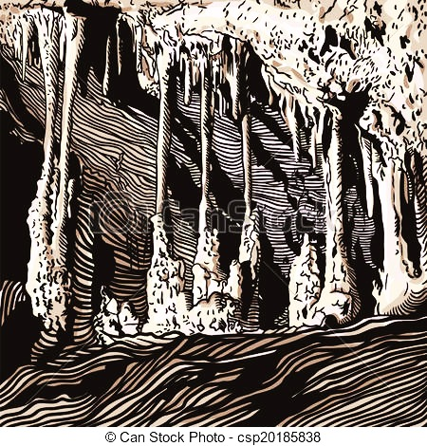


NM NEW MEXICANS HERE, NEW MEXICANS THERE
By Diana Pinkston

New Mexicans here, New Mexicans there,
New Mexicans, New Mexicans everywhere!

Industrious New Mexicans researching diligently,
Artistic New Mexicans creating artfully,
Multicultural New Mexicans coexisting peacefully,
And, adventurous New Mexicans ballooning gleefully.

New Mexicans in each region,
New Mexicans from many cultures,
New Mexicans at their work places,
And, New Mexicans with family and friends.

New Mexicans here, New Mexicans there,
New Mexicans, New Mexicans, everywhere.

NEW MEXICO GEOGRAPHY CADENCE

by Diana Pinkston

New Mexico’s a unique state.
Geography is part of what makes it great.
Land of Enchantment is its nickname.
Its geography and cultures have brought it fame.

New Mexico, mountains,
New Mexico, valleys,
New Mexico, rivers and deserts, Land of Enchantment!

Tourists come from all around,
To hike, climb, ski and paint this land.
Red Rocks, White Sands and Abiquiu,
So much to see and more to do.

New Mexico, mesas,
New Mexico, plateaus,
New Mexico, Carlsbad Caverns, Gila Cliff Dwellings!

Northern lands are green and cool,
In the South, hot and dry is the rule,
Western winds carve arches from stone,
In the Eastern plains the pronghorn roam.

New Mexico, physical features,
New Mexico, many cultures,
New Mexico, unique and, enchanting!
NEW MEXICO INDUSTRIES BUGALOO
By Diana Pinkston

We’re New Mexicans and we’re here to say,

Industries create jobs for people every day,
Our land is stunning and resources abound,
The climate is varied, the sun shines year round.

Services, tourism, national security too,
Doing the New Mexico Industries Bugaloo!

People in the West mine uranium,
Oil, coal and gas make our businesses hum,
Ranching and peanut farms across the Eastern Plains,
Southern chile and pecan farmers irrigate for lack of rain.

Agriculture, ranching, energy production too,
Doing the New Mexico Industries Bugaloo!

Wide open spaces to test our might,
Government projects run day and night.
Scientists advance our nations cause,
Space and Technology create New Mexico jobs.

Los Alamos, White Sands, Intel Corporation too,
Doing the New Mexico Industries Bugaloo!

New Mexico Cultures – Yes, Ma’am
By Diana Pinkston

Are you a New Mexican? Yes, ma’am.
Are you a New Mexican? Yes, we are the Pueblo people.
How do you know? We’ve been in this land for many centuries.
How do you know? The Ancestral Pueblo people are our ancestors.
Tell me more about your people There are nineteen Pueblos in New Mexico.
Tell me more about your people We speak Tewa, Towa, Tiwa and Keres.

Are you a New Mexican? Yes, ma’am.
Are you a New Mexican? Yes, we are the Navajo Nation.
How do you know? We are the largest Native American tribe in the country.
How do you know? We live in New Mexico, Arizona and Utah.
Tell me more about your people. We herded sheep and lived in hogans.
Tell me more about your people. We call ourselves the “Diné”.

Are you a New Mexican? Yes, ma’am.
Are you a New Mexican? Yes, we are Hispanic People.
How do you know? We are over half of the New Mexican population.
How do you know? Our roots are from Spain and Mexico.
Tell me more about your people We speak the Spanish and English languages.
Tell me more about your people We arrived after the Native American people.

Are you a New Mexican? Yes, ma’am.
Are you a New Mexican? Yes, we are the Anglo people.
How do you know? We are second to Hispanics in population.
How do you know? We speak English as our first language.
Tell me more about your people. We came after the Native Americans and the Hispanics.
Tell me more about your people. We trace our roots back to England.

Are you a New Mexican? Yes, ma’am.
Native American, Hispanic and Anglo? African American, Cuban and Asian.
Are there other cultures? We have cultures from all over the world!

Home School Connection
Conexión entre el hogar y la escuela

Interview your family. What languages have been spoken by members of your family? Are there family stories shared about where your family originated?

Entrevista a tu familia. ¿En cuáles idiomas se han hablado los miembros de tu familia? ¿Hay historias compartidas acerca del origen su familia?

Adult Signature ________________ Student Signature _____________________
firma de un adulto firma del estudiante

Home School Connection
Conexión entre el hogar y la escuela

Observe how people in your household use water. Draw a picture of the different ways water is used and write a sentence to go with each picture explaining what is happening.

Observa cómo se usa el agua en su casa. Haz un dibujo de las diferentes maneras que se usa agua en tu casa y escribe una oración para cada imagen explicando lo que está pasando.

Adult Signature ________________ Student Signature _____________________
firma de un adulto firma del estudiante

Home School Connection
Conexión entre el hogar y la escuela

Talk to your family about some of the tourist attractions that New Mexico has to offer. If you and your family could take a trip, where would you go and what would you do?

Habla con tu familia acerca de algunas de las atracciones turísticas que hay en Nuevo México. Si tú y tu familia podrían hacer un viaje, ¿a dónde irían y qué harían?

Adult Signature ________________ Student Signature _____________________
firma de un adulto firma del estudiante

Home School Connection
Conexión entre el hogar y la escuela

Talk to your family about the Native American groups that live in your area. What does your family know about their culture and traditions?

Habla con tu familia sobre los grupos de americanos nativos que viven en tu área. ¿Qué sabe tu familia sobre la cultura y las tradiciones de estos americanos nativos?

Adult Signature ________________ Student Signature _____________________
firma de un adulto firma del estudiante

EXPERT GROUP: CENTRAL BASIN AND RANGE REGION OF NEW MEXICO
EXPERT:

MODERN HISTORY
In 1926, Route 66 was built to connect the east and west coasts of the United States. The highway went through New Mexico and brought tourists and businesses to the area. Kirtland Air Force base was opened in 1939 and has supported national defense since then. In 1949, Sandia National Labs opened and conduct research and develop technology for national security.

ECONOMICS
Tourism is an important industry in central region of New Mexico. People come from all over the world for recreation, shopping, restaurants, and museums. Scientific research at Sandia National Labs provides many jobs in this area. Intel in Rio Rancho builds chips for computers. The University of New Mexico is located in this area, employing many and educating thousands of people.

GEOGRAPHY
The Rio Grande River flows through from north to south and a cottonwood bosque thrives along the valley created by the river. Sandia Peak is the highest peak in the region at 10,300 ft. above sea level. This area has moderate temperatures and rainfall. Elevations range from 4,800 to over 13,000 ft. Major cities include: Albuquerque and Rio Rancho.

CULTURE
This is an area with many cultures. The dominant groups are the Hispanic, Anglo and Native American. The pueblos here are known for their unique languages, arts, and crafts. Many Hispanics in this area, trace their roots to the Spanish colonial period. English, Spanish & Native Languages are spoken by people here. Many people moved to this area because of the climate and opportunities for jobs.

INTERESTING FACTS
The Albuquerque Balloon Fiesta is held every fall and is the largest in the world. The Sandia Peak Tram is the longest aerial tram in the world at 2.7 miles. The Albuquerque Bio Park includes a zoo, an aquarium and botanic gardens.

EXPERT GROUP: ROCKY MOUNTAIN REGION OF NEW MEXICO
EXPERT:

MODERN HISTORY
This region became the birthplace of the atomic bomb during World War II. This was in the city of Los Alamo and was called the Manhattan Project. Some people say that it helped end the war. Since then Los Alamos has become a leader in nuclear research in the United States.

ECONOMICS
Tourism is an important industry in Northern & North Central New Mexico. People come from all over the world to experience art, nature, culture, and museums. Scientific research at Los Alamos National Labs provides many jobs in this area. State government is also a major employer in the area.

GEOGRAPHY
This region of New Mexico has mountains, river valleys, and high desert plains. The Rio Grande River flows through from north to south. Wheeler Peak, near Taos, is the highest peak in the state at 13, 161 ft. This area has moderate temperatures and receives the state’s highest rainfall. Elevations range from 5,000 to over 13,000 ft. above sea level. Major cities include: Española, Los Alamos, Santa Fe, and Taos.

CULTURE
This is the home of the eight northern pueblos. Each pueblo is known for its unique language, arts and crafts. Hispanics in this area, trace their roots to the Spanish colonial period and land grants. Fiestas and feast days are traditions that are celebrated throughout the year. English, Spanish & Native Languages are spoken by people here. The Spanish spoken in the Rocky Mountain region of New Mexico is unique to this region and dates back to the 1500s when Spanish colonist settled here.

INTERESTING FACTS
The Santa Fe Opera entertains people from all over the world every summer. El Rancho de Las Golondrinas is a living- history museum south of Santa Fe. It depicts life in the 18th and 19th centuries. However, a dark period in the history of this area was the internment of Japanese American citizens during World War II.

EXPERT GROUP: SW BASIN AND RANGE REGION OF NEW MEXICO
EXPERT:

MODERN HISTORY
In 1945 the United States government detonated an atomic bomb at the Trinity Site on White Sands Missile Range. This was the first time an atomic bomb was used. This technology helped the United States and its allies win World War II. Since World War II, other uses of nuclear energy have been developed. The SW Basin and Range is one of the regions of New Mexico now considered a leader in the nuclear and space industry in the United States.
ECONOMICS
Farming and ranching are the oldest industries in the SW Basin and Range region. They are still important to this region. The areas around Hatch and Deming are the second largest producers of “chile” products in the United States. The largest producer of pecans in the world is Stahmann Farms in Las Cruces. These industries provide jobs for the local residents. The Space and Technology industries also employ a large number of people in the SW Basin and Range region. These include: the Very Large Array (VLA), White Sands Missile Range, Spaceport America, New Mexico Tech and New Mexico State University.

GEOGRAPHY
The SW Basin and Range has deserts crossed with scattered mountain ranges. The elevation in this area ranges from 3,900 to 5,000 feet above sea level. The Rio Grande runs through this area. White Sands is a large area of gypsum sand dunes. It covers 275 square miles of area and is visited by people from all over the world. It is a dry and hot area with an average of 10 inches of precipitation per year. The largest city in the SW Basin and Range is Las Cruces, the second largest city in New Mexico.

CULTURE
The SW Basin and Range region has people from many backgrounds and cultures. As in most parts of New Mexico, the first people living in this region were Native American people. Later, Spanish, Anglo, Mexican and people from many other cultures arrived to this region. The main languages spoken are Spanish and English. The languages of the native people are now extinct. There is a strong influence of Mexican culture in this area. People celebrate holidays such as the “Cinco de Mayo” and “Día de los muertos”.

INTERESTING FACTS
Fifty miles west of Socorro, in the open desert of the SW Basin and Range, is the Very Large Array (VLA). The VLA consists of 27 large satellite antennas. Each dish is more than 25 feet wide and weighs more than 200 tons. It is used to investigate space. The Deming “Duck Races”, held in late August, brings tourist from all over the world to race ducks and enjoy family and friends. Every Labor Day weekend, the town of Hatch, NM hosts the “Hatch Chile Festival” attracting over 30,000 people from all over the country.

EXPERT GROUP: GREAT PLAINS OF NEW MEXICO
EXPERT:

MODERN HISTORY

During the Great Depression in the 1930’s, there was no rain for crops. The long drought & high winds caused bad dust storms. The Dust Bowl affected 13 New Mexico counties. In 1930, an act of Congress made Carlsbad Caverns a national Park. This natural wonder has been visited by over 41 million people.

ECONOMICS

Jobs in this part of New Mexico are tied to the land. The oil drilling and refining industry employs many people in the southeast part of the state. Cattle and sheep ranching cover large areas of the Great Plains. Cotton and dairy farming have expanded due to irrigation. In fact, New Mexico is becoming a major producer of milk and cheese. Tourism plays an important role in the Great Plains Region.

GEOGRAPHY
The eastern third of New Mexico is covered by the Great Plains. The Great Plains range from the high plateau in the north to the state’s southern border with Texas. Rivers in the high plateau have cut deep canyons into the land. The elevation in this area ranges from 2,800 – 5,000 feet. Temperatures vary from the hottest in the lowlands of the south to cooler temperatures in the high plateaus of the north. Carlsbad Caverns is located in the south of this region and has over 100 caves with the deepest cave in the USA at over 1500 feet deep. Some of the major cities of this region are Las Vegas to the north, Portales to the east and Roswell to the south.
CULTURE
Today in the Eastern Plains region, Spanish, English and Native American languages are spoken. The Mescalero Apache tribe lives in the area around the city of Ruidoso. Celebrations and daily life reflects the peaceful mixture of these three cultures. A history of sheep and cattle ranching in this region has created a “cowboy” culture that is unique to the Great Plains region of New Mexico.

INTERESTING FACTS
On July 8, 1947, there was a military report of a captured “flying disc”! Rumors of UFO’s and recovered alien bodies spread throughout the world. This is known as “The Roswell Incident.” The report was never officially confirmed, but each year thousands of people come to Roswell for the Flying Object (UFO) Festival.

EXPERT GROUP: COLORADO PLATEAU REGION OF NEW MEXICO
EXPERT:

MODERN HISTORY
The Colorado Plateau is home to Navajo, or Diné, people. They are the largest Native American tribe in the United States. During World War II, 1939-1945, a group of Navajo soldiers helped win the war. They used their native language to create an unbreakable code. The code was this: Navajo words were used in transmitted messages. Each Navajo word was then translated to English. The first letters of each English word were put together to spell English words and phrases. These soldiers were called the “Navajo Code Talkers”. These soldiers were finally recognized in a public ceremony in Washington, DC in 1992.
ECONOMICS
The Colorado Plateau is the second largest area where uranium is produced in the country. Uranium is used to produce nuclear energy and bombs. There are also rich deposits of coal, natural gas and oil in the Colorado Plateau. These resources provide energy for homes and businesses in New Mexico and throughout the country and provide jobs for local residents. Other industries include government, services, and tourism. Tourists who travel to this region purchase Native American arts and crafts, such as jewelry, pottery and rugs. Railroads also support the economy of this area by providing jobs and transporting people and resources.

GEOGRAPHY
The Colorado Plateau is a rugged area of wide valleys, deep canyons, sharp cliffs and flat top hills called mesas. The elevation in this area ranges from 5,000 to 11,000 feet above sea level. The Continental Divide is in the Colorado Plateau. It is the high ridge of land that separates the rivers flowing east and west. Mount Taylor is the highest point in the plateau. Temperatures in the area are moderate and the climate is semi-arid. The largest cities in the Colorado Plateau are Farmington and Gallup.
CULTURE
The Navajo are the largest group of Native American people in the Colorado Plateau. There are also Native American people from the Pueblos of Zuni, Laguna and Acoma. The Jicarilla Apache tribe also lives here. Hispanic and Anglo people came to this area after the Native Americans. They now make up a small percentage of this area’s population. Languages spoken in this area are the languages of the different Native American groups as well as Spanish and English.

INTERESTING FACTS
Shiprock is a rock formation sitting high above the surrounding Four Corners area in the Colorado Plateau region. It plays a significant part of Navajo religion, mythology and tradition. The 1700-foot eroded volcanic plume is sacred to the Navajo. It is known as “Tse Bi dahi”, or the Rock with Wings. This name comes from an ancient folk myth that tells how the rock was once a great bird that transported the ancestors of the Navajo to their lands in northwestern New Mexico. The El Malpaís lava flow is located in the southern part of the Colorado Plateau. It was created by ancient volcanic eruptions. El Malpais is known for its stark and unique beauty. Chaco Canyon is a vast area of historic ruins. It tells stories of some of the earliest people in this region.

MIND MAP Name _________________________

Economics
Modern History
Interesting Facts
Region:
Geography

Culture

PROCESS GRID

 | Modern History | Economics | Geography | Culture | Interesting Facts
Central Basin and Range
Rocky Mountains

Southwest Basin and Range

Great Plains
Colorado Plateau

Uniquely New Mexico: Background Information
- Central Basin and Range Region: Important historical events in this area include the fact that Route 66 was built in 1926. It was the major highway linking Chicago to Los Angeles and came through Albuquerque. Kirtland Air Force Base was opened in 1939. Sandia National Laboratory was established in 1949 and became an important factor in research and development. The economics of this region are supported by government, tourism, and service industries. Intel Corporation is a major employer in high-tech and computer fields. The University of New Mexico is located here along with the UNM Hospital system. The geography of the region includes mountains, the Sandia and Manzano, and the Rio Grande river valley and its cottonwood bosque. The elevation in this region varies from 4,800 to 10,300 ft. above sea level. Its major cities are Albuquerque and Rio Rancho. Culture and language embrace the Hispanic, Anglo, and Native American people. This central area of New Mexico also has many people who have relocated from other parts of the country. Albuquerque is the home of the International Hot Air Balloon Fiesta. It is held every October and is the largest such festival in the world. The Sandia Peak Tramway, just east of Albuquerque, is the longest aerial tram in the world at 2.7 miles.

- Rocky Mountain Region: This region of New Mexico is famous for the nuclear research conducted in Los Alamos. This small town was the home of the Manhattan Project, the origin of the atomic bomb. The Los Alamos National Labs are a major employer in the area along with state government, tourism, and a thriving arts community. This region includes the highest peak in New Mexico, Wheeler Peak at 13,161 ft. Elevations range from 5,000 to over 13,000 ft. above sea level. Its major cities are Santa Fe, Los Alamos, Espanola, and Taos. This area is known for its large and well-established Hispanic and Native American populations. The Eight Northern Pueblos are located here and many Hispanics in the area trace their roots to Spanish colonial times. Santa Fe is the home of the renowned Santa Fe Opera and El Rancho de las Golondrinas, a living-history museum. During World War II, this area also housed an internment camp for Japanese-American citizens.
- Southwest Basin and Range Region: The area now known as White Sands Missile Range (WSMR) was the location of the Trinity Site, the place where the first atomic bomb was tested. The region continues to lead in the space and technology industries. Those industries support the economy in the region and include the N.M. Tech University, N.M. State University, Spaceport America, and WSMR. Farming also supports the economy and is famous for green chile and pecans. Much of this area is desert with scattered mountain ranges. The Rio Grande flows through bringing water for farmers and communities. Elevations in the area range from 3,900 ft. to 5,000 ft. above sea level. Las Cruces is the region’s major city and White Sands National Monument is a vast expanse of shimmering gypsum. There is a strong influence of the Mexican culture in this part of the state. Spanish, English and a few native languages are spoken here. The Very Large Array near Socorro is a telescope array consisting of twenty-seven dish antennas that together comprise a single radio telescope system. The region also boasts the Hatch Chile Festival and the Deming Duck Races.

- Great Plains Region: The Dust Bowl of the 1930’s brought drought and misery to this region of New Mexico during the Great Depression. At the same time Carlsbad Caverns become a national park. The economy of the area is now supported by oil and natural gas, tourism, and ranching and farming. It has become a major producer of milk and cheese. The geography of the Great Plains includes high plateaus, mountains, range land, and the Pecos River valley. Carlsbad Caverns is a maze of over 100 limestone caves. Elevations vary from 2,800 ft. to 5,000 ft. above sea level and the major cities are Las Vegas, Roswell, and Portales. This area is home to the Mescalero Apache Tribe along with Hispanic and Anglo cultures. The region is famous for the reported UFO incident near Roswell in 1947.

- Colorado Plateau Region: During World War II, Navajo Code Talkers from this area used their native language to create an unbreakable code to support communication between American forces. Those Code Talkers were finally recognized for their efforts in 1992. The economy in this region is supported by uranium mining, oil and natural gas, government, and tourism. The area consists of valleys, mesas, canyons, and cliffs. The Continental Divide runs through this area and Mount Taylor is the highest point. Its major cities are Farmington and Gallup and elevations range from 5,000 ft. to 11,000 ft. above sea level. This area is the home of the Navajo Nation, the Jicarilla Apache tribe, and the pueblos of Zuni, Laguna, and Acoma. Hispanics and Anglos also live in this region. Along with several native languages, Spanish and English are also spoken here. This region is known for several geological and historic sites including Shiprock, Chaco Canyon and the El Malpais Lava Flow.

Writing Prompt
DIRECTIONS:
Write an essay persuading a person living in New York City to move to New Mexico. In your essay, refer to the economics, geography, culture and interesting facts about New Mexico. Provide reasons for moving to New Mexico that are supported by the facts and details you have learned during this unit of study. Be persuasive!
In your writing, be sure to clearly state a main idea through the use of a topic sentence. Each paragraph should provide supporting details about one big idea of why it would be good to make a move to New Mexico. Write a conclusion that restates and expands on your topic sentence and supports your main idea. Have fun!

This essay has 4 assignments due when submitting your final draft:

- Prewriting Activities ________ 3. Rough Draft ________
- Topic Sentence ________ 4. Final Draft ________

Writing Rubric: Persuasive Essay

Grading Scale
4 Exceeds Standards
3 Meets Standards
2 Approaching Standards
1 Below Standards
0 Nonexistent

Yes/No
- Topic Sentence:
Does it state the main idea of your essay?
Score ________
- Evidence Used:
Are there three or more details that support the main idea?
Score ________
- Information and organization:
Is the information explained correctly and coherently?
Score ________
- Conclusion:
Does your conclusion strengthen the main idea?
Score ________
- Prewriting Activities:
Are all prewriting activities included and attached to the final?
Score ________
- Conventions:
Does the writing include correct spelling, capitalization and punctuation? __________
Score _________

Total Addition of Scores= ___________ ÷ 6 = _____________ Final Score

Team Action Plan
“Water Use in New Mexico”

Define what one problem is:

Brainstorm causes:

Brainstorm solutions:
Solutions | Pros (+) | Cons (-)

Choose one solution and write a plan of action for you and your team.
Solution | Reason

Graffiti Wall Questions

MULTIPLE CHOICE | The four regions of New Mexico are:  - Albuquerque, Roswell, Santa Fe, Carlsbad  - Rocky Mountain, Great Plains, Basin and Range, Colorado Plateau’  - Utah, Colorado, Texas, Oklahoma
TRUE/FALSE | The Rio Grande River is the 3rd longest river in the United States.
SHORT ANSWER | What are the major causes of drought in New Mexico?
FILL IN THE BLANK | New Mexico has belonged to these three countries: _______________, ________________________, ______________________.
OPEN ENDED | What makes New Mexico unique for you?

Uniquely New Mexico
Teacher Made Test

- List the four topographical regions in New Mexico.
- _______________________________________
- _______________________________________
- _______________________________________
- _______________________________________

- Which group used their native language to help the USA win World War II?
  - Ancestral Pueblo people b. Tewa c. Navajo d. Mescalero

- The atomic bomb was developed and tested in New Mexico. How did this bomb impact World War II?

- What is the longest river in New Mexico?

- During its history, New Mexico has belonged to three different countries. Which countries did New Mexico belong to?

- What are acequias and why are they important in New Mexico?

- Drought is a major issue in New Mexico. Describe three factors that contribute to drought.

- The title of our unit is “Uniquely New Mexico – The Land of Enchantment.” Using the information from our studies, why is New Mexico unique?

- Pick two topographical regions in New Mexico to compare. Write an essay that includes facts and details for each region. Identify similarities and differences between the regions.

 | IDEAS/CONTENT | ORGANIZATION | LANGUAGE/STYLE | CONVENTIONS
4 | - Writing is clearly focused and matches purpose  - Ideas are original, well developed and move beyond the obvious  - Relevant details and examples support the topic and enhance understanding | - Inviting introduction that captures readers’ attention  - Logical arrangement of ideas in body enhances flow  - Uses embedded transitions  - Effective conclusion | - Well-crafted sentences vary in length and structure  - Uses powerful words that are descriptive, accurate, and may include figurative language  - Voice demonstrates passion  - Writing hooks and engages a specific audience | Very few errors found/ Uses advanced knowledge of grade level:  - capitalization  - usage and grammar  - punctuation  - spelling  - paragraphs/format  - Writing is legible and neat
3 | - Writing is focused and matches purpose  - Ideas are developed  - Details support topic | - Effective introduction  - Logical arrangement of ideas in body  - Uses thoughtful transitions  - Conclusion is connected to topic | - Fluent sentences vary in length & structure  - Uses words that are descriptive and accurate  - Voice is evident  - Writes for a specific audience | Errors do not interfere with meaning and readability/Consistently uses grade level:  - capitalization  - usage and grammar  - punctuation  - spelling  - format  - Writing is legible
2 | - Writing is somewhat focused, on topic or attempts to match purpose  - Ideas are somewhat developed  - Some or irrelevant details and examples used to support topic | - Includes a recognizable introduction  - Ideas are somewhat logically arranged  - Basic or little use of transitions  - Ineffective conclusion | - Uses simple, repetitive, or run-on sentences  - Attempts to use descriptive language  - Voice is limited  - Attempts to write for an audience | Errors may interfere with meaning and readability/Inconsistently uses grade level:  - capitalization  - usage and grammar  - punctuation  - spelling  - format  - Writing is somewhat legible
1 | - Writing is not focused, on topic and/or purpose  - Ideas are not developed  - Few to no details or examples used to support topic | - Limited or no introduction  - Little or no logical arrangement  - Inappropriate or no use of transitions  - Limited or no conclusion | - Incomplete sentences  - Inaccurate or no descriptive words  - Voice is not present  - Does not consider audience | Errors interfere with meaning and readability/Rarely uses grade level:  - capitalization  - usage and grammar  - punctuation  - spelling  - format  - Writing is not legible
EXPOSITORY WRITING RUBRIC (additional)



