Project GLAD
LA GRANJA/THE FARM (KINDER)
Albuquerque Public Schools
Adapted from Willamette Educational Service District
Shealon Cooper, North Santiam S.D.
Amy Erwin, North Santiam S. D.
By Rhonda Lopez, Kavita Krishna, Annette Maestas, & Denise V. Balderas
Farmer to Consumer Grade 1
IDEA PAGES

I. UNIT THEMES
- Farmers like scientists, explore, ask questions, and research to find answers.
- Living things on a farm grow, change, reproduce, and provide products that humans rely upon everyday such as food, fiber, and labor.
- Animals and plants have certain characteristics that make them recognizable and help them survive; offspring often share these characteristics
- Informational text can be used to find answers to questions about what we are studying.
- Real life experiences help us understand what we are studying and can be shared in our reading and writing.

II. FOCUS/MOTIVATION
- Observation charts
- Teacher made big book
- Inquiry chart
- Farmer awards (agricultural)
- Picture file cards
- Realia
- Read aloud
- Cognitive Content Dictionary

III. CLOSURE
- Process charts and poems
- Group frame cooperative strip paragraph
- CCuoS performance task
- Opinion writing pieces connected to signal words from the picture cognitive content dictionary (using illustration and/or group frame and dictation)
- A letter home to families/evaluation of unit
- Build a model farm

IV. ELA Standards, APS Units of Study:
APS Unit of Study # 8
Overview Research Project

Using informational text and drawing on what they have learned, students will complete a research project. With guidance and support from adults, students will research and gather information to compose informative/explanatory writing. Students will present this information through drawings, or other visual displays and share the information they have learned. Their presentation should demonstrate an understanding of questioning words, plural nouns and complete sentences. Students will recall information, identify the main topic, retell key details, make connections, and name the author/illustrator. This unit does not address literary text.

The teacher will model a research project for the student. This model should include an example of how to present information using questioning words (i.e.; who, what, where, when, why, how). The teacher should also give clear guidelines of the research project structure and opportunities for the students to show basic knowledge of what they learned through research of informational text. The teacher should revisit the roles of author/illustrator, identifying main topic, retelling key details, and the basic similarities and differences between texts. Teacher will also model for the students how to take the information learned from the informational text and compose informative/explanatory text that includes writing, drawing, and dictating. Teachers should model how drawings and/or visual displays can add detail and give a better understanding. This is a good opportunity to revisit the use of digital tools in producing and publishing writing.

This unit is designed to give students the opportunity to use informational text and create a research project. The project allows them to present to their peers the information they have learned. Students will present this information in a variety of ways using writing, drawing and/or visual displays. Students will demonstrate their understanding of question words to help express their thoughts, as well as appropriate writing conventions.

As with all units aligned to the Common Core State Standards, Kindergarten teachers will read aloud texts within the appropriate range of complexity. Students should have the opportunity to actively engage with texts that are challenging for them, with support from the instructor as necessary and eventually texts that they can read fluently. Additionally, teachers should model close and/or multiple readings and with support and guidance assist students in expressing their ideas in speaking and writing with evidence from the texts they hear/read.

Essential Questions:

- How can we find answers to questions about things we are studying?
- Where else besides a book can I look for information?
- How does my writing and speaking make sense to others?
- How do we know if what we read is true?

APS Unit of Study # 9
Overview Making Connections/Higher Level Comprehension

Students will be able to recognize common types of texts (storybooks, poems, informational text). They will confirm their understanding of fiction and non-fiction texts by asking and answering questions about key details in both types of texts. When discussing texts, students will speak in complete sentences and use question words (who, what, where, when, why, how). Students will understand the important relationship between illustrations and text. They will be able to compare and contrast familiar stories and identify similarities and differences in informational texts. Students will use graphic organizers to assist them in understanding the similarities and differences between texts. Students will recall information from experiences or gather information to illustrate and write an informative/ explanatory piece of writing pertaining to a specific topic. Students will continue to demonstrate their understanding of the most frequently occurring inflections and affixes (-ed, -s, re-, un-, pre-, -ful, -less) as a strategy to figure out unknown words. They will also continue to demonstrate their growing comprehension of verbs and adjectives by relating them to their opposites.

Teachers will continue to provide a variety of texts that will allow for rich discussions, so that students can discuss real-life connections and demonstrate their developing comprehension skills. Teachers will use graphic organizers to display comparisons of familiar stories and make connections between informational texts. Teachers will provide students with experiences that enable them to recall and gather information to be used when composing informative/explanatory texts. Teachers will continue to model the use of question words, prepositions, inflections and affixes, and frequently occurring verbs and adjectives.

This unit is taught at the end of the year, after students have been introduced to a variety of types of text. Throughout the year, students have had opportunities to ask and answer questions about key details of familiar stories and informational texts. This unit allows them to demonstrate their understanding of information presented and gives them the opportunity to ask questions for deeper meaning and understanding. Using the information they have gained, they will be able to compose informative/explanatory texts using a combination of drawing, dictating, and writing.

As with all units aligned to the Common Core State Standards, Kindergarten teachers will read aloud texts within the appropriate range of complexity. Students should have the opportunity to actively engage with texts that are challenging for them, with support from the instructor as necessary and eventually texts that they can read fluently. Additionally, teachers should model close and/or multiple readings and with support and guidance assist students in expressing their ideas in reading and writing with evidence from the texts they read.

Essential Questions:

- What does the big book make you think of?
- How can we share our real-life experience in reading and writing?
- How do your real-life experiences help you understand the big book?

V. NM State Standards for Social Studies
Economics.
Resources. Understand that basic human needs are met in many ways. Economic Systems.1. Understand the concept of product (something produced by human, mechanical, or natural process). 2. Understand the importance of jobs.

VI. NM State Standards for Science
Life Science.
Benchmark I: Know that living things have diverse forms, structures, functions, and habitats:1. Identify major structures of common livings organisms (e.g., stems, leaves, and roots of plants; arms, wings, and legs of animals).2. Observe that differences exist among individual living organisms (e.g., plants, animals) of the same kind.
Benchmark II: Know that living things have similarities and differences and that living things change over time. 1. Observe and describe similarities and differences in the appearance and behavior of living organisms (e.g., plants, animals). 2. Observe that living organisms (e.g., plants, animals) closely resemble their parents.

Essential Questions :

- How can we learn about the world around us?
- How do we know if something is living?
- How are animals different from each other and plants?
- How do living things grow and change?
- What are the products of a farm?

VII Vocabulary: * Tier II Vocabulary
Farmer/el granjero
Agriculture/agriculura
Product/producto*
Production/produccion*
Goods/mercancía*
Services/servicios*
Needs/necesitadades*
Producer/productor*
Consumer/consumidor(a)*
Crop/la cosecha
Buyer/comprador(a)*
Seller/vendedor(a)*
Market/el Mercado*
Barn/el granero
Pig, hog/cerdo, marrando, puerco
Piglet/cochinillo, el lechón
Snout/el hocico
Hoof/la pestuña, el casco
Hoofed/ungulado
Sty/chiquero
Chick/el pollito
Chicken/la gallina
Beak/el pico
Coop/el gallinero
Hen/la gallina
Rooster/el gallo
Goat/la cabra, el chivo
Kid/el cabrito
Nanny/la cabra, la chiva
Grazing/pastando, pastar, pastorear
Billy/el chivo
Horns/los cuernos
Cows/las vacas
Milk (verb)/ordeñar
Milkman, woman/el lechero(a)
Dairy Farm/la granja lechera
Dairy store/lechería
Processing Plant/la fábrica
Dairy/la lechería
Pasteurization/la pasteurización, pasteurizar
Milk Truck/el camión lechero
Factory/la fábrica
Homogenization/homogeneizar
Livestock/el ganado
Udder/el ubre
Calf/el becerro,-erra, el ternero
Pasture/el pasto
Goose/el ganzo,(a)
Webbed/palmeado(a)
Gosling/el asarino
Feather/la pluma
Wing/el ala
Nest/el nido
Egg/el huevo (poner un huevo)
Bill/el pico
Sheep/ la oveja
Wool/la lana
Lamb/el cordero, el borrego
Shear/trasquilar

VIII. RESOURCES/MATERIALS

BOOKS
Non Fiction
All Pig’s are Beautiful: Read and Wonder Dick King-Smith 2001
Animal Babies on the Farm Editors of Kingfisher 2005
Extra Cheese, Please!: Mozzarella’s Journey from Cow to Pizza Chris Peterson 2004
Farm Animals (Watch Me Grow) DK Publishing 2005
Farm Crops (Let’s See Library) Jennifer Blizin Gillis 2004
Farmer’s (Community Helpers) Dee Ready 2005
Farmer’s Market: Families Working Together Marcie R. Rendon, et al 2001
Farming Gail Gibbons 1990
Follow the Crop: From the Farmer’s Field to Our Grocery Store Scott R. Welvaert 2003
From Egg to Chicken (Start to Finish) Robin Nelson 2003
Hooray for Sheep Farming! Bobbie Kalman 1997
If It Weren’t for Farmers Alan Fowler 1993
Life on a Cattle Farm (Life on a Farm) Judy Wolfman 2001
Life on a Crop Farm (Life on a Farm) 2001
Milk from Cow to Carton Aliki 1999
My Goats My Farm Heather Miller 2000
On the Farm Diane James 2000
Out and About at the Dairy Farm Andy Murphy Dick King-Smith 2002
Pig Jules Older 2004
Pig’s Have Piglets (Animals and Their Young) Lynn M Stone 2000
Sheep (Farm Animals) Rachel Bell 2003
Tractor (Machines at Work) 2004

Fiction
All the Places to Love Patricia MacLachlan 1994
Beatrice’s Goat Page McBrier 2004
Carlos and the Squash Plant Jan Romero Stevens 1995
The Farmer Mark Ludy 1999
Raising Yoder’s Barn Jane Yolen 2002
The Rusty, Trusty Tractor Joy Cowley 2000

Teacher Resources
Common Core APS Units of Study ELA/SLA 8 & 9

ONLINE RESOURCES
http://www.wisagclassroom.org/Books.htm
http://www.dairyfarmersor.com/
http://www.alpenrose.com/dairyd.htm
http://www.tillamookcheese.com/Education/
http://www.ageducate.org/links/links2.html
http://www.moomilk.com/tours/tour1-4.htm
http://www.agr.state.il.us/kidspage/milkstry.html
http://www.beef.org/
http://www.poultryegg.org/Resources/index.html
http://www.missionmill.org/index.html
http://www.n4hccs.org/shop/products.

Recipes/Projects
http://www.woolfestival.com/articles/koolaid.htm - Dye Wool Yarn
http://www.microsoft.com/education/icecreamscience.mspx -Make Ice Cream
http://www.educationworld.com/a_lesson/showbiz_science/showbiz_science047.shtml -Make cottage cheese
http://www.educationworld.com/a_lesson/showbiz_science/showbiz_science015.shtml - Make Butter
http://www.clover.okstate.edu/fourh/aitc/lessons/intermed/cheese.pdf - Make Cheese
http://www.wisc.edu/foodsafety/mozzarellacheese.pdf - Make Mozzarella Cheese
http://www.educationworld.com/a_lesson/showbiz_science/showbiz_science014.shtml - Make Mayonnaise
http://www.energyquest.ca.gov/projects/solardogs.html - Solar Hot Dog Cooker

LOCAL RESOURCES

UNIT PLANNING PAGES

I. FOCUS/MOTIVATION
- Cognitive Content Dictionary with Signal Word
- Visit a Farm
- Visitor from Center for Agriculture
- Classroom garden plot
- Teacher Made Big Book
- Observation Charts
- Inquiry Chart
- Picture File Cards
- Realia sort (open and closed)
- Super Scientists Awards Farm

II. INPUT
- Map of the Farm
- Pictorial Input with 10/2-Cow
- Narrative –La Vaca que dice Mu (en español) & The Little Red Hen
- Read Aloud

III. GUIDED ORAL PRACTICE
- T-graph for Social Skills
- Poetry /Chants
- Picture File Activities
- Sentence Patterning Chart
- Personal Interaction
- Team Tasks
- Expert Groups
- Mind Map
- Process Grid
- Echo Reading

IV. READING/WRITING
Total Group
- Group Frame- Compare and Contrast (two farm animals or a plant and an animal)
- Cooperative Strip Paragraph (group frame style) with responding, revising, and editing
- Story Map (coop strip summary group frame style)
- Poetry Frame and Flip Chant
- Highlighting and Sketching Chants
- Estrellitas and Fundations for foundational skills
- Interactive Writing with picture dictionary and learning log using sentence stems (The cow produces______)
Flexible Group
- Team Tasks
  - Flip Chant
  - Process Grid
  - Focused Reading
  - Input Charts: Creating and Labeling
- ELD Review
- Expert Groups
- Ear to Ear Reading
- Flexible Group Reading-leveled and heterogeneous

Individual
- Learning Log
- Interactive Journals
- Team Tasks Taken to Individual Task
- Home-School Connection
- Individual Tasks

Writer’s Workshop
- Mini-lesson
- Writing
- Conferences
- Authors Chair

Extended Activities
- Die wool yarn with Kool-Aid
- Field Trip to Grocery Store
- Act Out Narrative
- Bridges Math Farm Unit
- Art; seed art, corn husk dolls, decorating pumpkins
- Guest Speakers
  - Veterinarian
  - 4H Raising Pigs
  - Leather Worker
  - Artisan Cheese Maker
- Cooking
- Making butter, stringing orejones, pumpkin seed roasting
- Hatching live chicken eggs

V. CLOSURE
- Process Charts
- Assessment of Skills in Group Frames and Learning Logs
- Unit Folders Containing Individual Tasks
- Teacher and Student Made Quizzes
- Oral Graffiti Wall

SAMPLE DAILY LESSON PLANS

DAY 1
FOCUS/MOTIVATION
- Super Scientist Awards-Standards
- Picture Dictionary (Cognitive Content Dictionary) with Signal Word/Interactive Writing
- Observation Charts
- Inquiry Chart
- Big Book- Important Book About Farms
  - Shared Reading

INPUT
- Graphic Organizer-Map of the Farm
  - 10/2 Primary Language
  - ELD Review
  - Learning Log

FOCUS/MOTIVATION
- Poetry/Chant

GUIDED ORAL PRACTICE
- T-graph for Social Skills-Team Points
- Picture File Activity
-Free exploration
-Classify/categorize
- Exploration Report-Modeled Writing
- Poetry/Chant

INPUT
- Pictorial Input –Cow
  - 10/2
  - ELD Review
  - Learning Log
- Read Aloud-
  - Learning Log

READING/WRITING
- Reading/Writing Choice
  - Journals/Teacher Models
- Alphabet Book

CLOSURE
- Process Inquiry Chart
- Home/School Connection

DAY 2
FOCUS/MOTIVATION
- Picture Dictionary (Cognitive Content Dictionary) with Signal Word/Interactive Writing
- Process Home School Connection
- Review Graphic Organizer with Word Cards
- Review Input Chart with Word Cards
- Read Aloud

INPUT
- Narrative Input Chart
  - 10/2
  - ELD Review
  - Learning Log

GUIDED ORAL PRACTICE
- Poetry/ Chant-Highlighting

READING/WRITING
- Alphabet Book

INPUT
- Read Aloud Extra Cheese, Please: Mozzarellas Journey From Cow to Pizza
  - Learning Log-Text/You

READING/ WRITING
- Flexible Grouping
  - Expert Group
  - Team Tasks
- Phonemic Awareness Chant
- Chalkboard Phonics
- Reading/Writing Choice
  - Journals/Teacher Models

CLOSURE
- Process Inquiry
- Home/School Connection

DAY 3
FOCUS/MOTIVATION
- Picture Dictionary (Cognitive Content Dictionary) with Signal Word
- Process Home School Connection
- Review Input Chart with Word Cards
- Act Out/ Review Narrative with Word Cards/Conversation Bubbles
- Highlight Poetry/Chants

GUIDED ORAL PRACTICE
- Sentence Patterning Chart
  - Reading Game
  - Trading Game
  - Flip Chant
- Mind Map

READING/WRITING
- Alphabet Book
- Flexible Grouping
  - Expert Groups
  - Team Tasks
- Read Aloud

GUIDED ORAL PRACTICE
- Process Grid
- Poetry/Chants

READING/WRITING
- Cooperative Strip Paragraph/Group Frame
  - Respond
  - Revise
  - Edit
- Reading/Writing Choice
  - Pocket Poetry, Retelling of Narrative, etc.
  - Authors Chair

CLOSURE
- Process Inquiry
- Home/School Connection

DAY 4
FOCUS/MOTIVATION
- Picture Dictionary (Cognitive Content Dictionary) with Signal Word
- Process Home School Connection
- Process Charts
- Poetry/Chants

INPUT
- Narrative Story Map

READING/WRITING
- Flexible Grouping-Leveled Groups
  - ELD Retell-Group Frame
  - Team Tasks

GUIDED ORAL PRACTICE
- Poetry/Chant
- Strip Book-Farms are…

READING/WRITING
- Listen and Sketch
- Reading/Writing Choice
  - Journals
  - Authors Chair

CLOSURE
- Process Inquiry
- Home/School Connection
- Poetry/Chants

Day 5
FOCUS/MOTIVATION
- Picture Dictionary (Cognitive Content Dictionary) with Signal Word
- Process Home School Connection
- Highlight Poetry/Chants

READING/WRITING
- Flexible Grouping-Leveled Groups
  - At or Above Grade Level from Class Group Frame
  - Struggling /Emergent –Small Here, There Poetry Booklet
  - Team Tasks
- Cloze Reading Activity
- Ear to Ear Reading
- Read Aloud

GUIDED ORAL PRACTICE
- Poetry/Chants

INPUT
- Guess My Category
- Introduce Social Action Plan: Recycling Chicken Feathers

READING/WRITING
- Focused Reading with Personal Cognitive Content Dictionary/Picture Dictionary
- Read Aloud- All the Places to Love
  - Learning Log
- Reading/Writing Choice
  - Big Book Tasks
- Model-Total Class
- Students-Write, Respond, Edit, Art
CLOSURE
- Team Presentations
- Process Inquiry
- Framed Letter Home
- Evaluation of the Week
- Home/School Connection
  - Take Portfolios Home
  - Share Work With Parents
THE IMPORTANT THING ABOUT FARMS
by Amy Erwin and Shealon Cooper
The important thing about farms is they provide products for us to use.
- Cattle are raised for many reasons including dairy and beef products.
- A female is called a cow, a male is called a bull and a baby is called a calf.

But, the most important thing about farms is they provide products for us to use.

The important thing about farms is they provide products for us to use.
- Chickens are raised for many reasons including egg and poultry products.
- A female chicken is called a hen, a male chicken is called a rooster and a baby chicken is called a chick.

But, the most important thing about farms is they provide products for us to use.

The important thing about farms is they provide products for us to use.
- Sheep are raised for many reasons including wool and meat products.
- A female is called an ewe, a male sheep is called a ram and a baby sheep is called a lamb.

But, the most important thing about farms is they provide products for us to use.

The important thing about farms is they provide products for us to use.
- Pigs are raised for many reasons including pork products.
- A female pig is called a sow, a male pig is called a boar, and a baby pig is called a piglet.

But, the most important thing about farms is they provide products for us to use.

The important thing about farms is they provide products for us to use.
- Goats are raised for many reasons including milk and meat products.
- A female goat is called a doe or nanny, a male goat is called a buck or billy, and a baby goat is called a kid.

But, the most important thing about farms is they provide products for us to use.
GRAPHIC ORGANIZER THE FARM
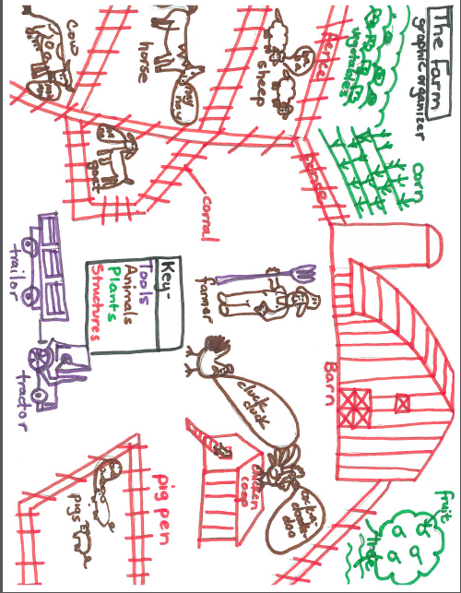
The Cow Pictorial Input Chart
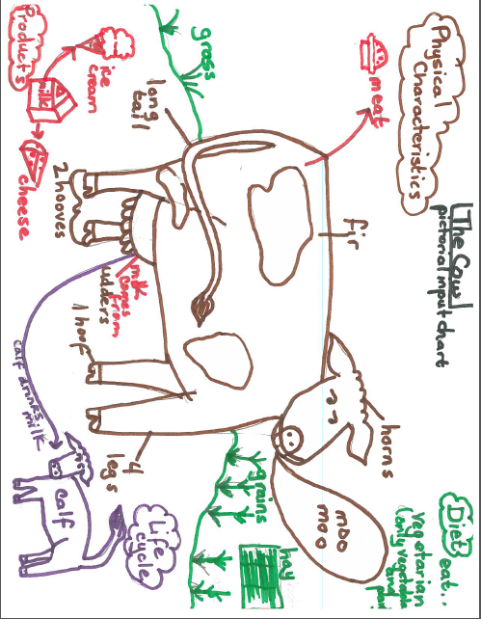
Dairy Cow to Milk Carton
- Physical Characteristics
  - 4 legs, hooves, ears, eyes, tail, mouth and an udder (add udder after calf is on chart)
- Diet
  - A cow grazes on grass, grain, hay and drinks water.
- Life Cycle
  - A cow gives live birth to a calf.
  - After she gives birth to the calf the cow’s udder fills with milk to feed the calf.
  - The udder is a bag with 4 teats that the calf sucks on for milk. As the calf gets older it also eats grass, grain, and hay.
- Product
  - On a dairy farm the milk a cow produces becomes a product for us.
  - The cow is taken to a milking parlor. The milking machine is attached to the cow’s teats on the udder.
  - The milk then goes through pipes to a cold storage tanks.
  - A special truck that keeps the milk cold takes the milk from the milking tanks and transports it to the dairy plant.
  - At the dairy plant the milk is pasteurized to kill the bacteria and then packaged. Some milk is packed in cartons like the milk we have in the school cafeteria.
  - The milk can also be used to make cheese, ice cream, and pudding.

Input Chart: The Cow Pictorial Input Chart Grade Level: kindergarten
Project GLAD® Trainers:

Stages of Language Acquisition | Preproduction | Early Production | Speech Emergence | Intermediate Fluency | Advanced Fluency
New Mexico WIDA (ELD)  Proficiency Level Descriptors | Entering | Emerging | Developing | Expanding | Lifelong Language/CCSS
Other: | Point To, Locate, Trace | Yes/No | Either/Or | Open Ended
Evaluation  Appraise, argue, assess, attach, choose, compare, defend, estimate, judge, predict, rate, select, support, value, evaluate | Show me one physical characteristic of the cow. | Do cows eat vegetables? | Is the purpose of the cow’s utters to produce milk or to feed the calf? | What are the physical characteristics of a cow?
Synthesis  Arrange, assemble, collect, compose, construct, create, design, develop, formulate, manage, organize, plan, prepare, propose, set up | Find a plant the cow eats. | Does this picture show where hay comes from? | Does ice cream come from milk or meat? | What happens to the milk before it is packaged?
Analysis  Analyze, appraise, calculate, categorize, compare, contrast, criticize, differentiate, discriminate, distinguish, examine, experiment, question, test | Show me where milk comes from on the cow. | (Show a picture of the open grass plains and a farm) Where does the cow live? | Does the cow have fur or hair? | What is it called when a cow eats grass?

Stages of Language Acquisition | Preproduction | Early Production | Speech Emergence | Intermediate Fluency | Advanced Fluency
New Mexico WIDA (ELD)  Proficiency Level Descriptors | Entering | Emerging | Developing | Expanding | Lifelong Language/CCSS
Other: | Point To | Yes/No | Either/Or | Open Ended
Application  Apply, choose, demonstrate, dramatize, employ, illustrate, interpret, operate, practice, schedule, sketch, solve, use | Identify the calf. | Do you think the calf eats grass or drinks milk? | Is the bacteria in the milk killed by it being pasteurized or left outside? | What do calves have in common with human babies?
Comprehension  Classify, describe, discuss, explain, express, identify, indicate, locate, recognize, restate, review, select, translate | Point to the products that come from a cow. | Are the feet of the cow called hooves or legs? | Do you kill the cow or milk the cow to get milk? | Explain the purpose of the cows utters.
Knowledge  Arrange, order, define, duplicate, label, list, name, recognize, relate, recall, repeat, reproduce | Point to the information that talks about the diet of a cow. | Do the products of cheese and meat come from a cow or do hay and calves come from a cow? | Does a cow graze on grain or fruit? How do you know? | List the other products made from milk.

Title: The Little Red Hen
Author: Unknown
Illustrator: Lucinda McQueen

1) Characters – hen, goose, cat, dog – and hen working

Once upon a time, there was a little red hen who shared her tiny cottage with a goose, a cat, and a dog. The goose was a gossip. She chatted with the neighbors all day long. The cat was very vain. She brushed her fur, straightened her whiskers, and polished her claws all day long. The dog was always sleepy. He napped on the front porch swing all day long.
The Little Red Hen ended up doing all of the work around the house. She cooked. She cleaned. She washed the clothes and took out the trash. She mowed the lawn and raked the leaves. She even did all of the shopping.

2) Finding grains and planting them

One morning on her way to market, the Little Red Hen found a few grains of wheat. She put them in the pocket of her apron. When she got home she asked her friends, “Who will plant these grains of wheat?”
“Not I,” said the goose.
“Not I,” said the cat.
“Not I,” said the dog.
“Then I will plant them myself,” said the Little Red Hen.
And she did.

3) Taking care of plants

When the grains of wheat began to sprout, the Little Red Hen cried, “Look, the wheat I planted is coming up! Who will help me take care of it this summer?”
“Not I,” said the goose.
“Not I,” said the cat.
“Not I,” said the dog.
“Then I will take care of it myself,” said the Little Red Hen.
And she did.
All summer she cared for the growing wheat. She made sure that it got enough water, and she hoed the weeds out carefully between each row. By the end of the summer, the wheat had grown tall.

4) Cutting and threshing wheat

And when it turned from green to gold, she asked her friends, “Who will help me cut and thresh this wheat?”
“Not I,” said the goose.
“Not I,” said the cat.
“Not I,” said the dog.
“Then I will cut and thresh it myself,” said the Little Red Hen.
And she did.

5) Taking to mill and grinding to flour

When all of the wheat had been cut and threshed, the Little Red Hen scooped the wheat into a wheelbarrow and said, “This wheat must be ground into flour. Who will help me take it to the mill?”
“Not I,” said the goose.
“Not I,” said the cat.
“Not I,” said the dog.
“Then I will take it myself,” said the Little Red Hen.
And she did.
The miller ground the wheat into flour and put it into a bag for the Little Red Hen. Then, all by herself, she pushed the bag home in the wheelbarrow.

6) Baking bread

One cool fall morning not many days later, the Little Red Hen got up early and said, “Today would be a perfect day to bake some bread. Who will help me bake a loaf of bread with the flour I brought home from the mill?”
“Not I,” said the goose.
“Not I,” said the cat.
“Not I,” said the dog.
“Then I will bake the bread myself,” said the Little Red Hen.
And she did.
She mixed the flour with milk and eggs and butter and salt. She kneaded the dough and shaped it into a nice plump loaf. Then she put the loaf in the oven and watched it as it baked.

7) Animals smelling bread

The smell of the baking bread soon filled the air. It smelled so delicious that the goose stopped chatting… the cat stopped brushing… and the dog stopped napping.
One by one, they came into the kitchen. When the Little Red Hen took the freshly baked loaf of bread out of the oven, she said, “Who will help me eat this bread?”
“Oh, I will!” said the goose.
“And I will!” said the cat.
“And I will!” said the dog.
“You will?” said the Little Red Hen.

8) Hen eating bread by herself

“Who planted the wheat and took care of it? I did.
“Who cut the wheat? Who threshed it and took it to the mill? I did.
“Who brought the flour home and baked this loaf of bread? I did.
“I did it all by myself. Now, I am going to eat it all by myself.”
And that is exactly what she did.

The Chickens
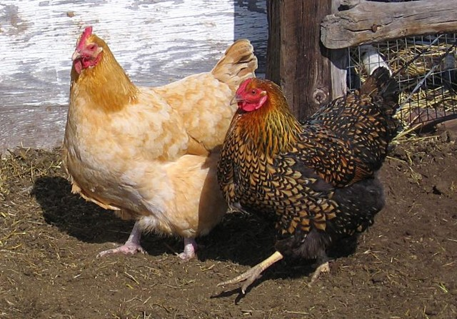

Las gallinas

The Goat
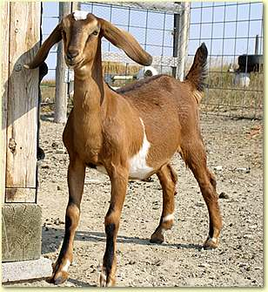

________________________
La Cabra

The Sheep
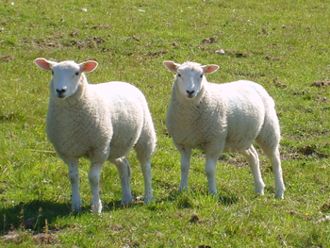

Las Ovejas

The Pig
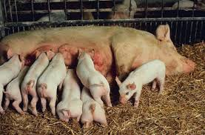

La Cerda

The Bull
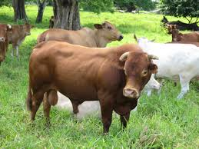

El toro

The Cow
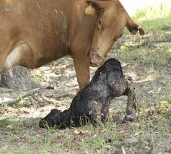

La vaca

________________________

LA GRANJA

Por Kavita Krishna y Rhonda López

Los animales de la granja crecen, reproducen, y proveen productos que los seres humanos usan todos los días.

- Las características de un animal son las partes de su cuerpo que le ayudan a sobrevivir.
- El ciclo de la vida de un animal es como nace, como crece, y como reproduce.
- La dieta de un animal es lo que come.
- Los productos de un animal es lo que el granjero puede usar o lo que puede vender para ganar dinero.

Recuerda que los animales de la granja crecen, reproducen, y proveen productos que los seres humanos usan todos los días.

PAGE 1
Los animales de la granja crecen, reproducen, y proveen productos que los seres humanos usan todos los días.

- Las gallinas y los gallos son aves con dos patas, dos alas, un pico y un cuerpo cubierto de plumaje.
- El macho es un gallo y la hembra es una gallina.
- Las gallinas ponen huevos en un nido.
- Las gallinas se sientan en sus huevos para calentarlos.
- Después de 21 días, los pollitos salen del cascarón.
- Los pollitos crecen hasta ser un gallo o una gallina.
- Las gallinas y los gallos comen plantas, insectos y otros animales. Son omnívoros.
- Les gusta mucho comer maíz, hojas, semillas y trigo.
- En todas partes del mundo la gente cría gallinas para producir huevos y carne.
- La carne de una gallina o un gallo se llama pollo.

Recuerda que los animales de la granja crecen, reproducen, y proveen productos que los seres humanos usan todos los días.

PAGE 2

Los animales de la granja crecen, reproducen, y proveen productos que los seres humanos usan todos los días.

- Las ovejas y los corderos son mamíferos. Están cubiertos de pelaje que se llama lana.
- Tienen cuatro patas con pezuñas.
- La hembra tiene ubres.
- Algunos corderos y ovejas tienen cuernos.
- La hembra es una oveja. El macho es un carnero.
- Las hembras normalmente dan a luz a uno o dos crías que se llaman corderitos.
- Las ovejas y los carneros comen plantas. Son herbívoros. No comen carne.

Recuerda que los animales de la granja crecen, reproducen, y proveen productos que los seres humanos usan todos los días.

PAGE 3

Los animales de la granja crecen, reproducen, y proveen productos que los seres humanos usan todos los días.

- Los corderitos toman leche de su mamá porque son mamíferos.
- Las ovejas y los carneros proveen lana y carne.
- El granjero corta la lana como si fuera un corte de pelo.
- Se usa la lana para hacer suéteres, calcetines y otra ropa.
- Se come la carne de cordero.

Recuerda que los animales de la granja crecen, reproducen, y proveen productos que los seres humanos usan todos los días.

PAGE 4

Los animales de la granja crecen, reproducen, y proveen productos que los seres humanos usan todos los días.

- Las cerdas y los cerdos son mamíferos. Tienen cuatro patas cortas, pezuñas y una cola corta.
- El hocico de este animal es plano, y la piel es gruesa y cubierta, en parte, con pelo grueso.
- La cerda, o la hembra, da a luz a dos camadas de 10 o más cerditos por año. ¡Qué montón de cerditos!
- Las cerdas y los cerdos son omnívoros. Comen plantas y animales.
- Les gusta comer lo que pueden encontrar; frutas, insectos, ratones y gusanos.
- Los cerditos toman leche de sus mamás.
- Los granjeros crían cerdos y cerdas para proveer carne, que se llama la carne de puerco.
- De la carne de puerco se hace tocino, chuletas, jamón y chorizo.

Recuerda que los animales de la granja crecen, reproducen, y proveen productos que los seres humanos usan todos los días.

PAGE 5

Los animales de la granja crecen, reproducen, y proveen productos que los seres humanos usan todos los días.

- Las chivas y los chivos son mamíferos con un pelaje grueso.
- Tienen cuatro patas con pezuñas y una cola corta.
- Las chivas y los chivos crecen barbas y tienen cuernos.
- La hembra tiene ubres.
- La hembra es una chiva o una cabra y sus crías son chivitos.
- Normalmente dan a luz a dos chivitos a la vez, pero pueden dar a luz a hasta cinco chivitos.
- Las chivas y los chivos son herbívoros. Sólo comen plantas.
- Les gusta comer hojas, ramas y zacate.
- Los chivitos toman leche de su mamá.
- Los granjeros crían chivas y chivos para proveer carne y leche de cabra.
- Usan la leche para hacer queso de cabra.

Recuerda que los animales de la granja crecen, reproducen, y proveen productos que los seres humanos usan todos los días.

PAGE 6

Los animales de la granja crecen, reproducen, y proveen productos que los seres humanos usan todos los días.

- Las vacas y los toros son mamíferos.
- Tienen cuatro patas con pezuñas y una cola larga.
- Los machos tienen cuernos y a veces las hembras tienen cuernos también.
- La hembra tiene ubres.
- La hembra es una vaca y el macho es un toro.
- Las vacas dan a luz a uno o dos bebés.
- Los bebés se llaman terneros.
- Las vacas y los toros son herbívoros.
- No comen animales.
- Les gusta comer zacate, granos y heno.
- Los terneros toman leche de su mamá.
- Los granjeros crían vacas para proveer carne, que se llama la carne de res.
- Las vacas producen leche.
- También usamos la leche para hacer queso y helado.

Recuerda que los animales de la granja crecen, reproducen, y proveen productos que los seres humanos usan todos los días.

PAGE 7

Poetry Book
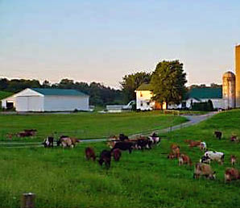

NAME:____________
Yes, Ma’am

Is this a cow? Yes, Ma’am!
Is this a cow? Yes, Ma’am!
How do you know? It lives on a farm.
How do you know? It gives us milk.
Tell me more. It’s a mammal.

Is this a chicken? Yes, Ma’am!
Is this a chicken? Yes, Ma’am!
How do you know? It lives on a farm.
How do you know? It gives us eggs.
Tell me more. It’s a bird.

Is this a sheep? Yes, Ma’am!
Is this a sheep? Yes, Ma’am!
How do you know? It lives on a farm.
How do you know? It gives us wool.
Tell me more. It’s a mammal.

Is this a pig? Yes, Ma’am!
Is this a pig? Yes, Ma’am!
How do you know? It lives on a farm.
How do you know? It gives us bacon and ham.

Is this corn? Yes, Ma’am!
Is this corn? Yes, Ma’am!
How do you know? It grows on the farm.
How do you know? We us it for tortillas.
Tell me more. It’s a plant.

Are these onions? Yes, Ma’am!
Are these onions? Yes, Ma’am!
How do you know? They grow on the farm.
How do you know? They grow underground.
Tell me more. They are plants.

Is this a horse? Yes, Ma’am!
Is this a horse? Yes, Ma’am!
How do you know? It lives on a farm.
How do you know? It helps with our work.
Tell me more. It’s a mammal.

I Know a Farmer

I know a farmer,
A very busy farmer,
A hard-working farmer,
Who works every day.

She plants the seeds,
Works the crops,
Milks the cows,
And feeds the chickens.

I know a farmer,
A very busy farmer,
A had-working farmer,
Who supplies us with the food we eat.
GABBY’S FARM

This is the farm that Gabby built.

These are the sheep
That provide the wool
On the farm that Gabby built.

This is the sheep shearer,
Who shears the sheep,
That provide the wool
On the farm that Gabby built.

This is the wool room worker,
Who washes and spins the wool.
Taken from the sheep shearer,
Who shears the sheep,
That provide the wool
On the farm that Gabby built.

This is Gabby’s sister,
Who knits a warm sweater,
Using the wool she loves,
Taken from the wool room worker
Who washes and spins the wool.
Taken from the sheep shearer,
Who shears the sheep,
That provide the wool
On the farm that Gabby built.

S. Cooper

Farmyard Boogaloo

I’m a farmer and I’m here to say,
I work on my farm everyday.
Raising livestock is what I like to do,
Providing products for your family and you.

Livestock, farmers, equipment too,
Doing the Farmyard Boogaloo!

Feeding calves and cows, there is milking to do,
Mucking out stalls full of lots of poo.
Gathering eggs from the chickens’ nests,
Shearing the sheep, no time to rest.

Livestock, farmers, equipment too,
Doing the Farmyard Boogaloo!

Goats in a herd chewing their cud,
Piglets in the pen wallowing in mud
Different types of farmers working hard every day,
Bringing important products to the market for their pay.

Livestock, farmers, equipment too,
Doing the Farmyard Boogaloo!

S. Cooper & A. Erwin

FARMERS HERE, FARMERS THERE

Farmers here, farmers there,
Farmers, farmers everywhere!

Young farmers feeding,
Happy farmers planting,
Old farmers picking,
And thirsty farmers resting.

Farmers in the field,
Farmers by the barn,
Farmers on a tractor,
And farmers at the market.

Farmers here, farmers there,
Farmers, farmers everywhere!

Farmers! Farmers! Farmers!

Rhonda López

Old MacDonald
Old MacDonald had a farm, A-E-I-O-U.
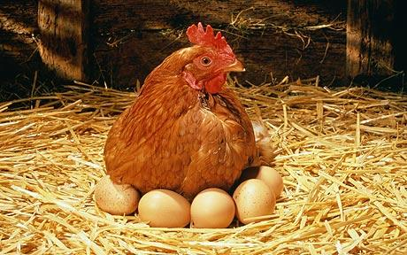And on his farm he had a chicken,
A-E-I-O-U.
With a cluck, cluck here,
And a cluck, cluck there,
Here a cluck, there a cluck,
Everywhere a cluck, cluck,
Old MacDonald had a farm,
A-E-I-O-U.

Old MacDonald had a farm, A-E-I-O-U.
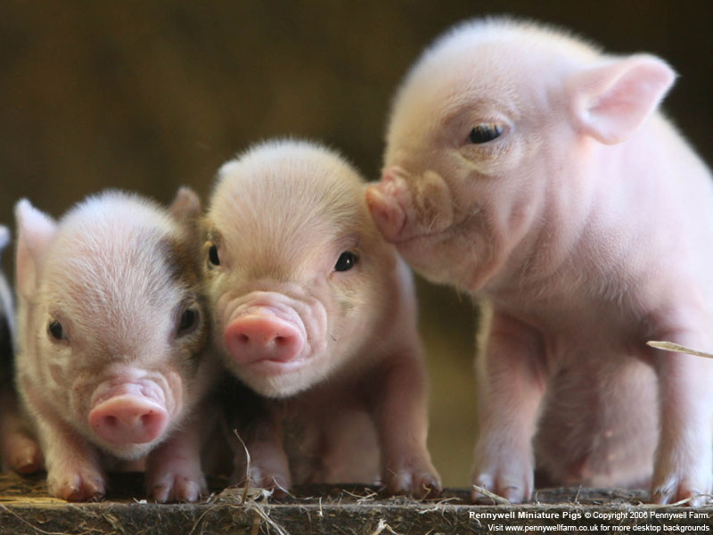And on his farm he had some pigs,
A-E-I-O-U.
With an oink, oink here,
And an oink, oink there,
Here an oink, there an oink,
Everywhere an oink, oink,
Old MacDonald had a farm,
A-E-I-O-U.

Old MacDonald had a farm, A-E-I-O-U.
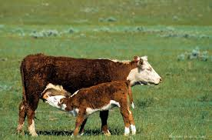And on his farm he had some cows,
A-E-I-O-U.
With a moo, moo here,
And a moo, moo there,
Here a moo, there a moo,
Everywhere a moo, moo,
Old MacDonald had a farm,
A-E-I-O-U.

Old MacDonald had a farm, A-E-I-O-U.
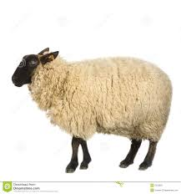And on his farm he had some sheep,
A-E-I-O-U.
With a baa, baa here,
And a baa, baa there,
Here a baa, there a baa,
Everywhere a baa, baa,
Old MacDonald had a farm,
A-E-I-O-U.
Old McDougal
Old McDougal had a farm, A-E-I-O-U.
And on his farm he had a chicken,
A-E-I-O-U.
With a cluck, cluck here,
And a cluck, cluck there,
Here a cluck, there a cluck,
Everywhere a cluck, cluck,
Old McDougal had a farm,
A-E-I-O-U.

Old McDougal had a farm, A-E-I-O-U.
And on his farm he had some pigs,
A-E-I-O-U.
With an oink, oink here,
And an oink, oink there,
Here an oink, there an oink,
Everywhere an oink, oink,
Old McDougal had a farm,
A-E-I-O-U.

Old McDougal had a farm, A-E-I-O-U.
And on his farm he had some cows,
A-E-I-O-U.
With a moo, moo here,
And a moo, moo there,
Here a moo, there a moo,
Everywhere a moo, moo,
Old McDougal had a farm,
A-E-I-O-U.

Old McDougal had a farm, A-E-I-O-U.
And on his farm he had some sheep,
A-E-I-O-U.
With a baa, baa here,
And a baa, baa there,
Here a baa, there a baa,
Everywhere a baa, baa,
Old McDougal had a farm,
A-E-I-O-U.

LIBRO DE POESIA
Y CANCIONES
LA GRANJA

NOMBRE________________________________

LOS POLLITOS

Los pollitos dicen, PIO PIO PIO
Cuando tienen hambre,
Cuando tienen frío.
La gallina busca,
El maíz y el trigo,
Y les da la comida.

MI GRANJA

Vengan a ver mi granja vengan todos,
Vengan a ver mi granja es muy linda.
La vaca hace así MU MU
La vaca hace así MU MU

O vengan a ver
O vengan a ver
O vengan vengan vengan
O vengan a ver
O vengan a ver
O vengan vengan vengan.

La gallina hace CARA CARA
La oveja hace BA BA
El caballo hace NI NI
El perro hace GUAU GUAU
El gallo hace QUI QIRI QUI
El cerdo hace OINK OINK

DE COLORES

De colores, de colores se visten los campos en la primavera.
De colores, de colores son los pajaritos que vienen de afuera
De colores, de colores es el arco iris que vemos lucir
Y por eso los grandes amores de muchos colores me gustan a mí.
Y por eso los grandes amores de muchos colores me gustan a mí.

Canta el gallo.
Canta el gallo con el quiri quiri quiri
La gallina.
La gallina con el cara cara cara
Los pollitos.
Los pollitos con pio pio pio pio
Y por eso los grandes amores de muchos colores
Me gustan a mí.
Y por eso los grandes amores de muchos colores
Me gustan a mí.

¡Sí Maestra!
¿Es una vaca? ¡ Sí, Maestra!
¿Es una vaca? ¡Sí, Maestra!
¿Cómo lo sabes? Vive en la granja.
¿Cómo lo sabes? Nos da la leche.
Dime más. Es un mamífero.
¿Es una gallina? ¡Sí, Maestra!
¿Es una gallina? ¡Sí, Maestra!
¿Cómo lo sabes? Vive en la granja.
¿Cómo lo sabes? Nos da los huevos.
Dime más. Es un ave.
¿Es una oveja? ¡Sí, Maestra!
¿Es una oveja? ¡Sí, Maestra!
¿Cómo lo sabes? Vive en la granja.
¿Cómo lo sabes? Nos da la lana.
Dime más. Es un mamífero.
¿Es un cerdo? ¡Sí, Maestra!
¿Es un cerdo? ¡Sí, Maestra!
¿Cómo lo sabes? Vive en la granja.
¿Cómo lo sabes? Nos da el tocino y el jamón.
Dime más. Es un mamífero.
¿Es maíz? ¡Sí, Maestra!
¿Es maíz? ¡Sí, Maestra!
¿Cómo lo sabes? Crece en la granja.
¿Cómo lo sabes? Lo usamos para hacer tortillas.
Dime más. Es una planta.
¿Son cebollas? ¡Sí, Maestra!
¿Son cebollas? ¡Sí, Maestra!
¿Cómo lo sabes? Crecen en la granja.
¿Cómo lo sabes? Crecen debajo de la tierra.
Dime más. Son plantas.
¿Es un caballo? ¡Sí, Maestra!
¿Es un caballo? ¡Sí, Maestra!
¿Cómo lo sabes? Vive en la granja.
¿Cómo lo sabes? Nos ayuda a trabaja

Vacas aquí, vacas allá

Vacas aquí, vacas allá,
¡Vacas, Vacas por todo lugar!

Vacas gordas pastoreando,
Vacas cansadas reposando,
Vacas hambrientas comiendo,
Vacas ruidosas mugiendo.

Vacas en la granja,
Vacas en el campo,
Vacas al lado de las gallinas,
Y vacas en el pasto.

Vacas aquí, vacas allá,
¡Vacas, vacas por todo lugar!
¡Vacas! ¡Vacas! ¡Vacas!

Gallinas

Gallinas aquí, Gallinas allá
Gallinas aquí, gallinas allá,
¡Gallinas, gallinas ra ra ra!

Gallinas mandonas picoteando,
Gallinas hambrientas rascando,
Pollitos salen del cascarón,
Gallos ruidosos cacaraquean.

Gallinas en la granja,
Gallinas en el gallinero,
Gallinas alrededor del corral,
Y gallinas encima de sus huevos.

Gallinas aquí, gallinas allá,
¡Gallinas, gallinas ra ra ra!

¡Gallinas! ¡Gallinas! ¡Gallinas!

Conozco un granjero

Conozco un granjero,
Un granjero muy ocupado,
Un granjero muy trabajador,
Que trabaja todos los días.

Siembra semillas,
Trabaja las cosechas,
Ordeña las vacas,
Alimenta a las gallinas.

Conozco un granjero,
Un granjero muy ocupado,
Un granjero muy ocupado,
Quién nos surte los alimentos que consumimos.

Home School Connection #1
Farm Unit

Name: _____________________ Date: _____________

Discuss with your family if they have ever been to a farm. Sketch or write what your family shared.

Parent Signature: _______________________________

Home School Connection #2

Farm Unit

Name: _____________________ Date: _____________

Talk to your family about how the “The Little Red Hen.” Tell your family about “The Little Red Hen.” Have you ever done a project that no one helped you with? How did it make you feel? Sketch or write what your family shared.

Parent Signature: _______________________________

Home School Connection #3
Farm Unit

Name: _____________________ Date: _____________

Survey your family and find out what their favorite farm product is (For example: cheese, milk, ice cream, eggs, meat). Sketch or write their answer.

Parent Signature: _______________________________

Home School Connection #4
Farm Unit

Name: _____________________ Date: _____________

Talk about the different kinds of animals you might find on a farm. Explain what you think is the most important part of a farm.

Parent Signature: _______________________________

CONECCION DE Y ESCUELA #1
UNIDAD DE GRANJA

Nombre: _____________________ Fecha: _____________

Habla con su famila para se informe de ellos han visitado una granja. Dibuja o escribe que su familia compartio.

Firma de padre_________________________

CONECCION DE Y ESCUELA #2
UNIDAD DE GRANJA

Nombre: _____________________ Fecha: _____________

Repite la presentación narrativa a alguien (La Gallinita Roja) en su familia. ¿Cuál era su parte favorite? Dibuja o escribe su respuesta.

Firma de padre_________________________

CONECCION DE Y ESCUELA #3
UNIDAD DE GRANJA

Nombre: _____________________ Fecha: _____________

Pregunta su familia para se informe de cual es su producto de granja favorite. Dibju o escriba sus respuestas.

Firma de padre_________________________

CONECCION DE Y ESCUELA #4

UNIDAD DE GRANJA

Nombre: _____________________ Fecha: _____________

Habla con tu familia acerca de los tipos de animales que puedes encontrar en la granja. Explica lo que crees que es la parte más importante de la granja.

Firma de padre_________________________
Chickens

Physical Characteristics
Chickens are birds with two legs, two wings, a beak and bodies covered in feathers called plumage. Chickens have two wattles hanging under their chin and a comb on the top of their head.

Life Cycle
Female chickens called hens lay eggs in nests. Hens keep the eggs warm by sitting on them. After 21 days the chick will hatch by breaking the shell apart. Chickens can live to be seven years old.

Diet
Chickens are omnivores. Omnivores eat both plants and other animals. Chickens will eat insects, worms, slugs, and snails. They also eat corn, leaves, seeds and grains.

Products
Chickens are raised all over the world to produce meat and eggs. The meat and eggs from chickens are called poultry products. Some poultry products are: chicken nuggets and eggs.

Las gallinas y los gallos

Características físicas
Las gallinas y los gallos son aves con dos patas, dos alas, un pico y un cuerpo cubierto de plumas.

Ciclo de vida
El macho se llama gallo y la hembra se llama gallina. Las gallinas ponen huevos en un nido. Las gallinas se sientan en sus huevos para calentarlos. Después de 21 días, los pollitos salen del cascarón. Los pollitos crecen hasta ser un gallo o una gallina.

Dieta
Las gallinas y los gallos comen plantas, insectos y otros animales. Son omnívoros. Les gusta mucho comer maíz, hojas, semillas y trigo.

Productos
En todas partes del mundo la gente cría a las gallinas para producir huevos y carne. La carne de una gallina o un gallo se llama pollo.

Sheep
Physical Characteristics
Sheep are mammals with a thick coat of hair called wool covering their body. Sheep have four legs and hooves. Female sheep have udders. Some sheep have horns that curve out from their head.

Lifecycle
Female sheep called ewes usually give live birth to one or two lambs at a time. Sheep are considered full grown at approximately a year old. Sheep can live to be twenty years old.

Diet
Sheep are herbivores. They do not eat other animals. Sheep are grazers eating grass hay and grain from the ground. Lambs drink their mother’s milk and at 4 months will also graze like their parents.

Products
Sheep are raised primarily for their wool and meat. The wool is sheared from the sheep like a haircut and then used to make clothes like sweaters and socks. Lamb chops and mutton are both meat products that come from sheep.

Interesting Facts
Sheep have many predators. To protect themselves they gather into large groups called flocks. Guardian dogs are used in many countries to protect the sheep from predators.

Las ovejas y los corderos
Características físicas
Las ovejas y los corderos son mamíferos estan cubiertos de pelaje que se llama lana. Tienen cuatro patas con pezuñas. La hembra tiene ubres. Algunos corderos y ovejas tienen cuernos.

Ciclo de vida
Una oveja femenina se llama una hembra. El macho se llama un carnero. Las hembras normalmente da luz a uno o dos bebes que se llaman corderos.

Dieta
Las ovejas y los corderos comen plantas. Son herbívoros. No comen carne. Los corderos toman leche de su mamá porque son mamíferos.

Productos
Las ovejas y los corderos son criados para su lana y su carne. El granjero corta la lana como un corte de pelo. Se usa la lana para hacer ropa como suéteres y calcetines. La carne del cordero se llama borrego.

Pigs
Physical Characteristics
Pigs are mammals with four short legs, hooves, and a short tail. Pigs have snouts and thick skin that is partly covered in bristly hair.

Life Cycle
Female pigs called sows give live birth to litters of 10 or more piglets. Pigs reach their adult size at about two years of age. Pigs can live from 9 to 15 years of age.

Diet
Pigs are omnivores, eating both plants and other animals. Pigs eat what they can find including fruit, insects, mice, and worms. Piglets nurse their mother for approximately 4 weeks then they begin to eat solid food. On a farm they may be fed pig food, which contains grains and soy.

Products
Pigs are raised primarily to provide meat, which is called pork. Pork products include: bacon, pork chops and ham. The skin of the pig may be used for leather and the bristles are used for brushes.

Interesting Facts
Pigs are considered smarter than dogs. They learning very quickly and they make excellent pets.

Las cerdas y los cerdos
Características físicas
Las cerdas y los cerdos son mamíferos. Tienen cuatro patas cortas, pezuñas y una cola corta. El hocico de este animal es plano, y la piel es gruesa y cubrieta en parte con pelo grueso.

Ciclo de vida
La cerda, o la hembra, da luz a dos camadas de 10 o más cerditos por año. ¡Qué montón de cerditos!

Dieta
Las cerdas y los cerdos son omnívoros. Comen plantas y animales. Les gusta comer lo que pueden encontrar, como frutas, insectos, ratones y gusanos. Los cerditos toman leche de sus mamás.

Productos
Los granjeros crian a los cerdos y a las cerdas para proveer carne, que se llama puerco. Otros productos son tocino, chuletas, jamón y chorizo.

Goats
Physical Characteristics
Goats are mammals with a thick furry coat of hair, short upturned tail, four legs, and hooves. Both male and female goats grow beards from their chins and have pointed horns. A female goat has an udder.

Lifecycle
Female goats called a nanny or doe give live birth to kids in the spring. The average number of kids a doe will birth is two, but they can give birth to as many as 5 kids. Goats can live 16 years.

Diet
Goats are herbivores; they eat only plants not other animals. Goats eat the leaves and bark of trees, shrubs, berry brambles, thistles and other plants and grass. Kids nurse their mother for a few months.

Products
Goats are raised around the world primarily to provide food products. The milk from goats can be used to make cheese and other dairy products. Goat meat is often called chevon.

Interesting Facts
Goats require little space and are often raised where cattle and sheep can’t be. Around the world people drink more goat milk than cow milk and goat meat is eaten more than chicken, beef, or pork.

Las chivas y los chivos
Características físicas
Las chivas y los chivos son mamíferos con un pelaje grueso. Tienen cuatro patas con pezuñas y una cola corta. Las chivas y los chivos crecen barbas y tienen cuernos. La hembra tiene ubres.

Ciclo de vida
La hembra se llama una chiva o una cabra y dan luz a los chivitos en la primavera. Normalmente dan luz a dos chivitos, pero pueden dar luz a cinco.

Dieta
Las chivas y los chivos son herbívoros. Sólo comen plantas y no comen animales. Les gusta comer hojas, ramas y zacate. Los chivitos toman leche de su mamá.

Productos
Los granjeros crian a las chivas y a los chivos para proveer carne y leche de cabra. Usan la leche también para hacer queso de cabra.

Las vacas y los toros
Características físicas
Las vacas y los toros son mamíferos. Tienene cuatro patas con pezuñas y una cola larga. Los machos tienen cuernos y a veces las hembras tienen cuernos también. La hembra tiene umbres.

Ciclo de vida
La hembra se llama una vaca y el macho se llama un toro. Las vacas dan luz a uno o dos bebés. Los bebés se llaman terneros.

Dieta
Las vacas y los toros son herbívoros. No comen animales. Les gusta comer zacate, granos y heno. Los terneros toman leche de su mamá.

Productos
Los granjeros crian a los toros para proveer carne que se llama carne de rez. Las vacas producen leche. También usamos la leche para hacer queso y helado.

Process Grid
Animal | Physical Characteristics | Life Cycle | Diet | Product

Cow

Chicken

Sheep
Pig
Goat

Animal | Características  Físicas | Ciclo de Vida | Dieta | Productos

La vaca

La gallina
La oveja
El chivo

Guess My Category

Cow | Sheep |  | Goat
Pig |  | Chicken
Guess My Category

Cow  Milk  Beef  Calf  Milk Parlor  Graze on grass | Sheep  Wool  Lamb  Wool Room  Shear  Ewe  Ram |  | Goat  Nanny  Beard  Kid  Eats berry brambles  Billy  Meat called chevon  Raised where there is little room for cattle
Pig  Pork  Omnivore: eat worms and mice  Litter of 10 or more piglets  Bacon  Ham  Short legs  Smarter than dogs |  | Chicken  Hens lay eggs  Has two wattles  Wings  Poultry  Chick

Farms (1)-ABC/Alphabet Book

Agriculture
Beef
Cow
Doe
Egg
Farmer
Goat
Hen
Ice Cream
Jerky
Kid
Livestock
Milk
Nanny
Omlette
Pig
Qual
Rooster
Sow
Turkey
Udder
Veil
Wool
FoX a predator of sheep
Yolk
Zoologist

LA GRANJA

Nombre______________

The Farm

Name______________

Title: The Cow That Went OINK
Author and Illustrator: Bernard Most

1- Animals laughing at cow
There was once a cow that went OINK.
“Oink.”
The cows that went MOO laughed at the cow that went OINK.
“Oink?”
“Moo-ha! Moo-ha!”
And the other animals on the farm laughed at her, too.
“Oink.”
“Gobble-ha!”
“Cock-a-doodle-doo-ha!”
“Cluck-ha!”
“Quack-ha!”
The cow that went OINK was very sad.

2- Cow and pig meeting

One day she heard a friendly MOO.
“Oink?”
“Moo.”
It was a pig that went MOO. What a surprise!
“Oink.”
“Moo.”

3- Animals laughing at pig or pig being sad

The pigs that went OINK laughed at the pig that went MOO.
“Moo?”
“Oink-ha! Oink-ha!”
And the other animals laughed at her, too.
“Moo?”
“Neigh-ha!”
“Hee-haw-ha!”
“Baa-ha!”
“Gribet-ha!”
The pig that went MOO was very sad.

4 – Cow teaching pig or animals laughing

The cow that went OINK had an idea. She would teach the pig to OINK.
“Oink.”
“Moo?”
So the cow that went OINK made a loud OINK, while the pig that went MOO listened carefully.
“OINK.”
“Moo.”
Then the pig that went MOO tried to OINK.
“OIMOO.”
“Oink?”

The horse, the donkey, and the sheep thought this was very funny.
“Neigh-ha!”
“Hee-haw-ha!”
“Baa-ha!”

5 – Pig learning OINK with approximations

But the pig that went MOO didn’t listen to them. She listened to the cow.
“Oink, oink. Oink, oink. OINK, OINK. Oink, oink.”
“Oimook?”
And the pig that went MOO tried again…
“Oinoomoo?”
“Oink.”
and again…
“OINOO?”
“Oink.”
and again…
“OINKOO?”
“O-i-n-k.”
until she finally went OINK.
“O-i-n-k? Oin…Oink. OINK!”
“Oink.”

6 – Pig teaching cow or animals laughing

The pig could OINK. Now she would teach the cow to MOO.
“MOO.”
“Oink?”
The cow that went OINK tried to go MOO.
“MOINK.”
“Moo?”
The rooster, the turkey, and the duck laughed and laughed.
“Cock-a-doodle-ha!”
“Gobble-ha!”
“Quack-ha!”

7- Cow learning MOO with approximations

But the cow didn’t listen to them. She listened to the pig.
“Moo, moo. Moo, moo. MOO, MOO. Moo, moo.”
“Moink?”
And the cow that went OINK tried again…
“MOINKOO?”
“Moo.”
and again…
“MOONK?”
“Moo.”
and again…
“MOOK?”
“M-o-o.”
until the cow that went OINK finally went MOO.
“M-o-o? Mo…Moo. MOO!”
“Moo.”

8 – Cow and pig laughing

The cow and the pig were very happy. Each of them could MOO and OINK.
“MOO, OINK.”
“OINK, MOO.”
And they were the only animals on the farm that could do both. So they had the last laugh.
“MOO-HA, OINK-HA.”
“OINK-HA, MOO-HA.”

