DLeNM Project GLAD
Texas Regions and People
Austin Independent School District, 7th grade
IDEA PAGES
- UNIT THEME: Texas - Location and place determine where people settle and how they develop culture.
- Geographic Regions/Subregions of Texas
- Richness of diversity of Texas people and cultures – focus on “The First Cultures of Texas” and European Settlement
- Natural resources and industries of Texas
- Impact of human development on Texas
- FOCUS & MOTIVATION
- Prediction-Reaction Guide
- Observation Charts
- Big Book: “The Important Book About Texas Regions”
- Cognitive Content Dictionary
- Inquiry Chart
- Read Aloud
- Three Personal Standards and Scouts
- Literacy Awards

- CLOSURE & ASSESSMENTS
- Processing of All Charts
- Learning Log
- Home/School Connections
- Portfolios
- Individual Tasks
- Team Presentations
- Graffiti Wall
- Jeopardy Game
- Teacher-Student Made Tests
- Teacher-made Test
- Chapter Tests
- Prediction-Reaction Guide (post)
- Action Plan
- Writing and Portfolio Rubrics

- CONCEPTS/STANDARDS: Social Studies, Grade 7 - Austin ISD Curriculum Road Map: 2014, 1st 6 Weeks
- 7.8 Geography. The student uses geographic tools to collect, analyze, and interpret data.
- 7.8A create and interpret thematic maps, graphs, charts, models, and databases representing various aspects of Texas during the 19th, 20th, and 21st centuries
- 7.9 Geography. The student understands the location and characteristics of places and regions of Texas.
- 7.9A locate the Mountains and Basins, Great Plains, North Central Plains, and Coastal Plains regions and places of importance in Texas during the 19th, 20th, and 21st centuries such as major cities, rivers, natural and historic landmarks, political and cultural regions, and local points of interest
- 7.9B compare places and regions of Texas in terms of physical and human characteristics
- 7.9C analyze the effects of physical and human factors such as climate, weather, landforms, irrigation, transportation, and communication on major events in Texas
- 7.10 Geography. The student understands the effects of the interaction between humans and the environment in Texas during the 19th, 20th, and 21st centuries.
- 7.10A identify ways in which Texans have adapted to and modified the environment and analyze the positive and negative consequences of the modifications
- 7.10B explain ways in which geographic factors such as… limited water resources, and alternative energy sources have affected the political, economic, and social development of Texas
- 7.11 Geography. The student understands the characteristics, distribution, and migration of population in Texas in the 19th, 20th, and 21st centuries.
- 7.11B analyze how immigration and migration to Texas in the 19th, 20th, and 21st centuries have influenced Texas
- 7.11C analyze the effects of the changing population distribution and growth in Texas during the 20th and 21st centuries and the additional need for education, health care and transportation
- 7.13 Economics. The student understands the interdependence of the Texas economy with the United States and the world.
- 7.13C analyze the impact of significant industries in Texas such as oil and gas, aerospace, medical, and computer technologies on local, national, and international markets.
- 7.19 Culture. The student understands the concept of diversity within unity in Texas.
- 7.19A explain how the diversity of Texas is reflected in a variety of cultural activities, celebrations, and performances
- 7.19B describe how people from various racial, ethnic, and religious groups attempt to maintain their cultural heritage while adapting to the larger Texas culture
- 7.19C identify examples of Spanish influence and the influence of other cultures on Texas such as place names, vocabulary, religion, architecture, food, and the arts
- 7.1 History. The student understands traditional historical points of reference in Texas history.
- 7.1A identify major eras in Texas history, describe their defining characteristics, and explain why historians divide the past into era, including Natural Texas and its People…
- 7.2 History. The student understands how individuals, events, and issues through the Mexican National Era shaped the history of Texas.
- 7.2A compare cultures of American Indians in Texas prior to European colonization such as Gulf, Plains, Puebloan, and Southeastern

- CONCEPTS/STANDARDS: English Language Arts, Grade 7 - Austin ISD Curriculum Road Map: 2014, 1st 6 Weeks
- 7.2 Reading/Vocabulary Development. Students understand new vocabulary and use it when reading and writing.
- 7.2A determine the meaning of grade-level academic English words derived from Latin, Greek, or other linguistic roots and affixes
- 7.2E use a dictionary, a glossary, or a thesaurus (printed or electronic) to determine the meanings, syllabication, pronunciations, alternate word choices, and parts of speech of words
- 7.F19B ask literal, interpretive, evaluative, and universal questions of text.
- 7.F19C monitor and adjust comprehension (e.g., using background knowledge; creating sensory images; rereading a portion aloud; generating questions).
- 7.22 Research. Students are expected to know how to locate a range of relevant sources and evaluate, synthesize, and present ideas and information.
- 7.22A brainstorm, consult with others, decide upon a topic, and formulate open-ended questions to address the major research topic
- 7.28 Listening and Speaking/Teamwork. Students work productively with others in teams. Students will continue to apply earlier standards with greater complexity. Students are expected to participate in student-led discussions by eliciting and considering suggestions from other group members and by identifying points of agreement and disagreement.
- 7.28A participate productively in discussions, plan agendas with clear goals and deadlines, set time limits for speakers, take notes, and vote on key issues.
- 7.6 Reading/Comprehension of Literary Text/Fiction. Students understand, make inferences and draw conclusions about the structure and elements of fiction and provide evidence from text to support their understanding.
- 7.6A explain the influence of the setting on plot development;
- 7.6B analyze the development of the plot through the internal and external responses of the characters, including their motivations
- 7.14 Writing/Writing Process. Students use elements of the writing process (planning, drafting, revising, editing, and publishing) to compose text.
- 7.14A plan a first draft by selecting a genre appropriate for conveying the intended meaning to an audience, determining appropriate topics through a range of strategies (e.g., discussion, background reading, personal interests, interviews), and developing a thesis or controlling idea;
- 7.14B develop drafts by choosing an appropriate organizational strategy (e.g., sequence of events, cause-effect, compare-contrast) and building on
- 7.14C revise drafts to ensure precise word choice and vivid images; consistent point of view; use of simple, compound, and complex sentences; internal and external coherence; and the use of effective transitions after rethinking how well questions of purpose, audience, and genre have been addressed
- 7.16 Writing. Students write about their own experiences.
- 7.16A Students are expected to write a personal narrative that has a clearly defined focus and communicates the importance of or reasons for actions and/or consequences.
- 7.19 Oral and Written Conventions/Conventions. Students understand the function of and use the conventions of academic language when speaking and writing. Students will continue to apply earlier standards with greater complexity.
- 7.19A use and understand the function of the following parts of speech in the context of reading, writing, and speaking RC3
- (i) verbs (perfect and progressive tenses) and participles RC3
- (ii) appositive phrases RC3
- (v) prepositions and prepositional phrases and their influence on subject-verb agreement

- CONCEPTS/STANDARDS: English Language Proficiency Standards (ELPS)

Cross-curricular second language acquisition essential knowledge and skills.
(1) Cross-curricular second language acquisition/learning strategies. The ELL uses language learning strategies to develop an awareness of his or her own learning processes in all content areas. In order for the ELL to meet grade-level learning expectations across the foundation and enrichment curriculum, all instruction delivered in English must be linguistically accommodated (communicated, sequenced, and scaffolded) commensurate with the student's level of English language proficiency. The student is expected to:
(A) use prior knowledge and experiences to understand meanings in English;
(B) monitor oral and written language production and employ self-corrective techniques or other resources;
(C) use strategic learning techniques such as concept mapping, drawing, memorizing, comparing, contrasting, and reviewing to acquire basic and grade-level vocabulary;
(D) speak using learning strategies such as requesting assistance, employing non-verbal cues, and using synonyms and circumlocution (conveying ideas by defining or describing when exact English words are not known);
(E) internalize new basic and academic language by using and reusing it in meaningful ways in speaking and writing activities that build concept and language attainment;
(F) use accessible language and learn new and essential language in the process;
(G) demonstrate an increasing ability to distinguish between formal and informal English and an increasing knowledge of when to use each one commensurate with grade-level learning expectations; and
(H) develop and expand repertoire of learning strategies such as reasoning inductively or deductively, looking for patterns in language, and analyzing sayings and expressions commensurate with grade-level learning expectations.
(2) Cross-curricular second language acquisition/listening. The ELL listens to a variety of speakers including teachers, peers, and electronic media to gain an increasing level of comprehension of newly acquired language in all content areas. ELLs may be at the beginning, intermediate, advanced, or advanced high stage of English language acquisition in listening. In order for the ELL to meet grade-level learning expectations across the foundation and enrichment curriculum, all instruction delivered in English must be linguistically accommodated (communicated, sequenced, and scaffolded) commensurate with the student's level of English language proficiency. The student is expected to:
(A) distinguish sounds and intonation patterns of English with increasing ease;
(B) recognize elements of the English sound system in newly acquired vocabulary such as long and short vowels, silent letters, and consonant clusters;
(C) learn new language structures, expressions, and basic and academic vocabulary heard during classroom instruction and interactions;
(D) monitor understanding of spoken language during classroom instruction and interactions and seek clarification as needed;
(E) use visual, contextual, and linguistic support to enhance and confirm understanding of increasingly complex and elaborated spoken language;
(F) listen to and derive meaning from a variety of media such as audio tape, video, DVD, and CD ROM to build and reinforce concept and language attainment;
(G) understand the general meaning, main points, and important details of spoken language ranging from situations in which topics, language, and contexts are familiar to unfamiliar;
(H) understand implicit ideas and information in increasingly complex spoken language commensurate with grade-level learning expectations; and
(I) demonstrate listening comprehension of increasingly complex spoken English by following directions, retelling or summarizing spoken messages, responding to questions and requests, collaborating with peers, and taking notes commensurate with content and grade-level needs.
(3) Cross-curricular second language acquisition/speaking. The ELL speaks in a variety of modes for a variety of purposes with an awareness of different language registers (formal/informal) using vocabulary with increasing fluency and accuracy in language arts and all content areas. ELLs may be at the beginning, intermediate, advanced, or advanced high stage of English language acquisition in speaking. In order for the ELL to meet grade-level learning expectations across the foundation and enrichment curriculum, all instruction delivered in English must be linguistically accommodated (communicated, sequenced, and scaffolded) commensurate with the student's level of English language proficiency. The student is expected to:
(A) practice producing sounds of newly acquired vocabulary such as long and short vowels, silent letters, and consonant clusters to pronounce English words in a manner that is increasingly comprehensible;
(B) expand and internalize initial English vocabulary by learning and using high-frequency English words necessary for identifying and describing people, places, and objects, by retelling simple stories and basic information represented or supported by pictures, and by learning and using routine language needed for classroom communication;
(C) speak using a variety of grammatical structures, sentence lengths, sentence types, and connecting words with increasing accuracy and ease as more English is acquired;
(D) speak using grade-level content area vocabulary in context to internalize new English words and build academic language proficiency;
(E) share information in cooperative learning interactions;
(F) ask and give information ranging from using a very limited bank of high-frequency, high-need, concrete vocabulary, including key words and expressions needed for basic communication in academic and social contexts, to using abstract and content-based vocabulary during extended speaking assignments;
(G) express opinions, ideas, and feelings ranging from communicating single words and short phrases to participating in extended discussions on a variety of social and grade-appropriate academic topics;
(H) narrate, describe, and explain with increasing specificity and detail as more English is acquired;
(I) adapt spoken language appropriately for formal and informal purposes; and
(J) respond orally to information presented in a wide variety of print, electronic, audio, and visual media to build and reinforce concept and language attainment.
(4) Cross-curricular second language acquisition/reading. The ELL reads a variety of texts for a variety of purposes with an increasing level of comprehension in all content areas. ELLs may be at the beginning, intermediate, advanced, or advanced high stage of English language acquisition in reading. In order for the ELL to meet grade-level learning expectations across the foundation and enrichment curriculum, all instruction delivered in English must be linguistically accommodated (communicated, sequenced, and scaffolded) commensurate with the student's level of English language proficiency. For Kindergarten and Grade 1, certain of these student expectations apply to text read aloud for students not yet at the stage of decoding written text. The student is expected to:
(A) learn relationships between sounds and letters of the English language and decode (sound out) words using a combination of skills such as recognizing sound-letter relationships and identifying cognates, affixes, roots, and base words;
(B) recognize directionality of English reading such as left to right and top to bottom;
(C) develop basic sight vocabulary, derive meaning of environmental print, and comprehend English vocabulary and language structures used routinely in written classroom materials;
(D) use prereading supports such as graphic organizers, illustrations, and pretaught topic-related vocabulary and other prereading activities to enhance comprehension of written text;
(E) read linguistically accommodated content area material with a decreasing need for linguistic accommodations as more English is learned;
(F) use visual and contextual support and support from peers and teachers to read grade-appropriate content area text, enhance and confirm understanding, and develop vocabulary, grasp of language structures, and background knowledge needed to comprehend increasingly challenging language;
(G) demonstrate comprehension of increasingly complex English by participating in shared reading, retelling or summarizing material, responding to questions, and taking notes commensurate with content area and grade level needs;
(H) read silently with increasing ease and comprehension for longer periods;
(I) demonstrate English comprehension and expand reading skills by employing basic reading skills such as demonstrating understanding of supporting ideas and details in text and graphic sources, summarizing text, and distinguishing main ideas from details commensurate with content area needs;
(J) demonstrate English comprehension and expand reading skills by employing inferential skills such as predicting, making connections between ideas, drawing inferences and conclusions from text and graphic sources, and finding supporting text evidence commensurate with content area needs; and
(K) demonstrate English comprehension and expand reading skills by employing analytical skills such as evaluating written information and performing critical analyses commensurate with content area and grade-level needs.
(5) Cross-curricular second language acquisition/writing. The ELL writes in a variety of forms with increasing accuracy to effectively address a specific purpose and audience in all content areas. ELLs may be at the beginning, intermediate, advanced, or advanced high stage of English language acquisition in writing. In order for the ELL to meet grade-level learning expectations across foundation and enrichment curriculum, all instruction delivered in English must be linguistically accommodated (communicated, sequenced, and scaffolded) commensurate with the student's level of English language proficiency. For Kindergarten and Grade 1, certain of these student expectations do not apply until the student has reached the stage of generating original written text using a standard writing system. The student is expected to:
(A) learn relationships between sounds and letters of the English language to represent sounds when writing in English;
(B) write using newly acquired basic vocabulary and content-based grade-level vocabulary;
(C) spell familiar English words with increasing accuracy, and employ English spelling patterns and rules with increasing accuracy as more English is acquired;
(D) edit writing for standard grammar and usage, including subject-verb agreement, pronoun agreement, and appropriate verb tenses commensurate with grade-level expectations as more English is acquired;
(E) employ increasingly complex grammatical structures in content area writing commensurate with grade-level expectations, such as:
(i) using correct verbs, tenses, and pronouns/antecedents;
(ii) using possessive case (apostrophe s) correctly; and
(iii) using negatives and contractions correctly;
(F) write using a variety of grade-appropriate sentence lengths, patterns, and connecting words to combine phrases, clauses, and sentences in increasingly accurate ways as more English is acquired; and
(G) narrate, describe, and explain with increasing specificity and detail to fulfill content area writing needs as more English is acquired.

- Vocabulary (bolded words are particularly good choices for CCD and word study)
Tier II |  | Tier III
agriculture | language | adobe
Anglo | manufacturing | Anglo
basin | Mexican | aquifer
border | mountain | barrier island
buffalo | multicultural | Caddo
climate | Native American | equator
culture | natural | First People
decimate | oil | Gulf Cultures
desert | physical | hunter-gatherers
disease | plains | physical features
diverse | population | Plains Cultures
drought | production | precipitation
economy | ranching | Pueblo Cultures
education | region | savanna
European | resources | Southeastern Cultures
extracted | river | spaceflight
farming | technology | subregion
fertile | timber | Texas Pan Handle
forest | traders | vegetation
geographer | transportation
geography | varied
grasslands | villages
irrigation | water
landscape | workforce

Tier 1: Basic words that commonly appear in spoken language. Because they are heard frequently in numerous contexts and with nonverbal communication, Tier 1 words rarely require explicit instruction. Examples of Tier 1 words are clock, baby, happy and walk.
Tier 2: High frequency words used by mature language users across several content areas. Because of their lack of redundancy in oral language, Tier 2 words present challenges to students who primarily meet them in print. Examples of Tier 2 words are obvious, complex, establish and verify.
Tier 3: Words that are not frequently used except in specific content areas or domains. Tier 3 words are central to building knowledge and conceptual understanding within the various academic domains and should be integral to instruction of content. Medical, legal, biology and mathematics terms are all examples of these words.
Bringing Words To Life, Beck, Isabel L., McKeown, Margaret G., Kucan, Linda. The Gilford Press, 2002.

- RESOURCES AND MATERIALS – Note – resources doc on drivebox with some resources for unit
Books:
Texas and Texans, Glencoe McGraw Hill, 2003
Texas: Portrait of a State, Portrait of a Place, Laurence Parent, 2013
Texas, Tanya Lloyd Kyi, 2010
Texas Then and Now, William Dylan Powel, 2013

Internet
http://www.texasbeyondhistory.net/kids/
http://www.tpwd.state.tx.us/kids/about_texas/regions/
http://www.celebratingtexas.com/tr/trans/03-2.pdf
http://www.mapsofworld.com/usa/states/texas/texas-river-map.html
http://www.texasindians.com/
ww.tshaonline.org/handbook/online/articles/lkf05
http://www.lsjunction.com/places/indians.htm
http://www.lsjunction.com/events/events.htm
http://www.texasalmanac.com/topics/culture/
https://www.tshaonline.org/sites/default/files/eradatesdefinitions.pdf
http://www.lone-star.net/mall/texasinfo/texas.htm
https://www.tsl.texas.gov/exhibits/indian/intro/page2.html
http://www.tamu.edu/faculty/ccbn/dewitt/adp/history/mission_period/valero/indian/indians.html
http://www.texasalmanac.com/topics/culture/mexican/mexican-texans
http://www.juneteenth.com/
http://www.slideshare.net/jenmulder/texas-regions
http://en.wikipedia.org/wiki/Culture_of_Texas
http://www.gis.ttu.edu/OgallalaAquiferMaps/
https://www.tsl.texas.gov/exhibits/indian/intro/page2.html
http://www.lsjunction.com/events/events.htm
http://texasneedstexas.blogspot.com
http://traveltips.usatoday.com/attractions-great-plains-texas-59311.html
http://peytonmcfarlain.weebly.com/
http://www.texasalmanac.com/topics/environment/physical-regions-texas
http://en.wikipedia.org/wiki/Geography_of_Texas
http://en.wikipedia.org/wiki/Culture_of_Texas
http://www.lone-star.net/mall/texasinfo/texas.htm
http://stateimpact.npr.org/texas/2011/11/15/five-things-you-didnt-know-about-water-in-texas/
http://www.austintexas.gov/watercon/calculator.cfm
http://www.traveltex.com/

Resources to support the Narrative Input Chart
The Legend of the Blue Bonnet
Tomie de Paola talking about identity and literature
https://www.youtube.com/watch?v=3_XINGTzl5U

The Legend of the Blue Bonnet read with pictures on YouTube
https://www.youtube.com/watch?v=vOhW6oDbguk

Bluebonnet Song
https://www.youtube.com/watch?v=Ic6EBf6iHok

Bluebonnet Sonata
https://www.youtube.com/watch?v=ZHmJM1bbte0

Teacher ELA resources
Explanation of the Hero’s Journey
http://mythologyteacher.com/documents/TheHeroJourney.pdf

Plot Diagrams (graphic organizer)
http://vashonsd.org/hello/images/plot_diagram.pdf

Powerpoint that could be used with students to explain a plot diagram
http://www.google.com/url?sa=t&rct=j&q=&esrc=s&source=web&cd=8&ved=0CF4QFjAH&url=http%3A%2F%2Falex.state.al.us%2Fuploads%2F6991%2FElements%2520of%2520a%2520Plot%2520Diagram%255D.ppt&ei=Ew4CVPWCC9WwggT2_4LgAw&usg=AFQjCNHE2PZULcA_Ga4QUOWzW3thlpPFAA&bvm=bv.74115972,d.eXY

Short Videos and Raps
Plot Rap (elements of fiction, 2:45 starts with plot diagram)
https://www.youtube.com/watch?v=cvDNJK1Gpc4

Flocabulary - Five Things (Elements of a Short Story)
https://www.youtube.com/watch?v=c6I24S72Jps

Deep in the Heart of Texas
https://www.youtube.com/watch?v=VGF4ibgcHQE

Four regions – simple information students could use for research
http://bookbuilder.cast.org/view_print.php?book=41216

PLANNING PAGES
- FOCUS/MOTIVATION
  - Zero Noise Signal
  - Three Personal Standards
  - Literacy Awards: Clue Cards, Vocabulary Word Search, Texas Map Books
  - Prediction-Reaction Guide
  - Cognitive Content Dictionary with Signal Word
  - Big Book: “Texas Regions and People”
  - Observation Charts
  - Inquiry Chart

- INPUT
  - Graphic Organizer: “Where in the World is Texas?”
  - Pictorial Input: “Coastal Plains Region”
  - Comparative Input: Water Use
  - Narrative Input: “The Legend of the Blue Bonnet”
  - 10/2 with Primary Language

- GUIDED ORAL PRACTICE
  - Personal Interactions (10/2)
  - T-Graph for Social Skills, Team Points, Oral Processing, and Written Evaluation
  - Cooperative Groups – Team Tasks – Numbered Heads
  - Picture File Cards – free exploration, open & closed sorts, classifying/categorizing
  - Poetry – Chanting, Modeling, Highlighting
  - Sentence Patterning Chart
  - Mind Map
  - Expert Groups
  - Process Grid
  - Exploration Report – sorting, grouping, labeling
    - List, group, label (not done at demo)
- READING/WRITING ACTIVITIES
- Whole Class Modeling
  - Cooperative Strip Paragraph
  - Sentence Patterning Chart
  - Poetry Frame
  - SPC - Flip Chant, Reading & Trading Game
  - Listen & Sketch
  - Story Map/Plot Diagram
  - Found Poetry

- Small/Flexible Group Practice
  - Focused Reading
  - Expert Group
  - Team Tasks
  - Group CCD
  - Ear-to-Ear Reading
  - Flexible Reading Groups: ELD Group Frame, Clunkers & Links, SQ3R, DRTA
  - Cooperative Strip Paragraph (emergent/struggling readers)
  - Mind Map
  - Flip Chants

- Individual Activities - Portfolios
  - Learning Logs
  - Interactive Journals
  - Focused Reading w/Personal CCD
  - Poetry Book
  - Personal Explorations
  - Individual Writing (Expository, Narrative, Poetry)

- Writer’s Workshop
  - Mini-Lesson
  - Write
  - Author’s Chair (questioning/listening)
  - Conferencing
  - Publish

- EXTENDED ACTIVITIES FOR INTEGRATION
  - Reader’s Theater
  - Electronic Power-point or Prezi
  - Travel itinerary with budget for “Texas Road Trip”
  - Exploratory Field trip within the region

- CLOSURE
  - Processing of All Charts
  - Learning Log
  - Home/School Connections
  - Portfolios
  - Individual Tasks
  - Team Presentations
  - Graffiti Wall
  - Jeopardy Game
  - Teacher-Student Made Tests
  - Teacher-made Test
  - Prediction-Reaction Guide (post)
  - Action Plan
  - Writing and Portfolio Rubrics

SAMPLE DAILY LESSON PLAN (5 Day)
NOTE: Italicized strategies are used daily in the classroom. Each day is the equivalent of 1 to 1 ½ weeks of instruction.

DAY 1:

FOCUS/MOTIVATION
• Three Personal Standards with Literacy Awards
• Prediction/Reaction Guide
• Cognitive Content Dictionary (CCD) with Signal Word
• Observation Charts
• Inquiry Chart
• Big Book
• Portfolios

INPUT
• Graphic Organizer – “Where in the World is Texas?”
- 10/2 lecture with primary language
- Learning Log
- ELD Review
• Pictorial Input Chart – “Coastal Plains Region”
- 10/2 lecture with primary language
- Learning Log
- ELD Review

GUIDED ORAL PRACTICE
• T-graph for Social Skills– Team points
• Picture File
- Free exploration
- List, Group, Label
• Poetry/Chants

READING/WRITING
• Interactive Journals

WRITER’S WORKSHOP
- Mini lesson – Sketch to Write
- Write/Plan
- Author’s Chair
- Conference

CLOSURE
• Process charts
• Home/School Connection

DAY 2:

FOCUS/MOTIVATION
• Cognitive Content Dictionary with Signal Word
• Process Home/School Connection
• Three Personal Standards with Literacy Awards
• Process “Where in the World is Texas?” Graphic Organizer with word cards
• Process “Coastal Plains” Pictorial Input Chart with word cards and picture file cards
• Process Chant- highlighting, sketching, picture file cards
• Review Big Book

INPUT
• Narrative Input Chart – “Legend of the Bluebonnet”
- 10/2 lecture with primary language
- Learning Log
- ELD review
• Comparative Input Chart – Responsible/Irresponsible Water Use
- 10/2 lecture with primary language
- Learning Log
- ELD review

GUIDED ORAL PRACTICE
• Poetry and Chants
• Review T-Graph for Social Skills
• Team Tasks
- Key
- Menu
- Process T-Graph for Social Skills
- Team Share

READING/WRITING
• Expert Groups: Flexible Groups Reading- leveled, skill, heterogeneous, homogeneous, ELD

WRITER’S WORKSHOP
- Mini-lesson
- Write/Plan
- Author’s Chair
- Conference
- Publish

CLOSURE
• Process charts
• Poetry, chanting
• Read Aloud
• Journals
• Home/School Connection

DAY 3:

FOCUS/MOTIVATION
• Cognitive Content Dictionary with Signal Word
• Process Home/School Connection
• Three Personal Standards with Literacy Awards
• Read Aloud (Picture Book)
• Review Narrative Input charts with words cards and conversation bubbles
• Process Chants- highlight, sketch, add picture file cards

GUIDED ORAL PRACTICE
• Sentence Patterning Chart (Farmer and the Dell)
- Reading Game
- Trading Game
- Flip Chant

READING/WRITING
• Expert Groups : Flexible Groups Reading- leveled, skill, heterogeneous, homogeneous, ELD
• Team Tasks

GUIDED ORAL PRACTICE
• Mind Map – whole group modeling of Coastal Regions
• Process Grid Game – Input from Expert Groups (numbered heads together)

READING/WRITING
• Cooperative Strip Paragraph- Read, respond, revise, edit
• Listen and Sketch

WRITER’S WORKSHOP
• Mini-lesson
• Write/Plan
• Author’s Chair
• Conference, Publish

CLOSURE
• Read Aloud – Expository Text
• Process charts
• Interactive Journal writing
• Home/School Connection

DAY 4

FOCUS/MOTIVATION
• Cognitive Content Dictionary with “Stumper Word” (student self- selected vocabulary)
• Process Home/School Connection
• Three Personal Standards with Literacy Awards
• Read Aloud – topic: water conservation
• Process Chants – highlight, sketch add picture file cards
• Review Narrative Input Chart with Story Map

GUIDED ORAL PRACTICE

READING/WRITING
• Found Poetry
• Flexible Groups Reading- leveled, skill, heterogeneous, homogeneous, ELD
- Coop Strip Paragraph group- struggling/emergent readers
- Clunker and Links- at or above grade level with SQ3R
- ELD Group Frame-- Story Retell based on narrative – “Legend of the Blue Bonnet”
- Team Tasks with oral evaluation

WRITER’S WORKSHOP
- Mini-lesson
- Write/Plan
- Author’s Chair
- Conferencing
- Publish

CLOSURE
• Home School Connection
• Interactive Journals
• Process Charts
• Action Plan (whole class first, then in teams) – Water waste at home and school based on the “Water Use” comparative input chart (see generic pages for action plan template)

DAY 5:

FOCUS/MOTIVATION
• Cognitive Content Dictionary with “stumper word”, self-selected Vocabulary
• Process Home/School Connection
• Three Personal Standards with Literacy Awards
• Chants/Poetry

READING/WRITING
• Flexible Reading Groups- leveled, skill, heterogeneous, homogeneous, ELD
• Team Tasks- with team written evaluation of T-Graph
• Ear-to-Ear reading with Poetry Booklet
• Found Poetry
• Focused Reading with personal Cognitive Content Dictionary

WRITER’S WORKSHOP
• Mini-lesson
• Write, plan, share and teacher conferences
• Author’s Chair

CLOSURE
• Process charts, especially Inquiry Chart
• Read Aloud
• Action Plan - Team
• Team Big Book
• Team Explorations with rubric
• Individual Explorations with rubric
• Graffiti Wall
- Simultaneous Numbered Heads Together
• Student generated tests
• Letter Home
• Jeopardy/Family Feud
• Evaluate Week

Literacy Awards: Clue Cards
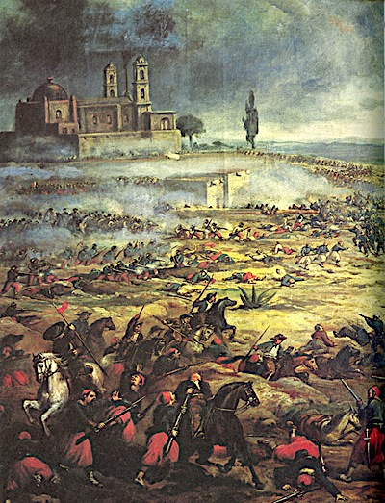
Texas Cultural Events and Celebrations - Clue Card
(This card will provide you with clues for the Simultaneous Heads Together game!)

Cinco de Mayo

Cinco de Mayo is a celebration held on May 5. The date commemorates the Mexican army's victory over the French at the Battle of Puebla on May 5, 1862. In Puebla, Mexico, it is called El Día de la Batalla de Puebla
In the United States, Cinco de Mayo is often mistaken to be Mexico's Independence Day—the most important national holiday in Mexico—that is celebrated on September 16.
Texas was once part of Mexico. It follows many Mexican traditions, including celebrating the popular Mexican holiday Cinco de Mayo. There are Cinco de Mayo celebrations held all over Texas, including many in Austin, the state’s capitol city.
Texas Cultural Events and Celebrations
Clue Card
(This card will provide you with answers for the Simultaneous Heads Together game!)

Texas Oktoberfest

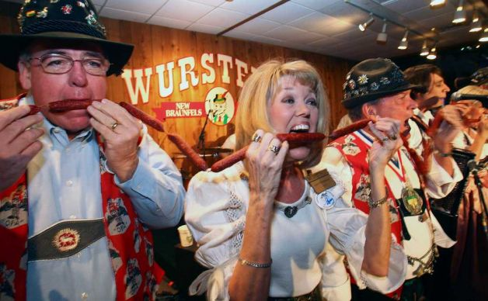
Oktoberfest is a fall festival held in Germany every October that features food, drink and merrymaking. Texas has a rich German heritage. Germans began immigrating to Texas in the 1800’s and currently make up the largest ethnic group coming directly from Europe to the state. For this reason, there are many Oktoberfest events across the Lone Star State.
The town of New Braunfels in the Blackland Prairie has a strong German culture. During the Fall, New Braunfels puts on a celebration called “Wurtfest” or a “Ten Day Salute to Sausage. Today, well over 100,000 people attend the event annually.

Texas Cultural Events and Celebrations - Clue Card
(This card will provide you with answers for the Simultaneous Heads Together game!)
Día de los Muertos
The Day of the Dead is a holiday that comes from Mexican culture. It is celebrated on November 1st and 2nd, during which the graves of loved ones are decorated. Special foods like mole and pan de muerto are made, and ofrendas are built to honor the dead. Special festivals and processions are held. The Day of the Dead has its origins in ancient Mesoamerican cultures from around the Yucatan area of Mexico and Guatemala.
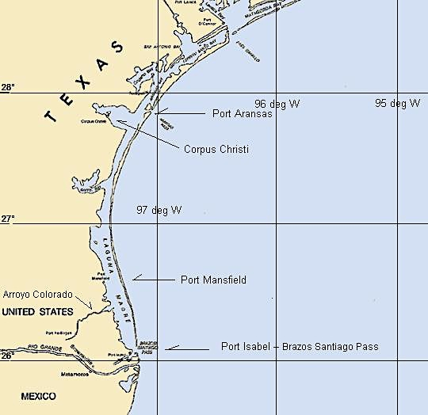
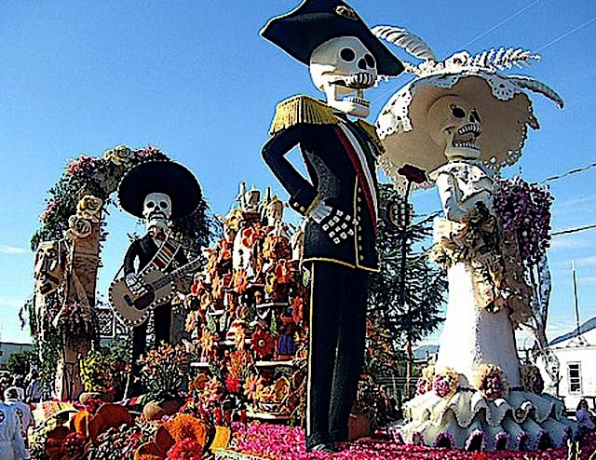
Today, the Day of the Dead continues to be celebrated by Mexicans and Mexican Americans across Mexico and the United States every November. In Texas, the tradition is strong in the Mexican-Texas border region. Towns across South Texas host celebrations on an annual basis. As one of the oldest cities in extreme south Texas, Port Isabel has a long and interesting tradition of celebrating Dia de los Muertos.
Dia de los Muertos parade in Port Isabel

Texas Cultural Events and Celebrations - Clue Card
(This card will provide you with answers for the Simultaneous Heads Together game!)
Juneteenth
Juneteenth, also called Freedom Day, is celebrated on June 19. It is a holiday that commemorates the emancipation of the last remaining slaves in the USA on June 19, 1865.
The Civil War was fought to put an end to slavery. The Union (North) won on April 9, 1865 and all slaves were supposed to be freed. The news of the end of the war and the enforcement of the liberation of all slaves did not reach far areas of the USA for months. Some of the last of the slaves to be freed were in Galveston, Texas. They were freed on June 19, 1865, when General Gordon Granger and 2,000 Union troops arrived on Galveston Island, Texas. They came to enforce the Emancipation Proclamation, freeing the remaining slaves.
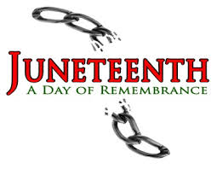
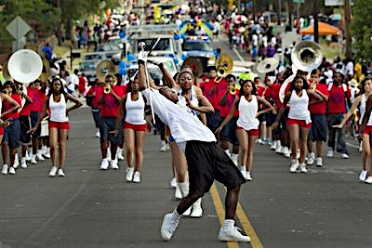
Juneteenth became an official holiday in Texas on Jan. 1, 1980, and is now celebrated in many US states. Texas-style activities often accompany this holiday, including picnics, barbecues, rodeos, pot-lucks, and other informal get-togethers.
Juneteenth Parade in Austin, TX

Texas Cultural Events and Celebrations - Clue Card
(This card will provide you with answers for the Simultaneous Heads Together game!)
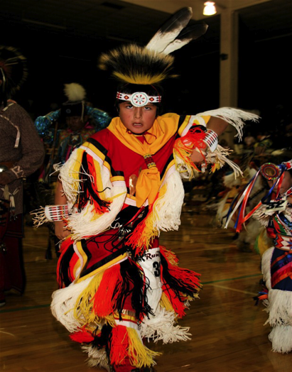
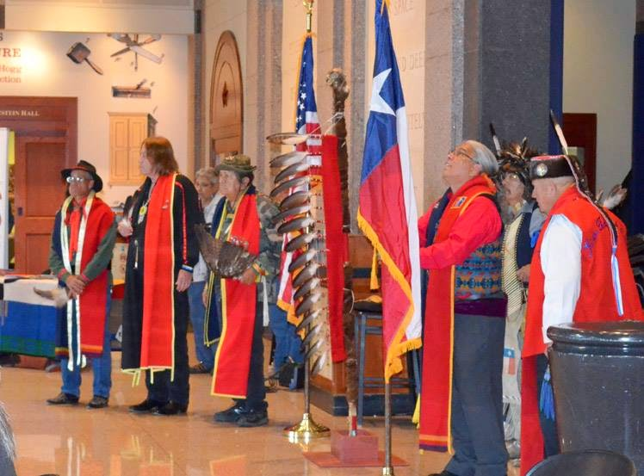
AMERICAN INDIAN HERITAGE DAY

In 2013 the Texas legislature passed a law to make the last Friday in September “American Indian Heritage Day”. The purpose of this day is to recognize the historical, cultural and social contributions of American Indian communities and leaders in Texas.
All over Texas school groups participate in activities to learn about the different Native American cultural traditions. Native Nations and groups come together to hold meetings to discuss important issues facing their communities. Public celebrations are held with Native American music, drumming and dancing.

Literacy Awards: Vocabulary Word Searches
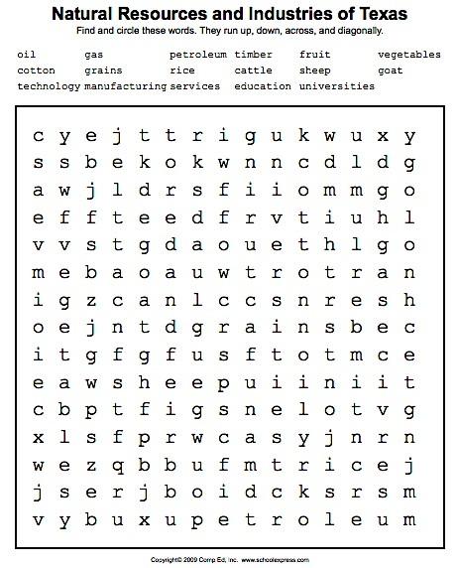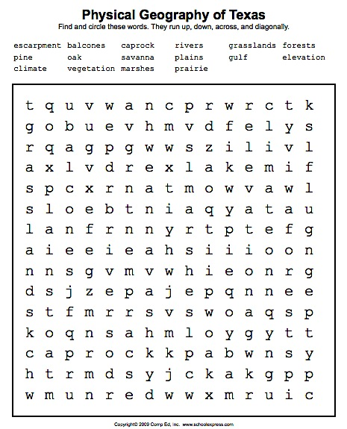
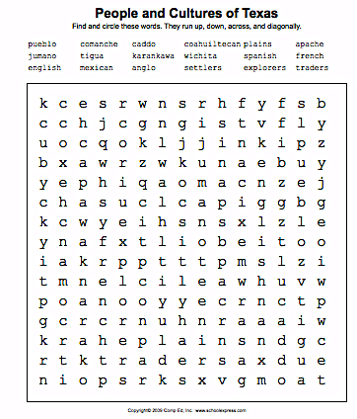

Literacy Awards: Texas Mini Map Notebooks
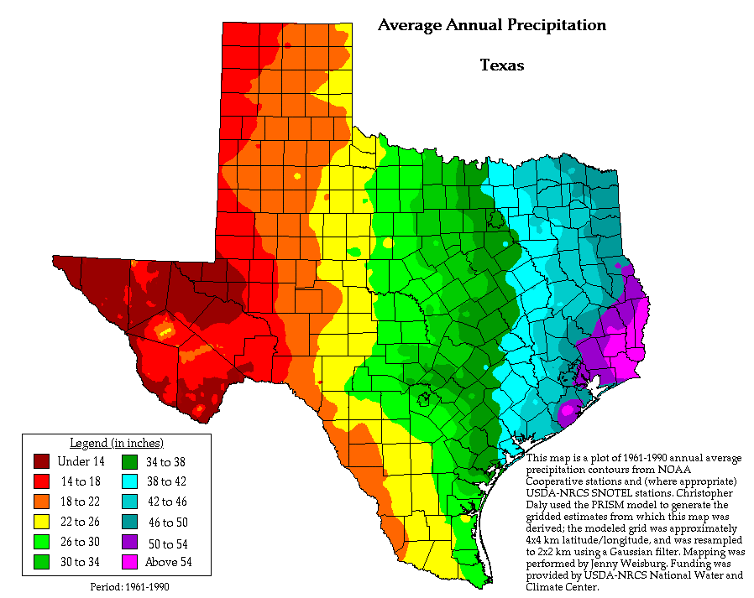
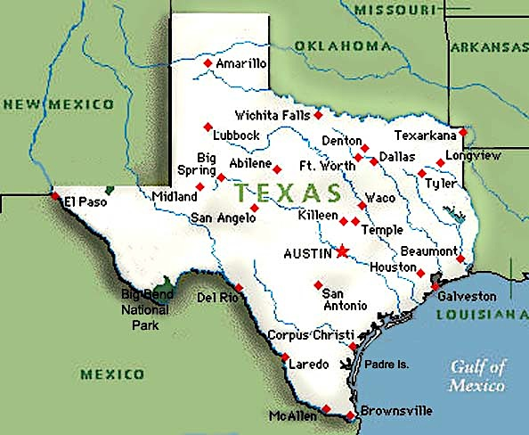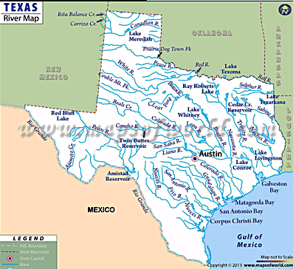
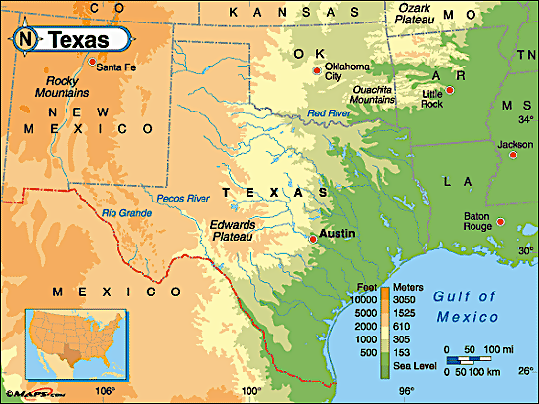

Prediction/Reaction Guide Name ______________________ Date __________

STATEMENT | TRUE | FALSE | HOW DO YOU KNOW?
People have been living in Texas for over 10,000 years.

The elevation of Texas rises as you move across the state from West to East.

The first people to farm in Texas were European.

Oil and natural gas are the only natural resources in the state of Texas.

The human impact on the environment of Texas today is larger than it was in the 1800’s.

Timber, or trees grown for wood, is a large industry in southern Texas.

The rivers of Texas flow from the wetter areas of the state to the drier areas.

Texas Regions and People

Texas Regions and People

by Diana Pinkston-Stewart
and Lisa Meyer

Table of Contents

Physical Geography of Texas page 1
People and Cultures – First People page 2
People and Cultures – European Arrival to Today page 3
Natural Resources and Industries page 4
Natural Resources and Industry – Services page 5
Human Impact page 6
Texas Regions and People and You! page 7
Glossary page 8
Bibliography page 9

Physical Geography of Texas
Texas has a varied and expansive landscape that has supported the growth of diverse groups of people and cultures over thousands of years.
- Texas has a land area of over 267,000 square miles and is the second largest state in our country - only Alaska is bigger!
- A wide variety of landscapes are found in Texas – green forests, savannas, open grasslands, hot deserts, sandy beaches, rolling hills and majestic mountains.
- Texas has many large rivers. These are often called “wrong-way” rivers because they flow from the drier lands of western Texas to the wetter lands of eastern Texas.
- Rich soil is one of the state’s most valuable resources. Huge areas of the state are used for farming and land that is not suitable for farming can still be used for ranching. Petroleum products, like oil and gas, are also extracted from the ground of Texas.
- Geographers have divided Texas up into four regions according to their physical geography, climate and natural resources. These four regions are: the Gulf Coast, North Central Plains, Great Plains and Mountains and Basins.

Texas has a varied and expansive landscape that has supported the growth of diverse groups of people and cultures over thousands of years.
People and Cultures – First People
Texas has a varied and expansive landscape that has supported the growth of diverse groups of people and cultures over thousands of years.
- People have been living in Texas for over 10,000 years. Anthropologists, people who study ancient cultures, have divided these people into four separate cultural groups according to where they lived and how they adapted to their environment. These groups are the Southeastern, Plains, Gulf and Pueblo cultures.
- The Southeastern cultures lived in the fertile, wet land of East Texas. They raised crops and lived in permanent villages. Fish was also an important part of their diet.
- The coastal land of the Gulf cultures was not very good for farming. They were nomadic, traveling from place to place hunting and foraging for food. They were hunter-gatherers.
- As their name suggests, people of the Plains cultures lived in the grassland plains of central Texas. These cultures were also largely nomadic, depending on the immense herds of buffalo that roamed the grasslands for their food and other needed materials.
- The people who were living in the southwestern tip of Texas were part of the Pueblo cultures. Most of the pueblo people lived in permanent dwellings made of adobe. Although the climate was dry, they used irrigation to bring water from the rivers and grew crops such as corn and squash. Some of the Pueblo people served as traders of goods across Mexico and Texas.

Texas has a varied and expansive landscape that has supported the growth of diverse groups of people and cultures over thousands of years.
People and Cultures – European Arrival to Today
Texas has a varied and expansive landscape that has supported the growth of diverse groups of people and cultures over thousands of years.
- In the early 1500’s Spain established a presence in the land to the south, known today as Mexico. Spanish and French explorers began arriving in the area that in Texas soon after. They brought with them new technology such as tools, weapons and horses. They also brought with them diseases. These diseases decimated the population of the Native people.
- Many of the Plains culture groups adopted the use of horses and weapons of the European explorers. The often used this new technology to conquer other tribes.
- The Spanish built missions and converted many of the Pueblo people to Catholicism. In this way, the Pueblo and Spanish cultures combined. This helped the Pueblo culture survive the changes that were wiping out many native people in Texas.
- By the time the English speaking, or Anglo, settlers came in large numbers to Texas in the 1800’s, many of the native cultures had been completely destroyed. Those left, were relocated to reservations. Anglo settlers brought with them the practice of using African slaves to farm their lands.
- Today, Texas has a diverse and multicultural heritage that reflects its roots in Native, European, Mexican and African cultures.
Texas has a varied and expansive landscape that has supported the growth of diverse groups of people and cultures over thousands of years.
Natural Resources and Industries
Texas has a varied and expansive landscape that has supported the growth of diverse groups of people and cultures over thousands of years.

- Texas is a land of immense natural resources!
- Timber, or wood, from the dense forests of eastern Texas, is one of the largest and fastest growing industries.
- Texas has many areas with fertile soils good for agriculture. Major crops in Texas include: cotton, peanuts, hay, grains, fruits and vegetables. In the Gulf area of Texas, rice production is the most important crop.
- Cattle ranching is common on the vast grasslands of Texas. Sheep and goat ranching happen on a smaller scale throughout the state. Fishing and shrimping are important industries in the Gulf area.
- The discovery of large oil and natural gas fields in the 1900’s has made the production of petroleum products one of the largest industries in Texas.

Texas has a varied and expansive landscape that has supported the growth of diverse groups of people and cultures over thousands of years.
Natural Resources and Industries - Services
Texas has a varied and expansive landscape that has supported the growth of diverse groups of people and cultures over thousands of years.

- The abundance of natural resources in Texas has supported huge population growth. Many people have immigrated to Texas from the United States, Mexico and across the world to take part in its growing economy.
- To accommodate the needs of a large population, Texas has developed a complex transportation system to help Texans get from one place to the other.
- Technology and manufacturing have become important industries in Texas. These are businesses that required an educated and skilled workforce.
- Education is one of the many service industries that have developed in Texas to support its large population. Today, there are over 35 public universities and hundreds of private colleges in Texas. The University of Texas at Austin is one of Texas’ top universities.

Texas has a varied and expansive landscape that has supported the growth of diverse groups of people and cultures over thousands of years.

Human Impact
Texas has a varied and expansive landscape that has supported the growth of diverse groups of people and cultures over thousands of years.
- The First People, or Native cultures, that lived in Texas had very little impact on the environment they lived in. The agricultural groups farmed the land and used irrigation to bring water to their crops, but their numbers did not require large-scale farming and they used their hands to work the soil. The nomadic groups depending on the hunting of buffalo to supply many of their needs. They hunted with bows and arrows, which limited the number they could kill.
- European cultures had a larger impact on the environment. They had guns to hunt the buffalo allowing them to kill large numbers of buffalo in a single hunt. They built permanent homes and towns, which required building materials. The growth in population meant a need for more agriculture. Small farms turned into large farms, plowed with the help of animals and machines.
- Today, humans in Texas are having an enormous impact on the land. Oil and natural gas drilling bring a lot of money into the state, but can cause problems with contamination of the natural environment. Large-scale production of crops, such as rice, requires a tremendous amount of water – a resource that is becoming scarce. Today’s Texans are faced with the enormous challenge of balancing their natural resource use and industries in a sustainable manner.
Texas has a varied and expansive landscape that has supported the growth of diverse groups of people and cultures over thousands of years.

Texas Regions and People and You!
Texas has a varied and expansive landscape that has supported the growth of diverse groups of people and cultures over thousands of years.
- Texas has a long history of people interacting with and being shaped by its unique and expansive physical geography. The cultures of Texas have also been shaped by the interactions of the people who have come to the area.

- What culture do you identify with? What are the things that make your culture the same or different from that of the other people in you community?

You are a Texan, and… Texas has a varied and expansive landscape that has supported the growth of diverse groups of people and cultures over thousands of years.

Glossary
Word | Definition
anthropologist | people who study human races, cultures and societies
climate | the usual weather conditions in a particular place or region
culture | a particular society that has its own beliefs, ways of life, language, etc.
diverse | differing from one another
economy | the system by which goods and services are produced, sold, and bought in a region
fertile | able to support the growth of many plants
geographer | a person who studies the natural and human features (such as rivers, mountains, people etc.) of a place
hunter-gatherer | a member of a culture in which people hunt animals and look for plants to eat instead of growing crops and raising animals
impact | a powerful or major influence or effect
landscape | an area of land that has a particular quality or appearance
manufacturing | the industry or business of making products especially with machines in factories
natural resource | a supply of something from the environment that someone has and can use when it is needed
nomadic | a member of a group of people who move from place to place instead of living in one place all the time
physical geography | the study of the natural features in an environment (rivers, mountains, rocks…)
savanna | a large flat area of land with grass and very few trees
timber | trees that are grown in order to produce wood
to decimate | to severely damage or destroy a large part of something
to extract | to remove(something by pulling it out or cutting it out
to relocate | to move to a new place
traders | a person who buys, sells, or exchanges goods
transportation | a way of traveling from one place to another place
village | a small town in the country
workforce | the number of people in a country or area who are available for work
http://www.learnersdictionary.com
Glossary of Social Studies Terms and Vocabulary http://www.aaps.k12.mi.us/ins.ell/files/10-02glossary_48851_7.pdf
National Geographic Education Glossary http://education.nationalgeographic.com/education/glossary/kids/?ar_a=1

Bibliography

- Texas and Texans, Glencoe McGraw Hill, 2003
- http://www.texasbeyondhistory.net/kids/
- http://www.tpwd.state.tx.us/kids/about_texas/regions/
- http://www.celebratingtexas.com/tr/trans/03-2.pdf
- http://www.mapsofworld.com/usa/states/texas/texas-river-map.html
- http://www.texasindians.com/
- www.tshaonline.org/handbook/online/articles/lkf05

Graphic Organizer – Texas Regions and People
(See next page.)
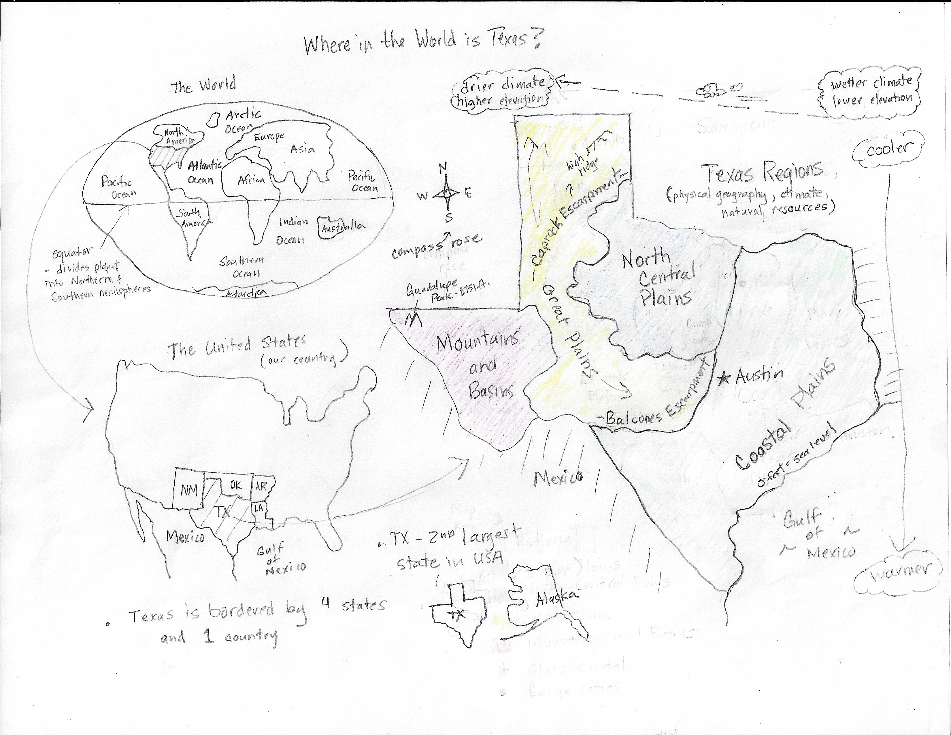
ELD Review Questions: Where in the World is Texas GO
Point To:
- Locate Texas on the map of The United States. (know/remember)
- Identify the seven continents and the five major oceans. . (know/remember)
- (Show two pictures.) Which of these could be in the Mountains and Basins region? (comprehend)
- (Show a picture of the Gulf of Mexico and the Arctic Ocean.) Which of these could be the Gulf of Mexico? (comprehend)
- Point to the two escarpments that define the plains regions. (apply)
- Show me the smallest/largest region of Texas. (apply)

Yes/No:
- Is Texas the largest state in the USA? (know/remember)
- Is it wetter on the eastern side of Texas? (know/remember)
- Does Texas share a border with the country of Canada?
- Is the equator north or south of Texas? (apply)
- If you wanted to get out of the heat in the summer time, would you go to the South Texas Plain? (comprehend)

Either/Or:
- Is the Mountain and Basins region on the west or east side of Texas? (know/remember)
- Does Texas share a border with 3 or 4 states? (know/remember)
- Is Mexico on a different continent than Texas? (comprehend)
- Does New Mexico or Arkansas share a long border with Texas? (apply)
- Does the compass rose tell about the climate or the directions? (comprehend)
- (Point to pictures) Would you rather live in northern or southern Texas? (evaluate)

Open Ended:
- What state shares the longest border with Texas. How do you know? (apply)
- What kind of landscape do the Balcones and Caprock Escarpments create? (know/remember)
- Which region do you think has the most rainfall? Explain your thinking. (apply)
- Which Texas region do you think is the most beautiful? Why did you choose that region? (evaluate)
- Do you think it is easier to breathe on the Gulf coast or on Guadalupe Peak. What is your reasoning? (Analysis)

Pictorial Input – The Coastal Plains Regions
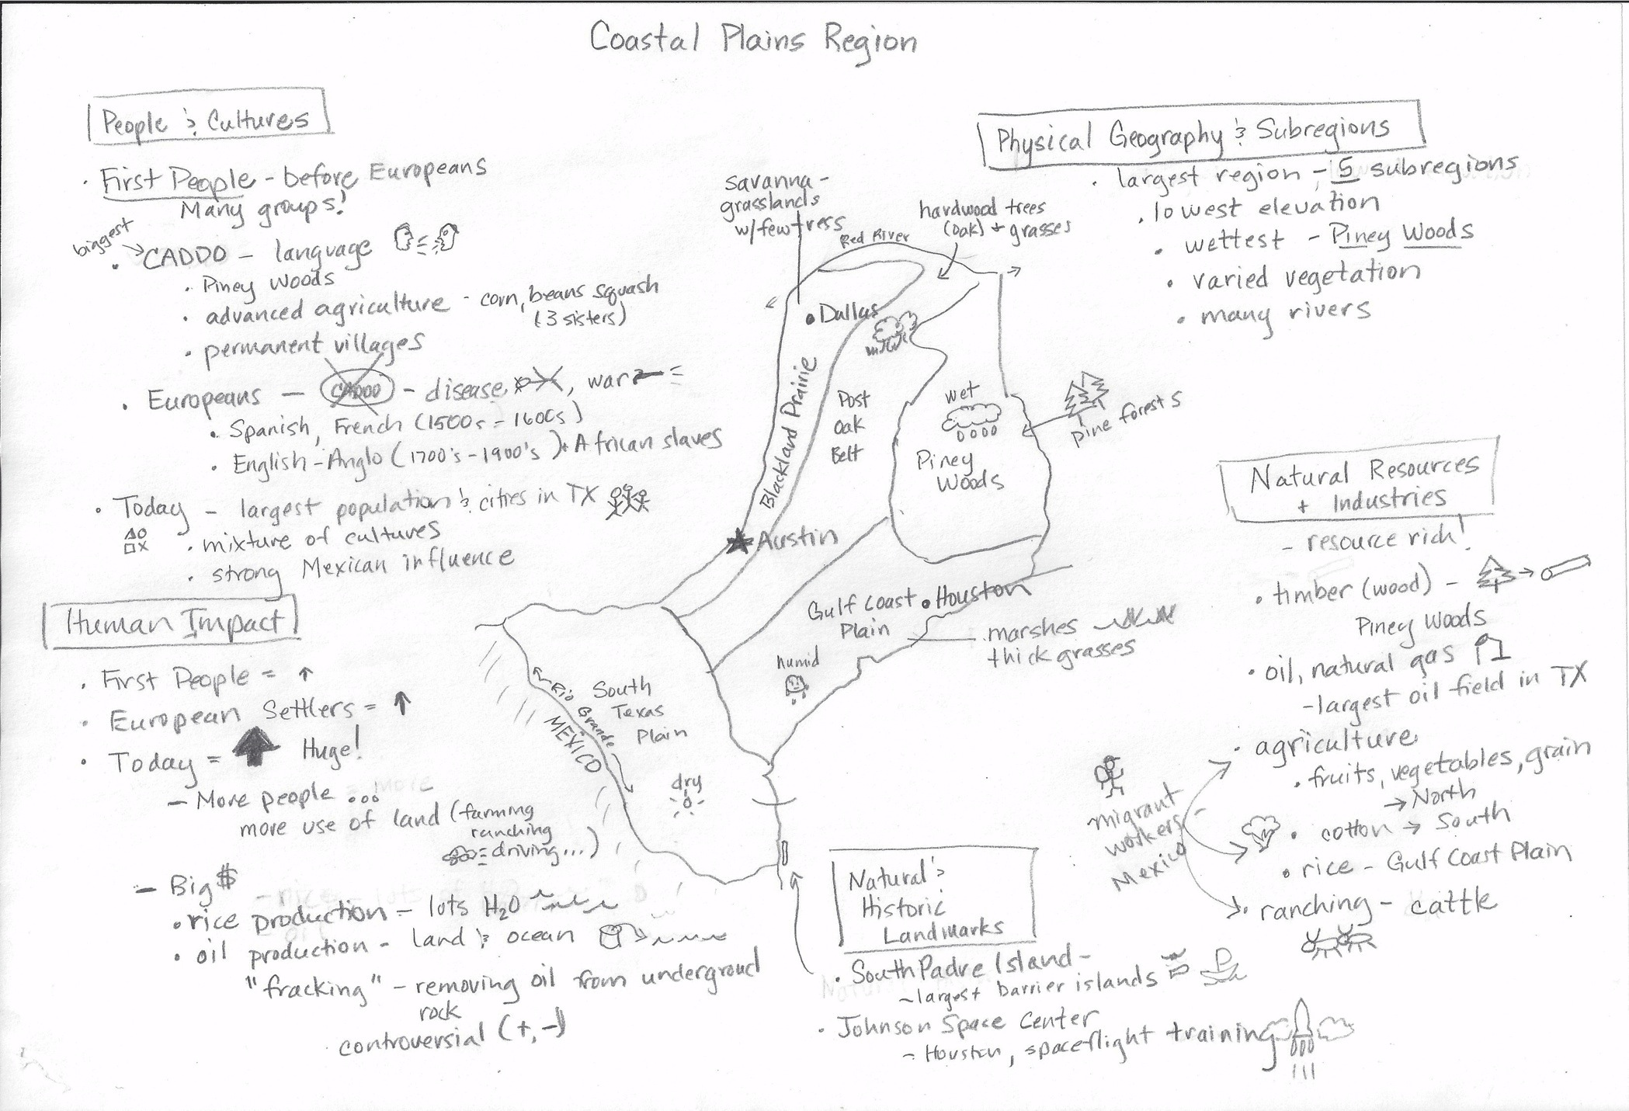

ELD Review Questions: Coastal Plains Region
Point To:
- Locate the Piney Woods subregion. (know/remember)
- Point to the name of one of the First People that lived in this region. (know/remember)
- Identify the major cities. (know/remember)
- (Show two pictures.) Which of these could be in this region? (apply)
- (Show a picture of Dallas and a smaller city.) Dallas is the largest city in Texas. Which one of these is Dallas? (cpmprehend)

Yes/No:
- Is South Padres Island the longest barrier island in the world?(know/remember)
- Is it wetter in the eastern side of the Gulf Coastal Plains? (know/remember)
- Did the Spanish arrive in Texas in the 1800’s? (know/remember)
- Would a lumber mill be located in the South Texas Plains? (apply)
- Do people of the Coastal Plains region all come from the same culture? (comprehend)

Either/Or:
- Is Mexico to the north or south of this region? (apply)
- Does rice production take place in the Blackland Prairie of the Gulf Coast Plain? (know/remember)
- Is Houston or Dallas near the Gulf of Mexico? (apply)
- Did the Caddo or the Europeans have a big impact on the environment? (know/rember)
- Does the category of Physical Geography or Natural Resources and Industries have information about ranching? (pply)
- Would you rather go to South Padre Island or the Johnson Space Center? (Point to pictures.) (evaluate)

Open Ended:
- Provide examples of different types of vegetation in the Coastal Plains. (know/remember)
- Why did the First People almost disappear when the Europeans settled this area? (know/remember)
- What plants would not grow well in the Coastal Plains? (apply)
- Would you have rather been a part of the Caddo culture or a European settler? Explain why. (evaluate)
- Would you rather visit the Johnson Space Center or South Padre Island? Explain why. (evaluate)
- From your experiences, why do you think people like to live in Austin? (evaluate)
- How does the oil industry have a big impact on the Coastal Plains environment today? (analyze)

COMPARATIVE INPUT CHART – EVERY DROP COUNTS
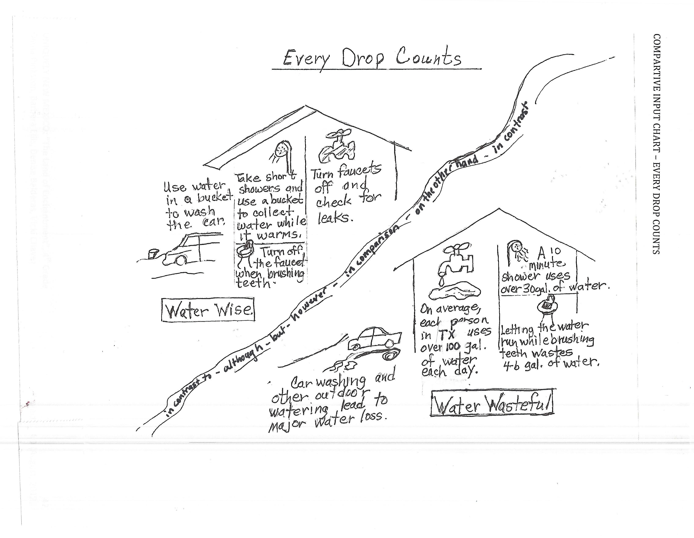
Barb Ellis, Santa Fe, NM
Narrative Input Chart
The Legend of the Blue Bonnet by Tomie DePaola
Adapted by Diana Pinkston-Stewart

# 1 “Great Spirit, the land is dying. Your People are dying too,” the long line of dancers sang. “Tell us what we have done to anger you. End this drought. Save your People. Tell us what we must do so you will send the rain that will bring back life.”
#2 For three days, the dancers danced to the sound of the drums, and for three days, the People called Comanche watched and waited. And even though the hard winter was over, no healing rains came.
#3 Drought and famine are hardest on the very young and the very old. Among the few children left was a small girl name She-Who-Is Alone. She sat by herself watching the dancers. In her lap was a doll made from buckskin – a warrior doll. On its head were brilliant blue feathers from the bird who cries ‘Jay-jay-jay.” She loved her doll very much.
“Soon,” She-Who-Is-Alone said to her doll, “the shaman will go off alone to the top of the hill to listen for the words of the Great Spirits. Then, we will know what to do so that one more the rains will come and the Earth will be green and alive. The buffalo will be plentiful and the People will be rich again.”
As she talked, she thought of the mother who made the doll, of the father who brought the blue feathers. She thought of the grandfather and the grandmother se had never known. They were all like shadows. It seemed long ago that they had died from the famine. The People had named her and cared for her. The warrior doll was the only thing she had left from those distant days.
#4 The sun is setting,” the runner called as he ran through the camp. The shaman is returning.” The people called in a circle and the shaman spoke.
“I have heard the words of the Great Spirits,” he said. “The People have become selfish. For years, they have taken from the Earth without giving anything back. The Great Spirits say the People must sacrifice. We must make a burnt offering of the most valued possession among us. The ashes of this offering shall then be scattered to the four points of the Earth, the Home of the Winds. When this sacrifice is made, drought and famine will cease. Life will be restored to the Earth and to the People!”
#5 The People sang a song of thanks to the Great Spirits for telling them what they must do. “I’m sure it is not my new bow that the Great Spirits want,” a warrior said. “Or my special blanket,” a woman added, as everyone went to their tipis to talk and think over what the Great Spirits had asked.

#6 Everyone, that is, except She-Who Is Alone. She held her doll tightly to her heart. “You,” she said, looking at her doll. “You are my most valued possession. It is you that the Great Spirits want.” And she knew what she must do. As the council fires died out and the tipi flaps began to close, the small girl returned to the tipi, where she slept, to wait.
#7 The night outside was still except for the distant sound of the night bird with the red wings. Soon everyone in the tipi was asleep, except She-Who-Is-Alone. She ran to the place on the hill where the Great Spirits had spoken to the shaman. Stars filled the sky, but there was no moon. “O Great Spirits,” She –Who-Is-Alone said, “here is my warrior doll. It is the only thing I have rom my family who died in this famine. It is my most valued possession. Please accept it.”
#8 Then gathering twigs, she started a fire with the glowing firestick. The small girl watched as the twigs began to catch and burn. She thought of her grandmother and grandfather, her mother and father and all the People – their suffering, their hunger. And before she could change her mind, she thrust the doll into the fire.
#9 She watched until the flames died down and the ashes had grown cold. Then, scooping up a handful, She-Who-Is-Alone scattered the ashes to the Home of the Winds, the North and the East, the South and the West. And there she fell asleep until the first light of the morning sun woke her.
#10 She looked over the hill, and stretching out from all sides, where the ashes had fallen, the ground was covered with flowers – beautiful flowers, as blue as the feathers in the hair of the doll, as blue as the feathers of the bird who cries “Jay-jay-jay.”
#11 When the People came out of their tipis, they could scarcely believe their eyes. They gathered on the hill with She-Who-Is-Alone to look at the miraculous sight. There was no doubt about it, the flowers were a sign of forgiveness from the Great Spirits. And as the People sang and danced their thanks to the Great Spirits, a warm rain began to fall and the land began to live again. From that day on, the little girl was known by another name – “One-Who-Dearly-Loved-Her–People.”
And every spring, the Great Spirits remember the sacrifice of a little girl and fill the hills and valleys of the land, now called Texas, with the beautiful blue flowers. Even to this very day.

ELD Review Questions
The Legend of the Bluebonnet
Choose questions that match your instructional focus with students. Questions were written assuming students are familiar with the hero’s journey and plot structure.
Point to (targets ELPS beginning level):
- Point to a picture that shows the setting of the story. (know/remember)
- Point to the beginning of the legend where we find out the tribe is experiencing drought because there has not been any rain. (know/remember)
- Point to the illustration that shows important people in the girl’s life who have died. (comprehend) Point to the girl’s most important or valued posession. (know/remember)
- Where do we see the Shaman or their spiritual leader saying the people must make a burnt offering to the Great Spirits to end the drought? (know/ remember)
- She-Who-Is-Alone saves her people. Point to the climax of the story where her action saves her people. (know/remember)
- In contrast to her action, point to the picture that shows someone being selfish or only thinking of themselves and not other people. (comprehend)
- Who is someone in our class who is not selfish who often helps others and takes care of other people? (apply)

Yes/no (targets ELPS beginning and intermediate levels):
- Is The Legend of the Bluebonnet about the Comanche or Apache People? (know/remember)
- Thinking of the hero’s journey, does the Shaman or another person in the tribe give the call to adventure where the people are called to action to save themselves from drought? (comprehend)
- In a hero’s journey, the hero has a talisman or special object that helps him or her on the quest. Is the doll or the fire stick the talisman in this legend? (Extension – How do you know?, apply)

Either/or (targets ELPS beginning and intermediate levels):
- Using the map, did the Comanche people first settle in the Northern or Southern part of Texas? Did they then mirgrate to the South or to the North? (comprehend/understand)
- Which name do you think the main character preferred, She-Who-Is-Alone or One-Who-Dearly-Loved-Her-People? (Extension-Why?, evaluate)
- Do you think famine or drought is hardest on people? (Extension – Why?, analyze)

Open-ended questions (need to adjust expectations for answers based on students’ language levels, targets ELPS intermediate, advanced and advanced-high levels)
- What stages of the hero’s journey do we see in this legend? Summarize each one. (apply)
- Give a summary of the basic plot structure of this legend. (comprehend)
- Early in the legend the author writes, “Drought and famine are hardest on the very young and very old.” Why is this important to understand in this story? (apply)
- When the people saw the field of flowers, the author says, “There was no doubt about it, the flowers were a sign of forgiveness from the great spirits.” Thinking of plot structure, is this part of a rising action in the legend or a falling action? Explain. (apply)
- In “The Legend of the Blue Bonnet”, how is the hero’s identity defined by the location of her tribe? by her name? (analyze)
- What does it mean to be a hero? How was She-Who-Is-Alone a hero for her people? Who else do you think is a hero? Why? (comprehend, evaluate)

Texas Regions and People
Poetry Booklet

Name_____________________
Date __________

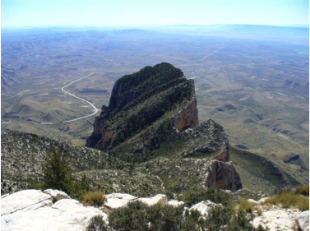
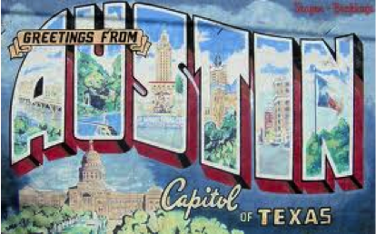
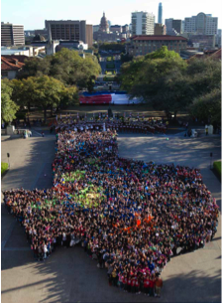

DEEP IN THE HEART OF TEXAS
https://www.youtube.com/watch?v=VGF4ibgcHQE
by June Hershey and music by Don Swander

The stars at night are big and bright
Deep in the heart of Texas
The prairie sky is wide and high
Deep in the heart of Texas

The sage in bloom is like perfume
Deep in the heart of Texas
Reminds me of the one that I love
Deep in the heart of Texas

The coyotes wail along the trail
Deep in the heart of Texas
The rabbits rush around the brush
Deep in the heart of Texas

The cowboys cry, "Ki yippee yi!"
Deep in the heart of Texas
The dogies bawl and bawl and bawl
Deep in the heart of Texas

The stars at night are big and bright
Deep in the heart of Texas
The prairie sky is wide and high
Deep in the heart of Texas

TEXANS HERE, TEXANS THERE
By Diana Pinkston-Stewart

Texans here, Texans there,
Texans, Texans everywhere

Industrious Texans working diligently,
Rural Texans farming productively,
Urban Texans commuting rapidly,
And multicultural Texans coexisting peacefully

Texans throughout the regions,
Texans from diverse cultures,
Texans at the university,
And Texans in different industries

Texans here, Texans there,
Texans, Texans everywhere
Texans! Texans! Texans!

TEXAS PHYSICAL GEOGRAPHY CADENCE

By Diana Pinkston-Stewart and Lisa Meyer

Texas is a diverse state.
Geography is part of what makes it great.
Lone Star State is its nickname.
Its unique landscape has brought it fame.

Texas, Coastal Plains
Texas, North Central Plains
Texas, forests, grasslands, savannas

Tourists come from all around,
To hunt and fish – much to be found
Plains, valleys and plateaus
So much to do and more to show.

Texas, Great Plains
Texas, Mountains and Basins
Texas, hills, valleys, mountain peaks

In the west elevations are high,
Guadalupe Peak is steep and dry
In the east the elevation drops
The Coastal Plains grow many crops

Texas, beautiful
Texas, topography
Texas, varied and expansive!

TEXAS INDUSTRIES BUGALOO

By Diana Pinkston-Stewart and Lisa Meyer

We’re Texans, and we’re here to say,
Industries create jobs for people everyday,
Our land is stunning and beauty abounds,
The climate is varied, the sun shines year round.

Services, tourism, fishing too,
Doing the Texas Industries Bugaloo!

People in the Coastal Plains mine uranium,
Oil, coal and gas make our businesses hum,
Ranching and peanut farms across the North Central Plains,
Rice, vegetable and cotton farmers irrigate for lack of rain.

Agriculture, ranching, energy production too,
Doing the Texas Industries Bugaloo!

Wide-open spaces to test our might,
Cattle ranches worked day and night,
Scientists advance our nation’s cause,
Aerospace and aviation creates Texas jobs.

Manufacturing, film production, information technology too,
Doing the Texas Industries Bugaloo!

CHARACTERS, SETTING AND PLOT
By Rhythm, Rhyme, Results (2:41-3:46)
https://www.youtube.com/watch?v=cvDNJK1Gpc4

Chorus: We’ve got the characters, the setting,
and of course the plot
It’s the elements of fiction
that I’m talking about (x4)

Now the plot unfolds
in five different phases
I’ll try to get you through it
in just a few phrases
Take you all the way from beginning to end
But you’ve got to listen close
or rewind again

Chorus

Before action happens,
we’ve got the exposition
Where the author can establish or begin a definition
of the characters, the setting, and yes, the point of view
And once that’s all established
we can move to phase two

Chorus

PLOT DIAGRAM CADENCE

by Lisa Meyer

We just know what we’ve been told,
Understanding plot structure’s worth its weight in gold.
Knowing how a story is organized
Boosts our grade and makes us wise

Sound off – plot diagram
Sound off – sequence of events
Sound off – 1, 2, 3, 4 Literature rocks!

The exposition is first you see
Introducing the characters and setting is key
Main problem or conflict is here too
Helps us understand it’s true

Sound off – exposition
Sound off – conflict
Sound off – 1, 2, 3, 4 Literature rocks!

Up next is the rising action
Interest and suspense give the story traction
The climax is the turning point
Leaves the reader ready for more

Sound off – rising action
Sound off – turning point
Sound off – 1, 2, 3, 4 Literature rocks!

Onward in the story to the falling action
Leads to the ending and the resolution
Once we are here and the story is done
Start the plot diagram, the fun has just begun

Texas Cultures – Yes, Ma’am
By Diana Pinkston

Are you a Texan? Yes, ma’am.
Are you a Texan? Yes, we are the Pueblo people.
How do you know? We’ve been in this land for many centuries.
How do you know? The Anazazi are our ancestors.
Tell me more about your people We built a mission in Ysleta.
Tell me more about your people We speak Tigua and English.

Are you a Texan? Yes, ma’am.
Are you a Texan? Yes, we are Hispanic People.
How do you know? We are about 38 percent of the population.
How do you know? Our roots are from Spain and from Mexico.
Tell me more about your people We speak the Spanish language.
Tell me more about your people We came after the Native American people.

Are you a Texan? Yes, ma’am.
Are you a Texan? Yes, we are the German people.
How do you know? We speak the German language.
How do you know? Many of us live in Texas Hill Country.
Tell me more about your people. We call ourselves German Texans.
Tell me more about your people. We celebrate Oktoberfest.

Are you a Texan? Yes, ma’am.
Are you a Texan? Yes, we are the Anglo people.
How do you know? We are almost half of the Texas population.
How do you know? We speak English as our first language.
Tell me more about your people. We came after the Native Americans and the Hispanics.
Tell me more about your people. We trace our roots back to England.

Are you a Texan? Yes, ma’am.
Native American, Hispanic and Anglo? German, African American, and Asian. .
Are there other cultures? We have cultures from all over the world!

Home School Connection
Conexión entre el hogar y la escuela

Where has your family traveled in Texas? What did you do when you were there?

¿Adónde ha viajado tu familia en Tejas? ¿Qué hicieron mientras estaban allí?

Adult Signature ____________________ Student Signature _______________________
firma de un adulto firma del estudiante

Home School Connection
Conexión entre el hogar y la escuela

Talk to your family about some of the natural and historical landmarks of Texas. If you and your family could visit one of these landmarks, where would you go and why?

Habla con su familia acerca de algunas de los monumentos naturales e históricos de Texas. Si tú y su familia podrían hacer un viaje a un monumento, ¿a dónde irían y porqué?

Adult Signature ____________________ Student Signature _______________________
firma de un adulto firma del estudiante

Home School Connection
Conexión entre el hogar y la escuela

Observe how people in your household use water. Write or draw a picture of different ideas your family has about how to conserve water at home.

Observa cómo se usa el agua en tu hogar. Escriba o dibuja de las diferentes ideas que tiene tu familia acerca de conservar agua en tu hogar.

Adult Signature ____________________ Student Signature _______________________
firma de un adulto firma del estudiante

North Central Plains Expert Group Name ________________________________

Physical Geography and Subregions
The North Central Plains region begins at the Balcones Escarpment and reaches west to the Caprock Escarpment. It is a region of rolling plains covered by small trees, brush, and grasses. As you move from East to West across this region, the land rises from about 500 feet to 2,000 feet above sea level and the climate becomes drier.
Near the eastern edge of the North Central Plains is the Grand Prairie subregion, where the vegetation is mostly grasses and scattered hardwood trees along streams in the area. The Cross Timbers subregion surrounds the Grand Prairie on the East and West. The soils in the Cross Timbers are rich and capable of growing large trees. The Rolling Plains is the largest subregion in the North Central Plains with the highest elevation. This area is mostly steppe - a large, flat area of land with grass, bushes and very few trees.

Natural Resources and Industries
The North Central Plains is primarily a ranching and farming region although oil and gas are also found in this area. The Grand Prairie subregion has cattle ranching as well as farming of wheat, peanuts and cotton. The Cross Timbers subregion is mostly agricultural – peanuts, fruit and vegetables are the main crops grown here although dairy farms are also important here. Large cattle ranches are found in the Rolling Plains subregion. Sheep and goats often graze in the driest parts of this subregion.
The largest city in the North Central Plains is Fort Worth. Fort Worth is home to many businesses that serve the agricultural needs of much of this region. It is also has large-scale aircraft manufacturing that brings in people from across the state. This region also holds one of our nation’s largest army installations, Fort Hood.

Diversity of People and Cultures
People have been living in Texas for over 10,000 years. Some of The First People to live in large groups in the North Central Plains region before the Spanish arrived were the Apache and Wichita. They are a part of a larger group called the “Plains Culture” who occupied land in the plains area throughout North America. The Apache were mostly nomadic, depending on the large herds of buffalo that roamed this area for food and materials to make clothing, shelter and tools. The Wichita did some farming during the warmer months and then would move west for the buffalo hunt in the colder months. With the arrival of the Spanish in the 1500’s, horses became a part of the Plains Culture life, making them even better hunters and fiercer warriors. By 1900, people of the Plains Culture were almost completely wiped out in this region. The Europeans had brought disease, overhunted the buffalo and eventually relocated the Plains Indians to reservations.
Today, the population of the Central Northern Plains region is a mixture of Native American, Anglo, African, Spanish, German and Mexican cultures – much as is the entire state of Texas. However, because it is farther from the Mexican border than other regions, it maintains a slightly larger European culture than other regions.

Human Impact on Environment
The First People who occupied this region had very little impact on the land due to their small numbers and hunter-gatherer lifestyle. They lived off what the environment provided and their homes were often tepees that traveled with them. When the Spanish and English began colonizing the area, a much larger impact on the environment was felt. As large numbers of settlers came, big areas of land were used for growing food. The buffalo population that once numbered in the millions was reduced to a few thousand. More and more land was used for the cattle ranching. Large-scale farming required the damming of rivers and digging of wells to provide enough water for this often dry area. The discovery of oil in the early 1900’s led to an even higher impact on the environment as oil is pumped out of the ground. In the last few years, fracking, a controversial method of removing oil from rock in the ground using high-pressure water, is also having an effect on the environment and the people who are living in this region.

Natural and Historic Landmarks
The Fort Worth Stockyards is a historic district located in the North Central region’s largest city, Fort Worth. It covers almost 100 acres and was opened in 1866 as a livestock market where cattle were bought and sold. Because of this stockyard, between 1866 and 1890 more than four million head of cattle were walked through Fort Worth, which was soon known as “Cowtown.” The Fort Worth Stockyards have seen many changes over the years and today is used to host special breed events and sales.

The Great Plains Expert Group Name ________________________________

Physical Geography and Subregions
The Great Plains region has three subregions. The High Plains, also known as the Llano Estacado, take up most of the Texas Panhandle. It is one of the flattest places on earth. It has a dry climate and an elevation from 3,000 feet to over 4,000 feet above sea level, making it cold here during the winter.
The Edwards Plateau makes up the southern part of the Great Plains region. It is a high plateau primarily made of limestone. It has a number of caves and underwater streams. It sits on top of a aquifer that supplies water for San Antonio and many other communities. The soil here is not good for farming.
The Llano Basin is the smallest subregion and lies almost in the center of Texas. The land here is has a lot of granite, a very hard and beautiful rock. The elevation here is much lower than the Edwards Plateau but still about 1,000 above sea level. This area is a savannah, with the land covered with grasses and few trees.

Natural Resources and Industries
Cattle ranching, farming and tourism are the major industries of the Great Plains region. Most of the cattle ranching and farming takes place in the High Plains sub region due to it large areas of land and an aquifer below that provides water for irrigation. Edwards Plateau also has cattle ranching but specializes in raising sheep and goats for producing wool. In the Llano Basin, there has developed an industry around cleaning the wool from the goats and sheep in Edwards Plateau. Thousands of hunters come to Edward’s plateau to hunt deer while others come to visit one of the many “dude ranches” found here. Tourists come to the Llano Basin to enjoy the lakes that have been created from damming the Colorado River.

Diversity of People and Cultures
People have been living in Texas for over 10,000 years. Some of tribes of Native American people to establish a large presence in the Great Plains region prior to the arrival of the Europeans were the Kiowa, Comanche and Apache. They are a part of a larger group called the “Plains Culture” who were nomadic and depended heavily on the buffalo. With the arrival of the Spanish in the 1500’s, horses became a part of the Plains Culture life, making them even better hunters and fiercer warriors. By 1900, people of the Plains Culture were almost completely wiped out in this region. The Europeans had brought disease, overhunted the buffalo and eventually relocated the Plains Indians to reservations.
Today, the population of the Great Plains region is a mixture of Native, Anglo, African, Spanish, German and Mexican cultures – much as is the entire state of Texas. However is largely a rural, ranching area, it has a very strong “cowboy” or ranch culture. The Edward’s Plateau subregion has a large German population and puts on celebrations in the fall that brings thousands of tourists to the region.
Human Impact on Environment

The First People who occupied this region had very little impact on the land due to their small numbers and hunter-gatherer lifestyle. They lived off what the environment provided and their homes were often tepees that traveled with them. When the Spanish and English began colonizing the area, a much larger impact on the environment was felt. As large numbers of settlers came, big areas of land were used for growing food. The buffalo population that once numbered in the millions was reduced to a few thousand. More and more land was used for the cattle ranching. Large-scale farming required the damming of rivers and digging of wells to provide enough water for this often dry area. The discovery of oil in the early 1900’s led to an even higher impact on the environment as oil is pumped out of the ground. In the last few years, fracking, a controversial method of removing oil from rock in the ground using high-pressure water, is also having an effect on the environment and the people who are living in this region.

Natural and Historic Landmarks
Two important landmarks of the Great Plains region are the Lyndon B. Johnson State Park and Historic Site and Palo Duro Canyon. The Lyndon B. Johnson State Historical Park is named for the 36th United States president who grew up in Edward’s Plateau. Visitors to this park will see buffaloes, white-tailed deer and bison. Palo Duro Canyon lies in the High Plains sub region and is the second largest canyon in the country. Thousands of people come from all over the world to camp, hike, animal-watch and ride horses.

Mountains and Basins Expert Group Name ________________________________

Physical Geography and Sub Regions
This is the only region of Texas that is not divided into sub regions. The Rio Grande forms this region's southern border and New Mexico borders it to the north. It is the westernmost region and is made up of tall mountains separated by large basins, or closed valleys. The basins are deserts, with cactus, shrubs, short grasses, and other kinds of vegetation that can live a long time without water. Overall, this region is extremely dry. This region contains the highest mountain in Texas, Guadalupe Peak, which stands 8,751 feet tall.

Natural Resources and Industries
In the Mountain and Basins region ranching of sheep, goats and cattle provides many jobs. Agriculture is another main industry. In the Upper Rio Grande Valley, irrigated fields grow cotton, fruits, vegetables, and cantaloupes. Another important part of this region's economy is petroleum and natural gas.
El Paso is by far the largest city in the region and it the commercial center for this region. It sits on the Texas – Mexico border opposite Ciudad Juarez. Together, these two cities make up the largest urban area on the United-States Mexico border. In 1994, the North American Free Trade Act or NAFTA took effect. NAFTA has brought much growth to the manufacturing industry in this region. El Paso also has oil refining facilities, various factories and businesses and important military installations.

Diversity of People and Culture
People have been living in Texas for over 10,000 years. The Jumanos and the Tigua. were part of a larger group of people called the “Pueblo”. The Pueblo people made multistoried homes out of adobe and sometimes built them into high cliffs. Many of these people were farmers who raised corn, beans and squash as well as gathering edible cacti and hunting small animals. Some Jumano groups specialized in trading with other native peoples and lived primarily as hunter-gatherers. At around the same time the Spanish explorers arrived, the Jumano people were overtaken by the Apache people that were moving south across the plains. It is believed that the Jumano eventually moved or joined other Native American groups. The Tigua people moved into the area from New Mexico after the Pueblo Revolt against Spanish authority in 1680, but already shared many of the same cultural characteristics with the Jumano.
With the arrival of the Spanish in the 1500s, missionaries converted many Pueblo people to Catholicism. A large percentage of the Pueblo culture died from diseases brought by the Spanish to which they had no resistance. Because they had a more peaceful relationship with the Spanish than many other native groups in Texas, the surviving Tigua Pueblo people able to assimilate into the European cultures that took over the region.
Today, the population of the Mountains and Basins region is a mixture of Native, Anglo, African, Spanish, and Mexican cultures – much as is the entire state of Texas. However, because of its proximity to Mexico, the Mexican influence is very strong in this region. Eighty percent of the nearly 700,000 people that live in El Paso identify themselves as Hispanic.

Human Impact on Environment
The Pueblo people who lived this region had some impact on the land as they used irrigation to bring water from the rivers to their fields and the adobe homes they built were somewhat permanent, although made of natural materials. When the Spanish and English began colonizing the area, a much larger impact on the environment was felt. As large numbers of settlers came, more land was used for farming and raising animals. This required a higher use of river water. Today this region, like most of Texas, is experiencing a drought. This puts even more of a stress on the limited water supply from the rivers and under the ground. The discovery of oil here in the early 1900’s has led to an even higher impact on the environment as oil is pumped out of the ground. In the last few years, fracking, a controversial method of removing oil from rock in the ground using high-pressure water, is also having an effect on the environment and the people living in this region.

Natural and Historic Landmarks
Big Bend National Park, in the southeastern tip of the Mountains and Basin region, is the largest protected area of Chihuahuan Desert in the United States. It contains many rare species of plants, birds and other animals . This region also has many missions that were established by the Spanish and later by the Pueblo people themselves. The Ysleta Mission, located in the Ysleta del Sur Pueblo near El Paso, is recognized as the oldest parish, or Catholic community, in Texas. Ysleta also claims to have the oldest continuously farmed plot of land in the United States.

Coastal Plains Expert Group Name ______________________________

Physical Geography and Subregions
The Coastal Plains region includes about one-third of the land of Texas. It runs the entire length of Texas from the northeast corner to the Gulf of Mexico. Most of Texas’s large cities are in the Coastal Plains. As a result, the Coastal Plains region is home to more people than any other part of Texas. About two out of every three Texans live in the Coastal Plains.
The Piney Woods subregion spreads from the northeastern tip of Texas to just north of the city Houston. It is the rainiest region in Texas. Its elevation is low, only 100 to 400 feet above sea level.
The Post Oak Belt subregion is west of the Piney Woods. In this subregion, the pine trees of the Piney Woods are replaced by hardwood trees. Prairie grasslands are scattered throughout the area as well. The climate in the Post Oak Belt is drier than in the Piney Woods and the elevation is slightly higher.
The Blackland Prairie subregion receives about the same amount of rainfall as the Post Oak belt but it is slightly higher in elevation. The soils of the Blackland Prairie are not good for growing most trees, so the vegetation is largely tall prairie grasses with a few hardwood trees.
The Gulf Coastal Plain subregion follows the coast of the Gulf of Mexico from the Sabine River to just south of Corpus Christi Elevations in the Gulf Coastal Plain are generally below 100 feet, and the climate is warm and humid. Some areas receive heavy rainfall where other receive moderate rainfall. Heavy stands of short grasses grow in most parts of this subregion.
The South Texas Plain is the furthest south subregion of the Coastal Plains and all of Texas. Elevations here range from sea level to just under 1,000 feet above sea level. The climate here is warm year round and it is drier here than in the Coastal Plain. Rich, alluvial soils are found in this area deposited by the Rio Grande River over the years.

Natural Resources and Industries
The four largest industries in the Coastal Plains region are: oil, fishing, farming and ranching. Rice is one of the largest crops grown in the Coastal Regions. The short grass of the prairie along the gulf coast makes it perfect for cattle grazing. The Gulf of Mexico is a plentiful source of seafood, which makes fishing a very common job and it brings tourists to the area. This region has many seaports, like Corpus Christi, Galveston and Houston, which are used to ship in goods to be sold in the United States and ship out goods to the rest of the world. Large oil fields are found in the Gulf Coastal Plains region. Processing oil and oil products is a major industry here. This region has more of the state’s largest cities than any other region. It contains Dallas, Houston, San Antonio and Austin, the capitol of Texas.

Diversity of People and Culture
The Coastal Plains are home to more Texans than any other region and were heavily populated even before the arrival of Europeans in the 1500s. The First People who occupied this area belong to a large group called the Southeastern and Gulf Cultures. The Caddo people lived in the northern part of the Coastal Plains and were made up of more than 24 groups that spoke a variation of the Caddo language. These groups were part of larger associations called Confederacies. The Caddo were the largest and most agriculturally productive of all of Texas’ First People. They lived in permanent villages and grew many vegetables like corn, squash and beans. They also depended heavily on fish in their diet. The Coahuiltecan people lived in the dry, brushy land of the South Texas Plain. They were nomadic people who hunted deer, javelin and sometimes bison and gathered plants such as cacti and mesquite to dry and grind into flour. The Karankawa people lived along the Gulf Coast on the small islands between Galveston and Corpus Christi Bays. There were also nomadic people that traveled constantly in search of food. During the warmer months, the Karankawa traveled to and camped in the forest to hunt animals and gather food.
Most of the native people who occupied this area when the Europeans arrived died from diseases brought by the Spanish, were conquered by warrior Plains Indian groups or were forced to leave in the 1800s when English settlers came to Texas. Today the people of the Coastal Plains are a mixture of Anglo, Spanish, African, French and Mexican heritage. Due to the proximity to Mexico, the southern sections of this region have a strong Mexican influence.

Human Impact on the Environment
The First People who lived in this region had some impact on the land as some of them farmed and made permanent villages. They lived off what the environment provided and the waste they produced would break down and go back into the Earth. When the Spanish and English began colonizing the area, a much larger impact on the environment was felt. As large numbers of settlers came, big areas of land were used for growing food. More and more land needed to be used for farming and raising animals putting more strain on the rivers to provide enough water for this desert area.
Today, this region, like most of Texas, is also experiencing a drought, which puts even more stress on the limited water supply. Rice farming requires large amounts of water, making the drought even harder in this region. The discovery of oil here in the early 1900’s has led to an even higher impact on the environment as oil is pumped out of the ground. In the last few years, fracking, a controversial method of removing oil from rock in the ground using high-pressure water, is also having an effect on the environment and the people living in this region.

Natural and Historic Landmarks
South Padre Island is the longest barrier island in the world! It is located in the Coastal Plains region in the deep south of Texas on the border of Mexico. The Island is about 30 miles long, running north and south and only 1/2 mile across at its widest point. Only about 2,000 residents live here year round, but, the island receives at least 1/2 million visitors throughout the year! The Lyndon B. Johnson Space Center in Houston is the National Aeronautics and Space Administration, or NASA. This is our country’s center for astronaut training, research, and flight control.

MIND MAP Name __________________________
Physical Geography & Subregions
Natural ‘Resources and Industries
People and Cultures
Human Impact on the Environment
Natural and Historical Landmarks

Region:

Region | Physical Geography and Sub-regions | Natural Resources and Industries | People and Culture | Natural and Historic Landmarks | Human Impact on Environment
Coastal Plains

Great Plains

North Central Plains

Mountains and Basins

Team Action Plan
“Water Use in Texas
(note: Action Plans are first done as a class to model the process, then released to teams and finally, to the individual student.)

Read this article as a team:
http://stateimpact.npr.org/texas/2011/11/15/five-things-you-didnt-know-about-water-in-texas/

Define what one problem is:

Brainstorm solutions:
Solutions | Pros (+) | Cons (-)

Choose one solution and write a plan of action for you and your team.
Solution | Reason

Create a learning poster describing the problem and your solutions. Make sure to reference all your resources. As a team, present your poster to the class and facilitate a discussion.

Writing Prompt
Texas is a state with a strong Hispanic culture. Think about what you have learned in this unit. Refer to articles such as the ones below to deepen your understanding of the influence of Hispanic culture in Texas:
- http://www.texasalmanac.com/topics/culture/mexican/mexican-texans
- http://www.humanitiestexas.org/news/articles/celebrating-hispanic-heritage-month

DIRECTIONS
Write a 5-paragraph essay explaining the influence of Hispanic cultural activities and celebrations in Texas.
This essay has six assignments due when submitting your final draft:
- Prewriting Activities ________ 4. Conclusion ________
- Thesis Statement________ 5. Rough Draft ________
- Outline ________ 6. Final Draft ________

Your work will be assessed using the Writing Rubric for a Multiparagraph Essay . Use this tool to as you move through the stages of your writing.

Writing Rubric
Multi-Paragraph Essay
Scale
4 Exceeds Standards
3 Meets Standards
2 Approaching Standards
1 Below Standards
0 Nonexistent

Yes/No
- Thesis Statement:
Does it state the main idea of your essay?
Score ________

- Evidence Used:
Are there three or more details that support the main idea?
Score ________

- Information and organization:
Is the information explained correctly and coherently?
Score ________

- Use of phrases, clauses and transitions:
Is there a link of ideas through the use of specific phrases?
Score ________

- Conclusion:
Does your conclusion strengthen the main idea?
Score ________

- Prewriting Activities:
Are all prewriting activities included and attached to the final?
Score ________

- Conventions:
Does the writing include correct spelling, capitalization and punctuation? __________
Score _________

Total Addition of Scores = ___________ ÷ 7 = _____________ Final Score

Graffiti Wall Questions

MULTIPLE CHOICE | The four regions of Texas are:  - Coastal Plains  - North Central Plains  - Great Plains  - Mountains and Basins
TRUE/FALSE | The rivers of Texas are called “right-way” rivers because they flow from the wettest regions to the driest regions.
SHORT ANSWER | What are some the way humans have impacted the environment in Texas?
FILL IN THE BLANK | Important industries of Texas are ______________________________.
OPEN ENDED | How has the North American Free Trade Agreement (NAFTA) affected the economy of Texas?



