SQ3R Name ____________________

- SURVEY
Take a quick look at what you are going to read.
What do you predict you are going to learn about?

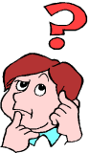
- QUESTION?
Write a question about what you are going to read.

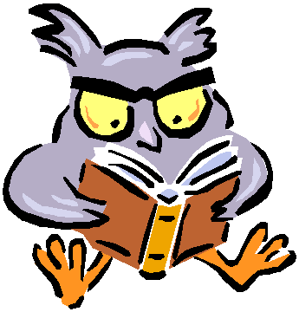
- READ
Read through the text.
Place a ! next to the words that are links for you.
Place a ? next to the words that do not make sense (clunkers).
Share your ! and ? words with a partner.
- RECITE
Look at the question you wrote in #2.
Can you answer your question now?
- REVIEW
What are the most important things that you learned from what you read?

