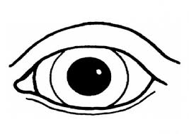  Observations  - I see _______________.  - I observe ___________.  - I notice ____________.  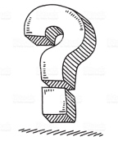  Questions – I wonder…..  - what _____________?  - why ______________?  - where ____________?  - why ______________?  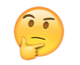  - how ______________?  Predictions  - I think ____________.  - I predict __________. | Observations  - I see _______________.  - I observe ___________.  - I notice ____________.  Questions – I wonder…..  - what _____________?  - why ______________?  - where ____________?  - why ______________?  - how ______________?  Predictions  - I think ____________.  - I predict __________._. | Observations  - I see _______________.  - I observe ___________.  - I notice ____________.  Questions – I wonder…..  - what _____________?  - why ______________?  - where ____________?  - why ______________?  - how ______________?  Predictions  - I think ____________.  - I predict __________.
Observations  - I see _______________.  - I observe ___________.  - I notice ____________.  Questions – I wonder…..  - what _____________?  - why ______________?  - where ____________?  - why ______________?  - how ______________?  Predictions  - I think ____________.  - I predict __________. | Observations  - I see _______________.  - I observe ___________.  - I notice ____________.  Questions – I wonder…..  - what _____________?  - why ______________?  - where ____________?  - why ______________?  - how ______________?  Predictions  - I think ____________.  - I predict __________. | Observations  - I see _______________.  - I observe ___________.  - I notice ____________.  Questions – I wonder…..  - what _____________?  - why ______________?  - where ____________?  - why ______________?  - how ______________?  Predictions  - I think ____________.  - I predict __________.

