Migration Stories

OCDE Project GLAD© English Language Arts Unit

Written for Dual Language Education of New Mexico by Eva Thaddeus

Middle School - Virginia Standards of Learning

IDEA PAGES

I. UNIT THEMES
• Migration stories share common patterns, though each person’s migration story is unique.
- Reading multiple migration stories allows us to compare and contrast them.
- Narratives develop their themes through plot, dialogue and detail.
- Narratives and documentary or historical accounts of the same events can be compared and contrasted.

II. FOCUS/MOTIVATION
- Important Big Book
- Literacy Awards
- Inquiry Charts
- Observation Charts
- Interest pieces from newspaper
- Guest speakers
- Videos, movies, filmstrips

III. CLOSURE
- Living Walls
- Important Big Books
- Where's My Answer
- Group presentations of team tasks
- Personal Explorations/Research projects
- Student Portfolio/Learning Logs
  - Student-authored books
  - Student action plans
  - End-of-unit exam

IV. Virginia Standards of Learning

English Language Arts - Grade Eight
In eighth grade, students continue to build upon skills previously learned in earlier grades. There is a continued emphasis on reading comprehension by comparing fiction and nonfiction texts. In fiction texts, students will explain the development of theme(s), and compare/contrast authors’ styles. In eighth grade, there will be an increased emphasis on nonfiction reading, and students will analyze authors’ qualifications, point-of-view, and style. The student will continue the study of word origins, roots, connotations, and denotations. The student will also plan, draft, revise, and edit while writing in a variety of forms with an emphasis on expository and persuasive writing. Students will compose a thesis statement and defend a position with reasons and evidence. Students will evaluate, analyze, develop, and produce media messages. Students will create multimodal presentations that include different points-of-view, and collaborate with others to exchange ideas, make decisions, and solve problems. The student will apply research techniques to analyze information gathered from diverse sources by identifying misconceptions and possible bias. Students will also cite primary and secondary sources using either MLA or APA style sheet. As in earlier grades, the meaning and consequences of plagiarism will be stressed.

Communication and Multimodal Literacies
8.1 The student will participate in, collaborate in, and report on small-group learning activities.
a) Assume responsibility for specific group tasks and share responsibility for collaborative work within diverse teams.
b) Exhibit willingness to make necessary compromises to accomplish a goal.
c) Collaborate with others to exchange ideas, develop new understandings, make decisions, and solve problems.
d) Include all group members, and value individual contributions made by each group member.
e) Make statements to communicate agreement or tactful disagreement with others’ ideas.
f) Use a variety of strategies to listen actively and speak using appropriate discussion rules with awareness of verbal and nonverbal cues.
g) Use self-reflection to evaluate one’s own role in preparation and participation in small-group activities.
8.2 The student will develop and deliver multimodal, interactive presentations collaboratively and individually.
a) Select, organize, and create multimodal content that encompasses opposing points of view.
b) Choose vocabulary and tone appropriate to the audience, topic, and purpose.
c) Use effective verbal and nonverbal communication skills to deliver multimodal presentations.
d) Cite information sources.
e) Respond to audience questions and comments.
f) Differentiate between Standard English and informal language.
g) Evaluate presentations.
8.3 The student will analyze, develop, and produce creative or informational media messages.
a) Analyze the purpose of information and persuasive techniques used in diverse media formats.
b) Examine how values and viewpoints are included or excluded and how the media can influence beliefs, behaviors, and interpretations.
c) Use media and visual literacy skills to create products to express new understandings.
d) Evaluate sources for relationships between intent and factual content.
e) Utilize multimedia to clarify information and emphasize differing points of view.
f) Evaluate the motives (e.g., social, commercial, political) behind media presentation(s).
g) Demonstrate the ethical use of the Internet when evaluating or producing creative or informational media messages.

Reading
8.4 The student will apply knowledge of word origins, and figurative language to extend vocabulary development within authentic texts.
a) Identify and analyze the construction and impact of an author’s use of figurative language.
b) Use context, structure, and connotations to determine meaning and differentiate among multiple meanings of words and phrases.
c) Use roots, affixes, synonyms, and antonyms to determine the meaning(s) of unfamiliar words and technical vocabulary.
d) Identify the meaning of common idioms.
e) Use word-reference materials to determine meanings and etymology.
f) Discriminate between connotative and denotative meanings and interpret the connotation.
g) Extend general and cross-curricular vocabulary through speaking, listening, reading, and writing.
8.5 The student will read and analyze a variety of fictional texts, literary nonfiction, poetry, and drama.
a) Analyze how authors’ development of characters, conflict, point of view, voice, and tone convey meaning.
b) Identify cause and effect relationships and their impact on plot.
c) Explain the development of the theme(s).
d) Explain the use of symbols and figurative language.
e) Make inferences and draw conclusions based on explicit and implied information using references to the text for support.
f) Identify and analyze characteristics within a variety of genres.
g) Compare/contrast details in literary and informational nonfiction texts.
h) Compare and contrast the authors’ use of word choice, dialogue, form, rhyme, rhythm, and voice in different texts.
i) Compare and contrast authors’ styles.
j) Use reading strategies to monitor comprehension throughout the reading process.
8.6 The student will read, comprehend, and analyze a variety of nonfiction texts.
a) Identify an author’s organizational pattern using textual clues, such as transitional words and phrases.
b) Apply knowledge of text features and organizational patterns to analyze selections.
c) Skim materials to develop an overview or locate information.
d) Make inferences and draw conclusions based on explicit and implied information using evidence from text as support.
e) Analyze the author’s qualifications, viewpoint, word choice, and impact.
f) Analyze details for relevance and accuracy.
g) Differentiate between fact and opinion.
h) Identify the main idea.
i) Summarize the text identifying supporting details.
j) Identify cause and effect relationships.
k) Evaluate, organize, and synthesize information for use in written and other formats.
l) Analyze ideas within and between selections providing textual evidence.
m) Use reading strategies to monitor comprehension throughout the reading process.

Writing
8.7 The student will write in a variety of forms to include narrative, expository, persuasive, and reflective with an emphasis on expository and persuasive writing.
a) Engage in writing as a recursive process.
b) Choose intended audience and purpose.
c) Use prewriting strategies to generate and organize ideas.
d) Organize writing structure to fit form or topic.
e) Establish a central idea incorporating evidence, maintaining an organized structure and formal style.
f) Compose a thesis statement for persuasive writing that advocates a position.
g) Clearly state and defend a position with reasons and evidence, from credible sources.
h) Identify a counterclaim and provide a counter - argument.
i) Distinguish between fact and opinion to support a position.
j) Organize information to provide elaboration and unity.
k) Develop and modify the central idea, tone, and voice to fit the audience and purpose.
l) Revise writing for clarity of content, word choice, sentence variety, and transitions among paragraphs.
8.8 The student will self- and peer-edit writing for capitalization, punctuation, spelling, sentence structure, paragraphing, and Standard English.
a) Use and punctuate correctly varied sentence structures to include conjunctions and transition words.
b) Correctly use pronouns in prepositional phrases with compound objects.
c) Use a variety of sentence structures to infuse sentence variety in writing.
d) Maintain consistent verb tense across paragraphs.
e) Use comparative and superlative degrees in adverbs and adjectives.
f) Use quotation marks with dialogue and direct quotations.
g) Use correct spelling for frequently used words.

Research
8.9 The student will find, evaluate, select, and synthesize appropriate resources to produce a research product.
a) Formulate and revise questions about a research topic.
b) Collect and synthesize information from multiple sources.
c) Evaluate and analyze the validity and credibility of resources.
d) Analyze information gathered from diverse sources by identifying misconceptions, main and supporting ideas, conflicting information, point of view, or bias.
e) Cite primary and secondary sources using Modern Language Association (MLA) or American Psychological Association (APA) style.
f) Quote, summarize and paraphrase research findings.
g) Publish findings and respond to feedback.
h) Avoid plagiarism by using own words and follow ethical and legal guidelines for gathering and using information.
i) Demonstrate ethical use of the Internet.

Possible 8th grade Standards to add to THE CIRCUIT Unit 9/20/17

STANDARD CE.1a, b, c, d, e, f, g, h
The student will develop the social studies skills responsible citizenship requires, including the ability to
a) examine and interpret primary and secondary source documents;
b) create and explain maps, diagrams, tables, charts, graphs, and spreadsheets;
c) analyze political cartoons, political advertisements, pictures, and other graphic media;
d) distinguish between relevant and irrelevant information;
e) review information for accuracy, separating fact from opinion;
f) identify a problem, weigh the expected costs and benefits and possible consequences of proposed solutions, and recommend solutions, using a decision-making model;
g) formulate an informed, carefully reasoned position on a community issue;
h) select and defend positions in writing, discussion, and debate.

STANDARD CE.3a The student will demonstrate knowledge of citizenship and the rights, duties, and responsibilities of citizens by
a) describing the processes by which an individual becomes a citizen of the United States.

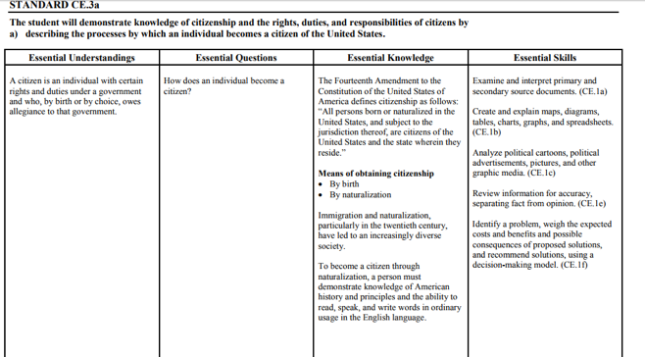

STANDARD CE.3e The student will demonstrate knowledge of citizenship and the rights, duties, and responsibilities of citizens by
e) evaluating how civic and social duties address community needs and serve the public good.
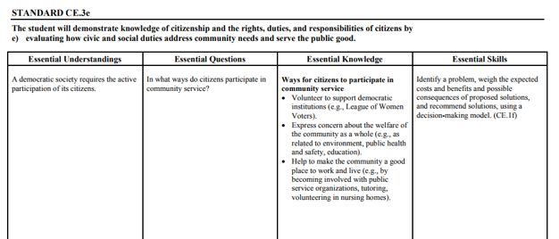

MAYBE:
STANDARD CE.9a The student will demonstrate knowledge of how public policy is made at the local, state, and national levels of government by
a) examining the impact of the media on public opinion and public policy.
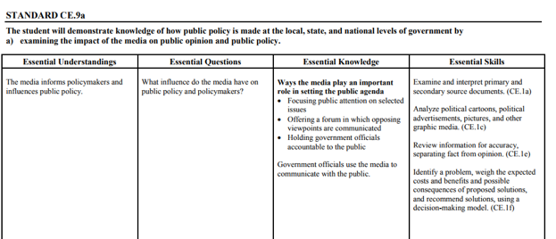

ALSO 7th Grade US History SOLS could be included
STANDARD USII.4b The student will apply social science skills to understand how life changed after the Civil War by
b) explaining the reasons for the increase in immigration, growth of cities, and challenges arising from this expansion;
STANDARD USII.1c The student will demonstrate skills for historical thinking, geographical analysis, economic decision making, and responsible citizenship by
c) interpreting charts, graphs, and pictures to determine characteristics of people, places, or events in United States history;

STANDARD USII.1d The student will demonstrate skills for historical thinking, geographical analysis, economic decision making, and responsible citizenship by
d) using evidence to draw conclusions and make generalizations;

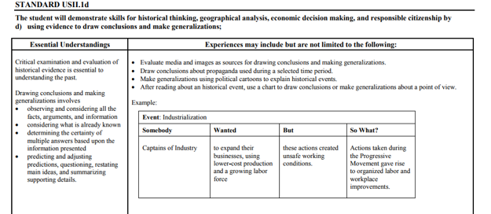

V. RESOURCES

BOOKS
The Circuit by Francisco Jiménez
Elegy on the Death of Cesar Chavez by Rudolfo Anaya (poetry)
Farmworker’s Friend: The Story of Cesar Chavez by David Collins (biography)
Children of the Dust Bowl by Jerry Stanley (history)
La Mariposa by Francisco Jimenez (memoir, historical fiction)
Number the Stars by Lois Lowry (historical fiction)
So Far from the Bamboo Grove by Yoko Kawashima Watkins (historical fiction)
A Long Walk to Water by Linda Sue Park (historical fiction)
Journey of the Sparrows by Fran Leeper Buss and Daisy Cubias (historical fiction)
Inside Out and Back Again by Thanhha Lai (historical fiction)
Cajas de cartón by F. Jimenez (Spanish version of The Circuit) (memoir/historical fiction)
“Pastures of Plenty” by Woody Guthrie (song lyrics)
“Colossus” by Emma Lazarus (poetry)
“The American Dream” by Jim Cullen (history)

Denied, Detained, Deported: Stories from the Dark Side of American Immigration
by Ann Bausum is a text that could be used to compare and contrast different immigration stories.

The patriotic stories of hope that shape most immigration books are supplemented here by the lesser-known stories of those denied, detained, and deported. Ann Bausum’s compelling book presents a revealing series of snapshots from the dark side of immigration history including:
• Immigrants Denied: The St. Louis, a ship filled with Jewish refugees from Nazi Germany sought refuge in American ports and was turned away, condemning many of its passengers to ultimately perish in the Holocaust.
• Immigrants Detained: Japanese-Americans were rounded up during World War II and placed in detention centers—regardless of their patriotism—for security reasons.
• Immigrants Deported: Emma Goldman was branded a dangerous extremist and sent back to Russia in 1919, after living 30 years in the United States.

ARTICLES
“Young Migrant Workers Toil in U.S. Fields” by Karen Fanning,
http://www.scholastic.com/browse/article.jsp?id=5426

“Desperate Journeys: Hundreds of thousands of people are fleeing their homelands and risking their lives to get to Europe.” September 22, 2015 Scholastic.com http://magazines.scholastic.com/Top-News/2015/09/desperate-journeys

“U.S. To Renew Effort To Deport Central American Immigrant Families” May 12, 20168:20 PM ET Laura Wagner http://www.npr.org/sections/thetwo-way/2016/05/12/477867455/immigration-to-renew-effort-to-deport-central-american-immigrant-families

VIDEOS

Which Way Home (video documentary) Available on Netflix

Short trailer about The Circuit https://www.youtube.com/watch?v=M-nzH0T_kyM

Video done about the life of Francisco Jiménez https://www.youtube.com/watch?v=d6oLe3_VSzw&t=7s

1 minute video about Bolivia Climate Refugees from NY Times
http://www.nytimes.com/video/world/americas/100000004512053/climate-refugees-bolivia.html?action=click&gtype=vhs&version=vhs-heading&module=vhs&region=title-area

BLOGS
http://www.debate.org/opinions/should-the-u-s-have-an-open-borders-policy-for-migrants

Internet Resources for literature study
https://www.napacoe.org/wp-content/uploads/.../NCReads_TheCircuitStudyGuide.doc
https://www.scholastic.com/teachers/lesson-plans/teaching-content/circuit-discussion-guide/
https://laii.unm.edu/outreach/common/educators-guides/2012-11_The-Circuit.pdf
https://www.shmoop.com/the-circuit/questions.html

PLOT DIAGRAM TOOLS
Notes and slides explaining a plot diagram, differentiated for different levels - http://slideplayer.com/slide/759366/

V. VOCABULARY
Compare | Contrast | Infer
Narrative | Memoir | Fiction
Non-fiction | History | Migrant
Immigrant | Emigrant | Refugee
Persecuted | Flee | Founded
Livelihood | Signatory | Asylum
Genocide | Detained | Deported
Denied | Granted | Human rights
Border | Sovereignty | United Nations

MIGRATION STORIES (TX, 6TH)
PLANNING PAGES

I. FOCUS AND MOTIVATION
- 3 standards of behavior with literacy awards
- Observation charts: California Gold Rush, Dust Bowl; Cesar Chavez and the UFW, Migrant Laborers today; Syrian refugees; Detainees from Central America; Isle de Saint Jean Charles and other climate disaster photos
- Big Book “Migration Stories”
- Inquiry Chart: What we know / What we want to know about Panchito
- Cognitive Content Dictionary

II. INPUT
- Graphic Organizer: Map and Timeline of The Circuit’s chronology
- Comparative Input Chart of Migrants and Refugees
- Pictorial Input Chart – elements of the novel “The Circuit” by Francisco Jiménez
- Narrative Input Chart of Story #1, “Under the Wire”
“Pastures of Plenty” by Woody Guthrie – Listen and Sketch
- Read aloud from “Children of the Dust Bowl” by Jerry Stanley
- Selected readings from Children at Work
- Harvesting Hope: The Story of Cesar Chavez by Kathleen Krull

- GUIDED ORAL PRACTICE
- T-graph/processing
- Team co-op group evaluation
- Open Sort with textbook Picture File Cards
- Closed Sort with Picture File Cards - classify, compare, order
- Exploration Report
- Inquiry Chart
- Mind Mapping, list-group-label
- Heads Together/Process Grid
- Poetry and chants

- Student demonstrations
- Silent Video
- Sentence Patterning Chart

- READING/WRITING
- Total Group
• Newspaper interest pieces
• Group Frames (Teacher uses info. from students to model appropriate frame)
• Big Book - The Important Book
• Cooperative Strip Paragraph - multiple paragraphs Information
• Poetry Frames
- B. Small Group Reading/Writing Activities
• Literature Circle books: Number the Stars, A Long Walk to Water, So Far from the Bamboo Grove, La Mariposa, Cajas de cartón (Spanish version of The Circuit) 10/2 lecture with primary language
• Ear-to-Ear Reading
• Textbook pairs of pairs reading, tutoring, worksheets
• Focused Reading
• Flexible Reading Groups
• Expert Groups
• Team Tasks
• Reader's Theater
• Team Writing Workshop
• Group Process Grids
• Interactive Reading
• Book Sharing
C. Individual Activities - Portfolio
• Paragraph/Essay writing
• Poetry writing
• Interactive Journal Writing
• Learning Logs
• Individual Tasks
- Writer's Workshop
• Mini Lesson
• Writing/planning
• Conferences
• Author's Chair
V. REINFORCEMENT/EXTENSION ACTIVITIES
• Videos
• Read alouds
• Newspaper interest pieces
• Guest speakers

VII. CLOSURE
• Focused Reading
• Process Inquiry Charts
•Vocabulary Strips - Where's My Answer
• Reading Big Books, share individual poetry
• Personal Exploration with Rubric
• Student Generated Text
• Student portfolios and presentations
• Student action plan
• Teacher-created exam

MIGRATION STORIES (TX, 6TH)
SAMPLE DAILY LESSON PLAN (5 Day)
NOTE: Italicized strategies are used frequently in the classroom. Each day is the equivalent of 1 ½ to 2 weeks of instruction in a typical middle school classroom.

Day (Week) 1

FOCUS/MOTIVATION
- Zero Noise Signal
- Cognitive Content Dictionary (CCD) with signal word
- Prediction/Reaction Guide
- Three Standards and Literacy Awards
- Observation Charts
- Inquiry Chart
- Big Book: Migration Stories
- Student Portfolios

INPUT
- Graphic Organizer: Timeline of The Circuit
- Pictorial input chart: elements of the The Circuit
- Narrative Input Chart: "Under the Wire”

GUIDED ORAL PRACTICE
- 10/2 could include primary language
- Learning log, ELD review
- T-Graph for Social Skills
- Picture File Sort
- Exploration Report
- Chant: Here There

READING AND WRITING
- Interactive Journal
- Learning Log
- Listen and Sketch

ASSESSMENT AND FEEDBACK
- Home-School connection
- Learning Log

MIGRATION STORIES (TX, 6TH)
SAMPLE DAILY LESSON PLAN (5 Day)
NOTE: Italicized strategies are used frequently in the classroom. Each day is the equivalent of 1 ½ to 2 weeks of instruction in a typical middle school classroom.

Day (Week) 2

FOCUS/MOTIVATION
- Cognitive Content Dictionary w/Signal Word
- Process Home/School Connection
- Three Personal Standards and Literacy Awards
- Process Chant (TPR, highlight, sketch, picture file cards)

INPUT
- Graphic Organizer - Review with word cards
- Comparative Input Chart – Review with word card and pictures
- Pictorial Input Chart – Review with word cards and pictures

GUIDED ORAL PRACTICE
- T-Graph for Social Skills – review and processing
- Poetry/Chants
- Sentence Patterning Chart

READING AND WRITING
- Expert Group
- Team Tasks: (i.e.: Team Task Key, Exploration Report, Graphic Organizer, Pictorial Input Chart, Here There Chant, Inquiry Chart, etc.)

ASSESSMENT AND FEEDBACK
- Process charts/ chants
- Home/School Connection
- Learning Log

MIGRATION STORIES (TX, 6TH)
SAMPLE DAILY LESSON PLAN (5 Day)
NOTE: Italicized strategies are used frequently in the classroom. Each day is the equivalent of 1 ½ to 2 weeks of instruction in a typical middle school classroom.

Day (Week) 3

FOCUS/MOTIVATION
- Three Standards of Behavior and Literacy Awards
- Cognitive Content Dictionary (CCD) with signal word
- Process home school connection

INPUT
- Narrative Input Chart – Review with word cards and speech bubbles

READING AND WRITING
- Sentence Patterning Chart Reading and Trading games
- Expert group
- Team Tasks: (i.e.: T-Graph for Social Skills, Sentence Patterning Chart, etc.)

GUIDED ORAL PRACTICE
- Poetry/Chants
- T-Graph for Social Skills – review and processing

READING AND WRITING
- Mind Map
- Process Grid game
- Cooperative Strip Paragraph: write, read, respond, revise

ASSESSMENT AND FEEDBACK
- Process Inquiry Chart
- Home-School Connection
- Interactive Journal Writing

MIGRATION STORIES (TX, 6TH)
SAMPLE DAILY LESSON PLAN (5 Day)
NOTE: Italicized strategies are used frequently in the classroom. Each day is the equivalent of 1 ½ to 2 weeks of instruction in a typical middle school classroom.

DAY 4:

FOCUS/MOTIVATION
- Cognitive Content Dictionary with “stumper word” (student self-selected vocabulary)
- Process Home School Connection
- Three Personal Standards and Literacy Awards

GUIDED ORAL PRACTICE
- Poetry/Chants
- Process T-Graph & Oral Evaluation

READING/WRITING
- Story Map
- Team Tasks (i.e. Here There Flip Chant, CCD, Team Cooperative Strip Paragraph, Big Book Page, etc.)
- Flexible Groups Reading- leveled, skill, heterogeneous, homogeneous, ELD
- Clunker and Links with SQ3R - at or above grade level
- Emergent Reading Group with Coop Strip Paragraph - struggling/emergent readers
- ELD Group Frame-- Story or Chart Retell (Assessment and Feedback)
- Ear-to-Ear Reading with Poetry Booklet
- Focused Reading with individual CCD

ASSESSMENT/FEEDBACK
- Interactive Journals
- Process Inquiry Chart
- Team Presentations
- Present Team Explorations with Rubric
- Graffiti Wall

MIGRATION STORIES (TX, 6TH)
SAMPLE DAILY LESSON PLAN (5 Day)
NOTE: Italicized strategies are used frequently in the classroom. Each day is the equivalent of 1 ½ to 2 weeks of instruction in a typical middle school classroom.

DAY 5:

FOCUS/MOTIVATION
- Cognitive Content Dictionary with “stumper word” (student self-selected vocabulary)
- Process Home School Connection
- Three Personal Standards and Literacy Awards
- Poetry/Chants

READING/WRITING
- Team Tasks
- Personal Explorations (individual task to be assessed)
- ELD Group Frame with Pictorial Input Chart
- Process T-graph
Written Evaluation
Team Presentation
- Interactive Journals
- Flexible group reading
- Guided reading

EXTENDED ACTIVITIES FOR INTEGRATION
- Guest Speaker
- Videos

ASSESSMENT/FEEDBACK
- Action Plan
- Portfolio work with rubric
- Present Personal Explorations with rubric
- Student and Teacher made test (based on Graffiti Wall questions)
- Writing Prompt
- Evaluate Week (letter)
- Jeopardy with Process Grid
- Metacognition of learning

Prediction/Reaction Guide
Read each question. At the beginning of the unit, write your prediction to the question based on the information that you currently have. At the end of the unit, go back and respond under reaction. Compare what you thought at the beginning of the unit and what you understand by the end.
- What is the theme of the book The Circuit?
Prediction: | Reaction:
- What is the meaning of the book’s title?
Prediction: | Reaction:
- What is a migration story?
Prediction: | Reaction:
- What do you think you will learn in this unit?
Prediction: | Reaction:

Literacy Award
On the back of the award, write an inference you can make from this passage from the book (p.3)

Noting that Papá had closed his eyes, I turned to Roberto and asked, “What’s California like?”
“I don’t know,” he answered, “but Fito told me that people there sweep money off the streets.”

Literacy Award
On the back of the award, write an inference you can make from this passage from the book (p.4)

Papá unloaded the suitcase from the trunk, took out his wallet, and paid the woman. “We have only seven dollars left,” he said, biting his lower lip.

Literacy Award
On the back of the award, write an inference you can make from this passage from the book (p.6)
“When can we start work?” Papá asked, rubbing his hands.
“In two weeks,” the foreman answered.
“That can’t be!” Papá exclaimed, shaking his head. “We were told we’d find work right away.”
“I am sorry, the strawberries won’t be ready to pick until then,” the foreman responded, shrugging his shoulders and walking away.

Photo author: Elucidate. This file is licensed under the Creative Commons Attribution 3.0 Unported license.

Literacy Award
On the back of the award, write an inference you can make from this passage from The Circuit (p.8)

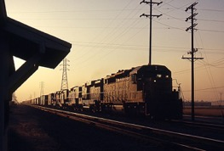 Photo author: Gordon Smith’s parents. This file is licensed under the Creative Commons Attribution-Share Alike 3.0 Unported license.
The conductor slowed the train to a crawl, waved, and gently dropped a large brown bag in front of us as he went by. We picked it up and looked inside. It was full of oranges, apples, and candy.
“See, it does come from California!” Roberto exclaimed.

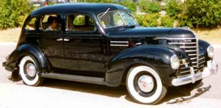
Literacy Award
On the back of the award, write an inference you can make from this passage from The Circuit (p.10)

When I finally saw them, my heart started racing. I jumped off the car, fell to the ground, got up, and ran to meet them. I almost knocked Roberto off his feet when I jumped on him.

Photo = Lars-Göran Lindgren Sweden - Own work, Media Commons

Literacy Award
On the back of the award, write an inference you can make from this passage from The Circuit (p.11)
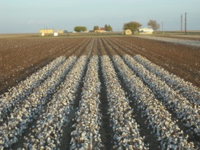
I climbed onto the roof of the carcachita again and watched them disappear into the sea of cotton. My eyes began to cloud up.

Photo author- Kimberly Vardeman This file is licensed under the Creative Commons Attribution 2.0 Generic license.

Literacy Award
On the back of the award, write an inference you can make from this passage from The Circuit (p.17)

I was about to put my hand in the jar to touch the caterpillar when the bell rang. All the kids lined up outside the classroom door and then walked in quietly and took their seats. Some of them looked at me and giggled. Embarrassed and nervous, I looked at the caterpillar in the jar. I did this every time someone looked at me.

Photo author = Miroslava Serova The copyright holder of this work allows anyone to use it for any purpose including unrestricted redistribution, commercial use, and modification

Literacy Award
On the back of the award, write an inference you can make from this passage from The Circuit (p.1
But when I spoke to Arthur in Spanish and Miss Scalapino heard me, she said “NO!” with body and soul. Her head turned left and right a hundred times a second and her index finger moved from side to side as fast as a windshield wiper on a rainy day. “English, English,” she repeated. Arthur avoided me whenever she was around.

Literacy Award
On the back of the award, write an inference you can make from this passage from The Circuit (p.23)

At the end of the school day, Miss Scalapino gave me a note to take home to my parents. Papá and Mamá did not know how to read, but they did not have to. As soon as they saw my swollen upper lip and the scratches on my left cheek, they knew what the note said. When I told them what happened, they were very upset but relieved that I did not disrespect the teacher.

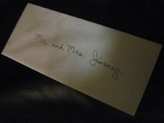

Literacy Award
On the back of the award, write an inference you can make from this passage from The Circuit (p.23)

“He really likes it, Francisco,’ Arthur said to me in Spanish.
“¿Cómo se dice ‘es tuyo’ en inglés?” I asked.
“It’s yours,” answered Arthur.
“It’s yours,” I repeated, handing the drawing to Curtis.

Literacy Awards-

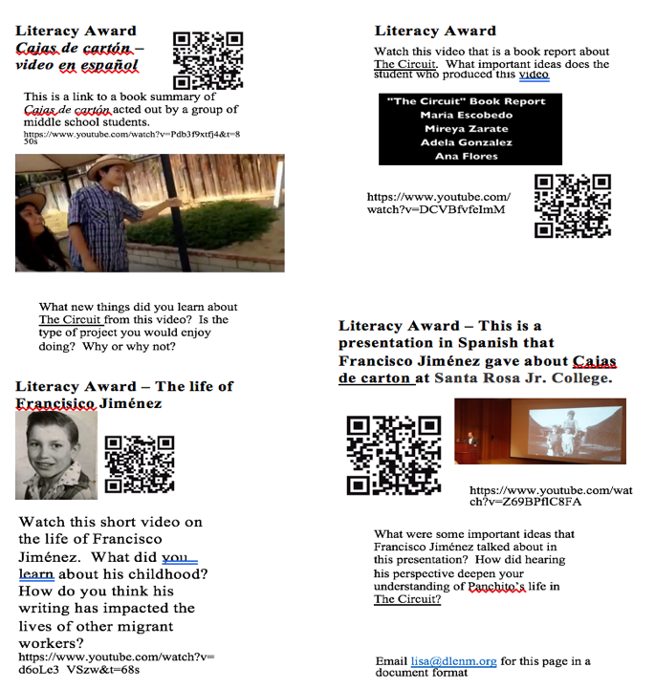
For a page of literacy awards using QR Codes and different videos on You Tube

BIG BOOK ABOUT MIGRATION STORIES

1. Here’s something to know. Migration stories show common patterns, even though each person’s experience is unique.

Migration means the large-scale movement of groups of animals from one place to another. Hummingbirds, caribous and some butterflies migrate. So do people.

Throughout human history, migration has been a frequent occurrence. According to biological science, the human species originated in Africa about 100,000 years ago. Since then, humans have migrated to other continents and now live on all of them except Antarctica.

Migration stories show common patterns, even though each person’s experience is unique. It’s important to remember.

2. Migration stories show common patterns, even though each person’s experience is unique.

Emigration means migration from somewhere, and immigration means migration to somewhere. The U.S.A. is often called a nation of immigrants because most people who live here had ancestors that arrived sometime within the last 500 years. 500 years is not a long time compared with the length of time that humans have existed on earth. That means that most Americans are relatively recent immigrants.

Migration stories show common patterns, even though each person’s experience is unique. It’s important to remember.

3. Migration stories show common patterns, even though each person’s experience is unique.

The first people to migrate to the Americas and settle here are believed to have traveled across a land bridge from Asia that existed thousands of years ago. These people became the Native Americans. After the Native Americans, the next immigrants to settle in North America came from Europe. These immigrants came by boat, beginning about 500 years ago. Some were fleeing religious persecution in England or Spain. Others were looking for economic opportunity. Farmers came looking for land. Hunters and trappers came to seek their fortunes in the wild woods.

Europeans soon brought others to work for them. Large numbers of people from West Africa were captured and brought against their will to North America as slaves. In later years, the slaves were freed and became citizens of the countries that had once enslaved them.

Migration stories show common patterns, even though each person’s experience is unique. It’s important to remember.

4.Migration stories show common patterns, even though each person’s experience is unique.

After the United States was founded, it became known as the “land of opportunity,” and also as a “melting pot.” Over the centuries, this country has received many thousands of immigrants. Some have come here to look for a better life. Others did not wish to leave their homelands but were forced to flee because of war or famine. Today’s immigrants to the U.S. come from Asia, Africa, Europe, South America and Central America.

Migration stories show common patterns, even though each person’s experience is unique. It’s important to remember.

5. Migration stories show common patterns, even though each person’s experience is unique.

Migration sometimes happens within countries. In the 1930s, agriculture failed in a large part of the central United States. Crops dried up, and large areas of topsoil blew away in the wind. Farms turned into wastelands and farmers lost their livelihoods. This time in American history is known as the Dust Bowl. Many people from Oklahoma, Kansas, Texas and Missouri fled to California and looked for work there. Although they did not leave their country, they were migrants nonetheless.

Migration stories show common patterns, even though each person’s experience is unique. It’s important to remember.

6. Migration stories show common patterns, even though each person’s experience is unique.

Violent times often result in mass migrations. For example, during and after the Second World War, many people left Europe. Some were fleeing the Nazi genocide known as the Holocaust. Others lost their jobs and homes because of war. Many of these war refugees settled in other countries around the world, and remained there even after the war was over.

Migration stories show common patterns, even though each person’s experience is unique. It’s important to remember.

7. Migration stories show common patterns, even though each person’s experience is unique.

After the Second World War, the organization called the United Nations was founded. This was an attempt to create a world-wide governing body that would help prevent global conflicts in the future. In 1948, the U.N. proclaimed a Universal Declaration of Human Rights. This statement describes the rights that, according to its signatories, all human beings should have, no matter where in the world they live.

8. Migration stories show common patterns, even though each person’s experience is unique.

People who flee their countries because of war, persecution or natural disaster are known as refugees. According to Article 14 of the Universal Declaration of Human Rights, these people have the right to seek “asylum from persecution” in other countries. A “U.N. High Commission on Refugees” was created to help the refugees from World War II find asylum in other countries. In 1951, a treaty called the “U.N. Convention Relating to the Status of Refugees,” or “Refugee Convention” for short, was adopted as the legal framework for international protection of refugees.

Migration stories show common patterns, even though each person’s experience is unique. It’s important to remember.

9. Migration stories show common patterns, even though each person’s experience is unique.

Immigration can be a source of controversy. Nations generally exercise control over their borders and hold the right to decide whether new immigrants are permitted to settle within their boundaries. In some times and places in history, nations have welcomed and even encouraged immigration. In other times and places, nations have closed their borders completely and refused to let new people in. In most places today, immigration is permitted but only within limits. The nature of those limits is a source of heated debate. Although discussions about the pros and cons of immigration can be passionate and complex, in today’s world, where mass migration is common, these discussions are of vital importance.

Migration stories show common patterns, even though each person’s experience is unique. It’s important to remember.

10. Migration stories show common patterns, even though each person’s experience is unique.

Many people have written migration narratives. Some, like The Circuit by Francisco Jimenez, are first-hand accounts of their own experiences. Others, like A Long Walk to Water by Linda Sue Park, are based on research about the experience of others. Well-known immigration novels for young readers include Esperanza Rising, So Far from the Bamboo Grove, and Number the Stars.

Historical accounts of migration have also been written for people your age. In this unit, you will be exposed to one such book, called Denied, Detained, Deported. You will also be reading selections from articles written for adults. You will have a chance to compare and contrast a migration narrative with an historical account of events from the same place and time. You will also consider the differences between refugees and other migrants, and think about which groups of people should be given refugee status. These are big issues, so get ready!

To recap one more time: Migration stories show common patterns, even though each person’s experience is unique. It’s important to remember.

Graphic Organizer Version 1
Chronology of the stories in The Circuit
To Have and To Hold
Learning the Game
Christmas
Gift
El Angel de Oro
Miracle in Tent City
Moving Still
The Circuit
Cotton Sack
Death Forgiven
Soledad
Under the Wire
Inside Out

------------------------------------------------------------------------------------------------------------------------------------------------------------------------------------------------------------------------------------------------------------------
Sixth Grade
Fourth Grade
Eighth Family
Grade Deported
Third Grade

First Grade
Panchito’s family
comes to U.S.A.

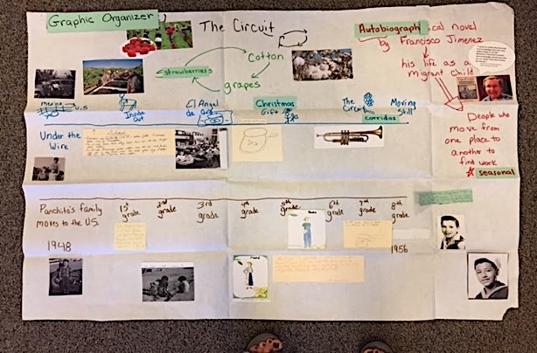
Short book trailer (1:24) to The Circuit could be a good introduction to doing this timeline. https://www.youtube.com/watch?v=M-nzH0T_kyM
Graphic Organizer Version 2
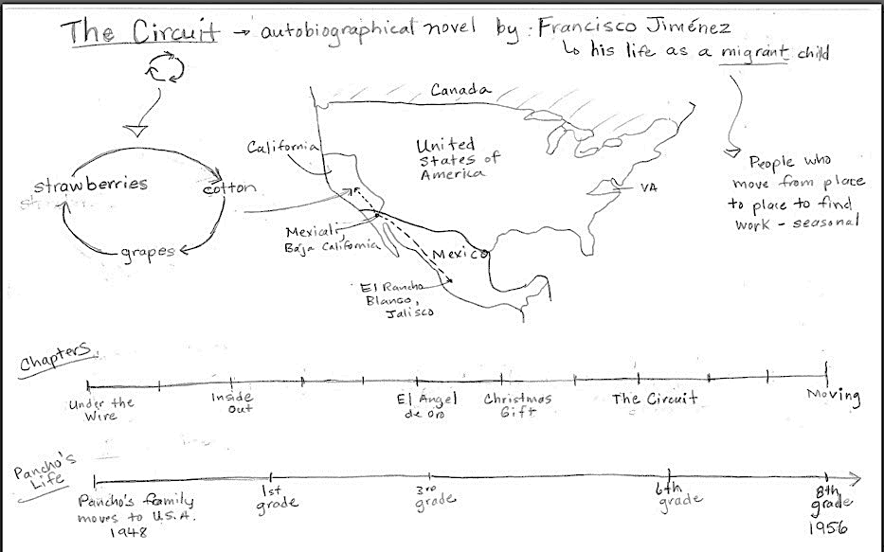
GO ELD Review Questions
Stages of Language Acquisition - WIDA | Level 1 Entering  Listening/Speaking | Level 2 Beginning  Listening/Speaking | Level 3 Developing  Listening/Speaking | Level 4 Expanding  Listening/Speaking | Level 5 Bridging  Listening/Speaking
Level of Questioning | Point To, Locate, Trace Yes/No Either/Or Open Ended
Create  Arrange, assemble, collect, compose, combine, construct, create, design, develop, devise, forecast, formulate, hypothesize, imagine, invent, manage, organize, plan, prepare, propose, set up | Choose the parts/features of the map that you would use to teach another student about a journey of a migrant farmworker in this country. | Is an autobiographical novel an interesting way to share the story of a migrant farmworkers life? | Look at these two pictures. Which one shows how a migrant farmworker in the 1950’s would travel? | If Panchito’s family did not come to the United States to work, how to you think their lives would have been different?
Evaluate  Appraise, argue, assess, choose, compare, critique, decide, debate, defend, determine, discuss, estimate, evaluate, judge, justify, predict, prioritize, rate, recommend, select, support, value, verify, weigh | Locate which chapter that you predict would be the most interesting. | Justify, could Panchito’ family survive if they stayed in Mexico? | What word would best describe migrant farm work: challenging or exciting? | Predict what would happen if Panchito and his family had not decided to come to the USA?
Analyze  Analyze, appraise, calculate, categorize, classify, compare, contrast, criticize, differentiate, discriminate, distinguish, examine, experiment, explain, identify, infer, question, test | Point to the parts of the timeline that are important for understanding what is happening in the chapters.  Showing two pictures: Which picture is an example of a migrant family? | (Showing two pictures.)Which picture shows how migrant workers work in the fields | Since Panchito was young when he crossed the border to the United States, do you infer that it he was excited or sad? | Compare the journey of Panchito’s family to the journey of someone else you know that has come to the USA from another country. How are they the same or different?
Apply  Apply, calculate, categorize, classify, change, choose, compare, construct, demonstrate, describe, determine, distinguish, dramatize, employ, estimate, explain, extend, illustrate, interpret, judge the effects, operate, practice, schedule, select, show, sketch, solve, use | On this chart, trace the sketch that shows which crops the family would move to pick or harvest. | Is The Circuit an example of an autobiographical novel? | Are Mexico, The United States and Canada categorized as states or countries? | Use the information on the chart to explain why migrants move from place to place.
Understand  Categorize, cite, clarify, classify, describe, discuss, explain, express, identify, indicate, interpret, locate, match, paraphrase, predict, recognize, restate, review, select, summarize, translate | Point to the information that shows what crops the family harvested in California. | Do the chapters of the story follow Panchito’s life in California? | Does the timeline teach us about the grades Panchito was in each chapter or about where Panchito lived? | Summarize the most important ideas about the journey Panchito and his family underwent to get to the United States.
Remember  Arrange, choose, define, describe, draw, , find, give example, identify, label, locate, list, match, name, recall, recite, recognize, record, repeat, reproduce, select, state, tell | Locate the place in Mexico where Panchito and his family lived. | Recall, did Panchito’s family move to the United States in 1948? | Point to the picture of the migrant family on the chart. In this picture is the family working or resting? | Tell me what you learned about Panchito’s journey to the United States.

Pictorial Input Chart
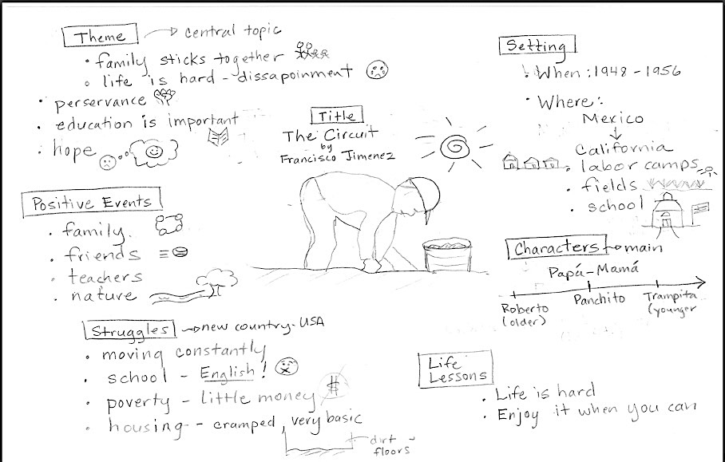
Stages of Language Acquisition - WIDA | Level 1 Entering  Listening/Speaking | Level 2 Beginning  Listening/Speaking | Level 3 Developing  Listening/Speaking | Level 4 Expanding  Listening/Speaking | Level 5 Bridging  Listening/Speaking
Level of Questioning | Point To, Locate, Trace Yes/No Either/Or Open Ended
Create  Arrange, assemble, collect, compose, combine, construct, create, design, develop, devise, forecast, formulate, hypothesize, imagine, invent, manage, organize, plan, prepare, propose, set up | Choose the elements of “The Circuit” that you would use to teach another student about. | Would better housing be a helpful way to support Panchito’s family? | Look at these two pictures. Which one shows how a migrant child who doesn’t speak English might feel on the first day at a new school? | If the migrant family did not have friends and family, propose how the family would have to deal with emergency situations.
Evaluate  Appraise, argue, assess, choose, compare, critique, decide, debate, defend, determine, discuss, estimate, evaluate, judge, justify, predict, prioritize, rate, recommend, select, support, value, verify, weigh | Locate which part of this novel that you predict would be the most interesting. | Justify, could Panchito’s family survive is they did not stick together? | What phrase would best describe the themes of this novel, ‘Never give up.” or “Life is a party.”? | Predict what would happen if Panchito already spoke English when he began school in California?
Analyze  Analyze, appraise, calculate, categorize, classify, compare, contrast, criticize, differentiate, discriminate, distinguish, examine, experiment, explain, identify, infer, question, test | (Showing two pictures) Which picture is an example of a migrant housing camp? | (Showing an additional picture.) Does this picture show a challenge of Panchito and his family’s life? | Since most of the story takes place in California, do you infer that California has a lot of farming or not much farming? | Compare the struggles of Panchito’s life to those of your life. How are they the same or different?
Apply  Apply, calculate, categorize, classify, change, choose, compare, construct, demonstrate, describe, determine, distinguish, dramatize, employ, estimate, explain, extend, illustrate, interpret, judge the effects, operate, practice, schedule, select, show, sketch, solve, use | On this chart, point to the information that supports the life lesson or “Life is hard.” | Is moving constantly an example of a struggle or of a positive event? | Are the events that happen with the people in Panchito’s life o/categorized as positive events or as struggles? | Use the information on the chart to explain why school is a struggle for Panchito.
Understand  Categorize, cite, clarify, classify, describe, discuss, explain, express, identify, indicate, interpret, locate, match, paraphrase, predict, recognize, restate, review, select, summarize, translate | Point to the category that shows when and where the story took place. | Do the themes of the novel reflect the positive events and challenges that Panchito and his family face? | Do the themes tell/teach us about the central idea of the story or where the story takes place? | Summarize the most important ideas about the struggles Panchito and his family face in this novel.
Remember  Arrange, choose, define, describe, draw, , find, give example, identify, label, locate, list, match, name, recall, recite, recognize, record, repeat, reproduce, select, state, tell | Locate the child that is harvesting the crop. | Recall, does Panchito’s family leave Mexico and move to the USA? | Point to category of Positive Events. In category are most of good things that happened about people or things? | Tell me what the struggles are in this novel.

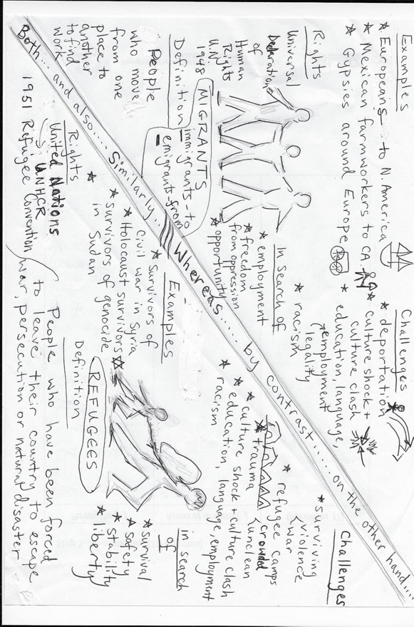
Comparative Input Chart – migrants vs. refugees

QUESTION GRID – Comparative Input Chart Migrants and Refugees
Thinking and Language Grid | Level 1 Entering  Listening/Speaking | Level 2 Beginning  Listening/Speaking | Level 3 Developing  Listening/Speaking | Level 4 Expanding  Listening/Speaking | Level 5 Bridging  Listening/Speaking
KNOWLEDGE  Arrange, order, define,  duplicate, label, list, name,  recognize, relate, recall, repeat,  Reproduce  COMPREHENSION  Classify, describe, discuss,  explain, express, identify,  indicate, locate, recognize,  report, restate, review, select,  translate | • Show me a migrant.  • Show me a refugee. | • Is this a migrant or a refugee?  • Did the Pilgrims travel by boat or by foot? | • What is the document that lists rights all human beings should have? | • Give some examples of refugees. | • Explain why refugees may need to flee their homeland.
APPLICATION  Apply, choose, demonstrate,  dramatize, employ, illustrate,  interpret, operate, practice,  schedule, sketch, solve, use ANALYSIS  Analyze, appraise, calculate,  categorize, compare, contrast, criticize, differentiate,  distinguish, examine, experiment, question, test | • Show me a person who may have to learn a new language.  • Show me a person who may be escaping violence. | • Which people are likely to be deported: refugees or migrants? | • What are two similarities between migrants and refugees?  • What is a difference between migrants and refugees? | • Compare and contrast the things that migrants and refugees are in search of. | • Why might refugees suffer from trauma?
SYNTHESIS  Arrange, assemble, collect,  compose, construct, create,  design, develop, formulate,  manage, organize, plan,  prepare, propose, set up  EVALUATION  Appraise, argue, assess, attach,  choose, compare, defend,  estimate, judge, predict, rate,  select, support, value | • Which people are in most danger? Show me. | • Which people have more rights: migrants or refugees? | • Which people do you predict will be more successful in their new country: migrants or refugees? Why? | • Refugees generally have more legal protections than other migrants. Do you think this is justified? Explain. | • Under what conditions do you think that migrants should be able to look for legal work in other countries?

I
Background information to support delivery of the Comparative Input Chart
UNHCR
The UN Refugee Agency

GENEVA, Aug 27 (UNHCR) - With almost 60 million people forcibly displaced globally and boat crossings of the Mediterranean in the headlines almost daily, it is becoming increasingly common to see the terms ‘refugee’ and ‘migrant’ being used interchangeably in media and public discourse. But is there a difference between the two, and does it matter?

Yes, there is a difference, and it does matter. The two terms have distinct and different meanings, and confusing them leads to problems for both populations. Here’s why:
Refugees are persons fleeing armed conflict or persecution. There were 19.5 million of them worldwide at the end of 2014. Their situation is often so perilous and intolerable that they cross national borders to seek safety in nearby countries, and thus become internationally recognized as "refugees" with access to assistance from States, UNHCR, and other organizations. They are so recognized precisely because it is too dangerous for them to return home, and they need sanctuary elsewhere. These are people for whom denial of asylum has potentially deadly consequences.

Refugees are defined and protected in international law. The 1951 Refugee Convention and its 1967 Protocol as well as other legal texts, such as the 1969 OAU Refugee Convention, remain the cornerstone of modern refugee protection. The legal principles they enshrine have permeated into countless other international, regional, and national laws and practices. The 1951 Convention defines who is a refugee and outlines the basic rights which States should afford to refugees. One of the most fundamental principles laid down in international law is that refugees should not be expelled or returned to situations where their life and freedom would be under threat.

The protection of refugees has many aspects. These include safety from being returned to the dangers they have fled; access to asylum procedures that are fair and efficient; and measures to ensure that their basic human rights are respected to allow them to live in dignity and safety while helping them to find a longer-term solution. States bear the primary responsibility for this protection. UNHCR therefore works closely with governments, advising and supporting them as needed to implement their responsibilities.

Migrants choose to move not because of a direct threat of persecution or death, but mainly to improve their lives by finding work, or in some cases for education, family reunion, or other reasons. Unlike refugees who cannot safely return home, migrants face no such impediment to return. If they choose to return home, they will continue to receive the protection of their government.

For individual governments, this distinction is important. Countries deal with migrants under their own immigration laws and processes. Countries deal with refugees through norms of refugee protection and asylum that are defined in both national legislation and international law. Countries have specific responsibilities towards anyone seeking asylum on their territories or at their borders. UNHCR helps countries deal with their asylum and refugee protection responsibilities.

Politics has a way of intervening in such debates. Conflating refugees and migrants can have serious consequences for the lives and safety of refugees. Blurring the two terms takes attention away from the specific legal protections refugees require. It can undermine public support for refugees and the institution of asylum at a time when more refugees need such protection than ever before. We need to treat all human beings with respect and dignity. We need to ensure that the human rights of migrants are respected. At the same time, we also need to provide an appropriate legal response for refugees, because of their particular predicament.

So, back to Europe and the large numbers of people arriving this year and last year by boats in Greece, Italy and elsewhere. Which are they? Refugees or migrants?
In fact, they happen to be both. The majority of people arriving this year in Italy and Greece especially have been from countries mired in war or which otherwise are considered to be ‘refugee-producing’ and for whom international protection is needed. However, a smaller proportion is from elsewhere, and for many of these individuals, the term ‘migrant’ would be correct.

So, at UNHCR we say ‘refugees and migrants’ when referring to movements of people by sea or in other circumstances where we think both groups may be present - boat movements in Southeast Asia are another example. We say ‘refugees’ when we mean people fleeing war or persecution across an international border. And we say ‘migrants’ when we mean people moving for reasons not included in the legal definition of a refugee. We hope that others will give thought to doing the same. Choices about words do matter.
By Adrian Edwards, Geneva

Narrative Input Text

Narrative input text is “Under the Wire,” the first story from the collection The Circuit by Francisco Jiménez.

The illustrations that follow were drawn by Eva Thaddeus for the purpose of teaching this unit and may be used and copied without any restrictions.

Text from the story should be cut up and attached to the back of the illustrations. The text itself is under copyright and cannot be reproduced here.
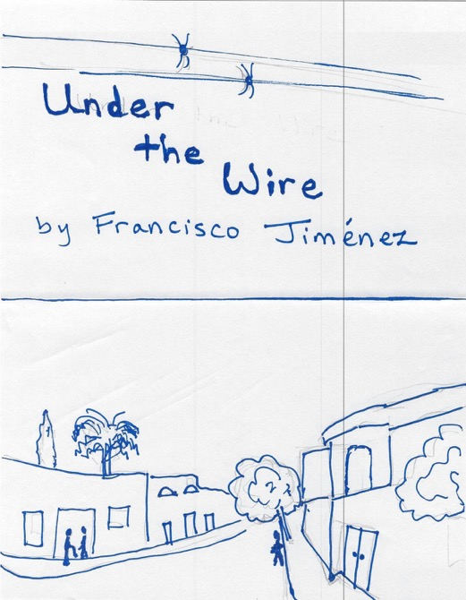

ELD questions for narrative Under the Wire
QUESTION GRID – Under the Wire
Thinking and Language Grid | Level 1 Entering  Listening/Speaking | Level 2 Beginning  Listening/Speaking | Level 3 Developing  Listening/Speaking | Level 4 Expanding  Listening/Speaking | Level 5 Bridging  Listening/Speaking
KNOWLEDGE  Arrange, order, define,  duplicate, label, list, name,  recognize, relate, recall, repeat,  Reproduce  COMPREHENSION  Classify, describe, discuss,  explain, express, identify,  indicate, locate, recognize,  report, restate, review, select,  translate | • Show me a train.  • Is this California, or Mexico? | • Show me the place where Panchito and his family cross the border.  • Show me Panchito and his family sleeping on the ground. | • Who are the members of Panchito’s family?  • How does the family travel from Mexico to the United States? | • Who are the main characters in this story?  • What happens in this story? | • Summarize this story.
APPLICATION  Apply, choose, demonstrate,  dramatize, employ, illustrate,  interpret, operate, practice,  schedule, sketch, solve, use ANALYSIS  Analyze, appraise, calculate,  categorize, compare, contrast, criticize, differentiate,  distinguish, examine, experiment, question, test | • Show me California. Where else? Any other parts here happen in California?  • Who is this? (Panchito’s mother.) | • Show me what the conductor gives to Panchito and his brother  • How do Panchito and Roberto feel about the gift? | Why is the story called “Under the Wire?”  What does Fito mean by saying that “In California they sweep money off the streets?” | Why does Roberto say at the end, “You see, it does come from California?”  Why does the father decide to move the family to California? | What is the theme of this story?
SYNTHESIS  Arrange, assemble, collect,  compose, construct, create,  design, develop, formulate,  manage, organize, plan,  prepare, propose, set up  EVALUATION  Appraise, argue, assess, attach,  choose, compare, defend,  estimate, judge, predict, rate,  select, support, value | • Do you think she (Panchito’s mother) feels happy or sad?  • Show me a part where Panchito is happy. | • Is the conductor friendly or unfriendly?  • What would have happened if la migra had caught the family crossing the border? | • Roberto has high hopes for California. How realistic do you think his hopes are? | • Do you think the father makes a good decision to move to California? Why/why not? | • What do you predict will happen to Panchito and his family in the next story? Cite evidence to support your opinion.

Migration Stories
Poetry booklet

Name _________________________________________ Number ________________
Migrant Workers Here There
By Ms. Nadera and Ms. Thaddeus

Migrant workers here, migrant workers there.
Migrant workers, migrant workers everywhere.

Energetic migrant workers harvesting daily,
Exhausted migrant workers relocating frequently,
Young migrant workers studying intermittently,
And determined migrant workers advocating passionatey.

Migrant workers in the fields,
Migrant workers with their families
Migrant workers in public schools,
And migrant workers at dawn.

Migrant workers here, migrant workers there,
Migrant workers, migrant workers everywhere.
Migrant workers! Migrant workers! Migrant workers!

Inmigrando
by Anna Harvin 2017
to the tune of: Despacito by Luis Fonsi Ft. Daddy Yankee

Inmigrando
La frontera is calling me to el norte
But when we get there it’s muy fuerte
I thought they had money on the streets they swept away

Inmigrando
My family has to follow the harvest
You know for us there is no time to rest
Barely enough money even when we do our best

I want to go to school all year
I want to learn more English
I want to stay in one place
I want to get out of this race

I want to have real floors
I want to have just a little more
I want to have a voice
I want to have a choice

Inmigrando.

When I'm Gone
by Anna Harvin 2017
to the tune of “Cups” by Anna Kendricks”

I got my ticket for the long way there
Finally to el norte we will go
And I sure would like to leave Mexico
No more living in this sad pueblo

When I’m gone
When I’m gone
It won’t miss me when I’m gone
I won’t miss the dirt floors
I won’t miss early chores, oh
El Rancho Blanco won’t miss me when I’m gone

I got my ticket for the long way there
By long train ride we will leave,
And I’m scared as we slip under the wire
But I know California is for me.

When I’m gone
When I’m gone
It won’t miss me when I’m gone
I won’t miss the dirt floors
I won’t miss early chores, oh
El Rancho Blanco won’t miss me when I’m gone

Know a Migration Story
By Eva Thaddeus

I know a migration story
A lengthy migration story
An extremely lengthy story
That begins in another country.

In it, a person walks many miles.
In it, a person lives in fear.
In it, a person has to seek help from others.
In it, a person is looking for a better life.

I know a migration story
A real-life migration story
A 21st Century story
That is happening right now.

Let’s Infer
By Eva Thaddeus

He clenches his fists and grits his teeth.
I infer he’s pretty mad.
She wipes away a tear and sniffs.
She must be feeling sad.

It doesn’t just express it.
It waits for you to guess it.
An inference is needed. Let’s infer!

He averts his eyes and looks at the ground.
I infer this man’s ashamed.
It shows its claws and bares its teeth.
This beast does not want to be tamed.

It doesn’t just express it.
It waits for you to guess it.
An inference is needed. Let’s infer!

He hides a knife in his pocket.
That suggests he might be in a fight.
She calls a cab for 3 A.M.
She’s planning to leave in the night.

It doesn’t just express it.
It waits for you to guess it.
An inference is needed. Let’s infer!

She presses both hands to her heart.
She might be feeling joy.
But now she shakes her head.
I’ll bet she’s pining for some boy.

It takes some reflection,
And making a connection.
An inference is needed. Let’s infer!

Pastures of Plenty
By Woody Guthrie, 1942

It’s a mighty hard road that my poor hands have hoed.
My poor feet have traveled that hot dusty road.
Out of your dust bowl and westward we rolled
And your desert was hot and your mountains was cold.

I’ve worked in your orchards of peaches and prunes
And I slept on the ground in the light of your moon
On the edge of your city you’ll see us and then
We come with the dust and we go with the wind.

California, Arizona I harvest your crops
Then it’s north up to Oregon to gather your hops
Take the beets from your ground, cut the grapes from your vine
To set on your table your light sparkling wines.

Green pastures of plenty from dry desert ground
From the Grand Coulie dam where the water runs down
Every state in this union us migrants have been
And we’ll work in this fight and we’ll fight till we win.

Well it’s always we ramble, that river and I.
All along your green valley I’ll work till I die.
This land I’ll defend with my life if need be,
Cause these pastures of plenty must always be free.

Statue of Liberty

“Give me your tired, your poor,
Your huddled masses yearning to breathe free,
The wretched refuse of your teeming shore.
Send these, the homeless, tempest-tossed to me,
I lift my lamp beside the golden door!”

-Emma Lazarus
Statue of Liberty State Park

The Anthropologist Bugaloo
Adapted by Cynthia Khawaja
From a version by Brooke Qunell, Laura Curry, and LK Moonwood

I’m an anthropologist and I’m here to say,
I study native cultures every day.
Sometimes I do interviews or hear an elder’s song,
Capturing history all day long.

Language, traditions, environment, too.
Doing the Anthropology Bugaloo!

The Kalpuyans lived far from the ocean
so they got their food another way.
Men hunted elk, small game and deer,
Women gathered plants and bulbs that were near.

Language, traditions, environment, too,
Doing the Anthropology Bugaloo!

The Nez Perce and the tribes of the plateau,
From their pole frame houses to teepees they would go.
Netting fish from the rivers and hunting for deer,
They moved to different places during seasons of the year.

Language, traditions, environment, too,
Doing the Anthropology Bugaloo!

PLOT DIAGRAM CADENCE
by Lisa Meyer

We just know what we’ve been told,
Understanding plot structure’s worth its weight in gold.
Knowing how a story is organized
Boosts our grade and makes us wise

Sound off – plot diagram
Sound off – sequence of events
Sound off – 1, 2, 3, 4 Literature rocks!

The exposition is first you see
Introducing the characters and setting is key
Main problem or conflict is here too
Helps us understand it’s true

Sound off – exposition
Sound off – conflict
Sound off – 1, 2, 3, 4 Literature rocks!

Up next is the rising action
Interest and suspense give the story traction
The climax is the turning point
Leaves the reader ready for more

Sound off – rising action
Sound off – turning point
Sound off – 1, 2, 3, 4 Literature rocks!

Onward in the story to the falling action
Leads to the ending and the resolution
Once we are here and the story is done
Start the plot diagram, the fun has just begun

Finding Answers Yes, Ma’am

(Centennial School District, Oregon)

Is it a “right there” answer? Yes, ma’am!
Is it a “right there” answer? Yes, ma’am!
How do you know? The answer is right in the book!
How do you know? I just need to look!

Is this a “think and search” answer? Yes, ma’am!
Is this a “think and search” answer? Yes, ma’am!
What do you do? I read between the lines!
What is the difference? I must use inference!

Is this an “on your own” answer? Yes, ma’am!
Is this an “on your own” answer? Yes, ma’am!
What should you do? Evaluate and synthesize!
What should you do? Read and then surmise!

Cognados
por Eva Thaddeus

Cognados, cognados
Aprovechamos los cognados
¿Cómo se dice en español? _____________
How do you say it in English? _____________

Cognados, cognados
Aprovechamos los cognados
¿Cómo se dice en español? _____________
How do you say it in English? _____________

Cuidado, cuidado
Todo no es un cognado.
¿Cómo se dice en español? _____________
How do you say it in English? _____________

Lista de cognados
Español | English

Cognates
by Eva Thaddeus and Lisa Meyer

Cognates, cognates
Take advantage of knowing cognates
¿Cómo se dice en español? _____________
How do you say it in English? _____________

Cognates, cognates
Take advantage of knowing cognates
¿Cómo se dice en español? _____________
How do you say it in English? _____________

Careful, careful
Not all words are cognates
¿Cómo se dice en español? _____________
How do you say it in English? _____________

List of Cognates
Español | English

Expert Group #1 – Inside Out, abridged by Francisco Jiménez

On our first day of school, Roberto and I got up early. We went out to catch the school bus, saying goodbye to Mamá who was staying home with the baby. Papá had already left to look for work.

I was excited about going to school for the first time. But I was nervous because I did not speak or understand English. When the school bus came, Roberto and I sat together. I took the window seat and watched endless rows of lettuce whiz by.

The bus kept stopping to pick up more kids, and by the time we got to Main Street School, the bus was packed. The driver pulled over in front of the red brick building and we all poured out. Roberto, who had attended the school the year before, accompanied me to the office where he managed to enroll me in first grade.

The principal walked me to my classroom. I liked it as soon as I saw it because unlike our tent, it had wooden floors, electric lights and heat. It felt cozy. I was introduced to the teacher, Miss Scalapino. She said my name, “Francisco.”

I sat at my new desk. To my left was a long counter. On the counter was a jar with a caterpillar inside. It was yellowish green with dark bands and it moved slowly, without making any sound.
I was about to put my hand in the jar to touch the caterpillar when the bell rang. All the kids lined up outside the classroom door and then walked in quietly and took their seats. Some of them looked at me and giggled. Embarrassed and nervous, I looked at the caterpillar in the jar. I did this every time someone looked at me.

Miss Scalapino began talking to the class and I did not understand a word she was saying. By the end of the day, I was very tired of hearing Miss Scalapino talk because the sounds made no sense to me.

In time I learned some of my classmates’ names. Curtis was the biggest and most popular boy in the class. He was always chosen captain when the kids formed teams. Because I was the smallest boy in the class and did not speak English, I was chosen last.

I preferred to hang around Arthur, a boy who knew a little Spanish. But during recess when I spoke to Arthur in Spanish and Miss Scalapino heard me, she said NO! with body and soul. Her index finger moved from side to side. “English, English,” she repeated.

Often during recess I stayed in with the caterpillar. Every day I brought him leaves from the playground. Just in front of the caterpillar, lying on top of the cabinet, was a big picture book of caterpillars and butterflies. I went through it page by page, studying all the pictures.

My favorite time in school was when we did art. Since I did not understand Miss Scalapino when she explained the art lessons, she let me draw whatever I wanted. I drew all kinds of animals but mostly birds and butterflies. I sketched them in pencil and then colored them using every color in my crayon box. Miss Scalapino even put one of my drawings on the board for everyone to see. After a couple of weeks it disappeared and I did not know how to ask where it had gone.

One cold Thursday during recess, I was the only kid on the playground without a jacket. The principal must have seen me shivering, because he gave me a big green jacket from the Lost and Found. But the next day, when I was on the playground in my new green jacket, I saw Curtis coming at me like an angry bull. He started to pull at the jacket. Next thing I knew we were on the ground wrestling. Then Miss Scalopino’s face appeared above. She pulled Curtis off me. At the end of the school day, Miss Scalopino gave me a note to take to my parents. When I told them what happened, they were very upset but relieved I did not disrespect the teacher.

I slowly got over what had happened that day. As I started to learn a few English words, I felt more comfortable in school.

One day I looked for the caterpillar but could not find it. To my surprise I found it had turned into a small cocoon and attached itself to a twig. I gently stroked it with my index finger, picturing it asleep and peaceful.

On Wednesday, May 23rd, a few days before the end of the school year, Miss Scalopino took me by surprise. I did not understand what she said, but I heard her call my name and hold up a blue ribbon. Then she held up my drawing of the butterfly that had disappeared weeks before and held it up for everyone to see. She gave the drawing and the ribbon to me. I knew then I had received first prize for my drawing. I was so proud I was bursting out of my skin.

That afternoon, during our free period, I went over to check on the caterpillar. Its cocoon was starting to crack. “Look, look,” I cried out excitedly. Miss Scalapino took the jar and placed it in the middle of the room where everyone could see it. For the next several minutes we all stood there and watched the butterfly emerging from its cocoon, in slow motion.

At the end of the day, Miss Scalapino picked up the jar and took the class outside to the playground. She let me open the jar and like magic, the butterfly flew up into the air.

After school I proudly waited for my bus. I carried my drawing in one hand and my blue ribbon in the other. Curtis came over and said something I did not understand.

“He really likes your drawing,” Arthur explained in Spanish.
“¿Como de dice ‘es tuyo’ en inglés?”

“It’s yours,” he said.

“It’s yours,” I repeated, handing the drawing to Curtis.

Expert Group #2- El Angel de Oro, abridged by Francisco Jiménez

It always rained a lot in Corcoran during the cotton season, but that year it rained more than usual. Our cabin was one of several farm-worker shacks lined up in a row behind which ran a small creek. There was not a lot to do when it rained. We stayed indoors telling ghost stories we had heard from other migrant workers. We also played guessing games.

When I got tired of listening to the same stories told many times before, I watched our neighbor’s goldfish. From our window I could see into the next cabin where a fishbowl sat on a small table. I spent hours glued to our window, watching the goldfish glide in slow motion, stirring the jade green plants with its delicate fins. Mamá enjoyed watching it too. She called it “el Angel de Oro.”

Papá passed most of his time worrying. He smoked one cigarette after another and complained about the rain because we could not pick the cotton when it was wet. “If this rain doesn’t stop we’ll have to leave and find work somewhere else,” he repeated, pacing up and down the floor. Even the thought of rain gave him a headache. Luckily for me, I got to go to school the following week.

Monday morning, after getting Mamá’s blessing, I headed for school, which was only about a mile from the cotton labor camp. I could see it from where we lived. On the way, I met Miguelito, who lived in the same labor camp. He was two years older than I and had started school for the first time that year a month earlier, in October. He took me to the main office and translated into Spanish some of the questions the principal asked me. Before I was led to my third-grade class, Miguelito and I agreed to meet on the playground after school and walk home together.

We splashed in puddles and laughed a lot as we walked home together. As we approached my cabin, I knew no one was home because our Carcachita, our old car, was not parked in front.
“Want to come in?” I asked.
“I have to go home first,” he answered. “I’ll come back in a little
while.”
“I’ll be in the back by the creek,’ I said. “Don’t forget, our cabin is
number ten.”
“I live ten cabins down from you, number twenty,” Miguelito replied
cheerfully.

I went inside our cabin. It was cold and quiet. I went over to our window to look at our neighbor’s goldfish. I watched it swim back and forth. ‘I wonder if he gets lonely,” I thought to myself. I then went out behind our cabin, and sat on a rock by the edge of the creek. I listened to the water murmur and watched the little gray fish play with each other.

“What are you doing?” asked Manuelito, coming up behind me and making me jump.
“I am just watching the little fish while I wait for my parents to get back from work.”
“Do you want to catch some?”
“Catch what?” I asked.
“Fish, tonto,” he replied, chuckling.
Before I could answer, he jumped up like a grasshopper, ran over to a small tree that was a few yards away, and yanked off two branches. “These are our fishing poles,” he said excitedly, handing one over to me. “Tomorrow I’ll bring the other stuff and we’ll finish making them.”

That night it poured again, and in the morning the rain turned to drizzle. I put my hat on and walked out the door, hoping to meet Miguelito so we could walk to school together. I could not wait to catch fish with him in the afternoon, but he did not show up, and I did not see him at school all day. When I returned home from school that afternoon, I remembered his cabin number. I hurried to number twenty and knocked on the door. No one answered. I went around to the side of the cabin and peeked through the window. The cabin was completely empty. My heart sank into my stomach. Slowly I walked home, feeling a lump in my throat. I heard Miguelito’s laugh in my head. When I got home I stood by our window and stared at our neighbor’s goldfish for the longest time. Finally, my family arrived. They had spent all day driving around looking for work.

One day, on my way home from school, I discovered little gray fish in the puddles. I had no idea how they got there, but I noticed that in the smaller puddles the fish were dying. The mud was suffocating them. As I gazed at the dead fish, the image of the goldfish flashed in my mind. I quickly ran to our cabin and got an empty coffee can. I filled it with water and began picking up the dying fish from the mud puddles, putting them in the can, and dumping them in the creek. After a couple of hours, I was exhausted. There were too many and I could not work fast enough to save them all.

I picked up one last, small dying fish and took it to our next-door neighbor who owned the goldfish. I knocked and knocked on the door until my hand hurt. No one was home. I placed the coffee can on the front steps and peered inside. The little gray fish looked up at me, rapidly opening and closing its mouth.

That evening I looked through the window into our neighbor’s cabin. The goldfish swam peacefully, alongside the little gray fish. I sighed and smiled to myself. The next morning I took the fishing rod Miguelito had given me, placed it gently in the creek, and watched it float away.

Expert Group #3 – Christmas Gift, abridged by Francisco Jiménez

A few days before Christmas, Papá decided to move from the cotton labor camp in Corcoran and look for work elsewhere. I did not mind too much moving for the third time that year. It rained most of the time we were there, and Papá, Mamá, and Roberto went days without work. Sometimes, in the evenings, we went into town in our Carcachita to look for food in the trash behind grocery stores. We picked up fruits and vegetables that had been thrown away because they were partly spoiled. Mamá sliced off the rotten parts and made soup with the good vegetable pieces, mixing them with bones she bought at the butcher shop. She made up a story and told the butcher the bones were for the dog. The butcher must have known the bones were for us and not a dog because he left more and more meat on the bones each time Mamá went back.

As we were packing to leave Corcoran that December, a young couple came to our door. Papá invited them in. The man, in his early twenties, wore a blue, faded shirt and khaki pants. His wife, about the same age as he, was dressed in a simple brown cotton dress and a grey wool sweater. Taking off his cap, the man said apologetically, “We’re sorry to bother you, but you know, with all this rain, and my wife expecting. . . well, we thought. . . perhaps you could help us out a little bit.” He reached into a paper bag he was carrying and pulled out a small wallet. “Perhaps you could give us fifty cents for this? Look, it’s pure leather, almost brand new,” he said, handing it to Papá.

Shaking his head, Papá replied sympathetically, “I am sorry. I wish I could, paisano, but we’re broke too.”

When I heard Papá say, “we’re broke too,” I panicked. My hope for getting a ball of my own that Christmas faded – but only for a second. “It can’t be like last year,” I told myself.

My thoughts were interrupted by the man’s desperate insistence. “Please, how about twenty-five cents?” Before Papá could answer, the man quickly pulled out from the bag a white embroidered handkerchief saying, “How about ten cents for this handkerchief? Please. My wife did the needlework on it.”

“I am very sorry,” Papá repeated.

“It’s beautiful,” Mamá said, gently placing her hand on the woman’s fragile shoulder. “Qué Dios los bendiga,” she added.

Papá walked the couple out the door and accompanied them part way to the next cabin where they continued trying to sell their few possessions.

After we finished packing and loading our belongings in our Carcachita, Papá closed the door to the cabin and we headed north. We were leaving only three weeks after I had enrolled in the fourth grade for the first time that year. As we drove by the school I saw some kids I knew on the playground. I imagined myself playing with them with the ball I would get for Christmas. I waved to them but they did not see me.

After stopping at several places and asking for work, we found a rancher who still had a few cotton fields to be picked. He offered us work and a tent to live in. It was one of many dark green tents lined up in rows. We unloaded the Carcachita, placed some cardboard on the dirt floor, and laid our wide mattress on it. All of us – Papá, Mamá, Roberto, Trampita, Torito, and Rubén, my baby brother – slept on the mattress to keep warm.

As Christmas drew closer, the more anxious and excited I became. When December 24 finally arrived, time seemed to stand still. “One more day to wait,” I thought.

That evening, after supper, we all sat on the side of the mattress and listened to Mamá tell us the story about the birth of Jesus and the Three Wise men who brought Him gifts. I only half listened. I wanted the evening to end quickly and for morning to come. Finally, sleep overcame my brothers and we turned in for the night. We huddled together and covered ourselves with army blankets we had bought at a secondhand store. I could not sleep thinking about Christmas. Once in a while, Papá’s words “but we’re broke too” entered my mind, but I pushed them out with fantasies of playing with my very own ball.

Thinking we were all asleep, Mamá quietly slipped out of bed and lit the kerosene lamp. I covered my head with the blanket and through a hole in it I watched her, trying to see what gifts she was going to wrap. But I could not see. As she began to wrap the gifts, silent tears ran down her cheeks. I did not know why.

At dawn, my brothers and I scrambled to get the presents that had been placed next to our shoes. I picked mine up and nervously tore at the butcher-paper wrapping: a bag of candy. Roberto, Trampita, and Torito looked sadly at me and at each other. They, too, had received a bag of candy. Searching for words to tell Mamá how I felt, I looked up at her. Her eyes were full of tears.

Papá, who was sitting next to her on the mattress, lifted its corner and pulled from underneath the white embroidered handkerchief. He tenderly handed it to Mamá, saying, “Feliz Navidad, vieja.”

Expert Group #4 - The Circuit, abridged by Francisco Jiménez
The Circuit Name ________________________

It was that time of year again. The peak of the strawberry season was over and the workers were not picking as many boxes as they had during the months of June and July. Yes, it was that time of year. When I opened the front door to the shack, I stopped. Everything we owned was neatly packed in cardboard boxes. I sat down on a box. The thought of having to move to Fresno and knowing what was in store for me there brought tears to my eyes.

That night I could not sleep. I lay in bed thinking about how much I hated this move.

A little before five in the morning, Papá woke everyone up. While we packed the breakfast dishes, Papá went outside to move the car. “Listo,” he shouted. Without saying a word Robert and I began to carry the boxes out to the car. Roberto carried the two big boxes and I carried the two smaller ones. Papá then threw the mattress on top of the car roof and tied it with ropes to the front and rear bumpers.

Everything was packed except Mamá’s pot. I held the front door open as she carefully carried her pot by both handles, making sure not to spill the cooked beans. All of us then climbed in. Papá sighed, wiped the sweat from his forehead with his sleeve, and said wearily, “Es todo.”

As we drove away, I felt a lump in my throat. I turned around and looked at

At sunset we drove into a labor camp near Fresno. When we got there, Mamá walked up to the big white house with a fence around it. When she came back, she clasped her hands and said, “We have work! Mr. Sullivan said we can stay there the whole season.” She pointed to an old garage.

The garage was worn out by the years. It had no windows and the floor was dirt. That night, by the light of a kerosene lamp, we unpacked and cleaned our new home. Mamá fed my little brothers and sister. “Mamá, you and the little ones sleep on the mattress. Roberto, Panchito and I will sleep outside under the trees,” Papá said.

Early the next morning, Papá, Roberto and I headed for the vineyard to pick. Around nine o’clock the temperature had risen to almost 100 degrees. I was completely soaked in sweat. I walked over to the end of the row, picked up the jug of water we had brought, and began drinking. “Don’t drink too much,” you’ll get sick,” Roberto shouted. No sooner had he said that than I felt sick to my stomach.

I still felt dizzy when we took a break to eat lunch. It was past two o’clock and we sat underneath a large tree that was on the side of the road. Suddenly I noticed Papá’s face turn pale as he looked down the road. “Here comes the school bus,” he whispered. Roberto and I ran and hid in the vineyards. We did not want to get in trouble for not going to school.

We picked grapes until it was too dark to continue picking. When we arrived home, we took a cold shower underneath a water hose. We then sat down to eat dinner around some wooden crates that served as a table. Mamá had cooked a special meal for us. We had rice and tortillas with “carne con chile,” my favorite dish.

The next morning I could hardly move. My body ached all over. This feeling went on every morning for days until my muscles finally got used to the work.

It was Monday, the first week of November. The grape season was over and I could now go to school. I woke up early that morning and lay in bed, looking at the stars and savoring the thought of not going to work and of starting sixth grade. At breakfast I sat at the table across from Robert, but I kept my head down. I did not want to look up and face him. I knew he was sad. He was not going to school today. He would not go until the cotton season was over, and that was some time in February.

Two hours later, I stood by the side of the road waiting for school bus number twenty. When it arrived I climbed in. Everyone was busy either talking or yelling. I sat in an empty seat in the back.

When the bus stopped in front of the school, I felt very nervous. I put my hands in my pant pockets and walked to the principal’s office. When I entered I heard a woman’s voice say: “May I help you?” I was startled. I had not heard English for months. I managed to tell her that I wanted to enroll in the sixth grade. After answering many questions, I was led to the classroom.

Mr. Lema, the sixth-grade teacher, greeted me and assigned me a desk. He then introduced me to the class. I was so nervous and scared at that moment when everyone’s eyes were on me that I wished I were with Papá and Roberto picking cotton. Mr. Lema walked up to me, handed me an English book, and asked me to read. “We are on page 125,” he said politely. My mouth was dry. My eyes began to water. There were many words I did not know.

During recess I walked up to Mr. Lema and asked if he could help me with the new words. “Gladly,” he said. The rest of the month I spent my lunch hours working on English with Mr. Lema, my best friend at school.

One Friday during lunch hour Mr. Lema asked me to take a walk with him to the music room. “Do you like music?” he asked me as we entered the building. “Yes, I like corridos,” I answered. He then picked up a trumpet, blew on it, and handed it to me. The sound gave me goose bumps. I knew that sound. I had heard it in many corridos. He said, “I’ll teach you to play it during our lunch hours.”

That day I could hardly wait to tell Papá and Mamá the great news. As I got off the bus, my little brothers and sister ran up to meet me. They were yelling and screaming. I thought they were happy to see me, but when I opened the door to our garage, I saw that everything we owned was neatly packed in cardboard boxes.

Story Map for Narrative or other stories in selection
Note: For this specific unit the story map and mind map match. The teacher could use either to support the process grid. In other content units, these are distinct.

Title | Author
Setting (place) | Setting (time)
Main character(s) and secondary characters | Main theme(s)
Struggles, hardships and losses | Enjoyment, relief & successes
How story ends | Life lessons for Panchito

Completed Story Map for “Under the Wire”
Title  Under the Wire | Author  Francisco Jimenez
Setting (place)  Mexico, train, border and Southern California | Setting (time)  1940s
Main character(s) and secondary characters  Panchito (his parents and siblings) | Main theme(s)  Hope even in the face of disappointment
Hopes, enjoyment and positive events  Gathering eggs and going to Mass  Hope to sweep money off the street  Hope California will be rewarding  Train watching is fun  Waving to the conductor  Apples, oranges and candies | Struggles, losses and disappointments  Afraid of running out of food  Only 7 dollars to last 2 weeks  Sleeping on ground and then in a tent  Have to wait for a job  California doesn’t seem so easy after all
How story ends  His brother has hopes for great things in California | Life lessons for Panchito  Change is hard

Process Grid

Title | Setting(s) | Characters | Theme(s) | Hope, enjoyment and positive events | Struggles, losses and disappointments | Life lessons for Panchito
Under the Wire | Mexico  Train  Border  Southern California  1940’s | Francisco  (Panchito)  His parents  Roberto | Hope even in the face of disappointment | Gathering eggs  Going to mass  Hoping to sweep money off the streets  Hope California will be rewarding  Train watching  Getting apples, oranges and candy | Afraid of running out of food  Only $7 to last two weeks  Sleeping on the ground  Living in tent  Waiting to start work  California not so easy | Change is hard
Inside Out/
La Mariposa
El Angel de Oro
Christmas Gift
The Circuit

SETTING
POSITIVE EVENTS
CHARACTERS
LIFE LESSONS
THEME
STRUGGLES
MIND MAP

TITLE

Action Plan: Supporting Immigrant Students in Becoming Part of our School Community

It can be hard to be an immigrant. Immigrants may feel uncomfortable and unwelcome in the new place where they live.

As a class, we have an opportunity to welcome new students during the course of the year. They may have just arrived from another country or another school. In either case, what can we do to make them feel welcome here?

Guiding questions and discussion:
What made Francisco feel welcome and unwelcome as he traveled from one place to another?

Has anybody in this class ever moved? What made you feel welcome and/or unwelcome in the place that you moved to?

Notes for the teacher on the Action Plan:
The Action Plan could be done at the class level, with teams or individuals. Typically this is done whole class and with teams before it is done individually. This process could take place across a number of units. For example, if this is early in the year, we could write a class action plan with concrete steps that we are going to take to support immigrant students in our classroom or at the school.

Because student voices are a key driver behind how the action plan develops, it is important to be flexible as you have these discussions with students. They often think of ideas that we have not considered. To be meaningful, student voices and ideas need to drive what is chosen and how the plan is put together.

Lesson Ideas:
- Have a class discussion about new immigrants entering the school. The guiding questions above could support this. Set a purpose for the action plan.
- Have teams brainstorm using the attached sheet.
- Facilitate a class discussion based on the team brainstorms. List out the ideas so everyone can see them. (See Class Action Plan Facilitated Discussion Chart.) Talk through what ideas would be manageable, who would do which steps, what resources would be needed…
- Put the plan into action!

Team Brainstorm for Action Plan

Team Member Names _________________________________________________________________
Date ________________________

What would be some challenges for a new immigrant to our school? | How might the person be feeling? Why? | What could help this person with this challenge?
Example –

Knowing how to get lunch and who to sit with

Class Action Plan Facilitated Discussion Chart
Students can choose some specific ideas that they would like to talk through to see how manageable the ideas are. Then a specific action plan can be chosen. This graphic organizer can help chart the conversation and help students make decisions.

Challenge | Action Step | Who would be responsible | When would it happen | Resources needed

Name____________________________

Migration Stories
Home-School Connection #1

The title of our new unit is “Migration Stories.” Ask if there is a migration story in your family history that your parent is willing to share with you. Listen to the story. Write and sketch about it here.

El título de nuestra unidad de estudio es “Cuentos de Migración.” Pregunta si hay un cuento de migración en tu propia familia que uno de sus padres te quiere contar. Escucha la historia. Escribe y dibuja aquí sobre la historia que oiste.

____________________________________ __________________________________
student signature adult signature
firma del estudiante firma del adulto

Name__________________________________
Migration Stories
Home-School Connection #2

Tell somebody at home the story of “Under the Wire.” Write/sketch three comments or questions your family member has about the story.

Repasa a alguien en tu casa el cuento “Under the Wire.” Escribe/dibuja 3 comentarios y/o preguntas que tiene tu familia sobre el cuento.

____________________________________ __________________________________
student signature adult signature
firma del estudiante firma del adulto
Name__________________________________
Migration Stories
Home-School Connection #3

On this page, make a Venn Diagram showing the similarities and differences between migrants and refugees. Use the diagram to teach somebody at home what you have learned about migrants and refugees.

En esta página, haz un diagrama “Venn” enseñando las similaridades y las diferencias entre los migrantes y los refugiados. Utiliza el diagrama para enseñar a alguien en tu casa lo que has aprendido sobre los migrantes y los refugiados.

____________________________________ __________________________________
student signature adult signature
firma del estudiante firma del adulto
Name__________________________________
Migration Stories
Home-School Connection #4

Talk with one of your parents about migration and immigration. What do they think about the United States immigration laws? Do you agree? Discuss with your parents, then write/sketch about your conversation.

Habla con uno de sus padres sobre la migración y la imigración. ¿Qué opinan sobre las leyes del los Estados Unidos tocante la imigración? ¿Estás de acuerdo? Habla con tus padres, pues escribe/dibuja sobre tu conversación.

____________________________________ __________________________________
student signature adult signature
firma del estudiante firma del adulto
Graffiti Wall Questions

1) Multiple Choice

An inference is
a. direct evidence
b. a guess based on background knowledge and evidence
c. a correct answer to a difficult question
d. a mistaken answer to a difficult question

2) True/False

Refugees are people who have to flee their homes because their lives are in danger.

3) Short Answer

Why does Panchito’s family leave Mexico?

4) Multiple Choice

Panchito’s family is afraid of deportation because
a. they are in the United States illegally
b. they are refugees from a war in Mexico
c. they are looking for work
d. they are trying to give their children an education

5) True/False

The train conductor tells Roberto and Panchito to stop watching the train and get away from the tracks.

6) Short Answer

What does the word “livelihood” mean?

Teacher-made Test – The Circuit
Name_____________________________ Date______________

PART | POSSIBLE  POINTS | YOUR POINTS
PART ONE | 40
PART TWO | 60
TOTAL | 100

PART ONE – 40 POINTS – SHORT ANSWERS

What inferences can you make from these passages from The Circuit?

1)
Noting that Papá had closed his eyes, I turned to Roberto and asked, “What’s California like?”
“I don’t know,” he answered, “but Fito told me that people there sweep money off the streets.”

What inference can you make about what Roberto thinks California is like?

2)
Papá unloaded the suitcase from the trunk, took out his wallet, and paid the woman. “We have only seven dollars left,” he said, biting his lower lip.

a. What inference can you make about how Papá feels?

b. Underline the words that make you think that.

3) “When can we start work?” Papá asked, rubbing his hands.
“In two weeks,” the foreman answered.
“That can’t be!” Papá exclaimed, shaking his head. “We were told we’d find work right away.”
“I am sorry, the strawberries won’t be ready to pick until then,” the foreman responded, shrugging his shoulders and walking away.

a. What inference can you make about how Papá feels?

b. Underline the words that make you think that.

4) The conductor slowed the train to a crawl, waved, and gently dropped a large brown bag in front of us as he went by. We picked it up and looked inside. It was full of oranges, apples, and candy.
“See, it does come from California!” Roberto exclaimed.

What inference can you make about why Roberto says the train comes from California?

PART TWO – 30 POINTS – LONG ANSWER

Write to the following prompts. Your answer will be graded on quality and thoroughness.

1) The theme of The Circuit is how Panchito’s family struggles to achieve the American Dream. Choose one story from the book that develops this theme. Summarize the story and give details that show how it develops the theme of the book.

2) “Migration stories show common patterns, even though each person’s experience is unique.” Do you agree with this statement? Explain why, using examples from books, articles and videos from this unit.

Writing Prompt with Rubric

Below are possible topic sentences and a specific writing prompt that students could use to guide their writing a multiple paragraph essay about The Circuit. Two possible tools are included that could be used for assessment depending on the language and literacy levels of your students.

Topic Sentences
Francisco Jimenez uses stories of triumphs and disappointments in Panchito’s life to help his readers understand what his migrant childhood was like.
In The Circuit, Francisco Jimenez writes about a boy who experiences many difficulties and disappointments.
In The Circuit, Francisco Jimenez writes about a family that struggles to achieve the American Dream.
In The Circuit, Francisco Jimenez writes about a boy whose love of learning stays strong even in the face of loss and disappointment.
In the final irony of The Circuit, Panchito is picked up by la migra on the day he is going to recite the Declaration of Independence in school.

Specific Prompt
“We hold these truths to be self-evident: that all men are created equal.” Panchito is picked up by la migra on the day he is preparing to recite these lines from the Declaration of Independence. Write about what point the author is trying to make in this final story, and give examples from previous stories that make a similar point. Write your own topic sentence.

Middle School Writing Rubric
Scoring Guide | 0 - Inadequate | 1 Beginning  1 - 12 | 2 Developing  13 - 20 | 3 Proficient  21 - 28 | 4 Advanced  29 - 32
Main Idea | • My writing does not have a main idea. | • There is a main idea but it is unclear/unfocused. | - There is a main idea.  - Sometimes my writing goes away from my main idea.  - I try to connect my conclusion/ending to the main idea. | - My main idea stays strong and focused from beginning to end.  - My conclusion/ending relates to the main idea. | - All elements of proficiency plus  - My main idea demonstrates my knowledge and/or experience.  - Ideas are fresh and original.  - My piece shows insight – an understanding of my topic and a knack for choosing what is significant.
Support  (Descriptive Detail and Word Choice) | - I did not use details and/or examples to support my main idea. | • My vocabulary is limited.  • The details/examples I used did not support my main idea. | - My writing needs more details and/or examples to support my main idea or  - My details look like a list.  - Some details may not seem significant to the reader.  - I use some descriptive / other high level vocabulary that makes sense in my writing. | - I use significant details and/or examples throughout my writing to support my main idea.  - I use descriptive / other high level vocabulary that makes sense throughout my writing. | - All elements of proficiency plus  - The details and examples I have used expand my main idea.  - My ideas are clearly developed.  - I use rich vocabulary to enhance my writing.
Voice | - My writing does not show a sense of audience or purpose.  - I do not yet know how to show my emotion, thoughts and personality in my writing. | - My writing is beginning to show a sense of audience or purpose.  - I am beginning to show my emotions, thoughts and /or personality in my writing. | - My writing shows some sense of audience and/or purpose.  - I am developing emotions, thoughts and /or personality in my writing. | - My writing shows a sense of audience and purpose.  - My writing shows my emotions, thoughts and/or personality. | - My writing is clearly directed to a certain audience or purpose.  - My writing shows my emotions, thoughts and personality throughout.
Organization | - The piece is disorganized.  - The piece is unfinished.  - There is no title.  - My piece has no visible structure.  - My ideas don’t connect to one another. | - My writing is missing an introduction/beginning, body and/or conclusion/ending.  - The organization of my writing is confusing to the reader.  - Transitional words are missing.  - My piece is a list. | - My writing has an introduction/beginning, body and conclusion/ending  - The organization of my writing is clear in places.  - I use some transitional words.  - I have a title.  - My piece is a single paragraph. | - The organization/sequencing of my writing works to clearly express my ideas.  - My writing has a well-developed introduction/beginning, body and conclusion/ending.  - I use transitional words correctly.  - I have a title that fits my writing.  - My piece is divided into paragraphs. | - All elements of proficiency plus  - My writing flows smoothly because I use a variety of transitional phrases and sentences.  - My conclusion is powerful and leaves the reader thinking / my story has a clear, concise ending.
Sentence Structure and fluency | - The piece is too short to give the reader a sense of how I write.  - The piece cannot be understood. | - My sentences are not clear enough, incomplete or run-on.  - Errors in grammar make my piece hard to understand. | - My sentences include run-ons or incomplete thoughts.  - My sentences are simple and repetitive.  - Some errors in grammar catch the reader’s attention. | - My sentences are clear, complete, varied, and complex at times.  - Grammar is mostly correct and does not interfere with meaning.  - I am consistent with verb tense. When I do switch tenses, it is purposeful & makes sense. | - My sentences are clear, complete, varied, and complex throughout my writing.  - Grammar is correct.  • I am consistent with verb tense. When I do switch tenses, it is done purposefully and skillfully.
Conventions  (Capitalization, punctuation) | - I do not yet use upper and lower case letters correctly.  - I do not use punctuation. | - I rarely use punctuation correctly.  - I use upper and lower case letters correctly in most of my writing. | - I use proper punctuation (including periods, commas, question marks, exclamation points, apostrophes and colons.) some of the time.  - I use upper and lower case letters (proper nouns, names, beginning of sentences, etc.) correctly. | - I usually use punctuation (period, comma, question and quotation marks, exclamation point, apostrophes and colons) correctly. | - All elements of proficiency plus  - I use basic punctuation correctly consistently.  - I try to use a variety of other punctuation in my writing correctly (i.e. semicolon)
Spelling | - The piece is so short that the reader cannot assess my spelling.  - Most words are spelled incorrectly. | - I do not yet know spelling patterns.  - I struggle with spelling basic words correctly. | - I am generally applying conventional spelling patterns and rules to write words.  - I spell most common words correctly. | - I use conventional spelling patterns and rules to write words correctly.  - I consistently spell common words correctly. | - I always spell common words correctly.  - I use challenging words and spell them correctly.
Presentation | - My writing is sloppy and does not show effort. | - My handwriting is hard to read.  - I have not indented my paragraphs. | - My handwriting needs improvement.  - Indentation is not consistent.  - Margins are not consistent. | - My handwriting is easy to read.  - My paragraphs are indented.  - Margins are consistent. | - My writing looks like a published product.
Name: Date: Score:

Rubric is from Cien Aguas International School in Albuquerque, New Mexico

Writing Assessment
Multi-Paragraph Essay
Scale
4 Exceeds Standards
3 Meets Standards
2 Approaching Standards
1 Below Standards
0 Nonexistent

Yes/No
- Thesis Statement:
Does it state the main idea of your essay?
Score ________

- Evidence Used:
Are there three or more details that support the main idea?
Score ________

- Information and organization:
Is the information explained correctly and coherently?
Score ________

- Use of phrases, clauses and transitions:
Is there a link of ideas through the use of specific phrases?
Score ________

- Conclusion:
Does your conclusion strengthen the main idea?
Score ________

- Prewriting Activities:
Are all prewriting activities included and attached to the final?
Score ________

- Conventions:
Does the writing include correct spelling, capitalization and punctuation? __________
Score _________

Total Addition of Scores = ___________ ÷ 7 = _____________ Final Score

