OCDE Project GLAD® National Training Center Model
Dual Language Education of New Mexico
Let’s Make a Change (2nd grade)
Written by: Loyola Garcia, Kavita Krishna, Michelle-Desireé Lobato, and Kathleen Salgado

Idea Pages

- Unit Theme-Social Leaders play an important part in history.
  - Leaders, groups, and events have influenced communities throughout history.
  - Social leaders come from many different cultural backgrounds and time periods throughout history.
  - Social leaders work with others to address problems people face and take action toward change.
  - Cross Cultural - People of all ages and backgrounds are leaders; anyone can be a leader by standing up for the rights of others.

- Focus and Motivation
  - Prediction/Reaction Guide
  - Cognitive Content Dictionary (CCD) with signal word
  - Important Book-Social Leaders
  - Observation Charts
  - Inquiry Chart
  - Poetry and Chants

- Assessment and Feedback
  - Team Task Presentations
  - Team/Individual Explorations
  - Graffiti Wall
  - Where’s My Answer?
  - Jeopardy/Family Feud
  - Students add to walls
  - Process all charts and learning
  - On-going assessments
  - Teacher and Student-made assessments
  - Individual Tasks (writing tasks include: expository, narrative, and poetry)
  - Whole Class Action Plan

- Concepts
  - Students understand that individuals’ backgrounds influence their actions to make positive changes in their communities.
  - Students will learn about the achievements of leaders who have influenced United States history.

- Social Studies Standards

SS I.A.1 Describe how historical people, groups, and events have influenced the local community.

SS I.B.2.1. Describe the cultural diversity of individuals and groups and their contributions to United States history (e.g., George Washington, Ben Franklin, César Chávez, Rosa Parks, National Association for Advancement of Colored People [NAACP], tribal leaders, American Indian Movement [AIM]).

SS I.C.2.1. Describe and compare similarities of the history of peoples in North America through literature (e.g., story-telling, fables, folktales, fairy tales).

SS I.D.2.1. Correctly sequence historical events.

SS II.A.2.1. Use a variety of maps to locate specific places and regions.

SS II.A.2.2. Identify major landforms, bodies of water, and other places of significance in selected countries, continents, and oceans.

SS II.E.2.1. Describe how characteristics of culture affect behaviors and lifestyles.

SS III.A.2.1 Understand the purposes of government.

SS III.D.2.1. Understand characteristics of “good citizenship” as exemplified by historic and ordinary people.

SS III.D.2.2. Explain the responsibilities of being a member of various groups (e.g. family, school, community).

- 2nd Grade Common Core State Standards- English Language Arts
Literacy
L.2.1: Demonstrate command of the conventions of standard English grammar and usage when writing or speaking.
L.2.1.a: Use collective nouns (e.g., group).
L.2.1.b: Form and use frequently occurring irregular plural nouns (e.g., feet, children, teeth, mice, fish).
L.2.1.c: Use reflexive pronouns (e.g., myself, ourselves).
L.2.1.d: Form and use the past tense of frequently occurring irregular verbs (e.g., sat, hid, told).
L.2.1.e: Use adjectives and adverbs, and choose between them depending on what is to be modified.
L.2.1.f: Produce, expand, and rearrange complete simple and compound sentences (e.g., The boy watched the movie; The little boy watched the movie; The action movie was watched by the little boy).
L.2.2: Demonstrate command of the conventions of standard English capitalization, punctuation, and spelling when writing.
L.2.2.a: Capitalize holidays, product names, and geographic names.
L.2.2.b: Use commas in greetings and closings of letters.
L.2.2.c: Use an apostrophe to form contractions and frequently occurring possessives.
L.2.2.d: Generalize learned spelling patterns when writing words (e.g., cage → badge; boy → boil).
L.2.2.e: Consult reference materials, including beginning dictionaries, as needed to check and correct spellings.
L.2.3: Use knowledge of language and its conventions when writing, speaking, reading, or listening.
L.2.4: Determine or clarify the meaning of unknown and multiple-meaning words and phrases based on grade 2 reading and content, choosing flexibly from an array of strategies.
L.2.4.a: Use sentence-level context as a clue to the meaning of a word or phrase.
L.2.4.b: Determine the meaning of the new word formed when a known prefix is added to a known word (e.g., happy/unhappy, tell/retell).
L.2.4.c: Use a known root word as a clue to the meaning of an unknown word with the same root (e.g., addition, additional).
L.2.4.d: Use knowledge of the meaning of individual words to predict the meaning of compound words (e.g., birdhouse, lighthouse, housefly; bookshelf, notebook, bookmark).
L.2.4.e: Use glossaries and beginning dictionaries, both print and digital, to determine or clarify the meaning of words and phrases.
L.2.5: Demonstrate understanding of word relationships and nuances in word meanings.
L.2.5.a: Identify real-life connections between words and their use (e.g., describe foods that are spicy or juicy).
L.2.5.b: Distinguish shades of meaning among closely related verbs (e.g., toss, throw, hurl) and closely related adjectives (e.g., thin, slender, skinny, scrawny).
L.2.6: Use words and phrases acquired through conversations, reading and being read to, and responding to texts, including using adjectives and adverbs to describe (e.g., When other kids are happy that makes me happy).

Reading Literature:

Key Ideas and Details:
RL.2.1: Ask and answer such questions as who, what, where, when, why, and how to demonstrate understanding of key details in a text.
RL.2.2: Recount stories, including fables and folktales from diverse cultures, and determine their central message, lesson, or moral.
RL.2.3: Describe how characters in a story respond to major events and challenges.

Craft and Structure:
RL.2.4: Describe how words and phrases (e.g., regular beats, alliteration, rhymes, repeated lines) supply rhythm and meaning in a story, poem, or song.
RL.2.5: Describe the overall structure of a story, including describing how the beginning introduces the story and the ending concludes the action.
RL.2.6: Acknowledge differences in the points of view of characters, including by speaking in a different voice for each character when reading dialogue aloud.

Integration of Knowledge and Ideas:
RL.2.7: Use information gained from the illustrations and words in a print or digital text to demonstrate understanding of its characters, setting, or plot.
RL.2.9: Compare and contrast two or more versions of the same story (e.g., Cinderella stories) by different authors or from different cultures.

Range of Reading and Level of Text Complexity:
RL.2.10: By the end of the year, read and comprehend literature, including stories and poetry, in the grades 2-3 text complexity band proficiently, with scaffolding as needed at the high end of the range.
Reading Informational Text:

Key Ideas and Details:
RI.2.1: Ask and answer such questions as who, what, where, when, why, and how to demonstrate understanding of key details in a text.
RI.2.2: Identify the main topic of a multi-paragraph text as well as the focus of specific paragraphs within the text.
RI.2.3: Describe the connection between a series of historical events, scientific ideas or concepts, or steps in technical procedures in a text.

Craft and Structure:
RI.2.4: Determine the meaning of words and phrases in a text relevant to a grade 2 topic or subject area.
RI.2.5: Know and use various text features (e.g., captions, bold print, subheadings, glossaries, indexes, electronic menus, icons) to locate key facts or information in a text efficiently.
RI.2.6: Identify the main purpose of a text, including what the author wants to answer, explain, or describe.

Integration of Knowledge and Ideas:
RI.2.7: Explain how specific images (e.g., a diagram showing how a machine works) contribute to and clarify a text.
RI.2.8: Describe how reasons support specific points the author makes in a text.
RI.2.9: Compare and contrast the most important points presented by two texts on the same topic.

Range of Reading and Level of Text Complexity:
RI.2.10: By the end of year, read and comprehend informational texts, including history/social studies, science, and technical texts, in the grades 2-3 text complexity band proficiently, with scaffolding as needed at the high end of the range.
Writing:

Text Types and Purposes:
W.2.1: Write opinion pieces in which they introduce the topic or book they are writing about, state an opinion, supply reasons that support the opinion, use linking words (e.g., because, and, also) to connect opinion and reasons, and provide a concluding statement or section.
W.2.2: Write informative/explanatory texts in which they introduce a topic, use facts and definitions to develop points, and provide a concluding statement or section.
W.2.3: Write narratives in which they recount a well-elaborated event or short sequence of events, include details to describe actions, thoughts, and feelings, use temporal words to signal event order, and provide a sense of closure.

Production and Distribution of Writing:
W.2.5: With guidance and support from adults and peers, focus on a topic and strengthen writing as needed by revising and editing.
W.2.6: With guidance and support from adults, use a variety of digital tools to produce and publish writing, including in collaboration with peers.

Research to Build and Present Knowledge:
W.2.7: Participate in shared research and writing projects (e.g., read a number of books on a single topic to produce a report; record science observations).
W.2.8: Recall information from experiences or gather information from provided sources to answer a question.
VII. WIDA Can Do Descriptors for first and second grade
What can you expect from different levels of language learners?
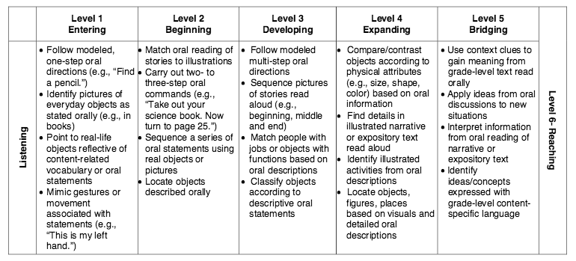
These list what students can do with support at the different language levels.
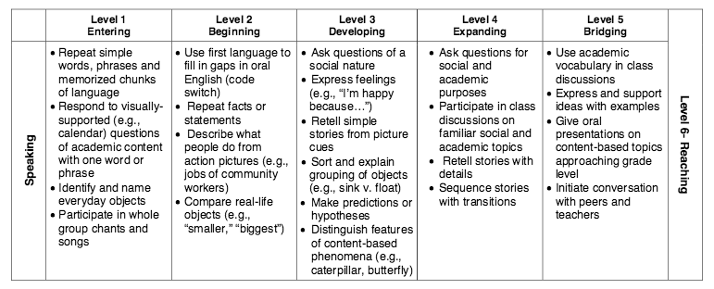
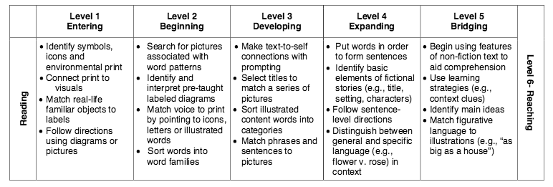

WIDA Can Do Descriptors for first and second grade (cont.)

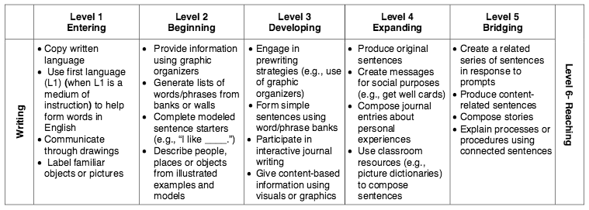

VIII: New Mexico English Language Development Standards
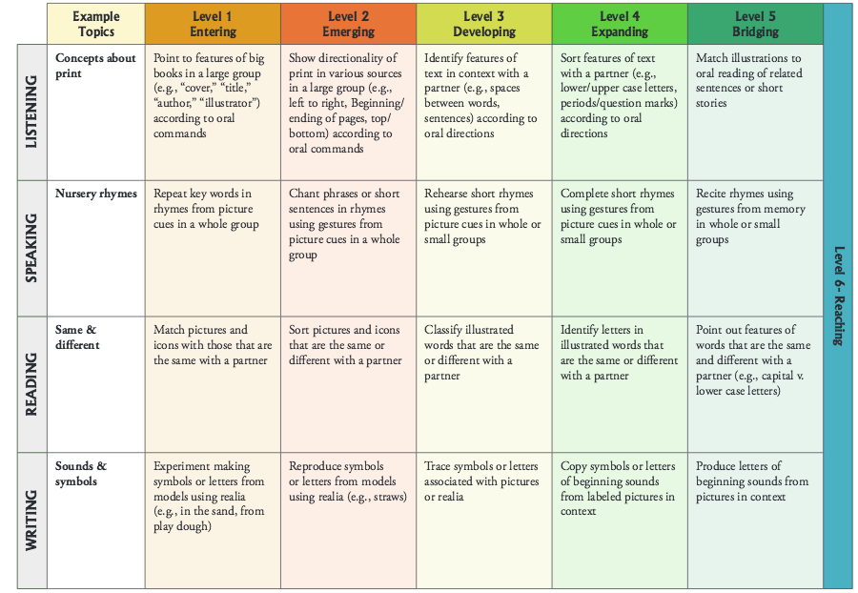
ELD Standard 2: The Language of Language Arts, Formative Framework
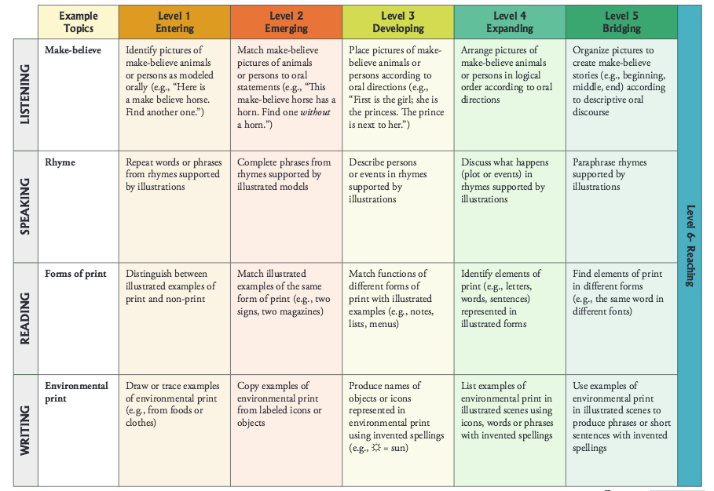
ELD Standard 2: The Language of Language Arts, Summative Framework

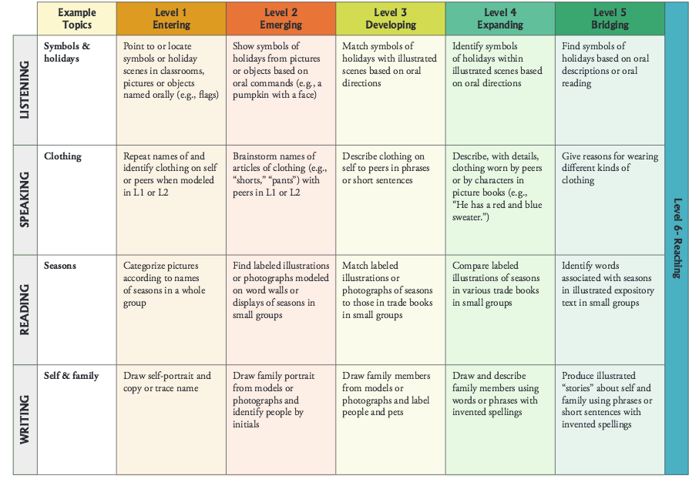
ELD Standard 5: The Language of Social Studies, Formative Framework
ELD Standard 5: The Language of Social Studies, Summative Framework

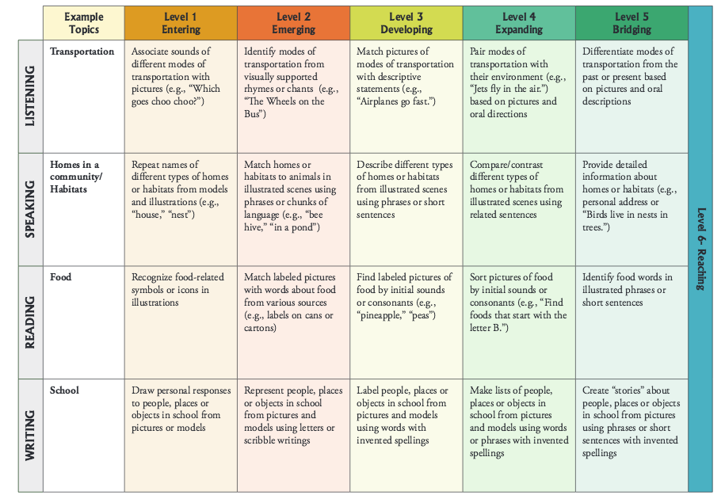
IX. Vocabulary List
1st CCD word: movement
Tier II-High frequency words used by mature language users across several content areas. | Tier III-Words that are not frequently used except in specific content areas or domains.
abolish  action  activist  agriculture  arrest  assemble  background  body of water  border  community  contribution  country  customs  determination  discrimination  equality  farm worker (Tier I)  freedom  government  history  influence  inspire  integration  journal  justice  kindness  leader  location  march  migrant  minorities  motivation  movement  nonviolent  oppression  organize  persuade  political  prejudice  Pueblo  race  racism  region  religion  revolt  rights  speech  tolerance  traditional  unjust  youth | abolitionist  boycott  civil rights  compass rose  Constitution  Convention  desegregation  enslaved  healer  inset map  kiva  landform  legend  NAACP—National Association for the Advancement of Colored People  NFWA—National Farm workers Association  NWSA—National Women’s Suffrage Association  picket  protest  Pueblo Revolt  Quaker  segregation  sit-in  slavery  strike  suffrage  Tewa  Underground Railroad  union  voting  wages

X. Resources and Materials (Non-Fiction)

Graphic Organizer
http://freecoloringpages.co.uk/?q=as+map+outline
http://www.nationsonline.org/oneworld/usa_map.htm

Po’pay
http://www.britannica.com/biography/Pope-Tewa-Pueblo-leader
http://nativeamericannetroots.net/diary/424
http://newmexicohistory.org/people/pope
http://www.americanjourneys.org/aj-009b/summary/
Justseeds Artists’ Cooperative. Firebrands.
http://www.warpaths2peacepipes.com/the-indian-wars/pueblo-revolt.htm
http://www.encyclopedia.com/doc/1G2-2536600359.html
http://diglib.amphilsoc.org/islandora/object/graphics%3AMss.Ms.Coll.29?display=list

Harriet Tubman
http://www.u-s-history.com/pages/h484.html
http://www.historynet.com/harriet-tubman
http://www.biography.com/people/harriet-tubman-9511430#escape-from-slavery-and-abolitionism
http://www.blackhistoryheroes.com/2013/08/what-harriet-tubman-teaches-us-today.html
http://www.pbs.org/black-culture/explore/harriet-tubman/?utm_source=Tumblr&utm_medium=thisdayhistory&utm_campaign=tdih_March10_HarrietTubman#.Vf8-NWRViko
http://www.civilwar.org/education/history/biographies/harriet-tubman.html?referrer=https://www.google.com/
http://teacher.scholastic.com/activities/bhistory/underground_railroad/
http://www.pbs.org/wgbh/aia/part4/4p1535.html
http://www.pbs.org/wgbh/aia/part4/4p2944.html

Lucy Stone
http://www.nps.gov/wori/learn/historyculture/lucy-stone.htm
https://www.nwhm.org/education-resources/biography/biographies/lucy-stone/
http://www.oberlin.edu/external/EOG/OYTT-images/LucyStone.html
http://www.biography.com/people/lucy-stone-9495976#later-life
http://www.anb.org/articles/15/15-00663.html
http://www.amazon.com/Lucy-Stone-Speaking-Out-Equality/dp/0813518601
Lucy Stone resources cont.
http://www.historynet.com/womens-suffrage-movement
http://history.house.gov/Exhibitions-and-Publications/WIC/Historical-Essays/No-Lady/Womens-Rights/
http://www.nwhp.org/resources/womens-rights-movement/history-of-the-womens-rights-movement/
http://bwht.org/lucy-stone/

Ruby Bridges
http://www.biography.com/people/ruby-bridges-475426
http://nationalhumanitiescenter.org/tserve/freedom/1865-1917/essays/segregation.htm
https://www.nwhm.org/education-resources/biography/biographies/ruby-bridges/

César Chávez
http://www.notablebiographies.com/Ch-Co/Ch-vez-C-sar.html
http://www.ufw.org/_page.php?menu=research&inc=history/07.html
http://www.ufw.org/_board.php?mode=view&b_code=cc_his_research&b_no=10482

Civil Rights
http://civilrights.findlaw.com/civil-rights-overview/what-are-civil-rights.html

Labor Rights
http://www.aflcio.org/About/Our-History/Labor-and-Civil-Rights

Child’s Rights
http://www.refworld.org/cgi-bin/texis/vtx/rwmain?docid=3ae6b38f0

Note: Italicized strategies are used daily in the classroom. Day 1 is the equivalent of 1 to 1 ½ weeks of instruction.

OCDE Project GLAD® National Training Center Model
Dual Language Education of New Mexico
Let’s Make a Change (2nd grade)
PLANNING PAGES

I. FOCUS/MOTIVATION
- Cognitive Content Dictionary with Signal Word
- Three Standards and the Super Activist Awards
- Observation Charts
- Inquiry Charts
- Important Book – Social Movements
- Portfolios

II. INPUT
- Graphic Organizer – Regions of the United States
- Pictorial Input-Po’pay/Popé
- Narrative Input
- Read Aloud stories of Social Leaders and Movements

III. GUIDED ORAL PRACTICE
- Poems and Chants
- Personal Interactions (10/2)
- Cooperative groups/ team tasks
- T-Graph for social skills
- Picture File Activities-observe and predict accomplishments of leaders
- Sentence Patterning Chart – Leaders
- Process Grid-Social Leaders
- Guess My Category
- Home/School Connections

IV. READING/WRITING
A. Whole Class
- Writing Frames
  - Found Poetry
  - Expository paragraphs about Social Leaders
  - Poetry Frames
  - Cooperative strip with responding and revising
  - Story Map
  - Strip Books
  - Flip Chant

B. Co-op Reading/Writing Choices
- Team tasks
- Team poetry
- Story mapping
- Cooperative strip paragraph
- Cooperative found poetry
- Ear-to-ear reading-team worksheet
- Expert Groups

C. Individual Activities – Portfolio
- Mind-mapping
- Interactive journals
- Learning logs
- Personal exploration/ research
- Poetry
- Expository paragraph(s)
- Any pieces assigned as team tasks can be assigned at individual tasks

E. Portfolio Writing
- Expository, based on process grid.
- Poetry – modeled on poetry frame or chants
- Narrative – can be modeled after narrative input chart shared with class

V. EXTENDED ACTIVITIES FOR INTEGRATION
- Regional Cooking
- Music (regional, activist)
- Art (regional, activist)
- Field trips / guest speakers (community leaders)
- Action Plan
- Poetry (regional, activist)

V. ASSESSMENT AND FEEDBACK
- Team presentations
- Students Add to Walls
- Process all charts and information
- On-going Assessments
- Teacher/Student-Made Assessments
- Student made Big Book
- Team Paragraph of “Social Leader” and Team Art Project
- Parent Letter
- Graffiti Wall
- Where’s My Answer
- Jeopardy/Family Feud
- Individual Tasks
- Team Action Plan

OCDE Project GLAD® National Training Center Model
Dual Language Education of New Mexico
Let’s Make a Change (2nd grade)
Sample Daily Lesson Plan (5 Day)

Day 1 (week 1)
Focus/Motivation
- Cognitive Content Dictionary (CCD) with signal word – movement
- Three Standards and Super Activist Awards
- Observation Chart
- Inquiry Chart - Leaders
- Important Book - The Important Book about Social Movements
Input
- Graphic Organizer (Big Picture): Regions of the United States
Guided Oral practice
- T-Graph for Social Skills – Cooperation
- Picture File Cards
- Exploration Report
- 10/2 lecture, primary language groups- Pictorial Input Chart and Graphic Organizer
- Chants
- ELD/ SLD review - Pictorial Input Chart and Graphic Organizer
- Home/School Connection
Input
- Pictorial Input Chart: Po’pay
Reading/Writing
Note: Italicized strategies are used daily in the classroom. Day 1 is the equivalent of 1 to 1 ½ weeks of instruction.
- Learning Logs
- Interactive Journal
Assessment and Feedback
- Process Charts

OCDE Project GLAD® National Training Center Model
Note: Italicized strategies are used daily in the classroom. Day 1 is the equivalent of 1 to 1 ½ weeks of instruction.
Dual Language Education of New Mexico
Let’s Make a Change (2nd grade)
Sample Daily Lesson Plan (5 Day)

Day 2 (week 2)
Focus/Motivation
- T-Graph/Team Points Review
- Cognitive Content Dictionary w/Signal Word - inspire
- Process Home School Connection & team points
- Three Standards and Super Activist Awards
- Review Graphic Organizer (Regions of the U.S.) with Word Cards & Picture File Cards
- Review Pictorial Input Chart (Po’pay) with Word Cards & Picture File Cards
Input
- Narrative Input Chart - Freedom on the Menu: The Greensboro Sit-ins
Guided Oral practice
- Chants
- Review T-Graph on Cooperation
- 10/2 lecture, primary language groups-Narrative Input Chart
- ELD Review-Narrative Input Chart
- Home/School Connection
Reading/Writing
- Learning Logs
- Team Tasks
- Read Aloud
- Flexible Group Reading
  - Expert Groups
- Interactive Journal

Assessment and Feedback
- Process Charts

OCDE Project GLAD® National Training Center Model
Note: Italicized strategies are used daily in the classroom. Day 1 is the equivalent of 1 to 1 ½ weeks of instruction.
Dual Language Education of New Mexico
Let’s Make a Change (2nd grade)
Sample Daily Lesson Plan (5 Day)

Day 3 (week 3)
Focus/Motivation
- T-Graph/Team Points Review
- Cognitive Content Dictionary w/Signal Word-activist
- Process Home School Connection
- Three Standards and Super Activist Awards
- Review Narrative Input Chart with Word Cards and Speech Bubbles
Guided Oral Practice
- Process chants
- Sentence Patterning Chart - leaders
  - Reading Game
  - Trading Game
- Home/School Connection
Reading/Writing
- Learning Logs
- Team Tasks-Add CCD
- Flexible Group Reading
- Whole Class Mind Map
- Process Grid
- Cooperative Strip Paragraph: Write, revise and edit
- Interactive Journals
Assessment and Feedback
- Review Charts
- Revisit the Important Book

Note: Italicized strategies are used daily in the classroom. Day 1 is the equivalent of 1 to 1 ½ weeks of instruction.

OCDE Project GLAD® National Training Center Model
Dual Language Education of New Mexico
Let’s Make a Change (2nd grade)
Sample Daily Lesson Plan (5 Day)

Day 4 (week 4)

Focus/Motivation
- T-Graph/Team Points Review
- Cognitive Content Dictionary w/Signal Word or Stumper Word
- Three Standards and Super Activist Awards
- Review Big Book
- Process Home School Connection
Guided Oral Practice
- Review narrative with story map
- Oral Team Evaluation/ T-graph
- Chants
- Home/School Connection
Input
- Action Plan-Rights of the Child
- Read Alouds
Reading/Writing
- Story Map on Narrative Input Chart
- Team Tasks
- Listen and Sketch
- Flexible Reading Groups
  - Clunkers and Links (at or above grade level)
  - ELD/ SLD Group Frame of Narrative or Pictorial Input Chart (ELD/ far below grade level)
- Ear to Ear Reading
- Interactive Journal
Assessment and Feedback
- Process Charts

Note: Italicized strategies are used daily in the classroom. Day 1 is the equivalent of 1 to 1 ½ weeks of instruction.
OCDE Project GLAD® National Training Center Model
Dual Language Education of New Mexico
Let’s Make a Change (2nd grade)
Sample Daily Lesson Plan (5 Day)

Day 5 (week 5)

Focus/Motivation
- T-Graph/Team Points Review
- Three Standards and Super Activist Awards
- Cognitive Content Dictionary w/Stumper Word
- Process Home School Connection
Input
- Read Alouds
- Internet Resources
Guided Oral Practice
- Chants
- Team Group Presentations
Reading/Writing
- Flexible Reading Groups
  - Cooperative Strip Paragraph Reading Group: rebuilding the cooperative strip paragraph (below or at grade level in second grade)
- Found Poetry
- Letter Writing-Whole class and individual
- Read the Walls
Assessment and Feedback
- Team Action Plan
- Team Tasks, Team Self-evaluations
- Graffiti Wall
- Family Feud/Jeopardy
- Teacher/Student-made tests
- Portfolios
- Process Charts
- Letter home to parents
- Evaluate week – “What helped you learn?

Prediction/Reaction Guide
Social Leaders
Directions: Please respond by sketching and writing below.
1. Is this statement true or false? Why or why not?
Po’pay’s lasting influence was to help women get voting rights.
Prediction | Reaction
2. Harriet Tubman and Lucy Stone were both social leaders that fought hard to change things in America. How are these two women alike?
Prediction | Reaction
3. Is this statement true or false? Why or why not?
A boycott is when a person or group of people refuses to buy or use a product as a form of protest.
Prediction | Reaction
4. Together, ordinary people can help their community, change laws, and change behaviors through social movements. What is a movement, as it’s used here?
Prediction | Reaction
5. Is this statement true or false? Why or why not?
In 1960, Ruby Bridges was one of the first black students to attend an all-white school.
Prediction | Reaction
6. César Chávez said, “You are never strong enough that you don't need help.”
Why do you think leaders need help from other people?
Prediction | Reaction

1. False
2. Answers may vary (ex: helped people obtain rights they did not have, worked during the same time period)
3. True
4. A series of organized activities working toward a common goal
5. True
6. Answers may vary

Rosa Parks | Super Activist Award  Rosa Parks was a Civil Rights Activist.  Go to the resource center, find the information below.  - Find an action that Rosa Parks did to help her cause.  - When and where did that action (event) happen?  Now add this card to the United States map where the action happened.
Martin Luther King Jr. | Super Activist Award  Martin Luther King Jr. was a leader for the Civil Rights Movement.  Go to the resource center, find the information below.  - Find an action that Martin Luther King Jr. did to help his cause.  - When and where did that action (event) happen?  Now add this card to the United States map where the action happened.

Susan B. Anthony | Super Activist Award  Susan B. Anthony was a leader for the Women’s Suffrage movement.  Go to the resource center, find the information below.  - Find an action that Susan B. Anthony did to help her cause.  - When and where did that action (event) happen?  Now add this card to the United States map where the action happened.

Frederick Douglass | Super Activist Award  Frederick Douglass was an abolitionist and writer.  Go to the resource center, find the information below.  - Find an action that Frederick Douglass did to help his cause.  - When and where did that action (event) happen?  Now add this card to the United States map where the action happened.

Dolores Huerta | Super Activist Award  Dolores Huerta is a labor union and civil rights activist.  Go to the resource center, find the information below.  - Find an action that Dolores Huerta did to help her cause.  - When and where did that action (event) happen?  Now add this card to the United States map where the action happened.

Elizabeth  Cady Stanton | Super Activist Award  Elizabeth Cady Stanton leader in the Women’s Suffrage Movement.  Go to the resource center, find the information below.  - Find an action that Elizabeth Cady Stanton did to help her cause.  - When and where did that action (event) happen?  Now add this card to the United States map where the action happened.
The Important Book about Social Movements
Important book about Social Movements
by Loyola Garcia

Table of Contents

Social Leaders Pg. 1
The Pueblo Revolt Pg. 2
The Abolitionist Movement Pg. 3
The Women's Suffrage Movement Pg. 4
The Civil Rights Movement Pg. 5
The Farm Workers Movement Pg. 6
Lasting Influences Pg. 7
Glossary Pg. 9

p.1
Social Leaders

I just thought you would like to know that leaders, groups, and events have influenced communities throughout history.

- A social leader is a person who is able to
  - bring people together
  - start discussions
  - make changes
- Many social leaders devote their life to improving the community they live in.
- They are often part of large social movements, or groups of people taking action together to create change.

I just thought you would like to know that leaders, groups, and events have influenced communities throughout history.

p.2
The Pueblo Revolt

I just thought you would like to know that leaders, groups, and events have influenced communities throughout history.

An important event that shaped United States history was the Pueblo Revolt, which occurred in the time period, or year, of 1680.
- The Pueblo Revolt was located in what is now the Southwest Region of the country.
- Many Pueblo people were forced to practice Christianity and were enslaved by the Spanish.
- Po’pay organized a large revolt, or attack, against the Spanish on August 10, 1680.
- The Pueblo Revolt was effective because Pueblo people drove out the Spanish for 12 years.

I just thought you would like to know that leaders, groups, and events have influenced communities throughout history.

p.3
The Abolitionist Movement

I just thought you would like to know that leaders, groups, and events have influenced communities throughout history.

The Abolitionist Movement, which occurred in the 1840-1860, helped to shaped the history of the United States.
- Abolitionism was a movement to end slavery in the U.S., where a black person could be considered ‘property’ of a white owner and forced to work for him.
- Abolitionist leaders included William Lloyd Garrison, Frederick Douglass, and Harriet Tubman.
- During this movement, leaders used the Underground Railroad. Enslaved people were led to freedom using a pathway of safe houses. The location, or place, of the safe houses was from the South to the North.
- Because of the Abolitionist Movement, slavery in the United States was abolished, or ended, in 1865.

I just thought you would like to know that leaders, groups, and events have influenced communities throughout history.

p.4
The Women’s Suffrage Movement

I just thought you would like to know that leaders, groups, and events have influenced communities throughout history.

In the 1800’s and early 1900’s, the Women's Suffrage Movement shaped United States history.
- During this time, men were the only people allowed to vote. Women's suffrage is the right of women to vote and to hold an elected office.
- Some leaders of the Women’s Suffrage Movement were Susan B. Anthony, Elizabeth Cady Stanton, Carrie Chapman Catt, and Lucy Stone.
- Lucy Stone’s background, or the way she grew up, helped her become a leader. She did not have the same opportunities as the men around her, who made her want to fight for equal rights.
- Thanks to the Women’s Suffrage Movement, women won the right to vote in 1920.

I just thought you would like to know that leaders, groups, and events have influenced communities throughout history.

p.5
The Civil Rights Movement

I just thought you would like to know that leaders, groups, and events have influenced communities throughout history.

Movements, such as the Civil Rights Movement, are formed around the problems people are facing, which many times means a group of people is not being treated equally.
- During the Civil Rights Movement in the mid 1900’s, people of color faced the problem of not having the same basic rights, including equal education, right to vote, and right to use public places (pools, restaurant, bathrooms), as white people.
- Some leaders of the Civil Rights Movement were Martin Luther King, Rosa Parks, and Ruby Bridges.
- Because of the Civil Rights Movement, the law was changed in 1964 and 1965 to protect the rights of all people in the United States.

I just thought you would like to know that leaders, groups, and events have influenced communities throughout history.

p. 6
The Farm Workers Movement

I just thought you would like to know that leaders, groups, and events have influenced communities throughout history.

Leaders of social movements take action, or do something, to solve problems in their communities. Many people took action together in the Farm Workers Movement of the 1960’s and 1970’s.
- The Farm Workers Movement was formed to improve the labor and living conditions of farm workers.
- Some of the leaders of the Farm Workers Movement were Dolores Huerta and César Chávez. The actions these leaders took were boycotts and strikes, where farm workers walked with signs asking for better treatment.
- Because of the actions of these leaders of the Farm Workers Movement, the United Farm Workers union (UFW) was formed. To this day, UFW works to ensure that farmer workers are treated fairly and safely.

I just thought you would like to know that leaders, groups, and events have influenced communities throughout history.

p. 7
Lasting Influences

I just thought you would like to know that leaders, groups, and events have influenced communities throughout history.

Because of social leaders in our history, we have
- the right to use any public place
- the right to practice our own religious traditions
- the right to vote
- the right to be treated fairly

Pg. 8

Remember, leaders, groups, and events have influenced communities throughout history.

p.9
Glossary

action: n. Something done or performed; act; deed.

abolitionist: n. A person who supported the end of slavery in the United States.

background: n. One’s origin, education, experience, etc., in relation to one’s present character, status, etc.

boycott: v. To not buy or use a product as a form of protest.

civil rights: n. The rights to full, legal, social, and economic equality extended to all citizens of a country

leader: n. A guiding or directing head of a movement or group.

location: n. A place of settlement, activity, or residence.

movement: n. A series of organized activities working toward a common goal.

slavery: n. The state of a person being owned as property by someone else and being forced to obey that person.

revolt; n. An attack against an oppressing force

suffrage: n. The right to vote, especially in a political election.

strike: v. To refuse to work in order to gain something from an employer or boss.

Regions of the United States Graphic Organizer
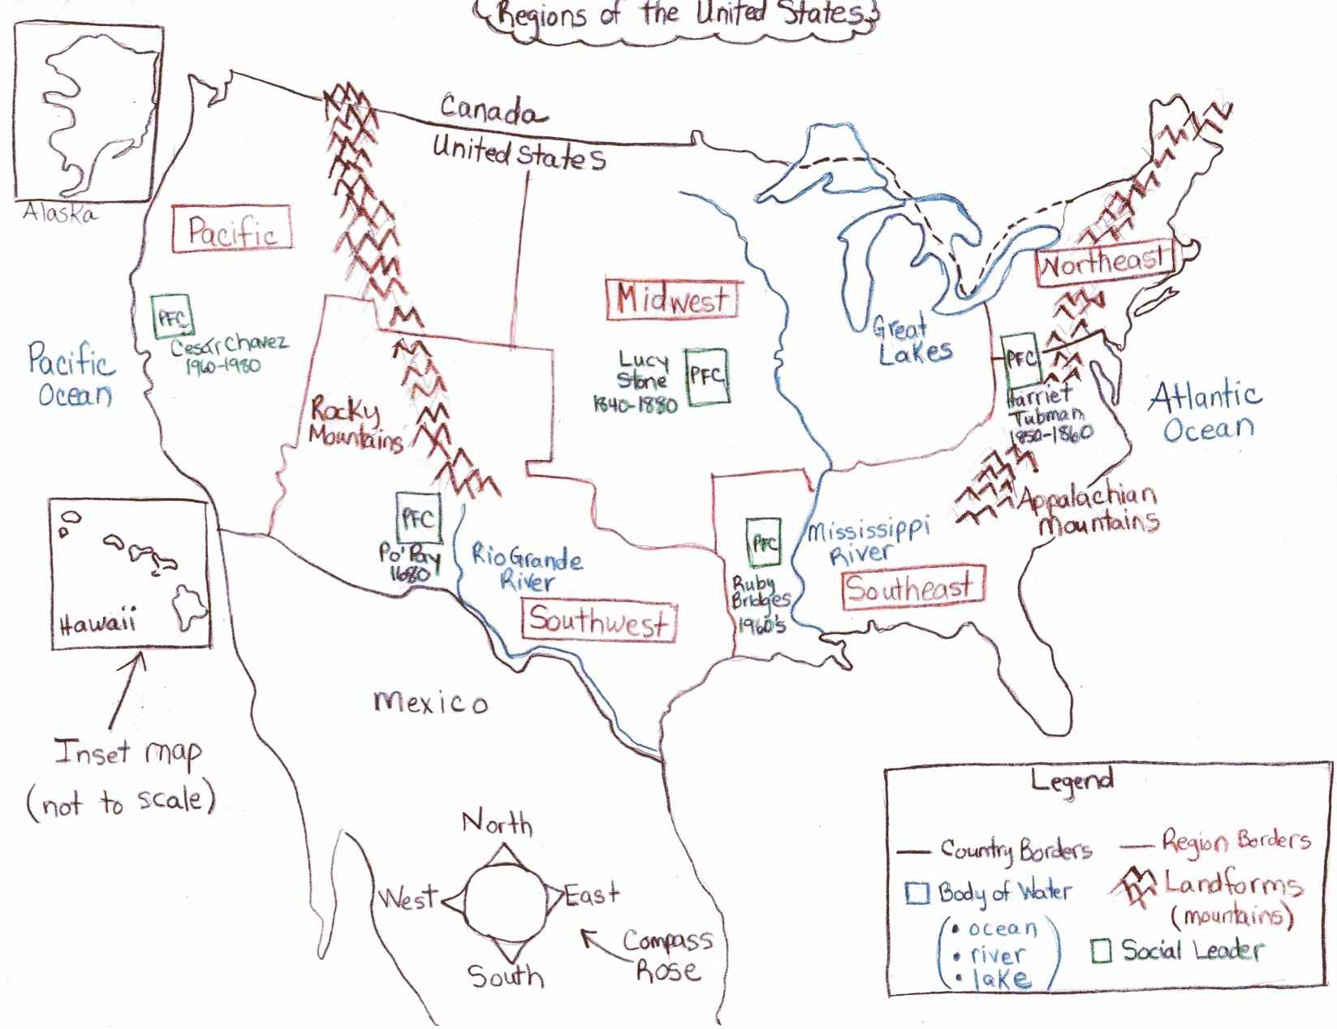

"Online Maps." Free Coloring Pages of As+map+outline. N.p., n.d. Web. 16 Jan. 2016. http://freecoloringpages.co.uk/?q=as+map+outline

"Map of the United States of America." United States Map. N.p., n.d. Web. 16 Jan. 2016. http://www.nationsonline.org/oneworld/usa_map.htm

Background Information
Graphic Organizer

Objectives:
At the end of this session, you will be able to
- Identify and name map features (i.e. compass rose, map legend, inset map) and describe what they are used for
- Identify and name the regions of the United States, some of its major rivers and landforms.
- Name a social leader and identify their area of influence

Map Features:
- The United States is a country on the continent of North America. The country that borders to the north is Canada. The country that borders to the south is Mexico.
Draw in country borders in black.

- A Compass Rose is a feature that you will find on all maps that shows the directions: north, south, east and west.

Draw in Compass Rose.
TPR: Have students show directions with their hands.

- Another feature you will see on most maps is a legend. A legend tells us what the symbols and colors used on a map represent. Our legend provides symbols and colors for: country borders, region borders, bodies of water and landforms.

Draw the outline and label of the legend and the country borders
(You will complete this as the symbols or colors are represented on the map).

- Sometimes, maps will have inset maps that show smaller maps inside a larger map. Hawaii and Alaska are shown on inset maps.

Draw in and label the inset maps of Hawaii and Alaska.
10-2: Turn and tell your neighbor about what a compass rose and map legend is

- The United States has several important bodies of waters such as oceans, lakes and rivers.
Label bodies of water on legend in blue.
- The United States is in between the Pacific Ocean and the Atlantic Ocean.

Draw in oceans and map in blue.
Attach picture file cards of the Pacific Ocean and Atlantic Oceans.

- Two major rivers in the United States are the Rio Grande River and the Mississippi River.

Draw in rivers on the map in blue.
Attach a picture file cards of the Rio Grande River and Mississippi Rivers.

- Between the United States and Canada are five large lakes named the, Great Lakes.
Draw in the Great Lakes on the map in blue.
TPR: Show me between.
10-2: Turn and tell your neighbor the major bodies of water in the United States

- All countries have important landforms such as mountain ranges. Two important mountain ranges in the United States are the Rocky Mountains in the west and the Appalachian Mountains in the east.

Draw in the mountain ranges on the map in brown.
10-2: Turn and tell your neighbor the landform in the eastern part of the United States

- The United States can be divided into parts or sections called, regions. There are five regions of the United States. On the west coast is the Pacific Region. In the southern part of the of the western United States is the Southwest Region. North of the Southwest Region is the Midwest Region. To the East of the Midwest Region is the Northeast Region. To the South of the Northwest Region is the Southeast Region.

Draw the region borders in red as presented on the map.
10-2: Turn and tell your neighbor the five regions of the Unites States

Social Leaders:
- In the Southwest region, in 1680, a leader named Po’pay lead the Pueblo revolt that drove the Spanish out for nearly 12 years.

Attach a picture file card of Po’pay in the Southwest region
and trace in his name and active dates.

- A leader, Lucy Stone, worked hard from 1840-1880’s, mostly in the Midwest and Northeast regions to help women gain the right to vote in the United States.

Attach a picture file card of Lucy Stone in the Midwest region
and trace in her name and active dates.

- A leader named Harriet Tubman helped enslaved people in the Southeast region find freedom in the Northeast region through the underground railroad in 1850-1860.

Attach a picture file card of Harriet Tubman
and trace in her name and active dates.

- Between 1960-1980, in the Pacific region, a leader named César Chávez helped farm workers get better conditions and better pay.

Attach a picture file card of César Chávez in the Pacific region
and trace in his name and active dates.

- In the year, 1960 a leader named Ruby Bridges was the first black student to attend an all white school in the Southeast region.

Attach a picture file card of Ruby Bridges in the Southeast region and trace in her name and active dates.

10-2: Turn and tell your neighbor about one social leaders and which region they worked or lived in.

Input Chart: Regions of the United States Graphic Organizer Input Chart
Grade level: 2nd Grade
Project GLAD® Trainers: Loyola Garcia, Kavita Krishna, Michelle-Desireé Lobato, and Kathleen Salgado
Stages of Language Acquisition | Preproduction | Early Production | Speech Emergence | Intermediate Fluency | Advanced Fluency
New Mexico WIDA (ELD)  Proficiency Level Descriptors | Entering | Emerging | Developing | Expanding | Language/CCSS
Level of Questioning | Point To, Locate, Trace | Yes/No | Either/Or | Open Ended
Create  Arrange, assemble, collect, compose, construct, create, design, develop, formulate, manage, organize, plan, prepare, propose, set up | T: Trace the Compass Rose from South to North.  S: Traces the Compass Rose from South to North. | T: Did Harriet Tubman lead before César Chávez?  S: Yes | T: Which region has a border with Canada, the Southwest or the Midwest?  S: Midwest | T: Describe the differences between the Southeast region and the Pacific region.  S: Answers may vary (example- Southeast has Mississippi River) | T: What important information can be found on this map? And why is it important?  S: Answers may vary.
Evaluate  Appraise, argue, assess, attach, choose, compare, defend, estimate, judge, predict, rate, select, support, value, evaluate | T: Point to a region in the North.  S: Points to Pacific, Midwest, or Northeast | T: Are the Rocky Mountains located in two different regions?  S: Yes | T: Which is furthest west on the map, the Mississippi River or the Rio Grande River?  S: The Rio Grande River | T: What would happen if a map did not include a legend?  S: We would have a hard time understand what the symbols and colors mean. | T: How is compass rose useful on a map?  S: Helps to show the direction of one place in relation to another.
Analyze  Analyze, appraise, calculate, categorize, compare, contrast, criticize, differentiate, discriminate, distinguish, examine, experiment | T: Point to an inset map.  S: Points to the inset map of Hawaii or Alaska. | T: Are the Great Lakes in the Pacific Region?  S: No | T: Is the Atlantic Ocean next to the Northeast Region or the Pacific Region?  S: Northeast | T: What is a body of water located in the Southwest region?  S: Rio Grande River | T: Why is a compass rose important to have on a map?  S: Shows the directions.
Apply  Apply, calculate, categorize, classify, change, choose, compare, construct, demonstrate, describe, determine, distinguish, dramatize, employ, estimate, explain, extend, illustrate, interpret, judge the effects, operate, practice, schedule, select, show, sketch, solve, use | T: Point to two bodies of water.  S: Points to two bodies of water.  (oceans, rivers, or rivers) | T: Is Mexico south of the United States?  S: Yes | T: Is an example of a landform a mountain or a lake?  S: Mountain | T: Describe a difference between the inset map and the larger map?  S: Shows smaller maps inside a larger map. | T: Explain the benefits of a legend.  S: Tells what the symbols and colors on the map represent.
Understand  Categorize, cite, clarify, classify, describe, discuss, explain, express, identify, indicate, interpret, locate, match, paraphrase, predict, recognize, restate, review, select, summarize, translate | T: Point to a river.  S: Points to a river. | T: Are the mountains in brown on the map?  S: Yes | T: Are the Appalachian Mountains in the Pacific region or Northeast region?  S: Northeast region | T: What is a map legend used for?  S: To tell what the symbols and colors on the maps represent. | T: What are some landforms on the map?  S: Names a mountain on the map.
Remember  Arrange, choose, define, describe, draw, , find, give example, identify, label, locate, list, match, name, recall, recite, recognize, record, repeat, reproduce, select, state, tell | T: Point to the Southwest region.  S: Points to the Southwest region. | T: Did César Chávez actively lead in the Southwest?  S: Yes | T: Are rivers in blue or brown in the legend?  S: Blue | T: Tell me one thing that is found on the map legend.  S: Talks about any of the items on the map legend (example- bodies of water, land formations) | T: Describe the Southwest region.  S: Answers may vary. (example- has Rocky Mountains and Rio Grande River)

Po’pay (Popé) Pictorial Input
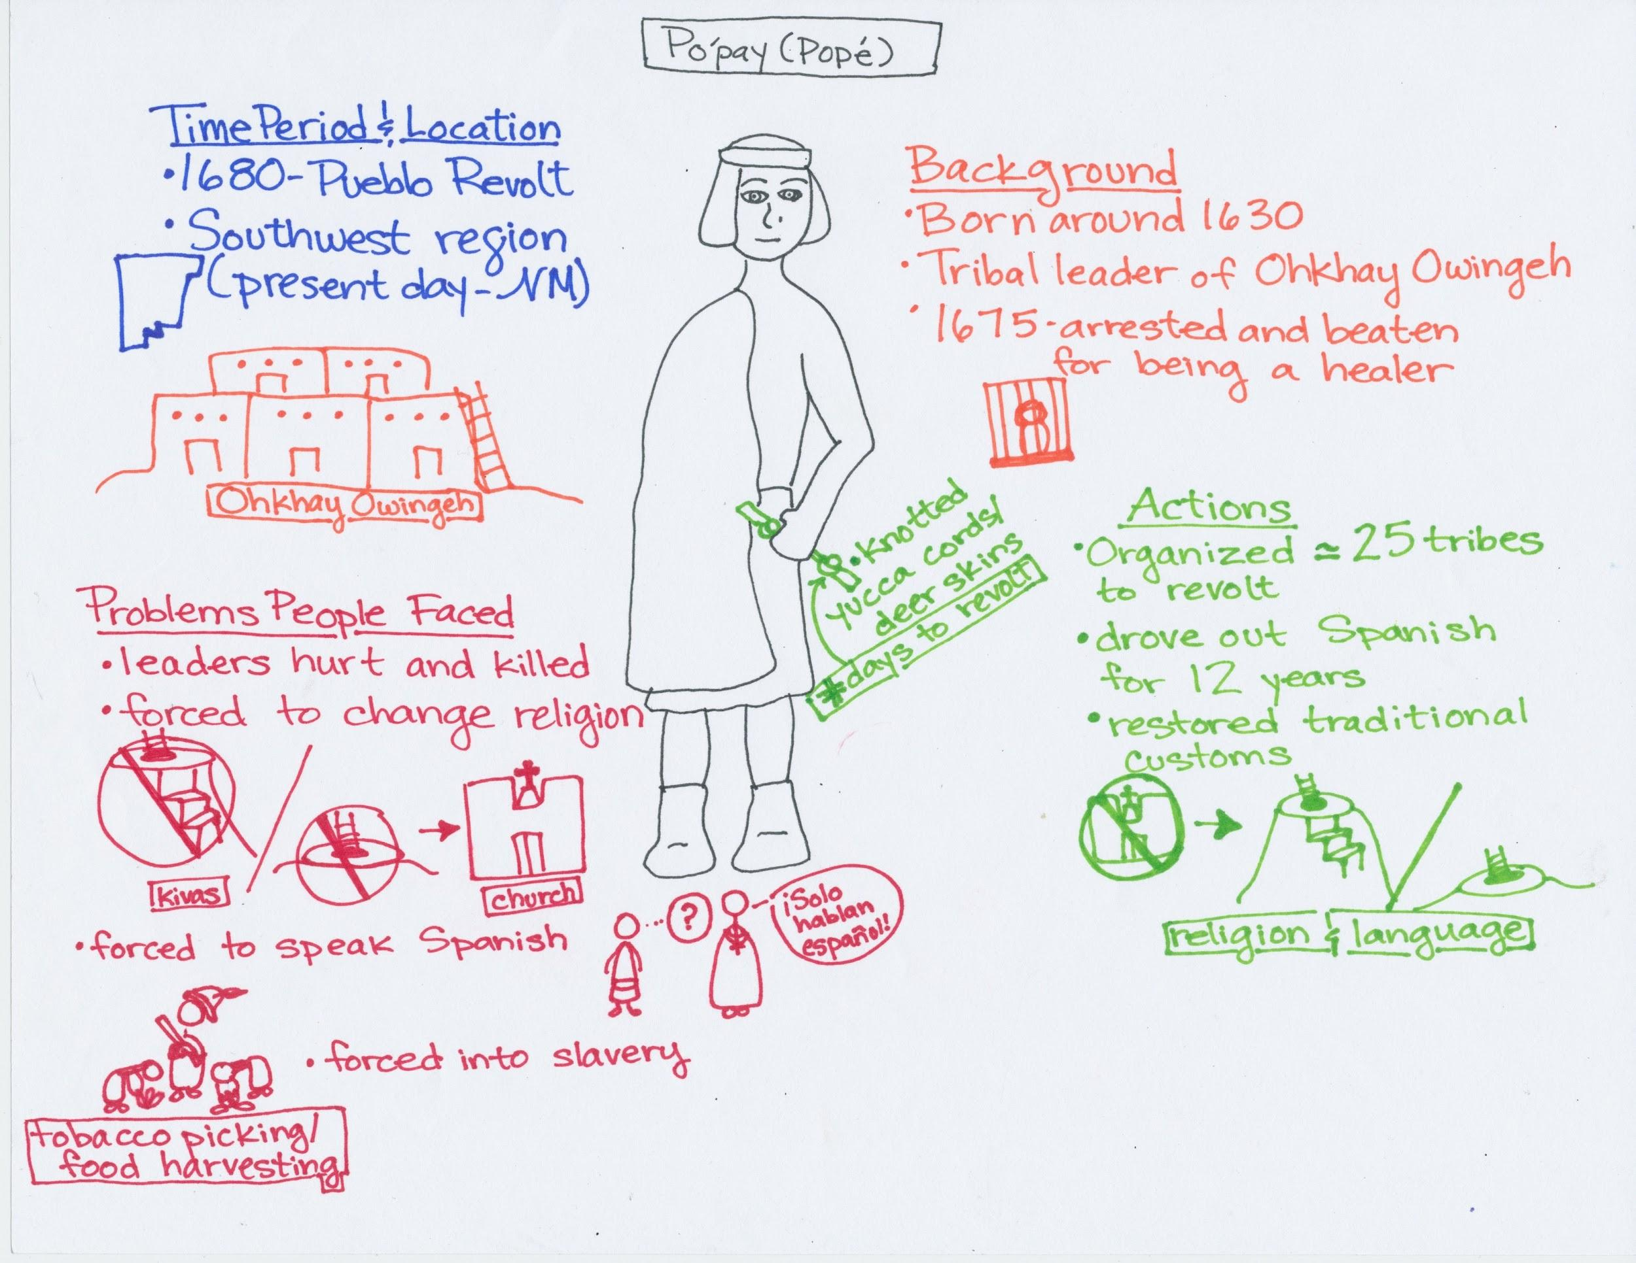
"Pope | Tewa Pueblo Leader." Encyclopedia Britannica Online. Encyclopedia Britannica. Web. 16 Jan. 2016. http://www.britannica.com/biography/Pope-Tewa-Pueblo-leader
"Native American Netroots." Native American Netroots. 20 Mar. 2010. Web. 16 Jan. 2016. http://nativeamericannetroots.net/diary/424
Martinez, Matthew. "New Mexico Office of the State Historian | People." New Mexico Office of the State Historian | People. Web. 16 Jan. 2016. http://newmexicohistory.org/people/pope

Po’pay/Popé Background

Time Period & Location
- 1680-Po’pay led many Pueblo tribes in present-day New Mexico to revolt against the Spanish people who had invaded their territory.
- Po’pay is from the Southwestern region of the United States in present-day New Mexico. He is from the Tewa-speaking village or Pueblo of Ohkay Owingeh.
Background
- Po’pay was born around 1630 in Ohkay Owingeh, which the Spanish had renamed San Juan Pueblo.
- He was a tribal leader for his people as well as a spiritual healer.
- In 1675, the Spanish arrested and beat Po’pay and other spiritual healers. Several years after his release, Po’pay decided it was time to attack the Spanish.
Problems People Faced
- Several peaceful Pueblo leaders were hurt and killed by the Spanish.
- Pueblo people were forced to stop practicing their religion and practice Catholicism. Any people found practicing their own religion would be punished.
- Pueblo people were also forced to abandon their languages and speak only Spanish.
- The Spanish also forced the Pueblo people into slavery. They were used as labor for tobacco picking, food harvesting, and construction of their buildings.
Actions
- Worked to organize around 25 tribes to revolt on a single day.
- Used knotted yucca cords or knotted deer skins to count down the days until attack.
- The Pueblo Revolt drove the Spanish out of present-day New Mexico for nearly 12 years.
- This event and the subsequent driving out of the Spanish helped to restore the traditional customs and religious practices of Pueblo people in the area. Today, many Pueblos, like Ohkay Owingeh, have taken back their original names in their native languages.

Input Chart: Po’pay/Popé Pictorial Input Chart
Grade level: 2nd Grade
Project GLAD® Trainers: Loyola Garcia, Kavita Krishna, Michelle-Desireé Lobato, and Kathleen Salgado
Stages of Language Acquisition | Preproduction | Early Production | Speech Emergence | Intermediate Fluency | Advanced Fluency
New Mexico WIDA (ELD)  Proficiency Level Descriptors | Entering | Emerging | Developing | Expanding | Language/CCSS
Level of Questioning | Point To, Locate, Trace | Yes/No | Either/Or | Open Ended
Create  Arrange, assemble, collect, compose, construct, create, design, develop, formulate, manage, organize, plan, prepare, propose, set up | T: Point to something that may have caused the revolt.  S: Points to anything in the problems people faced category | T: Did the Pueblo people use kivas before the Spanish arrived?  S: Yes | T: Did Po’pay want people to help him drive out the Spanish or did he want to do it on his own?  S: He wanted people to help him  T: Did the Spanish treat the people fairly or unfairly?  S: Unfairly | T: Predict what would have happened if the revolt never took place.  S: Answers will vary | T: Why is it important that people are able to speak their own language?  S: Answers will vary
Evaluate  Appraise, argue, assess, attach, choose, compare, defend, estimate, judge, predict, rate, select, support, value, evaluate | T: Point to something that shows Po’pay’s bravery.  S: Example- arrested for being a healer (answers may vary) | T: Was Po’pay’s plan successful?  S: Yes | T: Which was a problem for Po'pay, that his people were forced into slavery or that they restored their customs?  S: His people were forced into slavery | T: Why did Po'pay want to revolt against the Spanish?  S: Talk about any information from problems people face category | T: Did Po’pay’s plan work? Why or why not?  S: Yes- answers may vary to support why (ex: drove out Spanish for 12 years, restored traditional customs)
Analyze  Analyze, appraise, calculate, categorize, compare, contrast, criticize, differentiate, discriminate, distinguish, examine, experiment | T: Point to a problem and an action of Po'pay.  S: Points to anything in problems people faced category | T: Was Po'pay from present day New Mexico?  S: Yes | T: Who was taken into slavery, the Spanish or the Pueblo people?  S: The Pueblo people | T: What was a cause of the Pueblo Revolt?  S: Talk about any information from problems people face category | T: What in Po’pay's background could have led him to plan the Pueblo Revolt?  S: His arrest for being a healer
Apply  Apply, calculate, categorize, classify, change, choose, compare, construct, demonstrate, describe, determine, distinguish, dramatize, employ, estimate, explain, extend, illustrate, interpret, judge the effects, operate, practice, schedule, select, show, sketch, solve, use | T: Point to something that’s not a problem.  S: Points to anything from the categories of action, background, time period/location | T: Were the Pueblo people allowed to speak their own language under Spanish rule?  S: No | T: Were the Pueblo people forced into slavery by picking food or cleaning houses?  S: Picking food | T: Describe what happened when the Spanish invaded present-day New Mexico.  S: Talk about any information from problems people face category | T: Explain the benefits of Po’pay’s actions.  S: Drove out the Spanish, restored traditional customs
Understand  Categorize, cite, clarify, classify, describe, discuss, explain, express, identify, indicate, interpret, locate, match, paraphrase, predict, recognize, restate, review, select, summarize, translate | T: Point to a kiva.  S: Point to a kiva. | T: Was one of Po’pay’s actions to organize around 100 tribes?  S: Yes | T: Was an action of Po’pay’s to drive the Spanish out or to force people into slavery?  S: To drive the Spanish out | T: What were the knotted cords/skins used for?  S: Knots were used to count down the days until attach | T: What were some things that the Pueblo people forced to change?  S: Religion, language, freedom (slavery)
Remember  Arrange, choose, define, describe, draw, , find, give example, identify, label, locate, list, match, name, recall, recite, recognize, record, repeat, reproduce, select, state, tell | T: Point to the knotted yucca cord/deer skin.  S: Points to the knotted yucca cord/deer skin. | T: Was Po’pay arrested for being a healer?  S: Yes | T: Were churches built in the pueblos before or after the Spanish came?  S: After the Spanish came | T: Tell me one action of Po’pay.  S: Talks about any information under actions category | T: Describe Po’pay’s background.  S: Talk about any information from background/ location category

Narrative Input Chart

Text adapted from Freedom on the Menu: The Greensboro Sit-Ins
Author: Carole Boston Weatherford
Illustrator/Painter: Jerome Lagarrigue

Card 1
Just about every week, Mama and I went shopping downtown. I loved having her all to myself for the afternoon. Whenever it was hot or we got tired, we’d head over to the snack bar in Woolworth’s five-and-dime store. We’d stand as we sipped our Cokes because we weren’t allowed to sit at the lunch counter.
Once, I watched a girl swivel a stool as she spooned a banana split. In the empty seat beside her was a purse almost exactly like mine.
“Can I have a banana split?” I begged Mama.
“Not here, Connie,” said Mama. “I’ll fix you one at home.”
“Won’t be the same,” I grumbled.
All over town, signs told Mama and me where we could and couldn’t go. Signs on water fountains, swimming pools, movie theaters, even bathrooms.

Card 2
Everybody I knew obeyed the signs--except my great-aunt Gertie from New York. Once, when she visited us, she drank from a whites-only fountain. She lifted me up so I could take a sip.
I looked up from the fountain. “Y’all know better than to drink from that fountain!” a man scolded.
“I started to say “Sorry, mister,” but Aunt Gertie just huffed, “I’m too old for silly rules.”
It was a real hot day, but the man walked away without taking a drink.

Card 3
There weren’t any signs up in the five-and-dime, but we still knew how it was. Most people didn’t expect change anytime soon. But my daddy thought different.
“Dr. King’s coming to town,” he told us one morning.
“Who’s he?” I asked.
“He’s a minister who’s working to make things better for us,” said Daddy.
“So we can go anywhere we please,” said Mama.
“Like the lunch counter?” I asked.
“Yep,” said Daddy, “and other places, too.”
Later that week, our whole family went to hear Dr. King preached at the college chapel. Everyone felt inspired to make a change. Soon after that, my brother and sister joined the National Association for the Advancement of Colored People. Everyone called it the N-double A-C-P. They let me tag along as they went door-to-door helping people to sign up to vote.
Card 4
Then one day, Mama and I went shopping downtown. We stopped at the snack bar, just like always. I tugged at Mama’s sleeve. “Look over at the lunch counter! We know those boys!” There sat four of Brother’s friends from A&T College. “Do they know they’re in the wrong place?” I whispered.
“Some rules have to be broken,” Mama whispered back.
I heard one of them order: “Coffee and a doughnut, please.”
“I’m sorry, we can’t serve your kind,” said the blond-haired waitress, wringing her hands.
The boys didn’t budge.
“Don’t y’all understand English?” a kitchen worker asked. “Go on over to the snack bar,” she hissed. “Stop making trouble here.”
The manager stormed out of the store.

Card 5
An old white lady came up to the boys. “I’m so proud of you,” she said clear as a bell so everyone could hear. “I wish someone had done this sooner.”
The waitress kept wiping and re-wiping the counter and refilling salt and pepper shakers, sugar pourers, and napkin holders.
Suddenly, the manager came back with a tall policeman.
“Let’s go, Connie,” said Mama. The manager shooed us right out of the store and then put a Closed sign in the window.
I couldn’t wait to tell Brother.

Card 6
“Why’d your friends do that?” I asked.
“They’re protesting,” said Brother. “If we can spend money at a store, it’s only fair that we should be able to eat at the store’s lunch counter.”
“I guess so,” I said. “Think it’ll work?”
“Sometimes it’s important just to try,” said Daddy, rubbing his chin.
The next day, Daddy showed me the newspaper. The headline said: Negro Students Stand Up By Sitting Down.
“They sat four hours,” said Daddy, peering over the newspaper.
“I’d be too hungry to wait that long,” I said.
“Connie, they didn’t really want food,” said Daddy. “They wanted to be allowed to get it, same as if they were white. To be treated fairly.

Card 7
By Friday, we heard on the news how hundreds more had joined sit-ins at more lunch counters. “The protests are growing!” I told Daddy.
“I’m joining the sit-ins,” Brother said, bursting into the room.
“And I’m going to picket downtown,” said Sister. “Tomorrow.”
“I want to go, too,” I said. “I’m plenty big enough to hold a sign, and I know I can sit.”
“It’s good that you want to help,” said Daddy. “But, Connie, you’re still too young for these things.”
“I never get to do anything important,” I pouted.
“You can help us make picket signs,” said Sister. “That’s very important.”
“We’ll tell you everything when we get home,” Brother promised.

Card 8
Turns out, I saw the protests on TV. Hundreds of people walked up and down the sidewalks in front of stores, restaurants, and movie theaters. I saw my own sister carrying my picket sign. And there was the back of Brother’s head at the lunch counter. My own brother!
“I’m just so proud of them,” said Daddy.
“Me, too,” I said.
“I just pray there’s no trouble,” Mama fretted.
After a while, I watched the news on TV almost as much as Mama and Daddy. One night I saw a report on the sit-ins. “That doesn’t look like downtown,” I said.
“Connie, the sit-ins have spread all over the South,” said Daddy
Card 9
Just then, the phone rang. I answered it. “Daddy! It’s Sister. She got arrested outside of the Woolworth’s. She’s in jail!”
Daddy raced to the police station, but Sister wouldn’t let him get her out of jail. Sister, who hardly ever got in trouble, was stubborn. She wanted people to understand how important it was to fight for what she believed in.
“We can’t leave Sister there with the bad guys,” I pleaded.
“She’s made up her mind, Connie,” said Mama, wiping a tear. “She wants to stay with the other students.”
In a few days, Sister came home. “Promise me you’ll stop picketing,” I begged.
“I can’t do that,” she said, hugging me tight.

Card 10
The sit-ins and protests went on for months.
That summer, Mama, Daddy, and I finally went downtown. When we passed Woolworth’s, I heard someone shout, “They’re serving them!” Daddy stopped so fast that the brakes screeched and Mama and I jolted forward. We parked and ran to the lunch counter.
There sat the women who worked in the restaurant’s kitchen. They were all dressed up fancy and eating egg salad!
I can’t even stand the smell of egg salad, but I stood and watched them eat every bite. “Looks pretty good,” I said. Daddy and I shared big grins.

Card 11
The next day, Brother, Sister, and I made a special trip downtown. Brother wore a suit and tie. We girls wore hats and white gloves. At the lunch counter, I climbed up on a stool next to them. “We’ll have three hot dogs, three French fries, two coffees, one Coke, and one banana split, please,” I told that blond-haired waitress.
Sister and Brother sipped coffee and I twisted on my stool while we waited for our meals. Our food soon arrived. As I ate, the waitress plopped an extra cherry on a mound of whipped cream. She still looked nervous, but she smiled at me.
It was the best banana split I ever had.

Input Chart: Narrative Input Chart
Grade level: 2nd Grade
Project GLAD® Trainers: Loyola Garcia, Kavita Krishna, Michelle-Desireé Lobato, Kathleen Salgado
Stages of Language Acquisition | Preproduction | Early Production | Speech Emergence | Intermediate Fluency | Advanced Fluency
New Mexico WIDA (ELD)  Proficiency Level Descriptors | Entering | Emerging | Developing | Expanding | Language/CCSS
Level of Questioning | Point To, Locate, Trace | Yes/No | Either/Or | Open Ended
Create  Arrange, assemble, collect, compose, construct, create, design, develop, formulate, manage, organize, plan, prepare, propose, set up | T: Locate the change that came from the sit-ns.  S: Answers may vary: Ex. Points to the girl sitting at the counter. | T: Do you think Dr. King inspired the four boys to make a change?  S: Yes; they organized the sit-ins. | T: Was the result of the sit-ins that only the people who protested were allowed to eat at the lunch counter or everyone was now allowed to eat at the lunch counter?  S: Answers will vary. | T: Why do you think mama said, “some rules have to be broken?”  S: Answers will vary. | T: What do you think would have happened if the boys at the lunch counter chose to be violent?  S: Answers will vary.
Evaluate  Appraise, argue, assess, attach, choose, compare, defend, estimate, judge, predict, rate, select, support, value, evaluate | T: Point to a picket sign.  S: Points to a picket sign. | T: Did sister go to jail because she was violent?  S: No; She went to jail because she was protesting. | T: Is the author’s purpose to show how people can make a difference or to show that the main character likes to eat banana splits?  S: The author’s purpose is to show how people can make a difference. | T: Why were the main character and her family not allowed to sit and eat at the lunch counter?  S: Answers will vary; Ex: The lunch counter was segregated. | T: Why did Sister and Brother want to become part of the protests?  S: Answers will vary; Ex: Dr. King inspired them.
Analyze  Analyze, appraise, calculate, categorize, compare, contrast, criticize, differentiate, discriminate, distinguish, examine, experiment | T: Locate the narrator at the five-and-dime store.  S: Points to appropriate picture. | T: Are the sit-ins taking place at Wal-Mart?  S: No; They are taking place at Wool-Worth’s/a five-and-dime. | T: Does Great-Aunt Gertie follow all the rules or does she break them?  S: Great-Aunt Gertie breaks rules. | T: What did people do after Dr. King’s speech?  S: Answer will vary; Ex: People begin to organize sit-ins and protests. | T: Why was the family allowed to eat at the lunch counter after the sit-ins?  S: Answers will vary; Ex: Segregation became illegal.
Apply  Apply, calculate, categorize, classify, change, choose, compare, construct, demonstrate, describe, determine, distinguish, dramatize, employ, estimate, explain, extend, illustrate, interpret, judge the effects, operate, practice, schedule, select, show, sketch, solve, use | T: Point to the signs on the water fountain.  S: Points to a sign on the water fountain. | T: Were there signs telling the main characters where they could not sit at the lunch counter?  S: No. | T: Is the problem of the story that the main character does not have money to buy a banana split or that she is not allowed to sit at the lunch counter?  S: The main problem is that she is not allowed to sit at the lunch counter. | T: How are Mama and Great-Aunt Gertie different?  S: Answers will vary; Ex: Great-Aunt Gertie breaks rules and Mama doesn’t. | T: How are the four boys, that started the sit-in, examples of social leaders?  S: Answers will vary; Ex: They are social leaders because they stood up for what they believed in.
Understand  Categorize, cite, clarify, classify, describe, discuss, explain, express, identify, indicate, interpret, locate, match, paraphrase, predict, recognize, restate, review, select, summarize, translate | T: Point to a character who was a part of the sit-ins.  S: Points to a member of the sit-ins. | T: Was the main character a part of the sit-ins?  S: No. | T: Was the main idea of the story that people can act to make change or that it is fun to twist on a stool?  S: The main idea is people can act to make change. | T: Describe Sister.  S: Answers will vary. | T: What does the word, stubborn mean?  S: Answers will vary.
Remember  Arrange, choose, define, describe, draw, , find, give example, identify, label, locate, list, match, name, recall, recite, recognize, record, repeat, reproduce, select, state, tell | T: Point to the main character.  S: Points to a main character. | T: Is the setting at the beginning of the story in the girl’s house?  S: No. | T: Is the setting of the story in the past or present?  S: It’s in the past. | T: Who are the main characters in the story?  S: Connie, Mama, Papa, Sister, Brother, and Great-Aunt Gertie. | T: Describe what happened after Dr. King visited the main character’s town?  S: Answer will vary; Ex: There were sit-ins/protests.

Action Plan: Rights of the Child
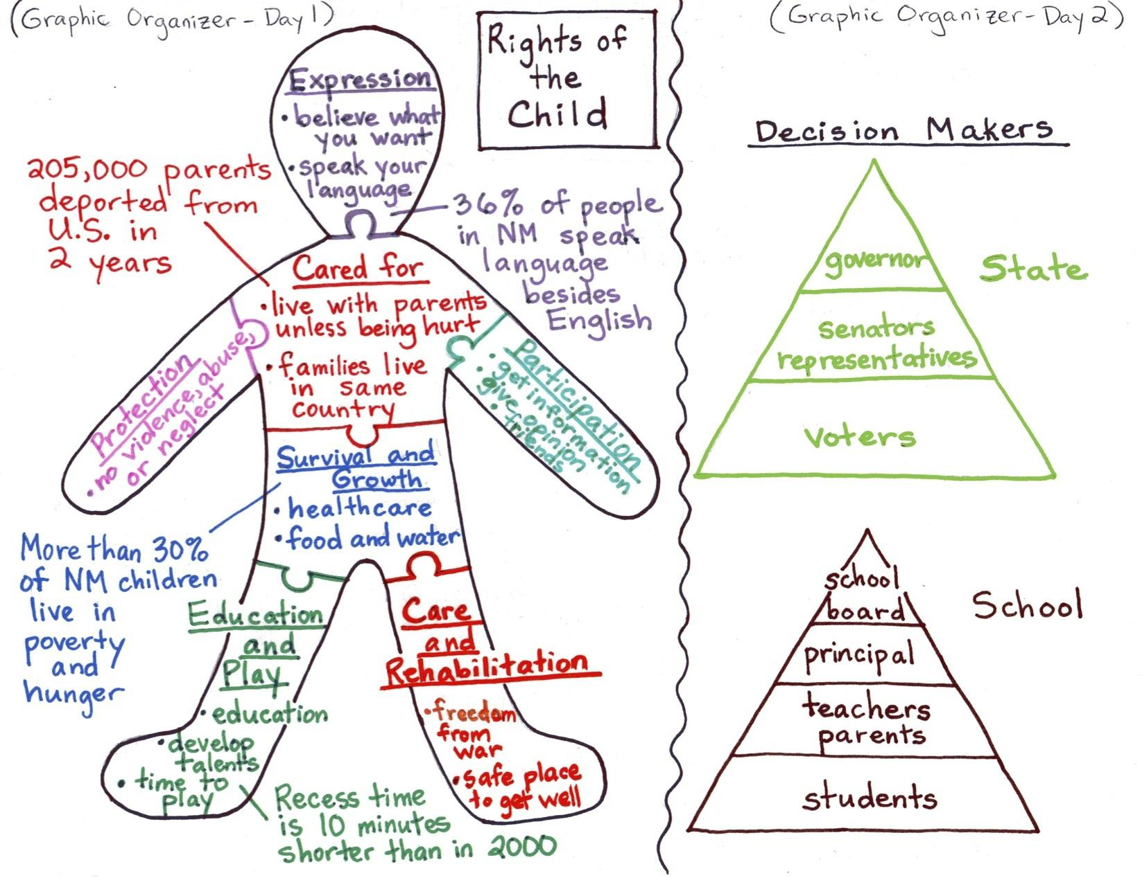

ACTION PLAN: LET’S MAKE A CHANGE
RIGHTS OF THE CHILD
I. Graphic Organizer: Rights of the Child
II. As a class, select one of the problems to focus on. Brainstorm possible causes and solutions (pros & cons) to the problem as a whole class.
III. Small group practice:
a. Each team selects one of the possible solutions from the whole-class brainstorm to focus on that they feel will “restore” freedom; contributing to their overall health and wellbeing as a child in the United States. Write a plan of action for you and your team with well-explained reasons for the proposed solution.
b. Develop a creative way to present your action plan to the class.
*Objective of Action Plan:
This action plan is a working graphic organizer to be constructed with the students as the topic develops. Students will explore the conceptual meaning of rights of children and then relate it to their own experiences and to other in community. Due to the nature of this kind of graphic organizer and its use within a Project GLAD unit, an ELD Review matrix may or may not be used to reinforce CCSS/ELD benchmarks.

Sources Cited:
Social Exclusion. Wikipedia. Retrieved September 18, 2013, from http://en.wikipedia.org/wiki/Marginalization
Urban Marginalized People. OMF. Retrieved September 18, 2013, from http://www.omf.org/taiwan

Poetry Book
Let’s Make A Change
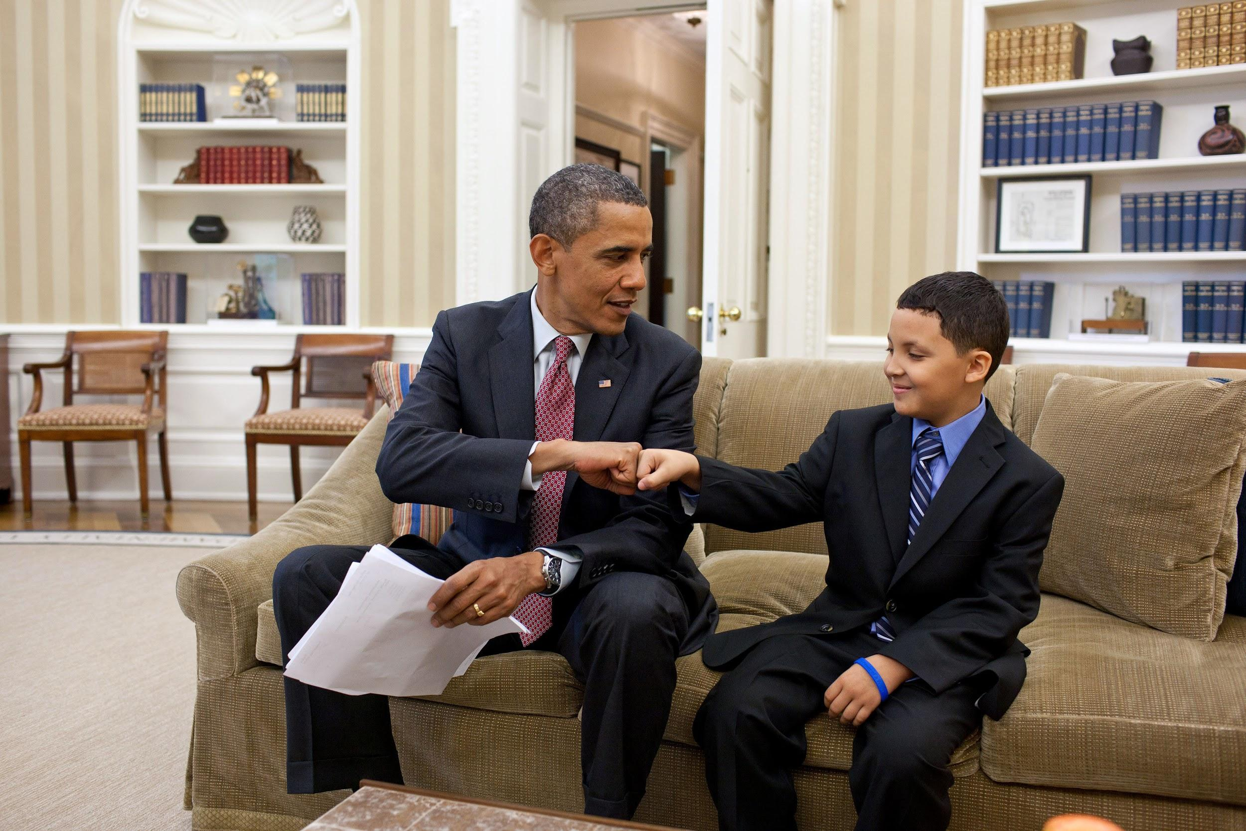
This book belongs to:
_____________________________________
2nd GRADE

Leaders Here, Leaders There
By Kavita Krishna
Leaders here, leaders there,
Leaders, leaders everywhere!

Brave leaders inspiring widely,
Intelligent leaders organizing brilliantly,
Confident leaders resisting courageously,
And thoughtful leaders protesting non-violently.

Leaders in our communities,
Leaders around the country,
Leaders within our classroom,
And leaders throughout history.

Leaders here, leaders there,
Leaders, leaders everywhere!

Leaders! Leaders! Leaders!

Yes Ma’am: Civil Rights
by: Michelle-Desireé Lobato

Are these civil rights?  Are these civil rights?  How do you know?  How do you know? | Yes, ma’am!  Yes, ma’am!  Protected by the Constitution  There’s freedom and equality
Are these civil rights?  Are these civil rights?  Can you give me some examples?  One more example? | Yes, ma’am!  Yes, ma’am!  Voting and free speech  Right to assemble
Has everyone always had them?  Has everyone always had them?  How do you know?  How do you know? | No, ma’am!  No, ma’am!  People owned slaves  Minorities couldn’t vote
Has that changed?  Has that changed?  How do you know?  How do you know? | Yes, ma’am!  Yes, ma’am!  Slavery is now illegal  Everyone can vote!

Historical Movements Cadence
by Kavita Krishna

We just know what we’ve been told
Historical change is as good as gold
We act together when something’s wrong
Marching the streets, singing protest songs

Sound off - Historical
Sound off - Movements
Sound off - 1-2-3-4 - Make a change!

Leaders can help us find the tools
To help people hurt by unfair rules
We can stand up by sitting in
Fighting against discrimination

Sound off - Historical
Sound off - Movements

Sound off - 1-2-3-4 - Make a change!
I Know a Social Leader
By Kavita Krishna

I know a social leader,
A courageous and strong social leader,
A courageous and strong social leader,
That lived in Ohkay Owingeh Pueblo.

He helped people as a healer,
He fought against Spanish control,
He led the Pueblo Revolt,
And restored people’s customs and language.

I know a social leader,
A courageous and strong social leader,
A courageous and strong social leader,

A leader who was called Po’pay.

The Activist Bugaloo
by Kathleen Salgado

I’m an activist and I’m here to say,
I work for my cause everyday.
Sometimes I speak at conventions, sometimes I write a book;
Sometimes I ask people to take a second look.

Organizing, speaking, voting too,
Doing the activist BOOGALOO!

I get others involved to take a stand,
At every corner, I’m there to lend a hand.
People come together and try to persuade,
it might take awhile but eventually, change is made.

Boycotts, marches, revolting too!
Doing the activist BOOGALOO!

César Chávez
Expert Group

Time Period and Location
César Chávez was an active leader from 1960-1980. He lived in California, which is in the Pacific Region of the United States. In this region, farming is an important part of the economy, environment, and way of life.

Background
César Chávez was born in Arizona in 1927. As a young boy, he worked on his family’s farm. When he entered elementary school, César Chávez only spoke Spanish. Because his family was migrant farm workers that moved often, César Chávez attended over 30 schools until middle school.

Problems People Faced
César Chávez became very concerned, or worried, about the treatment of people who worked on farms. Farm workers were not paid fairly and had very unsafe working conditions. They worked long hours in the heat and were not allowed to drink water or use a bathroom.

Actions
As a leader, César Chávez believed in making changes for farm workers in nonviolent ways. Instead of fighting and hurting others, he organized peaceful marches, strikes, and boycotts. César Chávez helped people working on farms gain better working conditions and higher wages, or pay. He helped organize a workers’ union, which continued to fight for farm workers’ rights.
http://www.notablebiographies.com/Ch-Co/Ch-vez-C-sar.html

Harriet Tubman
Expert Group

Time Period and Location
Harriet Tubman was an active leader from 1850-1860. She lived in Maryland, which is in the southern part of the Northeast United States. During the 1850s in this region, many black people were enslaved. Their freedom was taken away and they were forced to work for a master or owner.

Background
In 1820, Harriet Tubman was born into slavery in Maryland in 1820. As an enslaved person, she was forced to work as a house servant as well as in the fields. Harriet Tubman escaped from slavery in 1849 when her owner died, and she fled, or ran away, to Philadelphia.

Problems People Faced
Enslaved people were often beaten and mistreated. Their families were torn apart, and they had no say over decisions in their lives. While most states in the South allowed slavery, states in the North were mainly free. Trying to escape was dangerous, but many slaves still fled to the North.

Actions
As an abolitionist leader, Harriet Tubman helped free many people. Traveling in the dark of night, she made over 19 trips on the Underground Railroad, which was a secret network of pathways from the South to the North with safe houses along the way. Harriet Tubman helped hundreds of enslaved people escape to freedom and never got caught.
http://www.u-s-history.com/pages/h484.html
http://www.historynet.com/harriet-tubman

Lucy Stone
Expert Group
Time Period and Location
Lucy Stone was an active leader from 1847 to 1893. She lived in Massachusetts in the Northeast Region of the United States. She worked in both the Northeast and the Midwest. During Lucy Stone’s life, women in these regions were seeking the same rights as men.

Background
Lucy Stone was born in Massachusetts in 1818. Even though her father did not support her getting an education, she became a teacher and saved money to go to college. She was the first woman to graduate from college in Ohio. Lucy Stone became a great writer and public speaker.

Problems People Faced
During the 1800’s, women in the U.S. were not treated the same as men. They were not allowed to vote or be political leaders. In many states, women could not go to college, hold certain jobs, or own property. Lucy Stone believed that both white and black women deserved the same rights as men.

Actions
As a leader, Lucy Stone organized the first national convention, or large meeting, to discuss women’s rights. She spoke passionately to crowds around the country and published an important journal. Through her speeches and writing, she persuaded people to fight for women’s right to vote. She also inspired women to stand up for themselves.

http://www.biography.com/people/lucy-stone-9495976
Ruby Bridges
Expert Group
Time Period and Location
Ruby Bridges has been an active leader from the 1960s to the present. She lived in New Orleans, which is in the Southeast Region of the United States. During this time in the South, black and white children were segregated and could not attend school together.

Background
Ruby Bridges was born in Mississippi in 1954. Her family moved to New Orleans when she was four years old. After Ruby Bridges passed a difficult test in Kindergarten, she was invited to attend a school that only white children attended.

Problems People Faced
During the 1950s, groups of people were not treated equally because of their race. Black and white people were segregated and could not go to the same restaurants, attend the same schools, or even drink from the same water fountains. Ruby Bridges’ mom felt that she would get a better education if she attended a school for white children.

Actions
In 1960, Ruby Bridges started first grade as the only black student at William Frantz Elementary School. Brave and courageous, she walked into school with people spitting, yelling, and throwing things at her. She worked alone every day with her teacher, Ms. Henry. Ruby Bridges paved the way for children of different races to attend school together. Today she continues to fight for equal rights for all.

http://www.biography.com/people/ruby-bridges-475426
https://www.nwhm.org/education-resources/biography/biographies/ruby-bridges/

Leader:
Background
Problems People Faced
Actions
Time Period and Location

Let’s Make a Change-Process Grid
Leader | Time Period & Location | Background | Problems People Faced | Actions

Leader | Time Period & Location | Background | Problems People Faced | Actions
Po’pay | - 1680  - Present day  New Mexico (Southwest Region) | - Born around 1630  - Tribal leader of Ohkay Owingeh  - 1675 arrested & beaten for being a healer | • Pueblo people forced to change religion  • Forced to speak Spanish  • Forced into slavery | • Organized 25 tribes to revolt against Spanish  • Used knotted yucca cords/deer skins to count days to revolt  • Restored traditional customs & language
César Chávez | - 1960-1980  - California  (Pacific Region) | - Born in Arizona 1927  - Worked on family farm  - Spoke Spanish when started school | • Farmworkers not paid fairly  • No water or bathrooms  • Long hours | • Non-violence  • Marches, strikes, boycotts  • Better pay & working conditions
Harriet Tubman | - 1850-1860  - Maryland  (southern Northeast Region) | - Born in Maryland in 1820 into slavery  - House servant  - Escaped in 1849 | • Enslaved people beaten, mistreated  • Families torn apart  • Escaping was dangerous | - Over 19 trips on the Underground Railroad  - Hundreds of enslaved to freedom  - Never got caught
Ruby Bridges | - 1960s to present  - New Orleans  (Southern Region) | - Born in Mississippi 1954  - Took a test in Kindergarten | • Black and whites segregated  • Better education in white school | • In 1st grade only black student  • Brave and courageous  • Worked alone with Ms. Henry  • Children can go to school together
Lucy Stone | - 1840-1880s  - Massachusetts (Northeast/Midwest Region) | • Born in 1818 in Massachusetts  • First woman to graduate from college in Ohio  • Public speaker | • Women did not have same rights as men  -public speaking, voting, own property | - Organized conventions  - Gave speeches  - Woman gained the right to vote with 19th amendment

Home-School Connection #1
With the help of your family, draw a map of a room in your house and discuss how it could be helpful to have a map of a room.
- Draw the shape of the room.
- Draw and label one piece of furniture.
- Draw and label any doors or windows.

Family Member Signature: _______________________________ Date: ___________
Student Signature: ______________________________________ Date: ___________
Teacher Comments: ___________________________________________________________

Conexión entre hogar y escuela #1
Con la ayuda de tu familia, dibuja un mapa de un cuarto en tu casa y hablen de cómo podría ser útil tener un mapa del cuarto.
- Dibuja la forma del cuarto.
- Dibuja y nombra un mueble.
- Dibuja y nombra alguna puerta o ventana.

Firma del familiar: ______________________________________ Fecha: ___________
Firma del estudiante: ______________________________________ Fecha: ___________
Comentarios del maestro:________________________________________________________

Home-School Connection #2
Today you learned about the social leader, Po’pay. Tell your family about the time period, location, background, and actions of Po’pay. Sketch and write about what you discussed.

Family Member Signature: _______________________________ Date: ___________
Student Signature: ______________________________________ Date: ___________
Teacher Comments: __________________________________________________________

Conexión entre hogar y escuela #2
Hoy aprendiste acerca del líder comunitario, Po’pay. Habla con tu familia sobre el período de tiempo, el lugar, la formación y las acciones de Po’pay. Dibuja y escribe de lo que hablaron.

Firma del familiar: ______________________________________ Fecha: ___________
Firma del estudiante: ______________________________________ Fecha: ___________
Comentarios del maestro: ______________________________________________________

Home-School Connection #3
Retell the story, Freedom on the Menu, to your family. Sketch and write about your favorite part of the story.

Family Member Signature: _______________________________ Date: ___________
Student Signature: ______________________________________ Date: ___________
Teacher Comments: ___________________________________________________________

Conexión entre hogar y escuela #3
Vuelve a contar el cuento, Freedom on the Menu, a tu familia. Dibuja y escribe sobre tu parte favorita de la historia.

Firma del familiar: ______________________________________ Fecha: ___________
Firma del estudiante: ______________________________________ Fecha: ___________
Comentarios del maestro: _______________________________________________________

Home-School Connection #4
Think of something that you or your family think is unfair. Sketch and write about how you would change it to make it more fair.

Family Member Signature: _______________________________ Date: ___________
Student Signature: ______________________________________ Date: ___________
Teacher Comments: ___________________________________________________________

Conexión entre hogar y escuela #4
Piensa en algo que tú o tu familia piensa es injusto. Dibuja y escribe sobre cómo lo cambiarías para hacerlo más justo.

Firma del familiar: ______________________________________ Fecha: ___________
Firma del estudiante: ______________________________________ Fecha: ___________
Comentarios de maestro: _______________________________________________________

Home-School Connection #5
Ask a family member what they think makes a strong leader.
Tell about a time you felt like a leader in your home, school or community. Sketch and write about a time you were a leader.

Family Member Signature: _______________________________ Date: ___________
Student Signature: ______________________________________ Date: ___________
Teacher Comments: ___________________________________________________________

Conexión entre hogar y escuela #5
Pregúntale a un familiar qué piensa hace un líder fuerte.
Cuéntale a un familiar sobre una vez cuando te sentiste como un líder en tu hogar, escuela o comunidad. Dibuja y escribe sobre una vez cuando fuiste un líder.

Firma del familiar: ______________________________________ Fecha: ___________
Firma del estudiante: ______________________________________ Fecha: ___________
Comentarios de maestro: _______________________________________________________

Home-School Connection #6
Discuss with a family member why social leaders have been important to the history of the United States. Sketch and write about what you discuss.

Family Member Signature: _______________________________ Date: ___________
Student Signature: ______________________________________ Date: ___________
Teacher Comments: ___________________________________________________________

Conexión entre hogar y escuela #6
Habla con un familiar acerca de por qué los líderes comunitarios han sido importantes a la historia de los Estados Unidos. Dibuja y escribe sobre lo que hablan.

Firma del familiar: ______________________________________ Fecha: ___________
Firma del estudiante: ______________________________________ Fecha: ___________
Comentarios de maestro: _______________________________________________________

Graffiti Wall Questions

During what time period was César Chávez an active leader?
a) 1960-1980
b) 1850-1860
c) 1840-1850
d) 1920-1930

Po’pay used knotted deer skins to count down the number of days until the _______________.

Harriet Tubman was a leader for the United Farm Workers. Yes or no?

A social leader is a person who is able to bring other people together and make change.
a) True
b) False

On the Graphic Organizer, what is the color and symbol used for a landform?

List Lucy Stone’s actions.

Name:______________________ Date:_________ Score:________

Let’s Make a Change
Final Teacher-Made Test

Answer the following questions by circling the best choice for each question.
1) Which movement is associated with Harriet Tubman?
a) United Farm Worker’s
b) The Pueblo Revolt
c) The Abolitionist Movement
d) The Civil Right’s Movement

2) What was Lucy Stone's goal during the Women’s Suffrage Movement ?
a) She wanted to help slaves escape to the North.
b) Her goal was to drive out the Spanish.
c) She didn’t have any goals.
d) She wanted women to have the right to vote in America.

Answer the following questions by filling in the blank with the correct word. Each word from the word bank will only be used once.

Word Bank
leader
movement
non-violent

3) Marched, strikes, boycotts and sit-ins are examples of _______________ protests.
4) A social ______________ is a series of organized activities working toward a common goal.

5) The word _______________ means a guiding or directing head of a movement or group.

Match the following social leaders to one of their actions. Draw a line to connect the action with the leader.
6) Ruby Bridges  7) César Chávez  8) Lucy Stone  9) Harriet Tubman  10) Po’pay | a)Paved the way for children of different races to attend school together  b) Organized the first national convention to discuss women’s rights  c) Helped Pueblo peoples to restore and maintain their traditions  d) Helped hundreds of enslaved people escape to freedom and never got caught  e) Helped people working on farms gain better working conditions and higher wages
Decide if the statements below are true or false. Circle the correct answer.

11) The Underground Railroad was a track for trains to run underground that went from the South to the North.
a) True
b) False

Answer the following questions in complete sentences.

12) Explain two ways that Pueblo People were impacted after the arrival of the Spanish in the Southwest.
__________________________________________________________________

__________________________________________________________________

__________________________________________________________________

__________________________________________________________________

__________________________________________________________________

Writing Prompt

DIRECTIONS:

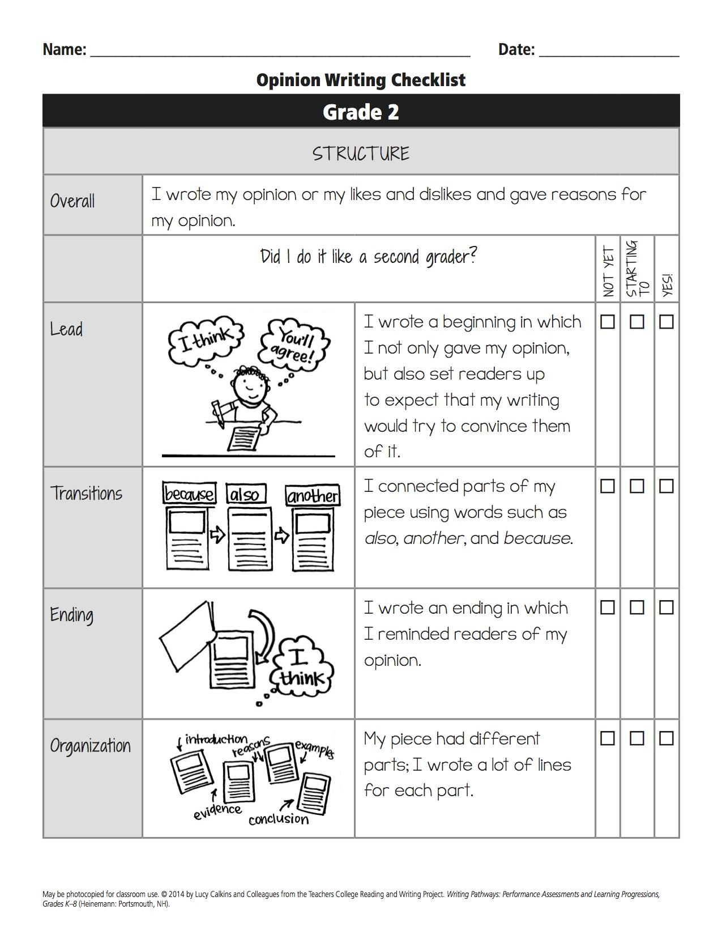
Write a persuasive letter to an important decision maker that your team chose from the Action Plan.
