Project GLAD
IDENTITY: Literary Text Driven by Identity
Level 8

Desired Results

Transfer: Students will independently use their understanding of literary structures and the theme of identity to analyze, make connections, and assess disconnections across a variety of texts.
Enduring Understandings
- I have control over how I am perceived, and my actions play a large role in determining my identity.
- The identities of genres are not exclusively determined by the absence or presence of literary elements.
- A writer’s choice of language and style establishes and personalizes imaginative stories.
Essential Questions
- Who am I in the eyes of others?
- Since many genres share literary elements such as plot and conflict, what determines the identities of genres?
- How do writers communicate identity?

IDEA PAGES

I. UNIT THEMES -
- An understanding of literary structures and the theme of identity can be used to analyze, make connections, and assess disconnections across a variety of texts.
- Literary texts are influenced by the author’s identity and experiences.
- Literary text tells a story, connects people to other people
- Cross-cultural theme: Storytelling is a universal means of communicating cultural traditions, values, and beliefs, as well as a vehicle for passing on information about history, science, government, and politics.
- Storytelling speaks of our cultures and identities.
- Literary text offers students the opportunity to discover, think, evaluate, and analyze the world around them in broader, more universal terms.

II. FOCUS/MOTIVATION
- Important Big Book
- Literary Awards
- Inquiry Charts
- Observation Charts
- Interest pieces from newspaper
- Guest speakers
- Videos, movies, filmstrips

III. CLOSURE
- Living Walls
- Important Big Books
- Graffiti Wall
- Group presentations of team tasks
- Personal Explorations/Research projects
- Student Portfolio/Learning Logs
  - Student-authored narratives
  - Student action plans
  - End-of-unit exam

IV. STANDARDS ADDRESSED IN THIS UNIT

TEXAS TEKS ELA
8.F19 Reading/Comprehension Skills. Students use a flexible range of metacognitive reading skills in both assigned and independent reading to understand an author's message. Students will continue to apply earlier standards with greater depth in increasingly more complex texts as they become self-directed, critical readers.
8.F19A establish purposes for reading selected texts based upon own or others' desired outcome to enhance comprehension.
STUDENTS WILL KNOW: Authors create text with a purpose (express thoughts or feelings, to inform or explain, to persuade, or to entertain) and audience in mind. Readers identify their own purposes for reading.
STUDENTS WILL BE ABLE TO: In order to read actively, I must prepare myself by setting my own reasons for reading. If authors imply most of their meanings, I must be ready to infer.
8.F19B ask literal, interpretive, evaluative, and universal questions of text.
STUDENTS WILL KNOW: Making connections within and between texts requires that I read actively, and clarify things I don't understand, notice, feel strongly about, or have a hunch about.
STUDENTS WILL BE ABLE TO: Read actively, marking texts for literal, interpretive, evaluative, and universal issues, and they by asking questions to clarify those areas.
8.F19C monitor and adjust comprehension (e.g., using background knowledge; creating sensory images; rereading a portion aloud; generating questions).
STUDENTS WILL KNOW: Answering interpretive questions about texts requires me to active my prior knowledge, picture what I'm reading, reread to clarify and test ideas, and come up with questions that will help me understand the author's implied messages.
STUDENTS WILL BE ABLE TO: Take an active role in awakening prior knowledge, picturing what I'm reading, re-reading to clarify, and generating questions to ask of the text and my peers.
8.F19D make inferences about text and use textual evidence to support understanding RC2/RC3
STUDENTS WILL KNOW: Good writing drives our curiosity by leaving out key information such as the reasons why characters or subjects behave as they do.
STUDENTS WILL BE ABLE TO: By actively reading with purpose, and by questioning the text, I will generate ideas about what the author is trying to imply. I must test my ideas by looking for textual evidence.
8.F19E Summarize, paraphrase, and synthesize texts in ways that maintain meaning and logical order within a text and across texts. RC2
STUDENTS WILL KNOW: Explaining texts in my own words requires that I fill in the gaps that authors create when they imply information.
STUDENTS WILL BE ABLE TO: Use the results of active critical reading to encapsulate textual ideas in ways that continue to be supportable with evidence.
8.F19F make connections (e.g., thematic links, author analysis) between and across multiple texts of various genres, and provide textual evidence RC1
STUDENTS WILL KNOW: Making connections using universal themes requires that I support my ideas with evidence.
STUDENTS WILL BE ABLE TO: Link textual evidence and themes such as identity, influences, change, power, systems, and choices to find commonalities and disconnections across texts from different genres.
8.22 Research. Students are expected to know how to locate a range of relevant sources and evaluate, synthesize, and present ideas and information.
8.22A brainstorm, consult with others, decide upon a topic, and formulate open-ended questions to address the major research topic
STUDENTS WILL KNOW: Researchers understand how to brainstorm with others or independently in order to define a research topic and open-ended questions that address the topic.
STUDENTS WILL BE ABLE TO: Brainstorm with others or independently to select a research topic and the open- ended questions that guide the research.
8.28 Listening and Speaking/Teamwork. Students work productively with others in teams. Students will continue to apply earlier standards with greater complexity. Students are expected to participate in student-led discussions by eliciting and considering suggestions from other group members and by identifying points of agreement and disagreement.
8.28A participate productively in discussions, plan agendas with clear goals and deadlines, set time limits for speakers, take notes, and vote on key issues.
STUDENTS WILL KNOW: Participating in Shared Inquiry Discussions will allow me to develop my point of view, reasoning, and evidence, and will give me a sense of ownership and responsibility in fostering a positive classroom environment.
STUDENTS WILL BE ABLE TO: Participate productively and respectfully in classroom discussions and other leadership oriented activities.
8.2 Reading/Vocabulary Development. Students understand new vocabulary and use it when reading and writing.
8.2A determine the meaning of grade- level academic English words derived from Latin, Greek, or other linguistic roots and affixes RC1
STUDENTS WILL KNOW: Acquiring a lexicon of roots will allow me to interpret unfamiliar vocabulary, preserving fluency, and increasing access to future vocabulary growth.
STUDENTS WILL BE ABLE TO: Acquire common roots and their meanings, analyze word parts of unfamiliar vocabulary to infer meanings appropriate with contexts.
8.2B use context (e.g., cause and effect or compare and contrast organizational text structures) to determine or clarify the meaning of unfamiliar or multiple meaning words RC1
STUDENTS WILL KNOW: Context doesn’t just mean the words that surround unclear vocabulary. The way a passage is organized can also give us clues as to what a words means.
STUDENTS WILL BE ABLE TO: Detect a text’s organizational structure, and use it to help figure out a word’s relationship to other words in passage.
8.2C complete analogies that describe a function or its description (e.g., pen:paper as chalk: ______ or soft:kitten as hard: ______)
STUDENTS WILL KNOW: Analogies are valuable to practice the thinking skills needed to make connections, and they are metacognitive tools to be able to integrate word understandings.
STUDENTS WILL BE ABLE TO: Use analogies in the service of interpreting and integrating previously unfamiliar vocabulary.
8.2D identify common words or word parts from other languages that are used in written English (e.g., phenomenon, charisma, chorus, passé, flora, fauna)
STUDENTS WILL KNOW: English is a worldwide language that acquires vocabulary as it expands.
STUDENTS WILL BE ABLE TO: Use root analysis, context, and reference resources to understand the meanings of foreign words and phrases.
8.2E use a dictionary, a glossary, or a thesaurus (printed or electronic) to determine the meanings, syllabication, pronunciations, alternate word choices, and parts of speech of words RC1
STUDENTS WILL KNOW: Reference resources are valuable tools in choosing the right word meaning for the context in which unfamiliar vocabulary appears, and for selecting the right word for the right intention in my own writing.
STUDENTS WILL BE ABLE TO: Use the skills cited in the TEK to support the acquisition of new vocabulary, to clarify author’s intent, and to bring accuracy and specificity to his or her own writing.
8.3 Reading/Comprehension of Literary Text/Theme and Genre. Students analyze, make inferences and draw conclusions about theme and genre in different cultural, historical, and contemporary contexts and provide evidence from the text to support their understanding.
8.3A analyze literary works that share similar themes across cultures RC1
STUDENTS WILL KNOW: Literary themes are often are universal across cultures, and viewing literature through thematic lenses will allow me to make connections across multicultural writing.
STUDENTS WILL BE ABLE TO: Make connections between texts by looking for thematic commonalities.
8.3B compare and contrast the similarities and differences in mythologies from various cultures (e.g., ideas of afterlife, roles and characteristics of deities, purposes of myths) RC2
STUDENTS WILL KNOW: Mythological ideas about deities and afterlife are universal subjects across cultures, and allow readers ways to compare and contrast cultural messages.
STUDENTS WILL BE ABLE TO: Use active reading to analyze mythologies from various cultures, and to infer, compare, and contrast cultural messaging.
8.3C explain how the values and beliefs of particular characters are affected by the historical and cultural setting of the literary work RC1
STUDENTS WILL KNOW: The historical and cultural setting of a work frame the plot, and directly or indirectly fuel conflict. This can be detected by analyzing character values and beliefs. Consider Billy Jo Kelby's rededication to her father in Karen Hesse’s novel Out of the Dust.
STUDENTS WILL BE ABLE TO: Analyze how a character's values and beliefs would be different if he or she were put into a different historical and cultural setting, and then determine which of those values/beliefs are be directly attributable to the historical and cultural setting of the work.
8.5 Reading/Comprehension of Literary Text/Drama. Students understand, make inferences and draw conclusions about the structure and elements of drama and provide evidence from text. RC2
8.5A analyze how different playwrights characterize their protagonists and antagonists through the dialogue and staging of their plays RC2
STUDENTS WILL KNOW: Drama is told exclusively through dialogue and stage directions, so to interpret characterization in drama, I need to analyze what the protagonists say and do.
STUDENTS WILL BE ABLE TO: Compare how different playwrights characterize their protagonists and antagonists through dialogue and staging.
8.6 Reading/Comprehension of Literary Text/Fiction. Students understand, make inferences and draw conclusions about the structure and elements of fiction and provide evidence from text to support their understanding.
8.6A analyze linear plot developments (e.g., conflict, rising action, falling action, resolution, subplots) to determine whether and how conflicts are resolved RC2
STUDENTS WILL KNOW: Understanding plot structure will give me clues as to whether or not a conflict has been resolved.
STUDENTS WILL BE ABLE TO: Analyze linear plot development to determine whether and how conflicts are resolved.
8.6B analyze how the central characters' qualities influence the theme of a fictional work and resolution of the central conflict RC2
STUDENTS WILL KNOW: The speech patterns, diction, pronunciation, and grammatical usage that authors give their characters can give readers insights into how the character in question fits into the setting, conflict and plot of a fictional work.
STUDENTS WILL BE ABLE TO: Use dialect to analyze character traits, and infer themes.
8.6C analyze different forms of point of view, including limited versus omniscient, subjective versus objective. RC2
STUDENTS WILL KNOW: All action in a story is transmitted through a particular point of view, and awareness of the narrative mode at work allows readers windows into the connections at work within stories.
STUDENTS WILL BE ABLE TO: Use point-of-view to infer thematic elements by connecting character perspective and behavior to causal and consequential plot events.
8.17 Writing/Expository and Procedural Texts. Students write expository and procedural or work-related texts to communicate ideas and information to specific audiences for specific purposes.
8.17C write responses to literary or expository texts that demonstrate the use of writing skills for a multi-paragraph essay and provide sustained evidence from the text using quotations when appropriate.
STUDENTS WILL KNOW: Responding to literary or expository texts, and supporting answers with evidence helps clarify insights, and lays the groundwork for further analysis in writing.
STUDENTS WILL BE ABLE TO: Effectively wield specificity and evidence in short answer format response writing to prepare for class discussions, frame thinking about texts, and to synthesize ideas generated during class discussions.
8.14 Writing/Writing Process. Students use elements of the writing process (planning, drafting, revising, editing, and publishing) to compose text.
8.14A plan a first draft by selecting a genre appropriate for conveying the intended meaning to an audience, determining appropriate topics through a range of strategies (e.g., discussion, background reading, personal interests, interviews), and developing a thesis or controlling idea
STUDENTS WILL KNOW: There are a number of strategies to help writers generate and organize their ideas for writing.
STUDENTS WILL BE ABLE TO: Choose strategies that work best for him or her, and use those strategies consistently when pre-writing.
8.14B develop drafts by choosing an appropriate organizational strategy (e.g., sequence of events, cause-effect, compare-contrast) and building on ideas to create a focused, organized, and coherent piece of writing
STUDENTS WILL KNOW: Organizing drafts help develop ideas in writing.
STUDENTS WILL BE ABLE TO: Choose the organizational strategy that best fits the audience, occasion, and purpose.
8.14C revise drafts to clarify meaning, enhance style, include simple and compound sentences, and improve transitions by adding, deleting, combining, and rearranging sentences or larger units of text after rethinking how well questions of purpose, audience, and genre have been addressed
STUDENTS WILL KNOW: Revising drafts during the writing process requires examining my ideas, and clarifying them by rewriting, adding to, and rearranging parts of the text.
STUDENTS WILL BE ABLE TO: Work with others to help identify areas where ideas need more clarity, and to explore ways of making that clarity happen.
8.14D edit drafts for grammar, mechanics, and spelling
STUDENTS WILL KNOW: Editing drafts during the writing process requires attention to writing conventions.
STUDENTS WILL BE ABLE TO: Work with others to identify and repair problems of grammar, mechanics and spelling.
8.14E revise final draft in response to feedback from peers and teacher and publish written work for appropriate audiences.
STUDENTS WILL KNOW: Publishing during the writing process incorporates feedback prior to final draft.
STUDENTS WILL BE ABLE TO: Publish work in a way that is appropriate for the audience, occasion, and purpose.
8.15 Writing/Literary Texts. Students write literary texts to express their ideas and feelings about real or imagined people, events, and ideas.
8.15A write an imaginative story: (i) sustains reader interest
(ii) includes well-paced action and an engaging story line
(iii) creates a specific, believable setting through the use of sensory details
(iv) develops interesting characters
(v) uses a range of literary strategies and devices to enhance the style and tone
- STUDENTS WILL KNOW: Writers secure and sustain reader interest by not revealing too much, too soon. Keeping readers hooked has a lot to do with the pace at which my plot unfolds. To create realistic stories, authors use sensory details to help the reader visualize the setting and other elements. Kurt Vonnegut once said, “Every character should want something, even if it is only a glass of water.” Characters are interesting when readers have some insights into their internal worlds. When reading imaginative stories, I should notice the moves other writers make, and I should try to replicate those that I like.
STUDENTS WILL BE ABLE TO: Using the format of a dramatic script: Write a story that uses a clearly developed focus, plot, and point of view. Write a story that unfolds the plot in a pace that maintains reader interest, and builds to a climax. Use sensory details to create a realistic setting that the reader can easily visualize. Develop characters who act on motivations. Apply learned literary patterns and devices from mentor texts.
8.15B write a poem using:
- (i) poetic techniques (e.g., rhyme scheme, meter)
- (ii) figurative language (e.g., personification, idioms, hyperbole)
- (iii) graphicelements(e.g.,wordposition)
STUDENTS WILL KNOW: Poetry was developed to be recited by and to non-literate people (Beowulf was told for hundreds of years before someone wrote it down). As a result, poetic techniques such as rhyme scheme and meter came to be useful in helping people remember the poem later. Poetry emphasizes emotional understanding rather than literal meaning. As a result, poetry relies heavily on figurative language to communicate relationships and ideas. The most noticeable feature of poetry is how it looks on the page in comparison to prose, and poets often take advantage of the freedom poetic forms allow to play with its graphic elements to imply meanings.
STUDENTS WILL BE ABLE TO: Write a personal narrative styled as a lyric or epic poem that: Uses a clearly developed focus, plot, and point of view. Write a story that unfolds the plot in a pace that maintains reader interest, and builds to a climax. Use sensory details to create a realistic setting that the reader can easily visualize. Develop characters who act on motivations. Apply learned literary patterns and devices from mentor texts.
8.16 Writing. Students write about their own experiences.
8.16A write a personal narrative that has a clearly defined focus and communicates the importance of or reasons for actions and/or consequences.
STUDENTS WILL KNOW: A personal narrative is an account of a person's memories related to a particular event. It takes a narrative form, may contain dialog and other elements of literature, and may even involve a certain amount of artistic license to make it more interesting and compelling.
Writers provide a clear focus, reasons for actions, importance of actions, and consequences of actions in a personal narrative.
STUDENTS WILL BE ABLE TO: Write an effective and engaging personal narrative that includes a defined focus, and communicates the reasons, importance and consequences of actions
8.19 Oral and Written Conventions/Conventions. Students understand the function of and use the conventions of academic language when speaking and writing. Students will continue to apply earlier standards with greater complexity.
8.19B differentiate between the active and passive voice and know how to use them both
STUDENTS WILL KNOW: Authors usually try to write in the active voice because it is more direct and easier to understand.
STUDENTS WILL BE ABLE TO: Transfer text from active to passive voice and vice versa.
8.21 Oral and Written Conventions/Spelling. Students spell correctly.
8.21A use spelling patterns and rules and print and electronic resources to determine and check correct spellings
STUDENTS WILL KNOW: Many resources exist to help me verify spelling.
STUDENTS WILL BE ABLE TO: Consult reference resources as needed in drafting and editing to ensure effective usage.
8.28 Listening and Speaking/Teamwork. Students work productively with others in teams. Students will continue to apply earlier standards with greater complexity. Students are expected to participate in student-led discussions by eliciting and considering suggestions from other group members and by identifying points of agreement and disagreement.
8.28A participate productively in discussions, plan agendas with clear goals and deadlines, set time limits for speakers, take notes, and vote on key issues.
STUDENTS WILL KNOW: Participating in Shared Inquiry Discussions will allow me to develop my point of view, reasoning, and evidence, and will give me a sense of ownership and responsibility in fostering a positive classroom
STUDENTS WILL BE ABLE TO: Participate productively and respectfully in classroom discussions and other leadership oriented activities.
CONCEPTS/STANDARDS: English Language Proficiency Standards (ELPS)

Cross-curricular second language acquisition essential knowledge and skills.
(1) Cross-curricular second language acquisition/learning strategies. The ELL uses language learning strategies to develop an awareness of his or her own learning processes in all content areas. In order for the ELL to meet grade-level learning expectations across the foundation and enrichment curriculum, all instruction delivered in English must be linguistically accommodated (communicated, sequenced, and scaffolded) commensurate with the student's level of English language proficiency. The student is expected to:
- use prior knowledge and experiences to understand meanings in English;
- monitor oral and written language production and employ self-corrective techniques or other resources;
- (C) use strategic learning techniques such as concept mapping, drawing, memorizing, comparing, contrasting, and reviewing to acquire basic and grade-level vocabulary;
- (D) speak using learning strategies such as requesting assistance, employing non-verbal cues, and using synonyms and circumlocution (conveying ideas by defining or describing when exact English words are not known);
- (E) internalize new basic and academic language by using and reusing it in meaningful ways in speaking and writing activities that build concept and language attainment;
- (F) use accessible language and learn new and essential language in the process;
- (G) demonstrate an increasing ability to distinguish between formal and informal English and an increasing knowledge of when to use each one commensurate with grade-level learning expectations; and
- (H) develop and expand repertoire of learning strategies such as reasoning inductively or deductively, looking for patterns in language, and analyzing sayings and expressions commensurate with grade-level learning expectations.
(2) Cross-curricular second language acquisition/listening. The ELL listens to a variety of speakers including teachers, peers, and electronic media to gain an increasing level of comprehension of newly acquired language in all content areas. ELLs may be at the beginning, intermediate, advanced, or advanced high stage of English language acquisition in listening. In order for the ELL to meet grade-level learning expectations across the foundation and enrichment curriculum, all instruction delivered in English must be linguistically accommodated (communicated, sequenced, and scaffolded) commensurate with the student's level of English language proficiency. The student is expected to:
- (A) distinguish sounds and intonation patterns of English with increasing ease;
- (B) recognize elements of the English sound system in newly acquired vocabulary such as long and short vowels, silent letters, and consonant clusters;
- (C) learn new language structures, expressions, and basic and academic vocabulary heard during classroom instruction and interactions;
- (D) monitor understanding of spoken language during classroom instruction and interactions and seek clarification as needed;
- (E) use visual, contextual, and linguistic support to enhance and confirm understanding of increasingly complex and elaborated spoken language;
- (F) listen to and derive meaning from a variety of media such as audio tape, video, DVD, and CD ROM to build and reinforce concept and language attainment;
- (G) understand the general meaning, main points, and important details of spoken language ranging from situations in which topics, language, and contexts are familiar to unfamiliar;
- (H) understand implicit ideas and information in increasingly complex spoken language commensurate with grade-level learning expectations; and
- (I) demonstrate listening comprehension of increasingly complex spoken English by following directions, retelling or summarizing spoken messages, responding to questions and requests, collaborating with peers, and taking notes commensurate with content and grade-level needs.
(3) Cross-curricular second language acquisition/speaking. The ELL speaks in a variety of modes for a variety of purposes with an awareness of different language registers (formal/informal) using vocabulary with increasing fluency and accuracy in language arts and all content areas. ELLs may be at the beginning, intermediate, advanced, or advanced high stage of English language acquisition in speaking. In order for the ELL to meet grade-level learning expectations across the foundation and enrichment curriculum, all instruction delivered in English must be linguistically accommodated (communicated, sequenced, and scaffolded) commensurate with the student's level of English language proficiency. The student is expected to:
- (A) practice producing sounds of newly acquired vocabulary such as long and short vowels, silent letters, and consonant clusters to pronounce English words in a manner that is increasingly comprehensible;
- (B) expand and internalize initial English vocabulary by learning and using high-frequency English words necessary for identifying and describing people, places, and objects, by retelling simple stories and basic information represented or supported by pictures, and by learning and using routine language needed for classroom communication;
- (C) speak using a variety of grammatical structures, sentence lengths, sentence types, and connecting words with increasing accuracy and ease as more English is acquired;
- (D) speak using grade-level content area vocabulary in context to internalize new English words and build academic language proficiency;
- (E) share information in cooperative learning interactions;
- (F) ask and give information ranging from using a very limited bank of high-frequency, high-need, concrete vocabulary, including key words and expressions needed for basic communication in academic and social contexts, to using abstract and content-based vocabulary during extended speaking assignments;
- (G) express opinions, ideas, and feelings ranging from communicating single words and short phrases to participating in extended discussions on a variety of social and grade-appropriate academic topics;
- (H) narrate, describe, and explain with increasing specificity and detail as more English is acquired;
- (I) adapt spoken language appropriately for formal and informal purposes; and
- (J) respond orally to information presented in a wide variety of print, electronic, audio, and visual media to build and reinforce concept and language attainment.
(4) Cross-curricular second language acquisition/reading. The ELL reads a variety of texts for a variety of purposes with an increasing level of comprehension in all content areas. ELLs may be at the beginning, intermediate, advanced, or advanced high stage of English language acquisition in reading. In order for the ELL to meet grade-level learning expectations across the foundation and enrichment curriculum, all instruction delivered in English must be linguistically accommodated (communicated, sequenced, and scaffolded) commensurate with the student's level of English language proficiency. For Kindergarten and Grade 1, certain of these student expectations apply to text read aloud for students not yet at the stage of decoding written text. The student is expected to:
- (A) learn relationships between sounds and letters of the English language and decode (sound out) words using a combination of skills such as recognizing sound-letter relationships and identifying cognates, affixes, roots, and base words;
- (B) recognize directionality of English reading such as left to right and top to bottom;
- (C) develop basic sight vocabulary, derive meaning of environmental print, and comprehend English vocabulary and language structures used routinely in written classroom materials;
- (D) use prereading supports such as graphic organizers, illustrations, and pretaught topic-related vocabulary and other prereading activities to enhance comprehension of written text;
- (E) read linguistically accommodated content area material with a decreasing need for linguistic accommodations as more English is learned;
- (F) use visual and contextual support and support from peers and teachers to read grade-appropriate content area text, enhance and confirm understanding, and develop vocabulary, grasp of language structures, and background knowledge needed to comprehend increasingly challenging language;
- (G) demonstrate comprehension of increasingly complex English by participating in shared reading, retelling or summarizing material, responding to questions, and taking notes commensurate with content area and grade level needs;
- (H) read silently with increasing ease and comprehension for longer periods;
- demonstrate English comprehension and expand reading skills by employing basic reading skills such as demonstrating understanding of supporting ideas and details in text and graphic sources, summarizing text, and distinguishing main ideas from details commensurate with content area needs;
- (J) demonstrate English comprehension and expand reading skills by employing inferential skills such as predicting, making connections between ideas, drawing inferences and conclusions from text and graphic sources, and finding supporting text evidence commensurate with content area needs; and
- (K) demonstrate English comprehension and expand reading skills by employing analytical skills such as evaluating written information and performing critical analyses commensurate with content area and grade-level needs.
(5) Cross-curricular second language acquisition/writing. The ELL writes in a variety of forms with increasing accuracy to effectively address a specific purpose and audience in all content areas. ELLs may be at the beginning, intermediate, advanced, or advanced high stage of English language acquisition in writing. In order for the ELL to meet grade-level learning expectations across foundation and enrichment curriculum, all instruction delivered in English must be linguistically accommodated (communicated, sequenced, and scaffolded) commensurate with the student's level of English language proficiency. For Kindergarten and Grade 1, certain of these student expectations do not apply until the student has reached the stage of generating original written text using a standard writing system. The student is expected to:
- (A) learn relationships between sounds and letters of the English language to represent sounds when writing in English;
- (B) write using newly acquired basic vocabulary and content-based grade-level vocabulary;
- (C) spell familiar English words with increasing accuracy, and employ English spelling patterns and rules with increasing accuracy as more English is acquired;
- (D) edit writing for standard grammar and usage, including subject-verb agreement, pronoun agreement, and appropriate verb tenses commensurate with grade-level expectations as more English is acquired;
- (E) employ increasingly complex grammatical structures in content area writing commensurate with grade-level expectations, such as:
(i) using correct verbs, tenses, and pronouns/antecedents;
(ii) using possessive case (apostrophe s) correctly; and
(iii) using negatives and contractions correctly;
(F) write using a variety of grade-appropriate sentence lengths, patterns, and connecting words to combine phrases, clauses, and sentences in increasingly accurate ways as more English is acquired; and
(G) narrate, describe, and explain with increasing specificity and detail to fulfill content area writing needs as more English is acquired.
V. VOCABULARY

affix
analyze
antagonist
biography
character
climax
conflict
culture
drama
ekphrasis
epic poem
evidence
exposition
external
falling action
fiction
First-person
foreground
foreshadowing
genre
identity
identity
imply
infer
internal
interpret
irony
limited and omniscient point of view
linear plot development (character driven v. plot driven)
literary text
lyric poem
motivation
nonfiction
omniscient
plot
point of view
protagonist
resolution
rising action
root
Setting
subplots
theme
third-person
traits
villain

VI. RESOURCES AND MATERIALS
Teacher
- I, Claudia (drama) Kristen Thomson, 2001. Playwrights Canada Press
  - Claudia is "an official pre-teen" still reeling from her parents' divorce. Her father is getting re-married, she has a science fair project coming due, and she is in the physical and emotional throes of puberty. Finding refuge in the basement of her school, Claudia discovers the pain at the center of her brimming child 's heart. Some important adults in Claudia 's life -her grandfather, her father 's new girlfriend and the school custodian -shed light on her situation.
  - Kristen Thomson is an actress and playwright. Thomson was born in Toronto, Ontario. She is known for her one-woman play I, Claudia, which was adapted to film in 2004. In that play and film, Thomson plays all of the roles, using masks to change character. In 2003, Thomson won an ACTRA Award for her performance in I Shout Love (2001), a short film directed by Sarah Polley. She has also won three Dora Awards for her stage work.
- Toni Morrison: A Biography of a Nobel Prize-Winning Writer (nonfiction biography) Barbara Kramer, 2013. Enslow Pulbishers, Inc.
  - In TONI MORRISON: A BIOGRAPHY OF A NOBEL PRIZE-WINNING WRITER, author Barbara Kramer explores the life and career of this talented writer. From her childhood in Loraine, Ohio, to her creative expressions of African-American culture, Morrison has always remembered her past. She has taught at several universities, as well as being the author of novels, short stories essays, and a play. Morrison invites readers to participate in her stories and enables them to enter into the characters' lives.
  - Barbara Kramer is an independent researcher who has written extensively about the arts. She lives in Bermuda Dunes, California.
- Locomotion (Fiction – narrative poem) Jacqueline Woodson, 2003. Penguin Putnam Books.
  - When Lonnie was seven years old, his parents died in a fire. Now he's eleven, and he still misses them terribly. And he misses his little sister, Lili, who was put into a different foster home because "not a lot of people want boys-not foster boys that ain't babies." But Lonnie hasn't given up. His foster mother, Miss Edna, is growing on him. She's already raised two sons and she seems to know what makes them tick. And his teacher, Ms. Marcus, is showing him ways to put his jumbled feelings on paper. Told entirely through Lonnie's poetry, we see his heartbreak over his lost family, his thoughtful perspective on the world around him, and most of all his love for Lili and his determination to one day put at least half of their family back together. Jacqueline Woodson's poignant story of love, loss, and hope is lyrically written and enormously accessible.
  - Jacqueline Woodson's awards include 3 Newbery Honors, a Coretta Scott King Award and 3 Coretta Scott King Honors, 2 National Book Awards, a Margaret A. Edwards Award and an ALAN Award -- both for Lifetime Achievement in YA Literature. She is the author of more than 2 dozen books for children and young adults and lives with her family in Brooklyn, New York
- The House on Mango Street (Fiction-short stories) Sandra Cisneros, 1984. Vintage Contemporaries: A Division of Random House, Inc.
  - Told in a series of vignettes – sometimes heartbreaking, sometimes deeply joyous – it is the story of a young Latina girl growing up in Chicago, inventing for herself who and what she will become. Few other books in our time have touched so many readers.
  - SANDRA CISNEROS is the author of two widely acclaimed novels, a story collection, two books of poetry, and, most recently, Have You Seen Marie? She is the recipient of numerous awards, including National Endowment for the Arts Fellowships, the Lannan Literary Award, the American Book Award, the Thomas Wolfe Prize, and a MacArthur Fellowship. Her work has been translated into more than twenty languages. Cisneros is the founder of the Alfredo Cisneros del Moral and Macondo Foundations, which serve creative writers. She lives in Mexico.
- A Wish for Her (fiction) short story Emily K. (teen author), Sudbury, MA. Teenink Magazine, Teenink.com, Issue Jan. 28, 2012.
  - Middle school girl faces her cruelties on another and realizes her mistake.
- Home (fiction) short story Samantha A. (teen author), Vancouver, WA. Teenink Magazine, Teenink.com, Issue May 2016.
  - 17 year old girl faces the death of her long gone father.
- My Lucy Friend Who Smells Like Corn (fiction) Short story out of Woman Hollering Creek and Other Stories Sandra Cisneros, 1991. Random House
  - A story that communicates the joys of youthful friendship in a poor neighborhood. The speaker breathlessly describes her friend while recounting past and current activities and adventures, including snatches of dialogue. She reveals her pleasures in playing at Lucy’s house with her friend’s eight sisters and tells of her wish for sisters of her own so that she could sleep with them “instead of alone on a fold-out chair in the living room.”

- NARRATIVE INPUT CHART Diary of a Wimpy Kid (Fiction) Jeff Kinney, 2007. Abrams
  - It’s a new school year, and Greg Heffley finds himself thrust into middle school, where undersized weaklings share the hallways with kids who are taller, meaner, and already shaving. The hazards of growing up before you’re ready are uniquely revealed through words and drawings as Greg records them in his diary.
  - Author/illustrator Jeff Kinney recalls the growing pains of school life and introduces a new kind of hero who epitomizes the challenges of being a kid. As Greg says in his diary, “Just don’t expect me to be all ‘Dear Diary’ this and ‘Dear Diary’ that.” Luckily for us, what Greg Heffley says he won’t do and what he actually does are two very different things.
- POETRY FRAME The Road Not Taken (poetry) Robert Frost, 1916. Mountain Interval
  - Robert Lee Frost (March 26, 1874 – January 29, 1963) was an American poet. His work was initially published in England before it was published in America. He is highly regarded for his realistic depictions of rural life and his command of American colloquial speech. His work frequently employed settings from rural life in New England in the early twentieth century, using them to examine complex social and philosophical themes. One of the most popular and critically respected American poets of the twentieth century, Frost was honored frequently during his lifetime, receiving four Pulitzer Prizes for Poetry. He became one of America's rare "public literary figures, almost an artistic institution." He was awarded the Congressional Gold Medal in 1960 for his poetic works. On July 22, 1961, Frost was named Poet laureate of Vermont.

VII. WEBSITES

Toni Morrison

http://www.biography.com/people/toni-morrison-9415590
http://www.britannica.com/biography/Toni-Morrison
video
http://www.npr.org/2015/04/20/400394947/i-regret-everything-toni-morrison-looks-back-on-her-personal-life
http://www.nytimes.com/2015/04/12/magazine/the-radical-vision-of-toni-morrison.html?_r=0

Barbara Kramer
https://barbarakramer.com/my-books/
https://www.goodreads.com/author/list/1348.Barbara_Kramer

Kristen Thomson
http://torontolife.com/city/spotlight-kristen-thomson/
http://magazine.utoronto.ca/cover-story/actor-stage-producer-kristen-thomson-i-claudia/
http://www.playwrightscanada.com/index.php/kristen-thomson.html

I, Claudia Youtube
https://www.youtube.com/watch?v=1X6DFv5SJcc

Jeff Kinney
http://www.wimpykid.com/about-the-author/

Diary of a Wimpy Kid
http://www.wimpykid.com

Lesson Guide
http://www.wimpykid.com/wp-content/uploads/2014/03/Book1TeachingGuide.pdf

Video
https://www.youtube.com/watch?v=dS4slnQMeio

Sandra Cisneros
http://www.sandracisneros.com/bio.php
http://www.biography.com/people/sandra-cisneros-185853
Video
http://latino.foxnews.com/latino/lifestyle/2015/10/15/house-on-mango-street-author-sandra-cisneros-traces-her-life-through-places/
https://www.youtube.com/watch?v=4CuRcFkH9nU

Personal Narratives
Teen writing sites
http://www.teenink.com/fiction/realistic_fiction/article/807303/Home/
Teenink review
http://www.nwp.org/cs/public/print/resource/3119

A Wish for Her by Emily K.
http://www.teenink.com/fiction/all/article/71534/A-Wish-For-Her/

Home by Samantha A.
http://www.teenink.com/fiction/realistic_fiction/article/807303/Home/

Jacqueline Woodson
http://www.jacquelinewoodson.com

Locomotion
http://www.scholastic.com/teachers/book/locomotion#cart/cleanup

Action Plan
Identity short film
https://www.youtube.com/watch?v=ikGVWEvUzNM

http://lifeskiller.com/self-discovery-activities/

http://www.stageoflife.com/education/NotestotheTeacher/10TeachingTipsforCreatingGreatWriting.aspx

Literary Elements Test
http://schoolwires.henry.k12.ga.us/Page/41172

IDENTITY
PLANNING PAGES

- FOCUS/MOTIVATION
- Cognitive Content Dictionary with Signal Word
- Important Big Book
- Observation Charts
- Literary Awards
- Poetry
- Inquiry Charts
- Guest speakers
- Videos, movies, filmstrips
- Field trips
- Pre/post tests

II. INPUT
- Brace Map (Text Genres)
- Pictorial Input Chart – I, Claudia
- 10/2 lecture with primary language
- Website interest pieces
- Student demonstrations

- GUIDED ORAL PRACTICE
- T-graph/processing
- Team co-op group evaluation
- Open Sort with textbook Picture File Cards
- Closed Sort with Picture File Cards - classify, compare, order
- Exploration Report
- Inquiry Chart
- Mind Mapping (Plot Diagram/Thinking Maps), list-group-label
- Heads Together/Process Grid
- Poetry
- Sentence Patterning Chart

- READING/WRITING
A. Total Group
• Group Frames (Teacher uses info. from students to model appropriate frame)
- Big Book - The Important Book
Cooperative Strip Paragraph - multiple paragraphs Information
- Poetry Frames
B. Small Group Reading/Writing Activities
• Ear-to-Ear Reading
• Textbook pairs of pairs reading, tutoring, worksheets
• Focused Reading
• Flexible Reading Groups
• Expert Groups
• Team Tasks
• Reader's Theater
• Team Writing Workshop
• Group Process Grids
• Farmer-in-the-Dell/Sentencing Patterning Chart
• Interactive Reading
• Book Sharing
C. Individual Activities - Portfolio
• Paragraph writing
• Poetry writing
• Interactive Journal Writing
• Learning Logs
• Individual Tasks
- Writer's Workshop
• Mini Lesson
• Writing/planning
• Conferences
• Author's Chair
V. REINFORCEMENT/EXTENSION ACTIVITIES
• Personal Narratives
• Read Aloud
• Website Blog/Newspaper interest pieces

VII. CLOSURE
• Focused Reading
• Process Inquiry Charts
•Graffiti Wall questions
• Reading Big Books, share individual poetry
• Personal Exploration with Rubric
• Student Generated Text
• Student portfolios and presentations
• Student action plan
• Teacher-created exam
SAMPLE DAILY LESSON PLAN
NOTE: Italicized strategies are used frequently in the classroom. Each day is the equivalent of 1 to 1 ½ weeks of instruction.

DAY 1:
FOCUS/MOTIVATION
- Three Personal Standards and Literacy (Literary) Awards
- Cognitive Content Dictionary w/Signal Word
- Observation Charts
- Prediction Reaction Guide
- Inquiry Chart
- Big Book - Teacher made
- Portfolios

INPUT
- Graphic Organizer Input Chart Brace Map – Big Picture
10/2 lecture with primary language
Learning log
ELD Review & Primary Language Preview/Review
- Pictorial Input Chart—I, Claudia
10/2 lecture with primary language
Learning log
ELD review & primary language preview/review

GUIDED ORAL PRACTICE
- Chants
- T-graph for social skills – Team Points
- Picture File Cards
-Free Exploration
-open sort – list, group, label
-closed sort – provide categories
- Exploration Report

READING/WRITING
- Listen & Sketch
- Interactive Journals

CLOSURE
- Home/School Connection
- Process inquiry charts, chants and input charts
SAMPLE DAILY LESSON PLAN
NOTE: Italicized strategies are used frequently in the classroom. Each day is the equivalent of 1 to 1 ½ weeks of instruction.

DAY 2:
FOCUS/MOTIVATION
- Cognitive Content Dictionary w/Signal Word
- Process Home/School Connection (HSC)
- Three Personal Standards and Literacy (Literary) Awards
- Process Chant (TPR, highlight, sketch, picture file cards)

GUIDED ORAL PRACTICE
- World Map Input Chart Review with word cards

INPUT
- Narrative Input – Diary of a Wimpy Kid
10/2 lecture with primary language
Learning log
ELD review & primary language preview/review

GUIDED ORAL PRACTICE
- Chants (TPR, highlight, sketch, picture file cards)
- Pictorial Input Chart Review with word cards (emphasize concept words)
- Review T-Graph for Social Skills
Team Tasks

READING/WRITING
- Expert Groups
Team Share & Process T-graph

GUIDED ORAL PRACTICE
- Narrative Input - Review with word cards and conversation bubbles
Learning Log
- Chants

READING/WRITING
- Sentence Patterning Chart (AKA Farmer-in-the-Dell)
Reading Game
Trading Game
- Writer’s Workshop
Mini-lesson: Using the comparative input chart to write a compare/contrast
Writing
Author’s Chair
CLOSURE
- Process charts/ chants
- Home/School Connection
SAMPLE DAILY LESSON PLAN
NOTE: Italicized strategies are used frequently in the classroom. Each day is the equivalent of 1 to 1 ½ weeks of instruction.

DAY 3:
FOCUS/MOTIVATION
- Cognitive Content Dictionary w/Signal Word
- Process Home/School connection
- Three Personal Standards and Literacy (Literary) Awards

GUIDED ORAL PRACTICE
- Mind Map
- Process Grid Game

- READING/WRITING
- Cooperative Strip Paragraph
-read, respond, revise, edit
- Found Poetry

GUIDED ORAL PRACTICE
- Narrative Input - Review with story map
- Poems/Chants
- Sentence Patterning Chart (AKA Farmer-in-the-Dell) – change verb to –ing

READING/WRITING
- Flip Chant
- Team Tasks
- Read Aloud
- Reading/Writing Workshop
-Mini-lesson based on Narrative Input Chart
-Author’s Chair
- Interactive Journals

CLOSURE
- Process Inquiry Chart
- Home School Connection
SAMPLE DAILY LESSON PLAN
NOTE: Italicized strategies are used frequently in the classroom. Each day is the equivalent of 1 to 1 ½ weeks of instruction.

DAY 4:

FOCUS/MOTIVATION
- Cognitive Content Dictionary with “stumper word” (student self-selected vocabulary)
- Process Home School Connection
- Three Personal Standards and Literacy (Literary) Awards

GUIDED ORAL PRACTICE
- Poetry/Chants

READING/WRITING
- Process T-Graph & Oral Evaluation
Team tasks

- Flexible Groups Reading- leveled, skill, heterogeneous, homogeneous, ELD
- Coop Strip Paragraph group- struggling/emergent readers
- Clunker and Links- at or above grade level with SQ3R
- ELD Group Frame-- Story or Chart Retell

- Team Presentation
- Ear-to-Ear Reading with Poetry Booklet
- Read the Walls with individual CCD
- Team Writing Workshop, topic based on narrative input chart

CLOSURE
- Interactive Journals
- Process Inquiry Chart

SAMPLE DAILY LESSON PLAN
NOTE: Italicized strategies are used frequently in the classroom. Each day is the equivalent of 1 to 1 ½ weeks of instruction.

DAY 5:

FOCUS/MOTIVATION
- Cognitive Content Dictionary with “stumper word” (student self-selected vocabulary)
- Process Home School Connection
- Three Personal Standards and Literacy (Literary) Awards
- Poetry/Chants

READING/WRITING
- Action Plan
- Team Tasks
-Living Walls
-Individual tasks
-ELD Group Frame with Pictorial Input Chart
- Process T-graph
Written Evaluation
Team Presentation
- Interactive Journals
- Listen and Sketch
- Flexible group reading
- Guided reading
Team Tasks:
- Team Big Book Page "The Most Important Thing to Know About…"
- Team Evaluation
- Team Presentation

CLOSURE
- Personal Exploration w/the Inquiry Chart
- Expert Group Presentations
- Share Team Big Book
- Evaluate Week (letter)
- Jeopardy with Process Grid
- Metacognition of learning

Literary Awards (just add pictures)

LITERARY AWARD
I am an author who wants to convince the reader to agree with me. I might even want you to think or even act in a specific way. My type of writing is extremely common. I often push a certain opinion or ask for some sort of call for action.
What is my purpose for writing?

Write the answer on the back.
(add picture of persuasive writing)

LITERARY AWARD
My goal is to enlighten you, the reader, about real-world topics and provide facts on those topics. I write in order to teach you. I work to provide you with facts. It is important to note that I may, at times, present my work many facts, while at the same time inserting my own opinions into the piece. As a reader, be sure to be ready for opinions masked as information.
What is my purpose for writing?

Examples of texts written to in this manner include textbooks and cookbooks.
What are two other examples?

Write the answer on the back.
(add picture of informational writing)

LITERARY AWARD
I write because I want to share the stories in my head. Now, I write about real things too, but the way I write about it makes you want to keep reading. My words can make you cry, laugh and even angry at times.
What is my purpose for writing?

Write the answer on the back.
(add picture of writing that entertains)

LITERARY AWARD
In a story, we are introduced to two characters. One character, Sam, initially asks the unnamed character to try green eggs and ham. The unnamed character spends most of the book refusing to try green eggs and ham. The story's other character, Sam, constantly asks the unnamed character to try green eggs and ham in various settings. The unnamed character refuses all these possibilities until, near the book's end he agrees to try them so Sam will leave him alone. He realizes he actually does like green eggs and ham, and he thanks Sam for introducing them to him.
This is a summary of what literary element?

Write the answer on the back.
(add picture of a plot diagram)

LITERARY AWARD
In a story, we are introduced to two characters. One character, Sam, initially asks the unnamed character to try green eggs and ham. The unnamed character spends most of the book refusing to try green eggs and ham. The story's other character, Sam, constantly asks the unnamed character to try green eggs and ham in various settings. The unnamed character refuses all these possibilities until, near the book's end he agrees to try them so Sam will leave him alone. He realizes he actually does like green eggs and ham, and he thanks Sam for introducing them to him.
The highlighted part is what literary device?

Write the answer on the back.
(add picture of a plot diagram)

LITERARY AWARD
In a story, we are introduced to two characters. One character, Sam, initially asks the unnamed character to try green eggs and ham. The unnamed character spends most of the book refusing to try green eggs and ham. The story's other character, Sam, constantly asks the unnamed character to try green eggs and ham in various settings. The unnamed character refuses all these possibilities until, near the book's end he agrees to try them so Sam will leave him alone. He realizes he actually does like green eggs and ham, and he thanks Sam for introducing them to him.
The highlighted part is what literary device?

Write the answer on the back.
(add picture of a plot diagram)
QR Code LITERARY AWARDS

Use the QR codes below or create a QR code at http://www.qr-code-generator.com/?PID=1076&kw=qr%20code%20generator&gclid=CIycpO64-scCFZCCaQodb0cC1Q or other site. (It is very easy, and kids will love this.) Verify that the websites below are active and then use those links in your QR code. Students predict the missing words based on context and then use the QR code to see the actual text.

Literary Award
Read this figurative language example.
The wild and woolly walrus waits and wonders when we’ll walk by. What figurative language
term best describes this example? _____________________________
Check the QR code to see if you are correct.

Literary Award
Read this figurative language example.
The stuffed bear smiled as the little boy hugged him close. What figurative language
term best describes this example? _____________________________
Check the QR code to see if you are correct.

Prediction/Reaction Guide
(The following doesn’t have to be given in its entirety.)
Name___________________

Predict whether each statement is true (T) or false (F).

1_______The time and place of the action in a story is the setting.

2_______Writing or speech that attempts to convince the reader to
adopt a particular opinion or course of action is imagery.

3______Writing that presents and explains ideas or tells about real
people is called nonfiction.

4______Descriptive or figurative language used in literature to create
word pictures for the reader is imagery.

5______Anything that stands for or represents something else is called
plot.

6______A person or an animal that takes part in the action of a literary
work is called a character.

7______Writing that tells a story is a narration.

8______A brief work of fiction is a tone.

9______Lesson taught by a literary work is a moral.

10_____A poem that tells a story is a narrative poem.

11_____A high point of interest or suspense is a stanza.

12_____A conversation between characters is a narration.

13_____The sequence of events in a literary work is the dialect.

14_____A poem that tells a story is a narrative poem.

15_____A general term for literary techniques that portray differences
between appearance and reality is genre.

16_____A figure of speech in which like or as is used to make comparison
between two basically unlike ideas is a simile.

17_____The type of figurative language in which a nonhuman subject is
given human characteristics is a hyperbole.

18_____Dialect is the form of language spoken by people in a particular
region or group.

19_____Onomatopoeia is the use of words that imitate sounds.

20_____Plot is the struggle between opposing forces.

21_____Motivation is the reason that explains or partially explains why a
character thinks, feels, acts, or behaves in a certain way.

22_____A poem that tells a story is a narrative poem.

23_____Writing or speech that appeals to one or more of the senses is
called haiku.

24_____A monologue is when a speech is given by one character in a
play, story or poem.

25_____Personificaiton is the use of clues in a literary work that suggests
events that have yet to occur.

26_____A category or type of literature is called genre.

27_____A stanza is the formal division of lines of a poem.

28_____The tone is a speaker or character that tells a story.

29_____An anecdote is the ordinary form of written language.

30_____A poem that tells a story is a narrative poem.

35_____Alliteration is the repetition of initial consonant sounds.

36_____Conflict is a feeling of curiosity or uncertainty about the outcome
of events in a literary work.

37_____A long work of fiction is a novel.

38_____A poem that tells a story is a narrative poem.

39_____A central message or insight into life revealed through the
literary work is called the theme.

40_____A metaphor is a figure of speech in which one thing is spoken of
a though it were something else.
Big Book Text

Literary Texts Big Book
By Katie Brensinger
Table of Contents
- Title Page
- Literary text
- Fiction
- Setting
- Plot
- Exposition
- Conflict
- Rising Action
- Climax
- Falling Action
- Resolution
- Characters
- Character Traits
- Motivations
- Point of View
- First Person Point of View
- Third Person Limited Point of View
- Third Person Omniscient Point of View
- Imagery
- Mood
- Theme

1) In a Literary text, the author’s influences shape their creative writing.

- A literary text tells a story. It is written to entertain people who read it or share reflections on a meaningful event. In literary texts, authors use stylistic elements and figurative language in their writing to express ideas in a more creative way. Fiction stories, dramas, and biographical nonfiction texts are all literary texts.

In a Literary text, the author’s influences shape their creative writing.

2) In a Literary text, the author’s influences shape their creative writing.

- Fiction refers to stories about made-up events and characters.
- Does fiction mean “fake”? Some authors dream up every element of a story, from the setting to the plot and the characters. Others may be inspired by real events and people, and build a story around them. Whether it’s an original product of an author’s imagination or an idea “ripped straight from the headlines,” all good fiction guarantees a stirring plot, a vivid setting, and compelling characters. Most works of fiction also have themes, or larger messages about life.

In a Literary text, the author’s influences shape their creative writing.

3) In a Literary text, the author’s influences shape their creative writing.

- Setting is the time and place in which the action occurs in a story. The time can be a particular time of day, season, year, or historical period. The place can be anywhere. A writer reveals the setting by describing details of that time and place.
- In some stories, the details of a setting do more than create a backdrop for events. A setting can affect how characters live and what they do, values, and believe. It can even create conflicts that they must endure.

In a Literary text, the author’s influences shape their creative writing.

4) In a Literary text, the author’s influences shape their creative writing.

- To draw readers into a story and maintain their interest, a writer must do more than simply introduce an intriguing conflict. The author has to create a plot in which every development builds upon the conflict.
- The author uses a plot structure to tell the events of a story in the order they happen. In other words, the author uses a sequence organizational pattern in their writing.
- The plot includes 5 stages of development:
- 1. exposition/conflict 4. falling action
- 2. rising action 5. resolution
- 3. climax

In a Literary text, the author’s influences shape their creative writing.

5) In a Literary text, the author’s influences shape their creative writing.

- The exposition is beginning of the story, or the first part of a plot line. The author uses the exposition to introduce the setting, the narrator of the story, and the characters. The author also reveals the conflict.
- Without an exposition, the reader would not understand who the main character is or the basic situation of the story.

In a Literary text, the author’s influences shape their creative writing.

6) In a Literary text, the author’s influences shape their creative writing.

- In a literary text, the conflict is the main struggle or problem in the story. The conflict is revealed through the exposition, which drives the story forward from its beginning to its end.
- There are two types of conflicts within a story:
- An internal conflict is a struggle that takes place within a character’s own mind, as he or she wrestles with difficult thoughts, feelings, or choices.
- An external conflict involves a struggle between a character and an outside force, such as another character, a force of nature, or society.

In a Literary text, the author’s influences shape their creative writing.

7) In a Literary text, the author’s influences shape their creative writing.

- The rising action follows the exposition. The rising action builds suspense by introducing obstacles that makes the conflict more complicated for the characters.
- Without rising action events, the plot would go nowhere, and the reader would lose interest.
- The rising action leads to the turning point of the story.

In a Literary text, the author’s influences shape their creative writing.

8) In a Literary text, the author’s influences shape their creative writing.

- The climax is the turning point in the story.
- The climax happens when the main character makes a decision that addresses the conflict. This choice changes the plot direction of the story.
- Without a climax, the reader would not experience excitement and suspense as the conflict reaches a crisis point.

In a Literary text, the author’s influences shape their creative writing.

9) In a Literary text, the author’s influences shape their creative writing.

- The falling action follows the climax, and includes events that reveal the immediate outcome of the character’s decision.
- Without falling action, the reader would not see what happens as the results of the main character’s choices in the climax or how the conflict is being resolved.

In a Literary text, the author’s influences shape their creative writing.

10) In a Literary text, the author’s influences shape their creative writing.

- A big part of understanding characters is analyzing their motivations, or the reasons behind their actions.
- To uncover a character’s motivation, you often have to look for details in the story. As you read consider the following:
- The narrator’s direct comments about a characters motivation
- A character’s actions, thoughts, and values
- Your own understanding of the emotions—such as love, greed, ambition, jealousy– that drive the human behavior

In a Literary text, the author’s influences shape their creative writing.

11) In a Literary text, the author’s influences shape their creative writing.

- A point of view is the vantage point from which the story is told. It can affect your understanding of characters and events. Point of view is created by a writer’s choice of narrator. The narrator may be a character in the story or an outside observer.
- Point of view can be presented as First-person point of view, Second-person point of view, Third-person limited point of view, and Third-person omniscient point of view.

In a Literary text, the author’s influences shape their creative writing.

12) In a Literary text, the author’s influences shape their creative writing.

- First-person point of view means the narrator is a character in the story. You know it’s first-person point of view when you see the pronouns “I, me, we, us, our”.
- In first-person point of view, the narrator shares ONLY his or her PERSONAL views and feelings towards other characters and events. The narrator will not know the thoughts, feelings, and opinions of other characters in the story.
- A story told by a first-person narrator helps the reader identify with that character and understand their internal thoughts or struggles as the story unfolds.

In a Literary text, the author’s influences shape their creative writing.

13) In a Literary text, the author’s influences shape their creative writing.

- Third-person LIMITED point of view means the narrator in not a character in the story but an outside observer. The narrator will zoom in on the thoughts, feelings, and opinions of ONE character. You will see characters names mentioned as well as the pronouns “he, she, they, them”.
- In a story told by a third-person LIMITED narrator, readers know how the main character thinks and feels, but the story is not told in the character’s own voice. The narrator may comment on the character’s ideas, feelings, talents, and flaws in a more objective way than a first-person narrator would.

In a Literary text, the author’s influences shape their creative writing.

14) In a Literary text, the author’s influences shape their creative writing.

- Third-person omniscient point of view means the narrator is not a character in the story but an outside observer who is telling the story. The narrator’s observations can be objective, or unbiased.
- Omniscient means “all knowing”, which means the narrator knows ALL the characters thoughts, feelings, and opinions.
- The pronouns that let you know you’re reading third-person omniscient point of view are “he, she, they, his, her, them”.
- When a story is told by a third-person omniscient narrator, it’s as if the reader knows everything about everybody. This type of narrator knows the past, present, and future and can also tell about events that are happening at the same time in different places.

In a Literary text, the author’s influences shape their creative writing.

15) In a Literary text, the author’s influences shape their creative writing.

- Imagery is an author’s use of specific language that appeals to one or more of your senses. Imagery helps make the story come to life for the reader. These vivid images help readers more clearly understand what an author is trying to say.
- One way author’s create imagery is using figurative language, or imaginative descriptions, that are not literally true. The following are common types of figurative language:
- Personification: A description of an object, animal, or idea as if it has human qualities and emotions
- Metaphor: A comparison of two un-like things that do NOT include the word like or as. Instead, it states that something is something else.
- Simile: A comparison of two un-like things using the word like or as

In a Literary text, the author’s influences shape their creative writing.

16) In a Literary text, the author’s influences shape their creative writing.

- A writer’s careful choice of words or details help determine the mood of a story. Like setting, mood is responsible for prompting a reaction in you to make your feel as if “you are there” in the story’s setting.
- Mood is the feeling or atmosphere that a writer creates for readers. A mood can be described as exciting, somber, terrifying, cheerful, carefree, or something else. A reader can identify the mood in a story in the following ways:
- Descriptions of setting- words specifically chosen by the author to make you feel as if you are “there” in a story.
- Imagery- language that appeals to your 5 senses (touch, taste, smell, hear, and feel)
- Descriptions of characters’ speech or feelings- words specifically chosen by the author to help show what the characters in a story are thinking, saying, or feeling about the setting or conflict

In a Literary text, the author’s influences shape their creative writing.

17) In a Literary text, the author’s influences shape their creative writing.

- A Theme is a message about life or human nature that a writer wants you to understand or learn at the end of a story—it’s the big idea at the heart of the story. Often, the lesson the main character learns in the story is tied to the theme. Themes can give readers insight into events, issues, and relationships in your life. Themes help make a story memorable for a reader. Themes can be communicated to a reader in four ways: characters, setting, conflict, and symbols.
- Symbol
- A symbol is an object, activity, place, or person that stands for something beyond it’s original intention. Symbols are hints in a story that help the reader identify the theme.

In a Literary text, the author’s influences shape their creative writing.

Glossary

characters - are the people, animals, or imaginary creatures that do action in a text which help drive the plot forward
character traits – character’s qualities
climax - the turning point in the story
conflict - the main struggle or problem in the story
exposition - beginning of the story, or the first part of a plot line
falling action - follows the climax, and includes events that reveal the immediate outcome of the character’s decision
fiction - stories about made-up events and characters
first person point of view – the narrator is a character in the story; when you see the pronouns “I, me, we, us, our”
imagery - an author’s use of specific language that appeals to one or more of your senses
literary text - tells a story; examples are fiction stories, dramas, and biographical nonfiction texts
mood - is the feeling or atmosphere that a writer creates for readers
motivations - the reasons behind a character’s actions
plot - the main events of a play, novel, movie, or similar work, devised and presented by the writer as an interrelated sequence
point of view - the vantage point from which the story is told
resolution - when the author ties up any loose ends and finishes the story
rising action - builds suspense by introducing obstacles that makes the conflict more complicated for the characters
setting - the time and place in which the action occurs in a story
theme - a message about life or human nature that a writer wants you to understand or learn at the end of a story
third person limited point of view - means the narrator in not a character in the story but an outside observer
third person omniscient point of view - the narrator is not a character in the story but an outside observer who is telling the story

Graphic Organizer; Text Genres
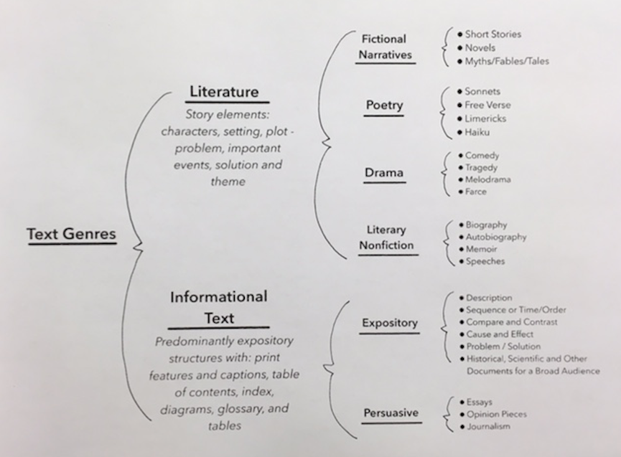
Pictorial: I, Claudia

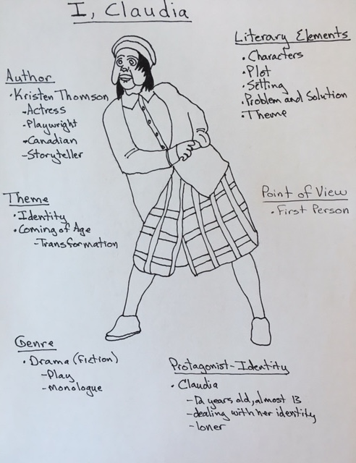
ELD review, Pictorial: I, Claudia
Thinking and Language Grid | Beginning Level (Point to)  Listening/Speaking | Beginning & Intermediate Levels (Yes/No, Either/Or)  Listening/Speaking | Intermediate Level (Open Ended Questions)  Listening/Speaking | Advanced Level (Open Ended Questions)  Listening/Speaking
KNOWLEDGE  Arrange, order, define,  duplicate, label, list, name,  recognize, relate, recall, repeat,  Reproduce  COMPREHENSION  Classify, describe, discuss,  explain, express, identify,  indicate, locate, recognize,  report, restate, review, select,  translate | • Point to the protagonist.  • Is this the character or the setting? (show pictures) | •Is the setting a literary element?  •Is this a true story? | •What are the literary elements?  •What do we know about the author? | • What is the definition of a theme?  • Explain what “identity” means.
APPLICATION  Apply, choose, demonstrate,  dramatize, employ, illustrate,  interpret, operate, practice,  schedule, sketch, solve, use ANALYSIS  Analyze, appraise, calculate,  categorize, compare, contrast, criticize, differentiate,  distinguish, examine, experiment, question, test | • Point to the most important information on the chart.  • Point to the theme you think is most important in the story. | • Does this area or this area describe the protagonist?  • Would this character or this character be closest in age to Claudia? (show pictures) | • What other ways would you describe Claudia? | • Which literary element is most important? Why?  • Explain the difference between plot and theme.
SYNTHESIS  Arrange, assemble, collect,  compose, construct, create,  design, develop, formulate,  manage, organize, plan,  prepare, propose, set up  EVALUATION  Appraise, argue, assess, attach,  choose, compare, defend,  estimate, judge, predict, rate,  select, support, value | • Do you think Claudia is happy or sad?  • Do you like the story? | • Would it be hard for you to play Claudia’s part in the play? | • If you could pick two characters to be in the play, which ones would you pick and why?  • Do you think a drama or play is the best way to tell Claudia’s story? Why or why not? | • Would you have included Claudia’s mom or dad as characters in the play? Why?  • Why do you think this play won so many awards?

Notes on Input Charts
Exemplar pictorial – I, Claudia by Kristen Thomson
Author
Kristen Thomson is an actress and playwright. Thomson was born in Toronto, Ontario. She is known for her one-woman play I, Claudia, which was adapted to film in 2004. In that play and film, Thomson plays all of the roles, using masks to change character. In 2003, Thomson won an ACTRA Award for her performance in I Shout Love (2001), a short film directed by Sarah Polley. She has also won three Dora Awards for her stage work.

Literary Elements/Text structure

Theme
Identity
Coming of age - transformation

Genre
Fiction - realistic
A narrative is a sequence of connected events, whether real or fictional. The definition of narrative is the same as that of a story. There are many types of narratives, such as non-fiction (journalism, memoir, biography, etc.), prose, drama, and some forms of poetry, songs, and video games. Examples of narrative can be found everywhere in human expression and creativity, from everyday speech to performance of all types, including television, movies, radio, and even in more static arts such as sculpture, painting, and photography. Even scientific reports may contain elements of narrative, as they describe the initial hypotheses and how those theses were challenged and changed over the course of the study. Thus, narrative is truly a vital aspect of the experience of being human, and has been since the beginning of communication.

Protagonist: Identity
Claudia is "an official pre-teen" still reeling from her parents' divorce. Her father is getting re-married, she has a science fair project coming due, and she is in the physical and emotional throes of puberty. Finding refuge in the basement of her school, Claudia discovers the pain at the center of her brimming child 's heart. Some important adults in Claudia 's life -her grandfather, her father 's new girlfriend and the school custodian -shed light on her situation.

Point of View
I, Claudia is written in first person point of view.
Narrative Input Chart

Diary of a Wimpy Kid
By Jeff Kinney
Kinney, Jeff. Diary of a Wimpy Kid. New York: Abrams, 2007. Web.

Narrative will be over the section: September to introduce the book. Then book would become a choice in literacy circles.

1)
(Back of narrative card #1) Text example (back of illustration)

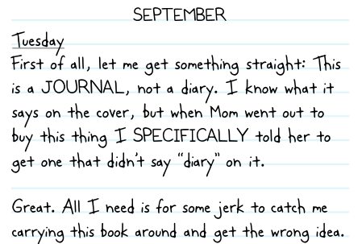
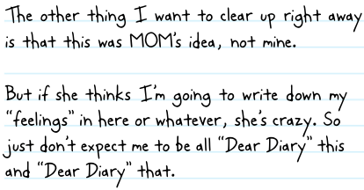

(Front of narrative card #1) Illustration example
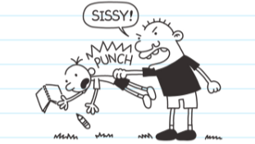

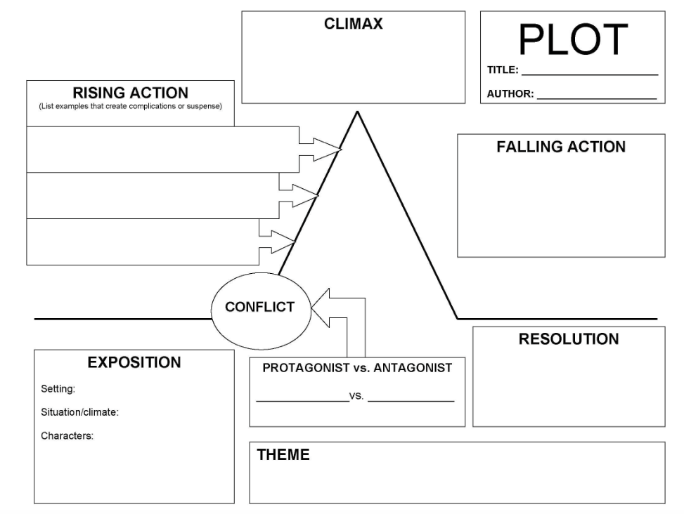
ELD review, Dairy of a Wimpy Kid narrative

Thinking and Language Grid | Beginning Level (Point to)  Listening/Speaking | Beginning & Intermediate Levels (Yes/No, Either/Or)  Listening/Speaking | Intermediate Level (Open Ended Questions)  Listening/Speaking | Advanced Level (Open Ended Questions)  Listening/Speaking
KNOWLEDGE  Arrange, order, define,  duplicate, label, list, name,  recognize, relate, recall, repeat,  Reproduce  COMPREHENSION  Classify, describe, discuss,  explain, express, identify,  indicate, locate, recognize,  report, restate, review, select,  translate | • Point to the protagonist.  • Is this the character or the setting? (show pictures) | •Is the setting a literary element?  •Is this a true story? | •What are the literary elements?  •What do we know about the author? | • What is the definition of a theme?  • Explain what “identity” means.
APPLICATION  Apply, choose, demonstrate,  dramatize, employ, illustrate,  interpret, operate, practice,  schedule, sketch, solve, use ANALYSIS  Analyze, appraise, calculate,  categorize, compare, contrast, criticize, differentiate,  distinguish, examine, experiment, question, test | • Point to the most important part of the story.  • Would you rather be Greg or Rowley? | • Does this area or this area describe the protagonist?  • Would this character or this character be similar to Greg? (show pictures) | • How would you define wimpy? | • How is your relationship with your parents or your siblings similar or different?  •What do you think the author is trying to tell you about Greg Heffley?
SYNTHESIS  Arrange, assemble, collect,  compose, construct, create,  design, develop, formulate,  manage, organize, plan,  prepare, propose, set up  EVALUATION  Appraise, argue, assess, attach,  choose, compare, defend,  estimate, judge, predict, rate,  select, support, value | • Do you think Greg is happy or sad?  • Do you like the story? | • Do you agree or disagree with Greg’s opinions about what makes someone popular? | • What characteristics and behaviors do you associate with Greg? What characteristics and behaviors do you want people to associate with you? Why?  • Do you think a cartoon novel or a regular novel is the best way to tell Greg’s story? Why or why not? | • Would you have included Claudia’s mom or dad as characters in the play? Why?  • Diary of a Wimpy Kid is subtitled “a novel in cartoons.” How do the cartoons affect the story? Besides the cartoons, in what ways do you think the book is different from other novels you have read?

Literary Text
POETRY BOOKLET

Name : _______________________________

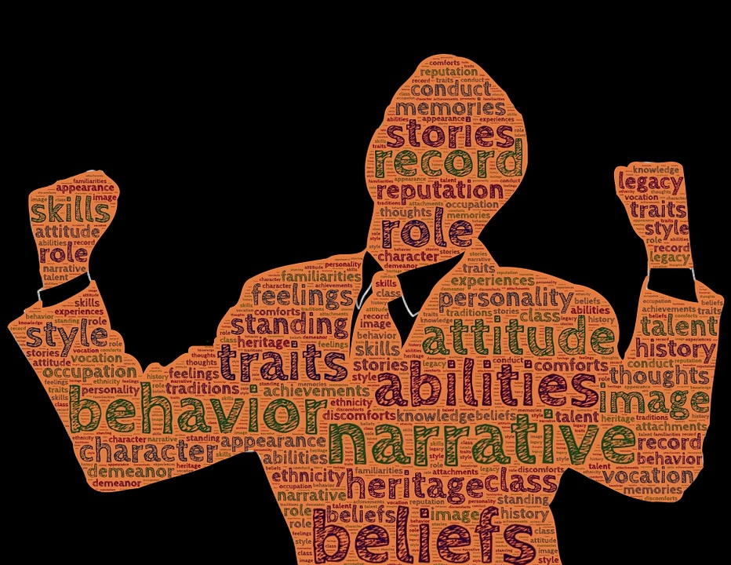

Literary Texts Here, There
By Erin Mayer

Literary texts here, literary texts there.
Literary texts everywhere.

Spooky literary texts whispering scarily,
Mysterious literary texts speaking quietly,
Dramatic literary texts acting foolishly,
And true literary texts recording inspiringly.

Plays at the theater,
Books in our hands,
Short stories without censor,
And biographies throughout time.

Literary texts here, literary texts there.
Literary texts everywhere.

Fiction! Biographies! Dramas!

LITERARY SOUND OFF!
By Sally Fox, SDCOE
6-16-07

We all know ‘cause we’ve been told
Literature is good as gold!
Reading novels is a blast,
Gives us insight into the past.

SOUND OFF! Metaphor!
SOUND OFF! Dialogue!
1, 2, 3, 4... Literature!

Authors write with a purpose in mind.
Some improve the lives of humankind.
They’re social reformers if they try to change
Problems in society that to them seem strange.

SOUND OFF! Metaphor!
SOUND OFF! Dialogue!
1, 2, 3, 4... Literature!

Stories comprise character, setting, and plot.
Analyzing story structure mustn’t be forgot!
Literary devices help you visualize
And paint a vivid picture in your mind’s eye.

SOUND OFF! Metaphor!
SOUND OFF! Dialogue!
1, 2, 3, 4... Literature!

Identity
Anonymouswasawoman

I am not the amount of likes my selfies get.
I am not the amount of heads that turn when I walk into a room.
I am not the amount of makeup I wear.
I am not the weight I gain or lose.
I am not the brands I have.
I am none of that.

But I'll tell you what I am...
I'm a thinker.
I'm a writer.
I'm a fighter.
I'm my faith.
I'm my laughter.
I'm a sister.
I'm a friend.
I'm shy.
I'm smart.

And I'm still learning that what matters is what's inside my heart.

Is this a Literary Element?
By Erin Mayer

Is this a plot? Yes, of Course!
Is this a plot? Yes, of Course!
How do you know? Tells the story
How do you know? Gives a story structure.
Give me some examples: Someone finds a problem
Give me some examples: Lesson to be learned.

Is this a character? Yes, of Course!
Is this a character? Yes, of Course!
How do you know? A person in your story,
How do you know? Creature doing the action.
Give me some examples: Claudia getting mad.
Give me some examples: Lonnie writing poems.

Is this a setting? Yes, of Course!
Is this a setting? Yes, of Course!
How do you know? Tells the time.
How do you know? Tells where it takes place.
Give me some examples: In the halls of our school.
Give me some examples: In 2022.

Is this a theme? Yes, of Course!
Is this a theme? Yes, of Course!
How do you know? Message about life,
How do you know? Tells about human nature.
Give me some examples: Search for self.
Give me some examples: Coming of age.

And are we through? Yes, of Course!
Did you tell me true? Yes, of Course!
What did you chant? Literary Elements!
What did you chant? Literary Elements!

The Road Not Taken
BY ROBERT FROST

Two roads diverged in a yellow wood,
And sorry I could not travel both
And be one traveler, long I stood
And looked down one as far as I could
To where it bent in the undergrowth;

Then took the other, as just as fair,
And having perhaps the better claim,
Because it was grassy and wanted wear;
Though as for that the passing there
Had worn them really about the same,

And both that morning equally lay
In leaves no step had trodden black.
Oh, I kept the first for another day!
Yet knowing how way leads on to way,
I doubted if I should ever come back.

I shall be telling this with a sigh
Somewhere ages and ages hence:
Two roads diverged in a wood, and I—
I took the one less traveled by,
And that has made all the difference.

Student's Name: __________________ Date: _____________________ Period: ____
Conexión entre el hogar y la escuela
Home School Connection

Pregúntale a un adulto o un familiar: ¿Alguna vez ha escrito un cuento o un poema?¿De qué se trata? ¿Qué le gustó de escribirlo? ¿Qué fue difícil? Dibuja y escribe abajo de tus descubrimientos.

Ask an adult or family member: Have you ever written a short story or poem? What was it about? What did you enjoy about writing it? What was challenging? Sketch and write below about your discoveries.

Firma de un adulto Firma del estudiante
Adult Signature ________________ Student Signature ____________________
Student's Name: __________________ Date: _____________________ Period: ____
Conexión entre el hogar y la escuela
Home School Connection

Pregúntale a un adulto o un familiar: ¿Cómo describiría su identidad cuando estaba en la escuela secundaria? ¿Quién le influyó ? ¿Por qué? Escribe y dibuja su respuesta.

Ask an adult or family member: How would you describe your identity when you were in middle school? Who influenced you? Why? Write or sketch below their response.

Firma de un adulto Firma del estudiante
Adult Signature ________________ Student Signature ____________________
Student's Name: __________________ Date: _____________________ Period: ____
Home School Connection
Conexión entre el hogar y la escuela

Ask an adult or family member: What cultural experiences are most important to you? Why? Write or sketch below what they tell you.

Pregúntale a un adulto o un familiar: ¿Qué experiencias culturales son de más importancia para usted? ¿Por qué? Escribe y dibuja abajo lo que te dijo.

Adult Signature ________________ Student Signature ____________________
Firma de un adulto Firma del estudiante
Student's Name: __________________ Date: _____________________ Period: ____
Home School Connection
Conexión entre el hogar y la escuela

Tell a family member or adult about your favorite literary text we have read. What story do they know that is similar? What did they find most interesting? Write or sketch what they tell you.

Cuéntale a un familiar o un adulto sobre tu texto literario favorito que hemos leído. ¿Qué cuento conoce que es parecido? ¿Qué le parece más interesante? Escribe y dibuja lo que te dice.

Adult Signature ________________ Student Signature ____________________
Firma de un adulto Firma del estudiante
Expert Group #1—Toni Morrison: A Biography of a Nobel Prize-Winning Writer by Barbara Kramer
Expert name______________________

Author
Barbara Kramer is an independent researcher who has written extensively about the arts. She lives in Bermuda Dunes, California. Kramer has worked as an editor, proofreader, and teacher in addition to being a professional writer. A graduate of Mercy College, Ms. Kramer enjoys speaking with young people about writing.
Literary Elements/Text structure
Biographies have overlapping qualities of fiction and nonfiction texts. Similar to fiction, biographies are meant to read like a story with a beginning, middle and end. They are about main characters whose life stories show struggle, conflict and resolution. Their lives often exhibit great achievements. As nonfiction, biographies use different text structures such as a description, sequence, comparison, cause and effect, or problem and solution. They often have informational text features (e.g., headings, timelines, photographs and captions). Students will want to capitalize and extend upon their current understanding of character development and nonfiction as they read their biographies.

Theme
Celebration of Toni's achievements
Understanding of her life
Inspiration
Perseverance

Genre
A biography is a detailed description of a person's life. It involves more than just the basic facts like education, work, relationships, and death, but also portrays a subject's experience of these life events. Unlike a profile or curriculum vitae (résumé), a biography presents a subject's life story, highlighting various aspects of his or her life, including intimate details of experience, and may include an analysis of the subject's personality.
Biographical works are usually non-fiction, but fiction can also be used to portray a person's life. One in-depth form of biographical coverage is called legacy writing.

Protagonist: Identity
Toni Morrison (born Chloe Ardelia Wofford; February 18, 1931) is an American novelist, editor, and Professor Emeritus at Princeton University. Her novels are known for their epic themes, vivid dialogue, and richly detailed characters. Among her best-known novels are The Bluest Eye (1970), Sula (1973), Song of Solomon (1977), and Beloved (1987).
Morrison won the Pulitzer Prize and the American Book Award in 1988 for Beloved. Beloved was adapted into a film of the same name (starring Oprah Winfrey and Danny Glover) in 1998. Morrison was awarded the Nobel Prize in Literature in 1993. In 1996, the National Endowment for the Humanities selected her for the Jefferson Lecture, the U.S. federal government's highest honor for achievement in the humanities. She was also honored with the 1996 National Book Foundation's Medal of Distinguished Contribution to American Letters. Morrison was commissioned to write the libretto for a new opera, Margaret Garner, first performed in 2005. On May 29, 2012, Morrison received the Presidential Medal of Freedom.

Point of View
Toni Morrison: A Biography of a Nobel Prize-Winning Writer is written in third person limited point of view.

Expert Group #2—Locomotion by Jacqueline Woodson
Expert name______________________
Author
Jacqueline Woodson's awards include 3 Newbery Honors, a Coretta Scott King Award and 3 Coretta Scott King Honors, 2 National Book Awards, a Margaret A. Edwards Award and an ALAN Award -- both for Lifetime Achievement in YA Literature. She is the author of more than 2 dozen books for children and young adults and lives with her family in Brooklyn, New York. In January 2016 The American Library Association announced that Jacqueline Woodson will deliver the 2017 May Hill Arbuthnot Honor Lecture, which recognizes significant contribution to children's literature. Woodson's youth was split between South Carolina and Brooklyn. In her interview with Jennifer M. Brown she remembered: "The South was so lush and so slow-moving and so much about community. The city was thriving and fast-moving and electric. Brooklyn was so much more diverse: on the block where I grew up, there were German people, people from the Dominican Republic, people from Puerto Rico, African-Americans from the South, Caribbean-Americans, Asians."
When asked to name her literary influences in an interview with journalist Hazel Rochman, Woodson responded: "Two major writers for me are James Baldwin and Virginia Hamilton. It blew me away to find out Virginia Hamilton was a sister like me. Later, Nikki Giovanni had a similar effect on me. I feel that I learned how to write from Baldwin. He was onto some future stuff, writing about race and gender long before people were comfortable with those dialogues. He would cross class lines all over the place, and each of his characters was remarkably believable. I still pull him down from my shelf when I feel stuck." Other early influences included Toni Morrison's The Bluest Eye and Sula, and the work of Rosa Guy as well as her high-school English teacher, Mr. Miller. Louise Meriwether was also named.
Literary Elements/Text structure
A "Literary Element" is a constituent of all works of narrative fiction—a necessary feature of verbal storytelling that can be found in any written or spoken narrative. Examples of literary elements are plot, setting, mood, structure, language, point of view, conflict theme, character and tone.
Theme
Identity
Voice

Genre
Verse novel
The use of the literary term “verse” in a piece of writing has a pleasing effect on the reader’s mind. It is usually employed in poetry writing. The poets make use of the tool of verse in order to provide their poetry with a structure. It serves as an avenue through which writers project their ideas in the form of a composition having rhyme, rhythm and deeper meanings. The device provides the writer with a framework for poetry writing. Writing a verse novel involves a specific process that differs from writing a stand-alone poem or a prose narrative. Not only does the writer need to think about individual poems, he or she also needs to consider the overarching narrative structure. At the same time, these verse novelists have suggested that writing a verse novel shares much with the writing of poetry. In both processes, the writer is thinking about things like language, density, and character. This may indicate a fundamental likeness between the verse novel and the poem, despite the fact that the verse novel involves a more complex narrative structure.

Protagonist: Identity
Lonnie Collins Motion
When Lonnie was seven years old, his parents died in a fire. Now he's eleven, and he still misses them terribly. And he misses his little sister, Lili, who was put into a different foster home because "not a lot of people want boys-not foster boys that ain't babies." But Lonnie hasn't given up. His foster mother, Miss Edna, is growing on him. She's already raised two sons and she seems to know what makes them tick. And his teacher, Ms. Marcus, is showing him ways to put his jumbled feelings on paper. Lonnie's tells his story through poetry, we see his heartbreak over his lost family, his thoughtful perspective on the world around him, and most of all his love for Lili and his determination to one day put at least half of their family back together.

Point of View
Locomotion is written in first person point of view.

Expert Group #3—The House on Mango Street by Sandra Cisneros
Expert name______________________

Author
SANDRA CISNEROS is the author of two widely acclaimed novels, a story collection, two books of poetry, and, most recently, Have You Seen Marie? She is the recipient of numerous awards, including National Endowment for the Arts Fellowships, the Lannan Literary Award, the American Book Award, the Thomas Wolfe Prize, and a MacArthur Fellowship. Her work has been translated into more than twenty languages. Cisneros is the founder of the Alfredo Cisneros del Moral and Macondo Foundations, which serve creative writers. She lives in Mexico.
Cisneros's early life provided many experiences she would later draw on as a writer: she grew up as the only daughter in a family of six brothers, which often made her feel isolated, and the constant migration of her family between Mexico and the United States instilled in her the sense of "always straddling two countries ... but not belonging to either culture." Cisneros's work deals with the formation of Chicana identity, exploring the challenges of being caught between Mexican and Anglo-American cultures, facing the misogynist attitudes present in both these cultures, and experiencing poverty. For her insightful social critique and powerful prose style, Cisneros has achieved recognition far beyond Chicano and Latino communities, to the extent that The House on Mango Street has been translated worldwide and is taught in American classrooms as a coming-of-age novel.
Cisneros has held a variety of professional positions, working as a teacher, a counselor, a college recruiter, a poet-in-the-schools, and an arts administrator, and has maintained a strong commitment to community and literary causes. In 1998 she established the Macondo Writers Workshop, which provides socially conscious workshops for writers, and in 2000 she founded the Alfredo Cisneros Del Moral Foundation, which awards talented writers connected to Texas. Cisneros currently resides in San Antonio, Texas.
Literary Elements/Text structure
A "Literary Element" is a constituent of all works of narrative fiction—a necessary feature of verbal storytelling that can be found in any written or spoken narrative. Examples of literary elements are plot, setting, mood, structure, language, point of view, conflict theme, character and tone.
Theme
Coming of age
Language
Identity

Genre
Fiction - realistic
A narrative is a sequence of connected events, whether real or fictional. The definition of narrative is the same as that of a story. There are many types of narratives, such as non-fiction (journalism, memoir, biography, etc.), prose, drama, and some forms of poetry, songs, and video games. Examples of narrative can be found everywhere in human expression and creativity, from everyday speech to performance of all types, including television, movies, radio, and even in more static arts such as sculpture, painting, and photography. Even scientific reports may contain elements of narrative, as they describe the initial hypotheses and how those theses were challenged and changed over the course of the study. Thus, narrative is truly a vital aspect of the experience of being human, and has been since the beginning of communication.

Protagonist: Identity
Esparanza
The novel’s heroine and narrator, an approximately twelve-year-old Chicana (Mexican-American girl). Esperanza is a budding writer who wishes for a home of her own. The House on Mango Street chronicles a year in her life as she matures. The name Esperanza means “hope” in Spanish.

Point of View
The House on Mango Street is written in first person point of view.
Expert Group #4—A Wish for Her by Emily K., Sudbury, MA. Teenink Magazine
Expert name______________________
Author
Emily K., Sudbury, MA
Emily K. is a teen author of this short story that was published in Teen Ink Magazine. Teen Ink is a monthly magazine devoted entirely to teenage writing and artwork. We have no assigned stories, staff writers, or artists. Instead, we depend entirely on submissions from teenagers nationwide – and around the world – for our content. Join the millions of teens who read Teen Ink. Published by the nonprofit Young Authors Foundation, the Teen Ink magazine and website have been serving writing teachers and their students for more than two decades, providing a forum where teens can express themselves through poetry, essays, stories, reviews, art, and photographs
Literary Elements/Text structure
A "Literary Element" is a constituent of all works of narrative fiction—a necessary feature of verbal storytelling that can be found in any written or spoken narrative. Examples of literary elements are plot, setting, mood, structure, language, point of view, conflict theme, character and tone.

Theme
Identity
Bullying
Internal Conflict

Genre
Fiction - realistic
A narrative is a sequence of connected events, whether real or fictional. The definition of narrative is the same as that of a story. There are many types of narratives, such as non-fiction (journalism, memoir, biography, etc.), prose, drama, and some forms of poetry, songs, and video games. Examples of narrative can be found everywhere in human expression and creativity, from everyday speech to performance of all types, including television, movies, radio, and even in more static arts such as sculpture, painting, and photography. Even scientific reports may contain elements of narrative, as they describe the initial hypotheses and how those theses were challenged and changed over the course of the study. Thus, narrative is truly a vital aspect of the experience of being human, and has been since the beginning of communication.

Protagonist: Identity
Unnamed Narrator
Middle school girl faces her cruelties on another and realizes her mistake.

Point of View
A Wish for Her is written in first person point of view.

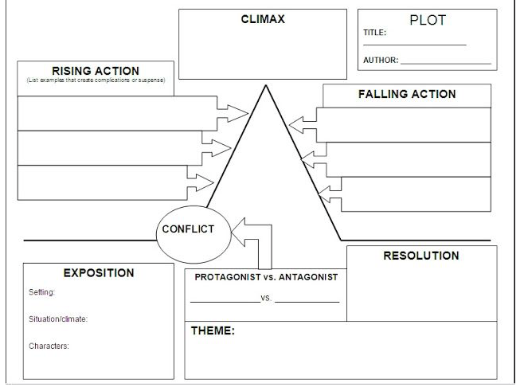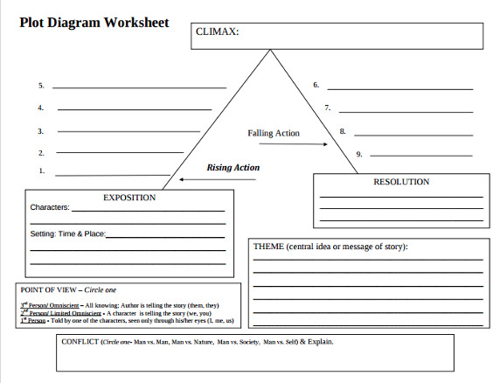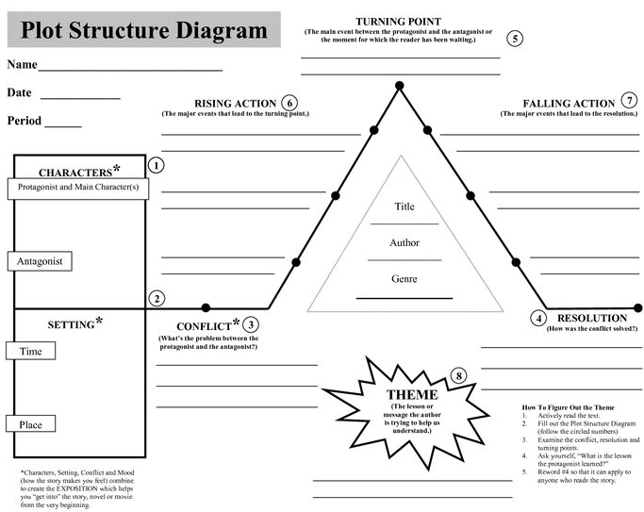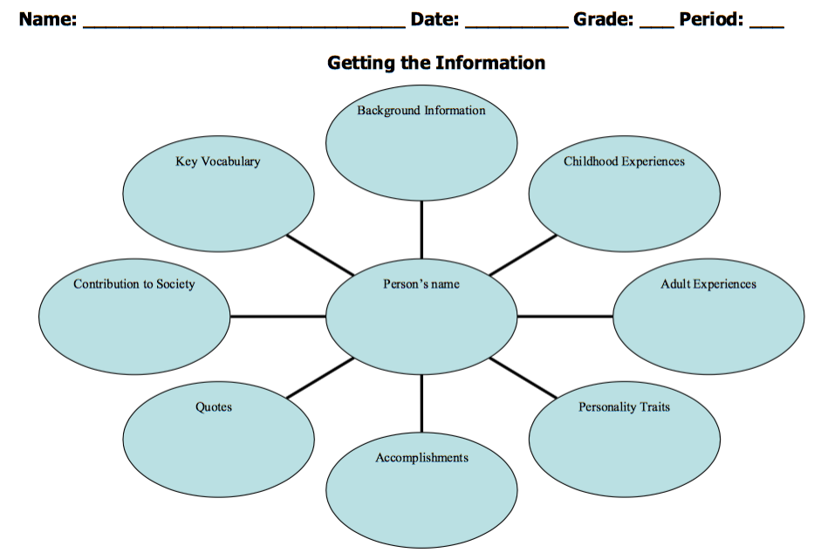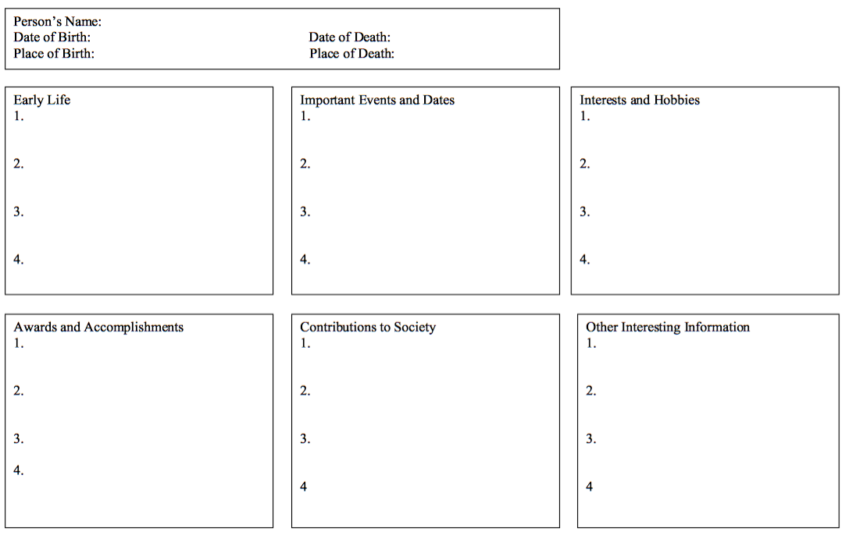

Process Grid
Process Grid
Literary Text | Author |  | Literary Elements/Text structure |  | Theme |  |  | Genre | Protagonist Identity |  | POV
I, Claudia (Drama) | Kristen Thomson | *actress *playwright *Canadian *storyteller | *Characters *Setting *Plot *Problem and solution * Theme |  | *Identity *Coming of age -transformation |  |  | *Drama - Fiction | *Claudia |  | *1st person
Locomotion (Narrative Poetry) | Jacqueline Woodson | *author of children and youth books *American | *Characters *Setting *Plot *Problem and solution * Theme |  | *Identity *Voice *Search for self |  |  | *Verse Novel - Fiction Narrative Poetry | *Lonnie |  | *1st person
The House on Mango Street (Fiction-short stories) | Sandra Cisneros | *Author *American born *Latina (Mexico) *teacher *counselor *migration family *supporter of Latino literature | *Characters *Setting *Plot *Problem and solution * Theme |  | *Coming of age *Language *Identity |  |  | *Fiction | *Esperanza |  | *1st person
Home (Fiction, short story, teen writer) | Samantha A. | *teen author *Vancouver, WA *teenink | *Characters *Setting *Plot *Problem and solution * Theme |  | *Identity *death *parental separation |  |  | *Fiction - Realistic | *Narrator |  | *1st person
A Wish for Her (Fiction, short story, teen writer) | Emily K. | *teen author *Sudbury, MA *teenink | *Characters *Setting *Plot *Problem and solution * Theme |  | *Identity *bullying *internal conflict |  |  | *Fiction - Realistic | *Narrator |  | *1st person
Toni Morrison: A Biography of a Nobel Prize-Winning Writer (Biography Non-fiction) | Barbara Kramer | *author *educator * editor *proofreader *researcher |  | *Expository *date and place of birth  *information about family and childhood  *achievements  major events in her life  *why she is important |  | *Celebration of Toni's achievements and her life *inspiration *perseverance | *non-fiction biography |  |  | *Toni Morrison *author *educator (college) * editor *supporter of black literature |  | *3rd person limited
My Lucy Friend Who Smells Like Corn (Fiction-short story) | Sandra Cisneros | *Author *American born *Latina (Mexico) *teacher *counselor *migration family *supporter of Latino literature |  | *Characters *Setting *Plot *Problem and solution * Theme |  | *Identity *Friendship *Belonging | *Fiction |  |  | *Narrator |  | *1st person

Action Plan

- Thinking of all the literary texts we have read, what really determines someone’s identity? With the class, create an inquiry chart on what influences identity. What do we control about our own identities and what don’t we control? The inquiry chart should look like this.

Our Identity
What we control about our own identities? | What we don’t control about our own identities?

2) Choose one of the items from the control list and conduct research with the class/partner/or individually to learn more about identity issues. The research can include bringing in a guest speaker, taking a field trip, watching videos and TV, and/or bringing in articles from the newspaper or online.

3) Using the template on the next page, guide the class to choose an area about identity and select one action to help address it.

Our Action Plan

Background Knowledge

Problems &
Why we should be concerned
Ways we might contribute to a solution | 1.  2.  3.
Evaluating #1 | Pros | Cons
Evaluating #2 | Pros | Cons
Evaluating #3 | Pros | Cons
Our choice of plan

Resources for identity

Activity resource for Self Discovery
http://lifeskiller.com/self-discovery-activities/

http://www.stageoflife.com/education/NotestotheTeacher/10TeachingTipsforCreatingGreatWriting.aspx

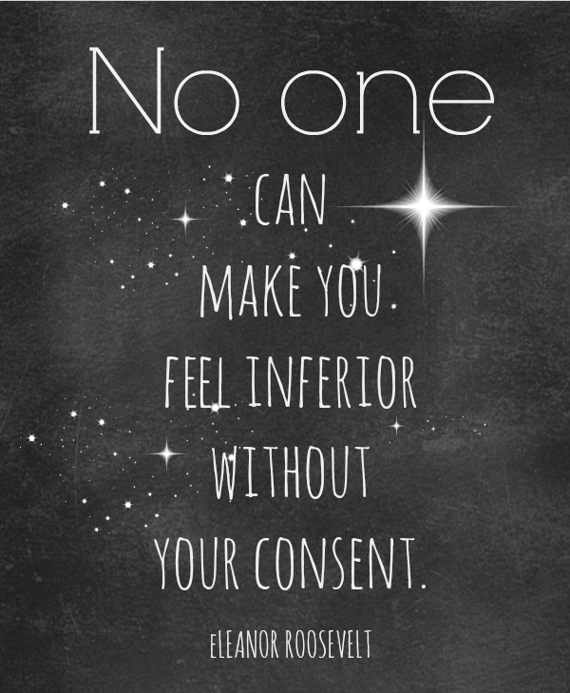

Student (teens) essays about identity

Posted: Saturday, September 27, 2014 2:49:04 AM
Identity: Kaleidoscope

To my peers, I am a soft-spoken, smart girl who always hands in her homework on time. When given a greeting in the halls, I give them a timid and sometimes uncertain smile in return. My eyes dart around anxiously and my feet drum a quick staccato as I walk briskly across the tiled floor, fearful of being late for my next class.

To my friends, I am a listener. I am not the life of the party, nor am I the one who can make everyone burst into waves of laughter from just one joke or facial expression. Instead, I’m their confidant -- the person they come to for comfort. I meet their tears with sympathetic eyes and gentle hand gestures, followed up by the best advice I can offer them. Sometimes, when I’ve had too much sugar and too little sleep, my friends see a more extroverted side of me. My quiet giggle crescendos into a hiccuping laugh, and I tend to dance, instead of walk, out of excitement and giddiness.

To my family, I function as both the lazy teenager and the sarcastic sister. Despite being an early bird on the weekdays, I tend to be the last one awake on weekend mornings. Every day I’m different. Sometimes, I’m the bossy sibling who tends to get stressed when no one will listen or comply to my wishes. Other times, I am the mischievous prankster who can’t seem to barricade the witty comments and teasing gestures that surface throughout the day. I am the hugger of the family, often ambushing anyone and everyone with my unavoidable, tight squeezes.

Identity is often associated with how people see us. Every person sees me differently, depending on the people I'm with and the environment I’m in. The side of me they see, however, is just one of many. When someone sees only one of these sides, they are only seeing a faint silhouette of who I really am. In order to see my true identity, they must take a step back and view all of these sides together. My identity is a mixture -- a kaleidoscope -- of all of these single identities.

To me, I am all of these things. Despite all of these traits and attributes being so different, somehow they manage to blend together and create something fascinating and unique, just like the different components of a kaleidoscope shift into a abstract, colorful array. My identity may seem to shift and change, but each change is just a new way of showing a small piece of who I really am.

Eleanor Roosevelt Quotation: Differences Do Not Define Me
Posted: Tuesday, February 24, 2015 10:56:17 PM
People all around Georgia say I’m strong. My parents, my friends, my peers, my teachers, and basically anyone who has a connection with me. But, the thing is, I don’t believe them. I believe that everyone faces their own challenges. Whether it’s work, school, relationship problems, religion, the death of a family member, or a physical disability, every living soul on this Earth has one thing that they must work for. I work to overcome Cerebral Palsy, which affects my legs, but also smaller motor muscles such as my fingers and tongue. I use canes, a walker, and a wheelchair at school. I used to despise it and go looking for cures. I thought I was different, an alien in a world of able bodied kids.
As a child, my twin sister, Katelyn was a figure skater. The whole family would cram into our Honda Odyssey minivan to drive a grueling forty-five minutes to the Cooler, the closest rink in our small city of Cumming. Don’t get me wrong, I loved watching my sister. She was so graceful, and the ice was her second home. But sometimes, her ability to jump, to spin, and to glide angered me. I wanted to be like Katelyn—to have working legs, to be graceful, to win competitions.
Then one day, something changed. My doctors told me that I would have to have a surgery. One that would leave me helpless. I supposedly couldn’t even sit up when it was over. Yet still, my family and I made the executive decision to undergo the biggest challenge I would ever face during December of my sixth grade year. I remember those few seconds before the anesthesiologists put me under. I was in the operating room; my mother was staring at my teary eyes, not uttering a word. I attempted to focus on the beeping of the heart monitor as my face began to droop into unconsciousness. Just as I caught my last glimpse of this messed up world, I remembered my sister and her figure skates. I loved them both so much.
Four years later, here I am. A freshman at North Forsyth High School. Defying every expectation the doctors set for me, but most importantly, not allowing anyone or anything to get in the way of my goals, to tell me what I can and cannot do. At some point in their lives, everyone has felt inferior. It’s not a question, but whether they can overcome their feelings depends on the person. Whether they can put aside their challenges and live a meaningful life—that’s strength.
When everyone tells me I’m strong, that I’m a role model, it’s not because I overcame the wheelchair; it’s because I realized that my differences don’t define me. That I can do anything I want, no matter what others say. That no one can make me feel inferior without my consent.

Writing prompt – personal narrative essay

Standards
8.16 Writing. Students write about their own experiences.
8.16A write a personal narrative that has a clearly defined focus and communicates the importance of or reasons for actions and/or consequences.
STUDENTS WILL KNOW: A personal narrative is an account of a person's memories related to a particular event. It takes a narrative form, may contain dialog and other elements of literature, and may even involve a certain amount of artistic license to make it more interesting and compelling.
Writers provide a clear focus, reasons for actions, importance of actions, and consequences of actions in a personal narrative.
STUDENTS WILL BE ABLE TO: Write an effective and engaging personal narrative that includes a defined focus, and communicates the reasons, importance and consequences of actions
Choose an event in the last three years that challenged your identity. Write an essay that describes the following:
- A description of the event
- How it challenged your identity
- How you felt about it
- How it changed you

See the next page for a rubric to assess the writing assignment. Share this rubric with students when they receive the assignment.

Six Traits Writing Rubric
 | 6  Exemplary | 5  Strong | 4  Proficient | 3  Developing | 2  Emerging | 1  Beginning
Ideas & Content  main theme  supporting details | • Exceptionally clear, focused, engaging with relevant, strong supporting detail | • Clear, focused, interesting ideas with appropriate detail | • Evident main idea with some support which may be general or limited | • Main idea may be cloudy because supporting detail is too general or even off-topic | • Purpose and main idea may be unclear and cluttered by irrelevant detail | • Lacks central idea; development is minimal or non-existent
Organization  structure  introduction  conclusion | • Effectively organized in logical and creative manner  • Creative and engaging intro and conclusion | • Strong order and structure  • Inviting intro and satisfying closure | • Organization is appropriate, but conventional  • Attempt at introduction and conclusion | • Attempts at organization; may be a “list” of events  • Beginning and ending not developed | • Lack of structure; disorganized and hard to follow  • Missing or weak intro and conclusion | • Lack of coherence; confusing  • No identifiable introduction or conclusion
Voice  personality  sense of audience | • Expressive, engaging, sincere  • Strong sense of audience  • Shows emotion: humour, honesty, suspense or life | • Appropriate to audience and purpose  • Writer behind the words comes through | • Evident commitment to topic  • Inconsistent or dull personality | • Voice may be inappropriate or non-existent  • Writing may seem mechanical | • Writing tends to be flat or stiff  • Little or no hint of writer behind words | • Writing is lifeless  • No hint of the writer
Word Choice  precision  effectiveness  imagery | • Precise, carefully chosen  • Strong, fresh, vivid images | • Descriptive, broad range of words  • Word choice energizes writing | • Language is functional and appropriate  • Descriptions may be overdone at times | • Words may be correct but mundane  • No attempt at deliberate choice | • Monotonous, often repetitious, sometimes inappropriate | • Limited range of words  • Some vocabulary misused
Sentence Fluency  rhythm, flow  variety | • High degree of craftsmanship  • Effective variation in sentence patterns | • Easy flow and rhythm  • Good variety in length and structure | • Generally in control  • Lack variety in length and structure | • Some awkward constructions  • Many similar patterns and beginnings | • Often choppy  • Monotonous sentence patterns  • Frequent run-on sentences | • Difficult to follow or read aloud  • Disjointed, confusing, rambling
Conventions  age appropriate, spelling, caps, punctuation, grammar | • Exceptionally strong control of standard conventions of writing | • Strong control of conventions; errors are few and minor | • Control of most writing conventions; occasional errors with high risks | • Limited control of conventions; frequent errors do not interfere with understanding | • Frequent significant errors may impede readability | • Numerous errors distract the reader and make the text difficult to read

Graffiti Wall starters

- Match the word to the definition.
plot | the vantage point from which the story is told
climax | the main events of a play, novel, movie, or similar work, devised and presented by the writer as an interrelated sequence
point of view | the turning point in the story

- Fill in the blanks. _______________________and_______________________are literary elements.

- True of False.
The setting is one of the 5 stages of plot development.

- Fill in the blank. The rising action follows the __________.

- Choose the correct answer.

The mood of a story is responsible for
- prompting a reaction in the reader to feel the story
- describing an idea as if it has human qualities
- comparing two un-like things
- identifying who is telling the story

Literary Elements Unit Test

NAME: _________________________

ELEMENTS OF LITERATURE REVIEW

1. The type of conflict in which a character struggles with himself and has
trouble deciding what to do is called _____________________________.

2. _______________________________ is figurative language in which a
nonhuman subject is given human characteristics.

3. _________________________ is the subject or message being written
about or discussed; it is the principal idea behind the story. It deals with the lessons or t ruths that the character and / or reader learns about life.

4. The _____________________________ is the time and place of a story.

5. __________________________ is the “problem” in a story which triggers
the action.

6. The _______________________ is the highest point (turning point) in the
action of the story.

7. ___________________________________ is the use of clues or hints to
suggest events that will occur later in the story.

8. The part of the story (usually the beginning) which explains the background
and the setting of the story is called the _________________________.

9. __________________________________ is the type of conflict where
one character in a story has a problem with one or more of the other
characters.

10. The angle from which a story is told is called the ____________________.

11. The __________________________ is the action of the story.

12. The use of a word whose sound imitates or suggests its meaning is called
____________________________. (Examples: Boom, ding, hush)

13. The _____________________ is the overall emotion created by a work of
literature. It can be described using adjectives like dreamy, depressing, or
mysterious.

14. A __________________________ is a person in the story.

15. A _________________________________ point of view means that one
of the characters is telling the story. He or she is involved in the action and
refers to himself or herself as “I.”

16. The person or thing fighting against the hero of the story is called the
_________________________________.

17. The action of the plot is usually made up of a series of events called the
_______________________________________.

18. A ___________________________ is a figure of speech in which some-
thing is described as though it were something else.

19. The type of conflict in which a character has a problem or conflict with the
school, the law, or tradition is called _____________________________.

20. A ________________________________ point of view means that some-
one outside the story is telling it. This someone is not a character in the
story.

21. The _____________________________ is the part of the story which
follows the climax. It contains the action or dialogue necessary to lead the
story to a resolution or ending.

22. _______________ is the attitude a writer takes toward an audience,
subject, or a character. It is conveyed through the writer’s choice of
words. It can be light and humorous, serious and sad, friendly or hostile
toward a character, and so on.

23. The ______________________________ is the person or character
telling the story.

24. A figure of speech that puts two words or phrases together that literally
have opposite meanings is a __________________________________.

25. The _____________________________ is the satisfying end of a play or
story. It is the part of the story in which the problems are solved.

26. ____________________________________ is the type of conflict in
which a character has a problem with some natural happening.

27. The _________________________________ is the hero of the story.

28. A ____________________________ is a figure of speech that makes a
comparison between two unlike subjects using like, as, or resembles.

29. ____________________________ refers to the talking that goes on
between characters in a story.

30. An ________________________ is a phrase or expression which means
something different from what the words actually say.

31-35. Label the parts of the plot line correctly.

