FORCES AND MOTION
GRADE 8

IDEA PAGES

UNIT THEME
Essential Question: How can one describe physical interactions between objects and within systems of objects?

- Force and motion are fundamental to all matter in the Universe
- A force is required to do work and generating a force requires energy
- Forces are an integral part of our daily lives
- Forces explain the motion of objects
- Some materials attract and others repel
- Anyone can be a physicist, no matter your race, gender, sexual orientation, socio-economic background, religion, disability etc.

FOCUS/MOTIVATION
- Observation charts
- Cognitive content dictionary
- Inquiry chart
- Science Demonstrations
- Big Book
- Video clips

ASSESSMENT/FEEDBACK
- Chapter test
- Engineering Design. Team and Personal exploration with rubric
- Team Big Books
- Action Plan

STANDARDS

NM STATE SCIENCE STANDARDS

Strand I: Scientific Thinking and Practice
Standard I: Understand the processes of scientific investigations and use inquiry and scientific ways of observing, experimenting, predicting, and validating to think critically.

5-8 Benchmark I: Use scientific methods to develop questions, design and conduct experiments using appropriate technologies, analyze and evaluate results, make predictions, and communicate findings.
1. Evaluate the accuracy and reproducibility of data and observations.
2. Use a variety of technologies to gather, analyze and interpret scientific data.
3. Know how to recognize and explain anomalous data.

5-8 Benchmark II: Understand the processes of scientific investigation and how scientific inquiry results in scientific knowledge.
1. Examine alternative explanations for observations.
2. Describe ways in which science differs from other ways of knowing and from other bodies of knowledge (e.g., experimentation, logical arguments, skepticism).
3. Know that scientific knowledge is built on questions posed as testable hypotheses, which are tested until the results are accepted by peers.

5-8 Benchmark III: Use mathematical ideas, tools, and techniques to understand scientific knowledge.
1. Use mathematical expressions and techniques to explain data and observations and to communicate findings (e.g., formulas and equations, significant figures, graphing, sampling, estimation, mean).
2. Create models to describe phenomena.

Structure of Matter
4. Identify the protons, neutrons, and electrons within an atom and describe their locations (i.e., in the nucleus or in motion outside the nucleus).
5. Explain that elements are organized in the periodic table according to their properties.
6. Know that compounds are made of two or more elements, but not all sets of elements can combine to form compounds.

5-8 Benchmark III: Describe and explain forces that produce motion in objects.
Forces
1. Know that there are fundamental forces in nature (e.g., gravity, electromagnetic forces, nuclear forces).
2. Know that a force has both magnitude and direction.
3. Analyze the separate forces acting on an object at rest or in motion (e.g., gravity, elastic forces, friction), including how multiple forces reinforce or cancel one another to result in a net force that acts on an object.
4. Know that electric charge produces electrical fields and magnets produce magnetic fields.
5. Know how a moving magnetic field can produce an electric current (generator) and how an electric current can produce a magnetic field
(electromagnet).
6. Know that Earth has a magnetic field.

Motion
7. Know that an object’s motion is always described relative to some other object or point (i.e., frame of reference).
8. Understand and apply Newton’s Laws of Motion:
• Objects in motion will continue in motion and objects at rest will remain at rest unless acted upon by an unbalanced force (inertia).
• If a greater force is applied to an object a proportionally greater acceleration will occur.
• If an object has more mass the effect of an applied force is proportionally less.

MS-PS2 Motion and Stability: Forces and Interactions
MS-PS2 Motion and Stability: Forces and Interactions
Students who demonstrate understanding can:
MS-PS2-1. Apply Newton’s Third Law to design a solution to a problem involving the motion of two colliding objects.*
[Clarification Statement: Examples of practical problems could include the impact of collisions between two cars, between a car and stationary objects, and between a meteor and a space vehicle.] [Assessment Boundary: Assessment is limited to vertical or horizontal interactions in one dimension.]
MS-PS2-2. Plan an investigation to provide evidence that the change in an object’s motion depends on the sum of the
forces on the object and the mass of the object. [Clarification Statement: Emphasis is on balanced (Newton’s First Law) and unbalanced forces in a system, qualitative comparisons of forces, mass and changes in motion (Newton’s Second Law), frame of reference, and specification of units.] [Assessment Boundary: Assessment is limited to forces and changes in motion in one-dimension in an inertial reference frame and to change in one variable at a time. Assessment does not include the use of trigonometry.]
MS-PS2-3. Ask questions about data to determine the factors that affect the strength of electric and magnetic forces.
[Clarification Statement: Examples of devices that use electric and magnetic forces could include electromagnets, electric motors, or generators. Examples of data could include the effect of the number of turns of wire on the strength of an electromagnet, or the effect of increasing the number or strength of magnets on the speed of an electric motor.] [Assessment Boundary: Assessment about questions that require quantitative answers is limited to proportional reasoning and algebraic thinking.]
MS-PS2-4. Construct and present arguments using evidence to support the claim that gravitational interactions are
attractive and depend on the masses of interacting objects. [Clarification Statement: Examples of evidence for arguments could
include data generated from simulations or digital tools; and charts displaying mass, strength of interaction, distance from the Sun, and orbital periods of objects within the solar system.] [Assessment Boundary: Assessment does not include Newton’s Law of Gravitation or Kepler’s Laws.]
MS-PS2-5. Conduct an investigation and evaluate the experimental design to provide evidence that fields exist between
objects exerting forces on each other even though the objects are not in contact. [Clarification Statement: Examples of this
phenomenon could include the interactions of magnets, electrically-charged strips of tape, and electrically-charged pith balls. Examples of investigations could include first-hand experiences or simulations.] [Assessment Boundary: Assessment is limited to electric and magnetic fields, and limited to qualitative evidence for the existence of fields.]

The performance expectations above were developed using the following elements from the NRC document A Framework for K-12 Science Education:
Science and Engineering Practices |  | Disciplinary Core Ideas |  | Crosscutting Concepts
 | Asking Questions and Defining Problems  Asking questions and defining problems in grades 6–8 builds from grades K–5 experiences and progresses to specifying relationships between variables, and clarifying arguments and models.  - Ask questions that can be investigated within the scope of the classroom, outdoor environment, and museums and other public facilities with available resources and, when appropriate, frame a hypothesis based on observations and scientific principles. (MS-PS2-3)  Planning and Carrying Out Investigations  Planning and carrying out investigations to answer questions or test solutions to problems in 6–8 builds on K–5 experiences and progresses to include investigations that use multiple variables and provide evidence to support explanations or design solutions.  - Plan an investigation individually and collaboratively, and in the design: identify independent and dependent variables and controls, what tools are needed to do the gathering, how measurements will be recorded, and how many data are needed to support a claim. (MS-PS2-2)  - Conduct an investigation and evaluate the experimental design to produce data to serve as the basis for evidence that can meet the goals of the investigation. (MS-PS2-5)  Constructing Explanations and Designing Solutions  Constructing explanations and designing solutions in 6–8 builds on K–5 experiences and progresses to include constructing explanations and designing solutions supported by multiple sources of evidence consistent with scientific ideas, principles, and theories.  - Apply scientific ideas or principles to design an object, tool, process or system. (MS-PS2-1)  Engaging in Argument from Evidence  Engaging in argument from evidence in 6–8 builds from K–5 experiences and progresses to constructing a convincing argument that supports or refutes claims for either explanations or solutions about the natural and designed world.  - Construct and present oral and written arguments supported by empirical evidence and scientific reasoning to support or refute an explanation or a model for a phenomenon or a solution to a problem.  (MS-PS2-4)  ------------------------------------------------------ Connections to Nature of Science  Scientific Knowledge is Based on Empirical Evidence  - Science knowledge is based upon logical and conceptual connections between evidence and explanations. (MS-PS2-2),(MS-PS2-4) |  | PS2.A: Forces and Motion  - For any pair of interacting objects, the force exerted by the first object on the second object is equal in strength to the force that the second object exerts on the first, but in the opposite direction (Newton’s third law). (MS-PS2-1)  - The motion of an object is determined by the sum of the forces acting on it; if the total force on the object is not zero, its motion will change. The greater the mass of the object, the greater the force needed to achieve the same change in motion. For any given object, a larger force causes a larger change in motion. (MS-PS2-2)  - All positions of objects and the directions of forces and motions must be described in an arbitrarily chosen reference frame and arbitrarily chosen units of size. In order to share information with other people, these choices must also be shared. (MSPS2-2)  PS2.B: Types of Interactions  - Electric and magnetic (electromagnetic) forces can be attractive or repulsive, and their sizes depend on the magnitudes of the charges, currents, or magnetic strengths involved and on the distances between the interacting objects. (MS-PS2-3)  - Gravitational forces are always attractive. There is a gravitational force between any two masses, but it is very small except when one or both of the objects have large mass—e.g., Earth and the sun.(MSPS2-4)  - Forces that act at a distance (electric, magnetic, and gravitational) can be explained by fields that extend through space and can be mapped by their effect on a test object (a charged object, a magnet, or a ball, respectively). (MS-PS2-5) |  | Cause and Effect  - Cause and effect relationships may be used to predict phenomena in natural or designed systems. (MS-PS2-3),(MS-PS25)  Systems and System Models  - Models can be used to represent systems and their interactions—such as inputs, processes and outputs—and energy and matter flows within systems. (MS-PS2-1),(MS-PS2-4),  Stability and Change  - Explanations of stability and change in natural or designed systems can be constructed by examining the changes over time and forces at different scales.  (MS-PS2-2)  ----------------------------------------------  Connections to Engineering, Technology, and Applications of Science  Influence of Science, Engineering, and  Technology on Society and the Natural  World  - The uses of technologies and any limitations on their use are driven by individual or societal needs, desires, and values; by the findings of scientific research; and by differences in such factors as climate, natural resources, and economic conditions. (MS-PS2-1)
Connections to other DCIs in this grade-band: MS.PS3.A (MS-PS2-2); MS.PS3.B (MS-PS2-2); MS.PS3.C (MS-PS2-1); MS.ESS1.A (MS-PS2-4); MS.ESS1.B (MS-PS2-4);
MS.ESS2.C (MS-PS2-2),(MS-PS2-4)
Articulation across grade-bands: 3.PS2.A (MS-PS2-1),(MS-PS2-2); 3.PS2.B (MS-PS2-3),(MS-PS2-5); 5.PS2.B (MS-PS2-4); HS.PS2.A (MS-PS2-1),(MS-PS2-2); HS.PS2.B (MS-PS23),(MS-PS2-4),(MS-PS2-5); HS.PS3.A (MS-PS2-5); HS.PS3.B (MS-PS2-2),(MS-PS2-5); HS.PS3.C (MS-PS2-5); HS.ESS1.B (MS-PS2-2),(MS-PS2-4)
Common Core State Standards Connections:
ELA/Literacy –

MS-PS2 Motion and Stability: Forces and Interactions
RST.6-8.1 Cite specific textual evidence to support analysis of science and technical texts, attending to the precise details of explanations or descriptions (MS-PS2-1),(MSPS2-3)
RST.6-8.3 Follow precisely a multistep procedure when carrying out experiments, taking measurements, or performing technical tasks. (MS-PS2-1),(MS-PS2-2),(MS-PS2-
5)
WHST.6-8.1 Write arguments focused on discipline-specific content. (MS-PS2-4)
WHST.6-8.7 Conduct short research projects to answer a question (including a self-generated question), drawing on several sources and generating additional related, focused questions that allow for multiple avenues of exploration. (MS-PS2-1),(MS-PS2-2),(MS-PS2-5)
Mathematics –
MP.2 Reason abstractly and quantitatively. (MS-PS2-1),(MS-PS2-2),(MS-PS2-3)
6.NS.C.5 Understand that positive and negative numbers are used together to describe quantities having opposite directions or values; use positive and negative numbers to represent quantities in real-world contexts, explaining the meaning of 0 in each situation. (MS-PS2-1)
6.EE.A.2 Write, read, and evaluate expressions in which letters stand for numbers. (MS-PS2-1),(MS-PS2-2)
7.EE.B.3 Solve multi-step real-life and mathematical problems posed with positive and negative rational numbers in any form, using tools strategically. Apply properties of operations to calculate with numbers in any form; convert between forms as appropriate; and assess the reasonableness of answers using mental computation and estimation strategies. (MS-PS2-1),(MS-PS2-2)
7.EE.B.4 Use variables to represent quantities in a real-world or mathematical problem, and construct simple equations and inequalities to solve problems by reasoning about the quantities. (MS-PS2-1),(MS-PS2-2)

ENGLISH LANGUAGE ARTS COMMON CORE STANDARDS 8TH GRADE

Key Ideas and Details:
CCSS.ELA-LITERACY.RL.8.1 Cite the textual evidence that most strongly supports an analysis of what the text says explicitly as well as inferences drawn from the text.
CCSS.ELA-LITERACY.RL.8.2 Determine a theme or central idea of a text and analyze its development over the course of the text, including its relationship to the characters, setting, and plot; provide an objective summary of the text.
CCSS.ELA-LITERACY.RL.8.3 Analyze how particular lines of dialogue or incidents in a story or drama propel the action, reveal aspects of a character, or provoke a decision.

Craft and Structure:
CCSS.ELA-LITERACY.RL.8.4 Determine the meaning of words and phrases as they are used in a text, including figurative and connotative meanings; analyze the impact of specific word choices on meaning and tone, including analogies or allusions to other texts.
CCSS.ELA-LITERACY.RL.8.5 Compare and contrast the structure of two or more texts and analyze how the differing structure of each text contributes to its meaning and style.
CCSS.ELA-LITERACY.RL.8.7
Analyze the extent to which a filmed or live production of a story or drama stays faithful to or departs from the text or script, evaluating the choices made by the director or actors.

Range of Reading and Level of Text Complexity:
CCSS.ELA-LITERACY.RL.8.10 By the end of the year, read and comprehend literature, including stories, dramas, and poems, at the high end of grades 6-8 text complexity band independently and proficiently.

Writing Standards

Text Types and Purposes:
CCSS.ELA-LITERACY.W.8.1 Write arguments to support claims with clear reasons and relevant evidence
CCSS.ELA-LITERACY.W.8.1.A Introduce claim(s), acknowledge and distinguish the claim(s) from alternate or opposing claims, and organize the reasons and evidence logically.
CCSS.ELA-LITERACY.W.8.1.B Support claim(s) with logical reasoning and relevant evidence, using accurate, credible sources and demonstrating an understanding of the topic or text.
CCSS.ELA-LITERACY.W.8.1.C Use words, phrases, and clauses to create cohesion and clarify the relationships among claim(s), counterclaims, reasons, and evidence.
CCSS.ELA-LITERACY.W.8.1.D Establish and maintain a formal style.
CCSS.ELA-LITERACY.W.8.1.E Provide a concluding statement or section that follows from and supports the argument presented.
CCSS.ELA-LITERACY.W.8.2 Write informative/explanatory texts to examine a topic and convey ideas, concepts, and information through the selection, organization, and analysis of relevant content.
CCSS.ELA-LITERACY.W.8.2.A Introduce a topic clearly, previewing what is to follow; organize ideas, concepts, and information into broader categories; include formatting (e.g., headings), graphics (e.g., charts, tables), and multimedia when useful to aiding comprehension.
CCSS.ELA-LITERACY.W.8.2.B Develop the topic with relevant, well-chosen facts, definitions, concrete details, quotations, or other information and examples.
CCSS.ELA-LITERACY.W.8.2.C Use appropriate and varied transitions to create cohesion and clarify the relationships among ideas and concepts.
CCSS.ELA-LITERACY.W.8.2.D Use precise language and domain-specific vocabulary to inform about or explain the topic.
CCSS.ELA-LITERACY.W.8.2.E Establish and maintain a formal style.
CCSS.ELA-LITERACY.W.8.2.F Provide a concluding statement or section that follows from and supports the information or explanation presented.

Production and Distribution of Writing:
CCSS.ELA-LITERACY.W.8.4-Produce clear and coherent writing in which the development, organization, and style are appropriate to task, purpose, and audience. (Grade-specific expectations for writing types are defined in standards 1-3 above.)
CCSS.ELA-LITERACY.W.8.5-With some guidance and support from peers and adults, develop and strengthen writing as needed by planning, revising, editing, rewriting, or trying a new approach, focusing on how well purpose and audience have been addressed. (Editing for conventions should demonstrate command of Language standards 1-3 up to and including grade 8 here.)
CCSS.ELA-LITERACY.W.8.6-Use technology, including the Internet, to produce and publish writing and present the relationships between information and ideas efficiently as well as to interact and collaborate with others.

Research to Build and Present Knowledge:
CCSS.ELA-LITERACY.W.8.7
Conduct short research projects to answer a question (including a self-generated question), drawing on several sources and generating additional related, focused questions that allow for multiple avenues of exploration.
CCSS.ELA-LITERACY.W.8.8-Gather relevant information from multiple print and digital sources, using search terms effectively; assess the credibility and accuracy of each source; and quote or paraphrase the data and conclusions of others while avoiding plagiarism and following a standard format for citation.
CCSS.ELA-LITERACY.W.8.9-Draw evidence from literary or informational texts to support analysis, reflection, and research.

Range of Writing:
CCSS.ELA-LITERACY.W.8.10-Write routinely over extended time frames (time for research, reflection, and revision) and shorter time frames (a single sitting or a day or two) for a range of discipline-specific tasks, purposes, and audiences.

Comprehension and Collaboration:
CCSS.ELA-LITERACY.SL.8.1-Engage effectively in a range of collaborative discussions (one-on-one, in groups, and teacher-led) with diverse partners on grade 8 topics, texts, and issues, building on others' ideas and expressing their own clearly.
CCSS.ELA-LITERACY.SL.8.1.A-Come to discussions prepared, having read or researched material under study; explicitly draw on that preparation by referring to evidence on the topic, text, or issue to probe and reflect on ideas under discussion.
CCSS.ELA-LITERACY.SL.8.1.B-Follow rules for collegial discussions and decision-making, track progress toward specific goals and deadlines, and define individual roles as needed.
CCSS.ELA-LITERACY.SL.8.1.C-Pose questions that connect the ideas of several speakers and respond to others' questions and comments with relevant evidence, observations, and ideas.
CCSS.ELA-LITERACY.SL.8.1.D-Acknowledge new information expressed by others, and, when warranted, qualify or justify their own views in light of the evidence presented.
CCSS.ELA-LITERACY.SL.8.2-Analyze the purpose of information presented in diverse media and formats (e.g., visually, quantitatively, orally) and evaluate the motives (e.g., social, commercial, political) behind its presentation.
CCSS.ELA-LITERACY.SL.8.3-Delineate a speaker's argument and specific claims, evaluating the soundness of the reasoning and relevance and sufficiency of the evidence and identifying when irrelevant evidence is introduced.

Presentation of Knowledge and Ideas:
CCSS.ELA-LITERACY.SL.8.4-Present claims and findings, emphasizing salient points in a focused, coherent manner with relevant evidence, sound valid reasoning, and well-chosen details; use appropriate eye contact, adequate volume, and clear pronunciation.
CCSS.ELA-LITERACY.SL.8.5-Integrate multimedia and visual displays into presentations to clarify information, strengthen claims and evidence, and add interest.
CCSS.ELA-LITERACY.SL.8.6 Adapt speech to a variety of contexts and tasks, demonstrating command of formal English when indicated or appropriate.
Conventions of Standard English:
CCSS.ELA-LITERACY.L.8.1Demonstrate command of the conventions of standard English grammar and usage when writing or speaking.
CCSS.ELA-LITERACY.L.8.1.A Explain the function of verbals (gerunds, participles, infinitives) in general and their function in particular sentences.
CCSS.ELA-LITERACY.L.8.1.B Form and use verbs in the active and passive voice.
CCSS.ELA-LITERACY.L.8.1.C Form and use verbs in the indicative, imperative, interrogative, conditional, and subjunctive mood.
CCSS.ELA-LITERACY.L.8.1.D Recognize and correct inappropriate shifts in verb voice and mood.*
CCSS.ELA-LITERACY.L.8.2 Demonstrate command of the conventions of standard English capitalization, punctuation, and spelling when writing.
CCSS.ELA-LITERACY.L.8.2.A Use punctuation (comma, ellipsis, dash) to indicate a pause or break.
CCSS.ELA-LITERACY.L.8.2.B Use an ellipsis to indicate an omission.
CCSS.ELA-LITERACY.L.8.2.C Spell correctly.

Knowledge of Language:
CCSS.ELA-LITERACY.L.8.3Use knowledge of language and its conventions when writing, speaking, reading, or listening.
CCSS.ELA-LITERACY.L.8.3.AUse verbs in the active and passive voice and in the conditional and subjunctive mood to achieve particular effects (e.g., emphasizing the actor or the action; expressing uncertainty or describing a state contrary to fact).

Vocabulary Acquisition and Use:
CCSS.ELA-LITERACY.L.8.4Determine or clarify the meaning of unknown and multiple-meaning words or phrases based on grade 8 reading and content, choosing flexibly from a range of strategies.
CCSS.ELA-LITERACY.L.8.4.A Use context (e.g., the overall meaning of a sentence or paragraph; a word's position or function in a sentence) as a clue to the meaning of a word or phrase.
CCSS.ELA-LITERACY.L.8.4.B Use common, grade-appropriate Greek or Latin affixes and roots as clues to the meaning of a word (e.g., precede, recede, secede).
CCSS.ELA-LITERACY.L.8.4.C Consult general and specialized reference materials (e.g., dictionaries, glossaries, thesauruses), both print and digital, to find the pronunciation of a word or determine or clarify its precise meaning or its part of speech.
CCSS.ELA-LITERACY.L.8.4.D Verify the preliminary determination of the meaning of a word or phrase (e.g., by checking the inferred meaning in context or in a dictionary).
CCSS.ELA-LITERACY.L.8.5 Demonstrate understanding of figurative language, word relationships, and nuances in word meanings.
CCSS.ELA-LITERACY.L.8.5.A Interpret figures of speech (e.g. verbal irony, puns) in context.
CCSS.ELA-LITERACY.L.8.5.B Use the relationship between particular words to better understand each of the words.
CCSS.ELA-LITERACY.L.8.5.C Distinguish among the connotations (associations) of words with similar denotations (definitions) (e.g., bullheaded, willful, firm, persistent, resolute).
CCSS.ELA-LITERACY.L.8.6 Acquire and use accurately grade-appropriate general academic and domain-specific words and phrases; gather vocabulary knowledge when considering a word or phrase important to comprehension or expression.

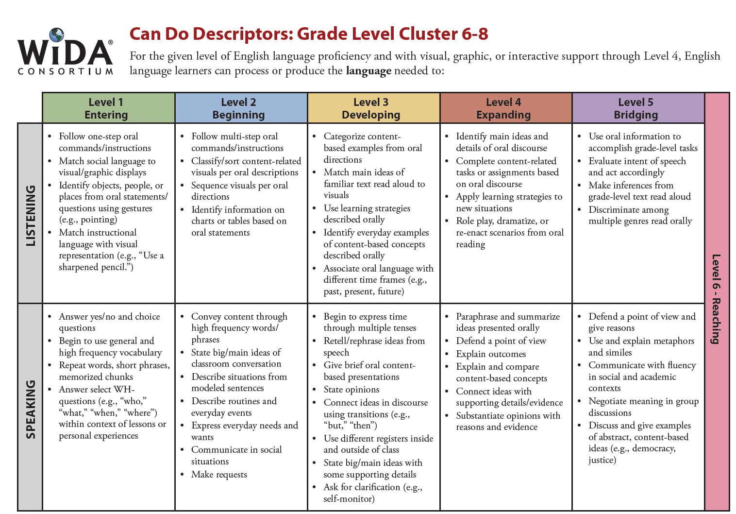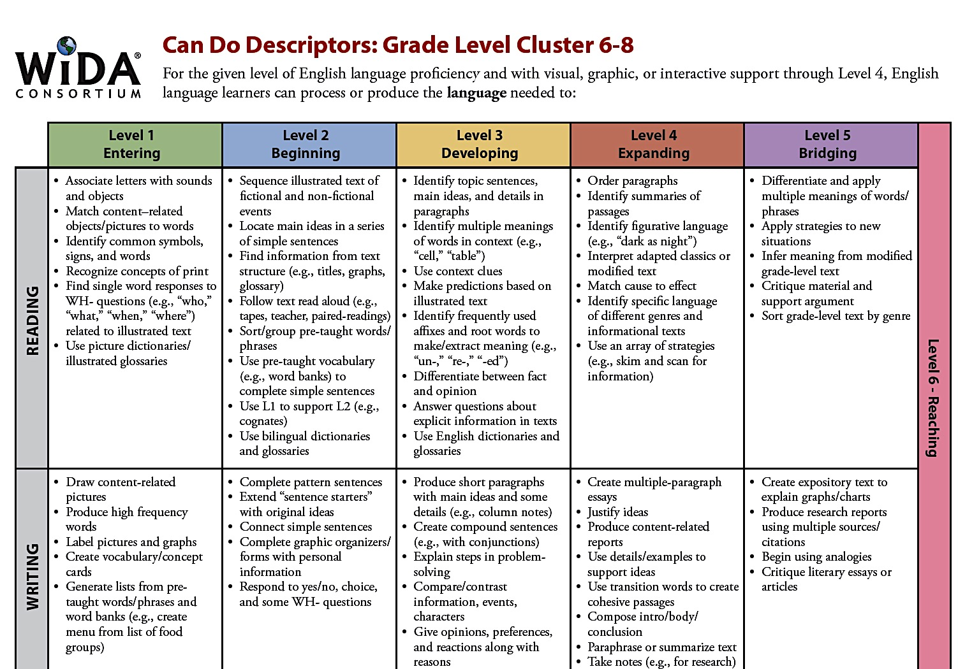
VOCABULARY
Tier 2 | Tier 3
Theory  Law  Balance  Displacement  Contact  Distance  Motion  Net  Spring  Strong  Tension  Unbalanced  Weak  Minority  Engineering  Engineer | Atoms  Molecules  Acceleration  Air resistance  Friction  Force  Electricity  Electromagnetism  Electromagnets  Hypothesis  Inertia  Magnetism  Mass  Momentum  Physics  Physicist  Velocity  Universe  STEM

RESOURCES
Websites

Physics and Forces
http://phystec.physics.cornell.edu/content/why-study-physics
http://www.thomastownps.vic.edu.au/app/webroot/uploaded_files/media/force_explanation_reuben.pdf
https://kids.britannica.com/students/article/force/323538/311824-toc4
http://www.ducksters.com/science/physics/force.php
http://eschooltoday.com/science/forces/balanced-forces.html
https://www.lcps.org/cms/lib/VA01000195/Centricity/Domain/5962/forceandmotion_5-6_nfb_-_mid.pdf

Newton’s Laws of Motion
https://www.grc.nasa.gov/www/k-12/rocket/TRCRocket/rocket_principles.html
http://www.panthercountry.org/userfiles/267/Classes/608/WordProblems-Calculating%20Force-0.pdf
http://www.physicsclassroom.com/class/newtlaws/Lesson-4/Newton-s-Third-Law
https://starchild.gsfc.nasa.gov/docs/StarChild/questions/question30.html
https://www.khanacademy.org/science/physics/forces-newtons-laws/newtons-laws-of-motion/a/what-is-newtons-second-law
https://www.theguardian.com/science/2014/may/11/what-is-newtons-second-law-of-motion
https://www.sophia.org/tutorials/newtons-second-law-chapter-2-lesson-3
https://www.sophia.org/tutorials/newtons-second-law-chapter-2-lesson-3
https://www.thoughtco.com/definition-of-scientific-law-605643
https://www.sciencefriday.com/educational-resources/balloon-rockets/
https://www.chemed.org/wp-content/uploads/Balloon-Rockets1.pdf
https://www.stevespanglerscience.com/lab/experiments/egg-drop-inertia-trick/
https://wow.osu.edu/experiments/Newton%27s%20Toolbox/Newton%27s%20Cradle
http://www.t4t.org/wp-content/uploads/2013/08/8th_Grade_Forces-Motion_Overview.pdf
https://www.slideshare.net/spwburleson/newtons-laws-of-motion-to-slideshare

Electromagnetism
https://sciencebob.com/make-an-electromagnet/
https://www.britannica.com/science/electromagnetism
https://www.vox.com/2016/5/26/11785562/water-bottle-flip-physicshttp://acme.highpoint.edu/~atitus/phy221/lecture-notes/2-1-momentum.pdf
https://learning-center.homesciencetools.com/article/electromagnetism-science-project/
https://futurism.com/understanding-quantum-mechanics-what-is-electromagnetism/
http://www.explainthatstuff.com/magnetism.html
http://www.ducksters.com/science/physics/electromagnetism_and_electric_motors.php
https://kidsresearchexpress-2.blogspot.com/2008/09/electromagnetic-force.html
http://www.chegg.com/homework-help/definitions/electromagnetic-force-2
https://www.ck12.org/physics/solenoid/lesson/Electromagnetic-Devices-MS-PS/
Gravity
http://nightsky.jpl.nasa.gov/docs/BHGravityFalling.pdf
https://www.ck12.org/ngss/middle-school-physical-sciences/motion-and-stability:-forces-and-interactions
https://www.theschoolrun.com/homework-help/gravity
http://coolcosmos.ipac.caltech.edu/ask/300-What-is-gravity-
http://blog.nomadpress.net/blog/the-science-of-bottle-flipping
https://www.youtube.com/watch?v=G9P2iUS2oFE
http://www.iop.org/resources/topic/archive/water-bottle-flip/page_68405.html
http://www.iopblog.org/its-flipping-great-to-think-like-a-physicist/

Fundamental Forces
https://science.howstuffworks.com/environmental/earth/geophysics/fundamental-forces-of-nature.htm
https://en.wikipedia.org/wiki/Fundamental_interaction Fundamental Forces

Scientific Method
http://www.biology4kids.com/files/studies_scimethod.html

NM PED Practice test
http://www.ped.state.nm.us/ped/AssessmentEvalDocs/EOC/blueprints/1718/Science_8th_Grade_Blueprint.pdf

Videos
https://www.youtube.com/watch?v=QP5H5uECFnY Video for Pictorial
https://www.youtube.com/watch?v=EgqcGrB3re8- Newton’s Third
https://www.youtube.com/watch?v=yUp4W9htmuY Laws Song
https://www.youtube.com/watch?v=OnoNITE-CLc- Space Shuttle Launch
https://www.youtube.com/watch?v=5eirTBW0rpI- Newton’s Third Law
https://www.youtube.com/watch?v=xQh8ji_4fZs- Newton’s Third Law
https://www.youtube.com/watch?v=aIzv6VM4nrA- Newton’s Third Law
https://www.youtube.com/watch?v=08BFCZJDn9w- Physics of Football
https://www.youtube.com/watch?v=V3NKs5dNb7M-First Law of Motion
https://www.youtube.com/watch?v=OKXVRu6JL54 Why the Moon Orbits the Earth
https://www.youtube.com/watch?v=7E4VVw4RDeo Physics of skateboarding
https://www.youtube.com/watch?v=TxhESW6YtOg 3rd Law Explained
https://www.youtube.com/watch?v=kOIj7AgonHM Washing hair in space
https://www.youtube.com/watch?v=E43-CfukEgs Gravity Chamber
https://www.youtube.com/watch?v=8YO_OlgP7jY Center of Gravity
https://www.youtube.com/watch?v=zaCAbKSCIpM Electromagnet

Narrative Input
https://achieve.lausd.net/cms/lib/CA01000043/Centricity/domain/244/sec%20professional%20development/black%20history%20month%20resources/Hidden%20Figures%20Lesson.pdf
https://www.biography.com/people/katherine-g-johnson-101016

Books
Physical Science- Glencoe Science 2008 Edition

UNIT PLANNING PAGES

- I. FOCUS/MOTIVATION
- Cognitive Content Dictionary with Signal Word
- Big Book: A Force is a Force of Course of Course
- Observation Charts
- Literacy Awards
- Poetry/Chants – GOP
- Inquiry Charts
- Guest speakers – Extended Activities for Integration
- Videos, movies
- Field trips– Extended Activities for Integration

II. INPUT
- Graphic Organizer- Physics Brace Map
- Pictorial Input Chart – Newton’s Law of Action/Reaction
- Comparative Input Chart-
- 10/2 lecture with primary language - GOP
- Videos

- GUIDED ORAL PRACTICE
- T-graph/processing
- Team co-op group evaluation
- Open Sort with textbook Picture File Cards
- Closed Sort with Picture File Cards - classify, compare, order
- Exploration Report
- Inquiry Chart
- Mind Mapping, list-group-label
- Heads Together/Process Grid
- Poetry
- Sentence Patterning Chart

- READING/WRITING
A. Whole Group
- Group Frames (Teacher uses info. from students to model appropriate frame)
- Cooperative Strip Paragraph - multiple paragraphs Information

B. Small Group Reading/Writing Activities
- Ear-to-Ear Reading
- Textbook pairs of pairs reading, tutoring, worksheets
- Co-op interpretations of literature legends poetry
- Focused Reading
- Flexible Reading Groups
Expert Groups
- Team Tasks
- Reader's Theater
- Team Writing Workshop
- Group Process Grids
- Farmer-in-the-Dell/Sentencing Patterning Chart
- Interactive Reading
- Book Sharing
C. Individual Activities - Portfolio
- Paragraph writing
- Poetry writing
- Interactive Journal Writing
- Learning Logs
- Individual Tasks
- Writer's Workshop
• Mini Lesson
• Writing/planning
• Conferences
- EXTENDED ACTIVITIES FOR INTEGRATION
• Science Experiments
• Field Trips
- Guest Speakers

VII. ASSESSMENT AND FEEDBACK
• Focused Reading
• Process Inquiry Charts
•Team and Individual Engineering Design Experiment
• Personal Exploration with Rubric
• Student Generated Text
• Student portfolios and presentations
• Student action plan
• Teacher-created exam

SAMPLE DAILY LESSON PLANS FORCES AND MOTION
DAY (Week) 1 (1 day equals 1 – 2 weeks of instruction. Italics indicate strategies done regularly.)

FOCUS/MOTIVATION
- Cognitive Content Dictionary with Signal Word
- Physicist Awards/ 3 Personal Standards
- Prediction/Reaction Guide
- Observation Charts
- Inquiry Chart Forces and motion
- Big Book- A Force is a Force of Course of Course
- Pass out portfolios, decide on numbers

INPUT
- Graphic Organizer- physics brace map

GUIDED ORAL PRACTICE
- Poetry/Chant: Physicist Here, There
- T-graph for Social Skills-Team points Collaboration
- Team Task Key
- Exploration Report whole class
- Picture Files/Realia
- Team Exploration Report
- Team Points

INPUT
- Pictorial Input- newton’s third law of motion

GUIDED ORAL PRACTICE
- ELD Review (Small homogenous group)

READING AND WRITING
- Learning Log
- Narrative Input- HIDDEN FIGURES
- Interactive Journal
- Memory bank

ASSESSMENT AND FEEDBACK
- Home/School Connection #1: Explain Newton’s Law of Motion to a family member. Look around your home, where do you see examples of Newton’s Third Law of Motion. Write and sketch your responses.

DAY (Week) 2 (1 day equals 1 – 2 weeks of instruction. Italics indicate strategies done regularly.)

FOCUS/MOTIVATION
- Process T-Graph for Social Skills
- Physicist Awards/ 3 Personal Standards
- Cognitive Content Dictionary – Signal Word
- Review Home/School Connection

INPUT
- Review Input Charts PHYSICS BRACE MAP/NEWTONS THIRD LAW
- Chant- Process HERE THERE with highlight, add pictures

GUIDED ORAL PRACTICE
- Review T-graph – ‘Read it with me’; introduce team tasks:
- Team Tasks: Exploration report, Graphic Organizer, Pictorial Input,
- Inquiry Chart, Add to the Walls
- Team Points

READING AND WRITING
- Expert Group #1
- Review Narrative Input with words cards and conversation bubbles
- Whole Class Mind Map for Thermal Energy PIC
- Process Grid Game

ASSESSMENT AND FEEDBACK
- Process Inquiry Chart

DAY (Week) 3 (1 day equals 1 – 2 weeks of instruction. Italics indicate strategies done regularly.)

FOCUS/MOTIVATION
- Physicist Awards/3 Personal Standards
- Home/School connection share out

GUIDED ORAL PRACTICE
- Poetry/Chant: PHYSICISTS HERE THERE review
- SPC add – ‘ing’ strip
- Flip chant (Here/There frame)

READING AND WRITING
- Whole Class Mind Map for Newton’s Third Law Pictorial
- Process Grid Game

READING/WRITING
- Expert Group #2
- Cooperative Strip Paragraph with Writing Checklist
  - Respond and Revise
- Edit
- Sentence Patterning Chart-PHYSICISTS
- Reading and Trading Game

GUIDED ORAL PRACTICE
- Chant

ASSESSMENT AND FEEDBACK
- Listen and Sketch

DAY (week) 4 (1 day equals 2 – week of instruction. Italics indicate strategies done regularly.)

FOCUS/MOTIVATION
- Cognitive Content Dictionary-Stumper word
- Physicist Awards/Three Personal Standards

READING/WRITING
- Review Narrative Input Chart with story map
- Ear to Ear Reading of Chants
- Highlight and sketch

GUIDED ORAL PRACTICE
- Oral team evaluation
- Team Tasks Review
  - SPC, Flip chants, team coop paragraph
- Flexible Group Reading
- SQ3R with Clunkers and Links (on or above grade level)
- Cooperative Strip Paragraph rebuild (struggling readers)
- ELD Group Frame (on Input Chart)
- Team presentations
- Team points (team reflection on goal)

ASSESSMENT AND FEEDBACK
· Graffiti Wall
- Process Inquiry
- Simultaneous Numbered Heads Together
- Walk the Walls/Stand by Charts
ANYONE CAN BE A PHYSICIST AWARD  It’s true! Anyone can be a physicist, no matter your race, gender, sexual orientation, socio-economic background, religion, disability etc.  What do all physicists have in common? They are determined, passionate and dedicated to their work!  Read the following information about this/these awesome physicists! On the back of the card, write about the obstacles they have/had to face and the awesome work they do/did as physicists!  Women in physics in the Palestinian territories  In the Palestinian territories, more women than men study physics, yet women faculty members remain a very small minority. At Birzeit University, outside Ramallah in the West Bank, Chair of the Physics Department Wafaa Khater offers a unique example of success to her postgraduate students. http://www.scidev.net/global/gender/multimedia/women-physics-palestinian-territories-photos.html | ANYONE CAN BE A PHYSICIST AWARD  It’s true! Anyone can be a physicist, no matter your race, gender, sexual orientation, socio-economic background, religion, disability etc.  What do all physicists have in common? They are determined, passionate and dedicated to their work!  Read the following information about this/these awesome physicists! On the back of the card, write about the obstacles they have/had to face and the awesome work they do/did as physicists!  A Conversation with Neil  Neil deGrasse Tyson is used to wearing a lot of hats. He is a leading astrophysicist, the director of the American Museum of Natural History's Hayden Planetarium, a columnist for Natural History Magazine, and the author or coauthor of six books. As host of NOVA's "Origins" miniseries, Tyson donned yet another hat, one that forced him to suppress his customary outspokenness to serve as dispassionate guide on a journey into the mysteries of the universe, the Earth, and life itself. http://www.pbs.org/wgbh/nova/space/conversation-with-neil-tyson.html | ANYONE CAN BE A PHYSICIST AWARD  It’s true! Anyone can be a physicist, no matter your race, gender, sexual orientation, socio-economic background, religion, disability etc.  What do all physicists have in common? They are determined, passionate and dedicated to their work!  Read the following information about this/these awesome physicists! On the back of the card, write about the obstacles they have/had to face and the awesome work they do/did as physicists!  Marie Curie  Marie Curie was born on 7th November, 1867, in Warsaw, Poland. She was the first woman to win a Nobel Prize and the only woman to win the award in two fields of science, Physics and Chemistry.

ANYONE CAN BE A PHYSICIST AWARD  It’s true! Anyone can be a physicist, no matter your race, gender, sexual orientation, socio-economic background, religion, disability etc.  What do all physicists have in common? They are determined, passionate and dedicated to their work!  Read the following information about this/these awesome physicists! On the back of the card, write about the obstacles they have/had to face and the awesome work they do/did as physicists!  Albert Einstein-Dyslexia the gift  Albert Einstein was a German-born theoretical physicist. He developed the general theory of relativity, one of the two pillars of modern physics (alongside quantum mechanics). Einstein’s work is also known for its influence on the philosophy of science. | ANYONE CAN BE A PHYSICIST AWARD  It’s true! Anyone can be a physicist, no matter your race, gender, sexual orientation, socio-economic background, religion, disability etc.  What do all physicists have in common? They are determined, passionate and dedicated to their work!  Read the following information about this/these awesome physicists! On the back of the card, write about the obstacles they have/had to face and the awesome work they do/did as physicists!  From DACA Recipient to Rocket Engineer  The 19-year-old UC Berkeley student says he couldn’t have done it without his parents — not only because of the sacrifices they made to bring him to the United States, but because they helped him apply for a program that has changed his life. | ANYONE CAN BE A PHYSICIST AWARD  It’s true! Anyone can be a physicist, no matter your race, gender, sexual orientation, socio-economic background, religion, disability etc.  What do all physicists have in common? They are determined, passionate and dedicated to their work!  Read the following information about this/these awesome physicists! On the back of the card, write about the obstacles they have/had to face and the awesome work they do/did as physicists!  Stephen Hawking: Questioning the Universe  Scientist Stephen Hawking is known for his groundbreaking work with black holes and relativity, and is the author of several popular science books including 'A Brief History of Time.'

Physicist Award  Notebook  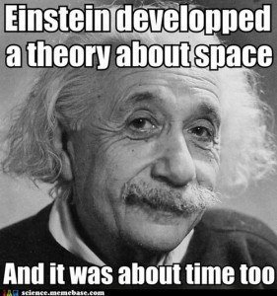 | Physicist Award  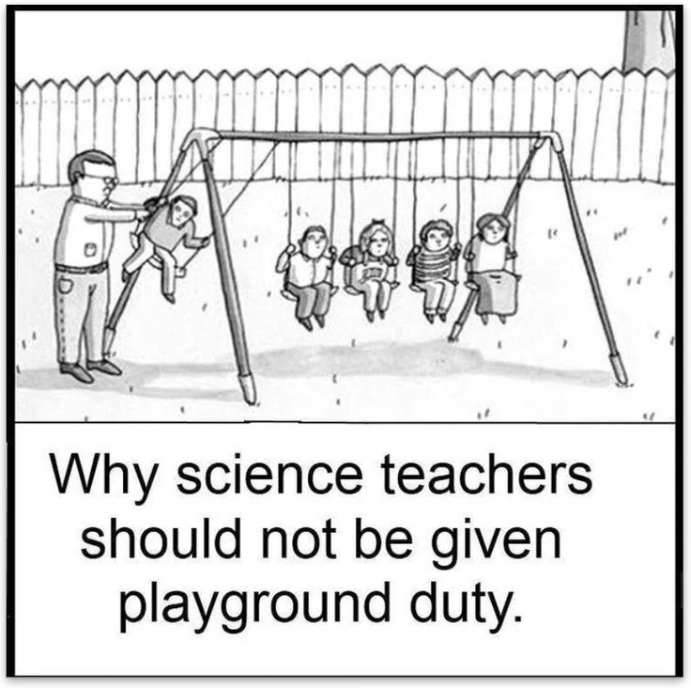  Notebook
Physicist Award  Notebook  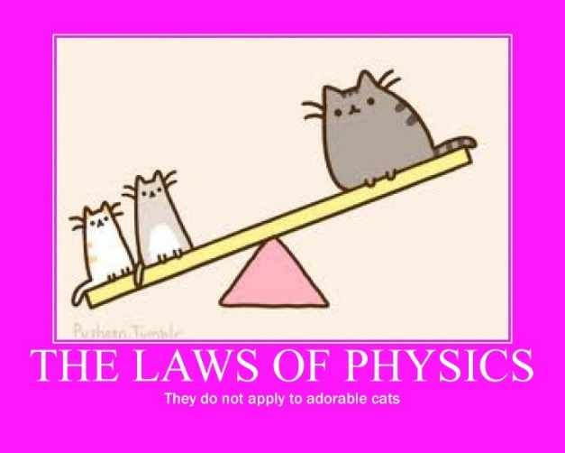 | Physicist Award  Notebook

Literacy Award Links
https://www.teacherspayteachers.com/Product/Force-Mass-Acceleration-Color-by-Number-1574935
http://sciencespot.net/Media/physicspuzzle.pdf
https://www.lakeshorelearning.com/media/product_guides/DD354.pdf
https://www.thoughtco.com/newtons-laws-of-motion-printables-1832432
PREDICTION/REACTION GUIDE: FORCES AND MOTION
  - What is a force?
Prediction: | Reaction:

  - What types of forces are there?
Prediction: | Reaction:

  - Describe Newton’s First Law of Motion.
Prediction: | Reaction:

  - Describe Newton’s Second Law of Motion.
Prediction: | Reaction:

  - Describe Newton’s Third Law of Motion.
Prediction: | Reaction:

  - What are the fundamental forces?
Prediction: | Reaction:

BIG BOOK
A FORCE IS A FORCE OF COURSE OF COURSE
Table of Contents
Pg. 1 Physics
Pg. 2 Scientific Method
Pg. 3 Hypothesis Theory Law
Pg. 4 Force
Pg. 5 Net, Balanced and Unbalanced Forces
Pg. 6. Acceleration and Velocity
Pg. 7 Three Laws of Motion
Pg. 8 Contact Forces
Pg. 9 Newton’s First Law
Pg. 10 Newton’s Second Law
Pg. 11 Newton’s Third Law
Pg. 12 Law of Conservation of Matter
Pg. 13 Fundamental Forces
Pg. 14 Electromagnetic Force
Pg. 15 Gravitational Force
Pg. 16 Nuclear Force
Pg. 1 Physics
A force is a force of course of course, a push or a pull that is a force.
- Physics is the study of matter, energy, and the interaction between them.
- Physics helps us to understand how the world around us works, from can openers, light bulbs and cell phones to muscles, lungs and brains.
- Physics helps us to organize the universe. It deals with fundamentals, and helps us to see the connections between seemly disparate phenomena.
- A physicist is an expert in the study of physics.
- If you want to study to be an astronaut, an engineer, science data and analyst you will need to study physics!

Pg.2 Scientific Method
A force is a force of course of course, a push or a pull that is a force.
- Scientists use the Scientific Method. The scientific method is a process used by scientists to study the world around them. It can also be used to test whether any statement is accurate. You can use the scientific method to study a plant, a cat, machines, or the Universe.

Pg.3 Hypothesis, Theory, Law
A force is a force of course of course, a push or a pull that is a force.
- There are different terms used to describe scientific ideas based on the amount of confirmed experimental evidence.
- Hypothesis
  - a statement that uses a few observations
  - an idea or proposition based on observations without experimental evidence
- Theory
  - uses many observations and has loads of experimental evidence
  - can be applied to unrelated facts and new relationships
  - flexible enough to be modified if new data/evidence introduced
- Law
  - stands the test of time, often without change
  - experimentally confirmed over and over
  - can create true predictions for different situations
  - has uniformity and is universal
Pg.4 Force
A force is a force of course of course, a push or a pull that is a force.
- A force is defined as a push or pull on an object.
- Forces change the motion of an object in specific ways.
- Motion is a change of position of a body or something that has mass.
- Motion occurs when an object changes its position relative to a reference point.
- Distance is the length of the path an object has traveled.
- Displacement is the distance and direction of a change in position

Pg.5 Net, Balanced and Unbalanced Forces
A force is a force of course of course, a push or a pull that is a force.
- The net force on an object is the combination of ALL the forces acting on the object.
- When the forces on an object are balanced, the net force on the object is zero.
- Unbalanced forces cause the motion of objects to change.

Pg.6 Acceleration and Velocity
A force is a force of course of course, a push or a pull that is a force.
- Acceleration is the rate of change of velocity.
- A change in velocity occurs when the speed of an object changes, or its direction changes, or both.
- The speed of an object increases if the acceleration is in the same direction as the velocity.
- The speed of an object decreases if the acceleration and the velocity of the object are in opposite directions.

Pg.7 Three Laws of Motion
A force is a force of course of course, a push or a pull that is a force.
- The three laws of motion were first compiled by British scientist Sir Isaac Newton (1642-1727) in his Philosophiæ Naturalis Principia Mathematica. Based on his observations and using the scientific method, Newton was able to state rules that describe the effects on the motion of objects.
- These rules or laws that describe contact forces, or forces where objects come into contact with one another.
- Examples of contact forces include frictional forces, tensional forces, normal forces, air resistance forces, and applied forces.

Pg. 8 Contact Forces
A force is a force of course of course, a push or a pull that is a force.
- Contact forces are forces are the result of two objects that come into contact with each other. Newton’s laws describe contact forces.
- Frictional Force- force exerted by a surface as an object moves across it or makes an effort to move across it.
- Tensional Force- the force exerted by a compressed or stretched spring upon any object that is attached to it.
- Spring Force- the force exerted by a compressed or stretched spring upon any object that is attached to it.
- Normal force-the support force exerted upon an object that is in contact with another stable object.
- Air resistance Force- a special type of frictional force that acts upon objects as they travel through the air.
- Applied Force-a force that is applied to an object by a person or another object.

Pg. 9 Newton’s First Law
A force is a force of course of course, a push or a pull that is a force.
Newton’s 1st Law
- The inertia of an object is the tendency of an object to resist a change in motion.
- The larger the mass of an object the greater its inertia.
- The motion of an object at rest or moving with constant velocity will not change unless an unbalanced net forces acts on the object.
- In a car crash, inertia causes unrestrained passenger to continue moving at the speed of the car before the crash.

Pg. 10 Newton’s Second Law
A force is a force of course of course, a push or a pull that is a force.
Newton’s 2nd Law
- The greater the force of an object, the greater the object's acceleration.
- The acceleration of an object depends on its mass as well as the force exerted on it.
- Newton’s second law of motion states that the acceleration of an object is in the direction of the net force on the object and can be calculated from this equation a=f/m f=ma.

Pg. 11 Newton’s 3rd Law
A force is a force of course of course, a push or a pull that is a force.
Newton’s 3rd Law
- According to Newton’s 3rd Law of motion, for every action force, there is an equal and opposite reaction force.
- Action and reaction forces act on different objects.
- The momentum of an object is the product of its mass and velocity p=mv.
- The net force on an object can be calculated by dividing its change in momentum by the time over which the change occurs.

Pg. 12 Law of Conservation of Momentum
A force is a force of course of course, a push or a pull that is a force.
- According to the Law of Conservation of Momentum, if objects exert forces only on each other, their total momentum is conserved.
- In a collision, momentum is transferred from one object to another.

Pg. 13 Fundamental Forces
A force is a force of course of course, a push or a pull that is a force.
- In physics, the fundamental interactions, also known as fundamental forces, are the interactions that do not appear to be reducible to more basic interactions.
  - Electromagnetic Force
  - Gravitational force
  - Strong Nuclear Force
  - Weak Nuclear Force

Pg. 14 Electromagnetic Force
A force is a force of course of course, a push or a pull that is a force.
- The word "electromagnetism" in physics is used to describe one of the fundamental forces of nature.
- This force is between subatomic particles such as protons and electrons. It helps to hold matter together.
- Electricity and magnetism are two aspects of electromagnetism.

Pg. 15 Gravitational Force
A force is a force of course of course, a push or a pull that is a force.
- Gravity is an attractive force between any two objects with mass. The gravitational force depends on the masses of the objects and the distance between them.

Pg. 16 Nuclear Forces
A force is a force of course of course, a push or a pull that is a force.
- Nuclear Forces work at the atomic level
- The strong nuclear force holds the nucleus of an atom together.
- The weak nuclear force is responsible for radioactive decay

Glossary
Acceleration- the rate of change of velocity
Air Resistance Force- a special type of frictional force that acts upon objects as they travel through the air.
Applied Force-a force that is applied to an object by a person or another object
Balanced force-forces on an object that combine to give a zero-net force and do not change the motion of the object
Contact Force- are forces are the result of two objects that come into contact with each other
Displacement-distance and direction of an object’s change in position from the starting point
Distance-how far an object moves
Electromagnetism- force between subatomic particles such as protons and electrons. It helps to hold matter together
Electricity-A type of energy fueled by the transfer of electrons from positive and negative points within a conductor
Force-a push or pull on an object
Frictional Force- force exerted by a surface as an object moves across it or makes an effort to move across it.
Fundamental Forces-the interactions that do not appear to be reducible to more basic interactions
Gravitation Force- depends on the masses of objects and the distance between them
Gravity- an attractive force between any two objects with mass
Hypothesis- a possible explanation for a problem using what you know and what you observe
Inertia- the tendency of an object to resist a change in motion
Law- describes something we can see happening in nature under certain circumstances. A scientific law gives us information about the relationship between two or more things and explains what will happen between them if conditions are right.
Magnetism-Magnetism is an invisible force or field caused by the unique properties of certain materials. In most objects, electrons spin in different, random directions. This causes them to cancel each other out over time
Mass-amount of matter an object has
Momentum- property of a moving object that equals its mass times its velocity
Motion- a change of position of a body or something that has mass
Net force-sum of all forces that are acting on an object
Normal Force-the support force exerted upon an object that is in contact with another stable object.
Physicist- a scientist who studies physics
Physics- the study of matter, energy, and the interaction between them
Scientific Method- a process used by scientists to study the world around them.
Spring Force- the force exerted by a compressed or stretched spring upon any object that is attached to it.
Strong Force- acts on hadrons and is responsible for the binding together of protons and neutrons in the atomic nucleus
Tensional Force- the force exerted by a compressed or stretched spring upon any object that is attached to it.
Theory- explanation of things or events that is based on knowledge gained from many observations and investigations
Unbalanced force- cause the motion of objects to change.
Velocity-Speed of an object and the direction of its motion
Weak Force- acts between leptons and is involved in the decay of hadrons. The weak nuclear force is responsible for nuclear beta decay (by changing the flavor of quarks) and for neutrino absorption and emission.

GRAPHIC ORGANIZER
Background Information for the Graphic Organizer: Physics Brace Map
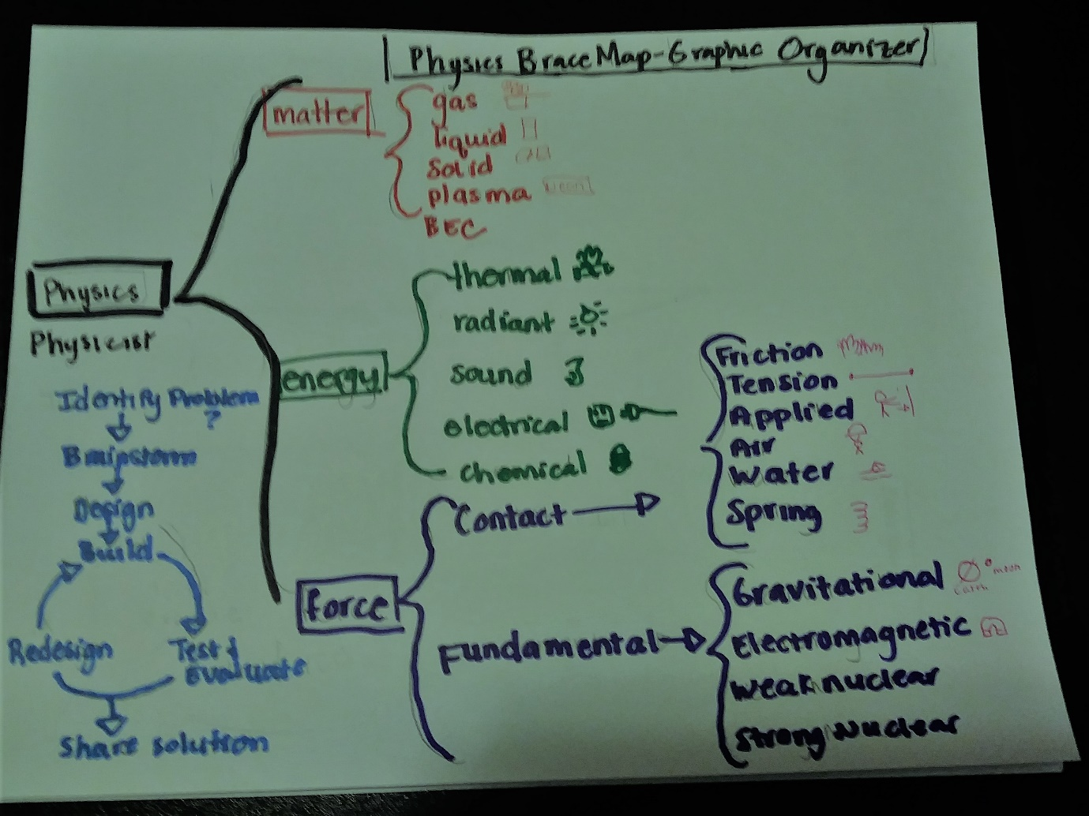
Note: This chart needs multiple pictures to be comprehensible to students. Only the text and sketches are shown below, but many pictures were added while it was first delivered. Also don’t forget “say it with” and “read it with me” so students can practice the language. (The brace map comes from Thinking Maps and looks at parts of a whole.)
This brace map is going to help us understand the branch of science called physics. Our unit on forces is part of physics. Physics explains how the world around us works. Physics is the study of matter, energy, and the interaction between them.
States of Matter
- In elementary school, you studied matter, energy and force when we study physics. Some of this information will look familiar to you. Some of it will be new.
- First let’s look at matter. Matter is all around us. It is anything that has mass and occupies or takes up space. Matter can take many forms. You may have learned that matter can be a solid, liquid or gas.
- Solids hold their shape. They can be hard like the floor or your desk. They can be soft like your shirt or socks. Touch a solid that is hard near you; touch a solid that is soft. Sketch – ice cube
- Liquids flow. They fill any shape or container. (Pour water from a water bottle into a glass.) Water, milk, gasoline, and many cleaners are liquid. Sketch – glass of water
- Gases are all around us. Water vapor is a gas. Our atmosphere is made up of gases. Gases fill the container or space that they are in. The molecules in gas spread out throughout a space. Sketch – boiling water
- There are other types of matter as well. Plasmas are a lot like gases, but the atoms are different, because they are made up of free electrons and ions. We find plasma in nature in stars and lightning balls. Man-made plasma is found in neon signs and fluorescent light bulbs. Sketch – a star, a neon “open” sign
- The last type of matter is very exciting because it was created in 1995 only about ___ years before you were born. Bose and Einstein had predicted that it could be made in the 1920’s but they didn’t have the technology to do it. BEC is made when the temperature of atoms become so cold, they can’t move at all. It creates like a “super atom” or “blob”. Sketch – not natural
  - 10/2 – What are other examples of solids, liquids and gases that you know?
Forms of Energy
- We said at the beginning that physics is the study of matter, energy, and the interaction between them. We just talked about the states of matter. Now we are going to talk about different forms of energy.
- Energy causes things to happen around us. As we heard in the big book, energy is the ability to do work. One form of energy is thermal or heat energy. A pot of boiling water or a burning fire have heat energy. Sketch – cup of hot coffee
- Another form of energy is radiant or light energy. Light energy travels in particles and waves. Stars are our primary source of light but anything that gives off light is a light source. (Share examples you see in the room.) Sketch - sun
- A third form of energy is sound energy. Sound energy travels in waves. Anything that you can hear is an example of sound energy. Sketch – drums or musical notes
- A fourth form of energy is electrical. Whenever we plug in an appliance we are using electrical energy. It is carried to us on electrical wires. Sketch – outlet with a plug
- A fifth type of energy is chemical energy. Chemical energy is stored energy. It is waiting to be changed into another form of energy. Wood, batteries and uneaten food are examples of chemical energy. Sketch – food, battery
  - 10/2 – Using our chart as a reference, what are examples of different forms of energy that you see in the classroom?

Forces
- We said physics was the study of matter, energy and the interaction between them. Force is often how matter and energy interact. In physics, force is a push or pull on an object.
- There are two different examples of forces. There are contact forces and fundamental forces.
- Contact forces are forces in which two or more objects come into contact with each other.
  - Frictional Force- force exerted by a surface as an object moves across it or makes an effort to move across it.
  - Tensional Force- the force exerted by a compressed or stretched spring upon any object that is attached to it.
  - Spring Force- the force exerted by a compressed or stretched spring upon any object that is attached to it.
  - Normal Force-the support force exerted upon an object that is in contact with another stable object.
  - Air Resistance Force- a special type of frictional force that acts upon objects as they travel through the air.
  - Water Resistance Force- a force acting opposite to the relative motion of any object moving with respect to a surrounding fluid.
  - Applied Force-a force that is applied to an object by a person or another object.
    - 10/2 - Looking at these examples of force. Which of these forces have you experienced? When?
- Fundamental Forces
- In physics, the fundamental interactions, also known as fundamental forces, are the interactions that do not appear to be reducible to more basic interactions.
  - Electromagnetic Force force between subatomic particles such as protons and electrons. It helps to hold matter together
  - Gravitational force an attractive force between any two objects with mass
  - Strong Nuclear Force- acts on hadrons and is responsible for the binding together of protons and neutrons in the atomic nucleus
  - Weak Nuclear Force acts between leptons and is involved in the decay of hadrons. The weak nuclear force is responsible for nuclear beta decay (by changing the flavor of quarks) and for neutrino absorption and emission.
- Looking back over our brace map we can see that the study of physics is the study of matter, energy and how they interact. Scientists who study physics are called physicists. They explore questions like: What are the basic building blocks of matter? How can we capture energy from the sun to power our cars and homes? The study of physics helps us understand our world and how it works.
Resources
- States of Matter - www.chem4kids.com
- Physics - http://www.ducksters.com/science/physics

ELD REVIEW PHYISCS BRACE MAP GRAPHIC ORGANIZER
Stages of Language Acquisition - WIDA | Level 1 Entering  Listening/Speaking | Level 2 Beginning  Listening/Speaking | Level 3 Developing  Listening/Speaking | Level 4 Expanding  Listening/Speaking | Level 5 Bridging  Listening/Speaking
Level of Questioning | Point To, Locate, Trace Yes/No Either/Or Open Ended
Create  Arrange, assemble, collect, compose, combine, construct, create, design, develop, devise, forecast, formulate, hypothesize, imagine, invent, manage, organize, plan, prepare, propose, set up | Choose the parts/features of the chart that you would use to teach another student about fundamental forces. | Would sitting by a campfire be a good way to use thermal energy? | Look at these two pictures. Which one shows how energy would(could) be used to listen to music? | If we did not (have) forces, propose how it/we could survive?
Evaluate  Appraise, argue, assess, choose, compare, critique, decide, debate, defend, determine, discuss, estimate, evaluate, judge, justify, predict, prioritize, rate, recommend, select, support, value, verify, weigh | Locate which part/feature of the chart that you predict would describe how scientists work. | Justify, could we survive without forces? | What word would best describe a slinky: spring or applied? | What are some ways that scientists could redesign a science experiment that does not work well the first trail?
Analyze  Analyze, appraise, calculate, categorize, classify, compare, contrast, criticize, differentiate, discriminate, distinguish, examine, experiment, explain, identify, infer, question, test | Point to the parts/features of the scientific method that are important to/for scientists when they create an experiment.  Showing two pictures: Which picture is an example of a normal or tension force? | Is the applied force part of the contact or fundamental forces?  Which picture shows how scientists brainstorm solutions? (additional picture) | Since gravity does not come into contact with other objects, do you infer that it is a contact or a fundamental force? | Compare the contact forces to fundamental forces. How are they the same or different?
Apply  Apply, calculate, categorize, classify, change, choose, compare, construct, demonstrate, describe, determine, distinguish, dramatize, employ, estimate, explain, extend, illustrate, interpret, judge the effects, operate, practice, schedule, select, show, sketch, solve, use | On this chart, show the three states of matter than water can be. | Is gravity an example of a contact force? | Is air pressure organized/categorized as a fundamental or contact force? | Use the information on the chart to explain why electromagnetism is a fundamental force.
Understand  Categorize, cite, clarify, classify, describe, discuss, explain, express, identify, indicate, interpret, locate, match, paraphrase, predict, recognize, restate, review, select, summarize, translate | Find an example of a contact force. | Do physicists test and evaluate, because of the scientific method? | Does the energy bracket tell/teach us about types of matter or types of energy? | Summarize the most important ideas about contact forces. .
Remember  Arrange, choose, define, describe, draw, , find, give example, identify, label, locate, list, match, name, recall, recite, recognize, record, repeat, reproduce, select, state, tell | Locate the Fundamental Forces. | Recall, does Panchito’s family leave Mexico and move to the USA? | Point to the matter on the chart. In this picture is solid, liquid or gas? | Tell me what you learned about forces.

PICTORIAL INPUT CHART: NEWTON’S THIRD LAW OF MOTION
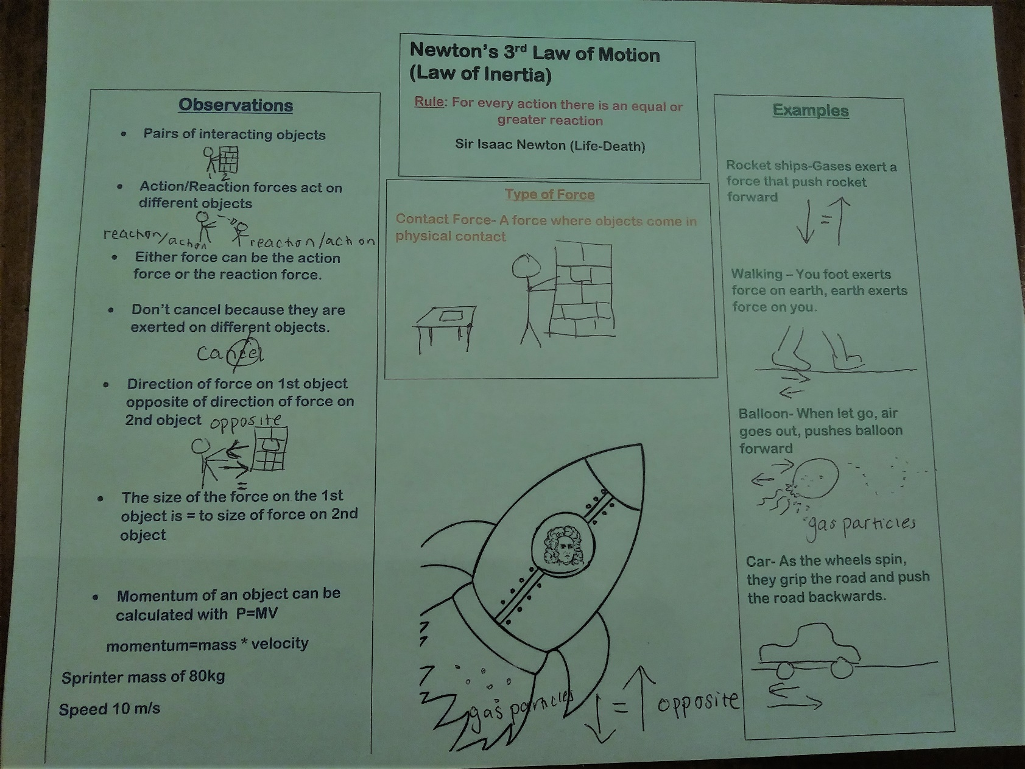

Newton’s 3rd Law of Motion Pictorial Input Chart Notes
Part 1: Today we are going to talk about Newton’s Third Law which is also known as the law of Inertia. Inertia is a property of matter by which it continues in its existing state of rest or uniform motion in a straight line, unless that state is changed by an external force.
First lest talk about Sir Isaac Newton
- 1643-1727
- English Physicists
- England
- Basic Principles of Physics (Law of Universal Gravitation, Laws of Motion, Calculus)
- Studied at Cambridge- Scientific Revolution- influenced by Aristotle and Descartes
- Philosophiae Naturalis Principia Mathematica (Mathematical Principles of Natural Philosophy, 1687) was one of the most important single works in the history of modern science.
In science, Laws are descriptions — often mathematical descriptions — of natural phenomenon
- stands the test of time, often without change
- experimentally confirmed over and over
- can create true predictions for different situations
- has uniformity and is universal Using the scientific method,
Sir Isaac Newton was able to develop laws using observations, experiments, data collection and evaluating evidence. Sir Isaac Newton was influential in developing a Scientific Method based on
Part 2: A force is a push or a pull on an object. There are different types of forces. Newtons laws describe contact forces which are forces that come in contact with each other. There are different types of contact forces.
- Frictional-The friction force is the force exerted by a surface as an object moves across it or makes an effort to move across it. sliding and static friction (Book sliding across the table)
- Normal- the support force exerted upon an object that is in contact with another stable object. (Book resting on a table, person leaning against a wall)
- Tension- force that is transmitted through a string, rope, cable or wire when it is pulled tight by forces acting from opposite ends.
- Air Resistance-acts upon objects as they travel through the air. often observed to oppose the motion of an object. (Parachute)
- Applied -An applied force is a force that is applied to an object by a person or another object.
- Spring-force exerted by a compressed or stretched spring upon any object that is attached to it.
Part 3: Rule: For every action there is an equal and greater reaction (forces always act in equal but opposite pair)
- Suppose you push on a wall, there is a force pushing back at you
- Balloon Demo- (move to observations section) Write the steps and explanation
  - When you blow up the balloon, you are filling it with gas particles. The gas particles move freely within the balloon and may collide with one another, exerting pressure on the inside of the balloon. As more gas is added to the balloon, the number of gas particles in the balloon increases, as well as the number of collisions. While the force of a single gas particle collision is too small to notice, the total force created by all of the gas particle collisions within the balloon is significant.
  - As the number of collisions within the balloon increases, so does the pressure within the balloon. In addition, the pressure of the gas inside the balloon becomes greater than the air pressure outside of the balloon. When you release the opening of the balloon, gas quickly escapes to equalize the pressure inside with the air pressure outside of the balloon. The escaping air exerts a force on the balloon itself. The balloon pushes back in a manner described by Newton’s Third Law of Motion. That opposing force—called thrust, in this case—propels the rocket forward.
  - In addition, the pressure of the gas inside the balloon becomes greater than the air pressure outside of the balloon. The pressure inside the balloon serves as the fuel for the rocket. When you release the opening of the balloon, gas quickly escapes to equalize the pressure inside with the air pressure outside of the balloon. As the gases escape from the balloon, the gas particles exert a force on the ground and the air outside of the balloon. According to Newton’s Third Law of Motion, every action has an equal and opposite reaction. Therefore, as the gas is released from the balloon, it pushes against the outside air, and the outside air pushes back. As a result, the rocket is propelled forward by the opposing force. This opposing force is thrust.
Part 5: Draw Rocket Ship with Newton inside it- In an aircraft or rocket, the engine provides power to the propeller, which produces the thrust. Power is the rate at which energy is converted or work is performed. In general, an engine with more power produces more thrust. In addition, the thrust must be greater than drag in order for an aircraft or rocket to accelerate forward for takeoff and to increase its speed during flight. If an aircraft is flying at a constant speed, the amount of thrust will equal drag
  - Jet engines work by igniting fuel, combined with compressed oxygen, inside the engine. As a result of the reaction, large amounts of gas are released quickly out of the rear of the aircraft. The extremely high acceleration of the mass of gas creates a large force. Then, as indicated by Newton’s Third Law of Motion, an equal and opposite force (thrust) is created in the opposite direction of the released gas, propelling the jet forward.
Part 4: Observations: Connect to the observations that Newton made.
- Occurs in pair of interacting objects
- Either force in an action-reaction force pair can be the action force or the reaction force.
- Action/Reaction forces act on different objects
- Direction of force on 1st object opposite of direction of force on 2nd object
- Action and reaction force pairs don’t cancel because they are exerted on different objects.
- The size of the force on the 1st object is = to size of force on 2nd object

Part 5: Examples
- Car- Consider the motion of a car on the way to school. A car is equipped with wheels that spin. As the wheels spin, they grip the road and push the road backwards. Since forces result from mutual interactions, the road must also be pushing the wheels forward. The size of the force on the road equals the size of the force on the wheels (or car); the direction of the force on the road (backwards) is opposite the direction of the force on the wheels (forwards). For every action, there is an equal (in size) and opposite (in direction) reaction. Action-reaction force pairs make it possible for cars to move along a roadway surface.
- Birds- Consider the flying motion of birds. A bird flies by use of its wings. The wings of a bird push air downwards. Since forces result from mutual interactions, the air must also be pushing the bird upwards. The size of the force on the air equals the size of the force on the bird; the direction of the force on the air (downwards) is opposite the direction of the force on the bird (upwards). For every action, there is an equal (in size) and opposite (in direction) reaction. Action-reaction force pairs make it possible for birds to fly.

ELD REVIEW FORCES AND MOTION PICTORIAL INPUT CHART
Stages of Language Acquisition - WIDA | Level 1 Entering  Listening/Speaking | Level 2 Beginning  Listening/Speaking | Level 3 Developing  Listening/Speaking | Level 4 Expanding  Listening/Speaking | Level 5 Bridging  Listening/Speaking
Level of Questioning | Point To, Locate, Trace Yes/No Either/Or Open Ended
Create-Arrange, assemble, collect, compose, combine, construct, create, design, develop, devise, forecast, formulate, hypothesize, imagine, invent, manage, organize, plan, prepare, propose, set up | Choose the parts/features of the observations section that you would use to teach another student about action reaction pairs. | Would air resistance be a good/helpful way/approach to flying an airplane? | Look at these two pictures. Which one shows how a rocket ship would propel forward? | If a bird had an injured wing, hypothesis how its action/reaction would be affected.
Evaluate  Appraise, argue, assess, choose, compare, critique, decide, debate, defend, determine, discuss, estimate, evaluate, judge, justify, predict, prioritize, rate, recommend, select, support, value, verify, weigh | Locate which part/feature of the chart is about how Newton’s third law demonstrates how a car moves forward. | Justify, could a rocket ship propel forward if there was not an initial action? | What word would best describe action/reaction pairs : opposite or unequal? | Predict what would happen if you put more or less air into the balloon and then let go.
Analyze -Analyze, appraise, calculate, categorize, classify, compare, contrast, criticize, differentiate, discriminate, distinguish, examine, experiment, explain, identify, infer question, test | Point to features of the chart that are important to understanding how objects act/ react to one another.  Show two pictures: Which picture is an example of the normal force? | Is the rocket ship part of the examples?  Which picture shows how a rocket ship propels forward? (additional picture) | Since, the dog is pulling on the leash do you infer that this is the tension force or the spring force? | Compare the normal force to the applied force. How are they the same or different?
Apply-Apply, calculate, categorize, classify, change, choose, compare, construct, demonstrate,describe, determine, distinguish, dramatize, employ, estimate, explain, extend, illustrate, interpret, judge the effects, operate, practice, schedule, select, show, sketch, solve, use | On this chart, trace the rocket ship that shows how action reaction pairs happens/takes place. | Is a bird flying an example of an action reaction pair?  Is a parked car an example of an action reaction pair? | Is the car movement organized/categorized as a normal force or a frictional force? | Use the information on the chart to explain how rocket ships move.
Understand-Categorize, cite, clarify, classify, describe, discuss, explain, express, identify, indicate, interpret, locate, match, paraphrase, predict, recognize, restate, review, select, summarize, translate | Point to the section that shows examples of the Action/Reaction Law.  Find an example of a tension force. | Does the balloon propel forward because of the law of acceleration? | Does the rule section describe the law or provide examples of the law? | Summarize the most important ideas about Newton’s 3rd Law of Motion..
Remember-Arrange, choose, define, describe, draw, , find, give example, identify, label, locate, list, match, name, recall, recite, recognize, record, repeat, reproduce, select, state, tell | Locate the part that says that the forces are equal | Recall, do forces cancel each other out? | (Point to visual information on the chart.) In this picture do the forces cancel each other out or are they equal and opposite? | Tell me what you learned about Action/Reaction Pairs.

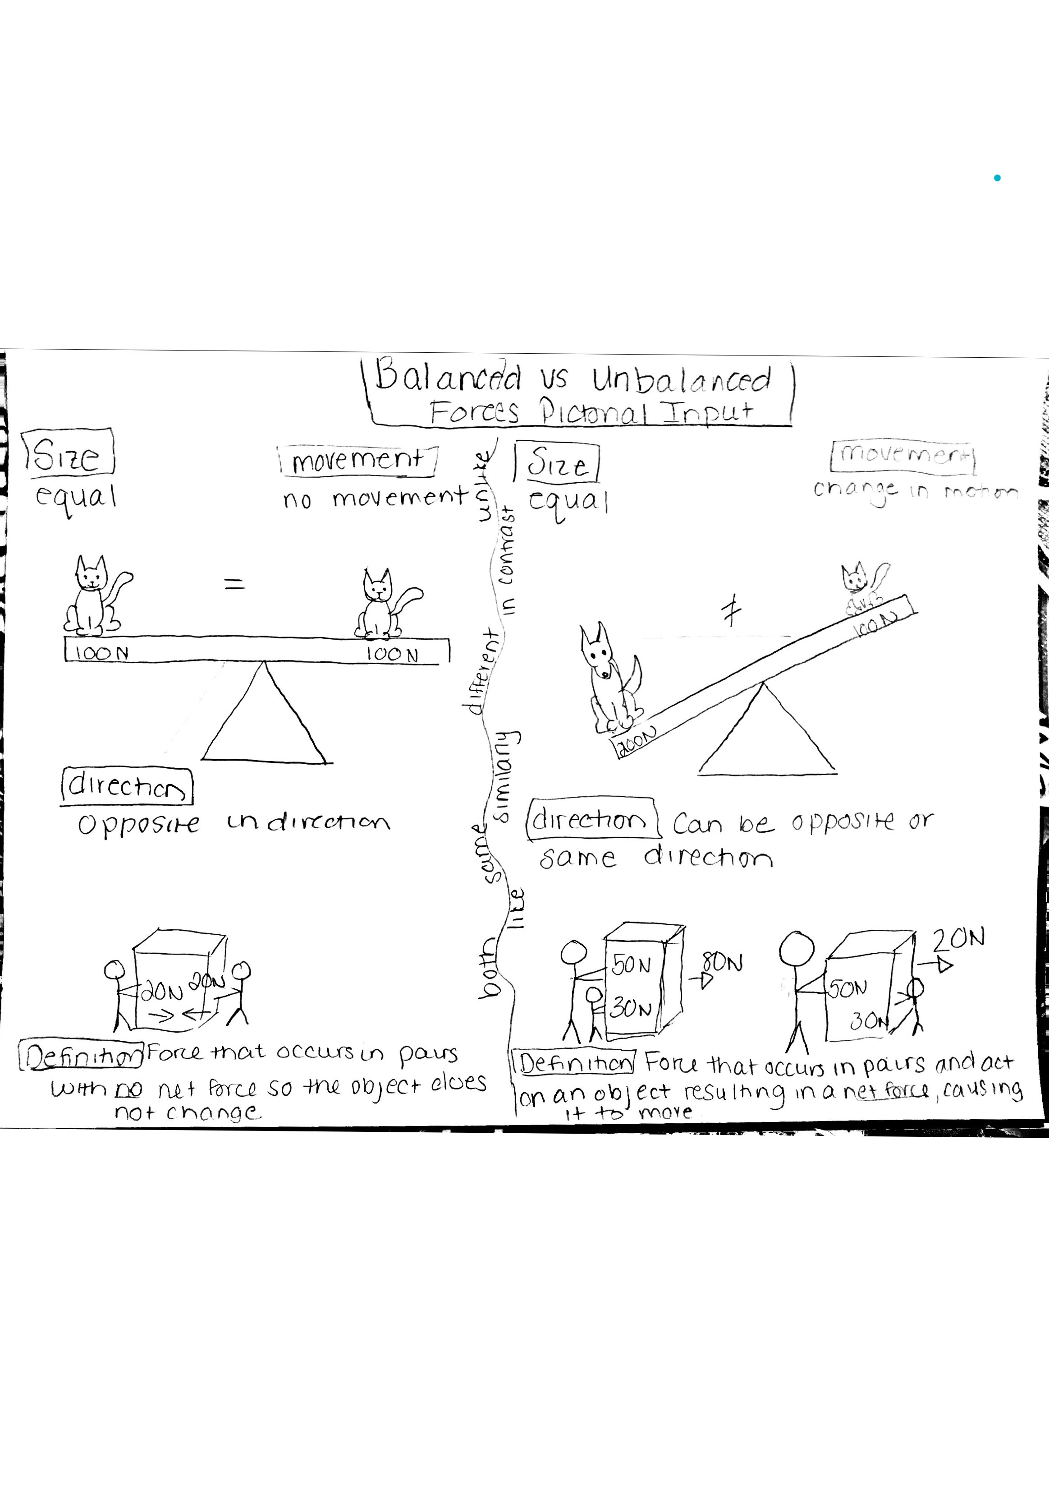
f
COMPARATIVE INPUT CHART
NARRATIVE INPUT CHART
Adapted by: Juanita Sandoval

Mobilization

There was no escaping the heat during the summer of 1943, especially for African American women working in Camp Pickett’s laundry boiler plant. Camp Pickett was an army training center in central Virginia the processed eighteen thousand bundles of laundry each week. Inside the facility, the heat and humidity were so intense that the workers stepped outdoors into the 100-plus degree summer heat to get relief. The women who worked at the plant earned forty cents an hour- among the lowest wages of all war workers-but for women with few employment options, even that modest sum felt like a windfall.

Dorothy Vaughan considered applying for a job at the laundry. The 32-year-old taught math at the black high school in Farmville, Virginia, about 30 miles from Camp Pickett. While teaching offered status, it didn’t pay well. Virginia’s white public-school teachers earned some of the lowest salaries in the United States, and black teachers in Virginia earned 50 percent less than that.

Some women with Dorothy’s education might have seen taking the laundry job as an unthinkable choice. Wasn’t the purpose of a college degree to get away from dirty and difficult work? But Dorothy didn’t care. She would do whatever was necessary to save enough money so that her four children might be able to get the best education possible.

Dorothy Vaughan's Childhood

Dorothy Vaughan was born in Kansas City, Missouri, in 1910. Her mother died when she was two and her father remarried a few years later. Dorothy's stepmother encouraged her to succeed, teaching her to read and right before she was old enough to start school. She moved to west Virginia with her family when she was eight.

Dorothy studied hard and became valedictorian of her high school. She earned a full scholarship to Wilberforce University, the country’s oldest private black college, located in Xenia, Ohio. At Wilberforce Dorothy majored in math. She earned good grades, and one of her professors recommended her for graduate studies at Howard University in Washington, DC. At the time the Depression was still affecting the country. Dorothy decided to turn down graduate school to take a job. She worked as a teacher at a black school in rural Tamms, Illinois. At the time, teaching was the most stable career for a black woman with a college degree. Due to economic effects of the great Depression, Dorothy's school had to close in 1929. Dorothy returned home and took a teaching job in Farmville Virginia.

In Farmville, she met Howard Vaughn, a tall charismatic bachelor who worked as a bellman at various luxury hotels. Dorothy and Howard fell in love, married and settled in Farmville. She had found steady work and a fulfilling job. But then World War 2 started, bringing with it more job opportunities and the hope for even better times ahead.

War Work

In the early 1940’s, the United States government spread the word far and wide that it was hiring. It was on a trip to Farmville Post Office in 1943 that Dorothy saw a notice for a laundry job at Camp Pickett. Then she glanced over and the word “mathematics” caught her eye. She looked more closely and learned that a federal government agency in Hampton, Virginia was looking for women to fill a number of mathematical jobs at a facility specializing in the development of airplanes. Dorothy at first assumed the advertisement was intended only for white women.

During World War 2, the United States asked for help from all its citizens, black, white and from every other ethnic background, women as well as men-were needed. In the first week of May 1943, the Norfolk Journal and Guide published an article that caught Dorothy's eye. “Paving the Way for Women Engineers” read the headline. The accompanying photo shows eleven well-dressed African American Women in front of Hampton’s institute Bemis Laboratory, graduates of engineering for women, a war training class. Maybe they're opportunities for African American women who love numbers. Dorothy decided to fill out an application.

In Dorothy Vaughan's world, there were black jobs and there were good black jobs. Sorting laundry, making beds in white people's houses, working in tobacco plants, those were good black jobs. Being a teacher or a preacher, a doctor or a lawyer those are very good black jobs. But the job at the aeronautical laboratory was something new, something so unusual it hadn't been dreamed of yet. Dorothy Vaughan filled out two applications, one to work laundry and one to work as a mathematician at Langley.

A New Beginning

In the fall of 1943, Dorothy Vaughan started the school year teaching math at a black high school in Farmville, Virginia. There she taught algebra in the school's over crowded auditorium with two other classes taking place in the same space. World War II was never far from anyone's mind. That fall, the high school’s 4-H Club made care packages for departing servicemen. They hosted a community discussion and asked “What can we do to win the war?”

In November, a letter from the National Advisory Committee for Aeronautics finally arrived. “You are hereby appointed Mathematician, Grade P-1, with pay at the rate of $2000 per annum”, the letter said. That was more than twice Dorothy’s annual salary as a teacher.

The job at the Langley Laboratory was a full-time position, 6 days a week. Dorothy would have to move four hours away from her children and she would only be able to come back home to see them on the holidays. But Dorothy knew this was a very good job, one that would allow her to help her family, so she accepted. The townspeople found out about Dorothy's decision when they read the notice in the Farmville section of the Norfolk Journal. It read, “Mrs. D.J. Vaughn, instructor in mathematics at the high school for several years, has accepted a position at Langley Field, Virginia”.

Dorothy didn't like didn't like long goodbyes. “I'll be back for Christmas”, she told her young children. Dorothy Vaughan rode a Greyhound Bus 137 miles from Farmville to Newport News, Virginia. While on the bus, she had plenty of time to think. She asked herself, “What would it be
like to work with white people? Would she sit side-by-side with young women like the ones at the State Teachers College? How would she endure the time away from her children and family?” Mile after mile, Dorothy watched the gentle hills rising and falling outside her window. She refused to feel any self-doubt. Her country needed her and she was ready and eager to do her part to support the war effort and her family.

The Double V

Dorothy Vaughan arrived in Newport News on a Thursday and started working at the Langley Memorial Aeronautical Laboratory the following Monday. The Personnel Department kept a file of available houses for new employees, divided by race, to comply with the custom of segregation. In Hampton Roads and across the country, relationships between blacks and whites were tense. Overcrowded buses, 6-day work weeks, constant noise and construction, shortages of sugar, coffee, butter, and meat all came together to create tension. This was not a new problem. Two years earlier, in his 1941 State of the Union Address, President Franklin D Roosevelt stated, “Men of every creed and every race, wherever they lived in the world, were entitled to freedom of speech, freedom of worship, freedom from want and freedom from fear”.

Because of the discrimination African Americans faced in the United States, they were sympathetic to the needs of oppressed people around the world. There was conflict in the African American community about the United States involvement in the war. Black newspapers spoke on the issue. “Help us to get some of the blessings of democracy here at home first before you jump on the ‘free other peoples’ bandwagon and tell us to go forth and die in a foreign land”. Said, P.B. Young, the owner of the Norfolk Journal and Guide, in a 1942 editorial.

“What are we fighting for?”, was a question asked by many African Americans in both public and private. From this divide, between feeling black and feeling American, came the idea of the “Double victory”. James Thompson expressed the idea in his letter to the Pittsburgh Courier. “Let colored Americans adopt the Double V for double victory; the first V for victory over our enemies from without, the second V for victory over enemies from within. For surely those who perpetuate these ugly prejudices here are seeking to destroy or democratic form of government just as surely as the Axis forces”.

The Colored Computers

As part of Dorothy Vaughan's orientation on her first day of work at Langley, she held up her right hand and swore the United States Civil Service oath of office. “I, Dorothy Vaughan do solemnly swear that I will support and defend the Constitution of the United States against all enemies, foreign and domestic”.

After the ceremony Dorothy boarded a campus shuttle bus that drove her to the end of a forested black road connecting the east side of the Langley campus with the west side.
She looked around at the strange landscape of two story brick offices and construction sites. The shuttle bus stopped to let Dorothy off at the front door of an office building called the Warehouse Building. She went inside and found rooms filled with desks arranged classroom style. From inside the rooms, Dorothy heard a new, unfamiliar sound, the steady beat of mechanical calculating machines, so big they took up an entire desktop. The same scene and the same sound played in all the rooms where the women were working. Women were performing the same work at a similar place on the East Side. The only difference between the East and West computers was that all the women sitting at the desk and Dorothy's workspace were black.

Take a Seat

The room for the West Area Computing pool was set up for about 20 workers. As members of a pool, each woman had to be ready to work on any mathematical assignment that came through the door. Dorothy Vaughan took a seat, and the women welcomed her. In 1940, just two percent of all black women earned college degrees, and sixty percent of those women became teachers, mostly in public Elementary and high schools. At a time when just 10% of white women, and not even a third of white men, the West Computers had found jobs at the single best and biggest aeronautical research complex in the world.

At the front of the room, sat two white women, the West Computing section head and her assistant. Dorothy was a welcome addition to the computer pool. The women had too much work to do and so little time. When Dorothy arrived, the agency was scrambling to keep up with the American Aircraft Industry, which had gone from the country's 43rd largest industry in 1938 to the world's number one by 1943.

Trouble in the Lunchroom

In the middle of the day, the women of West Computing walked as a group over to the cafeteria.
The women were the only Black women professionals at the laboratory, not exactly excluded but not quite included either. A white cardboard sign on a table in the back of the cafeteria said “Colored Computers” in crispy stenciled black letters. Tt was the only sign in the cafeteria. No other group needed assigned seating. This kind of racial insults was all-too-common. It was the kind of subtle jab that African-Americans had to learn to tolerate, if not accept, in order to function in their daily lives.

A mathematician named Miriam Mann finally decided she didn’t want to look at the cafeteria sign anymore. Not even 5 feet tall, Miriam had a huge personality. Dorothy and the other West Computers watched as Miriam put the sign into her purse. Her small act of defiance made them feel nervous but also empowered. The next day the sign reappeared. Miriam remove it again. This happened again and again for four weeks. “They are going to fire you over this”, Miriam’s husband said. Being black in America was a never-ending series of decisions about when to fight and when to let things go. “Then they're going to just have to do it”, Miriam said.

Numbers are Color Blind

On the Langley campus most of the engineers were conflicted on the issue of race. They may not have thought about inviting the black colleagues to their home for dinner, but at the office they were friendly. The same attitude applied to women in the workforce. When there was so much work to be done, the engineers were open to giving a smart person, black or white, male or female, the chance to work hard and get the numbers right.

The Sisterhood

As far as the West Computers were concerned, they assumed they would have to prove themselves equal to or better than the white mathematician. Because of the discrimination taking place, they believed that African-Americans needed to be twice as good to get half as far as their white counterparts.

The West Computers rejected all notions of being inferior because they were black or female and they banded together like sisters to help each other at work. Together, they fought against negative stereotypes.

Miriam Mann and the other women were no doubt delighted that at some point during the war the colored computer sign disappeared from the cafeteria. Many of the relationships that began in those early days and West Computing blossomed into lifetime friendships. Dorothy Vaughan Miriam Mann and the other women of West Computing became a sisterhood inside and outside of work. For ambitious young women with mathematical minds, there wasn't a better job in the world.

ELD REVIEW NARRATIVE INPUT CHART

Stages of Language Acquisition - WIDA | Level 1 EnteringListening/Speaking | Level 2 Beginning  Listening/Speaking | Level 3 Developing  Listening/Speaking | Level 4 Expanding  Listening/Speaking | Level 5 Bridging  Listening/Speaking
Level of Questioning | Point To, Locate, Trace Yes/No Either/Or Open Ended
Create  Arrange, assemble, collect, compose, combine, construct, create, design, develop, devise, forecast, formulate, hypothesize, imagine, invent, manage, organize, plan, prepare, propose, set up | Choose the parts/features of the story that you would use to teach another student about Dorothy Vaughan's life before she started to work at NACA. | Would allowing women to work at NACA be a good/helpful way/approach to adding diversity to the workplace? | Look at these two pictures. Which one shows how African Americans were discriminated against when they had to write the bus? | Imagine if you were Dorothy Vaughan. What would you say/do to people who were discriminating against you at work?
Evaluate  Appraise, argue, assess, choose, compare, critique, decide, debate, defend, determine, discuss, estimate, evaluate, judge, justify, predict, prioritize, rate, recommend, select, support, value, verify, weigh | Locate which part/feature of the story that you predict would be about Dorothy Vaughan moving to Virginia. | Justify, could we have won the war if Dorothy and other women who worked at NACA were not allowed to work? | What word would best describe Dorothy Vaughan: determined or lazy? | Predict what would happen if African Americans were not allowed to work at NACA?
Analyze  Analyze, appraise, calculate, categorize, classify, compare, contrast, criticize, differentiate, discriminate, distinguish, examine, experiment, explain, identify, infer, question, test | Point to the parts/features of the chart that are important to/for describing where Dorothy worked.  Showing two pictures: Which picture is an example of racial discrimination? | Which picture shows how working conditions were in the laundry plant? (additional picture) | Since Dorothy is African American, do you infer that she is treated good or bad by her peers? | Compare the Miriam Mann to Dorothy Vaughan. How are they the same or different?
Apply  Apply, calculate, categorize, classify, change, choose, compare, construct, demonstrate, describe, determine, distinguish, dramatize, employ, estimate, explain, extend, illustrate, interpret, judge the effects, operate, practice, schedule, select, show, sketch, solve, use | On this chart, locate that shows where Dorothy Vaughan worked. | Is the black women having to sit in separate tables in the cafeteria an example of discrimination? | Is/Are the women who work at Langley Lab or white or both white and black? | Use the information on the chart to explain why it is important that all people are treated equally in the workplace.
Understand  Categorize, cite, clarify, classify, describe, discuss, explain, express, identify, indicate, interpret, locate, match, paraphrase, predict, recognize, restate, review, select, summarize, translate | Find an example of racial discrimination. | Do(es) Dorothy decide to work for NACA because of her family? | Does the story tell/teach us about Dorothy Vaughan or Miriam Mann? | Summarize the most important ideas about Dorothy Vaughan and her life.
Remember  Arrange, choose, define, describe, draw, find, give example, identify, label, locate, list, match, name, recall, recite, recognize, record, repeat, reproduce, select, state, tell | Locate Dorothy Vaughan. | Recall, does Dorothy’s family move with her to work at Langley Labs? | Point to visual information on the chart. In this picture is/are they workers in a laundry plant, teachers or workers at Langley Labs? | Tell me what you learned about Dorothy Vaughan and her life.

POETRY BOOK
POETRY BOOK
FORCES AND MOTION
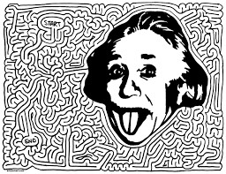

NAME:______________________________________________
TEAM:______________________________________________
NUMBER:________________________

Physicists Here There
By Juanita Sandoval

Physicists here
Physicists there
Physicists physicists everywhere

Diverse physicists engineering carefully
Inquisitive physicists inquiring cautiously
Intellectual physicists advocating passionately
And cosmic physicists calculating accurately

Physicists in the laboratory Physicists around the world
Physicists at NASA
And physicists inside a rocket ship

Physicists here
Physicists there
Physicists, physicists everywhere Physicists physicists physicists

Forces Marine Cadence

We just know ‘cause we’ve been told, Forces are worth their weight in gold. People use them every day,
Its helps us work, it helps us play.

Sound off- Actions Sound off- Reactions Sound off- 1, 2, 3, 4 Newton’s Laws

Forces and motion all around, They push, they pull and even pound. Gravity helps matter drop on down, Things get done in our home town.

Sound off- inertia and momentum,
Sound off- acceleration and velocity, Sound off- 1, 2, 3, 4, let’s move!

Examples of forces are abound, We just need to look around. Normal, frictional, and yes, gravity, Forces effect both you and me.

Sound off- Newton’s, Sound off- Three Laws,
Sound off- 1, 2, 3, 4s Forces and Motion!

Forces and Motion Yes, Ma’am By: Juanita Sandoval

Is this a force? Yes, ma’am!
Is this a force? Yes, ma’am!
Well, how do you know? It’s a push and pull.
Well, how do you know? It makes things happen.
Give me some examples. Contact and Fundamental.
Give me some examples. Normal and Gravitational.

Is this a normal force? Yes, ma’am!
Is this a normal force? Yes, ma’am!
Well, how do you know? Nothing is moving
Well, how do you know? They are equal and opposite
Give me some examples Book on a table
Give me some examples Sitting on a chair

Is this gravity? Yes, ma’am!
Is this gravity? Yes, ma’am!
Well, how do you know? Masses pull each other.
Well, how do you know? Greater masses have more force.
Give me some examples. Moon around the Earth.
Give me some examples. Falling to the ground.

Is this applied force? Yes, ma’am!
Is this applied force? Yes, ma’am!
Well, how do you know? Two objects touch.
Well, how do you know? A push or a pull is applied.
Give me some examples. Walking your dog.
Give me some examples. Closing the door.
And are you through? Yes, ma’am!
Did you tell me true? Yes, ma’am!
What did you chant? Forces!

A Fundamental Force Now (Tune Feelin’ Still by Portugal the Man)
By Juanita Sandoval

Under a tree by myself apple fell new discovery in of itself I am thinking this might be gravity
Could it be a force field?
*Chorus*
ooh woo, it’s a fundamental force now
I’ve been feeling it since 1666 now every object has mass and you feel a pull

ooh woo, it’s a fundamental force now Let me kick it like it’s 1686 now things may not touch but a force it’s still

It all depends on the mass
the closer it is the force is bigger farther away it gets weaker
Gone all the fallen things
Could there be a force field?

*Chorus*

Can see more gravity (ooh woo, it’s a fundamental force now)
Look the moon its revolving
All around the earth it seems.
Couldn’t do it without gravity
Gravity makes it all come down (ooh woo, it’s a fundamental force now)

Atoms they may be little have gravitational force it in the middle
But oh it makes it all fall
Won’t bother me

Is it falling?
Is it falling?
Is it falling?
Is it falling?
Is it falling?
Is it falling down?

(ooh woo, it’s a fundamental force now)
The force from one mass to another mass now

Things don't touch a force it’s still

*Chorus*

Newton’s Number One
By Anna Harvin 2017(To the tune of “Another One” By DJ Khalid)
Newton’s Law of Inertia
Another One DJ Sandoval

Yeah, you're lookin' at the truth, the forces never lie no
Law number one, yeah, Newton’s number one yeah

The more mass an object has the more inertia
It’s the one, yeah, Law number one, yeah

Yeah, an object tends to stay in motion if it’s movin’
At the same speed and direction ‘til its changin’
And when it’s resting it wants to stay still

Law number one, yeah
Oh-eh-oh-oh-oh, oh-eh-oh
I'm the one
Oh-eh-oh-oh-oh, oh-eh-oh
Newton’s number one
Oh-eh-oh-oh-oh, oh-eh-oh
I'm the one
Oh-eh-oh-oh-oh, oh-eh-oh
Law number one
Yeah, yeah!

Inertia Ooh Na-Na
By: Juanita Sandoval
(To the tune of Havana by Camila Cabello)

Inertia ooh na-na
It stays the same when
There’s inertia ooh na-na
Moves in a straight line with inertia ooh na-na More mass greater the inertia less mass there's less inertia
Inertia na na na

An object at rest it’s not movin (uh)
(Like a book on a table)
Unless a force gets it goin’
(But it would need a push)
It will go on forever until you stop it
(Like if you were out in space)

And Newton says it’s got inertia and then
It got me movin’ like
Ooh-ooh-ooh I knew when I pushed it
That it would gain momentum
Got it movin' like
Ooh-ooh-ooh, and in the same direction
It had to go, oh na-na-na-na-na

Inertia ooh na-na
It stays the same when
There’s inertia ooh na-na
Moves in a straight line with Inertia ooh na-na More mass greater the inertia less mass there's less inertia
Inertia na na na

HOME SCHOOL CONNECTION
Explain what you learned today about Newton’s Third Law of Motion with someone at home. Where do you see Newton’s 3rd Law of Action/Reaction applied at your home? Write and sketch your responses.
Explica lo que aprendiste hoy acerca de la ley de movimiento de Newton con alguien en tu casa. Donde lo encuentra ejemplos de la ley de movimiento de Newton en tu casa. Escribe y dibuja tu respuesta.

Student Signature/Firma de estudiante:___________________________

Parent Signature/Firma de pariente:_____________________

HOME SCHOOL CONNECTION

Explain what you learned today about Newton’s First Law of Inertia with someone at home. Where do you see Newton’s 1st Law of Inertia applied at your home? Write and sketch your responses.
Explica lo que aprendiste hoy acerca de la ley de inercia de Newton con alguien en tu casa. ¿Donde lo encuentra ejemplos de la ley de inercia de Newton en tu casa? Escribe y dibuja tu respuesta.

Student Signature/Firma de estudiante:___________________________

Parent Signature/Firma de pariente:_____________________
HOME SCHOOL CONNECTION
Explain with your family what you learned about the electromagnetic force. Where do you see examples of the electromagnetic force in your daily life? Write and sketch your response.
Explica lo que aprendiste hoy acerca de la fuerza electromagnética con alguien en tu casa. ¿Dónde se ve ejemplos de la fuerza electromagnética en tu vida diaria?

Student Signature/Firma de estudiante:___________________________

Parent Signature/Firma de pariente:_____________________
HOME SCHOOL CONNECTION
Explain with you family what you learned about balanced and unbalanced forces. Look for examples of unbalanced and balanced forces in your home. Write and sketch what you find.
Explica lo que aprendiste hoy acerca de fuerzas equilibradas y desequilibradas. Busca por ejemplos de fuerzas equilibradas y desequilibradas en tu casa. Escribe y dibuja lo que encuentra.

Student Signature/Firma de estudiante:_____________________________

Parent Signature/Firma de pariente:_____________________
EXPERT GROUP

Law of Inertia
Newton’s First Law of Motion

TYPE OF FORCE
Based on the scientific method, Sir Isaac Newton was able to state rules that describe the effects on the motion of objects. These rules or laws describe contact forces, or forces where objects come into contact with one another. A force is defined as a push or pull on an object. Forces change the motion of an object in specific ways. Newton’s First Law of Motion is also referred to as the law of inertia. Inertia is the tendency for something to do nothing or remain unchanged. The more mass something has, the greater its inertia, i.e. a bowling ball has more inertia than a tennis ball and an 8th grader has more inertia than a toddler!

RULE
The Law of Inertia can be explained in two parts:
- An object at rest tends to stay at rest unless there is an interaction with an unbalanced force.
- An object in motion tends to stay in motion with the same speed and direction until there is an interaction with an unbalanced force.
Newton’s cradle will help us understand this concept. The ball that is pulled back and released wants to keep moving, and the stationary balls would like to remain motionless. The collision that takes place between the moving ball and the stationary balls results in forces acting upon all the balls in the system. The moving ball has a certain amount of momentum (a tendency to remain in motion) and when it is stopped by the collision, this momentum is transferred to the next ball in the line. The next ball cannot go anywhere so it transfers the momentum to the next ball in line. This transfer continues until the momentum is given to the last ball in the line. This process will repeat itself, going back and forth, until the energy of the system is lost to air resistance, friction, and vibrations and all the balls again come to rest.

OBSERVATIONS
Let’s do an experiment to see the law in action! Record your observations This experiment will help you teach Newton’s Law to your team!

You will need an index card, penny and a glass!
1. Lay the card on top of the glass. Have one edge of the card a little beyond the rim so you can give that edge a good flick without smacking your fingertip on the glass.
2.Place a penny on top of the card so it’s centered over the glass.
3. Use a finger to flick an edge of the notecard. You want to flick the card directly from the side. (Don’t flick it downwards or upwards by hitting from above or below the card.)
4. Try again but keep adding more and more pennies!

Why Does It Work?

In the case of the Coin Drop activity, the penny is at rest sitting on top of the card. On its own, the penny will not move from that spot. When you flick the card out from under the penny, you allow gravity (an outside force) to act on it and drop it into the glass. The bottom of the glass stops the penny from falling. However, if the penny were a lot heavier (had more mass) and were falling much faster, it could go right through the glass.
So, why doesn’t the penny take off when the card is flicked? If you flick the card correctly, it simply slides out from between the glass and the penny. There’s not enough friction from the card to take the penny with it. Through observations of Newton’s 1st Law of Motion, one can conclude that objects with mass resist changes to their velocity.

EXAMPLES
Here is even more evidence of Newton’s First Law of Motion:

- While riding a skateboard (or wagon or bicycle), you fly forward off the board when hitting a curb or rock or other object that abruptly halts the motion of the skateboard.

- A rocket in outer space does not need to continuously apply thrusters in order to maintain a constant velocity. Because friction in space is practically zero, the rocket applies thrusters until it achieves the desired velocity, and will then travel continuously at that speed and direction until acted upon by gravity or some other external force.

- To dislodge ketchup from the bottom of a ketchup bottle, it is often turned upside down and thrusted downward at high speeds and then abruptly halted.

EXPERT GROUP
Law of Gravity

TYPE OF FORCE

For thousands of years people have observed the stars and the planets in the night sky. Gradually, data was collected on the motions of the planets by many observers. Isaac Newton used some these data to formulate the Law of Universal Gravitation. The force of gravity is one of the fundamental forces, which also include electromagnetic and nuclear forces. A
force is defined as a push or pull on an object. Forces change the motion of an object in specific ways. Gravity is an attractive force between any two objects. It is also an at-a-distance force because it occurs in objects that do not make direct contact.

RULE
Every object in the universe has mass or exerts a gravitational pull or force on every other mass.
The law of universal gravitation states that the gravitational force between two objects depends on
- masses of the objects
- the distance between the objects

OBSERVATIONS
Gravitational masses depend on masses of interacting objects. The gravitational force is very small except when one or both objects have a large mass. The farther objects are away from each other, the less gravitational force they exert on each other. Einstein said that massive objects curve space around themselves. More massive objects curve space more, so the force of gravity is stronger in the presence of more massive objects. If no air resistance is present, the Earth always produces the same acceleration on every object, no matter how heavy the object is. This means that two objects will reach the ground at the same time if they are dropped simultaneously from the same height. The Earth's gravitational force accelerates objects when they fall. It constantly pulls, and the objects constantly speed up.

Let’s do an experiment to see the gravity in action! Record your observations This experiment will help you teach the law to your team!
You are probably familiar with the good ol’ bottle flipping trick but, do you know how it works?

As the bottle moves through the air the liquid inside it starts to climb the sides. This increases the bottle’s moment of inertia and decreases its rotational speed, much like a diver who extends his arms and legs to slow his spin. Trying different amounts of water shows how important it is to get the amount of liquid right. The trick just doesn't work with a full bottle. The liquid can’t move, and its higher center of mass means that a full bottle topples over when it lands. Filling it to just a bit below a third seems to be optimal. You might think you’re just flipping bottles and annoying the adults around you, but you’re really exploring the physics of angular momentum, fluid dynamics, and gravity.

’Angular momentum’ is when an object spins around, as in a top, instead of proceeding in a straight line such as a car or baseball. The bigger and faster things are more difficult to stop or change direction than lighter or slower things. In space we see angular momentum in the stars, planets, nebulae and even black holes. They all spin and without anything to change it, will continue to spin.

EXAMPLES

Everything that has mass exerts a gravitational force. You exert a gravitational force on the people around you, but that force isn't very strong, since people aren't very massive. When you look at really large masses, like the Earth and Moon, the gravitational pull becomes very impressive. The gravitational force between the Earth and the molecules of gas in the atmosphere is strong enough to hold the atmosphere close to our surface. Smaller planets, that have less mass, may not be able to hold an atmosphere.

Gravity affects atoms the same way it affects all other matter. Every atom creates its own gravitational field which attracts all other matter in the universe. If you put a lot of atoms together, like in a planet or a star, all of the little gravitational fields add together, creating a much stronger pull.

EXPERT GROUP
Law of Force and Acceleration
Newton’s Second Law of Motion

TYPE OF FORCE
Based on the scientific method, Sir Isaac Newton was able to develop rules that describe the effects on the motion of objects. These rules or laws describe contact forces, or forces where objects come into contact with one another. A force is defined as a push or pull on an object. Forces change the motion of an object in specific ways. Newton’s Second Law of Motion is also referred to as the Law of Force and Acceleration. Acceleration is the increase in the rate of speed of an object. Pushing or pulling an object produces acceleration, a change in the speed of motion. Believe it or not, acceleration can mean slowing down OR speeding up.

RULE

The second law states:

The greater the mass of an object, the more force it will take to accelerate the object.
There is even an equation that says Force = mass x acceleration or F=ma.

This also means that the harder you kick a ball the farther it will go. This seems kind of obvious to us, but having an equation to figure out the math and science is very helpful to scientists.

Newton's second law of motion pertains to the behavior of objects for which all existing forces are not balanced. The second law states that the acceleration of an object is dependent upon two variables - the net force acting upon the object and the mass of the object. As the force acting upon an object is increased, the acceleration of the object is increased. As the mass of an object is increased, the acceleration of the object is decreased.
OBSERVATIONS
Let’s see the Law in Action. Let’s think about the craters on the moon
Materials:
- Pie Pan or Other Dish with Sides
- Flour
- Hot Chocolate Mix
- 3 Sizes of Marbles
- Spoon
- Ruler

Put several spoonfuls of flour in the bottom of the pan and spread it out to make a level surface. Then sprinkle a thin layer of hot chocolate mix on top of the flour. Now hold one marble/rock above the surface of the flour, use your ruler to measure how far you will drop the marble. Drop the marble from the top of the ruler. Do the same with the other two marbles/rocks. Now carefully lift each marble/rock out of the flour and look at the impact crater. Measure your impact crater in millimeters. Which marble/rock made the widest impact crater? Which one made the deepest impact crater? In this experiment we only want to change the size/weight of the object that is falling. If we changed the shape of the object too, it would be hard to measure the difference in the impact craters.
While doing the experiment, pay close attention to how far away the marbles are from the surface of the flour before you let go of them. Use a ruler to make sure you drop each marble from exactly one foot above the surface of the flour. Do the experiment three times using the same three objects. The three times you repeat the experiment are called trials. Make a chart to keep track of the results. After each trial measure the width of the impact crater made by each of the three marbles. Which marble makes the largest impact crater? Which marble makes the deepest impact crater? Why do you think so?
Trial | Marble 1 Diameter Measurement in MM | Marble 2 Diameter Measurement in MM | Marble 3 Diameter Measurement in MM
Trial 1
Trial 2
Trial 3

This experiment keeps the acceleration the same/consistent by dropping all 3 marbles from the same distance (F = m x a, the a is the same). What is changing (the variable) is the mass of the object, thereby changing the force and making the craters larger in the bottom of the pan. The larger the marble (the larger the mass), the larger the crater (the force it landed with was larger). M x A = F, so when M is changed, there is a different answer. For example, if a = 5 in M x A = F, if mass is 3, the force would be 15 Newtons because 3 x 5 = 15. But if mass is 4, the force would be 20 Newtons. The F, the a, and the m all affect each other. To cause acceleration, mass or force needs to act on the acceleration. If the mass is larger, the force will also be larger

EXAMPLES
Newton's second law of motion is especially useful when designing efficient rockets. To enable a rocket to climb into low Earth orbit, it is necessary to achieve a speed, in excess of 28,000 km per hour. A speed of over 40,250 km per hour, called escape velocity, enables a rocket to leave Earth and travel out into deep space. Attaining space flight speeds requires the rocket engine to achieve the greatest action force possible in the shortest time. In other words, the engine must burn a large mass of fuel and push the resulting gas out of the engine as rapidly as possible.
Can you solve some real-life examples of Newtons 2nd Law using the equation F=MA?
Mike's car, which weighs 1,000 kg, is out of gas. Mike is trying to push the car to a gas station, and he makes the car go 0.05 m/s/s. How much force Mike is applying to the car?

A batter hits a softball with 500 N and the ball is accelerated at 25 m/s2 . What is the mass of the ball?

A student starts a food fight by throwing a 0.5 kg burrito at some kid. He throws it kind-of hard so he accelerates it at 3 m/s2 . How much force did this take? 4. A hunter shoots a 2 kg arrow accelerating it at 15m/s2 . How much force does this require?

EXPERT GROUP
Electromagnetism
TYPE OF FORCE
Electricity and magnetism were long thought to be separate forces. Einstein’s Theory of Relativity confirmed that both are aspects of a common phenomenon. Electromagnetic forces are among the strongest of the fundamental forces and are far stronger than the force of gravity. Unlike contact forces, the electromagnetic force occurs between objects that do not come into direct contact with one another.

RULE

Electromagnetic forces are caused by electromagnetic fields. An electromagnetic field is the region that extends outward from a charged object. Every magnet has a north and a south-seeking pole. Similar poles repel each other. The flow of electricity through a wire conductor actively produces a magnetic field. When the wire is coiled, the magnetic field is intensified. A magnet created by the flow of electricity through a coiled wire is called an electromagnet.

OBSERVATIONS
Let’s do an experiment to see electromagnetism in action.
Materials:
- A large iron nail (about 3 inches)
About 3 feet of THIN COATED copper wire
A fresh D size battery
Some paper clips or other small magnetic objects
Procedure:
- Leave about 8 inches of wire loose at one end and wrap most of the rest of the wire around the nail. Try not to overlap the wires.
- Cut the wire (if needed) so that there is about another 8 inches loose at the other end too.
- Now remove about an inch of the plastic coating from both ends of the wire and attach the one wire to one end of a battery and the other wire to the other end of the battery. See picture below. (It is best to tape the wires to the battery – be careful though, the wire could get very hot!)
- Now you have an ELECTROMAGNET! Put the point of the nail near a few paper clips and it should pick them up!
NOTE: Making an electromagnet uses up the battery somewhat quickly which is why the battery may get warm, so disconnect the wires when you are done exploring.
How does it work?
Most magnets, like the ones on many refrigerators, cannot be turned off, they are called permanent magnets. Magnets like the one you made that can be turned on and off, are called electromagnets. They run on electricity and are only magnetic when the electricity is flowing. The electricity flowing through the wire arranges the molecules in the nail so that they are attracted to certain metals. Never get the wires of the electromagnet near an outlet!
After you have made your electromagnet, explore the following questions:
1. Does the number of times you wrap the wire around the nail affect the strength of the nail?
2. Does the thickness or length of the nail affect the electromagnets strength?
3. Does the thickness of the wire affect the power of the electromagnet?
EXAMPLES
Many common electric devices contain electromagnets. An electromagnet is a coil of wire wrapped around a bar of iron or other ferromagnetic material. When electric current flows through the wire, it causes the coil and iron bar to become magnetized. An electromagnet has north and south magnetic poles and a magnetic field. Turning off the current turns off the electromagnet. Electric devices that have electromagnets include hard disk drives, speakers, motors, and generators, as well as magnets in scrap yards to pick up heavy scrap metal. They're even used in MRI machines, which utilize magnets to take photos of inside your body!

MIND MAP
RULE/LAW
TYPE OF FORCE
NAME OF RULE/LAW
EXAMPLES
OBSERVATIONS
PROCESS GRID

LAW | TYPE OF FORCE | RULE | OBSERVATIONS | EXAMPLES
LAW OF ACTION/REACTION
LAW OF INERTIA
LAW OF FORCE AND ACCELERATION
ELECTROMAGNETISM
GRAVITY

PROCESS GRID

LAW | TYPE OF FORCE | RULE | OBSERVATIONS | EXAMPLES
LAW OF ACTION/REACTION | Contact | *For every action there is an equal or greater reaction | * Pairs of interacting objects  *Action/Reaction forces act on different objects  *Either force can be the action force or the reaction force.  *Don’t cancel  *Direction of force on 1st object opposite of direction of force on 2nd object  *The size of the force on the 1st object is = to size of force on 2nd object | *A rocket ship blasting off. Gas particles release and propel ship forward.  *You blow up a balloon and release it. Gas particles release and propel balloon forward.  *A car driving. Wheels push back on road and propel car forward  * Bird flying-wings push air down propels bird
LAW OF INERTIA | Contact | *An object at rest tends to stay at rest unless there is an interaction with an unbalanced force  *An object in motion tends to stay in motion with the same speed and direction until there is an interaction with an unbalanced force | *Objects with mass resist changes to their velocity  * Momentum transferred from one object to another | * While riding a skateboard, you fly forward off the board when hitting a curb. Abruptly halts the motion of the skateboard  * Friction in space is practically zero, the rocket applies thrusters until it achieves the desired velocity, and will then travel continuously at that speed and direction until acted upon by gravity or some other external force  *To dislodge ketchup from the bottom of a ketchup bottle, it is often turned upside down and thrusted downward at high speeds and then abruptly halted  - Rid  - Fl
LAW OF FORCE AND ACCELERATION | Contact | F=ma.  *The greater the mass of the object the more force it will take to accelerate the object  * F=MA | *To cause acceleration mass or force needs to act on the acceleration  *If mass is larger force will be larger  * The F, the a, and the m all affect each other | *Pushing A Car to get it to move  * Hitting a baseball  * Meteors of different sizes hitting the moon to create creators.  * Throwing food in a food fight
ELECTROMAGNETISM | Fundamental  Attractive | *Every magnet has a north and a south-seeking pole.  *Similar poles repel each other.  *Flow of electricity through a wire conductor actively produces a magnetic field | *Run on electricity and are only magnetic when the electricity is flowing.  *Electricity flowing through wire arranges the molecules in the nail | *Hard disk drives  *Speakers  *Motors  *Generators  *Magnets in scrap yards  *MRI machines
GRAVITY | *Fundamental  *Attractive | *Law of universal gravitation states that the gravitational force between two objects depends on  - masses of the objects  - the distance between the objects | *More massive objects curve space  *The gravitational force is very small except when one or both objects have a large mass.  *The farther objects are away from each other, the less gravitational force they exert on each other.  *The bigger and faster things are more difficult to stop or change direction than lighter or slower things | *Moon and satellites revolving around the Earth  *Atomic field in atoms. Electrons, protons, neutrons, nucleus  *Dropping a bowling ball and a feather. Will both fall to Earth at same rate with no air resistance

EXPERIMENTAL DESIGN
Now that all teams are experts on forces and motion, it is time for you to design and implement an investigation. Below are the Middle School NextGen Standards you have already been working with for forces and motion. Identify the Standard your team would like to investigate.

http://pbskids.org/designsquad/pdf/parentseducators/DS_TG_full.pdf

MS-PS2-1.
Apply Newton’s Third Law to design a solution to a problem involving the motion of two colliding objects.
MS-PS2-2.
Plan an investigation to provide evidence that the change in an object’s motion depends on the sum of the forces on the object and the mass of the object.
MS-PS2-3.
Ask questions about data to determine the factors that affect the strength of electric and magnetic forces.
MS-PS2-4.
Construct and present arguments using evidence to support the claim that gravitational interactions are attractive and depend on the masses of interacting objects.

The following link has many resources that provides detailed information on each of the standards.
https://www.ck12.org/ngss/middle-school-physical-sciences/motion-and-stability:-forces-and-interactions

Use the Design Process resource below to guide you through your teamwork process. The rubric at the end will be used to evaluate your investigation.

https://www.ck12.org/ngss/middle-school-physical-sciences/motion-and-stability:-forces-and-interactions

ENGINEERING DESIGN RUBRIC EXAMPLE
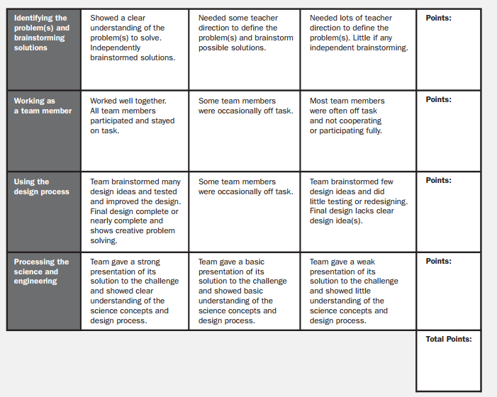

ACTION PLAN
Essential Questions
- Why are women and people of color underrepresented in STEM fields?
- What is the representation of minorities in my community?
- What can be done so all have equal access to STEM programs and jobs?
Resources
https://www.tolerance.org/classroom-resources/tolerance-lessons/stem-by-the-numbers
https://www.census.gov/prod/2013pubs/acs-24.pdf
http://edu.stemjobs.com/minority-students-in-stem/
http://www.tolerance.org/sites/default/files/general/Who%C2%B9s%20Underrepresented%20in%20STEM.pdf
https://www.youtube.com/watch?v=-v8aDo4dV3Q

In your team read the following information from the 2013 Census and Tolerance.org regarding minorities in STEM. Answer the following questions:

- What can you conclude from the information you read?
- What was most surprising?
- When thinking about the information you read, which groups of people have the most opportunities?

Identify STEM organizations in Albuquerque, New Mexico. Choose one organization to research further.

Conduct research on the demographics of the organizations.

What are the organizations doing well when it comes to representing minorities?
What needs to be improved?

Analyze the data you found.

Team:_____________________________ Date:___________ Period:_____________

on data come up an action plan for the community/organization:

And brainstorm solutions:
Solutions | Pros (+) | Cons (-)

As a team, choose one solution and write a plan of action for you and your team.
Solution | Reason

Create a learning poster describing the problem and your solutions. Make sure to reference all your resources. As a team, present your poster to the class and facilitate a discussion.

GRAFFITI WALL
Multiple Choice
Which forces are equal in size and opposite in direction?
A. balanced forces
B. net forces
C. unbalanced forces

Define:
What is inertia?

Short response:
A student launches a bottle rocket. Which of Newton’s Laws of Motion is being represented? How do you know?

Fill in the Blank
A push or a pull on an object is called a________________.

True/False
Gravity is stronger with objects that have less mass.

Matching
Match the word to the definition
Inertia | property of a moving object that equals its mass times its velocity
Acceleration | the tendency of an object to resist a change in motion
Momentum | Rate of change of velocity

