OCDE Project GLAD®

Ecosystems and Animal Interactions, 3rd Grade (NGSS, CCSS)

Ecosistemas e interacciones de los animales

IDEA PAGES

- UNIT THEMES
- An ecosystem is a specific area where living and nonliving things interact.
- Environmental factors within an ecosystem interact and change over time, which causes animals to adapt their structures and behaviors for survival.
- Humans can impact ecosystems both positively and negatively.

- FOCUS/MOTIVATION
- Literacy Awards
- Prediction Reaction Guide
- Observation Chart
- Inquiry Chart
- Teacher-Made Big Book: Ecosystems
- Cognitive Content Dictionary with signal words

- ASSESSMENT AND FEEDBACK
- On-going assessment
- Process all charts and learning
- Shared Team Tasks
- The Important Big Book of …. (student generated)
- Student Chants/ Poetry
- Portfolio/Learning Logs
- Writing Prompt with Rubric
- Personal Exploration – design and construct a model of an ecosystem for an animal with a specific adaptation
- Teacher and Student Created Tests
- State/District required assessments

- CONCEPTS

NM NGSS SCIENCE – 3RD GRADE

Disciplinary Core Ideas

LS2.D: Social Interactions and Group Behavior
Being part of a group helps animals obtain food, defend themselves, and cope with changes. Groups may serve different functions and vary dramatically in size (Note: Moved from K–2). (3-LS2-1)

LS2.C: Ecosystem Dynamics, Functioning, and Resilience
When the environment changes in ways that affect a place’s physical characteristics, temperature, or availability of resources, some organisms survive and reproduce, others move to new locations, yet others move into the transformed environment, and some die. (secondary to 3-LS4-4)

LS3.A: Inheritance of Traits
Many characteristics of organisms are inherited from their parents. (3-LS3-1)
Other characteristics result from individuals’ interactions with the environment, which can range from diet to learning. Many characteristics involve both inheritance and environment. (3- LS3-2)

LS3.B: Variation of Traits
Different organisms vary in how they look and function because they have different inherited information. (3-LS3-1)
The environment also affects the traits that an organism develops. (3-LS3-2)

LS4.C: Adaptation
For any particular environment, some kinds of organisms survive well, some survive less well, and some cannot survive at all. (3-LS4-3)

LS4.D: Biodiversity and Humans
Populations live in a variety of habitats, and change in those habitats affects the organisms living there. (3-LS4-4) Students will understand the properties, structures and processes of living things and the interdependence of living things and their environments.

Science and Engineering Practices

Engaging in Argument from Evidence
Engaging in argument from evidence in 3–5 builds on K–2 experiences and progresses to critiquing the scientific explanations or solutions proposed by peers by citing relevant evidence about the natural and designed world(s).
Construct an argument with evidence, data, and/or a model. (3-LS2-1)

Cross-Cutting Concepts

Cause and Effect
Cause and effect relationships are routinely identified and used to explain change. (3-LS2- 1)

NM SOCIAL STUDIES – 3RD GRADE

Geography Standard 1
Students understand how physical, natural and cultural processes influence where people live, the ways in which people live and how societies interact with one another and their environments. Students will:
1. Understand the concept of location by using and constructing maps, globes and other geographic tools to identify and derive information about people, places and environments;
- Identify and use the mapping tools of scale, compass rose, grid, symbols and mental mapping to locate and draw places on maps and globes;

CCSS ELA – 3RD GRADE

Reading Standards for Literature
  - RL .3.1 Ask and answer questions to demonstrate understanding of a text, referring explicitly to the text as the basis for the answers.
  - RL.3.2 Recount stories, including fables, folktales, and myths from diverse cultures; determine the central message, lesson, or moral and explain how it is conveyed through key details in the text
  - RL.3.3 Describe characters in a story (e.g., their traits, motivations, or feelings) and explain how their actions contribute to the sequence of events.
  - RL.3.4 Determine the meaning of words and phrases as they are used in a text, distinguishing literal from nonliteral language.
  - RL.3.5 Refer to parts of stories, dramas, and poems when writing or speaking about a text, using terms such as chapter, scene, and stanza; describe how each successive part builds on earlier sections
  - RL.3.6 Distinguish their own point of view from that of the narrator or those of the characters.
  - RL.3.7 Explain how specific aspects of a text’s illustrations contribute to what is conveyed by the words in a story (e.g., create mood, emphasize aspects of a character or setting).
  - RL.3.9 Compare and contrast the themes, settings, and plots of stories written by the same author about the same or similar characters (e.g., in books from a series).
  - RL.3.10 By the end of the year, read and comprehend literature, including stories, dramas, and poetry, at the high end of the grades 2–3 text complexity band independently and proficiently.

Reading Standards for Informational Text
  - RI.3.2 Determine the main idea of a text; recount the key details and explain how they support the main idea.
  - RI.3.3 Describe the relationship between a series of historical events, scientific ideas or concepts, or steps in technical procedures in a text, using language that pertains to time, sequence, and cause/effect.
  - RI.3.4 Determine the meaning of general academic and domain-specific words and phrases in a text relevant to a grade 3 topic or subject area.
  - RI.3.5 Use text features and search tools (e.g., key words, sidebars, hyperlinks) to locate information relevant to a given topic efficiently.
  - RI.3.6 Distinguish his or her own point of view from that of the author of a text.
  - RI.3.7 Use information gained from illustrations (e.g., maps, photographs) and the words in a text to demonstrate understanding of the text
  - RI.3.8 Describe the logical connection between particular sentences and paragraphs in a text (e.g., comparison, cause/effect, first/second/third in a sequence).
  - RI.3.9 Compare and contrast the most important points and key details presented in two texts on the same topic.
  - RI.3.10 By the end of the year, read and comprehend informational texts, including history/social studies, science, and technical texts, at the high end of the grades 2–3 text complexity band independently and proficiently

Foundational Skills
- RF.3.3 Know and apply grade-level phonics and word analysis skills in decoding words.
a. Identify and know the meaning of the most common prefixes and derivational
suffixes.
b. Decode words with common Latin suffixes.
c. Decode multisyllabic words.
d. Read grade-appropriate irregularly spelled words.
- RF.3.4 Read with sufficient accuracy and fluency to support comprehension.
- Read on-level text with purpose and understanding. Read on-level prose and poetry orally with accuracy, appropriate rate, and expression on successive readings.
- Use context to confirm or self-correct word recognition and understanding, rereading as necessary.

Writing Standards
- W.3.1 Write opinion pieces on topics or texts, supporting a point of view with reasons.
- Introduce the topic or text they are writing about, state an opinion, and create an organizational structure that lists reasons. Provide reasons that support the opinion.
- Use linking words and phrases to connect opinion and reasons.
- Provide a concluding statement or section.
- W.3.2 Write informative/explanatory texts to examine a topic and convey ideas and information clearly.
a. Introduce a topic and group related information together; include illustrations when useful to aiding comprehension.
b. Develop the topic with facts, definitions, and details.
c. Use linking words and phrases to connect ideas within categories of information.
d. Provide a concluding statement or section.
- W.3.3 Write narratives to develop real or imagined experiences or events using effective technique, descriptive details, and clear event sequences.
a. Establish a situation and introduce a narrator and/or characters; organize an event sequence that unfolds naturally. Use dialogue and descriptions of actions, thoughts, and feelings to develop experience and events or show the response of characters to situations.
b. Use temporal words and phrases to signal event order.
c. Provide a sense of closure.
- W.3.4 With guidance and support from adults, produce writing in which the development and organization are appropriate to task and purpose.
- W.3.5 With guidance and support from peers and adults, develop and strengthen writing as needed by planning, revising, and editing.
- W.3.6 With guidance and support from adults, use technology to produce and publish writing (using keyboarding skills) as well as to interact and collaborate with others.
- W.3.7 Conduct short research projects that build knowledge about a topic
- W.3.8 Recall information from experiences or gather information from print and digital sources; take brief notes on sources and sort evidence into provided categories.
- W.3.10 Write routinely over extended time frames (time for research, reflection, and revision) and shorter time frames (a single sitting or a day or two) for a range of discipline-specific tasks, purposes, and audiences.

Speaking and Listening Standards (SL)
- SL.3.1 Engage effectively in a range of collaborative discussions (one-on-one, in groups, and teacher led) with diverse partners on grade 3 topics and texts, building on others’ ideas and expressing their own clearly.
a. Follow agreed-upon rules for discussions (e.g., gaining the floor in respectful ways, listening to others with care, speaking one at a time about the topics and texts under discussion).
b. Ask questions to check understanding of information presented, stay on topic, and link their comments to the remarks of others.
c. Explain own ideas and understanding in light of the discussion.
- SL.3.2 Determine the main ideas and supporting details of a text read aloud or information presented in diverse media and formats, including visually, quantitatively, and orally.
- SL.3.3 Ask and answer questions about information from a speaker, offering appropriate elaboration and detail.
- SL.3.4 Report on a topic or text, tell a story, or recount an experience with appropriate facts and relevant, descriptive details, speaking clearly at an understandable pace.
- SL.3.5 Create engaging audio recordings of stories or poems that demonstrate fluid reading at an understandable pace; add visual displays when appropriate to emphasize or enhance certain facts or details.
- SL.3.6 Speak in complete sentences when appropriate to task and situation in order to provide requested detail or clarification.

Language Standards
- L.3.1 Demonstrate command of the conventions of standard English grammar and usage when writing or speaking.
a. Explain the function of nouns, pronouns, verbs, adjectives, and adverbs in general and their functions in particular sentences.
b. Form and use regular and irregular plural nouns.
c. Use abstract nouns.
d. Form and use regular and irregular verbs.
e. Form and use the simple verb tense (e.g., I walked, I walk, I will walk).
f. Ensure subject and pronoun antecedent agreement.
g. Form and use comparative and superlative adjectives and adverbs, and choose between them depending on what is to be modified.
h. Use coordinating and subordinating conjunctions.
i. Produce simple, compound and complex sentences.

- L.3.2 Demonstrate command of the conventions of standard English capitalization, punctuation, and spelling when writing.
a. Capitalize appropriate words in titles.
b. Use commas in addresses.
c. Use commas and quotation marks in dialogue.
d. Form and use possessives.
e. Use conventional spelling for high frequency and other studied words for adding suffixes to base words (e.g., sitting, smiled, cries, happiness).
f. Use spelling patterns and generalizations (e.g., words families, position-based spellings, syllable patterns, ending rules, meaningful word parts) in writing words.
g. Consult reference materials, including beginning dictionaries, as needed to check and correct spellings.
- L.3.3 Use knowledge of language and its conventions when writing, speaking, reading, or listening.
a. Choose words and phrases for effect. Recognize and observe differences between the conventions of spoken and written standard English.
- L .3.4 Determine or clarify the meaning of unknown and multiple-meaning word and phrases based on grade 3 reading and content, choosing flexibly from a range of strategies.
a. Use sentence-level context as a clue to the meaning of a word or phrase.
b. Determine the meaning of the new word formed when a known affix is added to a known word Use a known root word as a clue to the meaning of an unknown word with the same root.
c. Use glossaries or beginning dictionaries, both print and digital, to determine or clarify the precise meaning of key words and phrases.
- L.3.5 Demonstrate understanding of word relationships in word meanings.
a. Distinguish the literal and nonliteral meanings of words and phrases in context (e.g., take steps).
b. Identify real life connections between words and their use A (e.g., describe people who are friendly or helpful).
c. Distinguish shades of meaning among related words that describe states of mind or degrees of certainty
- L.3.6 Acquire and use accurately grade-appropriate conversational, general academic, and domain specific words and phrases, including those that signal spatial and temporal relationships.

CCSS en español: 3er grado, Estándares de lectura: destrezas fundamentales

Los suplementos lingüísticos al idioma español, se han marcado con letra italizada. Se ha añadido una sección para la enseñanza del acento que se relaciona y se enlaza a través de conceptos de lo impreso, la fonética, el reconocimiento de palabras y la ortografía.

Fonética y reconocimiento de palabras

3. Conocen y aplican la fonética y las destrezas de análisis de palabras a nivel de grado, en la decodificación de palabras.
a. Identifican y conocen el significado de los prefijos más comunes y los sufijos derivativos.
b. Decodifican palabras con sufijos comunes del latín.
c. Decodifican palabras de sílabas múltiples.
d. Leen palabras a nivel de grado, con deletreo irregular (ejemplo: reconocen que la h es muda, excepto en el dígrafo ch; y que la u es muda en las sílabas que, qui, gue, gui).
e. Reconocen cognados entre el inglés y español y explican las diferencias en su pronunciación y ortografía.
f. Reconocen las palabras de género masculino o femenino que no concuerdan con las reglas comunes (ejemplo: el mapa, el problema, el águila vs. las águilas).
g. Conocen y emplean diminutivos y aumentativos (ejemplo: -ito, -ote, -ón).
h. Conocen y emplean las terminaciones para la concordancia de adjetivos con sustantivos.
i. Reconocen los grados del adjetivo comparativo (ejemplo: mayor/menor) y superlativo (terminados en -ísimo).
Acentuación
j. Usan correctamente el acento escrito de acuerdo con el acento tónico en palabras ya conocidas aplicando análisis sistemático:
1. Cuentan el número de sílabas.
2. Nombran la sílaba que lleva el énfasis (última, penúltima, antepenúltima).
3. Categorizan la palabra según su acento tónico (aguda, grave, esdrújula).
4. Determinan el sonido o la letra en que termina la palabra (vocal o consonante /n/ o /s/).
5. Escriben el acento ortográfico si es necesario.
k. Reconocen que algunas palabras homófonas llevan acento escrito (acento diacrítico) para distinguir su función y significado (ejemplo: si, sí; el, él; te, té).

3er grado: Estándares de lenguaje

Normas y convenciones del español

1. Demuestran dominio de las normativas de la gramática del español y su uso al escribirlo o hablarlo.
a. Explican la función de los sustantivos, pronombres, verbos, adjetivos y adverbios en general y sus funciones en oraciones particulares.
b. Forman y usan plurales de sustantivos regulares e irregulares, incluyendo formas que requieren cambios ortográficos (ejemplo: pez, peces; lápiz, lápices; joven, jóvenes).
c. Usan sustantivos abstractos (ejemplo: libertad, belleza, amor).
d. Forman y usan verbos regulares que terminan en -ar, -er, -ir y verbos irregulares (ser, ir, haber).
e. Forman y usan los tiempos simples de los verbos (ejemplo: Yo caminé; Yo camino; Yo caminaré) y reconocen el uso de verbos en el modo subjuntivo (mandatos, expresión de posibilidad).
f. Aseguran la concordancia entre sujeto-verbo y pronombre-antecedente.* Reconocen el uso de formas verbales formales e informales (tú-usted, ustedes).
g. Forman y usan adjetivos y adverbios en sus tres grados: positivo, comparativo, superlativo, en concordancia a lo que modifican (ejemplo: Juan es alto; Pedro es más alto que Juan; Pedro es altísimo). h. Usan las conjunciones coordinadas y subordinadas.
i. Forman oraciones simples, compuestas y complejas.
j. Reconocen el cambio de significado o énfasis por la posición del adjetivo antes o después del sustantivo (ejemplo: una gran señora, una señora grande; comidas varias, varias comidas; un pobre hombre, un hombre pobre).

2. Demuestran, al escribir, dominio de normativas del español para el uso de las letras mayúsculas, signos de puntuación y ortografía.
a. Emplean la mayúscula solo en la primera letra de la primera palabra en títulos.
b. Usan comas al escribir una dirección.
c. Usan el guión largo para indicar los diálogos.
d. Usan la preposición “de” para indicar el posesivo.
e. Usan ortografía convencional para palabras de uso frecuente y para otras palabras ya estudiadas y para añadir sufijos a palabras base (ejemplo: infinitivos: sentarse, verme, verlo; gerundios: sentándose, viéndolo; mandatos: dámelo, siéntate).
f. Usan patrones de ortografía y generalizaciones al escribir las palabras (ejemplo: familias de palabras, ortografía basada en la posición, patrones silábicos, reglas para concluir, partes significativas de la palabra).
g. Consultan materia les de referencia, incluyendo diccionarios básicos, según sea necesario para revisar y corregir la ortografía o consultar traducciones.
Acentuación
h. Reconocen y emplean el acento ortográfico en palabras agudas, llanas (graves) y esdrújulas a nivel de grado.
i. Usan el acento diacrítico para distinguir palabras homófonas por su significado y función (ejemplo: te té, si, sí).

WIDA Can Do Descriptors for Third-Fifth Grade

Supporting language learners – Below are the WIDA Can Do Descriptors. These are a wonderful tool to support the NM ELD Standards. These describe what students can do at various language levels within the different language domains with support. WIDA Can Do descriptors are available at https://www.wida.us/standards/CAN_DOs/ (WIDA Can Do Descriptors Key Uses, original Can Do Descriptors and Spanish versions).
Domain | Level 1  Entering | Level 2  Emerging | Level 3  Developing | Level 4  Expanding | Level 5  Bridging | Level 6  Reaching
Listening | • Point to stated pictures, words, or phrases  • Follow one-step oral directions (e.g., physically or through drawings)  • Identify objects, figures, people from oral statements or questions (e.g., “Which one is a rock?”)  • Match classroom oral language to daily routines | • Categorize content-based pictures or objects from oral descriptions  • Arrange pictures or objects per oral information  • Follow two-step oral directions  • Draw in response to oral descriptions  • Evaluate oral information  (e.g., about lunch options) | • Follow multi-step oral directions  • Identify illustrated main ideas from paragraph-level oral discourse  • Match literal meanings of oral descriptions or oral reading to illustrations  • Sequence pictures from oral stories, processes, or procedures | • Interpret oral information and apply to new situations  • Identify illustrated main ideas and supporting details from oral discourse  • Infer from and act on oral information  • Role play the work of authors, mathematicians, scientists, historians from  oral readings, videos, or multi-media | • Carry out oral instructions containing grade-level, content-based language  • Construct models or use manipulatives to problem solve based on oral discourse  • Distinguish between literal and figurative language in oral discourse  • Form opinions of people, places, or ideas

Domain | Level 1  Entering | Level 2  Emerging | Level 3  Developing | Level 4  Expanding | Level 5  Bridging | Level 6  Reading
Speaking | • Express basic needs or conditions  • Name pre-taught objects, people, diagrams, or pictures  • Recite words or phrases from pictures of everyday objects and oral modeling  • Answer yes/no and choice  questions | • Ask simple, everyday questions (e.g., “Who is absent?”)  • Restate content-based facts  • Describe pictures, events, objects, or people using phrases or short sentences  • Share basic social  information with peers | • Answer simple content-based questions  • Re/tell short stories or events  • Make predictions or hypotheses from discourse  • Offer solutions to social conflict  • Present content-based information  • Engage in problem-solving | • Answer opinion questions with supporting details  • Discuss stories, issues, and concepts  • Give content-based oral reports  • Offer creative solutions to issues/problems  • Compare/ contrast content-based functions  and relationships | • Justify/defend opinions or explanations with evidence  • Give content-based presentations using technical vocabulary  • Sequence steps in grade level problem-solving  • Explain in detail results of inquiry (e.g., scientific  experiments)
WIDA Can Do Descriptors for Third-Fifth Grade

WIDA Can Do Descriptors for Third-Fifth Grade

Domain | Level 1  Entering | Level 2  Emerging | Level 3  Developing | Level 4  Expanding | Level 5  Bridging | Level 6  Reaching
Reading | • Match icons or diagrams with words/concepts  • Identify cognates from first language, as applicable  • Make sound/symbol/word relations  • Match illustrated words/ phrases in differing contexts (e.g., on the board, in a book) | • Identify facts and explicit messages from illustrated text  • Find changes to root words in context  • Identify elements of story grammar (e.g., characters, setting)  • Follow visually supported written directions (e.g.,  “Draw a star in the sky.”) | • Interpret information or data from charts and graphs  • Identify main ideas and some details  • Sequence events in stories or content-based processes  • Use context clues and illustrations to determine meaning of words/phrases | • Classify features of various genres of text (e.g., “and they lived happily ever after”— fairy tales)  • Match graphic organizers to different texts (e.g., compare/ contrast with  Venn diagram)  • Find details that support main ideas  • Differentiate between fact and opinion in narrative and expository text | • Summarize information from multiple related sources  • Answer analytical questions about grade-level text  • Identify, explain, and give examples of figures of speech  • Draw conclusions from explicit and implicit text at or near grade level

WIDA Can Do Descriptors for Third-Fifth Grade

Domain | Level 1  Entering | Level 2  Emerging | Level 3  Developing | Level 4  Expanding | Level 5  Bridging | Level 6  Reading
Writing | • Label objects, pictures, or diagrams from word/phrase banks  • Communicate ideas by drawing  • Copy words, phrases, and short sentences  • Answer oral questions with single words | • Make lists from labels or with peers  • Complete/produce sentences from word/ phrase banks or walls  • Fill in graphic organizers, charts, and tables  • Make comparisons using real-life or visually supported materials | • Produce simple expository or narrative text  • String related sentences together  • Compare/contrast content-based information  • Describe events, people, processes, procedures | • Take notes using graphic organizers  • Summarize content-based information  • Author multiple forms of writing (e.g., expository, narrative, persuasive) from models  • Explain strategies or use of information in solving problems | • Produce extended responses of original text approaching grade level  • Apply content-based information to new contexts  • Connect or integrate personal experiences with literature/ content  • Create grade-level stories or reports

- VOCABULARY
Tier 2 |  | Tier 3
adaptation*  body coverings  behavioral  physical  climate*  desert  characteristics*  survive*  shelter  burrow  roam  search  web  weather  sanctuary  camouflage  interaction  invasive  native  recovery  threaten  neutralize | flipper  structure  locate  blubber  hooves  beak  feathers  fur  protection  categories  diet  pincers  prey  predator  impact  pollution  disease  wildlife  biologist  endangered  manage | ecosystem  herbivore  carnivore  omnivore  habitat loss  ecology  species  hibernate  mammal  organism  migrate  echolocation  deforestation  tundra  grassland  tropical rainforest  temperate forest
Vocabulario en español Nivel 2 |  | Nivel 3
polluelo  deslizarse  aletas  jornada  calamares  kril  foca  tiburón  orca  apiñarse  grasa  plumaje  esponjoso  permanecer  voz  trompeta | guardería  impermeable  océano  cascarón  pico  acariciar  arrastrar  camarones  lanzarse  azotar  silbido | parche de cría  Antártida  pingüinera  pies palmeados  Pingüino Emperador  plumón  aves  tobogán  sustantivo  adjetivo  verbo  adverbio  frase preposicional

Tier 1 Basic words that commonly appear in spoken language. Because they are heard frequently in numerous contexts and with nonverbal communication, Tier 1 words rarely require explicit instruction. Examples of Tier 1 words are clock, baby, happy and walk.
Tier 2 High frequency words used by mature language users across several content areas. Because of their lack of redundancy in oral language, Tier 2 words present challenges to students who primarily meet them in print. Examples of Tier 2 words are obvious, complex, establish and verify.
Tier 3 Words that are not frequently used except in specific content areas or domains. Tier 3 words are central to building knowledge and conceptual understanding within the various academic domains and should be integral to instruction of content. Medical, legal, biology and mathematics terms are all examples of these words.
Beck, I. L., McKeown, M. G., Kucan, L. (2002). Bringing words to life: Robust vocabulary instruction. New York: The Guilford Press.

VI. RESOURCES AND MATERIALS

Books: English
- Animal Adaptations (My Science Library, Levels 1-2) Julie K. Lundgren, 2011
- How do Animals Adapt? (The Science of Living Things), Bobbie Kalman, 2000
- How and Why Do Animals Adapt? (All about Animals Close-Up), Bobbie Kalman, 2015
- Would You Survive? Animal and Plant Adaptation (Raintree Fusion: Life Science) John Townsend, 2005
- Animal Adaptations for Survival (Life Science Library - Powerkids Press), Elizabeth Rose, 2006
- Lobos - A Wolf Family Returns to the Wild, Brenda Peterson, 2018

Books: Spanish
- Adaptaciones de los animales por Julie Lundgren

¿Cómo se adaptan los animales? Ciencia de los Seres Vivos - Spanish

Edition, 2006 by Bobbie Kalman

Let's Explore Life Science Grades 2-3 Spanish, 10-Book Set (Spanish) 1st Edition, Teacher Created Materials

Benchmark Advance 2018- Benchmark Education Company, New Rochelle, NY
Note: Benchmark Adelante is the Spanish curriculum that parallels the English curriculum

3rd Grade Unit 3 Animal Adaptations
- Texts for Close Reading:
- Short Read 1 – Animal Disguises
- Short Read 2 – Animals’ Tools for Survival
- Word Study Read – The Remarkable Teeth of a Shark
- Extended Read 1 - Fur, Skin, Scales, or Feathers
- Word Study Read – Caterpillar Self-Defense
- Extended Read 2 – One Body, Many Adaptations
- Word Study Read – How the Chameleon Learned to Change Color

Leveled Text Titles
- Why Hummingbirds Drink Nectar
- Ostrich’s Long Neck
- Amazing Animal Senses!
- Habitats of South America
- How Rabbit Lost His Tail
- Why Polar Bears Like Snow…and Flamingos Don’t

Songs and Chants
https://www.songsforteaching.com/sciencesongslife.htm
https://www.flocabulary.com/unit/ecosystems/

informational Web Sites
www.seaworld.org
www.bushgardens.org
http://www.enchantedlearning.com
http://www.perspective.com/nature/anamalia
http://www.waynesword.palomar.edu
http://animaldiversity.org/

Animal Adaptation
http://phanimaladaptations.weebly.com/
https://www.durrell.org/kids/fun-factsheets/adaptation-factsheet/
http://www.pklifescience.com/article/481/behavioral-and-physical-adaptationslogin?username=thealberta&password=library
http://www.nhptv.org/natureworks/nwep1.htm

Mexican Gray Wolf:
https://www.fws.gov/southwest/es/mexicanwolf/
http://www.defenders.org/southwest/mexican-gray-wolf-recovery
http://www.biologicaldiversity.org/species/mammals/Mexican_gray_wolf/index.html

African Elephant:
http://www.nationalgeographic.com/animals/mammals/a/african-elephant/

Big Eared Bat:
https://www.desertmuseum.org/kids/bats/townsends.php

Hercules Beetle:
https://a-z-animals.com/animals/hercules-beetle/
http://www.softschools.com/facts/animals/hercules_beetle_facts/248/
http://www.uky.edu/Ag/CritterFiles/casefile/insects/beetles/hercules/hercules.htm

Siberian Musk Deer:
http://www.arkive.org/siberian-musk-deer/moschus-moschiferus/
https://en.wikipedia.org/wiki/Siberian_musk_deer

Ecosystem:
http://www.durrell.org/kids/fun-factsheets/habitats-factsheet/
http://addiesrainforest.weebly.com/herbivores.html

Human Impact: http://www.sheppardsoftware.com/content/animals/kidscorner/endangered_animals/whats_the_problem.htm

Sitios web informacionales – español
https://cva4cca.wordpress.com/2015/03/20/adaptaciones-de-los-animales/
http://www.botanical-online.com/animales/adaptaciones_animales.htm
http://www.teinteresasaber.com/2012/04/la-adaptacion-de-los-seres-vivos-al.html
http://cienciasprimeroeso.blogspot.com/2012/09/las-adaptaciones-de-los-animales.html
https://www.biologicaldiversity.org/espanol/especies/lobo_gris_mexicano.html

Science Experiment Websites
http://eisforexplore.blogspot.com/2012/06/animal-adaptations.html
http://hubpages.com/education/Animal-Adaptations
http://thirdgradethinkers8.blogspot.com/2013/05/animal-adaptations-engaging.html
http://www.education.com/science-fair/article/brilliant-bird-beeks/

OCDE NTC Project GLAD®
Animal Adaptations, 3rd Grade (NM standards)
PLANNING PAGES

I. FOCUS/MOTIVATION
- Three Personal Standards
- Literacy Awards
- Big Book
- Observation Charts
- Cognitive Content Dictionary
- Portfolio

II. INPUT
- Graphic Organizer – Ecosystem Brace Map
- Pictorial Input Chart – The Mexican Gray Wolf
- Narrative Input Chart – Penguin Chick
- 10-2 Lecture with primary language groups

III. GUIDED ORAL PRACTICE
- T-Graph for Social Skills: Cooperation
- Picture File Cards (open/closed sorts)
- Chants/Poetry Team co-op group evaluation
- Sentence Patterning Chart
- Daily processing of charts

IV. Reading/Writing Activities
Whole Class
  - Mind Map
  - Process Grid
  - Cooperative Strip Paragraph
  - Sentence Patterning Chart - Flip Chant
  - Story Mapping
  - Listen and Sketch

Small Group Practice (anything modeled whole class or teacher guided)
- Team Tasks
- Ear-to-Ear Reading
- Teacher-guided Flexible Reading Groups
  - Expert Groups
  - Emergent Readers Group
  - Clunkers & Links with SQ3R

Individual Work
- Learning Logs
- Reading/Writing Choice
- Interactive Journals
- Individual tasks
- Reading/Writing choices: picture file cards, add to charts, make word cards, highlight poetry booklets, focused reading, poetry booklet, flip chants

Writer’s Workshop
- Mini-Lessons
- Plan, Share, Write, Revise, Edit, Publish
- Conferencing
- Author’s Chair

- Extended Activities for Integration
  - Daily Activities
Read Aloud
Silent Sustained Reading/Book Sharing
Silent Sustained Writing
Listening Activities
Daily News/Interest Piece
Personal Interaction
Flexible group reading
Fieldtrip to wildlife open space
- Occasional Activities
Guest speaker: Wildlife biologist
Hands-on Explorations and Experiments
Team/Personal Exploration
- Interest pieces – guest speakers, videos, movies

VI. Assessment and Feedback
- Re-visit Inquiry Chart
- Learning Logs
- Writing Prompt with Rubric
- Student Generated Tests
- Team Task Presentations
- Student Portfolio and Presentation – Model Habitat
- Graffiti Wall
- Student Action Plan
- Vocabulary strips of “Where’s my answer?”
- Personal Exploration with Rubric
- Teacher-created Exams

OCDE NTC Project GLAD®
Animal Adaptations, 3rd Grade (NM standards)
SAMPLE DAILY LESSON PLAN
NOTE: Italicized strategies are used frequently in the classroom. Each day is the equivalent of 1 to 1 ½ weeks of instruction. Page numbers match strategy in Project GLAD® Learning Guide.

DAY 1:

FOCUS/MOTIVATION
- Cognitive Content Dictionary w/Signal Word, p.45
- Three Personal Standards and Literacy Awards, pgs.31-33
- Observation Charts, p.49
- Prediction Reaction Guide, p.39
- Inquiry Chart, p.51
- Teacher Made Big Book - The Important Book about Animal Adaptation, p.54
- Portfolios, p.268

INPUT
- Graphic Organizer Input Chart - World Map – Biomes of the World, p.83
- Pictorial Input Chart—Mexican Gray Wolf, p. 89

GUIDED ORAL PRACTICE
- Chants, p.145
- T-graph for social skills – Team Points
- Picture File Cards, p.138
-Free Exploration
-open sort – list, group, label
-closed sort – provide categories
- 10/2 lecture with primary language (GO and PIC), p.124
Learning log, p.240
ELD review, p.125

READING/WRITING
- Listen & Sketch, p.238
- Interactive Journals, p.236

EXTENDED ACTIVITIES FOR INTEGRATION
- Hands-on Explorations and Experiments/ Guest Speaker/ Field Trip

ASSESSMENT/FEEDBACK
- Home/School Connection, p.156
- Process inquiry charts, chants and input charts
- Learning Logs

SAMPLE DAILY LESSON PLAN
NOTE: Italicized strategies are used frequently in the classroom. Each day is the equivalent of 1 to 1 ½ weeks of instruction. Page numbers match strategy in Project GLAD® Learning Guide.

DAY 2:

FOCUS/MOTIVATION
- Cognitive Content Dictionary w/Signal Word, p.45
- Process Home/School Connection, p.156
- Three Personal Standards and Literacy Awards, pgs.31-33
- Process Chant (TPR, highlight, sketch, picture file cards)

GUIDED ORAL PRACTICE
- Graphic Organizer and Pictorial Input Chart Review with word cards (differentiated cards), pgs.83, 89

INPUT
- Narrative Input – Penguin Chick, p.101

GUIDED ORAL PRACTICE
- Chants (TPR, highlight, sketch, picture file cards, p.145
- Review T-Graph for Social Skills, p.135

Team Tasks, p.184
- 10/2 lecture with primary language (Narrative Input Chart), p.124
Learning log, p.240
ELD review & primary language preview/review, p.125

READING/WRITING
- Team Tasks, p.184
- Expert Group, p.187
Team Share & Process T-graph, p.135

GUIDED ORAL PRACTICE
- Narrative Input - Review with word cards and conversation bubbles, p.101
Learning Log, p.240
- Chants, p.145
- Sentence Patterning Chart (AKA Farmer-in-the-Dell), p.151
- w/Reading Game and Trading Game, p.179

EXTENDED ACTIVITIES FOR INTEGRATION
- Hands-on Explorations and Experiments/ Guest Speaker/ Field Trip

ASSESSMENT/FEEDBACK
- Process charts/ chants
- Home/School Connection
- Learning Log

SAMPLE DAILY LESSON PLAN
NOTE: Italicized strategies are used frequently in the classroom. Each day is the equivalent of 1 to 1 ½ weeks of instruction. Page numbers match strategy in Project GLAD® Learning Guide.

DAY 3:

FOCUS/MOTIVATION
- Cognitive Content Dictionary w/Signal Word, p.45
- Process Home/School connection, p.156
- Process T-graph, p.135

READING/WRITING
- Team Tasks, p.184
- Expert Group, p.187
- Team Share & Evaluation

FOCUS/MOTIVATION
- Three Standards and Literacy Awards, p.31

GUIDED ORAL PRACTICE
- Mind Map, p.196
- Process Grid Game, p.200

READING/WRITING
- Cooperative Strip Paragraph, p.203
-read, respond, revise, edit
- Found Poetry, pgs.175-176

GUIDED ORAL PRACTICE
- Narrative Input - Review with story map, p.201
- Poems/Chants, p.145
- Sentence Patterning Chart (AKA Farmer-in-the-Dell) – change verb to –ing, p.151

READING/WRITING
- Flip Chant, p.181
- Read Aloud
- Interactive Journals, p.236

EXTENDED ACTIVITIES FOR INTEGRATION
- Hands-on Explorations and Experiments/ Guest Speaker/ Field Trip

ASSESSMENT/FEEDBACK
- Process Inquiry Chart
- Home School Connection
- Learning Log

SAMPLE DAILY LESSON PLAN
NOTE: Italicized strategies are used frequently in the classroom. Each day is the equivalent of 1 to 1 ½ weeks of instruction. Page numbers match strategy in Project GLAD® Learning Guide.

DAY 4:

FOCUS/MOTIVATION
- Cognitive Content Dictionary with “stumper word” (student self-selected vocabulary), p.45
- Process Home School Connection, p.156
- Three Personal Standards and Literacy Awards, p.31

GUIDED ORAL PRACTICE
- Poetry/Chants, p.145

READING/WRITING
- Process T-Graph & Oral Evaluation, p.135
- Team tasks, p.184
- Flexible Groups Reading- leveled, skill, heterogeneous, homogeneous, ELD
- Emergent reader group, p.214
- Clunker and Links- at or above grade level with SQ3R, p.219
- ELD Group Frame-- Story or Chart Retell, p.265
- Team Presentations, p.277
- Ear-to-Ear Reading with Poetry Booklet, p.234
- Read the Walls with individual CCD, p.46
- Personal Exploration Work

EXTENDED ACTIVITIES FOR INTEGRATION
- Hands-on Explorations and Experiments/ Guest Speaker/ Field Trip
- Team/Personal Exploration

ASSESSMENT/FEEDBACK
- Interactive Journals, p.236
- Process Inquiry Chart, p.51
- Action Plan, p.270
- Graffiti Wall, p.279
- Writing Prompt with Rubric
- Personal Exploration, p.275 – Habitat Model

SAMPLE DAILY LESSON PLAN
NOTE: Italicized strategies are used frequently in the classroom. Each day is the equivalent of 1 to 1 ½ weeks of instruction. Page numbers match strategy in Project GLAD® Learning Guide.

DAY 5:

FOCUS/MOTIVATION
- Cognitive Content Dictionary with “stumper word” (student self-selected vocabulary), p.45
- Process Home School Connection, p.156
- Three Personal Standards and Literacy Awards p.31
- Poetry/Chants

READING/WRITING
- Action Plan, p.270
- Team Tasks
-Add to the Walls
-Individual tasks
- Process T-graph, p.135
Written Evaluation
Team Presentation
- Interactive Journals, p. 236
- Listen and Sketch, p.238
- Flexible group reading
- Guided reading
Team Task Ideas:
- Team Big Book Page "The Most Important Thing About …"
- Team Evaluation
- Team Presentation

EXTENDED ACTIVITIES FOR INTEGRATION
- Team/Personal Exploration

ASSESSMENT/FEEDBACK
- Personal Exploration w/the Inquiry Chart
- Expert Group Presentations
- Share Team Explorations, pgs.273-274
- Teacher and Student Generated Test, p.269

Wildlife Biologist Bookmarks/ Marcapáginas del biólogo de vida silvestre
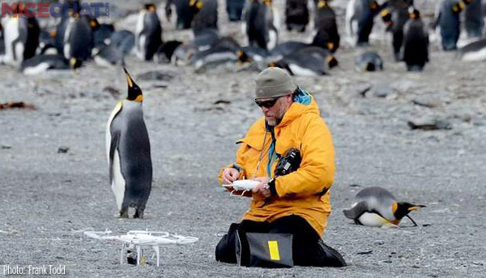  Los biólogos de la vida silvestre a menudo trabajan al aire libre en el campo, recopilando datos y estudiando los animales en sus hábitats naturales.  Atrás de este reconocimiento, dibuja o escribe sobre el animal que está estudiando este biólogo de la vida silvestre. | 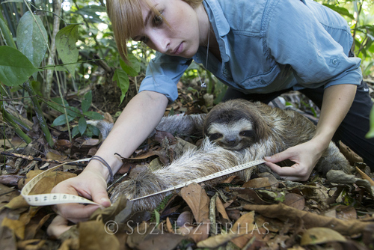  This wildlife biologist is working with a sloth in a country called Costa Rica. Sloths are an endangered species, which means that they are in danger of extinction. She is measuring it to see how much it has grown.  On the back, sketch or write about what you know about endangered animals. | 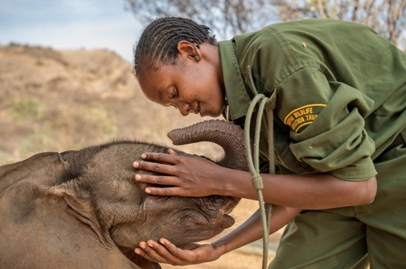  Un bebé elefante depende mucho de su madre, al igual que los bebés humanos. Este elefante bebé africano fue separado de su madre. Los biólogos de la vida silvestre lo rescataron y lo llevaron a un santuario donde podrían cuidarlo con otros elefantes.  Atrás de este reconocimiento, dibuja o escribe sobre cómo cuidarías a un bebé elefante. | 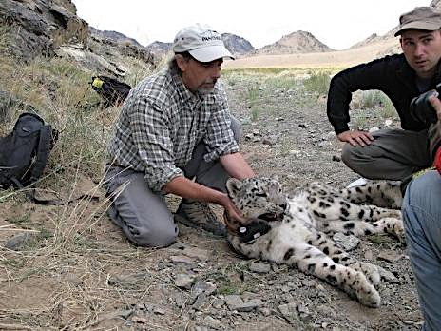  These wildlife biologists are putting a radio collar on a snow leopard in a country called Nepal. The radio collar will allow them to study the behaviors of the snow leopard. It is an endangered animal, which means that they are not many left and there is a possibility that snow leopards will die off.  On the back, write or sketch about what you think the wildlife biologists will learn about the snow leopard with the radio collar.
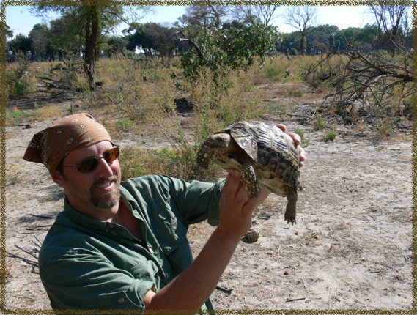  Este biólogo de vida silvestre está trabajando con una tortuga de caja. Los biólogos de la vida silvestre disfrutan aprendiendo y ayudando a conservar o salvar la vida silvestre. Los biólogos de la vida silvestre trabajan "en el campo", lo que significa que estudian la vida silvestre en su hábitat natural, en lugar de en un laboratorio.  Atrás de este reconocimiento, dibuja o escribe sobre por qué es importante conservar o salvar la vida silvestre. | 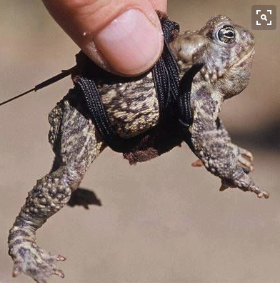  A wildlife biologist captured this Wyoming toad. Then he or she put a tiny backpack and a radio transmitter on it. This makes it so the movement of the toad can be studied. Wildlife biologists are working hard to figure out ways to keep the Wyoming toad from extinction.  Look up the word extinction in a dictionary. On the back, write the definition and add a sketch of the Wyoming toad.
Wildlife Biologist Awards

Word Search

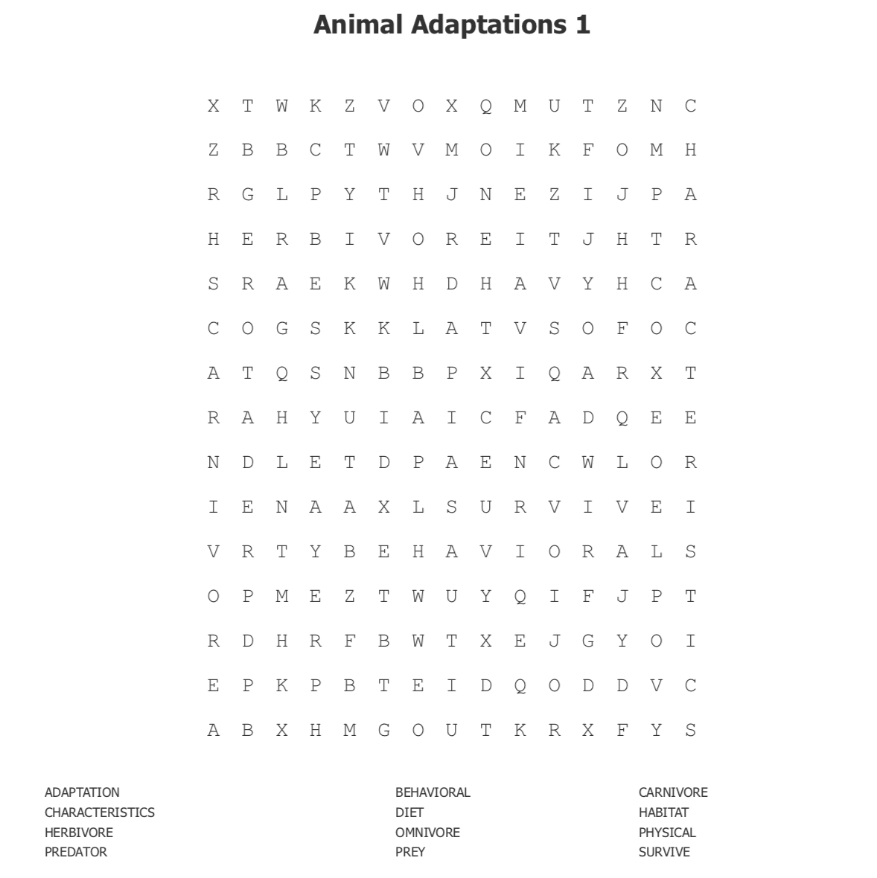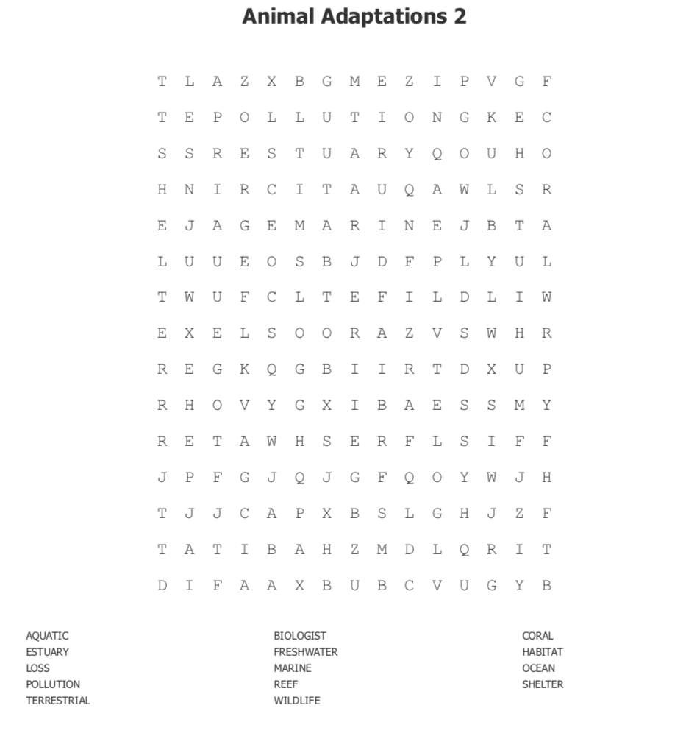

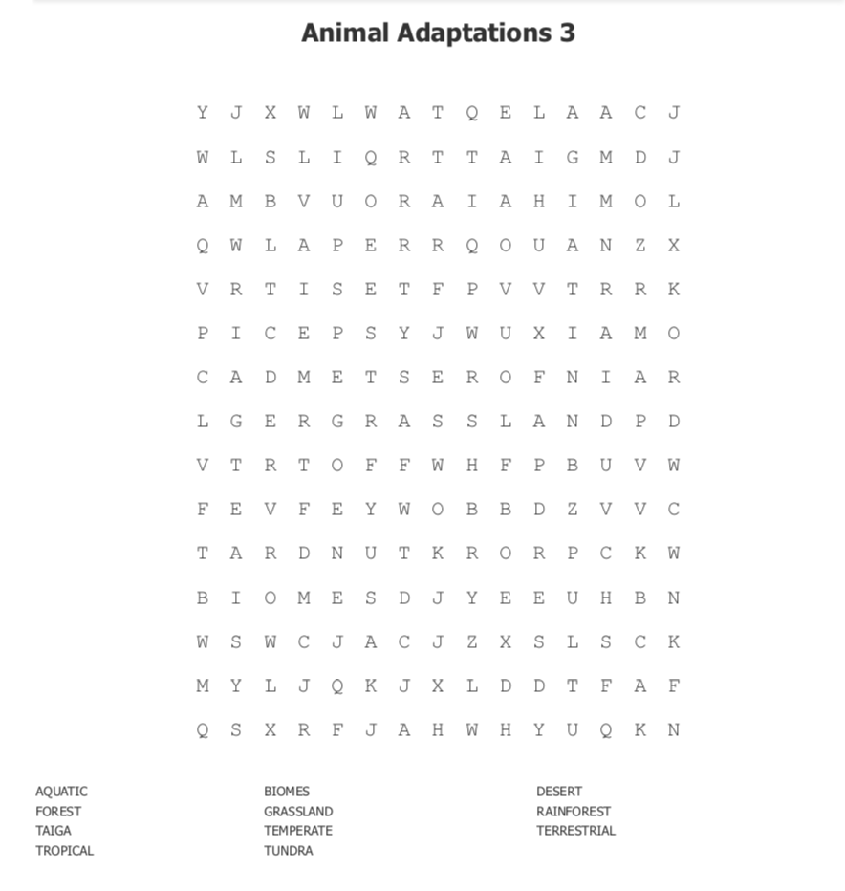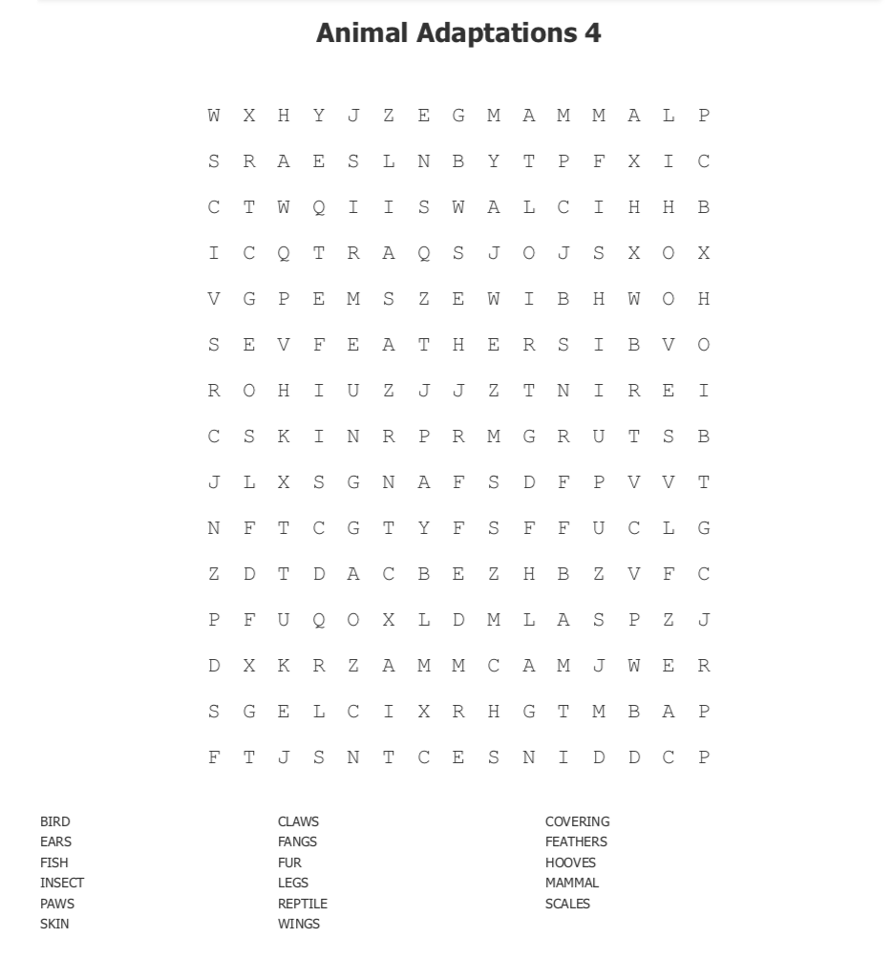

Wildlife Biologist Awards/ Reconocimientos del biólogo de vida silvestre
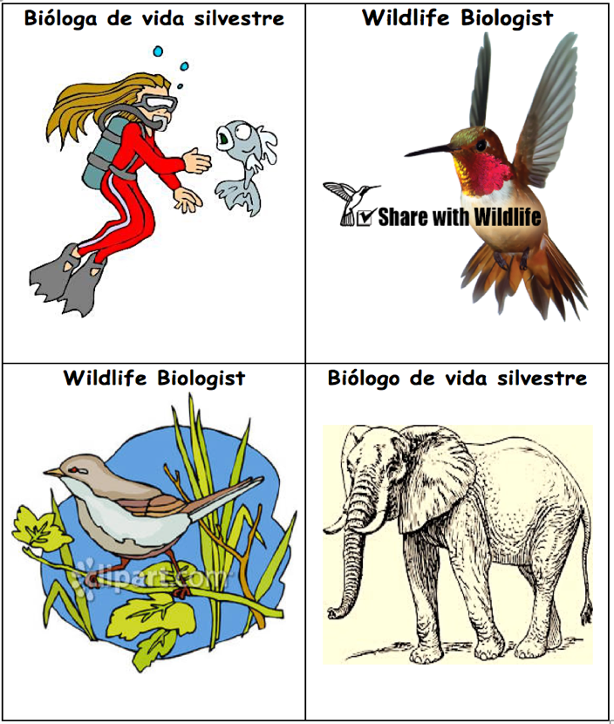

Wildlife Biologist Awards/ Reconocimientos del biólogo de vida silvestre

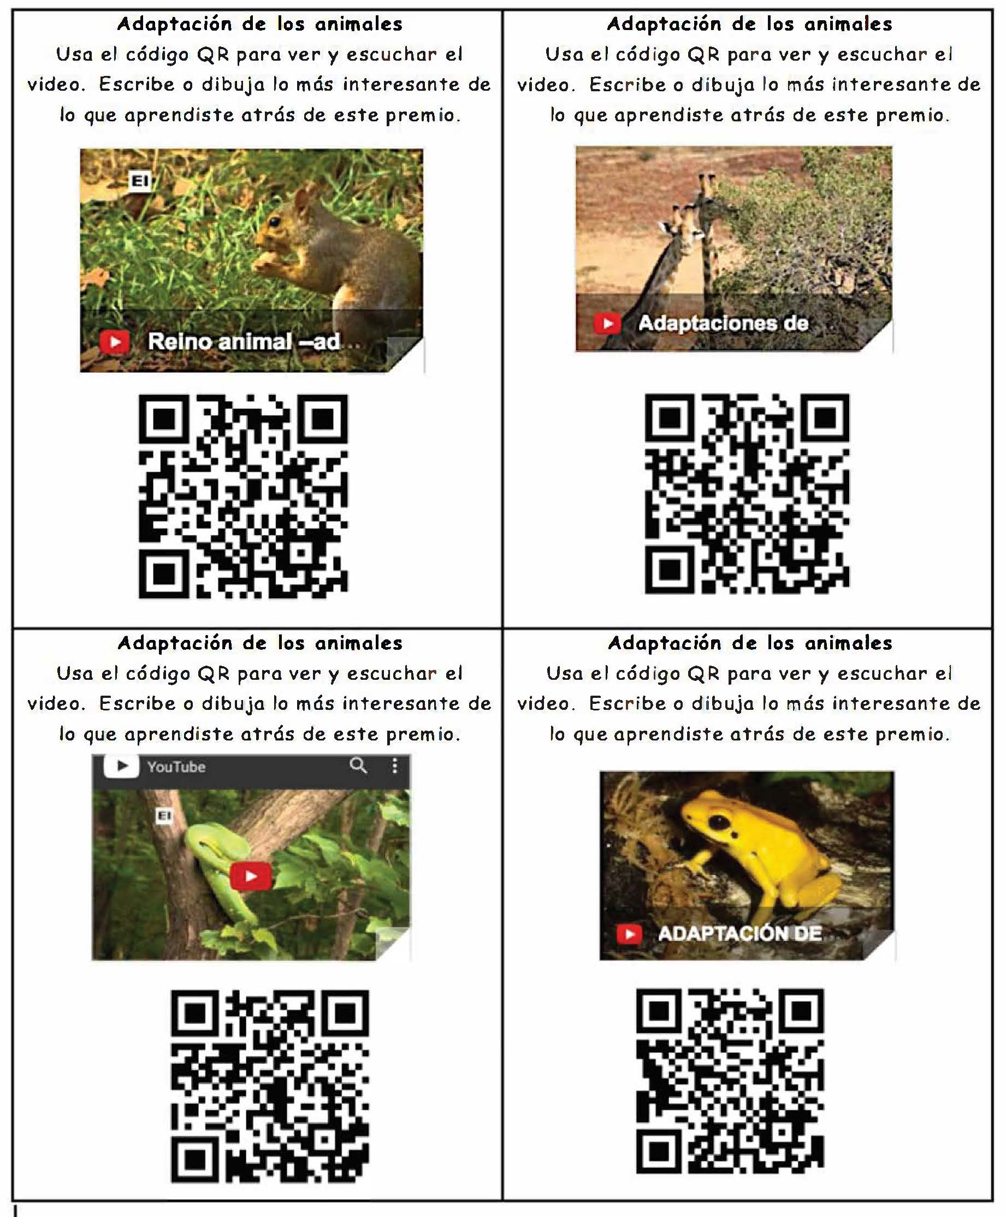

Hercules Beetle  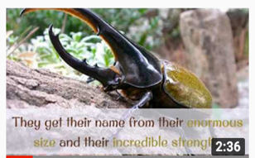  Write or draw the most  interesting thing you learned from the video. Match it to a chart on the wall and add your information. | African Elephant  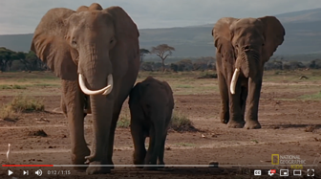  Write or draw the most  interesting thing you learned from the video. Match it to a chart on the wall and add your information.
Siberian Musk Deer  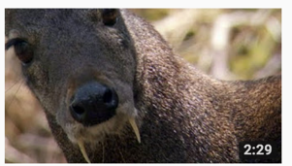  Write or draw the most  interesting thing you learned from the video. Match it to a chart on the wall and add your information. | Mexican Gray Wolf  (El lobo)  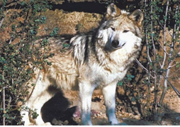  Write or draw the most  interesting thing you learned from the video. Match it to a chart on the wall and add your information.
Baby Emperor Penguins  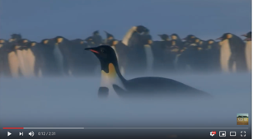  Write or draw the most  interesting thing you learned from the video. Match it to a chart on the wall and add your information. | Mexican Gray Wolf  (facts)  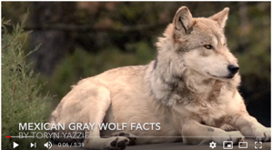  Write or draw the most  interesting thing you learned from the video. Match it to a chart on the wall and add your information.

Prediction/Reaction Guide
Directions: Please respond by sketching and writing below.

- What does animal adaptation mean?
Reaction
Prediction

- What does ecosystem mean?
Reaction
Prediction

- What are some behaviors of animals that help them survive in cold climates?
Prediction
Reaction

- What impact do humans have on animal environments?
Reaction
Prediction

- Give an example of how animals depend on other animals and plants.
Prediction
Reaction

Ecosystems:
Animal Interactions

by Michelle-Desiree Lobato and Kavita Krishna

Table of Contents

Ecosystems and Environmental Factors Page 1
Animal Habitats and Shelters Page 2
Animal Diets Page 3
Structural Adaptations of Animals Page 4
Behavioral Adaptations of Animals Page 5
Human Impact on Ecosystems Page 6
The Role of Wildlife Biologists Page 7
Glossary Page 8

Page 1

Environmental factors within an ecosystem interact and change over time, which causes animals to adapt their structure and behaviors.

- All organisms, or living things, are part of an ecosystem.
- An ecosystem is an area where a community of organisms interact with each other and with the nonliving parts of their environment. Ecosystems can be large, like deserts, or small, like ponds.
- The living or biotic parts of an ecosystem include plants, animals, and other organisms. The abiotic or nonliving parts include soil, temperature, sunlight, and rainfall.
- All of these environmental factors affect how well an animal can survive in an ecosystem. For example, if an ecosystem’s temperature gets warmer, the plants that grow there may change. Animals that eat plants or need them for shelter will adjust to the changes, move to another ecosystem, or die.

Environmental factors within an ecosystem interact and change over time, which causes animals to adapt their structure and behaviors.

Page 2

Environmental factors within an ecosystem interact and change over time, which causes animals to adapt their structure and behaviors.

- A habitat is the special place where a plant or animal lives. An animal needs five things to survive in its habitat: food, water, shelter, air, and a place to raise its young.
- Animals require different amounts of space. Habitats can be big like a forest or they can be much smaller like a burrow. Some animals roam over a large area, while other animals need only a small amount of space.
- Just like you live in a house, animals have shelters that keep them safe. Like humans, animals leave their shelters to search in their habitats for food and other materials they need.

Environmental factors within an ecosystem interact and change over time, which causes animals to adapt their structure and behaviors.

Page 3

Environmental factors within an ecosystem interact and change over time, which causes animals to adapt their structure and behaviors.

- In order to survive, animals must eat other living organisms, including both plants and other animals. Animals also need water.
- What an animal eats is called its diet. Animals are divided into three groups according to their diet: herbivores, omnivores, and carnivores.
- Animals who only eat plants are called herbivores. Elephants, rabbits, and deer are examples of herbivores.
- Animals who eat both plants and other animals are called omnivores. Humans, raccoons and bears are all omnivores.
- Animals who only eat other animals are called carnivores. Carnivores, such as wolves, sharks, and many bats, usually have sharp teeth and strong jaws so they can catch other animals. Carnivores are predators because they hunt other animals, called prey.

Environmental factors within an ecosystem interact and change over time, which causes animals to adapt their structure and behaviors.

Page 4

Environmental factors within an ecosystem interact and change over time, which causes animals to adapt their structure and behaviors.

- Adaptations are any structural or behavioral characteristics animals have developed over time that help them survive in their environments.
- These characteristics or traits fall into three main categories:
    - body parts
    - body coverings
    - behaviors
- Structural adaptations have to do with animals’ bodies. Some examples of structural adaptations are webbed, hooved or clawed feet; length and sharpness of teeth; the size and shape of a beak; and feathers, fur, or scales covering the body.

Environmental factors within an ecosystem interact and change over time, which causes animals to adapt their structure and behaviors.

Page 5

Environmental factors within an ecosystem interact and change over time, which causes animals to adapt their structure and behaviors.

- Behavioral adaptations are what an animal does in order to survive in its environment. Behavioral adaptions often fall into three categories:
      - how an animal gets its food and water,
      - how an animal moves, and
      - how an animal protects itself.
- Some animals, like the camel, have developed ways to store food and water in their bodies so they can survive a long time without eating or drinking.
- Many animals live in groups or families in shelters. This behavior protects them from predators and harsh weather.
- Animals that can fly or run quickly have developed these behaviors to help them move from place to place and to escape predators. Deer can often outrun wolves chasing them.

Environmental factors within an ecosystem interact and change over time, which causes animals to adapt their structure and behaviors.

Page 6

Environmental factors within an ecosystem interact and change over time, which causes animals to adapt their structure and behaviors.

- As the number of humans on our planet has grown, the impact on animal populations has been great.
- Humans have destroyed over half of the world’s forests to make places to live, like cities. The remaining forests are shrinking fast. Habitat loss is the biggest threat to wildlife today.
- Humans provide food for each other through farming, but animal populations can suffer if farms are not managed properly. Chemicals used on crops affect the water and food in an ecosystem. Farms can also cause habitat loss by taking up large areas of land for growing crops or cattle grazing.
- Pollution caused by the use of coal, gas and other energy sources has caused harmful changes that affect animal habitats. Pollution can destroy many living things in an ecosystem.

Environmental factors within an ecosystem interact and change over time, which causes animals to adapt their structure and behaviors.

Page 7

Environmental factors within an ecosystem interact and change over time, which causes animals to adapt their structure and behaviors.

- Wildlife biologists are people who study and manage wild animals, their behaviors, and their habitats.
- They create and carry out plans to protect endangered and threatened animal species.
- They evaluate the impact of humans on wildlife and find ways to lessen the effects of humans on ecosystems.
- Educating the public on wildlife ecology can be an important part of a wildlife biologist job.

Environmental factors within an ecosystem interact and change over time, which causes animals to adapt their structure and behaviors.

Page 8
Glossary
abiotic (adj.) – something that is not alive; sun, air, water, soil
adaptation (n.) – behavioral and structural characteristics that animals have developed over time to survive
behavioral (adj.) – the responses, reactions, or movements made by an organism in any situation
biotic (adj.) – anything that is alive; plants, animals, bacteria
carnivore (n.) – an animal that eats other animals
characteristic (n.) – a distinguishing quality
diet (n.) – the usual food and drink consumed by an organism
ecosystem (n.) – an area where a community of organisms interacts with each other and with the nonliving parts of their environment
endangered (adj.) – seriously at risk of extinction, or dying out
environmental factor (n.) – a biotic part or an abiotic part of an ecosystem that affects a living organism
farming (n.) – the job or business of running a farm (an area of land where humans grow crops, or plants for food)

grazing (n.) – when animals eat grass in a pasture
habitat (n.) – the local home of an animal or plant
habitat loss (n.) – when a natural habitat is unable to support the organisms that live in it
herbivore (n.) – an animal that only eats plants
impact (n.) – influence or effect
interact (v.) – have an effect on each other
omnivore (n.) – an animal that eats both plants and other animals
organism (n.) – any individual living thing
structural (adj.) – having to do with the physical body of an organism
pollution (n.) – the introduction of harmful substances or products into the environment
predator (n.) – an animal that survives by preying upon or hunting other animals
prey (n.) – an animal hunted for food, especially by a carnivorous animal
shelter (n.) – a place an animal lives in to keep safe and raise its young
wildlife biologist (n.) – a scientist that studies plants and animals in the wilderness

Ecosistemas:
Interacciones de animales

por: Michelle-Desiree Lobato y Kavita Krishna

Tabla de contenido

Factores ecológicos y medioambientales Página 1
Hábitats y refugios de los animales Página 2
Dietas de animales Página 3
Adaptaciones estructurales de animales Página 4
Adaptaciones de comportamiento de animales Página 5
Impacto humano en ecosistemas Página 6
El papel de los biólogos de la vida silvestre Página 7
Glosario Página 8

página 1
Factores medioambientales dentro de un ecosistema interactúan y cambian con el tiempo, lo que causa que los animales adapten sus estructuras y comportamientos.
- Todos los organismos, o cosas vivientes, son partes de un ecosistema.
- Un ecosistema es un área donde una comunidad de organismos interactúa uno con el otro y con las partes no vivientes de su ambiente. Los ecosistemas pueden ser grandes, como desiertos, o pequeños, como estanques.
- Las partes vivientes o bióticas de un ecosistema incluyen plantas, animales, y otros organismos. Las partes abióticas, o no vivientes incluyen tierra, temperatura, luz solar, y lluvia.
- Todos estos factores medioambientales afectan qué tan bien puede sobrevivir un animal en un ecosistema. Por ejemplo, si la temperatura de un ecosistema sea calienta, las plantas que crecen ahí pueden cambiar. Los animales que comen plantas o las necesitan para refugio se acostumbrarán; se moverán de ecosistema, o morirán.
Factores medioambientales dentro de un ecosistema interactúan y cambian con el tiempo, lo que causa que los animales adapten sus estructuras y comportamientos.

página 2
Factores medioambientales dentro de un ecosistema interactúan y cambian con el tiempo, lo que causa que los animales adapten sus estructuras y comportamientos.
- Un hábitat es el lugar especial donde vive una planta o un animal. Un animal necesita cinco cosas para sobrevivir en su hábitat: comida, agua, refugio, aire, y un lugar para criar a sus crías.
- Los animales requieren diferentes tamaños de espacio. Hábitats pueden ser grandes como un bosque o pueden ser mucho más pequeños como una madriguera. Algunos animales vagan por un área grande, mientras que otros animales solo necesitan un espacio pequeño.
- Al igual que tú vives en una casa, los animales también tienen refugios que los mantienen seguros. Como los humanos, los animales salen de su refugio para buscar en su hábitat comida y otros materiales que necesitan.

Factores medioambientales dentro de un ecosistema interactúan y cambian con el tiempo, lo que causa que los animales adapten sus estructuras y comportamientos.
página 3
Factores medioambientales dentro de un ecosistema interactúan y cambian con el tiempo, lo que causa que los animales adapten sus estructuras y comportamientos.
- Para poder sobrevivir, los animales deben comer otros organismos vivos, incluyendo a plantas y otros animales. Los animales también necesitan agua.
- Lo que un animal come se llama su dieta. Los animales se dividen en tres grupos según su dieta: herbívoros, omnívoros, y carnívoros.
- Animales que solo comen plantas se llaman herbívoros. Elefantes, conejos, y venados son ejemplos de animales herbívoros.
- Los animales que comen tanto plantas como otros animales se llaman omnívoros. Humanos, mapaches, y osos son omnívoros.
- Animales que solo comen otros animales se llaman carnívoros. Carnívoros, como los lobos, tiburones, y muchos murciélagos, usualmente tienen dientes afilados y mandíbulas fuertes para poder atrapar a otros animales. Los carnívoros son depredadores porque cazan otros animales, llamados presas.
Factores medioambientales dentro de un ecosistema interactúan y cambian con el tiempo, lo que causa que los animales adapten sus estructuras y comportamientos.
página 4
Factores medioambientales dentro de un ecosistema interactúan y cambian con el tiempo, lo que causa que los animales adapten sus estructuras y comportamientos.
- Las adaptaciones son cualquier característica estructural o de comportamiento que los animales han desarrollado con el tiempo que les ayuda a sobrevivir en su medio ambiente. Estas características o rasgos se dividen en tres categorías principales:
  - partes del cuerpo
  - coberturas del cuerpo
  - comportamientos
- Las adaptaciones estructurales tienen que ver con los cuerpos de los animales. Algunos ejemplos de adaptaciones estructurales son; pies palmeados, enganchados, o con garras; longitud y qué tan filosos son los dientes; el tamaño y la forma de un pico; y plumas, pelaje, o escamas cubriendo el cuerpo.
Factores medioambientales dentro de un ecosistema interactúan y cambian con el tiempo, lo que causa que los animales adapten sus estructuras y comportamientos.
página 5
Factores medioambientales dentro de un ecosistema interactúan y cambian con el tiempo, lo que causa que los animales adapten sus estructuras y comportamientos.
- Las adaptaciones de comportamiento son las cosas que los animales hacen para sobrevivir en su medio ambiente. Las adaptaciones de comportamiento, a menudo se dividen en tres categorías:
  - cómo un animal obtiene su comida y agua,
  - cómo un animal se mueve, y
  - cómo un animal se protege a sí mismo.
- Algunos animales, como los camellos, han desarrollado maneras de almacenar comida y agua en sus cuerpos para poder sobrevivir un largo tiempo sin comer o tomar agua.
- Muchos animales viven en grupos o familias en refugios. Este comportamiento los protege de los depredadores y del mal tiempo.
- Animales que pueden volar o correr rápido, han desarrollado estos comportamientos para ayudarles a moverse de un lugar a otro y para escapar de los depredadores. Los venados a menudo pueden escapar de los lobos que los persigue.
Factores medioambientales dentro de un ecosistema interactúan y cambian con el tiempo, lo que causa que los animales adapten sus estructuras y comportamientos.
página 6
Factores medioambientales dentro de un ecosistema interactúan y cambian con el tiempo, lo que causa que los animales adapten sus estructuras y comportamientos.
- Mientras el número de humanos en nuestro planeta ha crecido, el impacto en la población animal ha sido enorme.
- Los humanos han destruido más de la mitad de los bosques del mundo para construir lugares en donde vivir, como por ejemplo las ciudades. Los bosques que quedan se están reduciendo rápidamente.
- La pérdida de hábitat es la mayor amenaza para la vida silvestre hoy en día. Los humanos proveen comida para sí mismos a través de la agricultura, pero la población animal puede sufrir si las fincas no se manejan adecuadamente. Productos químicos utilizados en los cultivos afectan el agua y la comida en un ecosistema. Las granjas también pueden causar la pérdida de hábitat tomando grandes áreas de espacio de tierra para cultivos o pastoreo de ganado.
- La contaminación causada por el uso de carbón, gas, y otras fuentes de energía ha causado cambios dañinos que afectan el hábitat de los animales. La contaminación puede destruir muchos seres vivos en un ecosistema.
Factores medioambientales dentro de un ecosistema interactúan y cambian con el tiempo, lo que causa que los animales adapten sus estructuras y comportamientos.
página 7
Factores medioambientales dentro de un ecosistema interactúan y cambian con el tiempo, lo que causa que los animales adapten sus estructuras y comportamientos.
- Los biólogos de la vida silvestre son personas que estudian y manejan animales salvajes, sus comportamientos, y sus hábitats.
- Crean y llevan a cabo planes de protección para especies de animales amenazadas y en peligro de extinción.
- Evalúan el impacto de los humanos en la vida silvestre y encuentran maneras de disminuir los efectos de los humanos en los ecosistemas.
- Educar al público sobre la ecología de la vida silvestre es una parte importante del trabajo de un biólogo silvestre.
Factores medioambientales dentro de un ecosistema interactúan y cambian con el tiempo, lo que causa que los animales adapten sus estructuras y comportamientos.
página 8
Glosario
abiótico (adj.) – algo que no está vivo; sol, aire, agua, tierra
adaptación (sus..) – características estructurales y de comportamiento que los animales han desarrollado con el paso del tiempo para sobrevivir
agricultura (sus.) – el trabajo o negocio de dirigir una granja (un área de tierra donde los humanos producen cultivos, o plantas para la alimentación)
biótico (adj.) – cualquier cosa que esté viva; plantas, animales, bacteria
biólogo de vida silvestre (sus.) – un científico que estudia las plantas y los animales en la naturaleza
carnívoro (sus.) – un animal que come otros animales
característica (sus.) – una cualidad distintiva
comportamiento (adj.) – las respuestas, reacciones, o movimientos realizados por un organismo en cualquier situación
contaminación (sus.) – la introducción de substancias dañinas o productos nocivos en el medio ambiente
depredador (sus.) – un animal que sobrevive cazando a otros animales
dieta (sus.) – la comida y bebida habitual consumida por un organismo
ecosistema (sus.) – el área donde una comunidad de organismos interactúa entre sí y con las partes no vivientes de su ecosistema
estructural (adj.) – tiene que ver con el cuerpo físico de un organismo
factores ambientales (sus.) – una parte biótica o una parte abiótica de un ecosistema que afecta a un organismo vivo
hábitat (sus.) – el hogar local de un animal o una planta
herbívoro (sus.) – un animal que solo come plantas
impacto (sus.) – influencia o efecto
interacción (v.) – tener un efecto uno con el otro
omnívoro (sus.) – un animal que come plantas y a otros animales
organismo (sus.) – cualquier cosa viviente
pastoreo (sus.) – cuando los animales comen pasto en la pastura
peligro de extinción (adj.) – seriamente en peligro de desaparecer o morir
pérdida de hábitat (sus.) – cuando el hábitat natural no es capaz de apoyar a los organismos que viven dentro de él
presa (sus.) – un animal cazado como comida, especialmente por un animal carnívoro
refugio (sus.) – lugar donde vive un animal, donde se mantiene a salvo y cría a sus crías

Graphic Organizer: Ecosystem Brace Map

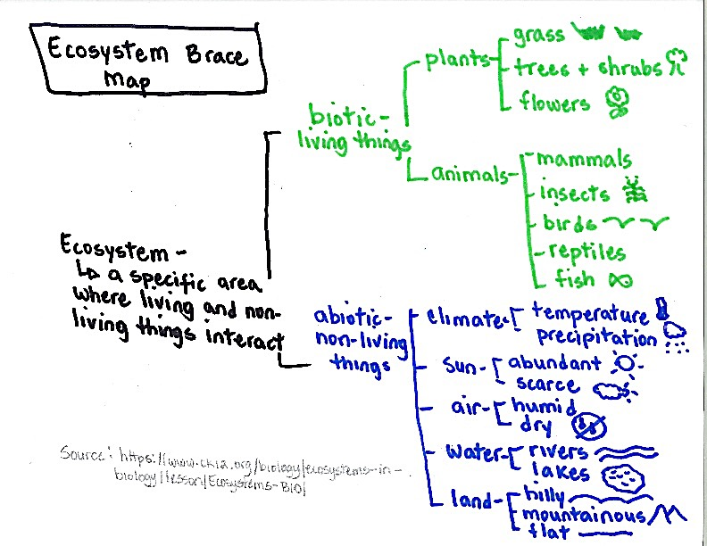

Organizador gráfico: Mapa de organización - Los Ecosistemas

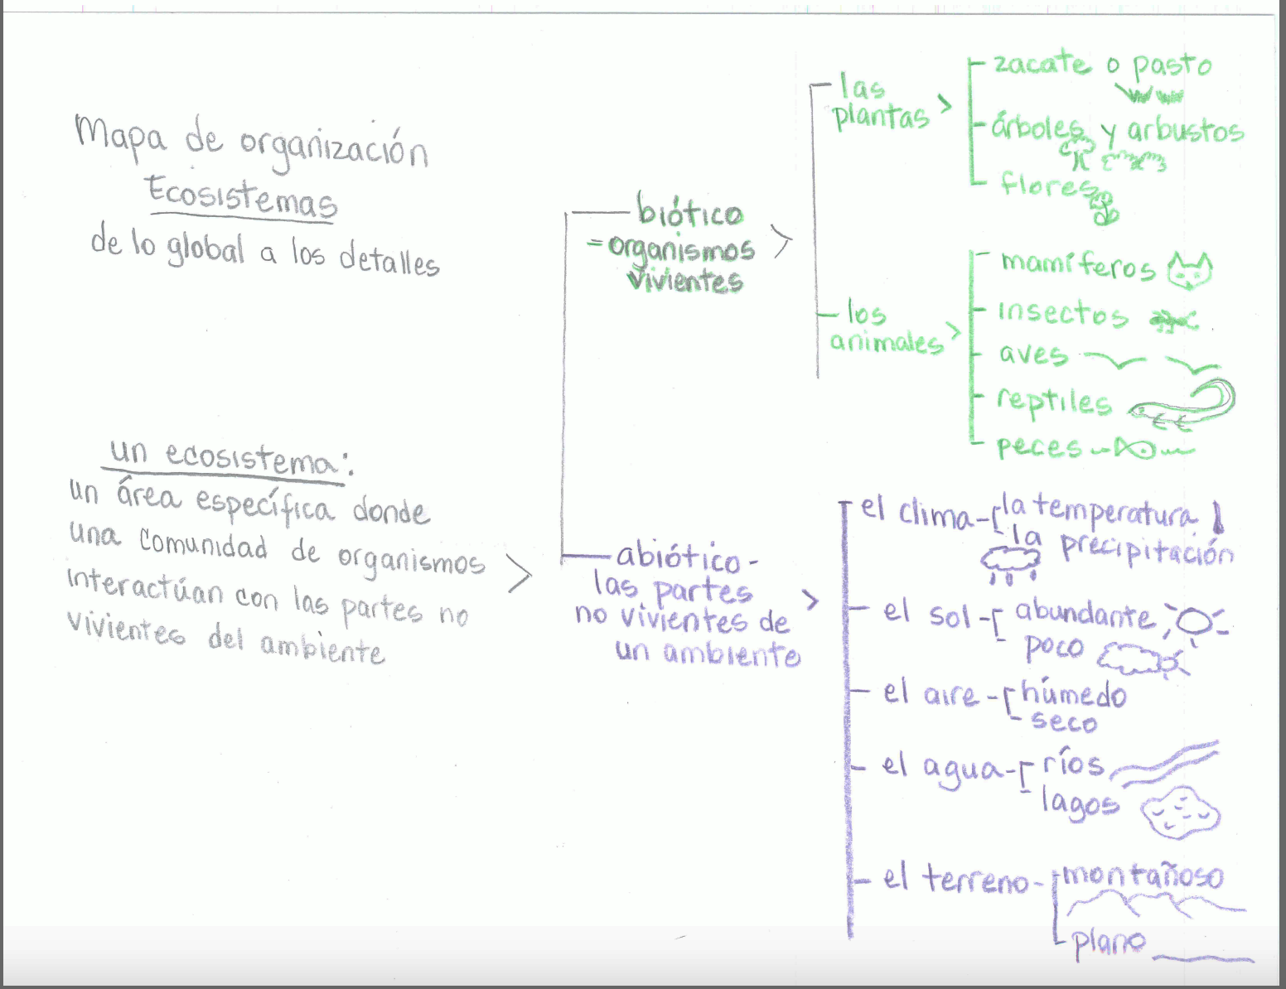

Graphic Organizer: Ecosystems

Background Information

Source: https://www.ck12.org/biology/ecosystems-in-biology/lesson/Ecosystems-BIO/
Ecology is the study of how living things interact with each other and with their environment. It is a major branch of biology, but has areas of overlap with geography, geology, climatology, and other sciences. The study of ecology begins with two fundamental concepts in ecology: the ecosystem and their organisms.
Organisms are individual living things. Despite their tremendous diversity, all organisms have the same basic needs: energy and matter. These must be obtained from the environment. Therefore, organisms are not closed systems. They depend on and are influenced by their environment. The environment includes two types of factors: abiotic and biotic.
- Abiotic factors are the nonliving aspects of the environment. They include factors such as climate (temperature and precipitation-the amount of rain or snowfall an area gets), sunlight (abundant sun or scarce sun), air (humid or dry), water (rivers, lakes, ponds, etc.), and land (flat, mountainous, hilly, rocky).
- Biotic factors are the living aspects of the environment. They consist of other organisms, including members of the same and different species. They are broken into two primary groups: plants and animals. Plant examples include grass, trees and shrubs, flowers, cacti. Animal groups (kingdoms) include mammals, insects, birds, reptiles, and fish.
An ecosystem is a unit of nature and the focus of study in ecology. It consists of all the biotic and abiotic factors in an area and their interactions. Ecosystems can vary in size. A lake could be considered an ecosystem. So, could a dead log on a forest floor. Both the lake and log contain a variety of species that interact with each other and with abiotic factors.

Ecosystems Brace Map: Question Grid

QUESTION GRID - Unit title: Animal Adaptations Strategy name: Graphic Organizer – Ecosystems Brace Map
Thinking and Language Grid | Level 1 Entering  Listening/Speaking | Level 2 Beginning  Listening/Speaking | Level 3 Developing  Listening/Speaking | Level 4 Expanding  Listening/Speaking | Level 5 Bridging  Listening/Speaking
REMEMBER  Choose, define, fined, how, label, list, match, recall, show, tell, spell, relate, name, omit, select, who, what, when, where, why  UNDERSTAND  Classify, compare, demonstrate, explain, extend, illustrate, infer, interpret, outline, rephrase, summarize, translate | Show me an example of a living thing.  Is this (pics) biotic or abiotic? | Name one abiotic feature.  Name an example of that feature. | Define the word -ecosystem-.  I’m thinking of kinds of plants. | What abiotic features are present in your ecosystem? | Explain what an ecosystem is.  What are its features?
APPLY  Apply, choose, construct, develop, experiment with, identify, interview, make use of, model, organize, plan, utilize  ANALYZE  Analyze, assume, categorize, classify, compare, conclusion, contrast, discover, dissect, distinguish, divide, examine, function, inspect, motive, relationships, simplify, survey, theme, test for | Point to an example of a biotic feature.  Which picture shows land features? | Which abiotic feature has to do with sources of water?  Show me an example of a water source. | What are some examples of animals found in an ecosystem.  What biotic features are present in your ecosystem? | Explain the difference between biotic and abiotic features.  How do they interact? | Compare climate and sun.  How does a change in the amount of sun affect an ecosystem’s climate?
EVALUATE  Agree, assess, compare, conclude, criticize, deduct, defend, determine, disprove, evaluate, influence, judge, justify, opinion, prove, recommend, support  CREATE  Build, change, choose, construct, design, develop, elaborate, formulate, imagine, improve, plan, predict, propose, solve, test, theory | Point to the abiotic feature that most affects you. | Which features do you recognize in this ecosystem (pics)? | Give me an example of the interaction between biotic and abiotic features. | If the climate of an ecosystem were to change, how would it affect its biotic features?  How do animals and plants interact? | Big-Eared Bats sleep in caves during the day.  Explain how abiotic features support the bats’ survival.

Pictorial Input Chart - Mexican Gray Wolf - "El lobo"
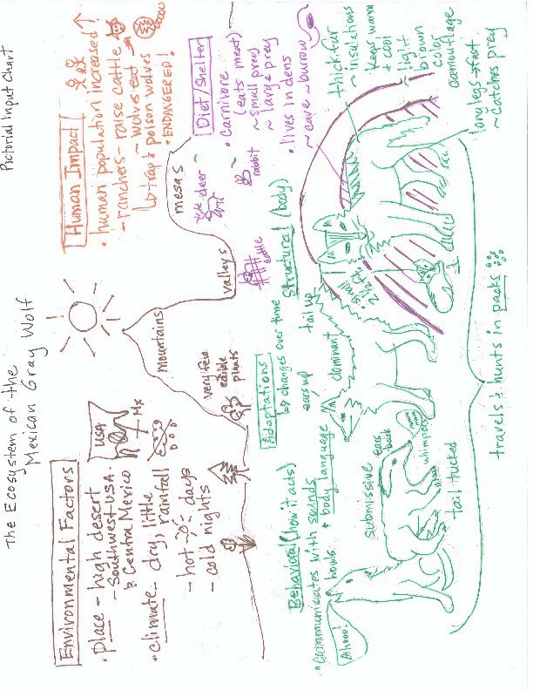
Diagrama pictórico: El lobo gris mexicano
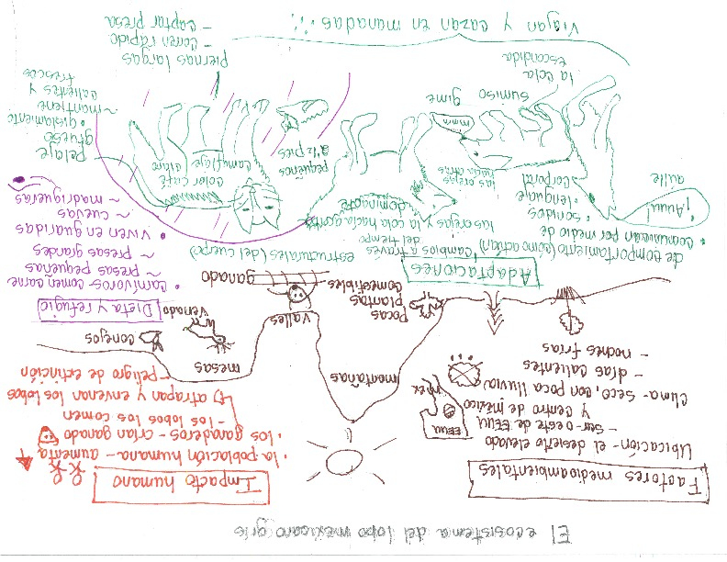
El ecosistema del lobo gris mexicano
Pictorial Input Chart Background Information
Mexican Gray Wolf (El Lobo)

Environmental Factors
The Mexican Gray Wolf is a mammal that lives in the Chihuahuan and Sonoran high desert ecosystems. They once lived throughout the southwestern United States and in central Mexico. They are now under endangered animal protection. Today, there are about 300 in captivity and 115 living in the mountains in Arizona and New Mexico.
The desert ecosystem is very dry, with average rain fall of 6-20 inches per year. The lack of water in a desert is an issue for most plants and animals living there. Because of this, there is little edible vegetation, which limits the types and sizes of herbivores living there. In a desert, there are huge temperature extremes: it’s very hot during the day with few large trees for shade, and very cold at night.

Adaptations
Structural: The Mexican Gray Wolf is one of the smallest species of wolves. It stands about 2 ½ feet tall and weighs about 50-85 pounds. They are gray with light brown fur on their back, which serves as camouflage in forested areas. Their think fur also provides insulation that helps the wolf to stay warm in the extreme cold at night and cool in the desert heat. It has long legs and a sleek body which helps it run very fast. El lobo has a superior sense of smell which help it find its prey easily.
Behavioral: Mexican gray wolves travel and hunt in packs. They use body language to communicate with each other, oftentimes involving the use of their ears and tails. They also use sound to communicate, howling out danger or the need for help or using whimpering to show submissiveness. This ensures their safety and gives the pack a higher chance at catching prey. All members of the pack care for the pups in the den until they mature. Some pups stay with the pack for life, while others leave after a few years to start new packs.

Diet/Shelter
The diet of the Mexican Gray Wolf is mostly large-hooved mammals such as elk, white-tailed deer, mule deer and sometimes cattle. They are also known to eat smaller mammals like javelinas, rabbits, ground squirrels, and mice.
Mexican gray wolves live in dens, which can be holes burrowed in the ground, under large tree roots, or small rock caves. This helps to protect them from day time temperatures as well as having a safe place for their pups to stay when the pack is out hunting.

Human Impact
El lobo was once “top dog” in the borderlands with no natural predators. However, when human populations began inhabiting their territory and raising livestock such as cattle, problems began. At one point, humans nearly eliminated these animals from the wild by trapping and killing them to protect their cattle. Biologists worked hard to save them and introduce them back into the wild. Wolves in the wild do kill a small amount of livestock. The US government will offer compensation to a rancher if a wolf kills a livestock animal. Los lobos remain critically endangered with only 113 counted in February, 2017.

The Mexican Gray Wolf PIC: ELD Review Question
Stages of Language Acquisition - WIDA | Level 1 Entering  Listening/Speaking | Level 2 Beginning  Listening/Speaking | Level 3 Developing  Listening/Speaking | Level 4 Expanding  Listening/Speaking | Level 5 Bridging  Listening/Speaking
Level of Questioning | Point To, Locate, Trace Yes/No Either/Or Open Ended
Create  Arrange, assemble, collect, compose, combine, construct, create, design, develop, devise, forecast, formulate, hypothesize, imagine, invent, manage, organize, plan, prepare, propose, set up | Choose the parts of the Mexican gray wolf that you would use to teach another student about how they camouflage. | Is living in a pack a helpful way to protect themselves against enemies? | Look at these two pictures. Which one shows a feature that helps a wolf catch its prey? | If the Mexican Gray Wolf did not have a superior sense of smell, how else could they catch their prey?
Evaluate  Appraise, argue, assess, choose, compare, critique, decide, debate, defend, determine, discuss, estimate, evaluate, judge, justify, predict, prioritize, rate, recommend, select, support, value, verify, weigh | Point to the adaptation that you think is most important for the Mexican Gray Wolf’s survival. | Justify—could wolves survive living in water? | What word would best describe the wolf: herbivore or carnivore? Explain why. | Predict what would happen if the wolf had to hunt by itself.
Analyze  Analyze, appraise, calculate, categorize, classify, compare, contrast, criticize, differentiate, discriminate, distinguish, examine, experiment, explain, identify, infer, question, test | Point to the features that help the Mexican Gray Wolf run fast. | Which picture shows a Mexican Gray Wolf’s shelter? | When a wolf is howling, do you think it is telling other wolves that everything is fine or that there may be danger near by? | Compare the Mexican Gray Wolf to another animal (that you are familiar with). How are they the same or different?
Apply  Apply, calculate, categorize, classify, change, choose, compare, construct, demonstrate, describe, determine, distinguish, dramatize, employ, estimate, explain, extend, illustrate, interpret, judge the effects, operate, practice, schedule, select, show, sketch, solve, use | On this chart, trace the part of the body the wolf uses to hear its prey. | Are cattle and deer examples of large-hooved mammals? | Are cattle the predator or prey of the Mexican gray wolf? | Use the information on the chart to explain why Mexican Gray Wolves are endangered.
Understand  Categorize, cite, clarify, classify, describe, discuss, explain, express, identify, indicate, interpret, locate, match, paraphrase, predict, recognize, restate, review, select, summarize, translate | Find an example of body language. | Does the Mexican Gray Wolf use body language to communicate? | Does body language teach us about how Mexican Gray Wolves communicate with each other or how they catch their prey? | Summarize the most important ideas about their offspring and young.
Remember  Arrange, choose, define, describe, draw, , find, give example, identify, label, locate, list, match, name, recall, recite, recognize, record, repeat, reproduce, select, state, tell | Locate the body part that helps the wolf run fast. | Recall—do Mexican Gray Wolves live in dens? | Teacher point to the sketch of the burrowed den on the chart.  In this picture is the den above ground or underground? | Tell me what you learned about the Mexican Gray Wolf’s diet.

El lobo gris mexicano: preguntas de SLD
Etapas de adquisición de lenguaje - WIDA | Nivel 1: Nivel de entrada  Escuchando/Hablando | Nivel 2: Nivel emergente  Escuchando/Hablando | Nivel 3: Nivel de desarrollo  Escuchando/Hablando | Nivel 4: Nivel de extensión  Escuchando/Hablando | Nivel 5: Nivel de transformación  Escuchando/Hablando
Nivel de preguntas | Apunta, Localiza, Traza Si/No Cuál Pregunta Abierta
Crear  Colocar, armar, coleccionar, componer, combinar, construir, crear, diseñar, desarrollar, idear, pronosticar, formular, hipotetizar, imaginar, inventar, manejar, organizar, planear, preparar, proponer, establecer | Escoge las adaptaciones estructurales del lobo gris mexicano que usarías para enseñar a un compañero cómo se camuflan. | Los lobos viajan en manadas, ¿eso les ayuda a protegerse de los enemigos? | Revisa estas dos fotos. ¿Cuál demuestra algo que le ayuda al lobo cazar su presa? | Si el Lobo gris mexicano no tuviera olfato superior, ¿qué más podría usar para captar su presa?
Evaluar  Valorar, argumentar, evaluar, escoger, comparar, criticar, decidir, debatir, defender, determinar, discutir, estimar, evaluar, juzgar, justificar, predecir, priorizar, clasificar, recomendar, seleccionar, apoyar, verificar, medir | Apunta la adaptación que más le ayuda al lobo gris mexicano sobrevivir. | Justifica—¿podría sobrevivir el lobo sin agua? | Escoge la palabra que mejor describe el lobo: herbívoro o carnívoro. Explica por qué. | ¿Qué pasaría si el lobo tuviera que cazar a solas?
Analizar  Analizar, evaluar, calcular, categorizar, clasificar, comparar, contrastar, criticar, diferenciar, discriminar, distinguir, examinar, experimentar, explicar, identificar, inferir, cuestionar, probar | Apunta la adaptación que le ayuda al lobo a correr rápidamente. | ¿Qué foto demuestra el refugio del Lobo gris mexicano? | Cuando el lobo aúlla, ¿piensas que les está comunicando con los demás lobos que está todo bien, o que existe un peligro cercano? | Compara el lobo gris mexicano con otro animal (uno con que tienes familiaridad). ¿Cómo son parecidos y diferentes?
Aplicar  Aplicar, calcular, categorizar, clasificar, cambiar, escoger, comparar, construir, demostrar, describir, determinar, distinguir, dramatizar, emplear, estimar, explicar, extender, ilustrar, interpretar, juzgar los efectos, operar, practicar, hacer un horario, seleccionar, enseñar, dibujar, resolver, usar | En este gráfico, traza la parte del cuerpo que usa el lobo para escuchar su presa. | El venado y el ganado, ¿son presas grandes? | El venado y el ganado, ¿son depredadores o presas del lobo gris mexicano? | Usa la información en este gráfico para explicar por qué el Lobo gris mexicano está en peligro de extinción.
Entender  Categorizar, citar, clarificar, clasificar, describir, discutir, explicar, expresar, identificar, indicar, interpretar, localizar, combinar, parafrasear, predecir, reconocer, reafirmar, repasar, seleccionar, resumir, traducir | Muéstrame un ejemplo del lenguaje corporal. | ¿El Lobo gris mexicano usa el lenguaje corporal para comunicarse? | ¿Para qué usa el lobo gris mexicano el lenguaje corporal, para comunicarse o para captar su presa? | Resume las ideas más importantes acerca de la dieta y el refugio del lobo.
Recordar  Ordenar, escoger, definir, describir, dibujar, encontrar, dar ejemplo, identificar, etiquetar, localizar, hacer lista, combinar, nombrar, recordar, recitar, reconocer, registrar, repetir, reproducir, seleccionar, declarar, decir | Localiza la parte del cuerpo del lobo que le ayuda a correr rápidamente. | Recuerda—¿viven los lobos en una guarida? | El maestro apunta el dibujo de la madriguera en el gráfico.  En este dibujo, ¿está la madriguera por encima o debajo de la tierra? | Háblame de lo que aprendiste de la dieta del lobo gris mexicano.

The Penguin Chick
By Betty Tatham
Illustrated by Helen K. Davie

Page 1
A fierce wind howls. It whips snow across the ice. Here, a female emperor penguin has just laid an egg. It is the only egg she will lay this year. Most birds build nests for the eggs. But on the ice in Antarctica, there are no twigs or leaves. There is no grass or mud. There is nothing to build a nest with. Nothing but snow and ice. The new penguin father uses his beak to scoop the egg onto his webbed feet. He tucks it under his feather-covered skin, into a special place called a brood patch. The egg will be as snug and warm there as if it were in a sleeping bag. “I have to protect my young! It’s my responsibility,” says Father penguin.

Page 2
In the rookery, where penguins lay their eggs, there is no food for them to eat. One of the penguin parents must stay with the egg to keep it warm. Father penguin is bigger and fatter than Mother penguin. He can live longer without food so Father penguin stays with the egg while Mother penguin travels to the sea to find food. The two parents sing together before the she leaves. Father sings, “Go hunt and get us food, my love. I will wait here.”

Page 3
Mother walks or slides on her belly. This is called tobogganing. She uses her flippers and webbed feet to push herself forward over ice and snow. “Bye, my dear. I have confidence that you will keep our baby safe. I have a long journey ahead, traveling across many miles of ice. Soon I will arrive at the ocean where I will find food.”

Page 4
When Mother arrives at the ocean, she dives into the water to hunt for fish, squid, and tiny shrimplike creatures called krill. “I have to hunt with all my might. My family is waiting and my new baby needs food,” Mother tells herself. Mother hunts carefully, alert for any enemies, like seals, sharks and the most dangerous of all, the orca. If she can’t bring back the food, her baby will not survive.

Page 5
Back at the rookery, the penguin fathers form a group called a huddle. They stand close together for warmth. Each one keeps his own egg warm. Father worried, “I wonder how Mother is doing? I am hungry and really cold but she is in the dangerous ocean hunting. What would happen if she doesn’t return? What would we do?”
For two months Father penguin always keeps his egg on his feet. When he walks, he shuffles his feet so the egg doesn’t roll away. He sleeps standing up. He has no food to eat, but the fat on his body keeps him alive.

Page 6
Finally, he feels the chick move inside the egg. The chick pecks and pecks. In about three days the egg cracks open. The chick is wet. Soon his soft feathers called, down, dry and become fluffy and gray. Father still keeps the chick warm in the brood patch. Sometimes Chick pokes his head out. While he’s so little, he must stay covered. Chick must stay on his father’s feet. Otherwise, the cold would kill him.

Page 7
Father talks to Chick in his trumpet voice, “How are you my chick?” Chick answers with a whistle. Father’s trumpet call echoes across the ice. Mother penguin is on her way back to the rookery, but she can’t hear him. She’s still too far way. If Mother doesn’t come back soon with food, Chick will die.

Page 8
Two days pass before Mother can hear Father penguin’s call. At last, Mother arrives at the rookery. She cuddles close to her chick and trumpets to him, “I’m home!”. He whistles back. With her beak she brushes his soft gray down.
Mother penguin swallowed many fish before she left the ocean. She brings some of this food back up from her stomach and feeds her chick. She has enough food to keep him fed for weeks. Now, Chick stays on her feet and snuggles into her brood patch.
Father is also very hungry, so he travels to open water. There he dives to hunt for food. Weeks later Father returns with more food for Chick.

Page 9
As Chick gets bigger, he and the other chicks no longer need to stay on their parents’ feet. Instead they stay together to keep warm. This group of chicks is called a nursery. Chick now spends most of his time here.

Page 10
Chick grows and grows. After five months, he has grown into a junior penguin. He is old enough to travel to the ocean. Now he has a waterproof coat of feathers, instead of fluffy down. He can swim in the icy cold ocean because his feathers keep him dry and warm. Chick soon becomes a young penguin. Now he spends most of his time in the water swimming, flapping his flippers as if he were flying underwater. He uses his webbed feet to steer wherever he wants to go. The young penguin catches a fish with his beak and swallows it headfirst. He can now take care of himself. In about five years, he’ll find a mate and take care of his own egg until his chick can hatch.

Polluelo de pingüino
Escrito por Betty Tatham
Ilustrado por Helen K. Davie
Traducido y adaptado por R. López y R. Kriteman

- El viento feroz sopla. La nieve cae sobre la tierra helada. Aquí, una hembra de pingüino emperador ha puesto su huevo. Es el único huevo que pondrá este año. La mayoría de las aves hacen nidos para sus huevos, pero en la fría Antártida no hay hojas ni leña para construir un nido. Solo nieve y hielo. Papá pingüino usa su pico para poner el huevo entre sus pies palmeados. Lo pone debajo de su piel cubierta de plumas, en un lugar especial llamado parche de cría. Aquí el huevo estará seguro y calientito.
“¡Tengo que proteger a mi cría! ¡Es mi responsabilidad!”

- El papá sabe que aquí en la pingüinera, donde los pingüinos ponen huevos, no hay nada de comer. El papá pingüino es más grande y gordo que la mamá y puede vivir más tiempo sin comida. Por eso, el papá pingüino se queda con el huevo mientras la mamá va al mar a buscar comida. Los dos padres cantan juntos antes de que la mamá pingüino se vaya. El papá le dice: “Ve, mi amor, te espero aquí. Ve y caza. Tráenos comida.”

- La mamá camina o se desliza sobre su panza, como si se deslizara en un tobogán. Usa sus aletas y sus pies palmeados para impulsarse sobre el hielo y la nieve.
“¡Adiós, mi vida! Tengo confianza en ti. Sé fuerte por nuestro bebé. Mi jornada será larga - millas y millas de agua congelada, pero pronto llegaré al mar y allí habrá comida.”

- Cuando la mamá pingüino llega finalmente al mar, ella se lanza al agua para atrapar peces, calamares, y pequeñas criaturas parecidos a los camarones, llamados kril.
“Tengo que cazar con toda mi fuerza. Mi familia me espera, y mi nuevo bebé necesita comida.”
La mamá pingüino caza con mucho cuidado, alerta para sus enemigos: las focas, tiburones, y los más peligrosos de todos, la orca. Si ella no alcanza cazar comida, el bebé nunca podrá sobrevivir.

- En la pingüinera helada, el papá y sus compadres, se apiñan para formar un grupo. Se paran muy juntos para calentarse. Cada uno mantiene caliente su propio huevo.
El papá piensa, “¿Cómo estará mi hembra? Tengo hambre y mucho frío, pero ella está en peligro cazando en el mar. ¿Qué pasa si nunca vuelve? ¿Qué haríamos?
Durante dos meses el papá guarda el huevo entre sus patas. Cuando camina, arrastra las patas para que el huevo no se le caiga. Duerme parado. No come, pero la grasa de su cuerpo lo mantiene vivo.

- Finalmente siente que el polluelo se mueve dentro del huevo. El polluelo picotea y picotea. En unos tres días el huevo se rompe y el polluelo sale mojado. Pero pronto su suave plumaje, llamado plumón, se seca y se vuelve esponjoso y gris. El papá sigue manteniendo caliente al polluelo en su parche de cría. A veces el polluelo asoma la cabeza, pero debe permanecer cubierto en los pies de su papá. De lo contrario, el frío lo mataría.

- El papá le habla al polluelo con su voz de trompeta. El polluelo le contesta con un silbido. El llamado de trompeta de su papá hace eco a través del hielo. La mamá pingüino está en camino hacia la pingüinera, pero todavía no lo oye. Aún está muy lejos. Si la mamá no vuelve pronto con comida, el polluelo morirá.

- Dos días pasan antes de que la mamá pueda oír el llamado del papá pingüino. Finalmente, la mamá llega a la pingüinera. Acaricia su polluelo y le habla con su voz de trompeta. El bebé le responde con un silbido. Usa su pico para peinarle el suave plumón gris. La mamá comió muchos peces antes de salir del mar. Los vuelve a traer de su estómago a su boca y alimenta a su polluelo. Tiene comida suficiente para varias semanas. El polluelo se sube a las patas de su mamá y se acomoda en el parche de cría. El papá tiene mucha hambre. Ahora le toca a él ir al mar a cazar. En unas semanas volverá con más comida para el polluelo.

- A medida que el polluelo crece, él y los otros polluelos ya no necesitan quedarse en las patas de sus papás. Ahora forman su propio grupo para mantenerse calientes, y a veces juegan juntos en el hielo. Este grupo se llama guardería. El polluelo pasa la mayor parte de su tiempo aquí.

- El polluelo crece y crece. Después de cinco meses, se ha vuelto un joven pingüino. Tiene edad suficiente para ir al océano. Ahora tiene un abrigo de plumas impermeables, en lugar de su plumón esponjoso. Puede nadar en las aguas oceánicas heladas porque sus plumas lo mantienen seco y caliente. El joven pingüino pasa la mayor parte del tiempo en el agua. Nada, mueve sus aletas como si volara bajo el agua. Usa sus pies palmeados para ir donde quiere. Atrapa un pez con su pico y se lo traga. Ahora el joven pingüino puede conseguir su propia comida y cuidarse solo. En unos cinco años, encontrará una pareja. Después cuidará a su propio huevo hasta que el polluelo salga del cascarón.

The Penguin Chick -ELD Review Questions

Stages of Language Acquisition - WIDA | Level 1 Entering  Listening/Speaking | Level 2 Beginning  Listening/Speaking | Level 3 Developing  Listening/Speaking |  | Level 4 Expanding  Listening/Speaking |  |  | Level 5 Bridging  Listening/Speaking
Level of Questioning | Point To, Locate, Trace Yes/No Either/Or Open Ended
Create  Arrange, assemble, collect, compose, combine, construct, create, design, develop, devise, forecast, formulate, hypothesize, imagine, invent, manage, organize, plan, prepare, propose, set up | Choose the part of the story that you think would be most important to teach to another student. | Could mother and father penguin find another way to feed their chick? | If you were the mother, would you hunt krill or fish? |  |  | How can the penguin parents improve their chicks’ chances for survival?  If the father did not have a brood pouch, what else could he do to keep the chick warm?
Evaluate  Appraise, argue, assess, choose, compare, critique, decide, debate, defend, determine, discuss, estimate, evaluate, judge, justify, predict, prioritize, rate, recommend, select, support, value, verify, weigh | Point to the information that shows us that both the father and mother penguin take care of the chick. | Is it dangerous for the penguins to hunt in the ocean? | Do you think it is more important for the chick to stay warm or have food? |  |  | What would happen to the penguin chick if the mother got hurt while hunting?  If you were a scientist in the Antarctic, would it be okay for you to help the mother hunt?
Analyze  Analyze, appraise, calculate, categorize, classify, compare, contrast, criticize, differentiate, discriminate, distinguish, examine, experiment, explain, identify, infer, question, test | Point to the part of the father that is most important for the chick. | Does this picture show how the father carries the egg? | Do the parents sing to their chick so it can sleep or so it knows where they are? |  |  | Why is it the father that stays with the egg and not the mother?  How is a penguin chick like a human baby?
Apply  Apply, calculate, categorize, classify, change, choose, compare, construct, demonstrate, describe, determine, distinguish, dramatize, employ, estimate, explain, extend, illustrate, interpret, judge the effects, operate, practice, schedule, select, show, sketch, solve, use | Locate the picture that show how the Emperor penguins travel to the ocean. | Does the chick have soft feathers called down when it is born? |  | Do the newly born chicks stay with their fathers because they keep them warm or because they have food for them to eat? |  |  | How do you think the penguin chick knows who its parents are?  Compare the skills of a baby penguin with that of a fully-grown penguin.
Understand  Categorize, cite, clarify, classify, describe, discuss, explain, express, identify, indicate, interpret, locate, match, paraphrase, predict, recognize, restate, review, select, summarize, translate | Show me an example of what Emperor penguins hunt. | Do Emperor penguins slide on the ice because it is fun? |  | Which of these pictures shows a newborn chick? |  |  | How does this story teach us about animal survival?  Summarize the most important events of this story.
Remember  Arrange, choose, define, describe, draw, , find, give example, identify, label, locate, list, match, name, recall, recite, recognize, record, repeat, reproduce, select, state, tell | Point to the father Emperor penguin. | Is the mother penguin fatter than the father penguin? |  | Does the father or the mother protect the egg in a brood patch? |  |  | Describe Antarctica’s environment.  How do the fathers keep their eggs warm in the freezing wind?

Diagrama narrativo – Revisión de preguntas diferenciadas, Desarrollo del lenguaje español

Etapas de adquisición de lenguaje - WIDA | Nivel 1: Nivel de entrada  Escuchando/Hablando | Nivel 2: Nivel emergente  Escuchando/Hablando | Nivel 3: Nivel de desarrollo  Escuchando/Hablando | Nivel 4: Nivel de extensión  Escuchando/Hablando | Nivel 5: Nivel de transformación  Escuchando/Hablando
Nivel de preguntas | Apunta a, Localiza, Traza Si/No Cualquiera/O Pregunta Abierta
Crear  Colocar, armar, coleccionar, componer, combinar, construir, crear, diseñar, desarrollar, idear, pronosticar, formular, hipotetizar, imaginar, inventar, manejar, organizar, planear, preparar, proponer, establecer | Escoge la parte del cuento que piensas que es la más importante para enseñar a otro estudiante. | ¿Podrían la madre y el padre pingüino encontrar otra manera de alimentar a su polluelo? | ¿Si fueras la madre, cazarías el kril o el pescado? | ¿Cómo podrían los padres pingüinos aumentar las posibilidades de supervivencia de sus polluelos?  Si el padre no tuviera la bolsa de cría, ¿qué más podría hacer para mantener al polluelo calientito?
Evaluar  Valorar, argumentar, evaluar, escoger, comparar, criticar, decidir, debatir, defender, determinar, discutir, estimar, evaluar, juzgar, justificar, predecir, priorizar, clasificar, recomendar, seleccionar, apoyar, verificar, medir | Apunta hacia la información que demuestra que ambos, el padre y la madre pingüino cuidan a su polluelo. | ¿Es peligroso para los pingüinos cazar en el océano? | ¿Qué crees que es más importante para el polluelo, estar calientito o tener comida? | ¿Qué le pasaría al polluelo si la madre pingüino se lastimara mientras caza?  Si fueras un científico en la Antártida, ¿estaría bien que le ayudaras a la madre a cazar?
Analizar  Analizar, evaluar, calcular, categorizar, clasificar, comparar, contrastar, criticar, diferenciar, discriminar, distinguir, examinar, experimentar, explicar, identificar, inferir, cuestionar, probar | Apunta hacia la parte del padre que es más importante para el polluelo. | ¿Muestra esta imagen como el padre carga el huevo? (mostrando una imagen)? | ¿Los padres le cantan al polluelo para que pueda dormir o para que sepa dónde están? | ¿Por qué es el padre el que se queda con el huevo y no la madre?  ¿Cómo es un polluelo parecido a un bebé humano?
Aplicar  Aplicar, calcular, categorizar, clasificar, cambiar, escoger, comparar, construir, demostrar, describir, determinar, distinguir, dramatizar, emplear, estimar, explicar, extender, ilustrar, interpretar, juzgar los efectos, operar, practicar, hacer un horario, seleccionar, enseñar, dibujar, resolver, usar | Localiza la imagen que demuestra cómo los pingüinos emperadores viajan al océano. | ¿Tiene el polluelo suave plumaje llamado plumón cuando nace? | ¿Los polluelos recién nacidos se quedan con su papá pingüino porque los mantiene calientitos o porque tienen comida para ellos? | ¿Cómo crees que el polluelo sabe quiénes son sus padres?  Compara las habilidades de un bebé pingüino (polluelo) a las de un pingüino adulto.
Entender  Categorizar, citar, clarificar, clasificar, describir, discutir, explicar, expresar, identificar, indicar, interpretar, localizar, combinar, parafrasear, predecir, reconocer, reafirmar, repasar, seleccionar, resumir, traducir | Muéstrame un ejemplo de lo que cazan los pingüinos emperadores. | ¿Los pingüinos emperadores se deslizan en el hielo porque es divertido? | ¿Cuál de estas imágenes muestra un polluelo recién nacido? | ¿Qué nos enseña esta historia acerca de la supervivencia animal?  Resume los eventos más importantes de este cuento.
Recordar  Ordenar, escoger, definir, describir, dibujar, encontrar, dar ejemplo, identificar, etiquetar, localizar, hacer lista, combinar, nombrar, recordar, recitar, reconocer, registrar, repetir, reproducir, seleccionar, declarar, decir | Apunta hacia el padre pingüino emperador. | ¿La madre pingüino es más gordita que el padre pingüino? | ¿Quién protege al huevo en la bolsa de cría, la madre o el padre pingüino? | Describe el ambiente de Antártida.  ¿Cómo le hacen los padres para mantener a sus huevos calientitos en el viento congelado?

Animal Ecosystems - Ecosistemas de los animales

Poetry Booklet – Librito de cantos y poesía
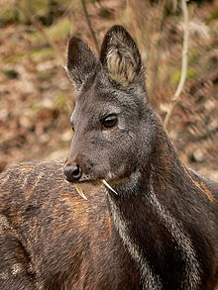
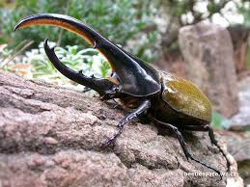
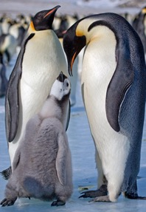
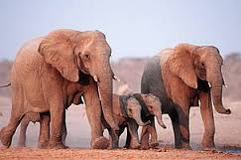
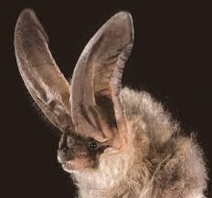

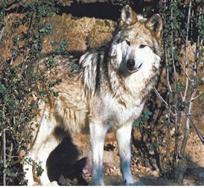

Animals Here, Animals There
By Ruth Kriteman
Adapted by Kavita Krishna

Animals here, animals there,
Animals, animals everywhere.

Colorful animals camouflaging cleverly,
Mother animals defending fiercely,
Powerful animals hunting stealthily,
And, solitary animals burrowing deeply.

Animals in a grassland ecosystem,
Animals in a rainforest ecosystem,
Animals after a long sleep,
And animals at dawn.

Animals here, animals there,
Animals, animals everywhere,
Animals! Animals! Animals!

Animales aquí, allá
por Ruth Kriteman

Animales aquí, animales allá
Animales, animales, ra ra ra.

Animales coloridos camuflándose hábilmente.
Animales maternales defendiéndose ferozmente.
Animales poderosos cazando clandestinamente, y
Animales solitarios cavando profundamente.

Animales en la sabana.
Animales en la selva.
Animales después de un largo sueño, y
Animales a punto de extinción.

Animales aquí, animales allá
Animales, animales, ra ra ra.
¡Animales, Animales, Animales!

Animal Adaptation Cadence
By Ruth Kriteman and Diana Pinkston-Stewart
Adapted by Kavita Krishna

We all know what we’ve been told,
Animals can grow to be quite old.
It takes some time for them to adapt,
Structurally and behaviorally, let’s learn about that.

Sound off – Structural,
Sound off – Behavioral,
Sound off – 1-2-3-4 –Adaptations!

Bodies adapt in different ways,
Webbed feet, big ears, are here to stay.
Scaly skin, sharp claws, extra fat,
Adaptations help animals survive - that’s a fact.

Sound off – Structural,
Sound off – Behavioral,
Sound off – 1-2-3-4 --Adaptations!

How they act help animals survive,
Communication helps keeps them alive.
Getting food and water is always a chore,
Climbing, hunting, hiding, and so much more.

Sound off – Structural,
Sound off – Behavioral,
Sound off – 1-2-3-4—Adaptations!

Wildlife Biologist Bugaloo
By Ruth Kriteman
Adapted by Kavita Krishna

I’m a wildlife biologist and here to say,
I study wild animals every day.
Sometimes I study their habitats or what they do,
To stay alive and flourish. There’s much to learn – Whew!

Animals, ecosystems, adaptations, too
Doing the wildlife biologist bugaloo!

We study how animals’ bodies help them survive,
These structural adaptations are more than just their size.
Their feet, their teeth, body-coverings and beaks,
Protect them, help them move, and decide what to eat.

Hooved feet, sharp teeth, fluffy feathers, too
Doing the wildlife biologist bugaloo!

Other animal adaptations are more about behavior,
How they communicate, protect themselves, and get food or water.
Some hide in deep, dark burrows, others soar through the sky,
Some save food in their cheeks, others don’t even try.

Chewing grass, storing water, hunting prey, too
Doing the wildlife biologist bugaloo!

Los ecosistemas - ¡sí señora!
por Diana Pinkston-Stewart

¿Es esto un ecosistema? Sí, señora.
¿Es esto un ecosistema? Sí, señora.
¿Cómo sabemos? Tiene factores bióticos y abióticos.
¿Cómo sabemos? Hay plantas y animales.
Díganme más. Hay tierra, agua y sol.
Díganme más. Todas las partes se interactúan.

¿Es esto un desierto? Sí, señora.
¿Es esto un desierto? Sí, señora.
¿Cómo sabemos? Tiene poca lluvia y mucho sol.
¿Cómo sabemos? Tiene pocas plantas y animales.
Díganme más. Allá vive el lobo.
Díganme más. En conflicto con los seres humanos.

¿Es esto un bosque tropical? Sí, señora.
¿Es esto un bosque tropical? Sí, señora.
¿Cómo sabemos? Tiene mucha lluvia y mucho calor.
¿Cómo sabemos? Tiene muchas plantas y animales.
Díganme más. Allá vive el escarabajo Hércules.
Díganme más. Peleando con los otros machos.

¿Es esto la sabana africana? Sí, señora.
¿Es esto la sabana africana? Sí, señora.
¿Cómo sabemos? Tiene mucho pasto y pocos arboles.
¿Cómo sabemos? A veces tiene mucha agua y a veces no.
Díganme más. Allá viven los elefantes africanos.
Díganme más. Viajando en manadas para protegerse.

Name: ________________________________ Date:_______________

Home to School Connection #1
Animal Adaptations

Describe the environment that you and your family live in. What adaptations have humans developed to survive in this environment?

Describe el medioambiente en que vives con tu familia. ¿Cómo nos hemos adaptado como seres humanos para sobrevivir en este medioambiente?

________________________________ _______________________________
parent (padre de familia) student (estudiante)

Name: ____________________________ Date:_______________

Home to School Connection #2
Animal Adaptations

Explain to someone in your family what you have learned about structural and behavioral adaptations. Together decide what behavioral adaptations you have developed to live in your ecosystem. Sketch and write what you’ve decided.

Explícale a alguien de tu familia lo que has aprendido acerca de las adaptaciones estructurales y de comportamiento. Juntos decidan cuáles adaptaciones de comportamiento han desarrollado para poder vivir en el ecosistema donde viven. Dibuja y escribe lo que han decidido.

________________________________ _______________________________
parent (padre de familia) student (estudiante)

Name: ______________________________ Date__________________

Home to School Connection #3
Animal Adaptations

Tell a family member about the narrative story The Penguin Chick. What are some structural and behavioral adaptations that help the Emperor penguin survive in Antarctica? Discuss with a family member. Sketch or write the information.

Cuenta a un miembro de la familia el cuento narrativo de El polluelo de pingüino. ¿Cuáles son las adaptaciones estructurales y de comportamiento que le ayudan al pingüino emperador sobrevivir en el Antártida? Comparte con alguien de tu familia. Dibuja o escribe la información.

________________________________ _______________________________
parent (padre de familia) student (estudiante)

Name: _________________________ Date: _______________

Home to School Connection #4
Animal Adaptations

With someone at home, talk about what we have learned about the biotic (living) and abiotic (non-living) parts of an ecosystem and how they work together. Sketch and write about what you talked about.

Comparte con un familiar lo que has aprendido acerca de lo que hemos aprendido acerca de las parte bióticas y abióticas de un ecosistema y cómo funcionan. Dibuja y escribe acerca de lo que compartieron.

________________________________ ______________________________
parent (padre de familia) student (estudiante)

Mind Map Name ____________________________

Diet/Shelter
Human Impact
Adaptations:
Structural and Behavioral
Environmental Factors

Name: _________________________________________________________ Date: __________________

Expert Group 1
African Elephant

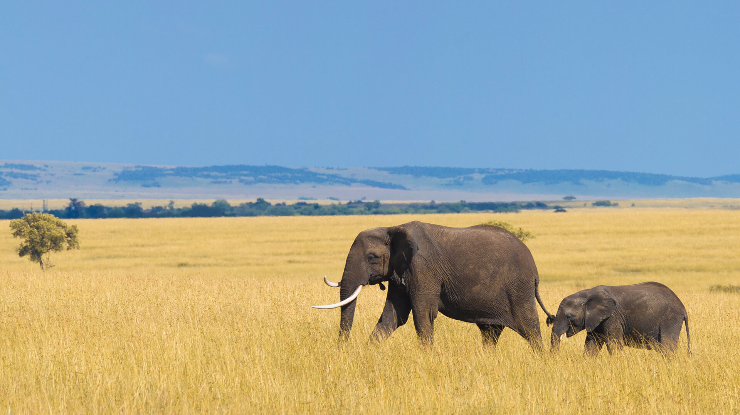
Environmental Factors
The African elephant lives in a tropical grasslands ecosystem also known as the savannah. In the tropical grasslands ecosystem, the temperature is warm year-long. Summers are short with lots of rain. Winters are long and dry. The land is mostly flat with dry grass, scattered trees, and shrubs. Many large and small animals roam the grasslands.
Figure 1: African elephants on the savannah

Adaptations: Structural and Behavioral
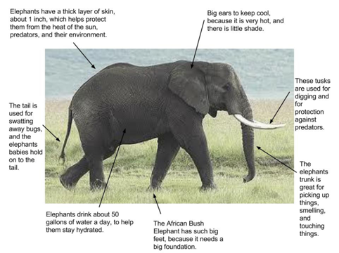
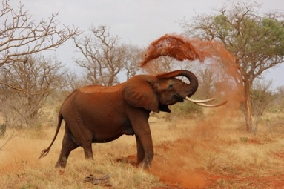
An important structural adaptation that helps the African elephant is their large ears that help keep them cool in the heat. Their long trunks help them grab food from tall trees. Ivory tusks are long teeth that help them dig roots and scrape bark from trees.
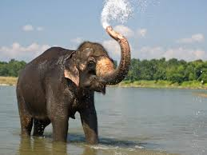
Some behavioral adaptations that help them to survive are showering their skin with water to keep cool or spraying themselves with dirt to protect their skin from the hot sun. They travel in families, called herds, for protection from threats.
Figure 2: African elephants have many structures that help it survive in its environment.
Figure 3: An elephant sprays itself with dirt to protect its skin.
Figure 5: An elephant showers with water.

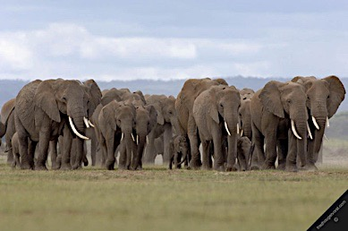

Figure 6: Herds are made up of females and their young. Males tend to travel alone.

Diet & Shelter
Figure 7: Adult African Elephant eat leaves and stems.
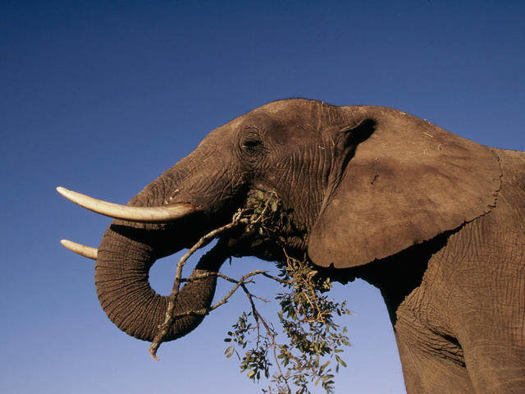
Elephants are herbivores, which means they feed on plants. Their diet is mostly dry grass, shrubs, roots, and tree-bark. An adult elephant can consume up to 300 pounds of food in a single day. African elephants are nomadic which means they are always on the move. They travel in families called herds.

Human Impact
Because ivory is so valuable to some humans, many elephants have been killed for their tusks. This trade is illegal today, but it has not been completely eliminated, and some African elephant populations remain endangered.

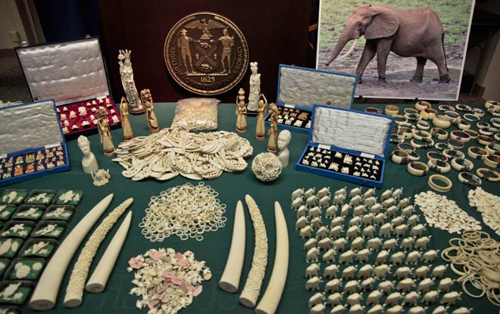

Figure 8: Ivory products are often sold illegally.

Name: ______________________________________________________ Date: __________________

Expert Group 2
Big-Eared Bat

Environmental Factors
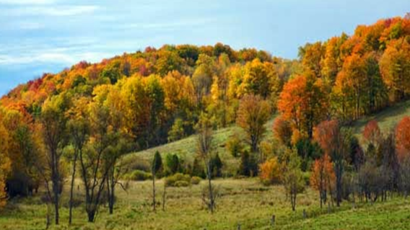
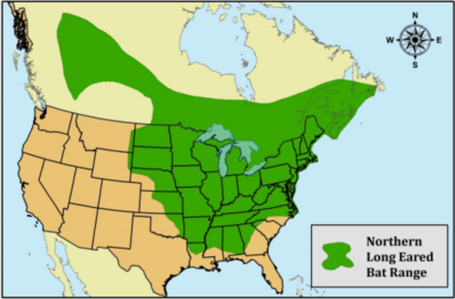
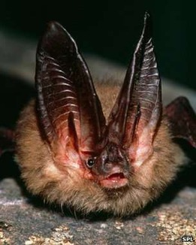
Big-eared bats live in a temperate forest ecosystem. In the United States, they are mostly found in Virginia, North Carolina, and Kentucky. Temperate forests have four seasons: spring, summer, autumn, and winter. There is plenty of rain and snow that provide water for lakes and rivers. The land has valleys, hills, and mountains. The forest has deciduous trees that change color with the seasons.
Figure 1: A map shows where Big-eared bats live..

1

Figure 2: the temperate forest
Figure 2: A Temperate forest in autumn

Adaptations: Structural and Behavioral
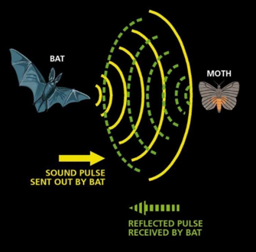
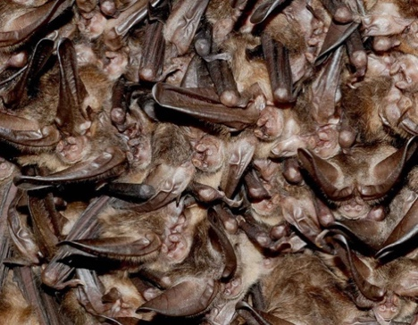
A structural adaptation of big-eared bats is their big ears. Their ear size and shape give them excellent hearing. They use echolocation to navigate through forests and locate their prey in the dark. Echolocation happens when a bat sends out sound waves that bounce off objects. The sound waves come back to the bat's ears and tells it where things are.

Some things that big-eared bats do to help them survive in their environment is to hibernate and roost. In winter they hibernate and use their body-fat to stay alive. When they hibernate, they hang together from the cave ceiling in tight clusters, called roosting, to stay warm.
Figure 3: A bat uses echolocation to sense a moth’s location.

Figure 4: Bats roosting from a cave ceiling.

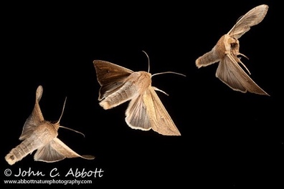
Diet and Shelter
Bats are carnivores. They eat insects like, moths, butterflies, beetles, crickets, spiders, flies, and bees. They take shelter, hibernate and roost in caves.

Figure 5: Moths are bats’ favorite meal.

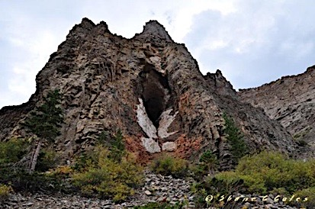

Figure 6: A large bat cave can be found in a Temperate Forest.

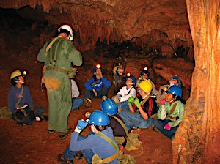
Human Impact
Some people like to explore caves. Cave exploration can disrupt the big-eared bats’ hibernation. Cave exploration has also introduced a fungus into the bats' environment that has caused a condition called white-nose syndrome. In ten years, white-nose syndrome has killed more than 6.5 million bats.

Figure 7: Some people like to explore caves.

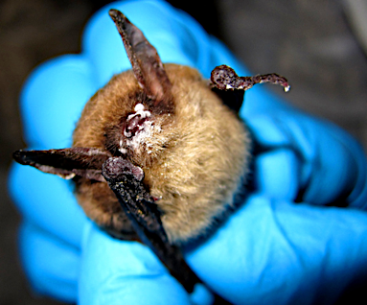
Figure 8: Scientists examine a bat suffering from white-nose syndrome.
Name: _________________________________________________________ Date: __________________
Expert Group 3
Hercules Beetle

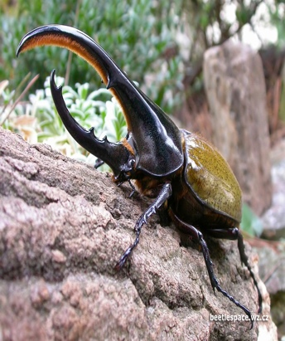
Environmental Factors
The Hercules beetle is one of the largest beetles in the world. Hercules beetles live in the tropical rainforests of Central and South America. Tropical rainforests have hot temperatures year-round. They have a lot of rain, which makes the air humid. Rainforests have a lot of bio-diversity, which means many different plants and animals live there. They live in tropical rainforests, hidden in rotten tree trunks.
Figure 1: A male Hercules beetle
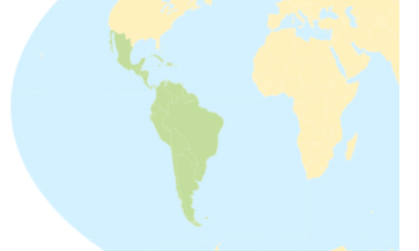
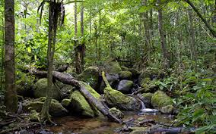

Figure 2; Hercules beetles are found in the tropical rainforests of Central and South America.

Figure 3: A tropical rainforest of South America

Adaptations: Structural and Behavioral
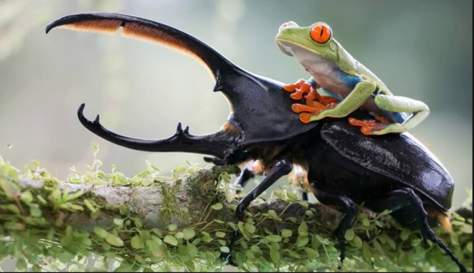
A structural adaptation that help the Hercules beetle is its colorful, strong shell, which acts as both protection and as camouflage. The shell can be black, brown, green blue, white, or yellow. It is also very strong so it can carry and move its food. It can carry up to 850 times its own body weight.
A behavioral adaptation of the male Hercules beetles is that they use their long horns to duel or fight each other as they try to “win” a mate (a partner to have babies with). Another behavioral adaption is that adult Hercules beetles can create a loud sound by rubbing their abdomen against their wings to tell predators to stay away.
Figure 4: Hercules beetles are one of the strongest creatures on earth for its size.

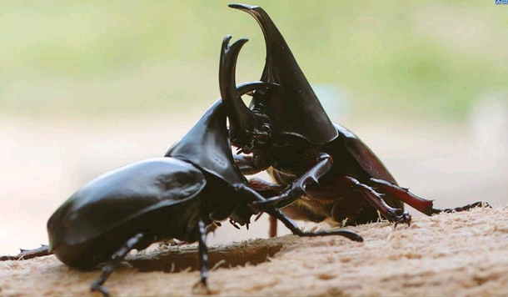

Figure 5: Male Hercules beetles dueling

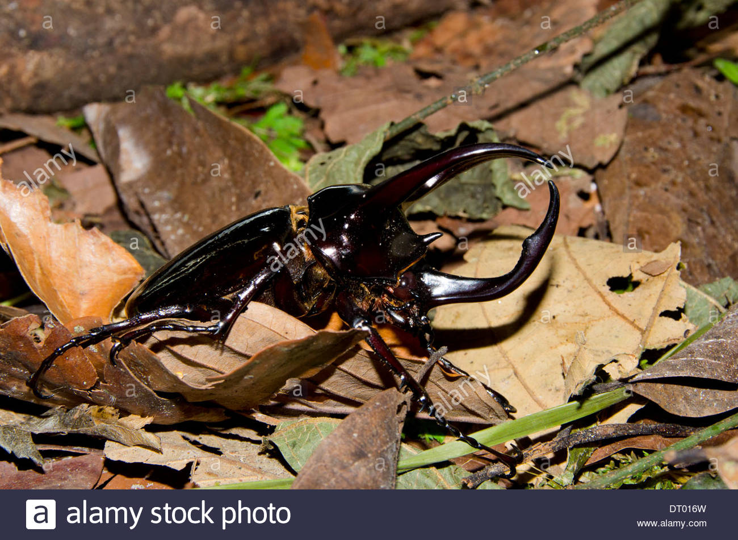
Diet & Shelter
Hercules beetles forage through leaf litter on the forest floor in search of something to eat. They mostly eat rotting wood. They spend most of their life on the forest floors in decaying wood and leaf litter. Hercules beetles are solitary animals, they live alone.

Figure 6: A Hercules beetle on leaf litter on the forest floor

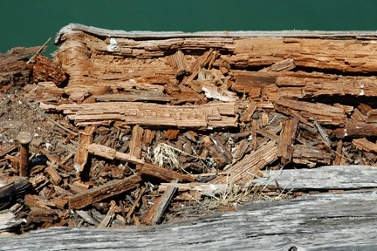

Figure 7: Decaying is when wood slowly breaks apart.

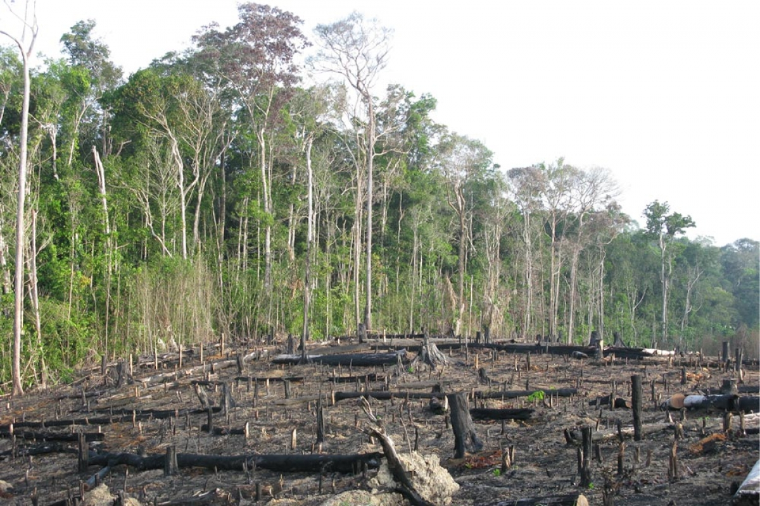
Human Impact
Humans populations also live in the tropical rainforest and are responsible for deforestation. Deforestation is clearing space by cutting down trees. With deforestation, the Hercules beetle’s habitats and shelters have been destroyed. This is called habitat loss.

Figure 8: Sometimes humans cut down rainforests to build roads..

Name: ________________________________________________________ Date: __________________
Expert Group 4
Siberian Musk Deer

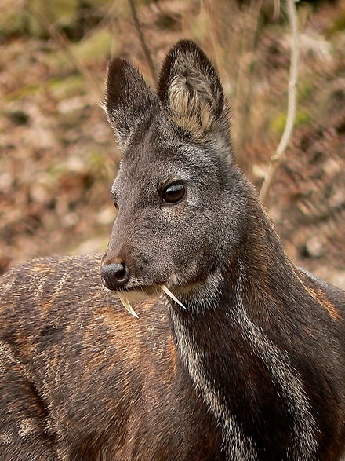
Environmental Factors
The Siberian musk deer lives in the taiga ecosystem in the Siberian region of Russia. Russia is located in the continent of Asia. The Taiga has long, snowy winters and short, hot summers. It has large mountains, evergreen forests, and lakes and rivers.
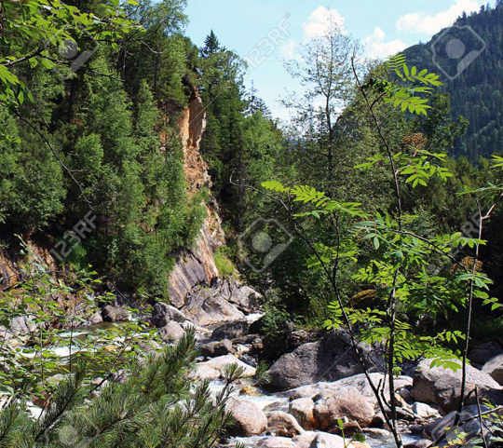

Figure1: An adult male Siberian musk deer

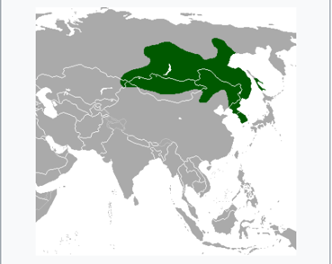
Figure 3: Summertime in the Russian taiga.

Figure 2: Eastern Russia is home to the Siberian musk deer.

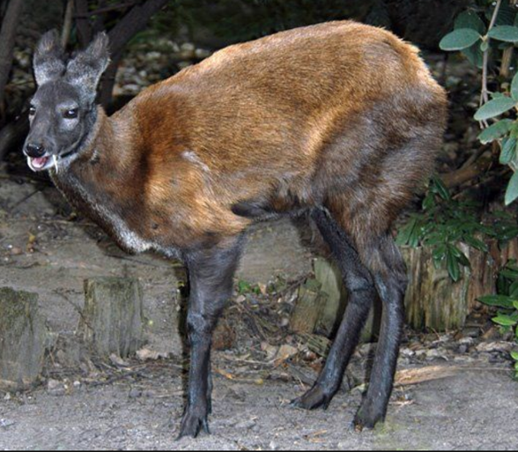
Adaptations: Structural and Behavioral

The Siberian musk deer has structural adaptations that help it in its environment. It is one of the smaller species of deer.
Its small size helps it hide in the crevices between the mountains. Its hind (back) legs are longer to assist with climbing rocks and mountains. Its pointy hooves make it easier to move better in the snow.
Whether they are alone or in small herds, Siberian musk deer are territorial. They mark their territory or area with their scents. They also gather branches and other things to create boundaries. Males have a special “musk” scent they release to attract females.
Figure 4: What adaptations do you notice in this photograph?

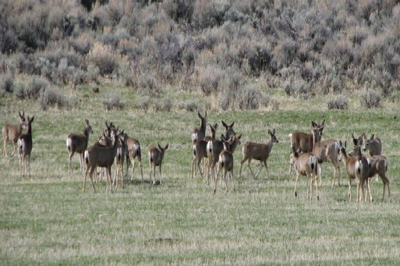
Diet & Shelter
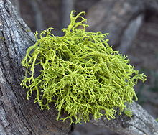
Siberian musk deer are herbivores. Their main source of nutrients is a plant that grows on evergreen trees called lichen. It is easy for their stomachs to digest. They take shelter in crevices between mountains. They are mostly solitary animals that live alone, but sometimes they chose to live in small herds.
Figure 6: Deer in a small herd.

Figure 5: Lichen can grow on trees and rocks

Human Impact
Some humans hunt the male Siberian musk deer for its musk, a liquid it produces that is used in making perfumes, cosmetics and some traditional medicines. The mush is one of the most expensive animal products around the world. Humans have also cut down the forests where the Siberian musk deer live to build settlements and for fuel. This is called deforestation and limits the area where they can live.
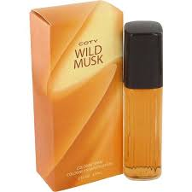
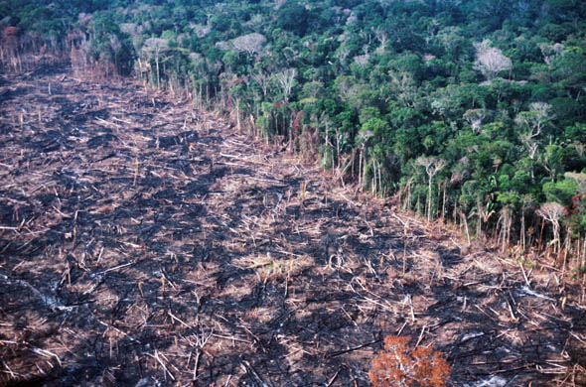

Figure 8: Humans cut down forests to make room for human settlements.
Figure 7: Musk-scented perfume is very popular.

Process Grid - Empty

Animal | Environmental Factors | Adaptations  -Structural  -Behavioral | Diet & Shelter | Human Impact
Mexican Gray Wolf

African Elephant

Big-Eared Bat
Hercules Beetle
Siberian Musk Deer

Process Grid – Complete
Animal | Environmental Factors | Adaptations  -Structural  -Behavioral | Diet & Shelter | Human Impact
Mexican Gray Wolf | - High desert  - Southwest USA & Central Mexico  - Dry- little rainfall/water  - Hot days/cold nights  - Mountains, valleys, mesas  - Little vegetation | - Small size- 2.5 ft tall. 50-80 lbs  - Thick fur- warmth  - Light-brown coat- camouflage  - Long legs- fast hunter  - Communicates w/sounds & body language  - Travel in packs- hunt | - Carnivore- small prey rabbits, large prey, deer  - Live in dens- caves, burrow | - Human population-ranchers raising cattle  - Poison and trap wolves  - Endangered
African Elephant | - Tropical grasslands  - Savannahs of Central Africa  - Warm all year  - Rainy summer  - Dry winter  - Flat land  - Dry grass, scattered trees & shrubs | - Big ears- cool off  - Tusk- scrape bark, dig roots  - Shower with water- cool off  - Travel in female herds- family  - Long trunk- reach leaves on tall trees | - Herbivore- grass, roots, bark & fruit  - Nomadic- in constant travel | - Human population- poachers hunt for ivory
Big Eared Bat | - Temperate forest  - Northeast USA  - 4 distinct seasons  - Good rainfall, snowy winters  - Valleys, mountains  - Lakes & rivers  - Deciduous trees | - Large ears - uses echolocation to locate food  - Roost-warmth and protection  - Hibernate- store energy for winter when there is less food | - Carnivore- insects, moths, beetles, flies  - Live in caves in groups | - Human population- cave exploration  - disturbs hibernation  - brought in bacteria that causes white-nose syndrome
Hercules Beetle | - Tropical Rainforest  - South America  - Hot temperature year-long  - High rainfall  - Humid air  - Diverse plants and animals | - Hard, colorful shell- protection & camouflage  - Very strong (can lift 850 times its weight)- needed to move food  - Horn-like pincers- fight/attract mate  - Adults create loud sound - rubbing abdomen against wings - tell predators to stay away | - Herbivore- leaf-litter, rotting wood  - Shelter in burrowed holes (solitary) | - Human population- deforestation & pollution  - habitat loss
Siberian Musk Deer | - Alpine Taiga  - Eastern Russia  - Long, snowy winters  - Short, hot summers  - Mountainous  - Coniferous forest  - Lakes & rivers | - Small body- hide in rock for protection  - Pointy hooves- walk in the snow  - Longer hind legs- assist with climbing  - Territorial- mark and keep their own space | - Herbivore- lichen, pine needles  - Shelter in mountain crevices (mostly solitary) | - Human population- hunting (musk)  - Deforestation - habitat loss

Writing Prompt

Directions:
Think about all the animals we have studied in this unit, including those you may have learned about during your team or individual research time. Choose one animal and write a paragraph about how the structural and behavioral adaptations of this animal help it survive in its environment.

In your writing, be sure to clearly state a main idea through the use of a topic sentence. You must provide at least three supporting sentences that support your topic sentence. Write a conclusion that restates and expands on your topic sentence and supports your main idea.

This essay has four assignments due when submitting your final draft:
- Prewriting Activities ________ 3. Rough Draft ________
- Topic Sentence ________ 4. Final Draft ________

Writing Rubric
Paragraph Grading Rubric

Grading Scale
4 Exceeds Standards
3 Meets Standards
2 Approaching Standards
1 Below Standards
0 Nonexistent
Yes/No
- Prewriting Activities:
Are all prewriting activities included and attached to the final?
Score ________
- Topic Sentence:
Does it state the main idea of your essay?
Score ________
- Evidence Used:
Are there three or more details that support the main idea?
Score ________
- Information and organization:
Is the information explained correctly and coherently?
Score ________
- Conclusion:
Does your conclusion strengthen the main idea?
Score ________
- Conventions:
Does the writing include correct spelling, capitalization, and punctuation? __________
Score _________

Score Total = ÷ 6 = ____________
Final Score

ACTION PLAN
Deforestation

Action Plan: Solutions to the problem of deforestation
Deforestation is the destruction of a forest ecosystems by the cutting, clearing, and removal of large areas of trees. It is a change to an animal’s environment that can be deadly!

- As a class we will study deforestation beginning with the information on this website: http://kids.mongabay.com/lesson_plans/lisa_algee/deforestation.html
We will focus on:
- causes,
- environmental consequences,
- societal consequences, and
- possible solutions.
- With your team, brainstorm what could be done in your state or in the United States to address this issue.
- With your team, create an action plan presentation on the issue of deforestation. (paper slides, video, power point, report, letter, play, poem, etc.)
- Present your action plan to the class.
- Revise and edit your action plan presentation based on class input.
- Find contact information for your school, neighborhood, or community. Submit a formal request to share your presentation. Follow-up your request and await a response.

*Objective of Action Plan:
This action plan is a working graphic organizer to be constructed with the students as the topic develops.

*Assessment: Teacher should provide students with a rubric for Action Plan including grade-level standards and school and/or classroom goals (21st Century Goals). This could be created with student input.

Graffiti Wall Questions (this could be a mix of English and Spanish questions.)

True/False

Animal adaptations are what humans do to help animals survive. T F
Why is this true or false?

Match the word with its definition

hibernate - an animal that hunts another animal
camouflage - when an animal’s body slows down for a long period of time to save energy
predator - an animal that is hunted by another animal
prey - when an animal is able to blend into its environment and not be easily seen

Pictorial Chart

Draw a picture of the Mexican Gray Wolf and label its physical adaptations.

Formación de oraciones

Escriban una oración interesante acerca de los animales usando todas las partes de la oración.

Historia narrativa

Dibujen una escena (algo importante que pasó) del cuento “El polluelo pingüino”. Escriban una oración describiendo lo que está pasando en la escena.

Open Response

Explain how humans have threatened some animal species.

Fill in the blank

An adaptation the Mexican Gray Wolves have is________________________, which helps them to _____________________________.

Animal Adaptation Test Name_____________________________

- A scientist who studies and works with animals in their habitats is called a ____________________.

- An adaptation is
  - an animal
  - a plant
  - a scientist
  - a structural or behavioral change

- A place where an animal lives is called its
  - diet
  - physical features
  - habitat
  - behavior

- Write about the structural adaptations of an animal we studied in this unit.

- Write about the behavioral adaptations of an animal we studied in this unit.

- Which part of speech is an action word, such as swims, eats, and hibernates?
  - verb
  - adjective
  - adverb
  - noun

- Which word is an example of an adverb?
  - seals
  - on the rocks
  - quickly
  - none of the above

- Write a sentence about animals using all the parts of speech from the Sentence Patterning Chart.

- How do structural and behavioral adaptations help animals survive in their habitats?

- On the back, write a paragraph about the impact of humans on animal habitats. Remember to begin with a topic sentence.

