Project GLAD
Albuquerque Public School District
Desert Life (3)
Idea Pages

- UNIT THEME
  - Characteristics of deserts
  - Adaptation – An adaptation in physical structure or behavior can improve an organism’s chance for survival
  - Similarities and differences among organisms
  - Interdependence of living things and their environments
  - Cross-cultural theme: All cultures have studied the ecosystems, animals, and plant life. All cultures have stories and legends that explain natural phenomenon and questions about the life.

- FOCUS/MOTIVATION
  - Cognitive Content Dictionary with signal words
  - Big Book The Important Book About Desert Life…
  - Desert Life Awards
  - Inquiry Chart
  - Observation Charts
  - Interest Pieces
  - Videos
  - Picture File Cards/Exploration Report
  - Fieldtrip to zoo/Talking Talons/Botanical Gardens

- CLOSURE and EVALUATION
  - Process all charts
  - Group presentations of team tasks
  - Where’s my answer
  - Reading Big Books, share individual poetry
  - Graffiti Wall
  - Chapter Test
  - Student required writings with rubrics

- STANDARDS

SCIENCE – 3RD GRADE

Content of Science Standard 2
Students will understand the properties, structures and processes of living things and the interdependence of living things and their environments. Students will:
- Know that living things have diverse forms, structures, functions and habitats;
3rd Grade
- Know that an adaptation in physical structure or behavior can improve an organism's chance for survival (e.g., horned toads, chameleons, cacti, mushrooms);
- Observe that plants and animals have structures that serve different functions (e.g., shape of animals' teeth);
- Classify common animals according to their observable characteristics (e.g., body coverings, structure);
- Classify plants according to their characteristics (e.g., tree leaves, flowers, seeds);
- Know that living things have similarities and differences, and that living things change over time;

3rd Grade
- Identify how living things cause changes to the environments in which they live, and that some of these changes are detrimental to the organism and some are beneficial;

Scientific Thinking and Practice Standard 1
Students will understand the processes of scientific investigations and use inquiry and scientific ways of observing, experimenting, predicting and validating in order to think critically. Students will:
- Use scientific methods to observe, collect, record, analyze, predict, interpret and determine reasonableness of data;
3rd Grade
- Make new observations when discrepancies exist between two descriptions of the same object or phenomenon to improve accuracy;
- Recognize the difference between data and opinion;
- Use numerical data in describing and comparing objects, events and measurements;
- Collect data in an investigation and analyze those data;

SOCIAL STUDIES – 3RD GRADE

Geography Standard 1
Students understand how physical, natural and cultural processes influence where people live, the ways in which people live and how societies interact with one another and their environments. Students will:
- Understand the concept of location by using and constructing maps, globes and other geographic tools to identify and derive information about people, places and environments;
3rd Grade
- Identify and use the mapping tools of scale, compass rose, grid, symbols and mental mapping to locate and draw places on maps and globes;

CCSS ELA – 3RD GRADE

Reading Standards for Literature
  - RL .3.1 Ask and answer questions to demonstrate understanding of a text, referring explicitly to the text as the basis for the answers.
  - RL.3.2 Recount stories, including fables, folktales, and myths from diverse cultures; determine the central message, lesson, or moral and explain how it is conveyed through key details in the text
  - RL.3.3 Describe characters in a story (e.g., their traits, motivations, or feelings) and explain how their actions contribute to the sequence of events.
  - RL.3.4 Determine the meaning of words and phrases as they are used in a text, distinguishing literal from nonliteral language.
  - RL.3.5 Refer to parts of stories, dramas, and poems when writing or speaking about a text, using terms such as chapter, scene, and stanza; describe how each successive part builds on earlier sections RL.3.6 Distinguish their own point of view from that of the narrator or those of the characters.
  - RL.3.7 Explain how specific aspects of a text’s illustrations contribute to what is conveyed by the words in a story (e.g., create mood, emphasize aspects of a character or setting).
  - RL.3.9 Compare and contrast the themes, settings, and plots of stories written by the same author about the same or similar characters (e.g., in books from a series).
  - RL.3.10 By the end of the year, read and comprehend literature, including stories, dramas, and poetry, at the high end of the grades 2–3 text complexity band independently and proficiently.
  - Reading Standards for Informational Text
  - RI.3.2 Determine the main idea of a text; recount the key details and explain how they support the main idea.
  - RI.3.3 Describe the relationship between a series of historical events, scientific ideas or concepts, or steps in technical procedures in a text, using language that pertains to time, sequence, and cause/effect.
  - RI.3.4 Determine the meaning of general academic and domain-specific words and phrases in a text relevant to a grade 3 topic or subject area.
  - RI.3.5 Use text features and search tools (e.g., key words, sidebars, hyperlinks) to locate information relevant to a given topic efficiently.
  - RI.3.6 Distinguish his or her own point of view from that of the author of a text.
  - RI.3.7 Use information gained from illustrations (e.g., maps, photographs) and the words in a text to demonstrate understanding of the text
  - RI.3.8 Describe the logical connection between particular sentences and paragraphs in a text (e.g., comparison, cause/effect, first/second/third in a sequence).
  - RI.3.9 Compare and contrast the most important points and key details presented in two texts on the same topic.
  - RI.3.10 By the end of the year, read and comprehend informational texts, including history/social studies, science, and technical texts, at the high end of the grades 2–3 text complexity band independently and proficiently

Foundational Skills
- RF.3.3 Know and apply grade-level phonics and word analysis skills in decoding words.
  - a. Identify and know the meaning of the most common prefixes and derivational
  - suffixes.
  - b. Decode words with common Latin suffixes.
  - c. Decode multisyllabic words.
  - d. Read grade-appropriate irregularly spelled words.
- RF.3.4 Read with sufficient accuracy and fluency to support comprehension.
- Read on-level text with purpose and understanding. Read on-level prose and poetry orally with accuracy, appropriate rate, and expression on successive readings.
- Use context to confirm or self-correct word recognition and understanding, rereading as necessary.
Writing Standards
W.3.1 Write opinion pieces on topics or texts, supporting a point of view with reasons.
  - a. Introduce the topic or text they are writing about, state an opinion, and create an organizational structure that lists reasons. Provide reasons that support the opinion.
  - c. Use linking words and phrases to connect opinion and reasons.
  - d. Provide a concluding statement or section.
W.3.2 Write informative/explanatory texts to examine a topic and convey ideas and information clearly.
a. Introduce a topic and group related information together; include illustrations when useful to aiding comprehension.
b. Develop the topic with facts, definitions, and details.
c. Use linking words and phrases to connect ideas within categories of information.
d. Provide a concluding statement or section.
W.3.3 Write narratives to develop real or imagined experiences or events using effective technique, descriptive details, and clear event sequences.
a. Establish a situation and introduce a narrator and/or characters; organize an event sequence that unfolds naturally. Use dialogue and descriptions of actions, thoughts, and feelings to develop experience and events or show the response of characters to situations.
b. Use temporal words and phrases to signal event order.
c. Provide a sense of closure.
W.3.4 With guidance and support from adults, produce writing in which the development and organization are appropriate to task and purpose.
W.3.5 With guidance and support from peers and adults, develop and strengthen writing as needed by planning, revising, and editing.
W.3.6 With guidance and support from adults, use technology to produce and publish writing (using keyboarding skills) as well as to interact and collaborate with others.
W.3.7 Conduct short research projects that build knowledge about a topic
W.3.8 Recall information from experiences or gather information from print and digital sources; take brief notes on sources and sort evidence into provided categories.
W.3.10 Write routinely over extended time frames (time for research, reflection, and revision) and shorter time frames (a single sitting or a day or two) for a range of discipline-specific tasks, purposes, and audiences.

Speaking and Listening Standards (SL)
SL.3.1 Engage effectively in a range of collaborative discussions (one-on-one, in groups, and teacher led) with diverse partners on grade 3 topics and texts, building on others’ ideas and expressing their own clearly.
a. Follow agreed-upon rules for discussions (e.g., gaining the floor in respectful ways, listening to others with care, speaking one at a time about the topics and texts under discussion).
b. Ask questions to check understanding of information presented, stay on topic, and link their comments to the remarks of others.
c. Explain own ideas and understanding in light of the discussion.
SL.3.2 Determine the main ideas and supporting details of a text read aloud or information presented in diverse media and formats, including visually, quantitatively, and orally.
SL.3.3 Ask and answer questions about information from a speaker, offering appropriate elaboration and detail.
SL.3.4 Report on a topic or text, tell a story, or recount an experience with appropriate facts and relevant, descriptive details, speaking clearly at an understandable pace.
SL.3.5 Create engaging audio recordings of stories or poems that demonstrate fluid reading at an understandable pace; add visual displays when appropriate to emphasize or enhance certain facts or details.
SL.3.6 Speak in complete sentences when appropriate to task and situation in order to provide requested detail or clarification.

Language Standards
L.3.1 Demonstrate command of the conventions of standard English grammar and usage when writing or speaking.
a. Explain the function of nouns, pronouns, verbs, adjectives, and adverbs in general and their functions in particular sentences.
b. Form and use regular and irregular plural nouns.
c. Use abstract nouns.
d. Form and use regular and irregular verbs.
e. Form and use the simple verb tense (e.g., I walked, I walk, I will walk).
f. Ensure subject and pronoun antecedent agreement.
g. Form and use comparative and superlative adjectives and adverbs, and choose between them depending on what is to be modified.
h. Use coordinating and subordinating conjunctions.
i. Produce simple, compound and complex sentences.

L.3.2 Demonstrate command of the conventions of standard English capitalization, punctuation, and spelling when writing.
a. Capitalize appropriate words in titles.
b. Use commas in addresses.
c. Use commas and quotation marks in dialogue.
d. Form and use possessives.
e. Use conventional spelling for high frequency and other studied words for adding suffixes to base words (e.g., sitting, smiled, cries, happiness).
f. Use spelling patterns and generalizations (e.g., words families, position-based spellings, syllable patterns, ending rules, meaningful word parts) in writing words.
g. Consult reference materials, including beginning dictionaries, as needed to check and correct spellings.
L.3.3 Use knowledge of language and its conventions when writing, speaking, reading, or listening.
a. Choose words and phrases for effect. Recognize and observe differences between the conventions of spoken and written standard English.
L .3.4 Determine or clarify the meaning of unknown and multiple-meaning word and phrases based on grade 3 reading and content, choosing flexibly from a range of strategies.
a. Use sentence-level context as a clue to the meaning of a word or phrase.
b. Determine the meaning of the new word formed when a known affix is added to a known word Use a known root word as a clue to the meaning of an unknown word with the same root.
c. Use glossaries or beginning dictionaries, both print and digital, to determine or clarify the precise meaning of key words and phrases.
L.3.5 Demonstrate understanding of word relationships in word meanings.
a. Distinguish the literal and nonliteral meanings of words and phrases in context (e.g., take steps).
b. Identify real life connections between words and their use A (e.g., describe people who are friendly or helpful).
c. Distinguish shades of meaning among related words that describe states of mind or degrees of certainty
L.3.6 Acquire and use accurately grade-appropriate conversational, general academic, and domain specific words and phrases, including those that signal spatial and temporal relationships.
WIDA English Language Development Standards – 3rd Grade 2012
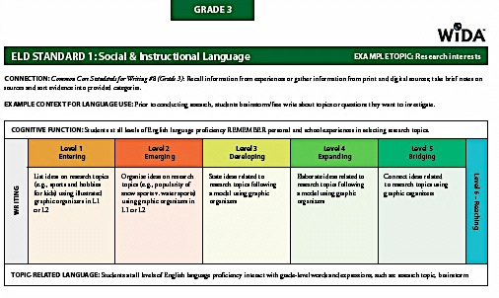
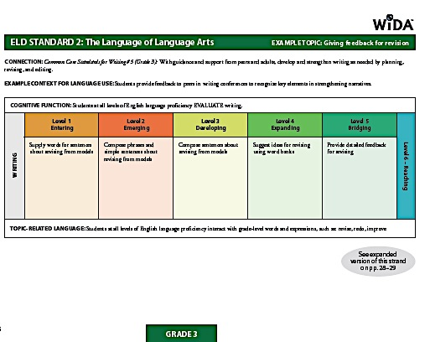
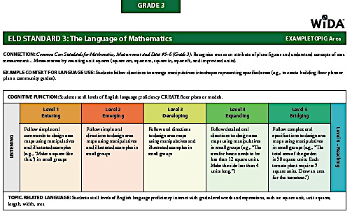
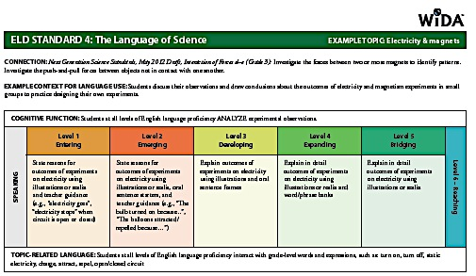

- VOCABULARY (bolded words are particularly good choices for CCD and word study)
Tier II |  | Tier III
adaptation | scavenger | amphibian
behavioral | shallow | Arid
burrow | shortage | camouflage
characteristics | spines | chlorophyll
conserve | structure | desert
dormant | survive | dew
drought | wary | digestive
environment |  | Diurnal
extreme |  | ecosystem
humidity |  | estivate
inherit |  | evaporation
instinct |  | habitat
interdependence |  | hibernate
mammal |  | invertebrate
migrate |  | pores
mimicry |  | nocturnal
moisture |  | organism
metamorphosis |  | photosynthesis
physical |  | reptile
reflect |  | vertebrate
resource |  | succulent
Tier 1 Basic words that commonly appear in spoken language. Because they are heard frequently in numerous contexts and with nonverbal communication, Tier 1 words rarely require explicit instruction. Examples of Tier 1 words are clock, baby, happy and walk.
Tier 2 High frequency words used by mature language users across several content areas. Because of their lack of redundancy in oral language, Tier 2 words present challenges to students who primarily meet them in print. Examples of Tier 2 words are obvious, complex, establish and verify.
Tier 3 Words that are not frequently used except in specific content areas or domains. Tier 3 words are central to building knowledge and conceptual understanding within the various academic domains and should be integral to instruction of content. Medical, legal, biology and mathematics terms are all examples of these words.
Bringing Words To Life, Beck, Isabel L., McKeown, Margaret G., Kucan, Linda. The Gilford Press, 2002.

- Resources and Materials –
Non-Fiction
Hampton Brown. A Hole is a Great home.
Steck-Vaughn. Lions.
Hampton Brown. Looking for the Queen.
Rigby. Animal Scavengers.
Children’s Press. Coyotes.
Rourke. Deserts.
Weelky Reader. Roadrunners.
Capstone Press. Desert Plants.
Children’s Press. Saguaro Cactus.
Sierra Club Books. Desert Giant The World of the Saguaro Cactus.
Children’s Press. Desert Birds.
Children’s Press. Cactuses.
Harcourt Brace Publisher. Science.
Scholastic. Reptiles and Amphibians Dictionary.
Meridith. Buggin’ with Ruud.
World Book. Animals.
Carolrhoda Books. Animal Predators Owls.
Story Kids. Raptor.
Laronze Books. Lizards.
Scholastic. Frogs and Other Amphibians.
Scholastic. All Kinds of Reptiles.
Scholastic. Animal Families.
Scholastic. What Has Wings.
Scholastic. Plants.
Harcourt School Publisher. Could Polar Bear Survive in the Desert.
Harcourt School Publisher. Types of Plants.
Harcourt School Publisher. Types of Living Things.
Harcourt School Pubishers. Where Living things are Found.
Harcourt School Publishers. Types of Animals.
Harcourt School Publisher. Understanding the Food Chain.
Harcourt School Publisher. What Kind of Animal.
Harcourt School Publisher. The Wonderful World of Plants.
Harcourt School Publisher. Living Things Grow and Change.
Harcourt School Publisher. Living Things Depend on One Another.
Harcourt School Publisher. Amazing Plants.
Harcourt School Publisher. Living Things Are All Around Us.

Resources and Materials – Fiction
Tambourine, 1996. Camel Caravan
Pinata Books, 1994. The Desert is My Mother/El desierto es mi madre.
Dutton Children’s Books, 1999. Two Cool Coyotes
Tony Johnston. Desert Song.
Susan Lowell. The Tortoise and the Hare.
Rigby. Visiting the Eagle Hotel.
Scholastic Inc. Prairie Dogs.
Harcourt Brace Publisher. Prairie Dogs.
Harcourt Brace Publisher. Folktales from Ecosystems Around the World.
Scholastic. My Home is Just Right for Me.

Resources and Materials – Poetry
Alma Flor Ada. A Chorus of Cultures
Millbrook Press. The Paisano Roadrunner.
Harcourt Brace Publisher. Storm on the Desert.

Resources and Materials – Internet
http://www.docseward.com/
www.desertusa.com
www.nps.gov/archive/moja/mojadewd.htm
www.livingdesert.org/deserts
http://kids.nceas.ucsb.edu/biomes/desert.html
http://www.sciencekids.co.nz/sciencefacts/earth/desert.html
http://environment.nationalgeographic.com/environment/habitats/desert-profile/
http://www.ducksters.com/science/ecosystems/desert_biome.php
http://www.desertanimals.net/
http://idahoptv.org/dialogue4kids/season3/desert/
http://environment.nationalgeographic.com/environment/habitats/desert-profile/
http://worldwildlife.org/habitats/deserts

Project GLAD
Albuquerque Public School District
Desert Life (3)
Planning Pages

I. FOCUS/MOTIVATION
- Cognitive Content Dictionary with Signal Word
- Desert Life Awards
- Observation Charts
- Inquiry charts: What do you know about desert life? What do you want to know?
- Big book, The Important Book About Desert Life…
- Chant
- Fieldtrip Zoo/Talking Talons/Botanical Gardens
- Poetry
- Interest Pieces
- Pre/post mind mapping with webbing

II. INPUT
- World Map (desert area focus) Graphic Organizer
- Comparison Pictorial
- Narrative Input (“The Cactus Wren and the Cholla”)
- Expert Groups
- 10/2 with primary language
- Interest pieces

III. GUIDED ORAL PRACTICE
- T-Graph for Social Skills: “Cooperation”
- Mind mapping, list-group-label
- Team Tasks
- Poetry
- Exploration Report
- Sentence Patterning Chart
- Daily review and processing of charts
- Narrative Retell
- Guess my Category
- Jeopardy

IV. Reading/Writing Activities
- Whole Class
  - Process Grid
  - Story Mapping
  - Expository Reading/Writing
  - Model Editing Process Group Frames (Teacher uses information from students to model appropriate)
- Big Book – The Important Book About Desert Life…
- Cooperative strip paragraph
Plus supporting details (expository, metaphors)
- Poetry – Stars are Silver Reindeer; they….(poetry)
  - Found Poetry
  - Listen and Sketch
- Flexible and Cooperative Groupings
- Sentence Patterning Chart with Word Cards (read and trade games)
- Ear-to-Ear Reading
- Cooperative Strip Paragraph
- Team Tasks
- Expert Groups
- Flexible Grouping for ELD differentiation, primary language, reading instructions, skill reinforcement (ELD review/retell)
- Individual Work
- Learning Logs
- Reading/Writing Choice
- Interactive Journals
- Individual tasks
- Reading/Writing choices: picture file cards, add to charts, make word cards, highlight poetry booklets, focused reading, poetry booklet, flip chants
- Writer’s Workshop
- Mini-Lessons
- Plan, Share, Write, Revise, Edit, Publish
- Conferencing
- Author’s Chair

- Extension Activities
  - Daily Activities
Read Aloud
Silent Sustained Reading/Book Sharing
Silent Sustained Writing
Listening Activities
Daily News/Interest Piece
Personal Interaction
Flexible group reading

VI. Closure/Evaluation
- Re-visit Inquiry Chart
- Student-Made Big Books
- Team Task Presentations
- Expert Group Presentations
- Portfolios
- Graffiti Wall
- Living wall
- Vocabulary strips of “Where’s my answer?”

Project GLAD
Albuquerque Public School District
Desert Life (3)
Sample Daily Lesson Plans
Day 1 (Weeks 1-1.5)
FOCUS/MOTIVATION
- Introduce 3 standards, Making good decisions, Solving problems, Showing respect
- Super Scientist Awards (Literacy Awards)
- Signal Word processing w/Cognitive Content Dictionary -
- Observation Charts
- Inquiry Chart on Desert Life
- Big Book
- Portfolios

INPUT
- Graphic Organizer Input Chart of Deserts of the World
- 10/2 Lecture with Primary Language
- Learning Log
- ELD Review

GUIDED ORAL PRACTICE
- T-graph for Social Skills – “cooperation”
- Guess My Category with Picture File Cards – Closed and Open Sort
- Chant

INPUT
- Pictorial Input: Gila Monster and Saguaro Cactus (Comparative Input for PIC)
- 10/2 Lecture with Primary Language
- Learning Log
- ELD Review
READING/WRITING
- Writer’s Workshop
- Mini-Lesson: Sketch to Write
- Author’s Chair
CLOSURE
- Interactive Journal
- Process Inquiry Chart
- Home/School Connection

Desert Life (3)
Sample Daily Lesson Plans
Day 2 (Week 2 – 3.5)
FOCUS/MOTIVATION
- T-Graph Review
- Share Home/School Connection share out
- Cognitive Content Dictionary – new word:
- Super Scientist Awards –

INPUT
- Process GO and PIC Charts with Picture File Cards and Word Cards
- Chant – Process
- Narrative Input Chart- “The Cactus Wren and the Cholla”

GUIDED ORAL PRACTICE
- Chant:
- Team Task Key, Team Task Menu

READING/WRITING
- Expert Groups
- Team tasks

CLOSURE
- T-Graph Teacher Participant Observation Share Out
- Process Inquiry Charts
- Interactive Journals
- Home/School Connection
Desert Life (3)
Sample Daily Lesson Plans
Day 3 (Week 3 – 4.5)
FOCUS/MOTIVATION
- T-Graph Review
- Share Home/School Connection share out
- Cognitive Content Dictionary – new word:
- Super Scientist Awards –

GUIDED ORAL PRACTICE
- Process Chant
- Narrative Input Review w/ Conversation Bubbles and Word Cards
- Sentence Patterning Chart (Farmer-in-the-Dell)
Reading Game
Trading Game
- Mind Map
- Process Grid

READING/WRITING
- Co-op Strip Paragraph – Write, Revise, and Edit
- Listen and Sketch: The Desert is my Mother

CLOSURE
- Interactive Journals
- Process Inquiry Chart
- Home/School Connection

Desert Life (3)
Sample Daily Lesson Plans
Day 4 (Week 4-5.5)
FOCUS/MOTIVATION
- T-Graph Review
- Share Home/School Connection share out
- Cognitive Content Dictionary – Stumper Word, Model Team CCD
- Super Scientist Awards –

GUIDED ORAL PRACTICE
- Oral Team Evaluation of T-Graph
- SPC – -ing change, Flip Chant

READING/WRITING
- Ear to Ear Reading
- Story Map of Narrative Input
- ELD Group Frame: Retell of Narrative Input
- Team Task Menu:
- Team Tasks
- Flexible Reading
- Emergent Readers: Cooperative Strip Paragraph Rebuild
- At or Above Readers: Clunkers and Links w/SQ3R

CLOSURE
- Team Presentations
- Process Inquiry Chart

Desert Life (3)
Sample Daily Lesson Plans
Day 5 (Week 5-6)
FOCUS/MOTIVATION
- Share Home/School connection
- Signal Word processing w/Cognitive Content Dictionary (stumper word)
- Interactive Journal
- Found poetry
- DRTA
- Read walls with personal CCD

CLOSURE
- Process Inquiry Chart
- Team Jeopardy game
- Evaluate week
- Share Team Big Books
- Letter Home

Prediction Reaction Guide: Desert Life
Directions: Please respond by sketching and writing below.

- What fraction of the Earth’s surface contains desert habitats?
Prediction
Reaction

- How have the bodies of desert animals adapted to the extremes of temperature of the desert?
Prediction
Reaction

- What are some behaviors of desert animals that help them survive in their harsh environment?
Prediction
Reaction

- Describe how the characteristics of desert plants help them to survive in the desert.
Reaction
Prediction

- Give and example of how desert plants and animals depend on each other.
Prediction
Reaction

Literacy Awards: Bookmarks, Fact Cards, Super Biologist Notebooks
Sage Grouse  (insert picture)  Description: Males weigh 4 to 7 pounds and have a distinctive white and black neckband. Females are smaller (2 - 4 pound range). Sage grouse are mostly a dusky, grayish-brown color - perfect for blending in with the habitat.  Diet: Feeds on sagebrush during the winter. At other times of the year will feed on leaves, blossoms and buds of plants. Also may eat ants and grasshoppers  Young: Females incubate 7 - 8 eggs for 25 -27 days. They are tended by the females and can fly when they are 7 - 14 days old..  Interesting Facts: This large bird was once abundant in sagebrush habitat, but a loss of habitat is affecting the population of the bird.  On the back, draw a detailed picture of a Sage Grouse eating. Label its distinct features and add interesting information. | Scorpion  (insert picture)  Description: Scorpions are arachnids. They have eight legs; each leg has tiny claws. They have a hard exoskeleton and not an internal skeleton. The stinger at the end of the tail injects a paralyzing poison into the prey. They range in color from black to brown to tan to red  Diet: insects and small rodents are the main food of this meat-eater  Young: Scorpions give birth to large litters of live young, who quickly climb onto the mother's back after birth. The mother cares for the young until they are able to hunt.  Interesting Facts: These animals have been on earth for over 400 millions years.  On the back, draw a detailed picture of a Scorpion carrying its young. Label its distinct features and add interesting information. | Great Basin Spadefoot Toad  (insert picture)  Description: This small toad lacks the bumpy glands and warty skin of its relatives. It has a black, wedge-shaped "spade" on each hind foot; this spade is used to dig burrows. The body is gray and brown or olive.  Diet: Larvae eat algae, organic debris and plant tissue. Adults are known to eat ants, beetles, grasshoppers, crickets and flies.  Young: Spadefoots hatch from eggs and become tadpoles for only a few days. They grow and change very quickly before the water pool dries up. I  Interesting Facts: Primarily nocturnal animals.  On the back, draw a detailed picture of a Great Basin Spadefoot Toad digging a burrow. Label its distinct features and add interesting information. | Western Pygmy-Blue Butterfly  (insert picture)  Description: Tiny. Upperside copper brown with dull blue at the bases of both wings. Underside is copper brown with white at the base, fringe mostly white. 3 small black spots near base; row of black spots at outer margin.  Diet: Adults eat flower nectar; caterpillars eat on tumbleweed.  Young: Blue green eggs hatch into light green caterpillars. Females lay eggs mostly on the upperside of leaves.  Interesting and Unique: Smallest butterfly in the Western United States. Human settlements and the introduction of weeds have increased its population.  On the back, draw a detailed picture of a Western Pygmy-Blue Butterfly flying. Label its distinct features and add interesting information.

SUPER BIOLOGIST  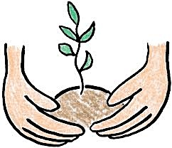 | SUPER BIOLOGIST  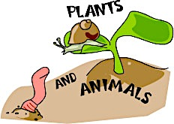
SUPER BIOLOGIST  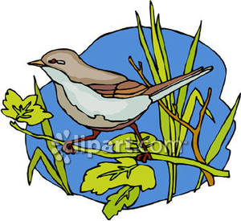 | SUPER BIOLOGIST  

American Badger (Add picture.)  Description: A badger has a white and black facial mask. It has extremely long and sharp claws which allow it to dig soil very efficiently.  Diet: The badger feeds primarily on small rodents such as ground squirrels, pocket gophers and kangaroo rats, but will also eat scorpions, insects, snakes, lizards and birds.  Reproduction: Female produces one litter (group of babies) with an average of about 3 born in March or early April. The young stay in the den for several weeks. Their young leave the family in the Fall.  Interesting and Unique: They are solitary animals, (they keep to themselves) Badgers stay underground, in burrows, when inactive. They usually do not stay underground for more than 24 hours except during winter.  On the back, draw a detailed picture of an American Badger digging soil. Label its features and add interesting information. | Bighorn Sheep (Add picture.)  Description: The bighorn is a thick-necked sheep with a creamy white rump (back end). Rams weigh between 125 - 315 pound and stand 3 to 3 ½ feet high at the shoulder.. Males have massive coiled horns that spiral back, out and then forward, forming a full curl. Females have shorter, thinner horns.  Diet: Bighorn Sheep often eats grasses, but their diet also includes significant amounts of shrubs and flowering plants.  Reproduction: The female usually produces one offspring (baby). Gestation (time in the mother’s womb) lasts about 180 days. Young are weaned from their mother’s milk in 4 to 6 months. Males engage in serious head butting contests in the fall. The sounds of crashing heads can be heard over a mile away.  Interesting and Unique: In the desert Bighorn can survive 10 or more days in summer without drinking. A Bighorn's hooves are well adapted to climbing. They have a very hard outer layer with a straight outer edge, and a softer, almost rubbery inner section.  On the back, draw a detailed picture of a Bighorn Sheep climbing on rock ledges and cliffs. Label its distinct features and add interesting information.
Bobcat (Add picture.)  Description: A bobcat's color varies from a warm light brown in the summer to a gray in the winter. It has idark spots (particularly on the legs), small ears and the tip of its tail, is black only on top.  Diet: The bobcat prefers small mammals, such as voles (a small rodent) and jackrabbits, although it will eat lizards as well.  Reproduction: Female produces one litter of 2 to 3 kits (babies). Gestation (time in the mother’s womb) lasts 50 - 60 days. Both parents care for the young during their time in the den. Young are weaned (they quit drinking their mother’s milk) when about 2 month of age & stay with their mother until early Fall.  Interesting and Unique: In its southern range a second litter of kits may be born in early August. Individuals are solitary (stay alone) except when breeding.  On the back, draw a detailed picture of Bobcat parents caring for their young. Label their distinct features and add interesting information. | Burrowing Owl (Add picture.)  Description: Small owl with no ear tufts on a rounded head; stubby (short) tail and long legs. Earth brown with white spots on back, wings and crown.  Diet: Feeds primarily on large insects and rodents. Sometimes eats birds and amphibians  Reproduction: Females incubate (keeps warm) 6 or 7 eggs for 27 to 30 days. Males provides food during incubation and early stages. Young run and forage (search for food) after 4 weeks and at 6 weeks they are capable of flying. Female usually produces 1 brood (group of young) per year.  Interesting & Unique: They nest and roost (sit on their eggs) in burrows dug by another mammal or owl. They may mimic (copy the sound of) a rattlesnake if disturbed. In the summer, this owl is most active in the daylight hours.  On the back, draw a detailed picture of a Burrowing Owl nesting in a burrow. Label its distinct features and add interesting information.
Coyote (Add picture.)  Description: This dog like animal is larger than a fox but smaller than a wolf. It may weigh up to 50 pounds. It is gray or reddish gray with rust legs, feet and ears, Its body underneath is white. It usually has a black stripe running down the back and tail.  Diet: Coyotes feeds on what is available but eat mainly dead animals, small vertebrates (jackrabbits, pocket mice, voles and ground squirrels) and invertebrates. It will sometimes feed on plants.  Reproduction: Gestation (time in mother’s womb) lasts 2 months. The litter averages 4 to 7 babies. Young are born in the spring and are cared for by both parents. Family leaves den when young are 8 to 10 weeks old. Young become independent by late Fall.  Interesting and Unique: The coyote runs with its tail held down between its legs. Although it is smaller than a wolf, its ears are larger. The coyote is one of the most adaptive of all animals. It can live in a wide variety of habitats.  On the back, draw a detailed picture of a Coyote running with its tail between its legs. Label its distinct features and add interesting information. | Darkling Beetle (Add picture.)  Description: Darkling beetles are found all across the desert west. They are fast running beetles with a shiny black "shell". The shell is actually made up of two hard wings that protect delicate wings underneath.  Diet: Adults are scavengers, eating mostly dead plants. The larvae eat roots, grasses and other plants.  Reproduction: This beetle goes through a metamorphosis like many other insects. The stages of life are egg, larvae, pupa and adult.  Interesting and Unique: This beetle is sometimes called the desert skunk beetle. When threatened, it will raise up on its back legs to stick its bottom in the air. This is a warning to stay back. For protection, it can emit a bad smelling odor. In foggy and dewy weather, this beetle will lie on its back and collect water from the fog and dew on its legs. The beetle can then drink the water off of its legs.  On the back, draw a detailed picture of a Darkling Beetle raising up on its back legs and sticking its bottom in the air. Label its distinct features and add interesting information.

THE IMPORTANT BOOK ABOUT DESERT LIFE

By Dr. Annette Maestas

TABLE OF CONTENTS

Introduction to deserts page 1
Physical structures of animals page 2
Physical adaptations of animals page 3
Behavioral adaptations of animals page 4
Physical structures of plants page 5-6
Interdependence of desert organisms page 7

The important thing about desert life is that physical structures and behavioral adaptations can improve an organism’s chance for survival.

- Desert habitats cover one-fifth of Earth’s land surface. The deserts of North America are located in the Southwestern United States and Mexico.
- Deserts are arid places that receive less than 10 inches of rain or snow a year.
- When it rains, flash floods are common because the dry soil often cannot absorb water fast enough.
- In summer, temperatures can reach over 100°F in the daytime. There is little humidity and so there is no cloud cover for shade. Nights can be chilly.
- Some deserts, like the desert on the continent of Antarctica, are always cold.
- The rapid heating and cooling causes winds which increase evaporation. Because of the dry conditions, there are not many organisms living in deserts. That means there is limited plant and animal life.

But, the important thing about desert life is that physical structures and behavioral adaptations can improve an organism’s chance for survival.

Page 1

The important thing about desert life is that physical structures and behavioral adaptations can improve an organism’s chance for survival.

- Over time, animals have developed physical structures that have helped them survive in the desert. Here are some examples of ways they have adapted to cope with the lack of water, extreme temperatures and the shortage or food.
- Just as we feel cooler on a hot day by wearing light-colored clothing, many desert animals are light-colored. That way, heat is reflected off their bodies.
- Many desert animals have fur, feathers, scales or leathery skin that protect them from getting sunburned.
- The desert tortoise stores water in sacs under its shell for droughts, or long spells without water.

But, the important thing about desert life is that physical structures and behavioral adaptations can improve an organism’s chance for survival.

Page 2

The important thing about desert life is that physical structure and behavioral adaptations can improve an organism’s chance for survival.

- The Gila Monster stores fat in its tail and body and can go a long time without food.
- The jackrabbit uses its long ears to cool off.
- Many insects have a waxy covering on their bodies that helps prevent water loss. They are able to absorb water from the air or soil.
- The kangaroo rat has the ability to get the water it needs just from the food it eats.
- Javelinas are able to eat spiny cactuses because they have adapted leathery skin around their mouths and a digestive system that allows sharp objects to pass through.

But, the important thing about desert life is that physical structures and behavior adaptations can improve an organism’s chance for survival.

Page 3

The important thing about desert life is that physical structures and behavioral adaptations can improve an organism’s chance for survival.

- Over time, animals have developed behaviors that have helped them survive in the desert by conserving water and avoiding the heat.
- Many small animals such as mice, ants, and tarantulas burrow underground to escape the heat. Others, such as scorpions, hide under rocks. To avoid the daytime heat, many animals such as coyotes, jackrabbits and bobcats are nocturnal. They hunt for food mostly at night.
- Some animals actually estivate, or sleep through the hottest months. Examples would be some snakes, lizards and frogs.
- Coyotes have learned to dig down through the topsoil to find water for a drink. The roadrunner has figured out it can drink dew from early morning plants.
- Tarantulas have learned to adjust the temperature in their environment. They live in web-lined burrows. When it is cold outside, tarantulas just plug up the opening and wait for warm weather.

But, the important thing about desert life is that physical structures and behavioral adaptations can improve an organism’s chance for survival.
Page 4

The important thing about desert life is that physical structure and behavioral adaptations can improve an organism’s chance for survival.

- Over time, plants have developed physical structures that have helped them survive in the desert.
- Cacti are succulent plants that can survive long periods of drought. They have many adaptations that help them collect water efficiently and store it for long periods of time.
- Cacti have many special structures. Cacti have thick stems. When it rains, water is stored in their stem. These stems have a thick, waxy coating that keeps the water inside the cactus from evaporating.
- Some cacti have very long roots that absorb moisture from deep in the soil.
- Instead of leaves, most cacti have spines. They do not lose a lot of water the way tree leaves do.

But, the important thing about desert life is that physical structures and behavioral adaptations can improve an organism’s chance for survival.
Page 5

The important thing about desert life is that physical structures and behavioral adaptations can improve an organism’s chance for survival.

- Some other plants you might find in the desert are the creosote bush, sagebrush and ocotillo.
- Many desert plants have very small, fewer and deeper pores, or openings on the surface of the plant. Often, desert plants don’t even open their pores until the sun goes down.
- Many desert grasses roll up their leaves and rest until the day cools down.
- The seeds of most desert plants can live a long time in the dry ground, waiting for rain.

But, the important thing about desert life is that physical structures and behavioral adaptations can improve an organism’s chance for survival.

Page 6

The important thing about desert life is that physical structures and behavioral adaptations can improve an organism’s chance for survival.

- Many organisms in the desert survive by depending on other organisms. This is called interdependence.
- Joshua Tree and the female Pronuba moth could not live without each other. This is the only moth that can transfer pollen from one Joshua Tree flower to another. The female moth lays her eggs in the flower and when the larvae hatch, they eat the Joshua Tree seeds.
- The dung beetle collects the droppings of mammals, shapes it into balls and buries them underground and uses the waste for its food. If it can’t eat all the waste, then the droppings serve as nutrients for the soil. The dung beetle keeps the environment clean for the mammals.
- Insects, birds and bats pollinate the flowers of the saguaro. In turn, the little animals can make a home in the saguaro. The coyote eats the fruits and seeds of the saguaro and maybe eat a small bird or mammal. The seeds pass through the digestive system of the coyote and in this way seeds are distributed throughout the desert.

But, the important thing about desert life is that physical structures and behavioral adaptations can improve an organism’s chance for survival.
Page 7

GLOSSARY
adaptation - a change that a living thing goes through to fit better with its environment
arid - very dry
behavior - to act in a certain way
burrow - to dig a tunnel or hole underground
camouflage - a disguise or appearance that makes something look like its surroundings
characteristics – special qualities or features that describe something
conserve – to keep from being used up
desert - a habitat that is arid and receives less than 10 inches of rain or snow per year
digestive system - the body system that breaks down food
diurnal – active during the day
dormant – not active; like a deep sleep
dew - water that has condensed on a cool surface overnight from water vapor in the air
drought –a long time of very dry weather
estivate – to sleep during the hottest months
evaporation - when liquid changes to a gas
extreme – much more than usual
habitat - the place and natural conditions where a plant or animal lives
humidity - dampness ad moistness
interdependence – depend on each other
moisture – a slight wetness
nocturnal - active at night
organism - a living plant or animal
pores – a very small opening
physical - anything having to do with the body
reflect - when rays of light or heat bounce off an object
shallow – not deep
shortage – too small an amount of something
spine – a stiff, sharp-pointed growth on plants and animals
structure - parts arranged together
succulent - juicy
survive - to continue to live or exist
waxy – covered with a film like wax

Graphic Organizer

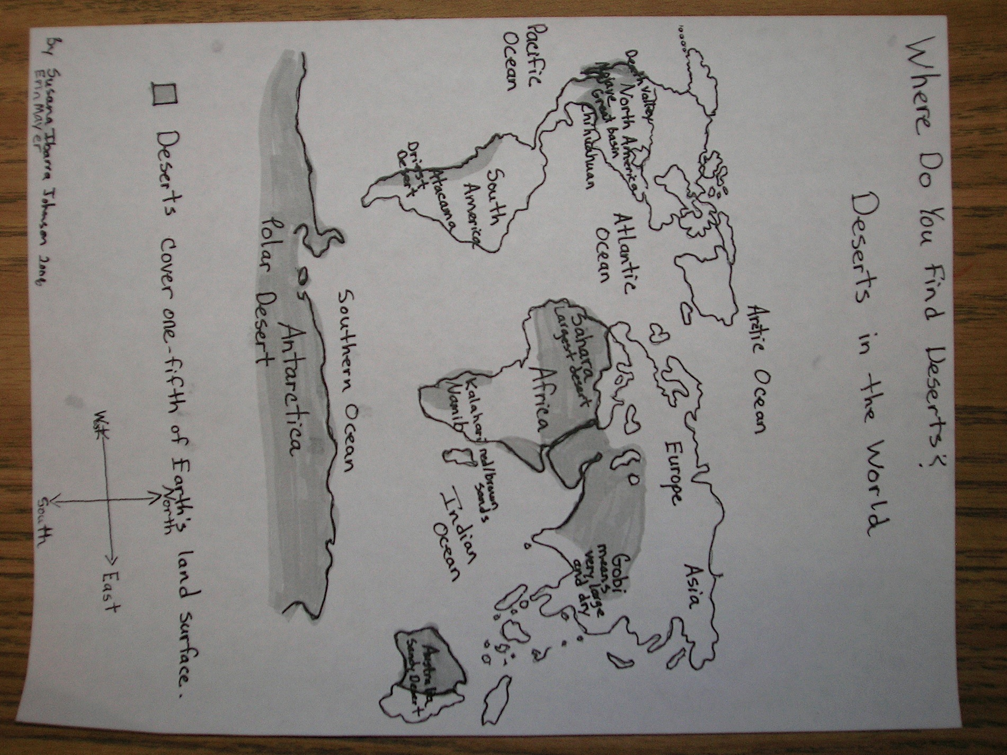

Input Chart: Desert Life: World Map
Grade Level: 3rd
Project GLAD® Trainers:
Stages of Language Acquisition | Preproduction | Early Production | Speech Emergence | Intermediate Fluency | Advanced Fluency
New Mexico WIDA (ELD)  Proficiency Level Descriptors | Entering | Emerging | Developing | Expanding | Language/CCSS
Level of Questioning | Point To, Locate, Trace | Yes/No | Either/Or | Open Ended
Create  Arrange, assemble, collect, compose, construct, create, design, develop, formulate, manage, organize, plan, prepare, propose, set up | Point to 3 locations where deserts are located. | Is the Sahara the driest desert in the world? | Do deserts cover ½ or 1/5 of Earth’s land surface? | Why do you think nature is important for us to explore?
Evaluate  Appraise, argue, assess, attach, choose, compare, defend, estimate, judge, predict, rate, select, support, value, evaluate | Locate a continent where you predict the Gila Monster would be found. | Are many deserts found around the equator? | Which deserts name means “very large and dry?” Is it the Gobi or Namib? | Why is it important to know about the organisms and locations of deserts around the world?
Analyze  Analyze, appraise, calculate, categorize, compare, contrast, criticize, differentiate, discriminate, distinguish, examine, experiment | Trace something different between North America and South America. | Does the country we live in (USA) have a desert? | Is the Chihuahuan High Desert more similar to either the Mojave Desert or the Sahara Desert? | How are all deserts the same? How are they different?

Stages of Language Acquisition | Preproduction | Early Production | Speech Emergence | Intermediate Fluency | Advanced Fluency
New Mexico WIDA (ELD)  Proficiency Level Descriptors | Entering | Emerging | Developing | Expanding | Lifelong Language/CCSS
Level of Questioning | Point To, Locate, Trace | Yes/No | Either/Or | Open Ended
Apply  Apply, choose, demonstrate, dramatize, employ, illustrate, interpret, operate, practice, schedule, sketch, solve, use | Locate a desert in Asia. | Would you be likely to find a desert in Africa? | In which continent is the Kalahari Desert located? European or African | What is one special feature of landscape of the Gobi Desert?
Understand  Classify, describe, discuss, explain, express, identify, indicate, locate, recognize, restate, review, select, translate | Trace the continent where Atacama Desert is located. | Do Polar Bears live in the Antarctica? | Does a Saguaro Cactus have a natural habitat in the Sonoran or Chihuahuan Desert? | What is one organism found in the desert? Where is its habitat?
Remember  Arrange, order, define, duplicate, label, list, name, recognize, relate, recall, repeat, reproduce | Point to North America. | Does the Pacific Ocean border the continent Antarctica? | Is the body of water that surrounds Antarctica either the Pacific Ocean or Southern Ocean? | Name the body of water that surrounds Antarctica.
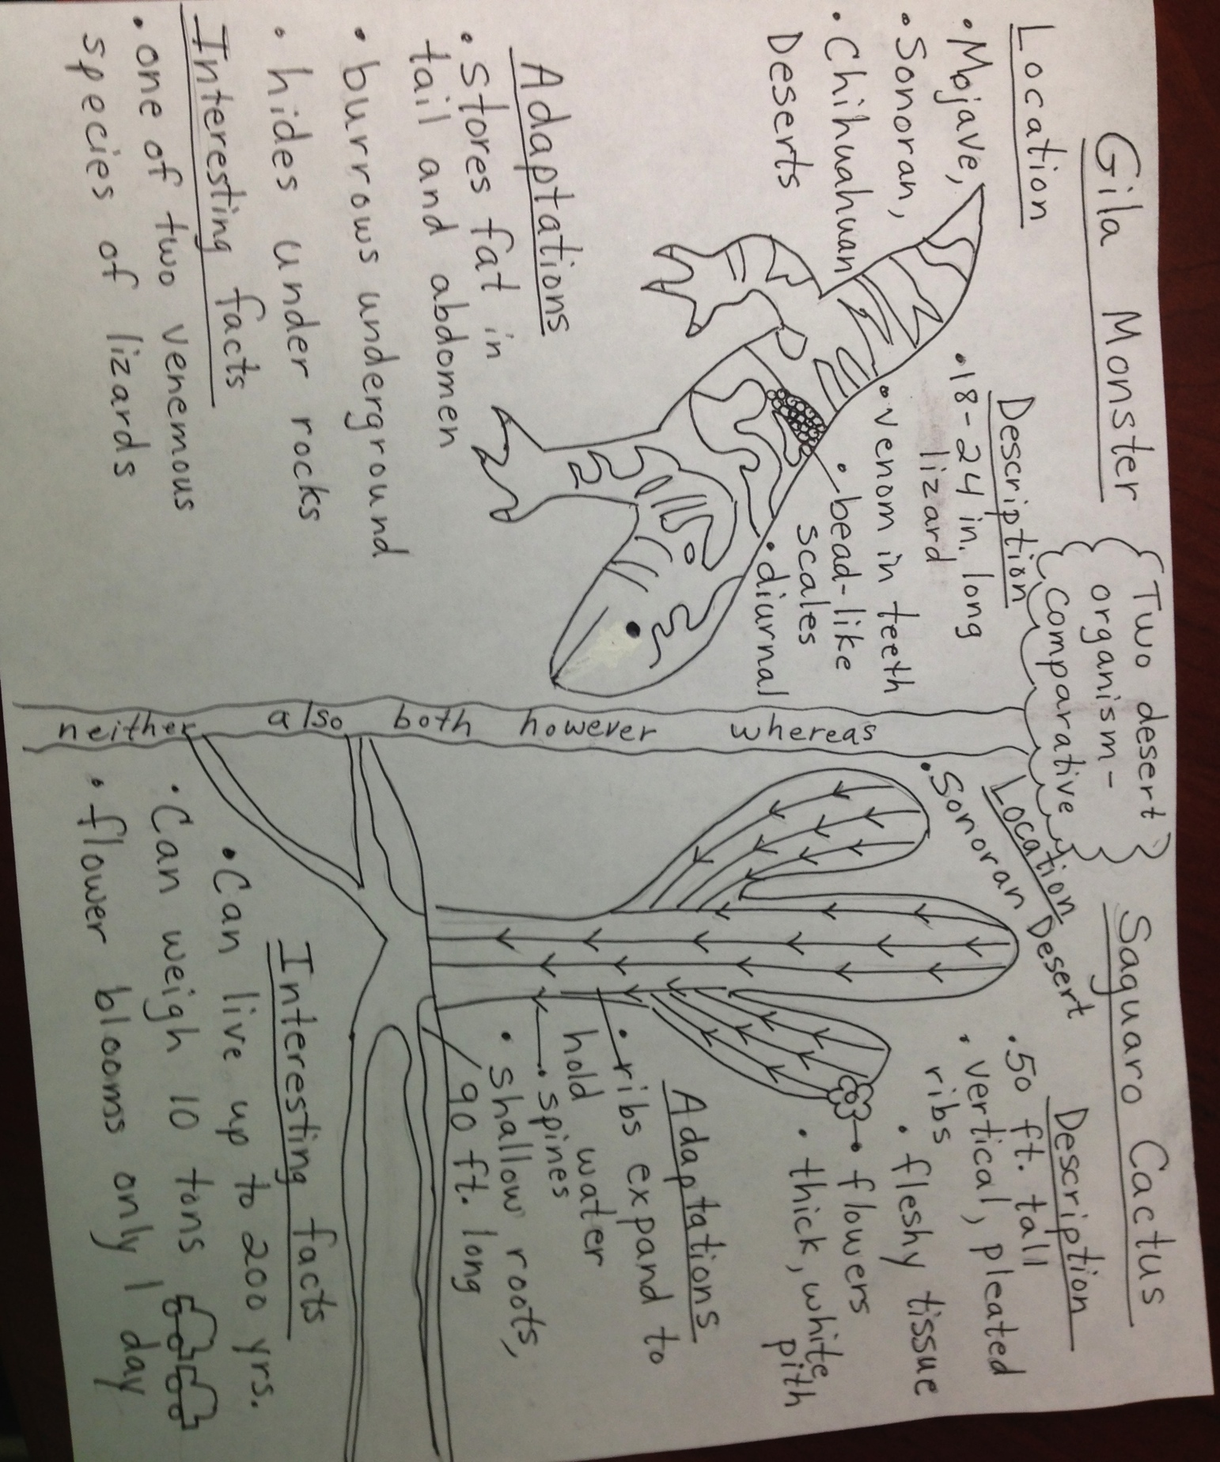
Input Chart Comparative Input: Gila Monster & Saguaro Cactus__________
Grade Level:_______________3rd_____________________________________

Stages of Language Acquisition | Preproduction | Early Production | Speech Emergence | Intermediate Fluency | Advanced Fluency
New Mexico WIDA (ELD)  Proficiency Level Descriptors | Entering | Emerging | Developing | Expanding | Lifelong/  Language/CCSS
Level of Questioning | Point To, Locate, Trace | Yes/No | Either/Or | Open Ended
Create  Arrange, assemble, collect, compose, construct, create, design, develop, formulate, manage, organize, plan, prepare, propose, set up | Point to the living thing that lives in the Mojave Desert.  Point to the Gila Monster’s bead like scales. | Is the Gila Monster found in the Southwestern United States?  Does the Gila Monster rely on rocks to survive? | Does the category of location or description tell what the saguaro cactus looks like? | What do you know about the Gila monster that would make it dangerous?  Why do you think the gila monster burrows underground?
Evaluate  Appraise, argue, assess, attach, choose, compare, defend, estimate, judge, predict, rate, select, support, value, evaluate | Locate the organism that lives in only one desert. | Can Gila Monsters be spotted near humans?  Are gila monsters venomous? | Based on what you know about the Saguaro Cactus, do the spines or ribs of the cactus help it to store water, why? | Explain why you think the roots of the saguaro cactus are so long and shallow?
Analyze  Analyze, appraise, calculate, categorize, compare, contrast, criticize, differentiate, discriminate, distinguish, examine, experiment, question, test | (Showing 2 pictures) Looking at these two pictures, which is a place where the cactus and the Gila Monster could not survive? | Can the Saguaro Cactus live up to 200 Years? | Which is larger, a Gila monster or a Saguaro Cactus? | How does the fact that the gila monster can store fat in its tail and abdomen help it to survive in the desert?

Stages of Language Acquisition | Preproduction | Early Production | Speech Emergence | Intermediate Fluency | Advanced Fluency
New Mexico WIDA (ELD)  Proficiency Level Descriptors | Entering | Emerging | Developing | Expanding | Lifelong Language/CCSS
Level of Questioning | Point To, Locate, Trace | Yes/No | Either/Or | Open Ended
Apply  Apply, choose, demonstrate, dramatize, employ, illustrate, interpret, operate, practice, schedule, sketch, solve, use | (Showing 3 different pictures) Identify two pictures that show parts of the Saguaro Cactus. | (Show Picture) Can Saguaro Cactus’ adapt to different habitats? | Does the Gila Monster or the saguaro cactus live in the Chihuahuan desert? | The Gila Monster is diurnal. When does it hunt for food? | How would animals in the desert be affected if there were no Saguaro Cactus and why?
Understand  Classify, describe, discuss, explain, express, identify, indicate, locate, recognize, restate, review, select, translate | Locate the Saguaro Cactus’s spines. | Do you think a Gila Monster would like to live in an aquarium? (Show picture ) | Can the Saguaro Cactus grow and thrive with little rain or do they need thick soil and moisture?  GF&F: Nouns & Articles, uncountable nouns-  Conjunctions-  Saguaro Cactus need little rain to grow because they are drought tolerant. | Explain why or why not people should plant Saguaro Cacti in their yards?  Why is the desert a good home for the saguaro cactus?
Remember  Arrange, order, define, duplicate, label, list, name, recognize, relate, recall, repeat, reproduce | ( Show picture ) The gila monster is diurnal. Which picture shows the time of day we might see a gila monster. | Do Gila Monsters store fat in their tails? | Are Gila Monsters either larger or smaller than most desert lizards? | Describe the Saguaro Cactus.  (What are some other descriptions?)  Do you think “Monster” is a good way to describe the Gila Monster?

Narrative Input
The Cactus Wren and the Cholla
by Valerie Chel Garcia
Adapted by Annette Maestas

I like to tell this story about the little bird in the desert. When I tell it, I am reminded of my Hispanic ancestors and their proud contribution to this land, and you will see why, as you learn about the Cactus Wren. When he came to the desert, he was alone. He was a stranger. But because he was also courageous and determined, he became an important part of this land through his efforts and hard work.

When you hear the story of the Cactus Wren, think of your mom, your dad, your grandparents, and be very proud of them. They, too, are an important part of the community. They, too worked very hard to help make this land beautiful. And they did it for you and for all the other children of all races who call the Southwest their home. “Thank you, Abuelita and Abuelito!”

A long time ago, only a few chollas lived in the deserts. Little by little, more plants came: The ocotillo and the prickly pear. The barrel cactus and the giant saguaro. But there were no trees. As there were no animals, everything was quiet. Only the sound of the wind could be heard.

Then, came the animals: Spiders and scorpions crawling. Snakes sliding. Mice and rabbits running. Javelinas, coyotes, foxes and mountain lions walking proudly. But because there were no trees, there were no birds.

One day, a little bird flew in from a distant land. A terrible storm had separated him from his brothers and sisters and taken him across the sky into this strange place. He was very tired and needed place to rest, so he perched on the highest arm of the tallest saguaro to look for a tree. But he saw no trees.

By now, the animals and plants of the desert had seen this strange, new creature. “What is it?” they whispered. “What is it doing here?” The little bird didn’t know what to do. Night was coming and a cool breeze ruffled his feathers. He had to stay, but where?
“Where can I find a tree?” he asked. “A tree?” the desert creatures repeated. “We know of no such thing.”

“Am I a tree?” the saguaro asked.You are tall and as beautiful as a tree, but you have no branches and no leaves,” the little bird answered. “I must find a tree to make my nest, or I will die.” “I cannot help you,” the saguaro said. “Perhaps you should go somewhere else.” “Yes, “ the others agreed. “We cannot help you.” “But night is coming,” the little bird said. “If I fly away, I will get lost in the dark. Please help me find a tree for my nest.” “My stalks are too thin,” the ocotillo said. “My thorns are too sharp,” the prickly pear said.

And then the cholla spoke. “You can make your nest in me,” the cholla said. At this, they all laughed and laughed, because no one could come close to the cholla without being hurt by its thorns. “Don’t do it,” they told the bird. “We fear the cholla and you should fear it too.” But the cholla ignored them and spoke again.

“Do you work hard?” the cholla asked the little bird.“I build my nest a twig at a time,” the bird answered, “and that is very hard work.” “Are you brave?” the cholla continued. ”Brave and strong enough to dare the wind and the rain,” the bird answered. “I believe you,” said the cholla. “Here are my arms. Build your nest. The little bird worked through the evening and worked through the night, while the creatures of the desert waited for him to give up But he never gave up. It was the best nest he had ever built in spite of the sharp needles of the cholla. We now know him as the Cactus Wren, a typical bird of the desert, but I like to think of him as symbol. To me, he is a symbol of courage. Of what we can do if we believe in ourselves. A proof that nothing is impossible. Nothing too difficult if we work hard to make it happen. This is what the Cactus Wren means to me and why it reminds me of my Hispanic ancestors

Input Chart:____________Narrative Input: The Cactus Wren and the Cholla____________
Grade Level:____________2nd________________________________________
Project GLAD™ Trainers: ___________________________________________

Stages of Language Acquisition | Preproduction |  | Early Production |  |  | Speech Emergence |  | Intermediate Fluency | Advanced Fluency
New Mexico WIDA (ELD)  Proficiency Level Descriptors |  | Entering |  | Emerging | Developing |  | Expanding |  |  | Lifelong Language/CCSS
Level of Questioning | Point To, Locate, Trace |  | Yes/No |  |  | Either/Or |  | Open Ended
Create  Arrange, assemble, collect, compose, construct, create, design, develop, formulate, manage, organize, plan, prepare, propose, set up | Locate the animals that live in the desert. |  | Can living things be found in every ecosystem?  Were there many Chollas that lived in the desert? |  |  | Were there many animals or no animals that lived in the desert at the beginning of this story? |  | How do we know the bird was brave and hard working?
Evaluate  Appraise, argue, assess, attach, choose, compare, defend, estimate, judge, predict, rate, select, support, value, evaluate | Locate a part in the story where more plants came to the desert. |  | Can a coyote be found in our community? |  |  | What is the best phrase to describe life in the desert, overflowing with life or quiet and still? |  | Recommend another environment for a bird to live. | What is the most interesting organism found in this story?
Analyze  Analyze, appraise, calculate, categorize, compare, contrast, criticize, differentiate, discriminate, distinguish, examine, experiment, question, test | Point to a characteristic of the Saguaro Cactus. |  | Can a duck survive living in the desert? |  |  | Are sticks and branches or feathers and rocks evidence that a Cactus Wren has built a nest? |  | What are the best materials for a Cactus Wren to build a nest?

Stages of Language Acquisition | Preproduction | Early Production | Speech Emergence | Intermediate Fluency | Advanced Fluency
California (ELD)  Proficiency Level  Descriptors | Emerging | Expanding | Expanding | Bridging | Lifelong Language/  CCSS
Level of Questioning | Point To, Locate, Trace | Yes/No | Either/Or | Open Ended
Apply  Apply, choose, demonstrate, dramatize, employ, illustrate, interpret, operate, practice, schedule, sketch, solve, use | Point to the evidence that the little bird was told that a nest could be made in the Cholla. | Would mice and scorpions be found living near a Cholla?  Can foxes live in other environments? | Does the little bird make his home in the Saguaro Cactus or the Cholla? | What did the other cacti tell the little bird to not do and why? | What is the lesson about this story?  How does this lesson apply to you and your life?
Understand  Classify, describe, discuss, explain, express, identify, indicate, locate, recognize, restate, review, select, translate | Show me where the Cactus Wren lives. | Did the creatures of the desert wait for the little bird to give up making his nest? | Did the cholla tell the little bird, “I am tired,” or “Here are my arms, build your nest.” | Why was the little bird afraid?  Why did the little bird not give up when every creature in the desert thought he would?
Remember  Arrange, order, define, duplicate, label, list, name, recognize, relate, recall, repeat, reproduce | Trace the Ocotillo. | Did the little bird listen to the Ocotillo Cactus about the Cholla? | Was building the nest in the Cholla a symbol of being scared or brave and why? | What did the Prickly Pear Cactus and the Ocotillo Cactus tell the little bird?

Name _______________________ Number _________

Desert Life
Poetry Booklet

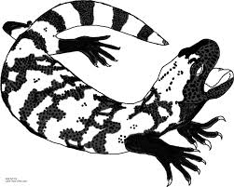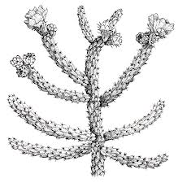
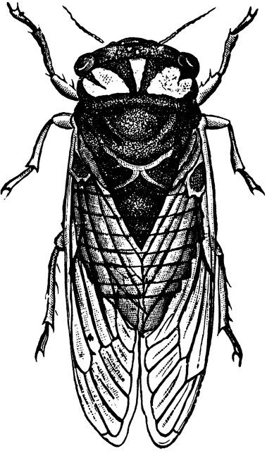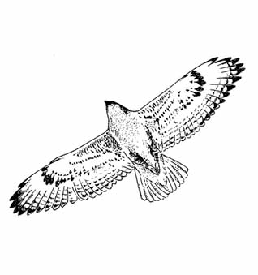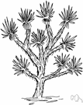

The Chihuahuan High Desert Cadence
by Kathy Waldman and Annette Maestas

We just know what we’ve been told
The Chihuahuan High Desert can be hot or cold.
It spans from New Mexico to Texas and Mexico,
The Chihuahuan High Desert lets cactus grow.

Sound off – Ocotillo
Sound off - Sagebrush
Sound off – 1, 2, 3, 4
Vegetation!

Plants and animals have learned to survive,
Special adaptations keep them alive.
The prickly pear cactus has sharp spines,
But the javelina eats it up just fine.

Sound off - Roadrunner
Sound off - Gila Monster
Sound off – 1, 2, 3, 4
Desert animals!

Desert Life (Organisms)
Here There Chant
by Annette Maestas

Organisms here, organisms there
Organisms, organisms everywhere.

Prickly organisms growing constantly,
Flying organisms flapping quickly,
Sneaky organisms scurrying secretly,
And cautious organisms listening carefully.

Organisms below the ground,
Organisms behind the cactus,
Organisms under the hot rocks,
And organisms in the Saguaro.

Organisms here, organisms there
Organisms, organisms everywhere.

Organisms! Organisms! Organisms!

Desert Habitat Bugaloo
by Kathy Waldman and Annette Maestas

I’m a scientist and I’m here to say,
I study desert habitats every day.
Sometimes I measure rainfall; sometimes I read a book,
But I like to use my compass and take a look.

Lizards, Vultures, Owls too
Doing the Desert Habitat BUGALOO!

A New Mexico desert is White Sands
Snow white sand covers the land.
Only 8.5 inches of rain per year,
but desert organisms persevere.

Drought, moisture, evaporation, too,
Doing the Desert Habitat BUGALOO!

The roadrunner can fly but prefers to run,
It lives underneath the desert’s hot sun.
Owl and woodpecker survive very well
because the Saguaro Cactus is their hotel.

Adaptation, survival, interdependence, too,
Doing the Desert Habitat BUGALOO!

Deserts cover one-fifth of the land,
not all deserts are covered with sand.
New Mexico is full of color,
The Mesas and canyons are like no other.

Mojave, Sonoran, Chihuahuan, too,
Doing the Desert Habitat BUGALOO!
Yes, Ma’am
by Annette Maestas

Is this a desert? Yes, Ma’am
Is this a desert? Yes, Ma’am
How do you know? Less than 10 in. rain per yr.
How do you know? Few plants and animals
Tell me more most deserts are hot
Tell me more Antarctica desert is cold

Is this a saguaro cactus? Yes, Ma’am
Is this a saguaro cactus? Yes, Ma’am
How do you know? 50 feet tall
How do you know? A home for animals
Tell me more. Pleated ribs
Tell me more. Long, shallow roots

Is this a Gila Monster? Yes, Ma’am
Is this a Gila Monster? Yes, Ma’am
How do you know? Bead-like scales
How do you know? Venomous lizard
Tell me more. burrowing reptile
Tell me more. stores fat for winter

Is this a coyote? Yes, Ma’am
Is this a coyote? Yes, Ma’am
How do you know? Light-colored fur
How do you know? It’s nocturnal
Tell me more. Eats saguaro seeds
Tell me more. Digs down for water

Is this a javelina ? Yes, Ma’am
Is this a javelina? Yes, Ma’am
How do you know? Can eat sharp objects
How do you know? Eats prickly pear cactus
Tell me more. Has a leathery mouth
Tell me more. Looks like a pig!

Home to School Connection #1
Desert Life

Ask someone in your family or an adult about any medicinal remedies that are made with the wildflowers from our desert. For example: Yerba Buena, Chamomile, etc. Sketch a picture and/or write about your findings.

Pregúntale a alguien de tu familia sobre remedios medicinales que están hechos con yerbas de nuestro desierto. Por ejemplo: yerba buena y manzanilla. Dibuja y escribe tu investigación.

___________________________ _________________________
parent (padre de familia) student (estudiante)

Name: _________________________ Date:_______________

Home to School Connection #2
Desert Life
Ask your family members if they know about cognates (words that English borrowed from Spanish). For example: Saguaro, a kind of cactus or Coyote a desert animal. If they know other cognates please list below. Sketch or write the information.

Pregúntale a tu familia si saben unos cognados (palabras que son similares en español e inglés). Por ejemplo: el saguaro, un tipo de cactus o el coyote un animal del desierto. Si saben de otros cognados por favor hagan una lista. Dibuja o escribe la información.

List Cognates

English Spanish
____________ ____________

____________ ____________

____________ ____________

____________ ____________

____________ ____________

____________ ____________

____________ ____________

____________ ____________

___________________________ _________________________
parent (padre de familia) student (estudiante)

Name: _________________________ Date:_______________

Home to School Connection #3
Desert Life

Observe the desert ecosystem in Taos, New Mexico from your backyard then sketch and or write the information.

Observa el ecosistema del desierto desde tu patio en Taos, Nuevo México y luego dibuja o escribe la información.

___________________________ _________________________
parent (padre de familia) student (estudiante)

Name: _________________________ Date:_______________

Home to School Connection #4
Desert Life

Tell a family member about the narrative story of The Desert is My Mother by Pat Mora. Why do you think that the author thinks that the desert is her Mother? Discuss with a family member. Sketch or write the information.

Cuenta a un miembro de la familia el cuento narrativo de El desierto es mi madre por Pat Mora. ¿Por qué crees que la autora piensa que el desierto es su madre? Discute con un miembro de la familia. Dibuja o escribe la información.

___________________________ _________________________
parent (padre de familia) student (estudiante)

Ferruginous (fer-OO-jin-us) Hawk Expert Group

Description

The Ferruginous Hawk is the largest of the Buteos and is a bird of prey. They are medium to large birds with broad, long wings and short tails. Ferruginous Hawks can soar in the air for long periods of time. These hawks can be up to 22.5-25 inches long. Their wingspan is 53-56 inches long. Ferruginous Hawks range in colors from rusty red to dark brown with white on their tails.

Location Ferruginous Hawks can be found in all three deserts – Mojave, Sonoran, and Chihuahuan. You will see them in northern and southern Arizona and northern New Mexico. They migrate to Baja and central Mexico during the winter months.

Adaptation
The Ferruginous Hawks ability to hunt in different ways allows for more opportunities to catch prey. These hawks can hunt four different ways: hunting from the ground, low from the air, high from the air, and from a perch.

Interesting Facts The word Ferruginous means “rusty color” which refers to the coloration on the hawks legging and wing feathers. The species name Regalis means “kingly” or “royal” in Latin. The female hawk lays an egg every two days until she is done, so the young birds can be several weeks apart in age. Hawks tear apart their prey in to chunks and then regurgitate a pellet. Pellets are made up of fur, feathers, bone, and other materials that the hawks cannot digest.

Cicadas Expert Group

Description
Cicadas are insects with large-heads; they have thick bodies and sucking mouth parts. They can be green with red and black markings. Their bodies can be an inch or more with 2 pairs of wings. Cicadas have a 3-jointed beak, an abdomen of six segments, and 3 prominent compound eyes. There are more than 1,500 species of Cicadas; over 100 species live in North America.

Location

Cicadas live in the Mojave, Great Basin, Chihuahuan and Sonoran Deserts throughout the southwest.

Adaptation
Cicadas like to fly when it is hot, they do not fly when their body temperature is below 72°. Most predators of the Cicadas do not hunt midday when it is hot out, so the Cicadas are less likely to become prey.

Interesting Facts
The 17-Year Cicada lives underground for 17 years and then emerges for 5 weeks of activity in the sunlight, and then dies. This Cicada is one of the longest living insects. During mid-summer to early fall, male Cicadas can be found in treetops making ticks, buzzes, or whines to attract a female. These sounds are made by vibrations from the drum-like abdominal membranes called timbals.

Joshua Tree Expert Group

Description
The Joshua Tree is the largest of the yuccas. It is an evergreen, meaning it is green all year round. It can stand up from 15-40 feet and be 1-3 feet in diameter. The Joshua Tree is actually a member of the Lily Family. The Joshua Tree has bell-shaped flowers that do not smell good and oval green-brown fruit. The Joshua Tree is very slow growing, they grow only 4 inches a year.

Location
The Joshua Tree can be found in the Mojave Desert of extreme southwest California, Nevada, Utah and Arizona. This plant likes dry soils and often grows in clumps or stands.

Adaptation

The Joshua Tree is able to survive the harsh, hot climate of the desert by being able to hold water and go long periods of time in dry, hot heat. Some years when there is little rain the Joshua Tree will not make any flowers, this helps the plant conserve energy.

Interesting Facts
The Joshua Tree lives only because of the female Pronuba Moth. Only this moth can transfer pollen from one Joshua Tree flower to another. The female moth lays her eggs in the flower and when the larvae hatch, they eat the Joshua Tree seeds. Like the Saguaro Cactus, the Joshua Tree can live a couple hundred years.

MIND MAP Name _________________________

Organism:
Location
Description
Interesting Facts
Adaptation

Process Grid
Organism | Description | Location | Adaptation | Interesting Facts

Completed Process Grid
Organism | Description | Location | Adaptation | Interesting Facts
Gila Monster | -18 to 24 inches long  -Venom in teeth  -Bead-like scales  -Diurnal | -Mojave Desert  -Sonoran Desert  -Chihuahuan Desert | -Stores fat in tail and abdomen  -burrows in ground  -hides under rocks | -One of two venomous species of lizards
Saguaro Cactus | -flowers  -thick, whitish pith  -fleshy tissue  -can grow 50 ft tall  -vertical, pleated ribs | -Sonoran Desert | -ribs expand to hold water for dry desert days  -spines  -shallow roots 90 ft long | -Can live up to 200 years  -weighs up to 10 tons  -flower blooms only 1 day
Ferruginous Hawk | -largest buteo breed  -bird of prey  -rusty colored  -22.5 to 25 inches long  -53 to 56 inch wingspan | -Mojave Desert  -Sonoran Desert  -Chihuahuan Desert | -able to hunt four ways | -make pellets  -name origin “royal” “kingly”  -eggs hatch up to two weeks apart
Cicada | -insect  -inch or more in length  -green with red and black  -3-jointed beak  -2 pair of wings | -Mojave Desert  -Chihuahuan Desert  -Sonoran Desert | -can fly when its hot, avoids predators | -17 year Cicada comes out after 17 years  -makes noises to attract a female  -uses abdominal membranes to make noises (timbals)
Joshua Tree | -evergreen  -has fruit  -has unpleasant odor  -largest yucca  -15-40 feet tall  -1-3 feet around | -Mojave Desert | -stores water for hot, dry periods  -conserves energy by not producing flowers | -can only reproduce with the aid of the Pronuba moth  -can live several 100 years
Desert Life
Writing Prompt

DIRECTIONS:

WRITE about how the physical and behavioral characteristics of one desert plant or animal helps it survive in its habitat.

In your writing, be sure to clearly state a main idea through the use of a topic sentence. You must provide at least three supporting sentences that support your topic sentence. Write a conclusion that restates and expands on your topic sentence and supports your main idea.

This essay has 4 assignments due when submitting your final draft:

- Prewriting Activities ________ 3. Rough Draft ________
- Topic Sentence ________ 4. Final Draft ________

Writing Rubric
Paragraph Grading Rubric

Grading Scale
4 Exceeds Standards
3 Meets Standards
2 Approaching Standards
1 Below Standards
0 Nonexistent

Yes/No
- Topic Sentence:
Does it state the main idea of your essay?
Score ________

- Evidence Used:
Are there three or more details that support the main idea?
Score ________

- Information and organization:
Is the information explained correctly and coherently?
Score ________

- Conclusion:
Does your conclusion strengthen the main idea?
Score ________

- Prewriting Activities:
Are all prewriting activities included and attached to the final?
Score ________

- Conventions:
Does the writing include correct spelling, capitalization and punctuation? __________
Score _________

Total Addition of Scores = ÷ 6

Final Score =

ACTION PLAN
Soil Erosion
Action Plan: Conservation of water in desert habitats

The desert is a fragile habitat or biome. Resources—especially water—can be hard to come by in desert landscapes. Growing human populations put increasing pressure on those resources. Water is a precious resource in a desert, and some deserts have stores of it deep underground. But these stores are vulnerable to overextraction (taking too much water out). Little water is available to recharge the stores of water every year.

- Do some research on the history of water conservation in your community and what people can do to conserve water.
- With your team, brainstorm what could be done in your school, neighborhood or community.
- As a team, decide which approach to water conservation would work best for your school, neighborhood or community.
- Create a presentation (power point, report, letter, play, poem,?) for the leadership of your school, neighborhood or community to convince them of your approach.
- Present your action plan to the class.
- Revise and edit your presentation based on class input.
- Find contact information for your school, neighborhood or community. Submit a formal request to share your presentation. Follow-up your request and await a response.

*Objective of Action Plan:
This action plan is a working graphic organizer to be constructed with the students as the topic develops.

*Assessment: Teacher should provide students with a rubric for Action Plan including grade level standards and school and/or classroom goals. (21st Centruy Goals) This could be created with student input.

