PROJECT GLAD
Orange Unified School District
THE CONSTITUTION
(Level 5/6)
IDEA PAGES

- UNIT THEME:
  - People and events associated with development of the U.S. Constitution.
  - Analyze the Constitution’s significance as the foundation of the American Democracy
  - The U.S. Constitution is the foundation of the American Democracy
  - Cross-Cultural Sensitivity Theme: People are unified in their desire for freedom.

- FOCUS/MOTIVATION
  - Big Book
  - Cognitive Content Dictionary
  - Picture File Cards
  - Observation Charts
  - Constitution Awards
  - Artifacts
  - Video Clips
  - Inquiry Chart: What do you know about The Constitution? And What do you want to know about The Constitution?

- CLOSURE
  - Completed Process Grid
  - A persuasive letter/speech
  - Editorial
  - Process unit charts
  - Team Task Group Presentation
  - Living Wall Hall Of Fame
  - Chapter Test
  - Original Poem

- CONCEPTS
Grade 5 New Mexico-Social Science Standards

HISTORY
5-8 Benchmark 1-B. United States: analyze and interpret major eras, events and individuals from the periods of exploration and colonization through the civil war and reconstruction in United States history: Grade 5 3. explain the significance of major historical documents (e.g., the declaration of independence, the federalist papers, United States constitution, bill of rights);
5-8 Benchmark 1-D. Skills: research historical events and people from a variety of perspectives: Grade 5 1.differentiate between, locate and use primary and secondary sources (e.g., computer software, interviews, biographies, oral histories, print, visual material, artifacts) to acquire information; 2. use resources for historical information (e.g., libraries, museums, historical societies, courthouse, worldwide web, family records, elders); 3. gather, organize and interpret information using a variety of media and technology; 4. show the relationship between social contexts and events; and 5. use effective communication skills and strategies to share research findings. Grade 6 1. organize information by sequencing, categorizing, identifying cause-and-effect relationships, comparing and contrasting, finding the main idea, summarizing, making generalizations and predictions, drawing inferences and conclusions; 2. identify different points of view about an issue or topic; and 3. use a decision-making process to identify a situation that requires a solution; gather information, identify options, predict consequences and take action to implement that solution.

GEOGRAPHY
5-8 Benchmark 2-A: analyze and evaluate the characteristics and purposes of geographic tools, knowledge, skills and perspectives and apply them to explain the past, present and future in terms of patterns, events and issues: Grade 5 1.make and use different kinds of maps, globes, charts and databases; 5. employ fundamental geographic vocabulary (e.g., latitude, longitude, interdependence, accessibility, connections); 7. use spatial organization to communicate information; and 8. identify and locate natural and man-made features of local, regional, state, national and international locales. Grade 6 1. identify the location of places using latitude and longitude

CIVICS AND GOVERNMENT
5-8 Benchmark 3-A: demonstrate understanding of the structure, functions and powers of government (local, state, tribal and national):
Grade 5 1.explain how the three branches of national government function and explain how they are defined in the United States constitution; 2. identify the fundamental ideals and principles of our republican form of government (e.g., inalienable rights such as “life, liberty, and the pursuit of happiness,” the rule of law, justice, equality under the law); 3.identify and describe the significance of American symbols, landmarks and essential documents (e.g., declaration of independence; United States constitution; bill of rights; the federalist papers; Washington, D.C.; and 4. compare and contrast the basic government sovereignty of local, state, tribal and national governments.
5-8 Benchmark 3-C: compare political philosophies and concepts of government that became the foundation for the American revolution and the United States government:
Grade 5 1. describe the narrative of the people and events associated with the development of the United States constitution, and describe its significance to the foundation of the American republic, to include: a. colonists’ and Native Americans’ shared sense of individualism, independence and religious freedom that developed before the revolution; b.articles of confederation; c. purpose of the constitutional convention; d. natural rights expressed in the declaration of independence; and 2.describe the contributions and roles of major individuals, including George Washington, James Madison and Benjamin Franklin.

5-8 Benchmark 3-D: explain how individuals have rights and responsibilities as members of social groups, families, schools, communities, states, tribes and countries: Grade 5 1.explain the meaning of the American creed that calls on citizens to safeguard the liberty of individual Americans within a unified nation, to respect the rule of law and to preserve the constitutions of local, state, tribal and federal governments.

Reading Anchor 1: Read closely to determine what the text says explicitly and to make logical inferences from it; cite specific textual evidence when writing or speaking to support conclusions drawn from the text.
Third | Fourth | Fifth | Sixth |  | Seventh |  | Eighth
RL.3.1 Ask and answer questions to demonstrate understanding of a text, referring explicitly to the text as the basis for the answers. | RL.4.1 Refer to details and examples in a text when explaining what the text says explicitly and when drawing inferences from the text. | RL.5.1 Quote accurately from a text when explaining what the text says explicitly and when drawing inferences from the text. | RL.6.1 Cite textual evidence to support analysis of what the text says explicitly as well as inferences drawn from the text. |  | RL.7.1 Cite several pieces of textual evidence to support analysis of what the text says explicitly as well as inferences drawn from the text. |  | RL.8.1 Cite the textual evidence that most strongly supports an analysis of what the text says explicitly as well as inferences drawn from the text.
Reading Anchor 2: Determine central ideas or themes of a text and analyze their development; summarize the key supporting details and ideas
Third | Fourth | Fifth | Sixth |  | Seventh |  | Eighth
RL.3.2 Recount stories, including fables, folktales, and myths from diverse cultures; determine the central message, lesson, or moral and explain how it is conveyed through key details in the text. | RL.4.2 Determine a theme of a story, drama, or poem from details in the text; summarize the text. | RL.5.2 Determine a theme of a story, drama, or poem from details in the text, including how characters in a story or drama respond to challenges or how the speaker in a poem reflects upon a topic; summarize the text. | RL.6.2 Determine a theme or central idea of a text and how it is conveyed through particular details; provide a summary of the text distinct from personal opinions or judgments. |  | RL.7.2 Determine a theme or central idea of a text and analyze its development over the course of the text; provide an objective summary of the text. |  | RL.8.2 Determine a theme or central idea of a text and analyze its development over the course of the text, including its relationship to the characters, setting, and plot; provide an objective summary of the text.
Reading Anchor 3: Analyze how and why individuals, events, and ideas develop and interact over the course of a text.
Third | Fourth | Fifth |  | Sixth |  | Seventh |  | Eighth
RL.3.3 Describe characters in a story (e.g., their traits, motivations, or feelings) and explain how their actions contribute to the sequence of events. | RL.4.3 Describe in depth a character, setting, or event in a story or drama, drawing on specific details in the text (e.g., a character’s thoughts, words, or actions). | RL.5.3 Compare and contrast two or more characters, settings, or events in a story or drama, drawing on specific details in the text (e.g., how characters interact). |  | RL.6.3 Describe how a particular story’s or drama’s plot unfolds in a series of episodes as well as how the characters respond or change as the plot moves toward a resolution. |  | RL7.3 Analyze how particular elements of a story or drama interact (e.g., how setting shapes the characters or plot). |  | RL8.3 Analyze how particular lines of dialogue or incidents in a story or drama propel the action, reveal aspects of a character, or provoke a decision.

Reading Literature: Craft and Structure
Reading Anchor 4: Interpret words and phrases as they are used in a text, including determining technical, connotative, and figurative meanings, and analyze how specific word choices shape meaning or tone.
Third | Fourth | Fifth |  | Sixth |  | Seventh |  | Eighth
RL.3.4 Determine the meaning of words and phrases as they are used in a text, distinguishing literal from nonliteral language. | RL.4.4 Determine the meaning of words and phrases as they are used in a text, including those that allude to significant characters found in mythology (e.g., Herculean). | RL.5.4 Determine the meaning of words and phrases as they are used in a text, including figurative language such as metaphors and similes |  | RL.6.4 Determine the meaning of words and phrases as they are used in a text, including figurative and connotative meanings; analyze the impact of a specific word choice on meaning and tone. |  | RL.7.4 Determine the meaning of words and phrases as they are used in a text, including figurative and connotative meanings; analyze the impact of rhymes and other repetitions of sounds (e.g., alliteration) on a specific verse or stanza of a poem or section of a story or drama. |  | RL.8.4 Determine the meaning of words and phrases as they are used in a text, including figurative and connotative meanings; analyze the impact of specific word choices on meaning and tone, including analogies or allusions to other texts.
Reading Anchor 5: Analyze the structure of texts, including how specific sentences, paragraphs, and larger portions of the text (e.g., a section, chapter, scene, or stanza) relate to each other and the whole.
Third | Fourth | Fifth |  | Sixth |  | Seventh |  | Eighth
RL.3.5 Refer to parts of stories, dramas, and poems when writing or speaking about a text, using terms such as chapter, scene, and stanza; describe how each successive part builds on earlier sections. | RL.4.5 Explain major differences between poems, drama, and prose, and refer to the structural elements of poems (e.g., verse, rhythm, meter) and drama (e.g., casts of characters, settings, descriptions, dialogue, stage directions) when writing or speaking about a text. | RL.5.5 Explain how a series of chapters, scenes, or stanzas fits together to provide the overall structure of a particular story, drama, or poem. |  | RL.6.5 Analyze how a particular sentence, chapter, scene, or stanza fits into the overall structure of a text and contributes to the development of the theme, setting, or plot. |  | RL.7.5 Analyze how a drama’s or poem’s form or structure (e.g., soliloquy, sonnet) contributes to its meaning. |  | RL.8.5 Compare and contrast the structure of two or more texts and analyze how the differing structure of each text contributes to its meaning and style.
Reading Anchor 6: Assess how point of view or purpose shapes the content and style of a text..
Third | Fourth | Fifth | Sixth |  | Seventh |  | Eighth
RL.3.6 Distinguish their own point of view from that of the narrator or those of the characters. | RL.4.6 Compare and contrast the point of view from which different stories are narrated, including the difference between first- and third-person narrations. | RL.5.6 Describe how a narrator’s or speaker’s point of view influences how events are described. | RL.6.6 Explain how an author develops the point of view of the narrator or speaker in a text. |  | RL.7.6 Analyze how an author develops and contrasts the points of view of different characters or narrators in a text. |  | RL.8.6 Analyze how differences in the points of view of the characters and the audience or reader (e.g., created through the use of dramatic irony) create such effects as suspense or humor.
Reading Literature: Integration of Knowledge and Ideas
Reading Anchor 7: Integrate and evaluate content presented in diverse media and formats, including visually and quantitatively, as well as in words.*
Third | Fourth | Fifth | Sixth | Seventh | Eighth
RL.3.7 Explain how specific aspects of a text’s illustrations contribute to what is conveyed by the words in a story (e.g., create mood, emphasize aspects of a character or setting). | RL.4.7 Make connections between the text of a story or drama and a visual or oral presentation of the text, identifying where each version reflects specific descriptions and directions in the text. | RL.5.7 Analyze how visual and multimedia elements contribute to the meaning, tone, or beauty of a text (e.g., graphic novel, multimedia presentation of fiction, folktale, myth, poem). | RL.6.7 Compare and contrast the experience of reading a story, drama, or poem to listening to or viewing an audio, video, or live version of the text, including contrasting what they “see” and “hear” when reading the text to what they perceive when they listen or watch. | RL.7.7 7. Compare and contrast a written story, drama, or poem to its audio, filmed, staged, or multimedia version, analyzing the effects of techniques unique to each medium (e.g., lighting, sound, color, or camera focus and angles in a film). | RL.8.7 7. Analyze the extent to which a filmed or live production of a story or drama stays faithful to or departs from the text or script, evaluating the choices made by the director or actors.
Reading Anchor 8: Delineate and evaluate the argument and specific claims in a text, including the validity of the reasoning as well as the relevance and sufficiency of the evidence.
Third | Fourth | Fifth | Sixth | Seventh | Eighth
RL.3.8 (Not applicable to literature) | RL.4.8 (Not applicable to literature) | RL.5.8 (Not applicable to literature) | RL.6.8 (Not applicable to literature) | RL.7.8 (Not applicable to literature) | RL.8.8 (Not applicable to literature)

Reading Anchor 9: Analyze how two or more texts address similar themes or topics in order to build knowledge or to compare the approaches the authors take.
Third | Fourth | Fifth | Sixth | Seventh | Eighth
RL.3.9 Compare and contrast the themes, settings, and plots of stories written by the same author about the same or similar characters (e.g., in books from a series). | RL.4.9 Compare and contrast the treatment of similar themes and topics (e.g., opposition of good and evil) and patterns of events (e.g., the quest) in stories, myths, and traditional literature from different cultures. | RL.5.9 Compare and contrast stories in the same genre (e.g., mysteries and adventure stories) on their approaches to similar themes and topics. | RL.6.9 Compare and contrast texts in different forms or genres (e.g., stories and poems; historical novels and fantasy stories) in terms of their approaches to similar themes and topics. | RL.7.9 Compare and contrast a fictional portrayal of a time, place, or character and a historical account of the same period as a means of understanding how authors of fiction use or alter history. | RL.8.9 Analyze how a modern work of fiction draws on themes, patterns of events, or character types from myths, traditional stories, or religious works such as the Bible, including describing how the material is rendered new.
Reading Literature: Range of Reading and Text Complexity
Reading Anchor 10: Read and comprehend complex literary and informational texts independently and proficiently
Third | Fourth | Fifth | Sixth | Seventh | Eighth
RL.3.10 By the end of the year, read and comprehend literature, including stories, dramas, and poetry, at the high end of the grades 2–3 text complexity band independently and proficiently. | RL.3.10 By the end of the year, read and comprehend literature, including stories, dramas, and poetry, in the grades 4–5 text complexity band proficiently, with scaffolding as needed at the high end of the range. | RL.5.10 By the end of the year, read and comprehend literature, including stories, dramas, and poetry, at the high end of the grades 4–5 text complexity band independently and proficiently. | RL.6.10 By the end of the year, read and comprehend literature, including stories, dramas, and poems, in the grades 6–8 text complexity band proficiently, with scaffolding as needed at the high end of the range. | RL7.10 By the end of the year, read and comprehend literature, including stories, dramas, and poems, in the grades 6–8 text complexity band proficiently, with scaffolding as needed at the high end of the range. | RL.8.10 By the end of the year, read and comprehend literature, including stories, dramas, and poems, at the high end of grades 6–8 text complexity band independently and proficiently.

Reading Informational Text: Key Ideas and Details
Reading Anchor 1: Read closely to determine what the text says explicitly and to make logical inferences from it; cite specific textual evidence when writing or speaking to support conclusions drawn from the text.
Third | Fourth | Fifth | Sixth | Seventh | Eighth
RI.3.1 Ask and answer questions to demonstrate understanding of a text, referring explicitly to the text as the basis for the answers. | RI.4.1 Refer to details and examples in a text when explaining what the text says explicitly and when drawing inferences from the text. | RI.5.1 Quote accurately from a text when explaining what the text says explicitly and when drawing inferences from the text. | RI.6.1 Cite textual evidence to support analysis of what the text says explicitly as well as inferences drawn from the text. | RI.7.1 Cite several pieces of textual evidence to support analysis of what the text says explicitly as well as inferences drawn from the text. | RI.8.1 Cite the textual evidence that most strongly supports an analysis of what the text says explicitly as well as inferences drawn from the text

Reading Anchor 2: Determine central ideas or themes of a text and analyze their development; summarize the key supporting details and ideas
Third | Fourth | Fifth | Sixth | Seventh | Eighth
RI.3.2 Determine the main idea of a text; recount the key details and explain how they support the main idea. | RI.4.2 Determine the main idea of a text and explain how it is supported by key details; summarize the text. | RI.5.2 Determine two or more main ideas of a text and explain how they are supported by key details; summarize the text. | RI.6.2 Determine a central idea of a text and how it is conveyed through particular details; provide a summary of the text distinct from personal opinions or judgments. | RI.7.2 Determine two or more central ideas in a text and analyze their development over the course of the text; provide an objective summary of the text | RI.8.2 Determine a central idea of a text and analyze its development over the course of the text, including its relationship to supporting ideas; provide an objective summary of the text.
Reading Anchor 3: Analyze how and why individuals, events, and ideas develop and interact over the course of a text.
Third | Fourth | Fifth | Sixth | Seventh | Eighth
RI.3.3 Describe the relationship between a series of historical events, scientific ideas or concepts, or steps in technical procedures in a text, using language that pertains to time, sequence, and cause/effect.. | RI.4.3 Explain events, procedures, ideas, or concepts in a historical, scientific, or technical text, including what happened and why, based on specific information in the text. | RI.5.3 Explain the relationships or interactions between two or more individuals, events, ideas, or concepts in a historical, scientific, or technical text based on specific information in the text. | RI.6.3 Analyze in detail how a key individual, event, or idea is introduced, illustrated, and elaborated in a text (e.g., through examples or anecdotes). | RI.7.3 Analyze the interactions between individuals, events, and ideas in a text (e.g., how ideas influence individuals or events, or how individuals influence ideas or events). | RI.8.3 Analyze how a text makes connections among and distinctions between individuals, ideas, or events (e.g., through comparisons, analogies, or categories).

Reading Informational Text: Craft and Structure
Reading Anchor 4: Interpret words and phrases as they are used in a text, including determining technical, connotative, and figurative meanings, and analyze how specific word choices shape meaning or tone.
Third | Fourth | Fifth | Sixth | Seventh | Eighth
RI.3.4 Determine the meaning of general academic and domain-specific words and phrases in a text relevant to a grade 3 topic or subject area. | RI.4.4 Determine the meaning of general academic and domain-specific words or phrases in a text relevant to a grade 4 topic or subject area. | RI.5.4 Determine the meaning of general academic and domain-specific words and phrases in a text relevant to a grade 5 topic or subject area. | RI.6.4 Determine the meaning of words and phrases as they are used in a text, including figurative, connotative, and technical meanings. | RI.7.4 Determine the meaning of words and phrases as they are used in a text, including figurative, connotative, and technical meanings; analyze the impact of a specific word choice on meaning and tone. | RI.8.4 Determine the meaning of words and phrases as they are used in a text, including figurative, connotative, and technical meanings; analyze the impact of specific word choices on meaning and tone, including analogies or allusions to other texts.

Reading Anchor 5: Analyze the structure of texts, including how specific sentences, paragraphs, and larger portions of the text (e.g., a section, chapter, scene, or stanza) relate to each other and the whole.
Third | Fourth | Fifth | Sixth | Seventh | Eighth
RI.3.5 Use text features and search tools (e.g., key words, sidebars, hyperlinks) to locate information relevant to a given topic efficiently. | RI.4.5 Describe the overall structure (e.g., chronology, comparison, cause/effect, problem/solution) of events, ideas, concepts, or information in a text or part of a text. | RI.5.5 Compare and contrast the overall structure (e.g., chronology, comparison, cause/effect, problem/solution) of events, ideas, concepts, or information in two or more texts. | RI.6.5 Analyze how a particular sentence, paragraph, chapter, or section fits into the overall structure of a text and contributes to the development of the ideas. | RI.7.5 Analyze the structure an author uses to organize a text, including how the major sections contribute to the whole and to the development of the ideas. | RI.8.5 Analyze in detail the structure of a specific paragraph in a text, including the role of particular sentences in developing and refining a key concept.
Reading Anchor 6: Assess how point of view or purpose shapes the content and style of a text..
Third | Fourth | Fifth | Sixth | Seventh | Eighth
RI.3.6 Distinguish their own point of view from that of the author of a text. | RI.4.6 Compare and contrast a firsthand and secondhand account of the same event or topic; describe the differences in focus and the information provided. | RI.5.6 Analyze multiple accounts of the same event or topic, noting important similarities and differences in the point of view they represent. | RI.6.6 Determine an author’s point of view or purpose in a text and explain how it is conveyed in the text. | RI.7.6 Determine an author’s point of view or purpose in a text and analyze how the author distinguishes his or her position from that of others. | RI.8.6 . Determine an author’s point of view or purpose in a text and analyze how the author acknowledges and responds to conflicting evidence or viewpoints.

Reading Informational Text: Integration of Knowledge and Ideas
Reading Anchor 7: Integrate and evaluate content presented in diverse media and formats, including visually and quantitatively, as well as in words.*
Third | Fourth | Fifth | Sixth | Seventh | Eighth
RI.3.7 Use information gained from illustrations (e.g., maps, photographs) and the words in a text to demonstrate understanding of the text (e.g., where, when, why, and how key events occur). | RI.4.7 Interpret information presented visually, orally, or quantitatively (e.g., in charts, graphs, diagrams, time lines, animations, or interactive elements on Web pages) and explain how the information contributes to an understanding of the text in which it appears. | RI.5.7 Draw on information from multiple print or digital sources, demonstrating the ability to locate an answer to a question quickly or to solve a problem efficiently. | RI.6.7 Integrate information presented in different media or formats (e.g., visually, quantitatively) as well as in words to develop a coherent understanding of a topic or issue | RI.7.7 Compare and contrast a text to an audio, video, or multimedia version of the text, analyzing each medium’s portrayal of the subject (e.g., how the delivery of a speech affects the impact of the words). | RI.8.7 Evaluate the advantages and disadvantages of using different mediums (e.g., print or digital text, video, multimedia) to present a particular topic or idea.
Reading Anchor 8: Delineate and evaluate the argument and specific claims in a text, including the validity of the reasoning as well as the relevance and sufficiency of the evidence.
Third | Fourth | Fifth | Sixth | Seventh | Eighth
RI.3.8 Describe the logical connection between particular sentences and paragraphs in a text (e.g., comparison, cause/effect, first/second/third in a sequence). | RI.4.8 Explain how an author uses reasons and evidence to support particular points in a text. | RI.5.8 Explain how an author uses reasons and evidence to support particular points in a text, identifying which reasons and evidence support which point(s). | RI.6.8 Trace and evaluate the argument and specific claims in a text, distinguishing claims that are supported by reasons and evidence from claims that are not. | RI.7.8 Trace and evaluate the argument and specific claims in a text, assessing whether the reasoning is sound and the evidence is relevant and sufficient to support the claims. | RI.8.8 Delineate and evaluate the argument and specific claims in a text, assessing whether the reasoning is sound and the evidence is relevant and sufficient; recognize when irrelevant evidence is introduced.

Reading Anchor 9: Analyze how two or more texts address similar themes or topics in order to build knowledge or to compare the approaches the authors take.
Third | Fourth | Fifth | Sixth | Seventh | Eighth
RI.3.9 Compare and contrast the most important points and key details presented in two texts on the same topic. | RI.4.9 Integrate information from two texts on the same topic in order to write or speak about the subject knowledgeably. | RI.5.9 Integrate information from several texts on the same topic in order to write or speak about the subject knowledgeably. | RI.6.9 Compare and contrast one author’s presentation of events with that of another (e.g., a memoir written by and a biography on the same person). | RI.7.9 Analyze how two or more authors writing about the same topic shape their presentations of key information by emphasizing different evidence or advancing different interpretations of facts. | RI.8.9 Analyze a case in which two or more texts provide conflicting information on the same topic and identify where the texts disagree on matters of fact or interpretation.

Reading Informational Text: Range of Reading and Text Complexity
Reading Anchor 10: Read and comprehend complex literary and informational texts independently and proficiently
Third | Fourth | Fifth | Sixth | Seventh | Eighth
RI.3.10 By the end of the year, read and comprehend informational texts, including history/social studies, science, and technical texts, at the high end of the grades 2–3 text complexity band independently and proficiently. | RI.4.10 By the end of year, read and comprehend informational texts, including history/social studies, science, and technical texts, in the grades 4–5 text complexity band proficiently, with scaffolding as needed at the high end of the range. | RI.5.10 By the end of the year, read and comprehend informational texts, including history/social studies, science, and technical texts, at the high end of the grades 4–5 text complexity band independently and proficiently. | RI.6.10 By the end of the year, read and comprehend literary nonfiction in the grades 6–8 text complexity band proficiently, with scaffolding as needed at the high end of the range. | RI.7.10 By the end of the year. read and comprehend literary nonfiction in the grades 6–8 text complexity band proficiently, with scaffolding as needed at the high end of the range. | RI.8.10 By the end of the year, read and comprehend literary nonfiction at the high end of the grades 6–8 text complexity band independently and proficiently.

Reading Foundational Skills: Phonics and Word Recognition
No Anchor Standards
Third | Fourth | Fifth |  | Sixth
RF.3.3. Know and apply grade-level phonics and word analysis skills in decoding words.  a. Identify and know the meaning of the most common prefixes and derivational suffixes.  b. Decode words with common Latin suffixes.  c. Decode multisyllable words.  d. Read grade-appropriate irregularly spelled words. | RF.4.3. Know and apply grade-level phonics and word analysis skills in decoding words.  a. Use combined knowledge of all letter-sound correspondences, syllabication patterns, and morphology (e.g., roots and affixes) to read accurately unfamiliar multisyllabic words in context and out of context. | RF.5.3. Know and apply grade-level phonics and word analysis skills in decoding words.  a. Use combined knowledge of all letter-sound correspondences, syllabication patterns, and morphology (e.g., roots and affixes) to read accurately unfamiliar multisyllabic words in context and out of context.

Reading Foundational Skills: Fluency

No Anchor Standards
Third | Fourth | Fifth | Sixth
RF.3.4. Read with sufficient accuracy and fluency to support comprehension.  a. Read on-level text with purpose and understanding.  b. Read on-level prose and poetry orally with accuracy, appropriate rate, and expression on successive readings  c. Use context to confirm or self-correct word recognition and understanding, rereading as necessary. | RF.4.4. Read with sufficient accuracy and fluency to support comprehension.  a. Read on-level text with purpose and understanding.  b. Read on-level prose and poetry orally with accuracy, appropriate rate, and expression on successive readings.  c. Use context to confirm or self-correct word recognition and understanding, rereading as necessary. | RF.5.4. Read with sufficient accuracy and fluency to support comprehension. a. Read on-level text with purpose and understanding. b. Read on-level prose and poetry orally with accuracy, appropriate rate, and expression on successive readings. c. Use context to confirm or self-correct word recognition and understanding, rereading as necessary.

Writing Standards
Writing: Text Types and Purposes
Writing Anchor 1: Write arguments to support claims in an analysis of substantive topics or texts, using valid reasoning and relevant and sufficient evidence.
Third | Fourth | Fifth | Sixth | Seventh | Eighth
W.3.1. Write opinion pieces on topics or texts, supporting a point of view with reasons.  a. Introduce the topic or text they are writing about, state an opinion, and create an organizational structure that lists reasons.  b. Provide reasons that support the opinion.  c. Use linking words and phrases (e.g., because, therefore, since, for example) to connect opinion and reasons.  d. Provide concluding statement or section. | W.4.1. Write opinion pieces on topics or texts, supporting a point of view with reasons and information.  a. Introduce a topic or text clearly, state an opinion, and create an organizational structure in which related ideas are grouped to support the writer’s purpose.  b. Provide reasons that are supported by facts and details.  c. Link opinion and reasons using words and phrases (e.g., for instance, in order to, in addition).  d. Provide a concluding statement or section related to the opinion presented. | W.5.1. Write opinion pieces on topics or texts, supporting a point of view with reasons and information.  a. Introduce a topic or text clearly, state an opinion, and create an organizational structure in which ideas are logically grouped to support the writer’s purpose.  b. Provide logically ordered reasons that are supported by facts and details.  c. Link opinion and reasons using words, phrases, and clauses (e.g., consequently, specifically).  d. Provide a concluding statement or section related to the opinion presented. | W.6.1. Write arguments to support claims with clear reasons and relevant evidence.  a. Introduce claim(s) and organize the reasons and evidence clearly.  b. Support claim(s) with clear reasons and relevant evidence, using credible sources and demonstrating an understanding of the topic or text.  c. Use words, phrases, and clauses to clarify the relationships among claim(s) and reasons.  d. Establish and maintain a formal style.  e. Provide a concluding statement or section that follows from the argument presented | W.7.1. Write arguments to support claims with clear reasons and relevant evidence.  a. Introduce claim(s), acknowledge alternate or opposing claims, and organize the reasons and evidence logically.  b. Support claim(s) with logical reasoning and relevant evidence, using accurate, credible sources and demonstrating an understanding of the topic or text.  c. Use words, phrases, and clauses to create cohesion and clarify the relationships among claim(s), reasons, and evidence.  d. Establish and maintain a formal style.  e. Provide a concluding statement or section that follows from and supports the argument presented. | W.8.1. Write arguments to support claims with clear reasons and relevant evidence.  a. Introduce claim(s), acknowledge and distinguish the claim(s) from alternate or opposing claims, and organize the reasons and evidence logically.  b. Support claim(s) with logical reasoning and relevant evidence, using accurate, credible sources and demonstrating an understanding of the topic or text.  c. Use words, phrases, and clauses to create cohesion and clarify the relationships among claim(s), counterclaims, reasons, and evidence.  d. Establish and maintain a formal style.  e. Provide a concluding statement or section that follows from and supports the argument presented

Writing Anchor 2: Write informative/explanatory texts to examine and convey complex ideas and information clearly and accurately through the elective selection, organization, and analysis of content.
Third | Fourth | Fifth | Sixth | Seventh | Eighth
W.3.2. Write informative/ explanatory texts to examine a topic and convey ideas and information clearly.  a. Introduce a topic and group related information together; include illustrations when useful to aiding comprehension.  b. Develop the topic with facts, definitions, and details.  c. Use linking words and phrases (e.g., also, another, and, more, but) to connect ideas within categories of information.  d. Provide a concluding statement or section. | W.4.2. Write informative/ explanatory texts to examine a topic and convey ideas and information clearly.  a. Introduce a topic clearly and group related information in paragraphs and sections; include formatting (e.g., headings), illustrations, and multimedia when useful to aiding comprehension.  b. Develop the topic with facts, definitions, concrete details, quotations, or other information and examples related to the topic.  c. Link ideas within categories of information using words and phrases (e.g., another, for example, also, because).  d. Use precise language and domain-specific vocabulary to inform about or explain the topic.  e. Provide a concluding statement or section related to the information or explanation presented. | W.5.2. Write informative/ explanatory texts to examine a topic and convey ideas and information clearly.  a. Introduce a topic clearly, provide a general observation and focus, and group related information logically; include formatting (e.g., headings), illustrations, and multimedia when useful to aiding comprehension.  b. Develop the topic with facts, definitions, concrete details, quotations, or other information and examples related to the topic.  c. Link ideas within and across categories of information using words, phrases, and clauses  (e.g., in contrast, especially).  d. Use precise language and domain-specific vocabulary to inform about or explain the topic.  e. Provide a concluding statement or section related to the information or explanation presented. | W.6.2. Write informative/explanatory texts to examine a topic and convey ideas, concepts, and information through the selection, organization, and analysis of relevant content.  a. Introduce a topic; organize ideas, concepts, and information, using strategies such as definition, classification, comparison/contrast, and cause/e!ect; include formatting (e.g., headings), graphics (e.g., charts, tables), and multimedia when useful to aiding comprehension.  b. Develop the topic with relevant facts, definitions, concrete details, quotations, or other information and examples.  c. Use appropriate transitions to clarify the relationships among ideas and concepts.  d. Use precise language and domain-specific vocabulary to inform about or explain the topic.  e. Establish and maintain a formal style.  f. Provide a concluding statement or section that follows from the information or explanation presented. | W.7.2. Write informative/explanatory texts to examine a topic and convey ideas, concepts, and information through the selection, organization, and analysis of relevant content.  a. Introduce a topic clearly, previewing what is to follow; organize ideas, concepts, and information, using strategies such as definition, classification, comparison/contrast, and cause/ effect; include formatting (e.g., headings), graphics (e.g., charts, tables), and multimedia when useful to aiding comprehension.  b. Develop the topic with relevant facts, definitions, concrete details, quotations, or other information and examples.  c. Use appropriate transitions to create cohesion and clarify the relationships among ideas and concepts.  d. Use precise language and domain-specific vocabulary to inform about or explain the topic.  e. Establish and maintain a formal style.  f. Provide a concluding statement or section that follows from and supports the information or explanation presented | W.8.2. Write informative/explanatory texts to examine a topic and convey ideas, concepts, and information through the selection, organization, and analysis of relevant content.  a. Introduce a topic clearly, previewing what is to follow; organize ideas, concepts, and information into broader categories; include formatting (e.g., headings), graphics (e.g., charts, tables), and multimedia when useful to aiding comprehension.  b. Develop the topic with relevant, well-chosen facts, definitions, concrete details, quotations, or other information and examples.  c. Use appropriate and varied transitions to create cohesion and clarify the relationships among ideas and concepts.  d. Use precise language and domain-specific vocabulary to inform about or explain the topic.  e. Establish and maintain a formal style.  f. Provide a concluding statement or section that follows from and supports the information or explanation presented.

Writing Anchor 3: Write narratives to develop real or imagined experiences or events using elective technique, well-chosen details, and well-structured event sequences.
Third | Fourth | Fifth | Sixth | Seventh | Eighth
W.3.3. Write narratives to develop real or imagined experiences or events using effective technique, descriptive details, and clear event sequences.  a. Establish a situation and introduce a narrator and/or characters; organize an event sequence that unfolds naturally.  b. Use dialogue and descriptions of actions, thoughts, and feelings to develop experiences and events or show the response of characters to situations.  c. Use temporal words and phrases to signal event order.  d. Provide a sense of closure. | W.4.3. Write narratives to develop real or imagined experiences or events using effective technique, descriptive details, and clear event sequences.  a. Orient the reader by establishing a situation and introducing a narrator and/or characters; organize an event sequence that unfolds naturally.  b. Use dialogue and description to develop experiences and events or show the responses of characters to situations.  c. Use a variety of transitional words and phrases to manage the sequence of events.  d. Use concrete words and phrases and sensory details to convey experiences and events precisely.  e. Provide a conclusion that follows from the narrated experiences or events. | W.5.3. Write narratives to develop real or imagined experiences or events using effective technique, descriptive details, and clear event sequences.  a. Orient the reader by establishing a situation and introducing a narrator and/or characters; organize an event sequence that unfolds naturally.  b. Use narrative techniques, such as dialogue, description, and pacing, to develop experiences and events or show the responses of characters to situations.  c. Use a variety of transitional words, phrases, and clauses to manage the sequence of events.  d. Use concrete words and phrases and sensory details to convey experiences and events precisely.  e. Provide a conclusion that follows from the narrated experiences or events. | W.6.3. Write narratives to develop real or imagined experiences or events using effective technique, relevant descriptive details, and well-structured event sequences.  a. Engage and orient the reader by establishing a context and introducing a narrator and/or characters; organize an event sequence that unfolds naturally and logically.  b. Use narrative techniques, such as dialogue, pacing, and description, to develop experiences, events, and/or characters.  c. Use a variety of transition words, phrases, and clauses to convey sequence and signal shifts from one time frame or setting to another.  d. Use precise words and phrases, relevant descriptive details, and sensory language to convey experiences and events.  e. Provide a conclusion that follows from the narrated experiences or events. | W.7.3. Write narratives to develop real or imagined experiences or events using effective technique, relevant descriptive details, and well-structured event sequences.  a. Engage and orient the reader by establishing a context and point of view and introducing a narrator and/or characters; organize an event sequence that unfolds naturally and logically.  b. Use narrative techniques, such as dialogue, pacing, and description, to develop experiences, events, and/or characters.  c. Use a variety of transition words, phrases, and clauses to convey sequence and signal shifts from one time frame or setting to another.  d. Use precise words and phrases, relevant descriptive details, and sensory language to capture the action and convey experiences and events.  e. Provide a conclusion that follows from and reflects on the narrated experiences or events. | W.8.3. Write narratives to develop real or imagined experiences or events using effective technique, relevant descriptive details, and well-structured event sequences.  a. Engage and orient the reader by establishing a context and point of view and introducing a narrator and/or characters; organize an event sequence that unfolds naturally and logically.  b. Use narrative techniques, such as dialogue, pacing, description, and reflection, to develop experiences, events, and/or characters.  c. Use a variety of transition words, phrases, and clauses to convey sequence, signal shifts from one time frame or setting to another, and show the relationships among experiences and events.  d. Use precise words and phrases, relevant descriptive details, and sensory language to capture the action and convey experiences and events.  e. Provide a conclusion that follows from and reflects on the narrated experiences or events.
Writing: Production and Distribution
Writing Anchor 4: Produce clear and coherent writing in which the development, organization, and style are appropriate to task, purpose, and audience.
Third | Fourth | Fifth | Sixth | Seventh | Eighth
W.3.4. With guidance and support from adults, produce writing in which the development and organization are appropriate to task and purpose. (Grade-specific expectations for writing types are defined in standards 1–3 above.) | W.4.4. Produce clear and coherent writing in which the development and organization are appropriate to task, purpose, and audience. (Grade-specific expectations for writing types are defined in standards 1–3 above.) | W.5.4. Produce clear and coherent writing in which the development and organization are appropriate to task, purpose, and audience. (Grade-specific expectations for writing types are defined in standards 1–3 above.) | W.6.4. Produce clear and coherent writing in which the development, organization, and style are appropriate to task, purpose, and audience. (Grade-specific expectations for writing types are defined in standards 1–3 above.) | W.7.4. Produce clear and coherent writing in which the development, organization, and style are appropriate to task, purpose, and audience. (Grade-specific expectations for writing types are defined in standards 1–3 above.) | W.8.4. Produce clear and coherent writing in which the development, organization, and style are appropriate to task, purpose, and audience. (Grade-specific expectations for writing types are defined in standards 1–3 above.)

Writing Anchor 5: Develop and strengthen writing as needed by planning, revising, editing, rewriting, or trying a new approach.
Third | Fourth | Fifth | Sixth | Seventh | Eighth
W.3.5. With guidance and support from peers and adults, develop and strengthen writing as needed by planning, revising, and editing. (Editing for conventions should demonstrate command of Language standards 1–3 up to and including grade 3 on pages 28 and 29.) | W.4.5. With guidance and support from peers and adults, develop and strengthen writing as needed by planning, revising, and editing. (Editing for conventions should demonstrate command of Language standards 1–3 up to and including grade 4 on pages 28 and 29.) | W.5.5. With guidance and support from peers and adults, develop and strengthen writing as needed by planning, revising, editing, rewriting, or trying a new approach. (Editing for conventions should demonstrate command of Language standards 1–3 up to and including grade 5 on pages 28 and 29.) | W.6.5. With some guidance and support from peers and adults, develop and strengthen writing as needed by planning, revising, editing, rewriting, or trying a new approach. (Editing for conventions should demonstrate command of Language standards 1–3 up to and including grade 6 on page 52.) | W.7.5. With some guidance and support from peers and adults, develop and strengthen writing as needed by planning, revising, editing, rewriting, or trying a new approach, focusing on how well purpose and audience have been addressed. (Editing for conventions should demonstrate command of Language standards 1–3 up to and including grade 7 on page 52.) | W.8.5. With some guidance and support from peers and adults, develop and strengthen writing as needed by planning, revising, editing, rewriting, or trying a new approach, focusing on how well purpose and audience have been addressed. (Editing for conventions should demonstrate command of Language standards 1–3 up to and including grade 8 on page 52.)
Writing Anchor 6: Use technology, including the Internet, to produce and publish writing and to interact and collaborate with others.
Third | Fourth | Fifth | Sixth | Seventh | Eighth
W.3.6. With guidance and support from adults, use technology to produce and publish writing (using keyboarding skills) as well as to interact and collaborate with others. | W.4.6. With some guidance and support from adults, use technology, including the Internet, to produce and publish writing as well as to interact and collaborate with others; demonstrate sufficient command of keyboarding skills to type a minimum of one page in a single sitting. | W.5.6. With some guidance and support from adults, use technology, including the Internet, to produce and publish writing as well as to interact and collaborate with others; demonstrate sufficient command of keyboarding skills to type a minimum of two pages in a single sitting. | W.6.6. Use technology, including the Internet, to produce and publish writing as well as to interact and collaborate with others; demonstrate sufficient command of keyboarding skills to type a minimum of three pages in a single sitting. | W.7.6. Use technology, including the Internet, to produce and publish writing and link to and cite sources as well as to interact and collaborate with others, including linking to and citing sources | W.8.6. Use technology, including the Internet, to produce and publish writing and present the relationships between information and ideas efficiently as well as to interact and collaborate with others.

Writing: Research to Build and Present Knowledge
Writing Anchor 7: Conduct short as well as more sustained research projects based on focused questions, demonstrating understanding of the subject under investigation.
Third | Fourth | Fifth | Sixth | Seventh | Eighth
W.3.7. Conduct short research projects that build knowledge about a topic. | W.4.7. Conduct short research projects that build knowledge through investigation of different aspects of a topic | W.5.7. Conduct short research projects that use several sources to build knowledge through investigation of different aspects of a topic | W.6.7. Conduct short research projects to answer a question, drawing on several sources and refocusing the inquiry when appropriate. | W.7.7. Conduct short research projects to answer a question, drawing on several sources and generating additional related, focused questions for further research and investigation. | W.8.7. Conduct short research projects to answer a question (including a self-generated question), drawing on several sources and generating additional related, focused questions that allow for multiple avenues of exploration.

Writing Anchor 8: Gather relevant information from multiple print and digital sources, assess the credibility and accuracy of each source, and integrate the information while avoiding plagiarism.
Third | Fourth | Fifth | Sixth | Seventh | Eighth
W.3.8. Recall information from experiences or gather information from print and digital sources; take brief notes on sources and sort evidence into provided categories | W.4.8. Recall relevant information from experiences or gather relevant information from print and digital sources; take notes and categorize information, and provide a list of sources. | W.5.8. Recall relevant information from experiences or gather relevant information from print and digital sources; summarize or paraphrase information in notes and finished work, and provide a list of sources. | W.6.8. Gather relevant information from multiple print and digital sources; assess the credibility of each source; and quote or paraphrase the data and conclusions of others while avoiding plagiarism and providing basic bibliographic information for sources | W.7.8. Gather relevant information from multiple print and digital sources, using search terms effectively; assess the credibility and accuracy of each source; and quote or paraphrase the data and conclusions of others while avoiding plagiarism and following a standard format for citation. | W.8.8. Gather relevant information from multiple print and digital sources, using search terms effectively; assess the credibility and accuracy of each source; and quote or paraphrase the data and conclusions of others while avoiding plagiarism and following a standard format for citation.

Writing Anchor 9: Draw evidence from literary or informational texts to support analysis, reflection, and research.
Third | Fourth | Fifth | Sixth | Seventh | Eighth
(Begins in grade 4) | W.4.9. Draw evidence from literary or informational texts to support analysis, reflection, and research.  a. Apply grade 4 Reading standards to literature (e.g., “Describe in depth a character, setting, or event in a story or drama, drawing on specific details in the text [e.g., a character’s thoughts, words, or actions].”).  b. Apply grade 4 Reading standards to informational texts (e.g., “Explain how an author uses reasons and evidence to support particular points in a text”). | W.5.9. Draw evidence from literary or informational texts to support analysis, reflection, and research.  a. Apply grade 5 Reading standards to literature (e.g., “Compare and contrast two or more characters, settings, or events in a story or a drama, drawing on specific details in the text [e.g., how characters interact]”).  b. Apply grade 5 Reading standards to informational texts (e.g., “Explain how an author uses reasons and evidence to support particular points in a text, identifying which reasons and evidence support which point[s]”). | W.6.9. Draw evidence from literary or informational texts to support analysis, reflection, and research.  a. Apply grade 6 Reading standards to literature (e.g., “Compare and contrast texts in different forms or genres [e.g., stories and poems; historical novels and fantasy stories] in terms of their approaches to similar themes and topics”).  b. Apply grade 6 Reading standards to literary nonfiction (e.g., “Trace and evaluate the argument and specific claims in a text, distinguishing claims that are supported by reasons and evidence from claims that are not”). | W.7.9. Draw evidence from literary or informational texts to support analysis, reflection, and research.  a. Apply grade 7 Reading standards to literature (e.g., “Compare and contrast a fictional portrayal of a time, place, or character and a historical account of the same period as a means of understanding how authors of fiction use or alter history”).  b. Apply grade 7 Reading standards to literary nonfiction (e.g. “Trace and evaluate the argument and specific claims in a text, assessing whether the reasoning is sound and the evidence is relevant and sufficient to support the claims”). | W.8.9. Draw evidence from literary or informational texts to support analysis, reflection, and research.  a. Apply grade 8 Reading standards to literature (e.g., “Analyze how a modern work of fiction draws on themes, patterns of events, or character types from myths, traditional stories, or religious works such as the Bible, including describing how the material is rendered new”).  b. Apply grade 8 Reading standards to literary nonfiction (e.g., “Delineate and evaluate the argument and specific claims in a text, assessing whether the reasoning is sound and the evidence is relevant and sufficient; recognize when irrelevant evidence is introduced”).
Writing: Range of Writing
Writing Anchor 10: Write routinely over extended time frames (time for research, reflection, and revision) and shorter time frames (a single sitting or a day or two) for a range of tasks, purposes, and audiences.
Third | Fourth | Fifth | Sixth | Seventh | Eighth
W.3.10. Write routinely over extended time frames (time for research, reflection, and revision) and shorter time frames (a single sitting or a day or two) for a range of discipline-specific tasks, purposes, and audiences. | W.4.10. Write routinely over extended time frames (time for research, reflection, and revision) and shorter time frames (a single sitting or a day or two) for a range of discipline-specific tasks, purposes, and audiences | W.5.10. Write routinely over extended time frames (time for research, reflection, and revision) and shorter time frames (a single sitting or a day or two) for a range of discipline-specific tasks, purposes, and audiences. | W.6.10. Write routinely over extended time frames (time for research, reflection, and revision) and shorter time frames (a single sitting or a day or two) for a range of discipline-specific tasks, purposes, and audiences. | W.7.10. Write routinely over extended time frames (time for research, reflection, and revision) and shorter time frames (a single sitting or a day or two) for a range of discipline-specific tasks, purposes, and audiences. | W.8.10. Write routinely over extended time frames (time for research, reflection, and revision) and shorter time frames (a single sitting or a day or two) for a range of discipline-specific tasks, purposes, and audiences.

Speaking and Listening Standards
Speaking and Listening: Comprehension and Collaboration
Speaking and Listening Anchor 1: Prepare for and participate effectively in a range of conversations and collaborations with diverse partners, building on others’ ideas and expressing their own clearly and persuasively.
Third | Fourth | Fifth | Sixth | Seventh | Eighth
SL.3.1. Engage effectively in a range of collaborative discussions (one-on-one, in groups, and teacher led) with diverse partners on grade 3 topics and texts, building on others’ ideas and expressing their own clearly.  a. Come to discussions prepared, having read or studied required material; explicitly draw on that preparation and other information known about the topic to explore ideas under discussion.  b. Follow agreed-upon rules for discussions (e.g., gaining the floor in respectful ways, listening to others with care, speaking one at a time about the topics and texts under discussion).  c. Ask questions to check understanding of information presented, stay on topic, and link their comments to the remarks of others.  d. Explain their own ideas and understanding in light of the discussion. | SL.4.1. Engage effectively in a range of collaborative discussions (one-on-one, in groups, and teacher led) with diverse partners on grade 4 topics and texts, building on others’ ideas and expressing their own clearly.  a. Come to discussions prepared, having read or studied required material; explicitly draw on that preparation and other information known about the topic to explore ideas under discussion.  b. Follow agreed-upon rules for discussions and carry out assigned roles.  c. Pose and respond to specific questions to clarify or follow up on information, and make comments that contribute to the discussion and link to the remarks of others.  d. Review the key ideas expressed and explain their own ideas and understanding in light of the discussion. | SL.5.1. Engage effectively in a range of collaborative discussions (one-on-one, in groups, and teacher led) with diverse partners on grade 5 topics and texts, building on others’ ideas and expressing their own clearly.  a. Come to discussions prepared, having read or studied required material; explicitly draw on that preparation and other information known about the topic to explore ideas under discussion.  b. Follow agreed-upon rules for discussions and carry out assigned roles.  c. Pose and respond to specific questions by making comments that contribute to the discussion and elaborate on the remarks of others.  d. Review the key ideas expressed and draw conclusions in light of information and knowledge gained from the discussions. | SL.6.1. Engage effectively in a range of collaborative discussions (one-on-one, in groups, and teacher led) with diverse partners on grade 6 topics, texts, and issues, building on others’ ideas and expressing their own clearly.  a. Come to discussions prepared, having read or studied required material; explicitly draw on that preparation by referring to evidence on the topic, text, or issue to probe and reflect on ideas under discussion.  b. Follow rules for collegial discussions, set specific goals and deadlines, and define individual roles as needed.  c. Pose and respond to specific questions with elaboration and detail by making comments that contribute to the topic, text, or issue under discussion.  d. Review the key ideas expressed and demonstrate understanding of multiple perspectives through reflection and paraphrasing. | SL.7.1. Engage effectively in a range of collaborative discussions (one-on-one, in groups, and teacher led) with diverse partners on grade 7 topics, texts, and issues, building on others’ ideas and expressing their own clearly.  a. Come to discussions prepared, having read or researched material under study; explicitly draw on that preparation by referring to evidence on the topic, text, or issue to probe and reflect on ideas under discussion.  b. Follow rules for collegial discussions, track progress toward specific goals and deadlines, and define individual roles as needed.  c. Pose questions that elicit elaboration and respond to others’ questions and comments with relevant observations and ideas that bring the discussion back on topic as needed.  d. Acknowledge new information expressed by others and, when warranted, modify their own views. | SL.8.1. Engage effectively in a range of collaborative discussions (one-on-one, in groups, and teacher led) with diverse partners on grade 8 topics, texts, and issues, building on others’ ideas and expressing their own clearly.  a. Come to discussions prepared, having read or researched material under study; explicitly draw on that preparation by referring to evidence on the topic, text, or issue to probe and reflect on ideas under discussion.  b. Follow rules for collegial discussions and decision-making, track progress toward specific goals and deadlines, and define individual roles as needed.  c. Pose questions that connect the ideas of several speakers and respond to others’ questions and comments with relevant evidence, observations, and ideas.  d. Acknowledge new information expressed by others, and, when warranted, qualify or justify their own views in light of the evidence presented.

Speaking and Listening Anchor 2: Integrate and evaluate information presented in diverse media and formats, including visually, quantitatively, and orally.
Third | Fourth | Fifth | Sixth | Seventh | Eighth
SL.3.2. Determine the main ideas and supporting details of a text read aloud or information presented in diverse media and formats, including visually, quantitatively, and orally. | SL.4.2. Paraphrase portions of a text read aloud or information presented in diverse media and formats, including visually, quantitatively, and orally | SL.5.2. Summarize a written text read aloud or information presented in diverse media and formats, including visually, quantitatively, and orally. | SL.6.2. Interpret information presented in diverse media and formats (e.g., visually, quantitatively, orally) and explain how it contributes to a topic, text, or issue under study. | SL.7.2. Analyze the main ideas and supporting details presented in diverse media and formats (e.g., visually, quantitatively, orally) and explain how the ideas clarify a topic, text, or issue under study. | SL.8.2. Analyze the purpose of information presented in diverse media and formats (e.g., visually, quantitatively, orally) and evaluate the motives (e.g., social, commercial, political) behind its presentation.
Speaking and Listening Anchor 3: Evaluate a speaker’s point of view, reasoning, and use of evidence and rhetoric.
Third | Fourth | Fifth | Sixth | Seventh | Eighth
SL.3.3. Ask and answer questions about information from a speaker, offering appropriate elaboration and detail. | SL.4.3. Identify the reasons and evidence a speaker provides to support particular points. | SL.5.3. Summarize the points a speaker makes and explain how each claim is supported by reasons and evidence. | SL.6.3. Delineate a speaker’s argument and specific claims, distinguishing claims that are supported by reasons and evidence from claims that are not. | SL.7.3. Delineate a speaker’s argument and specific claims, evaluating the soundness of the reasoning and the relevance and sufficiency of the evidence. | SL.8.3. Delineate a speaker’s argument and specific claims, evaluating the soundness of the reasoning and relevance and sufficiency of the evidence and identifying when irrelevant evidence is introduced.
Speaking and Listening: Presentation of Knowledge and Ideas
Speaking and Listening Anchor 4: Present information, findings, and supporting evidence such that listeners can follow the line of reasoning and the organization, development, and style are appropriate to task, purpose, and audience.
Third | Fourth | Fifth | Sixth | Seventh | Eighth
SL.3.4. Report on a topic or text, tell a story, or recount an experience with appropriate facts and relevant, descriptive details, speaking clearly at an understandable pace. | SL.4.4. Report on a topic or text, tell a story, or recount an experience in an organized manner, using appropriate facts and relevant, descriptive details to support main ideas or themes; speak clearly at an understandable pace | SL.5.4. Report on a topic or text or present an opinion, sequencing ideas logically and using appropriate facts and relevant, descriptive details to support main ideas or themes; speak clearly at an understandable pace | SL.6.4. Present claims and findings, sequencing ideas logically and using pertinent descriptions, facts, and details to accentuate main ideas or themes; use appropriate eye contact, adequate volume, and clear pronunciation. | SL.7.4. Present claims and findings, emphasizing salient points in a focused, coherent manner with pertinent descriptions, facts, details, and examples; use appropriate eye contact, adequate volume, and clear pronunciation | SL.8.4. Present claims and findings, emphasizing salient points in a focused, coherent manner with relevant evidence, sound valid reasoning, and well-chosen details; use appropriate eye contact, adequate volume, and clear pronunciation.

Speaking and Listening Anchor 5: Make strategic use of digital media and visual displays of data to express information and enhance understanding of presentations.
Third | Fourth | Fifth | Sixth |  | Seventh |  | Eighth
SL.3.5. Create engaging audio recordings of stories or poems that demonstrate fluid reading at an understandable pace; add visual displays when appropriate to emphasize or enhance certain facts or details. | SL.4.5. Add audio recordings and visual displays to presentations when appropriate to enhance the development of main ideas or themes. | SL.5.5. Include multimedia components (e.g., graphics, sound) and visual displays in presentations when appropriate to enhance the development of main ideas or themes. | SL.6.5. Include multimedia components (e.g., graphics, images, music, sound) and visual displays in presentations to clarify information |  | SL.7.5. Include multimedia components and visual displays in presentations to clarify claims and findings and emphasize salient points. |  | SL.8.5. Integrate multimedia and visual displays into presentations to clarify information, strengthen claims and evidence, and add interest.
Speaking and Listening Anchor 6: Adapt speech to a variety of contexts and communicative tasks, demonstrating command of formal English when indicated or appropriate.
Third | Fourth | Fifth |  | Sixth |  | Seventh |  | Eighth
SL.3.6. Speak in complete sentences when appropriate to task and situation in order to provide requested detail or clarification. (See grade 3 Language standards 1 and 3 on pages 28 and 29 for specific expectations.) | SL.4.6. Differentiate between contexts that call for formal English (e.g., presenting ideas) and situations where informal discourse is appropriate (e.g., small-group discussion); use formal English when appropriate to task and situation. (See grade 4 Language standards 1 on pages 28 and 29 for specific expectations.) | SL.5.6. Adapt speech to a variety of contexts and tasks, using formal English when appropriate to task and situation. (See grade 5 Language standards 1 and 3 on pages 28 and 29 for specific expectations.) |  | SL.6.6. Adapt speech to a variety of contexts and tasks, demonstrating command of formal English when indicated or appropriate. (See grade 6 Language standards 1 and 3 on page 52 for specific expectations.) |  | SL.7.6. Adapt speech to a variety of contexts and tasks, demonstrating command of formal English when indicated or appropriate. (See grade 7 Language standards 1 and 3 on page 52 for specific expectations.) |  | SL.8.6. Adapt speech to a variety of contexts and tasks, demonstrating command of formal English when indicated or appropriate. (See grade 8 Language standards 1 and 3 on page 52 for specific expectations.)

Language Standards
Language: Conventions of Standard English
Language Anchor 1: Demonstrate command of the conventions of standard English grammar and usage when writing or speaking.
Third | Fourth | Fifth | Sixth | Seventh | Eighth
L.3.1. Demonstrate command of the conventions of standard English grammar and usage when writing or speaking.  a. Explain the function of nouns, pronouns, verbs, adjectives, and adverbs in general and their functions in particular sentences.  b. Form and use regular and irregular plural nouns.  c. Use abstract nouns (e.g., childhood).  d. Form and use regular and irregular verbs.  e. Form and use the simple (e.g., I walked; I walk; I will walk) verb tenses.  f. Ensure subject-verb and pronoun-antecedent agreement.*  g. Form and use comparative and superlative adjectives and adverbs, and choose between them depending on what is to be modified.  h. Use coordinating and subordinating conjunctions.  i. Produce simple, compound, and complex sentences. | L.4.1. Demonstrate command of the conventions of standard English grammar and usage when writing or speaking.  a. Use relative pronouns (who, whose, whom, which, that) and relative adverbs (where, when, why).  b. Form and use the progressive (e.g., I was walking; I am walking; I will be walking) verb tenses.  c. Use modal auxiliaries (e.g., can, may, must) to convey various conditions.  d. Order adjectives within sentences according to conventional patterns (e.g., a small red bag rather than a red small bag).  e. Form and use prepositional phrases.  f. Produce complete sentences, recognizing and correcting inappropriate fragments and run-ons.*  g. Correctly use frequently confused words (e.g., to, too, two; there, their).* | L.5.1. Demonstrate command of the conventions of standard English grammar and usage when writing or speaking. a. Explain the function of conjunctions, prepositions, and interjections in general and their function in particular sentences. b. Form and use the perfect (e.g., I had walked; I have walked; I will have walked) verb tenses. c. Use verb tense to convey various times, sequences, states, and conditions. d. Recognize and correct inappropriate shifts in verb tense.* e. Use correlative conjunctions (e.g., either/or, neither/nor). | L.6.1. Demonstrate command of the conventions of standard English grammar and usage when writing or speaking. a. Ensure that pronouns are in the proper case (subjective, objective, possessive). b. Use intensive pronouns (e.g., myself, ourselves). c. Recognize and correct inappropriate shifts in pronoun number and person.* d. Recognize and correct vague pronouns (i.e., ones with unclear or ambiguous antecedents).* e. Recognize variations from standard English in their own and others’ writing and speaking, and identify and use strategies to improve expression in conventional language.* | L.7.1. Demonstrate command of the conventions of standard English grammar and usage when writing or speaking. a. Explain the function of phrases and clauses in general and their function in specific sentences. b. Choose among simple, compound, complex, and compound-complex sentences to signal differing relationships among ideas. c. Place phrases and clauses within a sentence, recognizing and correcting misplaced and dangling modifiers.* | L.8.1. Demonstrate command of the conventions of standard English grammar and usage when writing or speaking. a. Explain the function of verbals (gerunds, participles, infinitives) in general and their function in particular sentences. b. Form and use verbs in the active and passive voice. c. Form and use verbs in the indicative, imperative, interrogative, conditional, and subjunctive mood. d. Recognize and correct inappropriate shifts in verb voice and mood.*

Language Anchor 2: . Demonstrate command of the conventions of standard English capitalization, punctuation, and spelling when writing.
Third | Fourth | Fifth | Sixth | Seventh | Eighth
L.3.2. Demonstrate command of the conventions of standard English capitalization, punctuation, and spelling when writing.  a. Capitalize appropriate words in titles.  b. Use commas in addresses.  c. Use commas and quotation marks in dialogue.  d. Form and use possessives.  e. Use conventional spelling for high-frequency and other studied words and for adding suffixes to base words (e.g., sitting, smiled, cries, happiness).  f. Use spelling patterns and generalizations (e.g., word families, position-based spellings, syllable patterns, ending rules, meaningful word parts) in writing words.  g. Consult reference materials, including beginning dictionaries, as needed to check and correct spellings. | L.4.2. Demonstrate command of the conventions of standard English capitalization, punctuation, and spelling when writing.  a. Use correct capitalization.  b. Use commas and quotation marks to mark direct speech and quotations from a text.  c. Use a comma before a coordinating conjunction in a compound sentence.  d. Spell grade-appropriate words correctly, consulting references as needed. | L.5.2. Demonstrate command of the conventions of standard English capitalization, punctuation, and spelling when writing. a. Use punctuation to separate items in a series.* b. Use a comma to separate an introductory element from the rest of the sentence. c. Use a comma to set off the words yes and no (e.g., Yes, thank you), to set off a tag question from the rest of the sentence (e.g., It’s true, isn’t it?), and to indicate direct address (e.g., Is that you, Steve?). d. Use underlining, quotation marks, or italics to indicate titles of works. e. Spell grade-appropriate words correctly, consulting references as needed. | L.6.2. Demonstrate command of the conventions of standard English capitalization, punctuation, and spelling when writing.  a. Use punctuation (commas, parentheses, dashes) to set of nonrestrictive/ parenthetical elements.*  b. Spell correctly. | L.7.2. Demonstrate command of the conventions of standard English capitalization, punctuation, and spelling when writing.  a. Use a comma to separate coordinate adjectives (e.g., It was a fascinating, enjoyable movie but not He wore an old[,] green shirt).  b. Spell correctly. | L.8.2. Demonstrate command of the conventions of standard English capitalization, punctuation, and spelling when writing.  a. Use punctuation (comma, ellipsis, dash) to indicate a pause or break.  b. Use an ellipsis to indicate an omission.  c. Spell correctly.

Language: Knowledge of Language
Language Anchor 3: Apply knowledge of language to understand how language functions in different contexts, to make effective choices for meaning or style, and to comprehend more fully when reading or listening.
Third | Fourth | Fifth | Sixth | Seventh | Eighth
L.3.3. Use knowledge of language and its conventions when writing, speaking, reading, or listening.  a. Choose words and phrases for e!ect.*  b. Recognize and observe differences between the conventions of spoken and written standard English. | L.4.3. Use knowledge of language and its conventions when writing, speaking, reading, or listening.  a. Choose words and phrases to convey ideas precisely.*  b. Choose punctuation for effect.*  c. Differentiate between contexts that call for formal English (e.g., presenting ideas) and situations where informal discourse is appropriate (e.g., small-group discussion). | L.5.3. Use knowledge of language and its conventions when writing, speaking, reading, or listening.  a. Expand, combine, and reduce sentences for meaning, reader/listener interest, and style.  b. Compare and contrast the varieties of English (e.g., dialects, registers) used in stories, dramas, or poems. | L.6.3. Use knowledge of language and its conventions when writing, speaking, reading, or listening.  a. Vary sentence patterns for meaning, reader/listener interest, and style.*  b. Maintain consistency in style and tone.* | L.7.3. Use knowledge of language and its conventions when writing, speaking, reading, or listening.  a. Choose language that expresses ideas precisely and concisely, recognizing and eliminating wordiness and redundancy.* | L.8.3. Use knowledge of language and its conventions when writing, speaking, reading, or listening.  a. Use verbs in the active and passive voice and in the conditional and subjunctive mood to achieve particular effects (e.g., emphasizing the actor or the action; expressing uncertainty or describing a state contrary to fact).
Language: Vocabulary Acquisition and Use
Language Anchor 4: Determine or clarify the meaning of unknown and multiple-meaning words and phrases by using context clues, analyzing meaningful word parts, and consulting general and specialized reference materials, as appropriate.
Third | Fourth | Fifth | Sixth | Seventh | Eighth
L.3.4. Determine or clarify the meaning of unknown and multiple-meaning word and phrases based on grade 3 reading and content, choosing flexibly from a range of strategies.  a. Use sentence-level context as a clue to the meaning of a word or phrase.  b. Determine the meaning of the new word formed when a known affix is added to a known word (e.g., agreeable/disagreeable, comfortable/ uncomfortable, care/careless, heat/preheat).  c. Use a known root word as a clue to the meaning of an unknown word with the same root (e.g., company, companion).  d. Use glossaries or beginning dictionaries, both print and digital, to determine or clarify the precise meaning of key words and phrases. | L.4.4. Determine or clarify the meaning of unknown and multiple-meaning words and phrases based on grade 4 reading and content, choosing flexibly from a range of strategies.  a. Use context (e.g., definitions, examples, or restatements in text) as a clue to the meaning of a word or phrase.  b. Use common, grade-appropriate Greek and Latin affixes and roots as clues to the meaning of a word (e.g., telegraph, photograph, autograph).  c. Consult reference materials (e.g., dictionaries, glossaries, thesauruses), both print and digital, to find the pronunciation and determine or clarify the precise meaning of key words and phrases. | L.5.4. Determine or clarify the meaning of unknown and multiple-meaning words and phrases based on grade 5 reading and content, choosing flexibly from a range of strategies.  a. Use context (e.g., cause/effect relationships and comparisons in text) as a clue to the meaning of a word or phrase.  b. Use common, grade-appropriate Greek and Latin affixes and roots as clues to the meaning of a word (e.g., photograph, photosynthesis).  c. Consult reference materials (e.g., dictionaries, glossaries, thesauruses), both print and digital, to find the pronunciation and determine or clarify the precise meaning of key words and phrases. | L.6.4. Determine or clarify the meaning of unknown and multiple-meaning words and phrases based on grade 6 reading and content, choosing flexibly from a range of strategies.  a. Use context (e.g., the overall meaning of a sentence or paragraph; a word’s position or function in a sentence) as a clue to the meaning of a word or phrase.  b. Use common, grade-appropriate Greek or Latin affixes and roots as clues to the meaning of a word (e.g., audience, auditory, audible).  c. Consult reference materials (e.g., dictionaries, glossaries, thesauruses), both print and digital, to find the pronunciation of a word or determine or clarify its precise meaning or its part of speech.  d. Verify the preliminary determination of the meaning of a word or phrase (e.g., by checking the inferred meaning in context or in a dictionary). | L.7.4. Determine or clarify the meaning of unknown and multiple-meaning words and phrases based on grade 7 reading and content, choosing flexibly from a range of strategies.  a. Use context (e.g., the overall meaning of a sentence or paragraph; a word’s position or function in a sentence) as a clue to the meaning of a word or phrase.  b. Use common, grade-appropriate Greek or Latin affixes and roots as clues to the meaning of a word (e.g., belligerent, bellicose, rebel).  c. Consult general and specialized reference materials (e.g., dictionaries, glossaries, thesauruses), both print and digital, to find the pronunciation of a word or determine or clarify its precise meaning or its part of speech.  d. Verify the preliminary determination of the meaning of a word or phrase (e.g., by checking the inferred meaning in context or in a dictionary). | L.8.4. Determine or clarify the meaning of unknown and multiple-meaning words or phrases based on grade 8 reading and content, choosing flexibly from a range of strategies.  a. Use context (e.g., the overall meaning of a sentence or paragraph; a word’s position or function in a sentence) as a clue to the meaning of a word or phrase.  b. Use common, grade-appropriate Greek or Latin affixes and roots as clues to the meaning of a word (e.g., precede, recede, secede).  c. Consult general and specialized reference materials (e.g., dictionaries, glossaries, thesauruses), both print and digital, to find the pronunciation of a word or determine or clarify its precise meaning or its part of speech.  d. Verify the preliminary determination of the meaning of a word or phrase (e.g., by checking the inferred meaning in context or in a dictionary).

Language Anchor 5: Demonstrate understanding of figurative language, word relationships, and nuances in word meaning
Third | Fourth | Fifth | Sixth | Seventh | Eighth
L.3.5. Demonstrate understanding of word relationships and nuances in word meanings.  a. Distinguish the literal and nonliteral meanings of words and phrases in context (e.g., take steps).  b. Identify real-life connections between words and their use (e.g., describe people who are friendly or helpful).  c. Distinguish shades of meaning among related words that describe states of mind or degrees of certainty (e.g., knew, believed, suspected, heard, wondered). | L.4.5. Demonstrate understanding of figurative language, word relationships, and nuances in word meanings.  a. Explain the meaning of simple similes and metaphors (e.g., as pretty as a picture) in context.  b. Recognize and explain the meaning of common idioms, adages, and proverbs.  c. Demonstrate understanding of words by relating them to their opposites (antonyms) and to words with similar but not identical meanings (synonyms). | L.5.5. Demonstrate understanding of figurative language, word relationships, and nuances in word meanings. a. Interpret figurative language, including similes and metaphors, in context. b. Recognize and explain the meaning of common idioms, adages, and proverbs. c. Use the relationship between particular words (e.g., synonyms, antonyms, homographs) to better understand each of the words. | L.6.5. Demonstrate understanding of figurative language, word relationships, and nuances in word meanings. a. Interpret figures of speech (e.g., personification) in context. b. Use the relationship between particular words (e.g., cause/effect, part/whole, item/category) to better understand each of the words. c. Distinguish among the connotations (associations) of words with similar denotations (definitions) (e.g., stingy, scrimping, economical, unwasteful, thrifty). | L.7.5. Demonstrate understanding of figurative language, word relationships, and nuances in word meanings. a. Interpret figures of speech (e.g., literary, biblical, and mythological allusions) in context. b. Use the relationship between particular words (e.g., synonym/antonym, analogy) to better understand each of the words. c. Distinguish among the connotations (associations) of words with similar denotations (definitions) (e.g., refined, respectful, polite, diplomatic, condescending). | L.8.5. Demonstrate understanding of figurative language, word relationships, and nuances in word meanings. a. Interpret figures of speech (e.g. verbal irony, puns) in context. b. Use the relationship between particular words to better understand each of the words. c. Distinguish among the connotations (associations) of words with similar denotations (definitions) (e.g., bullheaded, willful, firm, persistent, resolute).

Language Anchor 6: Acquire and use accurately a range of general academic and domain-specific words and phrases sufficient for reading, writing, speaking, and listening at the college and career readiness level; demonstrate independence in gathering vocabulary knowledge when encountering an unknown term important to comprehension or expression.
Third | Fourth | Fifth | Sixth | Seventh | Eighth
L.3.6. Acquire and use accurately grade-appropriate conversational, general academic, and domain specific words and phrases, including those that signal spatial and temporal relationships (e.g., After dinner that night we went looking for them). | L.4.6. Acquire and use accurately grade-appropriate general academic and domain-specific words and phrases, including those that signal precise actions, emotions, or states of being (e.g., quizzed, whined, stammered) and that are basic to a particular topic (e.g., wildlife, conservation, and endangered when discussing animal preservation). | L.5.6. Acquire and use accurately grade-appropriate general academic and domain-specific words and phrases, including those that signal contrast, addition, and other logical relationships (e.g., however, although, nevertheless, similarly, moreover, in addition). | L.6.6. Acquire and use accurately grade-appropriate general academic and domain-specific words and phrases; gather vocabulary knowledge when considering a word or phrase important to comprehension or expression. | L.7.6. Acquire and use accurately grade-appropriate general academic and domain-specific words and phrases; gather vocabulary knowledge when considering a word or phrase important to comprehension or expression. | L.8.6. Acquire and use accurately grade-appropriate general academic and domain-specific words and phrases; gather vocabulary knowledge when considering a word or phrase important to comprehension or expression.

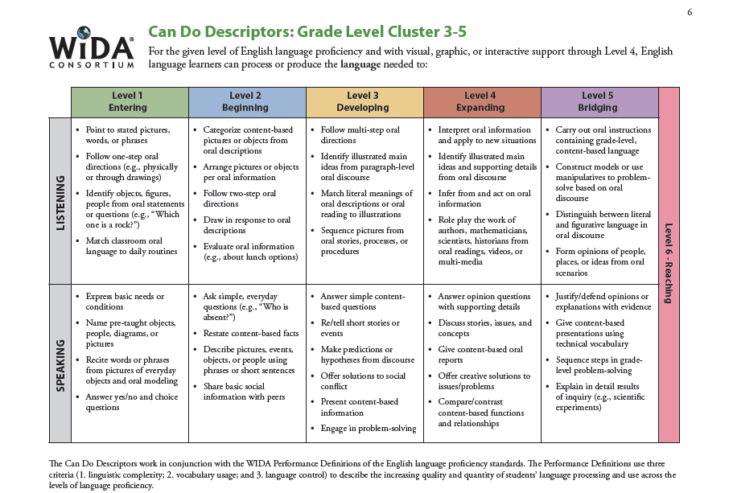
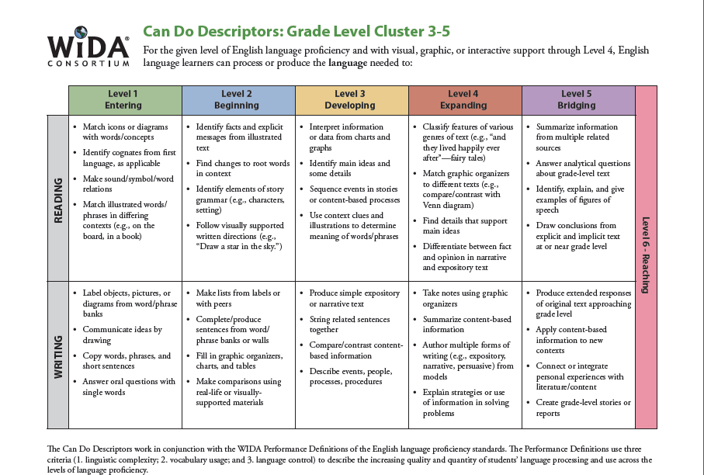
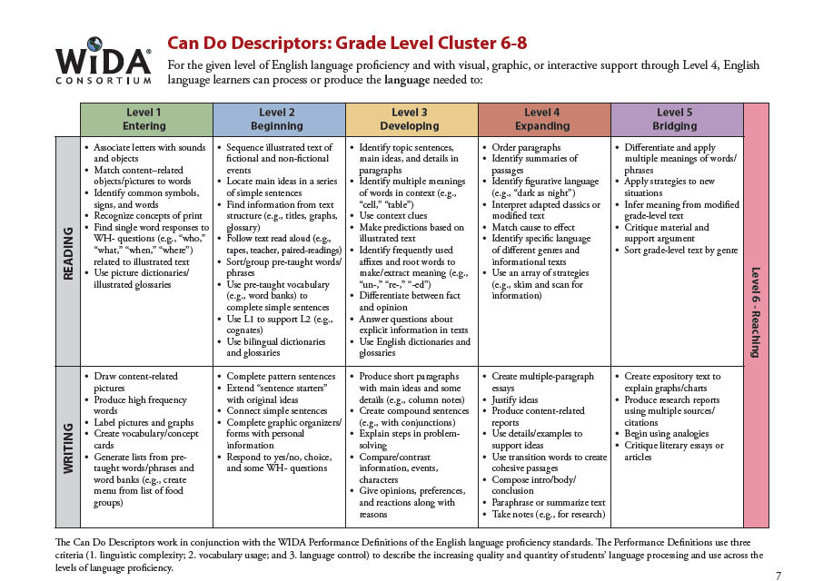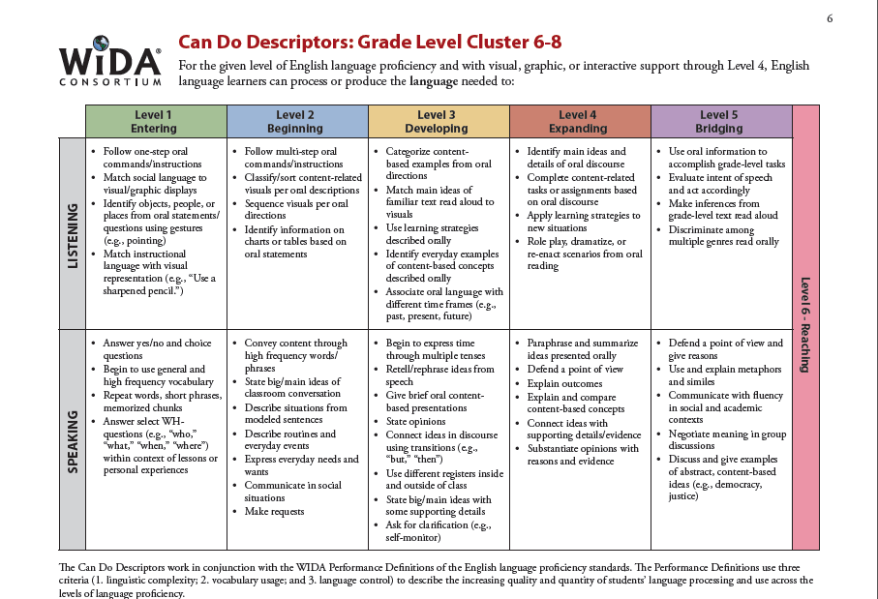

IV. Vocabulary
Tier 2 Vocabulary | Tier 3 Vocabulary
amendment justice  appoint law  balances national  bill nominate  cabinet political  checks press  civil principle  commerce representative  compromise separation  convention system  creed supreme  ideal treaty  impact veto  judge | Anti-Federalists government  citizen impeach  Civil Rights inflation  Congress judicial  constitution military  country patriotism  currency population  democracy ratify  due process rebellion  elect republic  electoral Senate  executive senator  federal state  Federalists taxes

- RESOURCES AND MATERIALS

Bateman, Teresa, Red, White, Blue, and Uncle Who? The Stories Behind Some of America’s Patriotic Symbols, Holiday House, 2001.

Bernstein, Amy, The Constitutional Convention, TIME FOR KIDS Harcourt

Collier, Christopher and Collier, James Lincoln, Creating The Constitution: 1787, Benchmark Books, 1998.

deMauro, Lisa, The Star-Spangled Banner, TIME FOR KIDS Harcourt

Fritz, Jean, Shh! We’re Writing The Constitution, Putnam Publishing Group, reissue edition 1998

Granfield, L and Bjorkman, S. America Votes: How Our President Is Elected, Kids Can Press, 2003

Jones, Veda Boyd, The Senate, Chelsea House Publications, 2000

Kroll, Steve, By The Dawn’s Early Light: The Story of the Star Spangled Banner, Scholastic, 2000.

Litwin, Laura Baskes, Benjamin Banneker: Astronomer and Mathematician , Enslow Publishers, 1999

Oatman, Eric, George Washington’s Cabinet, TIME FOR KIDS Harcourt

Quiri, Patricia Ryon, The Supreme Court, Children’s Press,1998

Santella, Andrew, Thomas Jefferson: Voice of Liberty, Children’s Press, 1999

Schleifer, Jay, Our Declaration of Independence, The Millbrook Press, 1992

Sobel, Syl., The U.S. Constitution and You, Barron’s Educational Series, 2001

Turner, Ann., Nettie’s Trip South, Aladdin Paperbacks, 1995

Younger, Barbara, Purple Mountain Majesties: The Story of Katharine Lee Bates and America The Beautiful, Dutton Children’s Books, 1998.

Internet Resources
www.harcourtschool.com
www.timeforkids.com
score.rims.k12.ca.us/literature/k6
www.califorianhistorian.com
www.library.ca.gov
www.museumca.org
www.nccs.net
www.constitutioncenter.org
www.abcteach.com
http://www.youtube.com/watch?v=FzAJyK0ovo8 (School House Rock Cartoon)
http://blogs.egusd.net/ccss/2012/01/12/ccss-aligned-rubrics-k-12/(K-12 CCSS writing rubric)
Colonial America: http://nm.pbslearningmedia.org/resource/vtl07.la.rv.text.lpcolhouse/a-characters-perspective-colonial-house/

The Constitution
(New Mexico Level 5/6)
UNIT PLANNING PAGES

- FOCUS AND MOTIVATION
- Observation Charts
- Inquiry Charts
- Realia /Artifacts
- Cognitive Content Dictionary- signal word
- Constitution Awards
- Big Book “The Important Book about American Government”
- Personal Interactions
- Patriotic Music
- Poetry / Chants

- INPUT
- Timeline – key documents, people, and events for the Constitution
- Graphic Organizer –
- Pictorial – Creating the Articles of Confederation
- Narrative-
- Expert groups—Three Branches of Government & Bill of Rights
- Graphic organizer – World Map with inset of east coast states/colonies
- Read Aloud
- 10/2 lecture

III.GUIDED ORAL PRACTICE
- T Graph with social skills/Team points
- Picture-file cards – observe, classify, open & closed sort, Guess My Category
- Process Grid
- Team Tasks
- Personal Interaction
- Reader’s Theater
- Sentence Patterning Chart
- Poetry
  - Yes Ma’am
  - Leaders Here, Leaders There
  - Constitution Cadence
  - Constitution Bugaloo

- READING/WRITING
- Whole Class
- Cooperative strip paragraph with responding, revising and editing
- Found poetry
- Narrative – story map
- DRTA
- Sentence Patterning Chart – Reading and Trading Game

- Cooperative Reading and Writing
- Team Tasks
- Ear-to-Ear Reading
- Flexible Group Reading
ELD – Group Frame
Struggling Readers – Cooperative Strip Paragraph
On Level – SQ3R and Clunkers and Links
- Focused Reading
- Expert Groups
- Mind Map

C. Individual
- Learning Logs
- Journals
- Personal Response
- Individual Tasks
- Explorations

D. Reading / Writing Workshop
        - Mini lesson
        - Write
        - Author’s Chair
        - Conference

- EXTENDED ACTIVITES
- Make a big book
- Write Chant
- Patriotic Songs
- Readers Theatre
- Poetry
- Museum Walk of Artifacts
- Art Project
- School House Rock songs and Video
- Mock trial with Judicial Branch
- Write a bill for the Legislative Branch

- CLOSURE
- Process all learning and inquiry chart
- Required expository, narrative and poetry writing
- Graffiti Wall
- Read the walls
- Team Feud
- Assess Learning Logs (on going)
- Prediction/Reaction guide
- Teacher and student made test
- Portfolio ( 3 pieces of writing)
- Evaluations
- Personal Exploration with rubric
- Class / Team Tasks

The Constitution
(New Mexico Level 5/6)
Sample Daily Lessons

Day 1:

Focus/Motivation
- Personal Behavior Standards – Historian Awards
- Prediction/Reaction Guide
- Cognitive Content Dictionary with signal word
- Observation Charts
- Inquiry Chart: What do you know about the Constitution? What do you want to know?
- Big Book, The Important Book about American Government

Input
- World Map/13 Colonies Inset
  - Learning Log
  - ELD Review
  - 10/2 Discussion w/ primary language

Input
- Timeline
  - 10/2
  - Learning Log
  - ELD Review

Guided Oral Practice
- T Graph for Social Skills: Cooperation
- Team Points
- Picture File Cards – Exploration Report
- Poetry/Chant

Input
- Pictorial – Creating the Articles of Confederation
  - 10/2
  - Learning Log
  - ELD Review

Reading/Writing
- Writer’s Workshop
  - Mini lesson
  - Plan, share, write
  - Author’s Chair
Closure
- Interactive journal writing
- Home-School Connection
Sample Daily Lesson Plans

Day 2

Focus/Motivation
- Cognitive Content Dictionary – with Signal word
- Review T-Chart
- Process Home-School Connection
- 3 Personal Standards & Literacy Awards
- Review Timeline/ World Map with word cards
- Review Articles of Confederation Pictorial with word cards & picture file cards

Input
- Narrative Input

Guided Oral Practice
- Process Here/There Chant, Highlight, Sketch/Picture File Cards
- Chant

Reading/Writing
- Team Tasks
- Expert Groups #1
- Writer’s Workshop
  - Mini lesson
  - Plan, share, write
  - Author’s Chair

Closure
- Process Inquiry Chart
- Read Aloud
- Home-School Connection

Sample Daily Lesson Plans

Day 3

Focus/Motivation
- Review T-Chart
- Cognitive Content Dictionary – with Signal word
- Process Home-School Connection
- 3-Standards & Literacy Awards

Input
- Review Narrative with Conversation Bubbles and Word cards

Guided Oral Practice
- Sentence Patterning Chart
  - Reading and Trading Game
  - Flip Chants

Reading/Writing
- Expert Group #2
- Team Tasks
- Mind Map
- Process Grid
- Cooperative Strip Paragraph – Revise and Edit
- Interactive journal writing
- Writer’s Workshop
  - Mini lesson
  - Plan, share, write
  - Author’s Chair

Closure
- Read Aloud
- Home/School Connection
Sample Daily Lesson Plans

Day 4

Focus/Motivation
- T-Graph for Social Skills, oral evaluation of teams
- Cognitive Content Dictionary – with Stumper Word
- Focused Reading with Personal CCD
- Process Home-School Connection
- 3-Standards & Literacy Awards

Reading/Writing
- Story Map
- Flexible Reading Groups
  - SQ3R/Clunkers and Links
  - ELD Group Frame
  - Co-op Strip Paragraph with struggling readers
- Team Task presentations & oral evaluations
- Listen and sketch

Closure
- Home/School Connection
- Interactive journal writing
- Process Charts
Sample Daily Lesson Plans

Day 5

Focus/Motivation
- Cognitive Content Dictionary – with Signal word
- Poetry
- Process Home-School Connection

Reading/Writing
Closure
- Team Feud
- Graffiti Wall
- Process Inquiry Chart
- Evaluate week
- Letter home

Prediction Reaction Guide
The Constitution of the United States
Directions: Please respond by sketching and writing below.
1. Is this statement true or false? Why or why not?
The Articles of Confederation created a weak central government, leaving most of the power with the state governments.
Prediction:
Reaction:

2. Was the Constitution of the United States signed in Washington D.C. or Philadelphia, Pennsylvania?

Prediction:
Reaction:

3.Explain how the Bill of Rights guarantees the rights of all people?
Prediction:
Reaction:

4. Does the President of the United States belong to the Judicial Branch, the Executive Branch, or the Legislative Branch? What are some of the Presidents responsibilities?
Reaction:

Prediction:

5. How do Supreme Court Justices become part of the Judicial Branch? How long is their appointment?
Prediction:
Reaction:

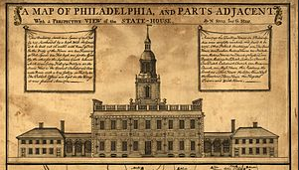
Independence Hall in Philadelphia
- Independence Hall is known primarily as the location where both the Declaration of Independence and the United States Constitution were debated and adopted.
- Independence Hall was built between 1732 and 1753, designed by Edmund Woolley and Andrew Hamilton, and built by Woolley.
- The lowest chamber of the original wooden steeple was the first home of the Liberty Bell.
- The Declaration was read aloud to the public in the area now known as Independence Square.
- This document unified the colonies in North America who declared themselves independent of the Kingdom of Great Britain and explained their justifications for doing so.
- These historic events are celebrated annually with a national holiday for U.S. Independence Day.

Why did Congress stop meeting at Independence Hall on December 12, 1776?

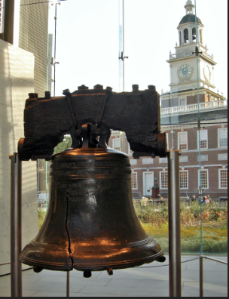
Liberty Bell in Philadelphia
- The Liberty Bell is an iconic symbol of American independence, located in Philadelphia, Pennsylvania.
- Bells were rung to mark the reading of the Declaration of Independence on July 8, 1776.
- The bell became famous after an 1847 short story claimed that an aged bell-ringer rang it on July 4, 1776, upon hearing of the Second Continental Congress's vote for independence.
- Charles duly ordered the bell from Thomas Lester of the London bellfounding firm of Lester and Pack.
- In 1893, former President Benjamin Harrison, speaking as the bell passed through Indianapolis, stated, "This old bell was made in England, but it had to be re-cast in America before it was attuned to proclaim the right of self-government and the equal rights of men."

Behind this Historian Award, draw the state of Pennsylvania and show the city where the Liberty Bell is located

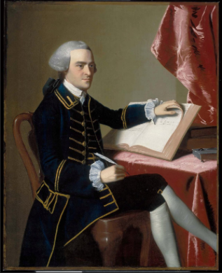
John Hancock
* John Hancock was born in Braintree, Massachusetts.
* He was a merchant, statesman, and prominent Patriot of the American Revolution.
*He served as president of the Second Continental Congress and was the first and third Governor of the Commonwealth of Massachusetts.
*Hancock began his political career in Boston as a protégé of Samuel Adams, an influential local politician.
*Hancock was one of Boston's leaders during the crisis that led to the outbreak of the American Revolutionary War in 1775.
*As John Hancock was president of Congress, was the first to sign the Declaration of Independence.

On the back of your award, explain what is meant by, “protégé of Samuel Adams.”

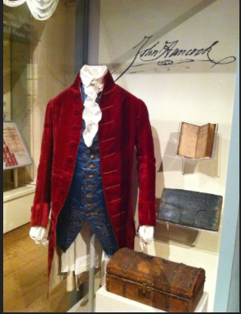
John Hancock Clothing
* After graduating from the Boston Latin School in 1750, Hancock enrolled in Harvard College and received a bachelors degree in 1754.

*John Hancock is remembered for his large and stylish signature on the United States Declaration of Independence.

*Hancock was one of the wealthiest men in the Thirteen Colonies, having inherited a profitable mercantile business from his uncle.

*As tensions between colonists and Great Britain increased in the 1760s, Hancock used his wealth to support the colonial cause.

How did John Hancock support colonists with is wealth?

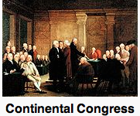
*The Continental Congress was a convention of delegates called together from the Thirteen Colonies that became the governing body of the United States during the American Revolution.
*The congress consisted of fifty-six delegates from twelve of the Thirteen Colonies.
*Benjamin Franklin had put forth the idea of such a meeting the year before but was unable to convince the colonies of its necessity until the British placed a blockade at the Port of Boston in response to the Boston Tea Party in 1773.
*All of the colonies sent their delegates except Georgia, which had its own troubles and needed the protection of British soldiers.
*Most of the delegates were not yet ready to break away from Great Britain, but they wanted the British King and Parliament to act in what they considered a more fair manner.
*Convened in response to the Intolerable Acts passed by the British Parliament in 1774, the delegates organized an economic boycott of Great Britain in protest and petitioned the King for a redress of grievances.

On a separate paper, write and sketch what Intolerable Acts & economic boycott mean?

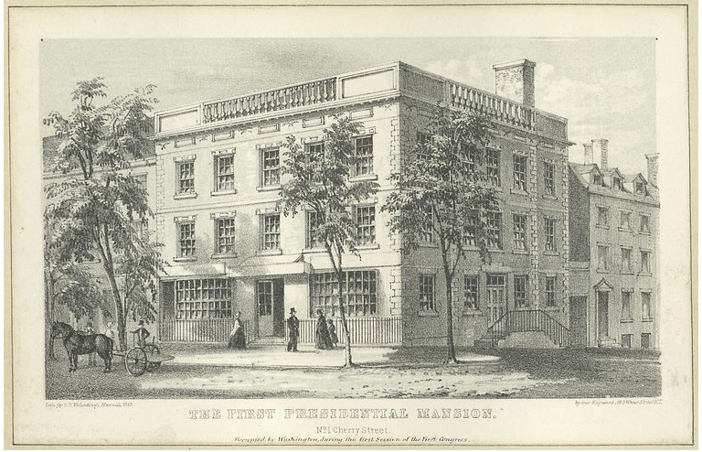
First White House in Washington
- First Presidential Mansion: Samuel Osgood House, Manhattan, New York. Occupied by Washington: April 1789 - February 1790.
- President Washington visited Charleston, South Carolina in May 1791 on his "Southern Tour", and saw the under-construction Charleston County Courthouse designed by Irish architect James Hoban.
- Construction of the White House began with the laying of the cornerstone on October 13, 1792, although there was no formal ceremony.
- The building was originally referred to variously as the "President's Palace", "Presidential Mansion", or "President's House".

When did people start calling the Presidential Mansion the White House?

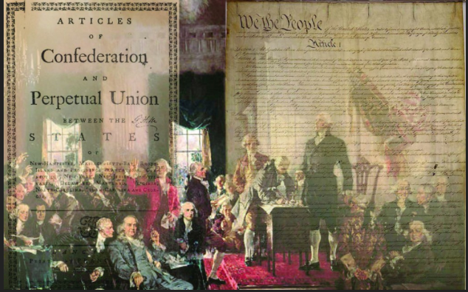
Articles of Confederation in Philadelphia
*The Articles of Confederation was an agreement among the 13 founding states that established the United States of America as a confederation of sovereign states and served as its first constitution.
* The formal ratification by all 13 states was completed in early 1781.
* On March 4, 1789, the Articles were replaced with the U.S. Constitution.
* The new Constitution provided for a much stronger national government with a chief executive (the president), courts, and taxing powers.

Activities to complete:
1. Sketch and label the 3 branches of government the Constitution guarantees.

2. List who are New Mexico’s United States Congressmen/Congresswoman & United States Senators?

Whole Class Graphic Organizer for Action Plan
Bullying:
(When is Freedom of Speech (1st Amendment) at Risk?)

What is Bullying?
Causes of Bullying:
*Silencing, fear, anxiousness, Cultural Differences, etc….
Outcomes of Bullying:
*Violence, gangs, etc…..
Social Media:
*Facebook
*Twitter
*Texting
*You Tube

Ways in Which Bullying is Done:
*Gossip
*Video posts on You Tube
*Writing Notes
*Put downs in the classroom

Laws, Policies, Community Resources & Solutions to Bullying in Our Communities:
*Warehouse 508 Non-Profit Organization in New Mexico (www.warehouse508.org)
*Anti-Bullying Program online: (www.meanstinks.com)
*Project GLAD Strategies (e.g. Personal Interaction)
*Cultural Proficiency Framework (student, teacher, & administrator training & ongoing follow-up)

Other Media Sources, Their Rights, & Their Way of Messaging:
*News
*Magazines
*Posters posted in public places
*Flyers handed out publicly
*Newspapers printing articles
*Editorial Cartoons – What are they, why are they done, and what messaging gets across?

ACTION PLAN:
WHEN IS FREEDOM OF SPEECH (1st Amendment) AT RISK?
use a decision-making process to identify a situation that requires a solution; gather information, identify options, predict consequences and take action to implement that solution.

- Graphic Organizer: Cause and Effect of Free Speech

- Brainstorm possible causes and solutions to the problem whole class

- Small group practice:

  - Choose one technological social networking idea (i.e., you tube, twitter, Facebook, etc.) and discuss the pros and cons of this type of media that might challenge the 1st Amendment of the Constitution, Freedom of Speech.
  - Discuss several real life scenarios of when the social network of your choice is within the law of the 1st Amendment but might be hurtful to others and when it would not be within the law.
  - As a team, create a solution that ensures Freedom of Speech that is well defined; contributing to their overall health and wellbeing as a U.S. citizen. Write a plan of action for you and your team with well-explained reasons for the proposed solution.

  - Develop a creative way to present your action plan to the class.

*Objective of Action Plan:
This action plan is a working graphic organizer to be constructed with the students as the topic develops. Students will explore the conceptual meaning of freedom and then relate it to various people groups today to discover if it is indeed truly experienced.
Due to the nature of this kind of graphic organizer and its use within a Project GLAD unit, an ELD Review matrix may or may not be used to reinforce CCSS/ELD benchmarks.

The Important Book about American Government
Written by: Joy Greenwood, Michele Menton, and Helen Matthews
Adapted by Eva Thaddeus and Annette Maestas

The important thing about our American democracy is that the power of government comes from the people.

- After the Revolutionary War, the United States of America needed to decide what kind of government would be best for their new country.
- A temporary government under the Articles of Confederation was approved in 1781.
- The states were loosely connected but soon it was obvious there was a need for a stronger federal government.
- So in 1787, delegates, or leaders from the states met in Philadelphia to create a new government.
- At this convention, or meeting, the United States Constitution was written.
- The Constitution outlines a plan for how the government works.
- It is the supreme law of our land.
- The delegates wanted a republic, which means the government would not be lead by a king.
- They decided a democracy, or a country whose government gets its power from the people, would be best.
- They finally agreed that the United States citizens would elect leaders to run the government.
- Our U.S. government is therefore called a democratic republic.
- The Constitution divides the government into three branches: legislative, executive, and judicial.

But, the important thing about our American democracy is that the power of the government comes from the people.

Page 2
The important thing about our American democracy is that the power of government comes from the people.

- Many people felt the Constitution did not adequately protect the freedom and rights of American citizens.
- A group of people called Federalists wanted more power to the Federal governemnt.
- The Anti-Federalists insisted that a bill of rights be included in the Constitution because they were afraid the federal government would have too much power over the states.
- The House of Representatives wrote the first 10 amendments to the Constitution.
- An amendment is a change.
- These amendments are called the Bill of Rights.
- All ten amendments deal with the protection of individual rights.

But, the important thing about our American democracy is that the power of the government comes from the people.
Page 3
The important thing about our American democracy is that the power of government comes from the people.

- The Constitution created three branches of government.
- One of the three branches of our national government is the legislative branch, called Congress.
- Congress has two parts, the House of Representatives, and the U.S. Senate.
- American citizens elect members of the House of Representatives and the U.S. Senate.
- Congress is responsible for making laws about money and taxes in the United States.
- It can create an army, navy or other armed forces.
- And only Congress can declare war.

But, the important thing about our American democracy is that the power of the government comes from the people.

Page 4
The important thing about our American democracy is that the power of government comes from the people.

- Another branch of the national government is the executive branch.
- The leader of the executive branch is the President of the United States.
- The president or chief executive is responsible for carrying out the laws that Congress makes.
- Many people work for the president to help him or her complete this job.
- The president is commander in chief of the army, navy and other armed forces.
- Only the president can meet with leaders of other countries and make treaties, or agreements with them.
- If anything happens to the president, the Vice-President takes the president’s place.

But, the important thing about our American democracy is that the power of the government comes from the people.
Page 5
The important thing about our American democracy is that the power of government comes from the people.

- The third branch of the U.S. National government is the judicial branch.
- Federal judges or justices make up this branch and are responsible for helping citizens understand the laws of the United States of America.
- The Supreme Court is the highest court in the U.S.
- Today there are 9 Supreme Court justices.
- A justice must be appointed by the president and approved by the Senate.
- A Supreme Court justice works for, or serves on the court for life.
- They settle disagreements, protect the rights of American citizens, and interpret the Constitution.

But, the important thing about our American democracy is that the power of the government comes from the people.

Page 6
The important thing about our American democracy is that the power of government comes from the people.

- The government of our country is called the Federal Government.
- There are other governments within our country: state, county, local and tribal.
- Most of these are modeled on the structure of our Federal Government and look similar to it, but on a smaller scale.
- For example, the state of New Mexico has a legislative branch with a Senate and a House, an executive branch led by the Governor, and a judicial branch with state courts.
- The Navajo Nation has a tribal government with a legislative branch called the Tribal Council, an executive branch led by the Navajo Nation President, and a judicial branch with Tribal Courts.
- The City of Albuquerque is a local government with a legislative branch called the City Council, an executive branch led by the Mayor, and a judicial branch with Metropolitan Courts.

But, at all levels of government, the important thing about our American democracy is that the power of the government comes from the people.

Glossary

Amendments – A change or addition to the Constitution.

Anti-Federalist – Person opposed to the new Constitution and its emphasis on a strong national government.

Bill of Rights – First 10 amendments to the Constitution.

Constitution – Written plan of government.

Constitutional Convention – Meeting of delegates who met in Philadelphia in 1787 and replaced the Articles of Confederation with the Constitution.

Delegate – Person chosen to represent others.

Democracy – Government that is run by the people.

Executive – Part of the government, headed by the President, that carries out the laws.

Federal – Refers to the national government.

Federalist – Supporter of a strong national government and in favor of adopting of the Constitution.

Judicial – Part of the government that decides the meaning of the laws.

Legislative – Part of the government that passes laws.

Republic – Form of government in which the people elect representatives to make laws and run the government.

Supreme Court – The highest court in the country.

Treaty – An agreement between states.

Table of Contents

Writing the Constitution page 1

Bill of Rights page 2

Legislative page 3

Executive page 4

Judicial page 5

State, local and tribal governments page 6

(Probable) Influences on the United States Constitution
for Graphic Organizer
Origins of the US Constitution
James Madison wrote most of the US Constitution, so he is often called the “Father of the Constitution.” Most of the ideas written in the Constitution were from the ideas found in the diaries of Gouverneur Morris and James Madison. Madison was an educated man who spent much time studying governments throughout history.
Roman Empire (509 BC – 476 AD) checks and balances so wealthy wouldn’t have all the power.
Greece ( ) called the cradle of democracy. Citizens were allowed to be part of the decision-making; men would gather and vote on issues.
Magna Carta(1215) was written to limit the power of King John of England. No freeman could be punished without the law of the land. They included the right of trial by jury, protection of personal property, limits on taxes, religious freedom.
Iroquois 1450-1600 Many historians believe the US Constitution may have been influenced by the Iroquois League. In our national seal, the 13 arrows grouped together to represent the 13 colonies imitate the 5 arrows representing the 5 nations (Mohawk, Oneida, Onondaga, Cayuga, Seneca) that are mentioned in the Iroquois Constitution (quoted below). Arrows can be broken individually, but when they are bound together, it is almost impossible to break them.
57. “Five arrows shall be bound together very strong and each arrow shall represent one nation. As the five arrows are strongly bound this shall symbolize the complete union of the nations.” From THE CONSTITUTION OF THE IROQUOIS NATIONS

English Bill of Rights (1689) was written to protect people from abuse of the monarchy. Included was : freedom of speech, elections, right to petition and bear arms, no cruel punishment and the consent of the people.
www.constitution.org/primarysources/influences
http:wikipedia.org/United_States_Constitution#historicalinfluences
Prepared by Gerald Murphy (The Cleveland Free-Net - aa300) Distributed by the Cybercasting Services Division of the National Public Telecomputing Network (NPTN).
Timeline to accompany Origins of the Constitution Graphic Organizer
8,000 BC archeologists document that Pueblo people were present in North America at least 10,000 years ago.
1607 first permanent colony in Virginia founded in Jamestown
1609 Santa Fe founded in NM
1776 Declaration of Independence and American Revolution
1781Articles of Confederation ratified
1787 US Constitution. Only white male property owners given right to vote at this time.
Graphic Organizer
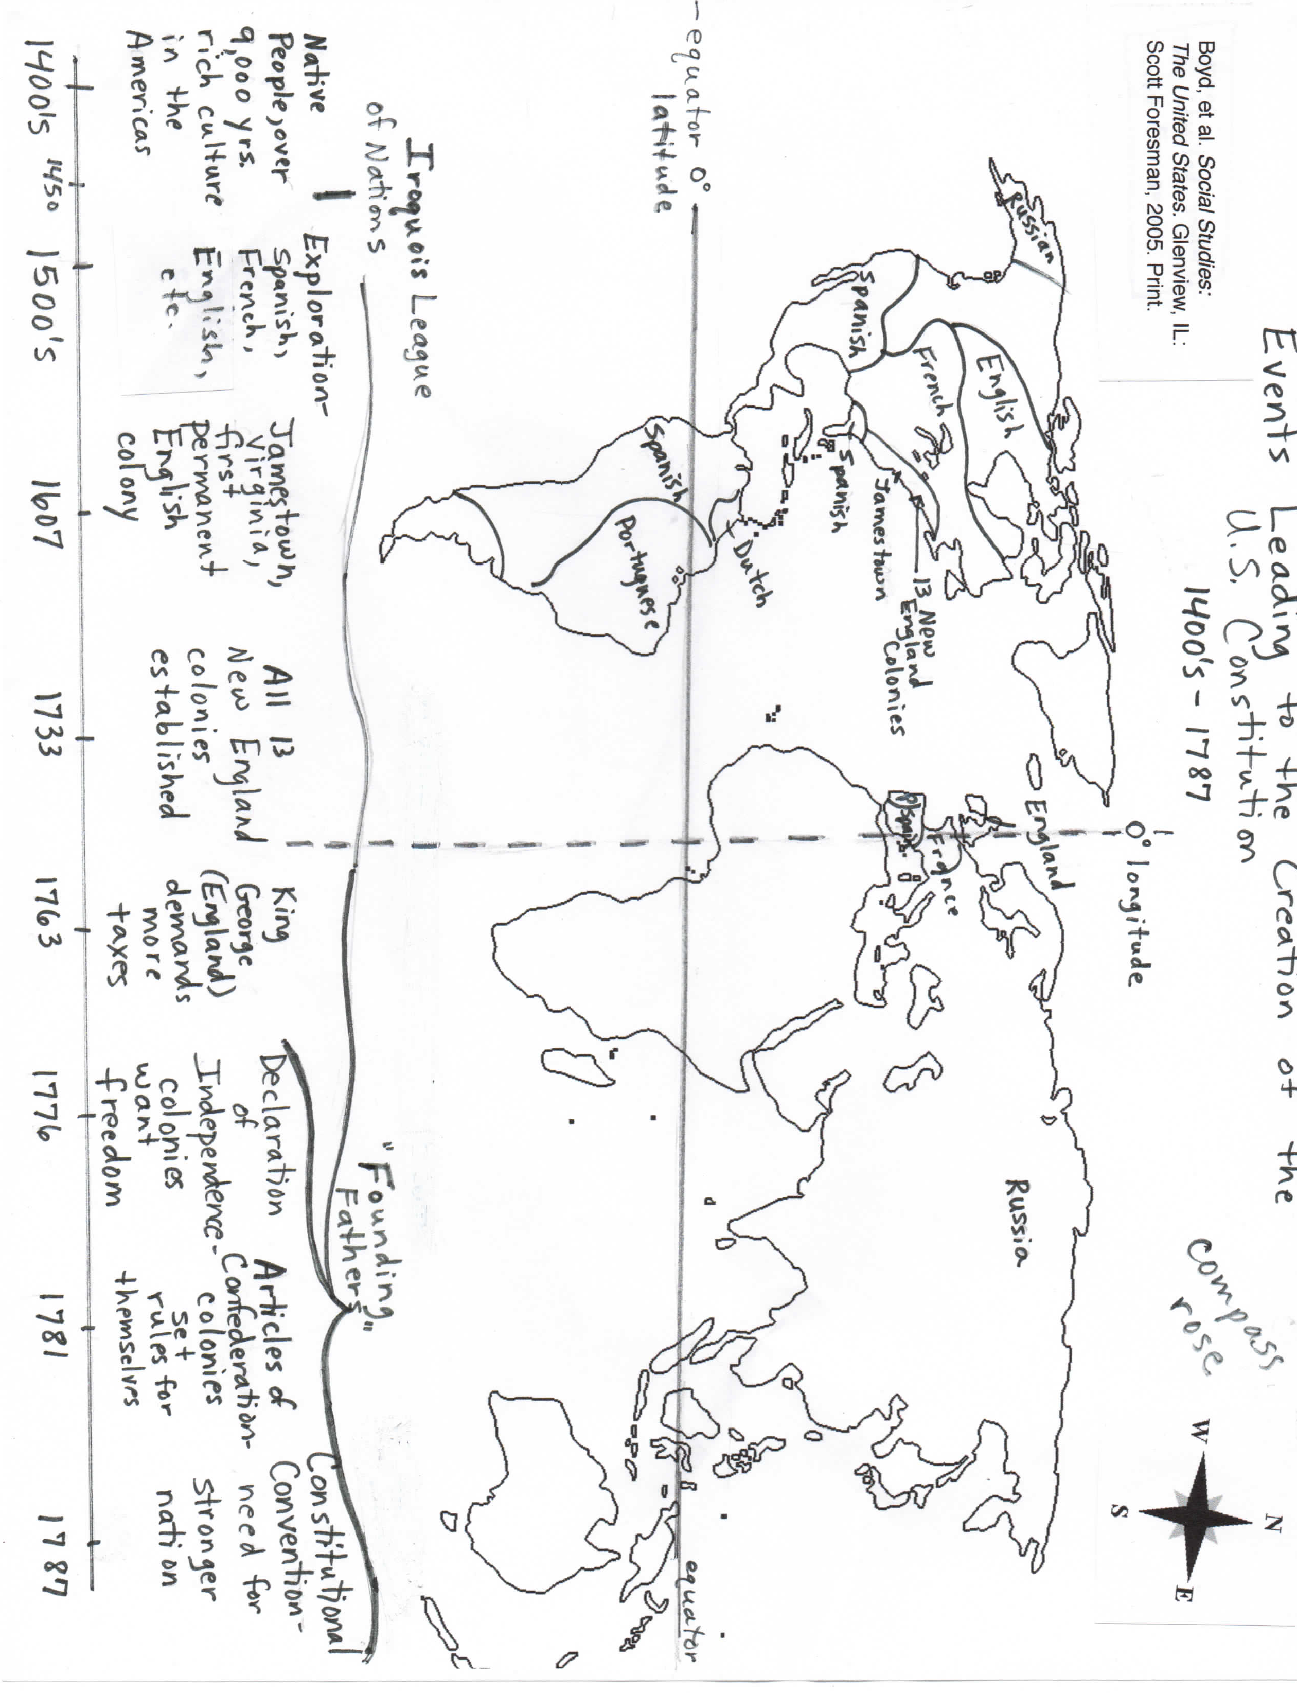

Input Chart: Events Leading to the Creation of the U.S. Constitution World Graphic Organizer Grade Level: 5th / 6th
Project GLAD™ Trainers:
Stages of Language Acquisition | Preproduction | Early Production | Speech Emergence | Intermediate Fluency | Advanced Fluency
New Mexico WIDA (ELD)  Proficiency Level Descriptors | Entering | Emerging | Developing | Expanding | Lifelong Language/CCSS
Level of Questioning | Point To, Locate, Trace | Yes/No | Either/Or | Open Ended
Create  Arrange, assemble, collect, compose, construct, create, design, develop, formulate, manage, organize, plan, prepare, propose, set up | Find the time period where the Spanish, French, & English exploration was taking place? | Is the ship (show several picture file cards of ships) sufficient for the passage of the colonists coming to Jamestown? | On what continent do you find the land that Portugal claimed, North America or South America? | Do you think the colonists struggled to survive? Explain why?
Evaluate  Appraise, argue, assess, attach, choose, compare, defend, estimate, judge, predict, rate, select, support, value, evaluate | Show me the location of the 13 New England Colonies. | Was the overall purpose of the colonists leaving England to have freedom from the king? | Who were the first people in North America, the Pueblo people or the Spanish, French, & English Explorers? | Explain the definition of the Articles of Confederation ‘ratified’.
Analyze  Analyze, appraise, calculate, categorize, compare, contrast, criticize, differentiate, discriminate, distinguish, examine, experiment, question, test | Show me when Jamestown, Virginia became the first permanent English colony. | Was the overall purpose of the trade routes to enrich the parent country (Enland)? | Did Dutch explore North or South America? | In your own words, what did the 13 colonies imitate from the Iroquoise League to represent the 5 nations?

Stages of Language Acquisition | Preproduction | Early Production | Speech Emergence | Intermediate Fluency | Advanced Fluency
New Mexico WIDA (ELD)  Proficiency Level Descriptors | Entering | Emerging | Developing | Expanding | Lifelong Language/CCSS
Level of Questioning | Point To, Locate, Trace | Yes/No | Either/Or | Open Ended
Apply  Apply, choose, demonstrate, dramatize, employ, illustrate, interpret, operate, practice, schedule, sketch, solve, use | How long ago did archeologists document that the Pueblo people were present in North America? | Do you think the United States Constitution, may have been influenced by the Iroquois League? | Who was given the right to vote in 1787, the white male property owners or the white women? | What is the Iroquoise League? | What is meant by, “As the 5 arrows are strongly bound, this shall symbolize the complete union of nations.”
Understand  Classify, describe, discuss, explain, express, identify, indicate, locate, recognize, restate, review, select, translate | Locate the territories that were explored by the Spanish. | Was King George of England demanding more taxes? | Was the Declaration of Independence created in 1787 or the United States Constitution? | Where did the first permanent colonists of North America land?
Remember  Arrange, order, define, duplicate, label, list, name, recognize, relate, recall, repeat, reproduce | Point to the time period where the Declaration of Independence was drafted. | Was the Constitution Convention in 1787? | Were the Articles of Confederation done before or after the Declaration of Independence? | List the names of the 13 colonies.

Background info Articles of Confederation pictorial

After the United States won the revolution and declared Independence in 1776, the founding fathers needed to create a new government. Leaders came together at the Second Continental Congress and created the Articles of Confederation. This new form of government was ratified or approved in 1781.

The Articles of Confederation set up one governing house called Congress. Congress had very little power. The states kept most of the power and the federal government could not make decisions without the approval from each state.

The Articles of Confederation had several negative impacts. First, Congress could not raise taxes to pay for the war and this young country had heavy debts to pa to France. Also, Congress could not control trade between the states and other countries or trade between each state. Finally, many states had their own currency, making travel and trade between states more difficult.

Several people were involved in the writing of the Articles of Confederation. Among the most influential were John Adams, Alexander Hamilton, Thomas Jefferson and Gouvernour Morris.

Other problems developed due to the new Articles of Confederation. Taxes in the states were extremely high. Many people could not pay their taxes resulting in people having to be put in prison and losing their land. In 1786, Daniel Shay led a group of angry citizens in an attack on an arms storehouse. Their attack known as Shay’s Rebellion, was defeated, but the federal government was now worried about future rebellion.

Pictorial Input
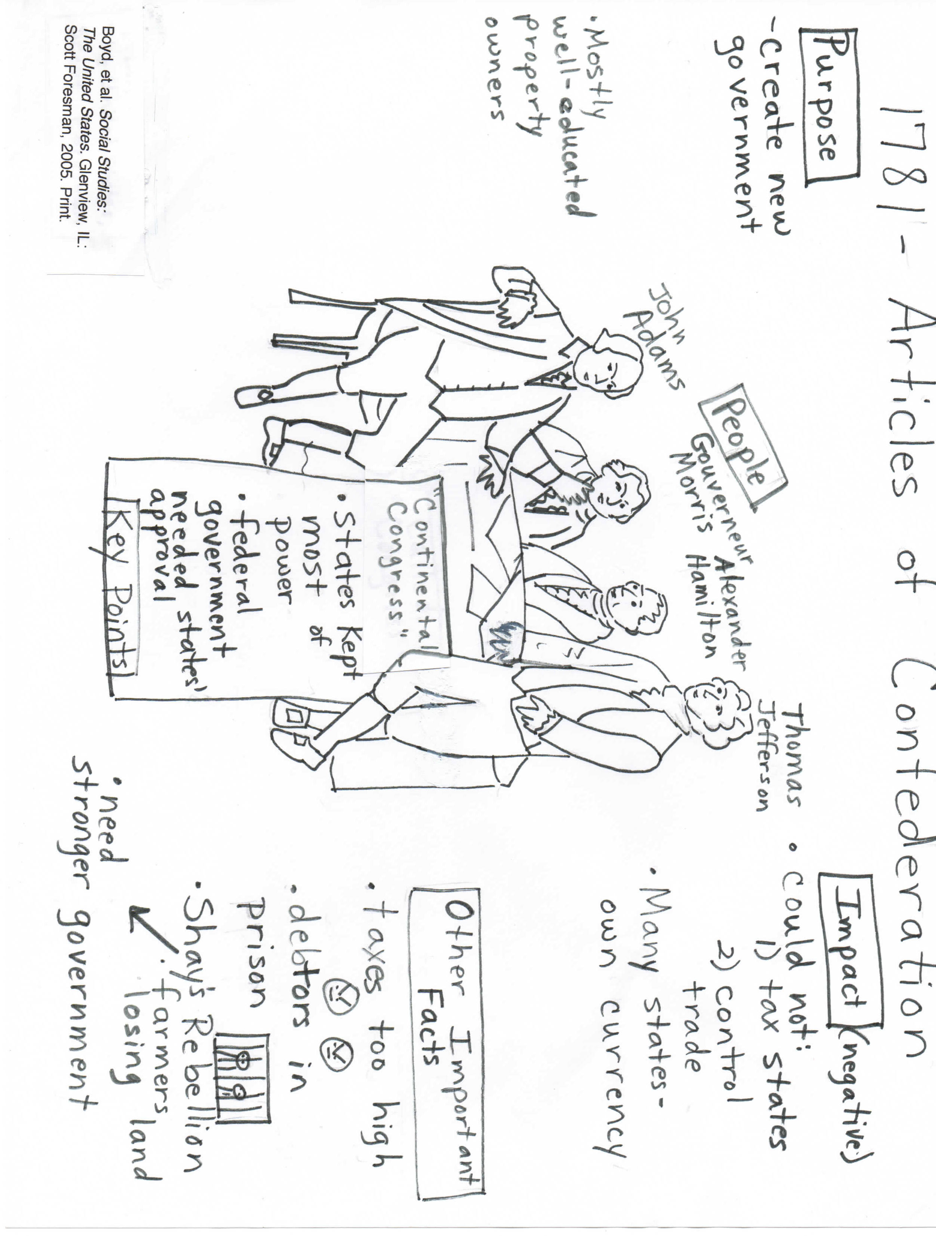

Input Chart: 1781- Articles of Confederation Pictorial Grade Level: 5th / 6th
Project GLAD® Trainers:

Stages of Language Acquisition | Preproduction | Early Production | Speech Emergence | Intermediate Fluency | Advanced Fluency
New Mexico WIDA (ELD)  Proficiency Level Descriptors | Entering | Emerging | Developing | Expanding | Lifelong Language/CCSS
Other: | Point To, Locate, Trace | Yes/No | Either/Or | Open Ended
Evaluation  Appraise, argue, assess, attach, choose, compare, defend, estimate, judge, predict, rate, select, support, value, evaluate | Show me the purpose of the Articles of Confederation | Did Shay’s Rebellion happen because of farmers losing land? | Was the purpose of the articles of confederation to create a new government or to gain their independence from England. | Explain why you think George Washington refused to be king.
Synthesis  Arrange, assemble, collect, compose, construct, create, design, develop, formulate, manage, organize, plan, prepare, propose, set up | Find negative impact of the Articles of Confederation | Does this picture depict strong leadership?  (show pictures of the founding fathers) | Infer, whether or not you think it was hard for the states to trade with each other, was it because of they all had their own currency or because taxes were too high. | Do you think the states needed a stronger government?
Analysis  Analyze, appraise, calculate, categorize, compare, contrast, criticize, differentiate, discriminate, distinguish, examine, experiment, question, test | Show me where and important fact shows debtors are put into prison for not paying their taxes. | Look at these pictures (show pictures of Shay’s Rebellion):  Determine if the people are upset. | Did the delegates convene at the 2nd Continental Congress to discuss independence or the need for a leader of the army? | Why do you think Shay’s Rebellion was important? | Do you think Shay’s Rebellion is as big as a war

Stages of Language Acquisition | Preproduction | Early Production | Speech Emergence | Intermediate Fluency | Advanced Fluency
New Mexico WIDA (ELD)  Proficiency Level Descriptors | Entering | Emerging | Developing | Expanding | Lifelong Language/CCSS
Other: | Point To | Yes/No | Either/Or | Open Ended
Application  Apply, choose, demonstrate, dramatize, employ, illustrate, interpret, operate, practice, schedule, sketch, solve, use | Identify a category on the chart that describes the results of the 2nd Continental Congress. | Do you think the federal government could not make decisions without the approval from each state? | Is Thomas Jefferson or the farmers involved in writing the Articles of Confederation? | Why were John Adams, Gouverneur Morris, Alexander Hamilton & Thomas Jefferson men of integrity?
Comprehension  Classify, describe, discuss, explain, express, identify, indicate, locate, recognize, restate, review, select, translate | Point to the people involved with creating the Articles of Confederation. | Was Shay’s Rebellion defeated? | Identify whether these men were well educated or men of power? | Explain the causes that led the colonists to meet for a second time at the Continental Congress?
Knowledge  Arrange, order, define, duplicate, label, list, name, recognize, relate, recall, repeat, reproduce | Point to the information that talks about congress. | With the Articles of Confederation, do states keep most of their power? | Was John Adams a property owner? How do you know? | List the people involved at the 2nd Continental Congress.

The United States Historical Timeline
- 1773 - Boston Tea Party
- 1774 - First Continental Congress
- 1774 - British pass Intolerable Acts
- 1775 - Battle of Lexington and Concord
- 1775 - Battle of Bunker Hill
- 1775 - Second Continental Congress
- 1776 - Declaration of Independence
- 1777 - Articles of Confederation adopted by the Second Continental Congress (November 15)
- 1777 - Vermont, as the Republic of Vermont, passes the Constitution of Vermont, the first in the nation to outlaw slavery
- 1781 - Articles of Confederation ratified
- 1781 - British surrender at Yorktown
- 1783 - Treaty of Paris (1783) ends United States Revolutionary War
- 1786 - Shays' Rebellion
- 1786 - Annapolis Convention fails
- 1787 - Constitutional Convention in Philadelphia
- 1787 - Delaware, Pennsylvania and New Jersey ratify the constitution
- 1788 - Georgia, Connecticut, Massachusetts, Maryland, South Carolina, New Hampshire, Virginia and New York ratify the constitution
- 1789 - Constitution goes into effect
- 1789 - George Washington becomes President
- 1789 - North Carolina ratifies the constitution
- 1790 - Rhode Island ratifies the constitution
- 1791 - Bill of Rights ratified
- 1799 - George Washington dies

Input Chart: The United States Historical Timeline Grade Level: 5th /6th
Project GLAD® Trainers:
Stages of Language Acquisition | Preproduction | Early Production | Speech Emergence | Intermediate Fluency | Advanced Fluency
New Mexico WIDA (ELD)  Proficiency Level Descriptors | Entering | Emerging | Developing | Expanding | Lifelong Language/CCSS
Level of Questioning | Point To, Locate, Trace | Yes/No | Either/Or | Open Ended
Create  Arrange, assemble, collect, compose, construct, create, design, develop, formulate, manage, organize, plan, prepare, propose, set up | Point to at least 3 events that took place in 1775. | Was the Constitution ratified in Pennsylvania? | Was the Bill of Rights ratified in 1791 or 1789? | Who is one patriot that greatly impacted the events of the American Revolution? Why?
Evaluate  Appraise, argue, assess, attach, choose, compare, defend, estimate, judge, predict, rate, select, support, value, evaluate | Show me on the timeline the person who became the 1st President of the United States. | Was the Declaration of Independence important for colonies?  Explain why? | In 1781 were the Articles of Confederation ratified or defeated? | Why is the Bill of Rights so important?
Analyze  Analyze, appraise, calculate, categorize, compare, contrast, criticize, differentiate, discriminate, distinguish, examine, experiment, question, test | Locate the 1st event that happened 2 years after the Constitutional Convention. | Which side was victorious after the Battle of Bunker Hill?  Did the colonists defend with rocks and bayonets? | Did General Washington take over the army before or after the Battle of Bunker Hill? | What was so important about Rhode Island ratifying the Constitution? | What does the term ‘ratified’ mean?

Stages of Language Acquisition | Preproduction | Early Production | Speech Emergence | Intermediate Fluency | Advanced Fluency
New Mexico WIDA (ELD)  Proficiency Level Descriptors | Entering | Emerging | Developing | Expanding | Lifelong Language/CCSS
Level of Questioning | Point To, Locate,  Trace | Yes/No | Either/Or | Open Ended
Apply  Apply, choose, demonstrate, dramatize, employ, illustrate, interpret, operate, practice, schedule, sketch, solve, use | Locate the portrait of a firebrand.  Where on the timeline did minutemen gather after ‘the call to arms’? | Did the American Revolution begin after the first ‘shot heard ‘round the world’? | Was the decision to elect George Washington as commander in chief of the army made at the 1st or 2nd Continental Congress? | What were the results of the Battle of Lexington/Concord?
Understand  Classify, describe, discuss, explain, express, identify, indicate, locate, recognize, restate, review, select, translate | Locate when the surrender at Yorkton took place. | Did they decide to boycott as an act of opposition? | Were the colonists upset because goods were too expensive or because they had no vote to decide about the taxes? | Why were the colonists upset and boycotting British goods?
Remember  Arrange, order, define, duplicate, label, list, name, recognize, relate, recall, repeat, reproduce | Point to the Boston Tea Party. | Did the 13 colonies get taxed on goods like paper, books, tea and luxuries? | Were laws passed down by England or Spain? | Recall what country was controlling the 13 colonies.

I Was There When They Signed the Constitution in 1787

By Annette Maestas
Adapted from …If You Were There When They Signed the Constitution by Elizabeth Levy
(Scholastic Inc.)

1. I’m James Madison. You may have heard of me. I was there when they signed the Constitution. In fact, I helped write it. Historians call me the “Father of the Constitution”, probably because I took daily notes for 4 months of everything that was said. The effort nearly killed me. I delivered speeches and helped formulate several compromises. I want to tell you the story of how this amazing document was created and why it has lasted for over 200 years.
2. Problems. After we won the Revolutionary War, there were still many problems. Sure, we were free from English rule, but most Americans did not yet think of themselves as citizens of the United States. They would identify themselves as a “Georgian” or a “Virginian”, not as an American.

3. The Articles of Confederation had created a weak and ineffective national government. The national government had no money and no authority to impose or collect taxes and had no way of enforcing public order. It was not able to create an army or a navy to deal with problems with other nations. Most people in the new states were farmers, and farmers were in debt due to high prices. People who could not pay their debts were thrown in debtors prison, so many Americans found themselves in jail. What a mess! We wanted America to have a new strong national government rather than a weak association of states.

4. The Delegates. So in 1787, Alexander Hamilton and I called for a convention of delegates, or representatives to meet in Independence Hall in Philadelphia in order to write our new Constitution. (Now people refer to it as the Constitutional Convention.) Fifty-five delegates showed up. Most of them were young, well-educated and wealthy landowners. Ben Franklin was the oldest delegate at eighty-one. George Washington was there, so was and Gouverneur Morris, among many others.

5. I came early, armed with books and ideas. My friend, Thomas Jefferson had sent me hundreds of books dealing with history and types of government, law, ancient civilizations, and modern nations. Before the convention, I had spent a whole year reading everything I could about all forms of government.

6. The Rules. We decided that we must work secretively because the delegates had to be able to speak freely and to change their minds. There were no visitors, no reporters. Guards were put at the doors and windows were nailed shut. Unfortunately for us, it turned out to be the hottest summer in years and we could not even enjoy a cool breeze.

7. The Debates. We spent a lot of time debating what should go into the constitution. Luckily, we all agreed that the United States should be a republic, i.e., a country governed by its people, and not a monarchy, where the king makes all the laws. When we disagreed and got stuck, we would compromise, or make a decision that would be acceptable to both sides.

8. There were opposing sides at the Convention. The “Anti-Federalists”, wanted to make sure that the states kept their rights. The small states were afraid the large states would overwhelm them if the number of national representatives from each state were based on population. They felt the large states would dominate them.

9. In contrast, the “Federalists”, wanted to see a strong and united nation resulting from the Convention. Edmund Randolph convinced us with these words, “What we need to create, gentlemen, is a strong national government with a Congress to make laws, a president to enforce those laws, and a judicial branch to determine that they are fair and equitable. Our poor nation right now is a collection of weak and arguing states who don’t trust each other. They impose taxes on each other and sometimes are even at the point of war.”

10. After much argument, we came up with the “Great Compromise.”
Congress would have two branches or houses. One house would be based on population, and in the other house, each state would be equal. Today you have 2 houses of Congress, the House of Representatives and the Senate.

11. What about the presidency? Some wanted a life time term for the president, but it was finally decided the president would serve a 4 year term with the possibility of re-election. Alexander Hamilton suggested, I think that he should be called His Highness, or His Excellency”; but Ben Franklin said, “How about just plain ‘Mister’ ?” After much discussion, we decided to elect George Washington as our first president because both sides respected him very much. We decided to call him ‘Mr. President’.
12. In the end, we created three branches of government. Congress makes up the Legislative Branch, which is in charge of making laws. The job of putting the laws into practice and making sure they are obeyed falls to the Executive Branch. The Judicial Branch, headed by the Supreme Court, interprets laws according to the Constitution. To guard against any one branch becoming too powerful, the Constitution provides a system of checks and balances. The Constitution leaves many other powers strictly to state governments. Some examples would be decisions about taxes and managing roads. They are called reserved powers, because they are reserved for the states but our best protection is the Bill of Rights

13. George Washington and I called the Constitution a miracle. The Constitution establishes justice, ensures peace, defends the nation and protects the people’s well-being and liberty. There are many miraculous things about the Constitution, but the real miracle is that it reflects the need of the people to control and change their government. That’s why it has served the country well for over 200 years.

Input Chart: Narrative Input: Grade Level: 5th /6th
Project GLAD® Trainers: ___________________________________________
Stages of Language Acquisition | Preproduction | Early Production | Speech Emergence | Intermediate Fluency | Advanced Fluency
New Mexico WIDA (ELD)  Proficiency Level Descriptors | Entering | Emerging | Devoloping | Expanding | Lifelong Language/CCSS
Level of Questioning | Point To, Locate, Trace | Yes/No | Either/Or | Open Ended
Create  Arrange, assemble, collect, compose, construct, create, design, develop, formulate, manage, organize, plan, prepare, propose, set up | Point to James Madison | Does this picture show Alexander Hamilton? | Infer, what motivated James Madison to help create the Constitution of the United States, was it because the Articles of Confederation created a weak and ineffective national government or was it because Americans did not think of themselves as citizens. | How would you respond during the time of the American Revolution to defend the cause of freedom?
Evaluate  Appraise, argue, assess, attach, choose, compare, defend, estimate, judge, predict, rate, select, support, value, evaluate | Locate some points in the story that show who was present when the Constitution was being signed. | Do you think the 2nd Continental Congress should have worked secretively? | In your opinion, would you describe the work the the 2nd Continental Congress did in creating the Constitution of the US a compromise they had to do to get it done, or was it an ethical thing to do? | Explain who’s prospective the story is being told?  Show evidence that supports your answer.
Anaylze  Analyze, appraise, calculate, categorize, compare, contrast, criticize, differentiate, discriminate, distinguish, examine, experiment, question, test | Show me a characteristic of how James Madison, Alexander & Thomas Jefferson worked.  (show pictures of guards at the door & windows being nailed shut) | Does working in secret help the 2nd Continental Congress get heir work on the Constitution done? | Analyzing these pictures, do you think the 2nd Continental Congress had many debates about what should go into the Constitution?  How did you arrive at your conclusion? | Compare and contrast the United States House of Representatives and the Senate. | Who do you think is more deserving of the title of hero, Sybil or Paul Revere? Support your opinion with clear evidence.

Stages of Language Acquisition | Preproduction | Early Production | Speech Emergence | Intermediate Fluency | Advanced Fluency
New Mexico WIDA (ELD)  Proficiency Level Descriptors | Emerging | Expanding | Bridging | Lifelong | Language/CCSS
Level of Questioning | Point To, Locate, Trace | Yes/No | Either/Or | Open Ended
Apply  Apply, choose, demonstrate, dramatize, employ, illustrate, interpret, operate, practice, schedule, sketch, solve, use | Identify the place in the story where the Constitution was created. | Did George Washington call the Constitution a miracle | Does the Constitution establish justice or protect the people’s well-being and liberty?  Cite evidence to support your answer. | How would you have responded when the 2nd Continental Congress agreed that the United States should be a country governed by its people and not a monarchy?
Understand  Classify, describe, discuss, explain, express, identify, indicate, locate, recognize, restate, review, select, translate | Show me where the 3 branches of government are talked about. | Does the Constitution provide a system of ‘checks and balances’?  Cite evidence to support your answer. | Was it decided that the President would serve a lifetime term or a 4 year term with the possibility of re-election? | Summarize the Edmund Randolph’s words, “What we need to create, gentlemen, is a strong national government with a Congress to make laws, a president to enforce those laws, and a judicial branch to determine that they are fair and equitable.”
Remember  Arrange, order, define, duplicate, label, list, name, recognize, relate, recall, repeat, reproduce | Point to George Washington.  Locate where the the 2nd Continental Congress decided to elect George Washington as the 1st President. | Did Alexander Hamilton suggest, the President should be called ‘His Highness’?  Locate where this was said. | Does the Constitution leave many other powers strictly to state governments?  Choose 3 of the pictures that show the ‘many other powers to state governments’:  (refer to picture file cards) | Recall why ‘the Constitution is a real miracle that reflects the need of the people’.

Poetry Booklet
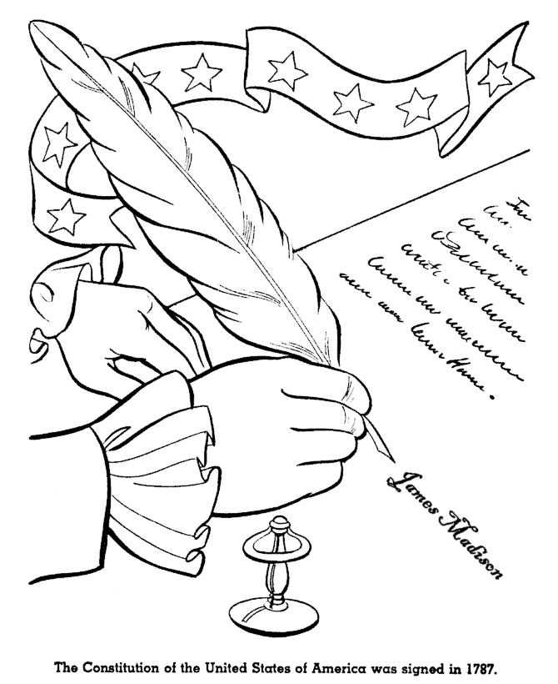

Name: ___________________________

Yes Ma’am

Is this our democratic republic? Yes Ma’am
Is this our democratic republic? Yes Ma’am
How do you know? By and for the people
How do you know? It has elected leaders
Give me some examples. Local, state and federal government
Give me some examples. Citizens vote for their leaders

Is this our U.S. Government? Yes Ma’am!
Is this our U.S. Government? Yes Ma’am!
How do you know? It’s our federal government
How do you know? There’s a separation of powers.
Give me some examples. It has three branches.
Give me some examples Legislative, Executive, Judicial,

Is this the executive branch? Yes Ma’am!
Is this the executive branch? Yes Ma’am!
How do you know? Its leader is the President
How do you know? He lives in the White House
What are his duties? Commander in chief of the military
What are his duties? Carries out laws of Congress

Is this the judicial branch? Yes Ma’am!
Is this the judicial branch? Yes Ma’am!
How do you know? 9 Supreme Court Justices
How do you know? They’re in the Supreme Court Building
What are its duties? Interprets the law
What are its duties? Upholds the U.S. Constitution

Is this the legislative branch? Yes Ma’am!
Is this the legislative branch? Yes Ma’am!
How do you know? It’s the U.S. Congress
How do you know? It’s the Senate and the House
What are its duties? Make laws, tax, and spend.
What are its duties? Can declare war

Constitution Cadence
By Scott Praska

We just know what we’ve been told.
Our Constitution is over 200 years old.
Our founding fathers did agree
To write a document, to keep people free.

Sound off – 1787
Sound off – Signed
Sound off 1,2,3, 4 – Constitution

Executive, is the branch
that includes the President.
He hears from his Cabinet as their advice is lent
Then he decides what money is spent!

Sound off – Executive
Sound off – President
Sound off 1,2,3, 4 – Constitution

What do the House of Representatives do
Along with one hundered Senators, too?
They make up new laws for me and you
The legislative branch helps the president too!

Sound off – Legislative
Sound off – Making Laws
Sound off 1,2,3, 4 – Constitution

Nine judges on the Supreme Court's bench
The President picks ‘em, but the senate votes 'em in
They decide if the laws of our land are still fair
In the Judicial branch, they watch the laws with care.

Sound off – Judicial
Sound off – Supreme Court
Sound off 1,2,3, 4 – Constitution
The Legislative Branch is good at making the laws
The Judicial branch makes sure the laws have no flaws
The Executive Branch is who enforces it all because
Balanced, but separate powers are good for us all

Sound off – Checks and Balances
Sound off – Government
Sound off 1,2,3, 4 – Constitution

Constitution Bugaloo
By Sharon Cecchi

I’m an American and here to say
I am proud of our country, the Revolutionaries made

Through a document known as the Constitution
The supreme law was made, a nation had begun.

Cooperation, delegation
Compromise, too
Doing the Constitution BUGALOO.

The delegates in Pennsylvania, ratified the plan
But “We the People”, took the stand!
To make our own laws, define our government, too.
We came together, we’re unified and true.

Cooperation, delegation
Compromise, too
Doing the Constitution BUGALOO

In 1787, the Convention honored the command
To create the longest living document known to man,
With fortitude, unity, they sealed their fate
They helped to make the best nation, the United States.

Cooperation, delegation
Compromise, too
Doing the Constitution BUGALOO

Leaders Here, Leaders There
by Annette Maestas

Leaders here, leaders there
Leaders, leaders everywhere.

Patriotic leaders compromising cooperatively,
Thoughtful leaders voting hopefully,
Visionary leaders composing creatively,
and revolutionary leaders inspiring peacefully.

Leaders beyond the Convention,
Leaders about our freedom,
Leaders among the citizens,
And leaders throughout our history.

Leaders here, leaders there
Leaders, leaders everywhere.
Leaders! Leaders! Leaders!

Home School Connection

Talk with your family about ways in which the Constitution of the United States protects you and your family. Sketch or write about it.

signature
Nombre_________________

Conexión entre el hogar y la escuela
Habla con tu familia sobre las formas en que la Constitución de los Estados Unidos te protege a ti y tu familia.

firma

Name_________________
Home School Connection

Sketch and write what the First Amendment of the Constitution of America, Freedom of Speech, means to American people? Why is this important?

signature
#____ Nombre_________________

Conexión entre el hogar y la escuela

Dibuja y escribe lo que la Primera Enmienda de la Constitución de los Estados Unidos, Libertad de expresión, significa para la gente americana? ¿Por qué es tan importante?

firma
Name_________________
Home School Connection

Out of all three branches of government, legislative, executive, and judicial, sketch or write which one would you like to work for and why?

signature

Nombre_________________

Conexión entre el hogar y la escuela
De las tres ramas del gobierno, legislativo, ejecutivo y judicial, dibuja ¿En cuál de ellas te gustaría trabajar y por qué?

firma
Name_________________
Home School Connection

Sketch or write any information that you know about the United States government.

signature
Nombre_________________

Conexión entre el hogar y la escuela

Dibuja o escribe cualquier información que te acuerdes acerca del gobierno de los Estados Unidos.

firma
Name_____________

Home School Connection

Sketch an American symbol that expresses our nation’s ideals. Explain why this symbol is important or any facts you know about the symbol.

signature

#____ Nombre_________________

Conexión entre el hogar y la escuela

Dibuja un símbolo americano que exprese los ideales de nuestra nación. Explica por que este símbolo es importante o algunos detalles que conozcas sobre este símbolo.

firma

Name:_____________
#:___________________
Date:________________
Legislative Branch - Article I
Purpose:
In Article I, the Constitution describes the legislative branch, or lawmaking branch, of the new government. Powers granted, or given, to Congress include making laws, raising an army and a navy, declaring war, and coining and printing money. It would also control commerce.
Key Points:
Under the Articles of Confederation, congress had been the only branch of the national government. Under the constitution, three branches share those powers. The delegates created this separation of powers to keep any one branch from controlling the government. During the Constitutional Convention, Congress set up two houses – the House of Representatives and the Senate. Either house could propose a bill.
Impact:
For a bill to become a law, a majority in each house would have to vote for it. Citizens were given the power to vote directly for the members of the House of Representatives. Senators would be chosen by their state legislatures. Today, citizens vote directly members of both houses of Congress.
People:
The number of members each state sent to the House of Representatives would depend on the state’s population. Today the number of representatives is limited to 435. That number is divided among the states based on their population. In the senate, each state has two senators.
Other Important Facts:
Article I outlines rules for congress that are still in effect. For example, members of the House of Representatives are elected to two-year terms, while members of the Senate serve six-year terms.

Name:_______________
#:___________________
Date:________________

Executive Branch - Article II
Purpose:
In Article II, the Constitution says the power to enforce laws made by Congress is given to the executive branch. Some delegates believed that one person should be the chief executive, or leader. Others worried that a single executive would be too much like a monarch. Citizens vote for electors, who, in turn, vote for the President. This group of electors is called the electoral college.
Key Points:
To be elected President, a person must be at least 35 years old and must have been born in the United States. The President must also have lived in the United States for 14 years and must be a natural born citizen. The President and the Vice President are elected to a four-year term.
Impact:
Once again, the delegates were careful to preserve the separation of powers. They decided that the President would be able to veto, or reject bills passed by congress. However, Congress could then override the President’s veto with a two-thirds majority vote.
People:
The delegates also made the President commander in chief of the United States military. Article II of the Constitution creates the office of the Vice President. The President’s main power, however, would be to “take care that laws be faithfully executed.” The Cabinet Secretaries of the United States are generally the heads of the federal executive departments and are appointed by the Present then the Senate can confirm or reject the appointment.
Other Important Facts:
The Constitution grants the House the power to impeach "The President, the Vice President, and all civil Officers of the United States," and the Senate the sole power to try impeachments. The Vice President would ascend to the Presidency upon the death, resignation, or removal of the President.

Name:_______________
#:___________________
Date:________________
Judicial Branch - Article III
Purpose:
According to Article III section 1of the Constitution, establishes the Supreme Court of the United States. The judicial branch has the power to declare a law Unconstitutional. Although the states already had their own courts, the delegates agreed to create a federal court system, too.
Key Points:
The delegates did not organize the judicial branch in the same way as the other branches. The courts in this system would interpret laws that deal with the constitution, treaties, and national laws. They would also rule on how a law should be applied with cases between states and citizens of different states. The Supreme Court would head the judicial branch and is the highest court in the land. Other courts would be created as needed.
Impact:
The delegates decided that the President would nominate the Supreme Court justices, or judges. The Senate would vote whether to approve them. The delegates decided that the Supreme Court justices could stay in office for life. This would allow justices to make decisions without worrying about losing their jobs.
People:
At first there were six Supreme Court justices. Today there are nine. The Supreme Court has the power to strike down any law that goes against the Constitution. Only by changing the Constitution can Congress restore a law struck down by the Supreme Court.

Other Important Facts:
The Court also has original jurisdiction in cases involving ambassadors and other diplomats, and in cases between states. Lower courts are obligated to follow the precedent set by the Supreme Court when rendering decisions. Federal judges can only be removed through impeachment by the House of Representatives and conviction by the Senate.

Name:_______________
#:___________________
Date:________________
Bill of Rights
Purpose:
After the Constitutional Convention, the Federalists agreed to add a list of amendments to the Constitution. The Bill of rights is the first ten amendments to the Constitution. It lists the rights that are guaranteed to all U.S. citizens and became part of the constitution in 1791. The writers of the Bill of Rights believed in the importance of fairness, unlike the British government. The amendments in the Bill of Rights make sure that the government respects the liberty of individual people. The First amendment gives people the freedom to follow any religion, or none at all. It also says the government cannot promote or financially support any religion. The First Amendment also protects freedom of speech, freedom of the press and the right of the people to assemble, or gather together.
Key Points:
The Second Amendment protects people’s rights to have weapons. The Third Amendment says the government cannot force citizens to house soldiers in their homes. The Fourth Amendment protects people against unreasonable searches of their homes.
Impact:
The Fifth through Eighth Amendments deal with due process of law. This term means that people have the right to a fair public trial by a jury. They do not have to testify against themselves in court, and they have the right to an attorney. If convicted, they cannot be sentenced to any cruel punishment.
People:
The Ninth amendment says the people have many other rights not specifically listed in the constitution. The Tenth Amendments says that the national government can only do things that are listed in the Constitution. This means that all other authority, called the reserved power, belongs to the states or to the people.
Other Important Facts:
The constitution has been called a “living document” because it can be changed to reflect new ideas about individual rights and the role of government. However, amendments to the Constitution are added only after a long process. That is why thousand of amendments have been suggest, but only twenty-seven have been added.

Mind Map

Purpose
Key Points
Impact
People
Other Important
Facts

Branch of Government

Process Grid
The Constitution | Purpose | Key Points | Impact | People | Other  Important  Facts
The  Articles of  Confederation | *new national  Government *declared Independence in 1776  *Ratified/App-roved 1781 | *Called Congress  *States kept  power  *Govt. could’nt  make decisions  without approval  of each state | *Congress could not tax states  *Heavy Debt to  France  *Congress could  not control trade  *Many states had  their own  currency | *John Adams  *Alex. Hamilton  *Thomas Jefferson  *Gov. Morris | *High taxes angered people  *Farmers losing property  *Daniel Shay led rebellion 1786  *Rebellion created need for a stronger govt.
Legislative  Branch  Article I | *Lawmaking branch  *make laws  *raise army and navy  *declaring war  *coining & printing money  *control commerce | *Set up 2 houses  *House of Reps *the Senate  *Each proposes bills | *Laws created by vote.  *Majority vote passes bill  *Citizens vote | *435 Senators & Representatives  *Population determines Representatives | *House reps. 2yr terms.  *Senators 6 yr. term
Executive Branch  Article II | *the President  *enforce laws  *Citizens vote  *Electoral college | *Must be 35 yr. old  *born in United States  *Live in U.S. 14 years  *Elected 4 yr. term | *Veto power  *Congress override veto  *2/3’s majority | *Commander in chief  *Chief of military  *Laws faithfully executed | *Citizens recall election  Congress impeach President  *Try P
Judicial Branch  Article III | *Supreme Court  *declare law unconstitutional | *Interpret laws  *Cases between States & citizens  *Highest court | *Nominated by President  *Senate approval  *Lifetime appointment | *Nine Chief Justices  *Strike down law  *Congress restore law  *change to constitution | *Cases with ambassadors  *Lower courts follow precedent  *Impeachment by House of Representatives
Bill  of  Rights | *First ten amendments  *Guaranteed rights  *Respect liberty  *Freedom of religion  *Freedom of speech  *Freedom of the press  *Right to assemble | *Citizens right to have weapons  *Protects unreasonable searches of homes.  *Housing soldiers | *Due process of law  *Fair public trial  *Not testify against self  *Right to attorney  *Not sentenced to cruel punishment | *citizens of United State | * living document  *Can be changed  *27 additional amendments added

