OCDE NTC Project GLAD®
Animal Adaptations, 3rd Grade (NM standards)

IDEA PAGES

- UNIT THEMES
- Scientists have divided the world into large natural areas called biomes. Biomes are characterized by climate and the plants and animals that live there.
- Habitats are the places where plants and animals live.
- Throughout the natural world, animals and other living things adapt physically and behaviorally in order to increase their chance of survival in their habitat.
- Animals depend on other animals and plants for their survival and are also threatened by other animals.
- The manner in which animals care for their offspring and young varies greatly.
- The growth of the human population has had a large impact on many animal species.

- FOCUS/MOTIVATION
- Cognitive Content Dictionary with signal words
- Big Book The Important Book About Animal Adaptation
- Wildlife Biologist Awards
- Inquiry Chart
- Observation Charts
- Read Alouds
- Hands-On Explorations and Experiments
- Guest Speakers
- Videos
- Picture File Cards/Exploration Report
- Fieldtrips

- ASSESSMENT AND FEEDBACK
- On-going assessment
- Process all charts and learning
- Shared Team Tasks
- The Important Big Book of …. (student generated)
- Student Chants/ Poetry
- Portfolio/Learning Logs
- Writing Prompt with Rubric
- Personal Exploration – design and construct a model of a habitat for an animal with a specific adaptation
- Teacher and Student Created Test
- State/District required assessment

- CONCEPTS

NM SCIENCE – 3RD GRADE

Content of Science Standard 2
Students will understand the properties, structures and processes of living things and the interdependence of living things and their environments. Students will:
- Know that living things have diverse forms, structures, functions and habitats;
3rd Grade
- Know that an adaptation in physical structure or behavior can improve an organism's chance for survival (e.g., horned toads, chameleons, cacti, mushrooms);
- Observe that plants and animals have structures that serve different functions (e.g., shape of animals' teeth);
- Classify common animals according to their observable characteristics (e.g., body coverings, structure);
- Classify plants according to their characteristics (e.g., tree leaves, flowers, seeds);
- Know that living things have similarities and differences, and that living things change over time;

3rd Grade
- Identify how living things cause changes to the environments in which they live, and that some of these changes are detrimental to the organism and some are beneficial;

Scientific Thinking and Practice Standard 1
Students will understand the processes of scientific investigations and use inquiry and scientific ways of observing, experimenting, predicting and validating in order to think critically. Students will:
- Use scientific methods to observe, collect, record, analyze, predict, interpret and determine reasonableness of data;
3rd Grade
- Make new observations when discrepancies exist between two descriptions of the same object or phenomenon to improve accuracy;
- Recognize the difference between data and opinion;
- Use numerical data in describing and comparing objects, events and measurements;
- Collect data in an investigation and analyze those data;

NM SOCIAL STUDIES – 3RD GRADE

Geography Standard 1
Students understand how physical, natural and cultural processes influence where people live, the ways in which people live and how societies interact with one another and their environments. Students will:
- Understand the concept of location by using and constructing maps, globes and other geographic tools to identify and derive information about people, places and environments;

3rd Grade
- Identify and use the mapping tools of scale, compass rose, grid, symbols and mental mapping to locate and draw places on maps and globes;

CCSS ELA – 3RD GRADE

Reading Standards for Literature
  - RL .3.1 Ask and answer questions to demonstrate understanding of a text, referring explicitly to the text as the basis for the answers.
  - RL.3.2 Recount stories, including fables, folktales, and myths from diverse cultures; determine the central message, lesson, or moral and explain how it is conveyed through key details in the text
  - RL.3.3 Describe characters in a story (e.g., their traits, motivations, or feelings) and explain how their actions contribute to the sequence of events.
  - RL.3.4 Determine the meaning of words and phrases as they are used in a text, distinguishing literal from nonliteral language.
  - RL.3.5 Refer to parts of stories, dramas, and poems when writing or speaking about a text, using terms such as chapter, scene, and stanza; describe how each successive part builds on earlier sections
  - RL.3.6 Distinguish their own point of view from that of the narrator or those of the characters.
  - RL.3.7 Explain how specific aspects of a text’s illustrations contribute to what is conveyed by the words in a story (e.g., create mood, emphasize aspects of a character or setting).
  - RL.3.9 Compare and contrast the themes, settings, and plots of stories written by the same author about the same or similar characters (e.g., in books from a series).
  - RL.3.10 By the end of the year, read and comprehend literature, including stories, dramas, and poetry, at the high end of the grades 2–3 text complexity band independently and proficiently.
Reading Standards for Informational Text
  - RI.3.2 Determine the main idea of a text; recount the key details and explain how they support the main idea.
  - RI.3.3 Describe the relationship between a series of historical events, scientific ideas or concepts, or steps in technical procedures in a text, using language that pertains to time, sequence, and cause/effect.
  - RI.3.4 Determine the meaning of general academic and domain-specific words and phrases in a text relevant to a grade 3 topic or subject area.
  - RI.3.5 Use text features and search tools (e.g., key words, sidebars, hyperlinks) to locate information relevant to a given topic efficiently.
  - RI.3.6 Distinguish his or her own point of view from that of the author of a text.
  - RI.3.7 Use information gained from illustrations (e.g., maps, photographs) and the words in a text to demonstrate understanding of the text
  - RI.3.8 Describe the logical connection between particular sentences and paragraphs in a text (e.g., comparison, cause/effect, first/second/third in a sequence).
  - RI.3.9 Compare and contrast the most important points and key details presented in two texts on the same topic.
  - RI.3.10 By the end of the year, read and comprehend informational texts, including history/social studies, science, and technical texts, at the high end of the grades 2–3 text complexity band independently and proficiently

Foundational Skills
- RF.3.3 Know and apply grade-level phonics and word analysis skills in decoding words.
a. Identify and know the meaning of the most common prefixes and derivational
suffixes.
b. Decode words with common Latin suffixes.
c. Decode multisyllabic words.
d. Read grade-appropriate irregularly spelled words.
- RF.3.4 Read with sufficient accuracy and fluency to support comprehension.
- Read on-level text with purpose and understanding. Read on-level prose and poetry orally with accuracy, appropriate rate, and expression on successive readings.
- Use context to confirm or self-correct word recognition and understanding, rereading as necessary.
Writing Standards
- W.3.1 Write opinion pieces on topics or texts, supporting a point of view with reasons.
- Introduce the topic or text they are writing about, state an opinion, and create an organizational structure that lists reasons. Provide reasons that support the opinion.
- Use linking words and phrases to connect opinion and reasons.
- Provide a concluding statement or section.
- W.3.2 Write informative/explanatory texts to examine a topic and convey ideas and information clearly.
a. Introduce a topic and group related information together; include illustrations when useful to aiding comprehension.
b. Develop the topic with facts, definitions, and details.
c. Use linking words and phrases to connect ideas within categories of information.
d. Provide a concluding statement or section.
- W.3.3 Write narratives to develop real or imagined experiences or events using effective technique, descriptive details, and clear event sequences.
a. Establish a situation and introduce a narrator and/or characters; organize an event sequence that unfolds naturally. Use dialogue and descriptions of actions, thoughts, and feelings to develop experience and events or show the response of characters to situations.
b. Use temporal words and phrases to signal event order.
c. Provide a sense of closure.
- W.3.4 With guidance and support from adults, produce writing in which the development and organization are appropriate to task and purpose.
- W.3.5 With guidance and support from peers and adults, develop and strengthen writing as needed by planning, revising, and editing.
- W.3.6 With guidance and support from adults, use technology to produce and publish writing (using keyboarding skills) as well as to interact and collaborate with others.
- W.3.7 Conduct short research projects that build knowledge about a topic
- W.3.8 Recall information from experiences or gather information from print and digital sources; take brief notes on sources and sort evidence into provided categories.
- W.3.10 Write routinely over extended time frames (time for research, reflection, and revision) and shorter time frames (a single sitting or a day or two) for a range of discipline-specific tasks, purposes, and audiences.

Speaking and Listening Standards (SL)
- SL.3.1 Engage effectively in a range of collaborative discussions (one-on-one, in groups, and teacher led) with diverse partners on grade 3 topics and texts, building on others’ ideas and expressing their own clearly.
a. Follow agreed-upon rules for discussions (e.g., gaining the floor in respectful ways, listening to others with care, speaking one at a time about the topics and texts under discussion).
b. Ask questions to check understanding of information presented, stay on topic, and link their comments to the remarks of others.
c. Explain own ideas and understanding in light of the discussion.
- SL.3.2 Determine the main ideas and supporting details of a text read aloud or information presented in diverse media and formats, including visually, quantitatively, and orally.
- SL.3.3 Ask and answer questions about information from a speaker, offering appropriate elaboration and detail.
- SL.3.4 Report on a topic or text, tell a story, or recount an experience with appropriate facts and relevant, descriptive details, speaking clearly at an understandable pace.
- SL.3.5 Create engaging audio recordings of stories or poems that demonstrate fluid reading at an understandable pace; add visual displays when appropriate to emphasize or enhance certain facts or details.
- SL.3.6 Speak in complete sentences when appropriate to task and situation in order to provide requested detail or clarification.

Language Standards
- L.3.1 Demonstrate command of the conventions of standard English grammar and usage when writing or speaking.
a. Explain the function of nouns, pronouns, verbs, adjectives, and adverbs in general and their functions in particular sentences.
b. Form and use regular and irregular plural nouns.
c. Use abstract nouns.
d. Form and use regular and irregular verbs.
e. Form and use the simple verb tense (e.g., I walked, I walk, I will walk).
f. Ensure subject and pronoun antecedent agreement.
g. Form and use comparative and superlative adjectives and adverbs, and choose between them depending on what is to be modified.
h. Use coordinating and subordinating conjunctions.
i. Produce simple, compound and complex sentences.

- L.3.2 Demonstrate command of the conventions of standard English capitalization, punctuation, and spelling when writing.
a. Capitalize appropriate words in titles.
b. Use commas in addresses.
c. Use commas and quotation marks in dialogue.
d. Form and use possessives.
e. Use conventional spelling for high frequency and other studied words for adding suffixes to base words (e.g., sitting, smiled, cries, happiness).
f. Use spelling patterns and generalizations (e.g., words families, position-based spellings, syllable patterns, ending rules, meaningful word parts) in writing words.
g. Consult reference materials, including beginning dictionaries, as needed to check and correct spellings.
- L.3.3 Use knowledge of language and its conventions when writing, speaking, reading, or listening.
a. Choose words and phrases for effect. Recognize and observe differences between the conventions of spoken and written standard English.
- L .3.4 Determine or clarify the meaning of unknown and multiple-meaning word and phrases based on grade 3 reading and content, choosing flexibly from a range of strategies.
a. Use sentence-level context as a clue to the meaning of a word or phrase.
b. Determine the meaning of the new word formed when a known affix is added to a known word Use a known root word as a clue to the meaning of an unknown word with the same root.
c. Use glossaries or beginning dictionaries, both print and digital, to determine or clarify the precise meaning of key words and phrases.
- L.3.5 Demonstrate understanding of word relationships in word meanings.
a. Distinguish the literal and nonliteral meanings of words and phrases in context (e.g., take steps).
b. Identify real life connections between words and their use A (e.g., describe people who are friendly or helpful).
c. Distinguish shades of meaning among related words that describe states of mind or degrees of certainty
- L.3.6 Acquire and use accurately grade-appropriate conversational, general academic, and domain specific words and phrases, including those that signal spatial and temporal relationships.
WIDA Can Do Descriptors for Third-Fifth Grade

Supporting language learners – Below are the WIDA Can Do Descriptors. These are a wonderful tool to support the NM ELD Standards. These describe what students can do at various language levels within the different language domains with support. WIDA Can Do descriptors available at https://www.wida.us/standards/CAN_DOs/ (WIDA Can Do Descriptors Key Uses, original Can Do Descriptors and Spanish versions).
Domain | Level 1  Entering | Level 2  Emerging | Level 3  Developing | Level 4  Expanding | Level 5  Bridging | Level 6  Reaching
Listening | • Point to stated pictures, words, or phrases  • Follow one-step oral directions (e.g., physically or through drawings)  • Identify objects, figures, people from oral statements or questions (e.g., “Which one is a rock?”)  • Match classroom oral language to daily routines | • Categorize content-based pictures or objects from oral descriptions  • Arrange pictures or objects per oral information  • Follow two-step oral directions  • Draw in response to oral descriptions  • Evaluate oral information  (e.g., about lunch options) | • Follow multi-step oral directions  • Identify illustrated main ideas from paragraph-level oral discourse  • Match literal meanings of oral descriptions or oral reading to illustrations  • Sequence pictures from oral stories, processes, or procedures | • Interpret oral information and apply to new situations  • Identify illustrated main ideas and supporting details from oral discourse  • Infer from and act on oral information  • Role play the work of authors, mathematicians, scientists, historians from  oral readings, videos, or multi-media | • Carry out oral instructions containing grade-level, content-based language  • Construct models or use manipulatives to problemsolve based on oral discourse  • Distinguish between literal and figurative language in oral discourse  • Form opinions of people, places, or ideas

Domain | Level 1  Entering | Level 2  Emerging | Level 3  Developing | Level 4  Expanding | Level 5  Bridging | Level 6  Reading
Speaking | • Express basic needs or conditions  • Name pre-taught objects, people, diagrams, or pictures  • Recite words or phrases from pictures of everyday objects and oral modeling  • Answer yes/no and choice  questions | • Ask simple, everyday questions (e.g., “Who is absent?”)  • Restate content-based facts  • Describe pictures, events, objects, or people using phrases or short sentences  • Share basic social  information with peers | • Answer simple content based questions  • Re/tell short stories or events  • Make predictions or hypotheses from discourse  • Offer solutions to social conflict  • Present content-based information  • Engage in problem-solving | • Answer opinion questions with supporting details  • Discuss stories, issues, and concepts  • Give content-based oral reports  • Offer creative solutions to issues/problems  • Compare/ contrast content-based functions  and relationships | • Justify/defend opinions or explanations with evidence  • Give content-based presentations using technical vocabulary  • Sequence steps in gradelevel problem-solving  • Explain in detail results of inquiry (e.g., scientific  experiments)
WIDA Can Do Descriptors for Third-Fifth Grade

WIDA Can Do Descriptors for Third-Fifth Grade

Domain | Level 1  Entering | Level 2  Emerging | Level 3  Developing | Level 4  Expanding | Level 5  Bridging | Level 6  Reaching
Reading | • Match icons or diagrams with words/concepts  • Identify cognates from first language, as applicable  • Make sound/symbol/word relations  • Match illustrated words/ phrases in differing contexts (e.g., on the board, in a book) | • Identify facts and explicit messages from illustrated text  • Find changes to root words in context  • Identify elements of story grammar (e.g., characters, setting)  • Follow visually supported written directions (e.g.,  “Draw a star in the sky.”) | • Interpret information or data from charts and graphs  • Identify main ideas and some details  • Sequence events in stories or content-based processes  • Use context clues and illustrations to determine meaning of words/phrases | • Classify features of various genres of text (e.g., “and they lived happily ever after”— fairy tales)  • Match graphic organizers to different texts (e.g., compare/ contrast with  Venn diagram)  • Find details that support main ideas  • Differentiate between fact and opinion in narrative and expository text | • Summarize information from multiple related sources  • Answer analytical questions about grade-level text  • Identify, explain, and give examples of figures of speech  • Draw conclusions from explicit and implicit text at or near grade level

WIDA Can Do Descriptors for Third-Fifth Grade

Domain | Level 1  Entering | Level 2  Emerging | Level 3  Developing | Level 4  Expanding | Level 5  Bridging | Level 6  Reading
Writing | • Label objects, pictures, or diagrams from word/phrase banks  • Communicate ideas by drawing  • Copy words, phrases, and short sentences  • Answer oral questions with single words | • Make lists from labels or with peers  • Complete/produce sentences from word/ phrase banks or walls  • Fill in graphic organizers, charts, and tables  • Make comparisons using real-life or visually supported materials | • Produce simple expository or narrative text  • String related sentences together  • Compare/contrast content based information  • Describe events, people, processes, procedures | • Take notes using graphic organizers  • Summarize content-based information  • Author multiple forms of writing (e.g., expository, narrative, persuasive) from models  • Explain strategies or use of information in solving problems | • Produce extended responses of original text approaching grade level  • Apply content-based information to new contexts  • Connect or integrate personal experiences with literature/ content  • Create grade-level stories or reports

- VOCABULARY
Tier 2 |  | Tier 3
adaptation*  aquatic  body coverings  terrestrial  behavioral  physical  climate*  desert  forage  characteristics*  survive*  shelter  burrow  roam  search  web  weather  sanctuary  camouflage  invasive  native  tropical  rainforest  locate  blubber | hooves  beak  feathers  fur  protection  categories  diet  pincers  prey  predator  impact  pollution  disease  wildlife  biologist  endangered  manage  recovery  threaten  neutralize  ecosystem  flipper | anthropod  habitat  biome  herbivore  carnivore  chordata  omnivore  habitat loss  ecology  species  hibernate  mammal  organism  migrate  echolocation  deforestation  taiga  tundra  grassland  tropical rainforest  temperate forest
Vocabulario en español Nivel 2 |  | Nivel 3
polluelo  deslizarse  aletas  jornada  calamares  kril  foca  tiburón  orca  apiñarse  grasa  plumaje  esponjoso  permanecer  voz  trompeta | guardería  impermeable  océano  cascarón  pico  acariciar  arrastrar  camarones  lanzarse  azotar  silbido | parche de cría  Antártida  pingüinera  pies palmeados  Pingüino Emperador  plumón  aves  tobogán  sustantivo  adjetivo  verbo  adverbio  frase preposicional

Tier 1 Basic words that commonly appear in spoken language. Because they are heard frequently in numerous contexts and with nonverbal communication, Tier 1 words rarely require explicit instruction. Examples of Tier 1 words are clock, baby, happy and walk.
Tier 2 High frequency words used by mature language users across several content areas. Because of their lack of redundancy in oral language, Tier 2 words present challenges to students who primarily meet them in print. Examples of Tier 2 words are obvious, complex, establish and verify.
Tier 3 Words that are not frequently used except in specific content areas or domains. Tier 3 words are central to building knowledge and conceptual understanding within the various academic domains and should be integral to instruction of content. Medical, legal, biology and mathematics terms are all examples of these words.
Bringing Words To Life, Beck, Isabel L., McKeown, Margaret G., Kucan, Linda. The Gilford Press, 2002.

VI. RESOURCES AND MATERIALS

Books: English
- Animal Adaptations (My Science Library, Levels 1-2) Julie K. Lundgren, 2011
- How do Animals Adapt? (The Science of Living Things), Bobbie Kalman, 2000
- How and Why Do Animals Adapt? (All about Animals Close-Up), Bobbie Kalman, 2015
- Would You Survive?: Animal and Plant Adaptation (Raintree Fusion: Life Science) John Townsend, 2005
- Animal Adaptations for Survival (Life Science Library - Powerkids Press), Elizabeth Rose, 2006

Books: Spanish
- Adaptaciónes de los animales by Julie Lundgren

¿Cómo se adaptan los animales? Ciencia de los Seres Vivos - Spanish

Edition, 2006 by Bobbie Kalman

Informational Web Sites - English
www.seaworld.org
www.bushgardens.org
http://www.enchantedlearning.com
http://www.perspective.com/nature/anamalia
http://www.waynesword.palomar.edu
http://animaldiversity.org/

Animal Adaptation
http://phanimaladaptations.weebly.com/
https://www.durrell.org/kids/fun-factsheets/adaptation-factsheet/
http://www.pklifescience.com/article/481/behavioral-and-physical-adaptationslogin?username=thealberta&password=library
http://www.nhptv.org/natureworks/nwep1.htm

Mexican Gray Wolf:
https://www.fws.gov/southwest/es/mexicanwolf/
http://www.defenders.org/southwest/mexican-gray-wolf-recovery
http://www.biologicaldiversity.org/species/mammals/Mexican_gray_wolf/index.html

African Elephant:
http://www.nationalgeographic.com/animals/mammals/a/african-elephant/

Big Eared Bat:
https://www.desertmuseum.org/kids/bats/townsends.php

Hercules Beetle:
https://a-z-animals.com/animals/hercules-beetle/
http://www.softschools.com/facts/animals/hercules_beetle_facts/248/
http://www.uky.edu/Ag/CritterFiles/casefile/insects/beetles/hercules/hercules.htm

Siberian Musk Deer:
http://www.arkive.org/siberian-musk-deer/moschus-moschiferus/
https://en.wikipedia.org/wiki/Siberian_musk_deer

Habitats:
http://www.durrell.org/kids/fun-factsheets/habitats-factsheet/
http://addiesrainforest.weebly.com/herbivores.html

Human Impact: http://www.sheppardsoftware.com/content/animals/kidscorner/endangered_animals/whats_the_problem.htm

Sitios web informacionales – español
https://cva4cca.wordpress.com/2015/03/20/adaptaciones-de-los-animales/
http://www.botanical-online.com/animales/adaptaciones_animales.htm
http://www.teinteresasaber.com/2012/04/la-adaptacion-de-los-seres-vivos-al.html
http://cienciasprimeroeso.blogspot.com/2012/09/las-adaptaciones-de-los-animales.html

Science Experiment Websites
http://eisforexplore.blogspot.com/2012/06/animal-adaptations.html
http://hubpages.com/education/Animal-Adaptations
http://thirdgradethinkers8.blogspot.com/2013/05/animal-adaptations-engaging.html
http://www.education.com/science-fair/article/brilliant-bird-beeks/

OCDE NTC Project GLAD®
Animal Adaptations, 3rd Grade (NM standards)
PLANNING PAGES

I. FOCUS/MOTIVATION
- Cognitive Content Dictionary with Signal Word
- Wildlife Biologist Awards
- Observation Charts
- Inquiry charts: What do you know about animal adaptations? What do you want to know?
- Big book: The Most Important Book About Animal Adaptations
- Fieldtrips
- Poetry
- Interest Pieces – guest speakers, videos, movies
- Prediction Reaction Guide

II. INPUT
- World Map Graphic Organizer – Biomes of the World
- Pictorial Input Chart – The Mexican Gray Wolf
- Narrative Input Chart –Penguin Chick
- Interest pieces – guest speakers, videos, movies

III. GUIDED ORAL PRACTICE
- 10/2 with primary language
- T-Graph for Social Skills: Cooperation
- Team co-op group evaluation
- Open sort – picture file cards
- Closed sort – picture file cards – classify, compare, order
- Mind mapping, list-group-label
- Team Tasks
- Poetry/Chants
- Exploration Report
- Sentence Patterning Chart
- Daily review and processing of charts
- Narrative Retell

IV. Reading/Writing Activities
Whole Class
  - Process Grid
  - Story Mapping
  - Expository Reading/Writing
  - Model Editing Process Group Frames (Teacher uses information from students to model appropriate)
- Big Book – The Important Book About Animal Adaptations
- Cooperative strip paragraph
Plus supporting details (expository, metaphors)
- Poetry Frames
- Found Poetry
  - Listen and Sketch

Flexible and Cooperative Groupings
- Sentence Patterning Chart with Word Cards (read and trade games)
- Ear-to-Ear Reading
- Cooperative Strip Paragraph
- Team Tasks
- Expert Groups
- Flexible Grouping for ELD differentiation, primary language, reading instructions, skill reinforcement (ELD review/retell)
Individual Work
- Learning Logs
- Reading/Writing Choice
- Interactive Journals
- Individual tasks
- Reading/Writing choices: picture file cards, add to charts, make word cards, highlight poetry booklets, focused reading, poetry booklet, flip chants
Writer’s Workshop
- Mini-Lessons
- Plan, Share, Write, Revise, Edit, Publish
- Conferencing
- Author’s Chair
- Extended Activities for Integration
  - Daily Activities
Read Aloud
Silent Sustained Reading/Book Sharing
Silent Sustained Writing
Listening Activities
Daily News/Interest Piece
Personal Interaction
Flexible group reading
Fieldtrip to wildlife open space
- Occasional Activities
Guest speaker: Wildlife biologist
Hands-on Explorations and Experiments
Team/Personal Exploration
VI. Assessment and Feedback
- Re-visit Inquiry Chart
- Learning Logs
- Writing Prompt with Rubric
- Student Generated Tests
- Team Task Presentations
- Student Portfolio and Presentation – Model Habitat
- Graffiti Wall
- Student Action Plan
- Vocabulary strips of “Where’s my answer?”
- Personal Exploration with Rubric
- Teacher-created Exams
OCDE NTC Project GLAD®
Animal Adaptations, 3rd Grade (NM standards)
SAMPLE DAILY LESSON PLAN
NOTE: Italicized strategies are used frequently in the classroom. Each day is the equivalent of 1 to 1 ½ weeks of instruction Page numbers match strategy in Project GLAD® Learning Guide.

DAY 1:
FOCUS/MOTIVATION
- Cognitive Content Dictionary w/Signal Word, 45
- Three Personal Standards and Literacy Awards, 31-33
- Observation Charts, 49
- Prediction Reaction Guide, 39
- Inquiry Chart, 51
- Teacher Made Big Book- The Important Book about Animal Adaptation, 54
- Portfolios, 268

INPUT
- Graphic Organizer Input Chart - World Map – Biomes of the World, 83
- Pictorial Input Chart—Mexican Gray Wolf, 89

GUIDED ORAL PRACTICE
- Chants, 145
- T-graph for social skills – Team Points
- Picture File Cards, 138
-Free Exploration
-open sort – list, group, label
-closed sort – provide categories
- 10/2 lecture with primary language (GO and PIC), 124
Learning log, 240
ELD review, 125

READING/WRITING
- Listen & Sketch, 238
- Interactive Journals, 236

EXTENDED ACTIVITIES FOR INTEGRATION
- Hands-on Explorations and Experiments/ Guest Speaker/ Field Trip

ASSESSMENT/FEEDBACK
- Home/School Connection, 156
- Process inquiry charts, chants and input charts
- Learning Logs
- Quiz
SAMPLE DAILY LESSON PLAN
NOTE: Italicized strategies are used frequently in the classroom. Each day is the equivalent of 1 to 1 ½ weeks of instruction Page numbers match strategy in Project GLAD® Learning Guide.

DAY 2:
FOCUS/MOTIVATION
- Cognitive Content Dictionary w/Signal Word, 45
- Process Home/School Connection, 156
- Three Personal Standards and Literacy Awards, 31-33
- Process Chant (TPR, highlight, sketch, picture file cards)

GUIDED ORAL PRACTICE
- Graphic Organizer and Pictorial Input Chart Review with word cards (differentiated cards), 83, 89

INPUT
- Narrative Input – Penguin Chick, 101

GUIDED ORAL PRACTICE
- Chants (TPR, highlight, sketch, picture file cards, 145
- Review T-Graph for Social Skills, 135
Team Tasks, 184
- 10/2 lecture with primary language (Narrative Input Chart), 124
Learning log, 240
ELD review & primary language preview/review, 125

READING/WRITING
- Team Tasks, 184
- Expert Group, 187
Team Share & Process T-graph, 135

GUIDED ORAL PRACTICE
- Narrative Input - Review with word cards and conversation bubbles, 101
Learning Log, 240
- Chants, 145
- Sentence Patterning Chart (AKA Farmer-in-the-Dell), 151
w/Reading Game and Trading Game, 179

EXTENDED ACTIVITIES FOR INTEGRATION
- Hands-on Explorations and Experiments/ Guest Speaker/ Field Trip

ASSESSMENT/FEEDBACK
- Process charts/ chants
- Home/School Connection
- Learning Log
- Quiz

SAMPLE DAILY LESSON PLAN
NOTE: Italicized strategies are used frequently in the classroom. Each day is the equivalent of 1 to 1 ½ weeks of instruction Page numbers match strategy in Project GLAD® Learning Guide.

DAY 3:
FOCUS/MOTIVATION
- Cognitive Content Dictionary w/Signal Word, 45
- Process Home/School connection, 156
- Process T-graph, 135

READING/WRITING
- Team Tasks, 184
- Expert Group, 187
- Team Share & Evaluation

FOCUS/MOTIVATION
- Three Standards and Literacy Awards, 31

GUIDED ORAL PRACTICE
- Mind Map, 196
- Process Grid Game, 200

READING/WRITING
- Cooperative Strip Paragraph, 203
-read, respond, revise, edit
- Found Poetry, 175-176

GUIDED ORAL PRACTICE
- Narrative Input - Review with story map, 201
- Poems/Chants,145
- Sentence Patterning Chart (AKA Farmer-in-the-Dell) – change verb to –ing, 151

READING/WRITING
- Flip Chant, 181
- Read Aloud
- Interactive Journals, 236

EXTENDED ACTIVITIES FOR INTEGRATION
- Hands-on Explorations and Experiments/ Guest Speaker/ Field Trip

ASSESSMENT/FEEDBACK
- Process Inquiry Chart
- Home School Connection
- Learning Log
- Quiz
SAMPLE DAILY LESSON PLAN
NOTE: Italicized strategies are used frequently in the classroom. Each day is the equivalent of 1 to 1 ½ weeks of instruction Page numbers match strategy in Project GLAD® Learning Guide.

DAY 4:
FOCUS/MOTIVATION
- Cognitive Content Dictionary with “stumper word” (student self-selected vocabulary), 45
- Process Home School Connection, 156
- Three Personal Standards and Literacy Awards, 31

GUIDED ORAL PRACTICE
- Poetry/Chants, 145

READING/WRITING
- Process T-Graph & Oral Evaluation, 135
- Team tasks, 184
- Flexible Groups Reading- leveled, skill, heterogeneous, homogeneous, ELD
- Emergent reader group, 214
- Clunker and Links- at or above grade level with SQ3R, 219
- ELD Group Frame-- Story or Chart Retell, 265
- Team Presentations, 277
- Ear-to-Ear Reading with Poetry Booklet, 234
- Read the Walls with individual CCD, 46
- Personal Exploration Work

EXTENDED ACTIVITIES FOR INTEGRATION
- Hands-on Explorations and Experiments/ Guest Speaker/ Field Trip
- Team/Personal Exploration

ASSESSMENT/FEEDBACK
- Interactive Journals, 236
- Process Inquiry Chart, 51
- Action Plan, 270
- Graffiti Wall, 279
- Writing Prompt with Rubric
- Personal Exploration – Habitat Model
- Quiz

SAMPLE DAILY LESSON PLAN
NOTE: Italicized strategies are used frequently in the classroom. Each day is the equivalent of 1 to 1 ½ weeks of instruction Page numbers match strategy in Project GLAD® Learning Guide.

DAY 5:
FOCUS/MOTIVATION
- Cognitive Content Dictionary with “stumper word” (student self-selected vocabulary), 45
- Process Home School Connection, 156
- Three Personal Standards and Literacy Awards 31
- Poetry/Chants

READING/WRITING
- Action Plan, 270
- Team Tasks
-Add to the Walls
-Individual tasks
- Process T-graph, 135
Written Evaluation
Team Presentation
- Interactive Journals, 236
- Listen and Sketch, 238
- Flexible group reading
- Guided reading
Team Task Ideas:
- Team Big Book Page "The Most Important Thing About…"
- Team Evaluation
- Team Presentation

EXTENDED ACTIVITIES FOR INTEGRATION
- Team/Personal Exploration

ASSESSMENT/FEEDBACK
- Personal Exploration w/the Inquiry Chart
- Expert Group Presentations
- Share Team Explorations
- Metacognition of learning - Writing
- Teacher and Student Generated Test
- Summative Test

Wildlife Biologist Bookmarks/ Marcapáginas del biólogo silvestre

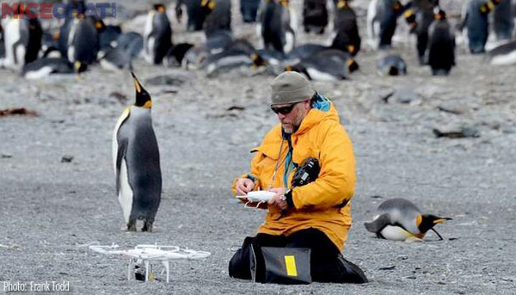  Wildlife biologists often work outdoors in the field gathering data and studying animals in their natural habitats.  On the back, sketch or write about the animal this wildlife biologist is studying. | 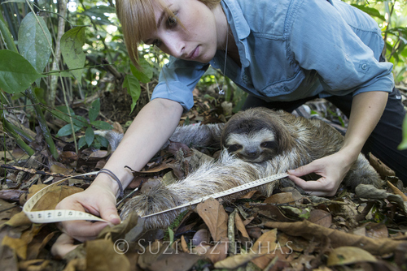  This wildlife biologist is working with a sloth in a country named Costa Rica. Sloths are an endangered species, which means that they are in danger of extinction. She is measuring it to see how much it has grown.  On the back, sketch or write about what you know about endangered animals. | 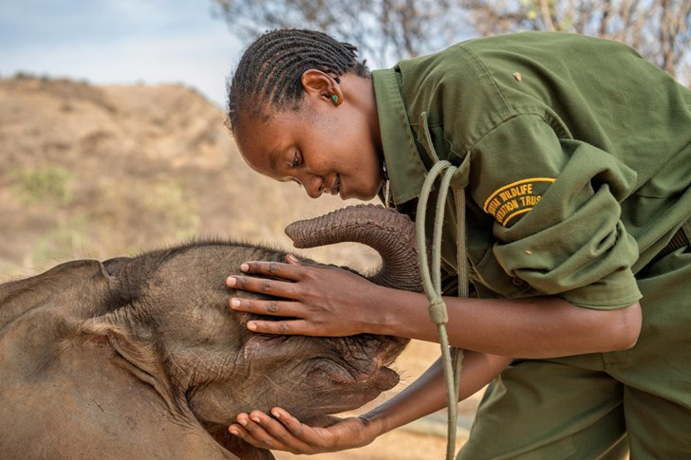  A baby elephant is very dependent on its mother, just like human babies. This baby elephant was separated from its mother. Wildlife biologist rescued it and brought it to a sanctuary where it could be cared for with other elephants.  On the back, sketch or write about how you would care for a baby elephant. | 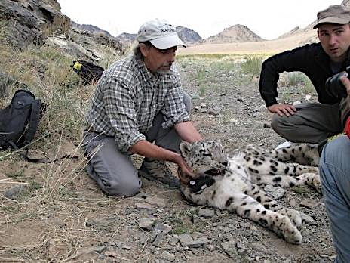  These wildlife biologists are putting a radio collar on a snow leopard in a country called Nepal. The radio collar will allow them to study the behaviors of the snow leopard. It is an endangered animal, which means that they are not many left and there is a possibility that snow leopards will die off.  On the back, write or sketch about what you think the wildlife biologists will learn about the snow leopard with the radio collar.

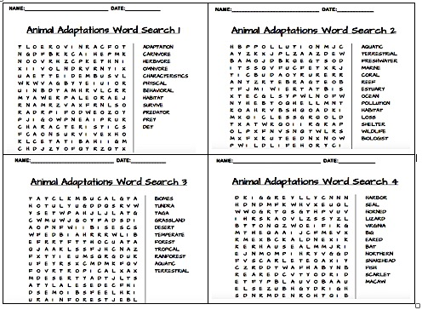
Wildlife Biologist Awards/ Reconocimientos del biólogo silvestre
Wildlife Biologist Awards/ Reconocimientos del biólogo silvestre
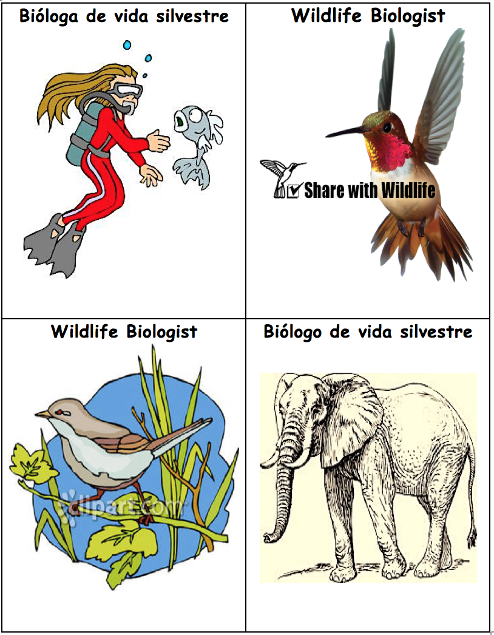
Wildlife Biologist Awards/ Reconocimientos del biólogo silvestre

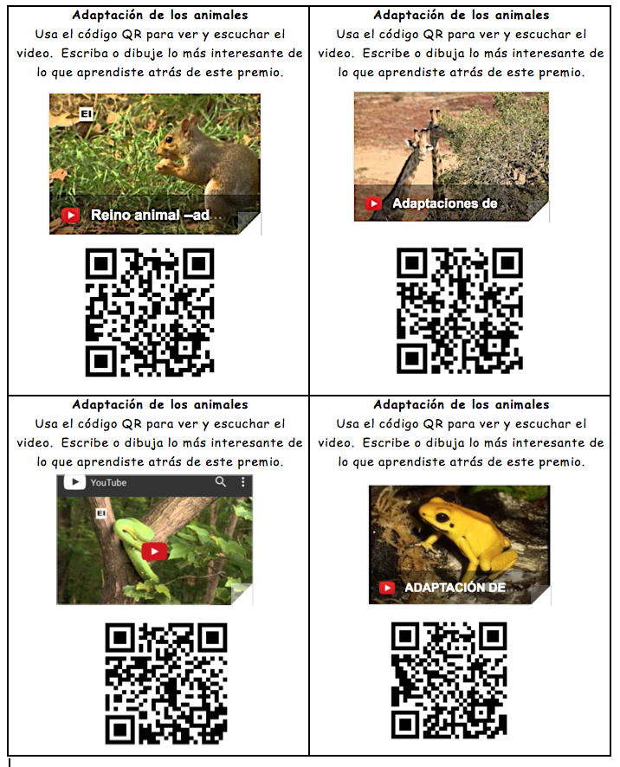

Hercules Beetle  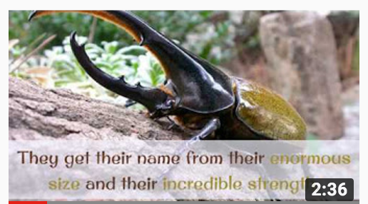  Write or draw the most  interesting thing you learned from the video. Match it to a chart on the wall and add your information. | African Elephant  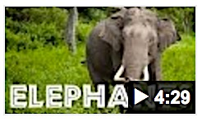  Write or draw the most  interesting thing you learned from the video. Match it to a chart on the wall and add your information.
Siberian Musk Deer  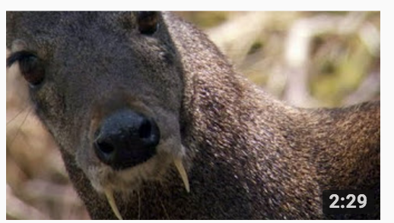  Write or draw the most  interesting thing you learned from the video. Match it to a chart on the wall and add your information. | Mexican Gray Wolf  (El lobo)  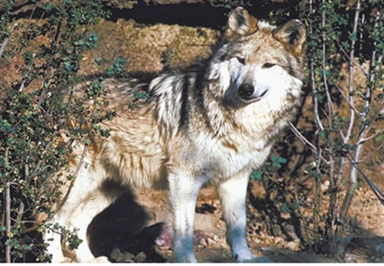  Write or draw the most  interesting thing you learned from the video. Match it to a chart on the wall and add your information.

Prediction/Reaction Guide
Directions: Please respond by sketching and writing below.

- What does animal adaptation mean?
Reaction
Prediction

- What does habitat mean?
Reaction
Prediction

- What are some behaviors of animals that help them survive in cold climates?
Prediction
Reaction

- What impact do humans have on animal habitats?
Reaction
Prediction

- Give an example of how animals depend on other animals and plants.
Prediction
Reaction
The Important Big Book About Animal Adaptation

by Diana Pinkston-Stewart and Ruth Kriteman

Table of Contents
Biomes of the World page 1

Animal Habitats and Shelters page 2

Physical Adaptations of Animals page 3

Behavioral Adaptations of Animals page 4

Animal Diets page 5

Human Impact on Animals page 6

The Role of the Wildlife Biologist page 7

Glossary page 8
The most important thing about animal adaptation is that animals have physical and behavioral characteristics that help them survive in their habitats.

- Biomes are large regions of the world with similar climate (weather, temperature), animals and plants. There are aquatic biomes and terrestrial biomes.
- About 75% of our planet is covered in water. Aquatic biomes are made up of mostly water and the plants and animals that live in the water. Marine biomes consist of the salty water of the oceans, seas, coral reefs and estuaries. Freshwater biomes consist of the freshwater (non-salty water) of lakes, rivers and ponds.
- About 25% of our planet is covered in land. Terrestrial biomes are made up of mostly land and the plants and animals that live on the land.

But, the most important thing about animal adaptation is that animals have physical and behavioral characteristics that help them survive in their habitats.
1
The most important thing about animal adaptation is that animals have physical and behavioral characteristics that help them survive in their habitats.

- A habitat is the special place where a plant or animal lives. An animal needs five things to survive in its habitat: food, water, shelter, air and a place to raise its young.
- Animals require different amounts of space. Habitats can be big like a forest or they can be much smaller like a burrow. Some animals roam over a large area while other animals need only a small amount of space.
- Just like you live in a house, animals have shelters that keep them safe. Like humans, animals leave their shelters to search in their habitats for food and other materials they need.
But, the most important thing about animal adaptation is that animals have physical and behavioral characteristics that help them survive in their habitats.
2
The most important thing about animal adaptation is that animals have physical and behavioral characteristics that help them survive in their habitats.

- Adaptations are any physical or behavioral characteristics an animal has developed that help it to survive in its environment. These characteristics fall into three main categories: body parts, body coverings and behaviors.
- Physical adaptions have to do with animals’ bodies. Some examples of physical adaptations are:
      - webbed, hooved or clawed feet
      - length and sharpness of teeth
      - the size and shape of a beak
      - feathers, fur or scales covering the body

But, the most important thing about animal adaptation is that animals have physical and behavioral characteristics that help them survive in their habitats.

3
The most important thing about animal adaptation is that animals have physical and behavioral characteristics that help them survive in their habitats.

- Behavioral adaptations are what an animal does in order to survive in its environment. Behavioral adaptions often fall into three categories:
      - how an animal gets its food and water
      - how an animal moves
      - how an animal protects itself
- Some animals, like the camel, have developed ways to store food and water in their bodies so they can survive a long time without eating or drinking.
- Many animals live in groups or families in shelters. This behavior provides them with protection from predators and harsh weather.
- Animals that are able to fly or run quickly have developed these skills to help them move from one place to another as well as to escape predators. Deer can often outrun wolves that are chasing them.

But, the most important thing about animal adaptation is that animals have physical and behavioral characteristics that help them survive in their habitats.
4
The most important thing about animal adaptation is that animals have physical and behavioral characteristics that help them survive in their habitats.

- Animals must eat other living organisms in order to survive, including both plants and other animals. Animals also need water.
- What an animal eats is called its diet. Animals are divided into three groups according to their diet: herbivores, omnivores and carnivores.
- Animals who only eat plants are called herbivores. Elephants, rabbits, and deer are examples of herbivores.
- Animals who eat both plants and other animals are called omnivores. Humans, raccoons and bears are all omnivores.
- Animals who only eat other animals are called carnivores. Carnivores usually have sharp teeth and strong jaws so they can catch other animals. Lions, crocodiles and sharks are examples of carnivores. Carnivores are predators, because they hunt other animals. Animals that are hunted are called prey.

But, the most important thing about animal adaptation is that animals have physical and behavioral characteristics that help them survive in their habitats.

5
The most important thing about animal adaptation is that animals have physical and behavioral characteristics that help them survive in their habitats.

- As the number of humans on our planet has grown, the impact on animal populations has been great.
- In order to make places to live like villages and cities, humans have destroyed over half of the world’s forests and the remaining forests are shrinking fast. Habitat loss is the biggest threat to wildlife today.
- Farming is an important way that humans provide food for each other, but if farms are not managed properly, there can be negative effects on animal populations. The overuse of chemicals on crops can affect the water and food in an animal’s habitat. Farms can also cause habitat loss by taking up large areas of land for growing crops or cattle grazing.
- Pollution caused by the use of coal, gas and other energy sources has caused harmful changes that effect animal habitats. Pollution can change and even destroy all the living things in an animal’s habitat.

But, the most important thing about animal adaptation is that animals have physical and behavioral characteristics that help them survive in their habitats.

6

The most important thing about animal adaptation is that animals have physical and behavioral characteristics that help them survive in their habitats.

- Wildlife biologists are people who study and manage wild animals, their habits, and habitats.
- They develop and carry out measures to protect endangered and threatened species.
- They evaluate the impact of humans on wildlife and develop ways to manage the effects of humans on animal habitats.
- Educating the public on wildlife ecology can be an important part of a wildlife biologist’s job.

But, the most important thing about animal adaptation is that animals have physical and behavioral characteristics that help them survive in their habitats.
7
Word | Definition
adaptation | behavioral and physical characteristics that animals have developed to survive
aquatic | relating to or consisting of or being in water; "an aquatic environment"
behavioral | the responses or reactions or movements made by an organism in any situation
carnivore | animals that eat other animals
characteristics | a distinguishing quality
coral reef | a ridge of rock in the sea formed by the growth and deposit of coral made by tiny marine animals called polyps
diet | the usual food and drink consumed by an organism
estuary | an area where seawater mixes with freshwater
farming | the job or business of running a farm
freshwater | inland water, as ponds, lakes, or streams, that does not have a high salt concentration
grazing | when animals eat grass in a pasture
habitat | the local home of an animal or a plant
habitat loss | when a natural habitat is unable to support the organisms that live in it
herbivore | animals that only eat plants
impact | influence or effect
marine | of or relating to the sea; existing in or produced by the sea
omnivore | animals that eat both plants and other animals
physical | having to do with the structure or body of an organism
pollution | the introduction of harmful substances or products into the environment
predator | an animal that survives by preying upon or hunting other animals
prey | an animal hunted for food, especially by a carnivorous animal.
shelter | a place an animal lives in to keep safe and raise its young
to store | to supply or stock up on something for future use
terrestrial | of or relating to land as distinct from water
wildlife biologist | scientists that study plants and animals in the wilderness

Graphic Organizer: Terrestrial Biomes of the World
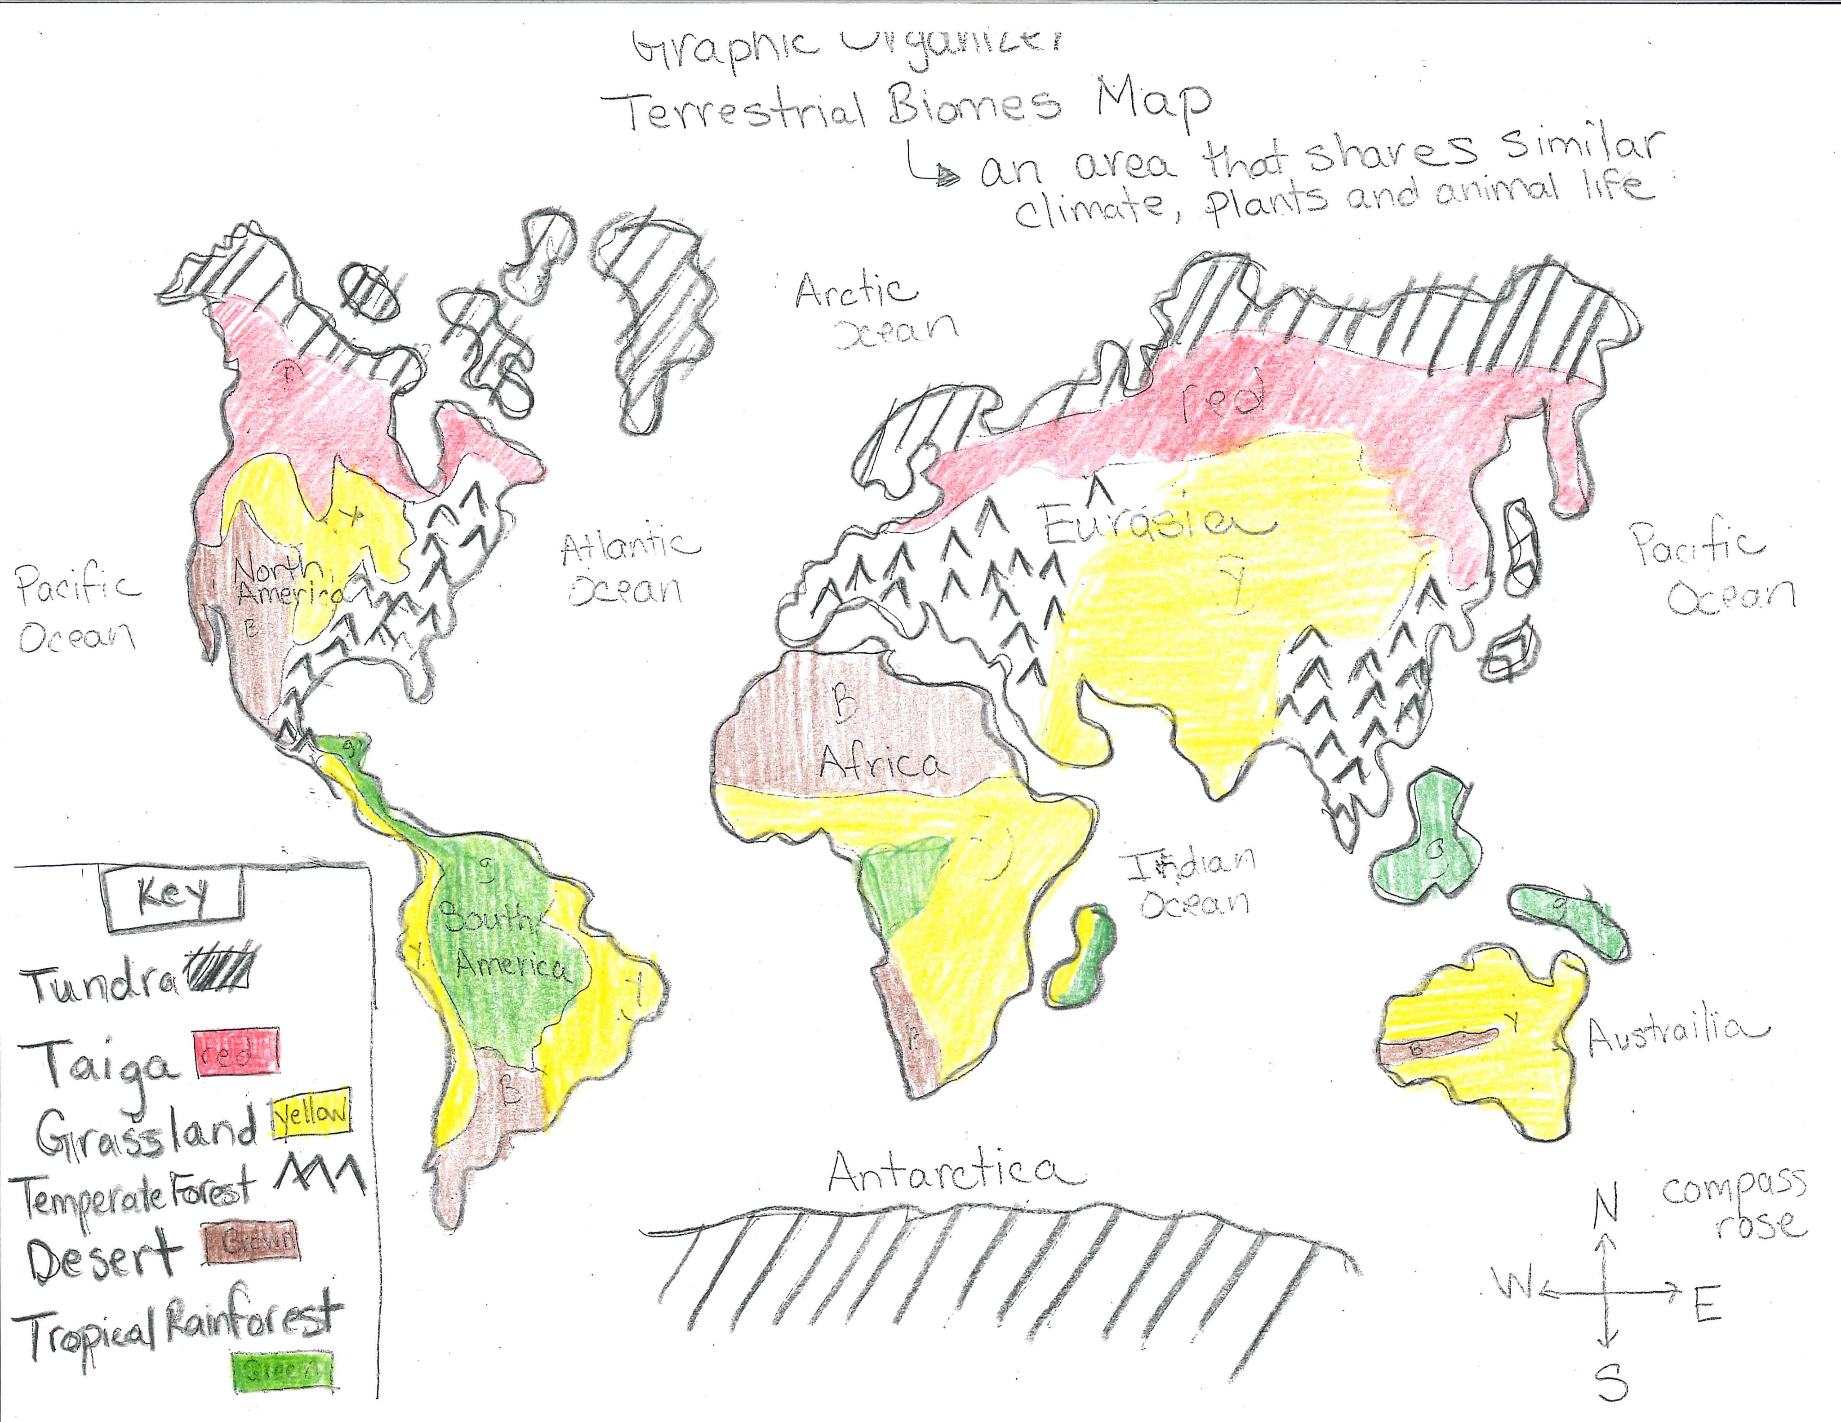

Biomes of the World Graphic Organizer: Question Grid
QUESTION GRID - Unit title: Animal Adaptations Strategy name: Graphic Organizer – Biomes of the World
Thinking and Language Grid | Level 1 Entering  Listening/Speaking | Level 2 Beginning  Listening/Speaking | Level 3 Developing  Listening/Speaking | Level 4 Expanding  Listening/Speaking | Level 5 Bridging  Listening/Speaking
REMEMBER  Choose, define, fined, how, label, list, match, recall, show, tell, spell, relate, name, omit, select, who, what, when, where, why  UNDERSTAND  Classify, compare, demonstrate, explain, extend, illustrate, infer, interpret, outline, rephrase, summarize, translate | Show me North America.  Is this (pics) a desert biome or a grassland biome? | What is this biome?  Where is it located? | Name the 2 kinds of biomes.  I’m thinking of the cold weather biomes. | What biomes are found in South America? | Explain what a biome is.  How are they characterized?
APPLY  Apply, choose, construct, develop, experiment with, identify, interview, make use of, model, organize, plan, utilize  ANALYZE  Analyze, assume, categorize, classify, compare, conclusion, contrast, discover, dissect, distinguish, divide, examine, function, inspect, motive, relationships, simplify, survey, theme, test for | Point to the tropical rainforest in Africa.  Which picture was taken in a tropical rainforest? | Which terrestrial biome is cold and has a short growing season?  Show me on the map. | What are some examples of desert biomes? | Explain the difference between a Temperate Forest biome and a Taiga biome. | Compare biomes in South America and Africa.
EVALUATE  Agree, assess, compare, conclude, criticize, deduct, defend, determine, disprove, evaluate, influence, judge, justify, opinion, prove, recommend, support  CREATE  Build, change, choose, construct, design, develop, elaborate, formulate, imagine, improve, plan, predict, propose, solve, test, theory | Point to the biome that you would most like to visit. | Which of these (pics) animals do you think live in the tundra? | Which biome would you like to visit?  Why? | How would you survive in the desert?  What would you need? | If you traveled to Antarctica, what would you need to do to survive?  What do you think you would see?

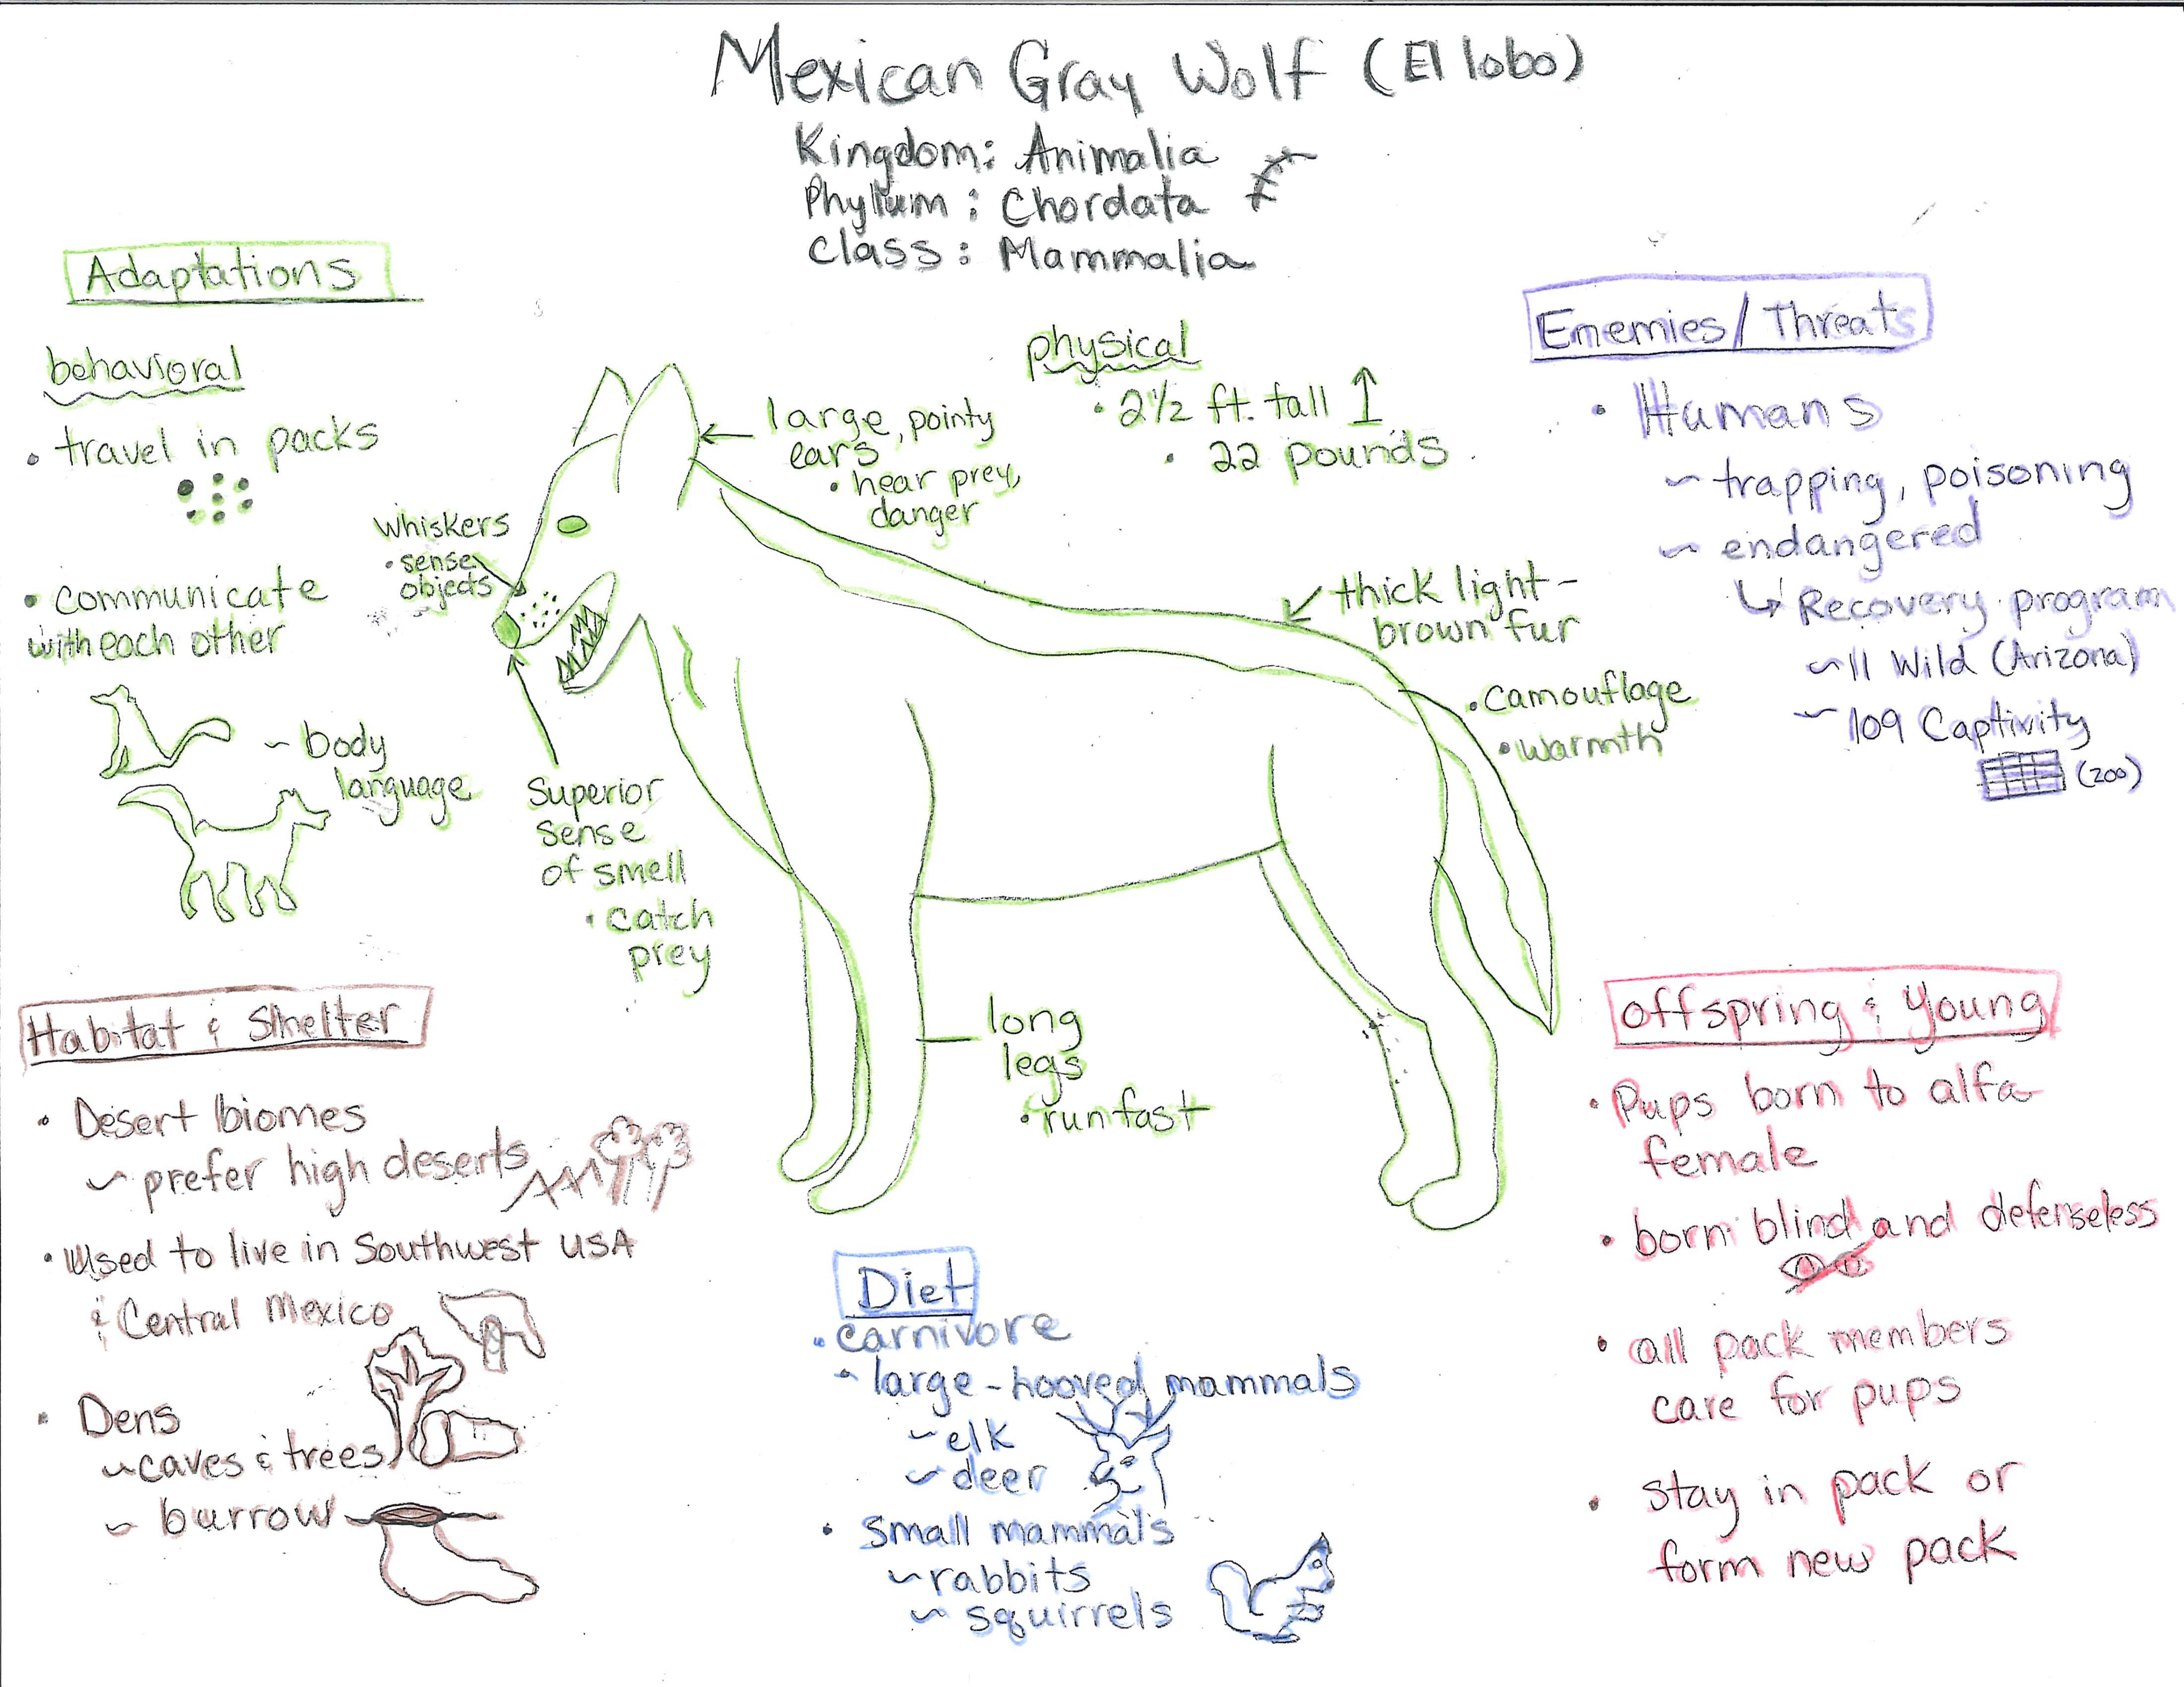

Note: Update wolf numbers when you deliver this.
Pictorial Input Chart Background Information

Mexican Gray Wolf (El Lobo)
Kingdom: Animalia
Phylum: Chordata
Class: Mammalia

Habitat and Shelter
The Mexican Gray Wolf is a terrestrial animal that lives in a desert biome, although if prefers mountainous forest and woodland in high deserts. They once lived throughout the southwestern United States and in Central Mexico. They are now under endangered animal protection. Today, there are about 300 in captivity and 115 living in the mountains in Arizona and New Mexico. Mexican gray wolves live in dens, which can be holes burrowed in the ground, under large tree roots or small rock caves.

Adaptations: Physical and Behavioral
The Mexican Gray Wolf is one of the smallest species of wolves. They stand about 2 ½ feet tall and weigh about 22 pounds. They are grey with light brown fur on their back, which serves as camouflage in forested areas. It has long legs and a sleek body which helps it run very fast. El lobo has a superior sense of smell which help it find its prey easily. Los lobos travel in packs. They use certain behaviors to communicate with each other. This ensures their safety and gives the pack a higher chance at catching prey.

Diet
The diet of the Mexican Gray Wolf is mostly large-hooved mammals such as elk, white-tailed deear and mule deer. They are also known to eat smaller mammals like javelinas, rabbits, ground squirrels and mice.

Offspring/Young
Between April and July an alpha female gives birth to her young. Their offspring are called “pups” and are born in a litter. A litter can have between 4-7 pups. The pups are born blind and defenseless. All members of the pack care for the pups in the den until they mature. Some pups stay with the pack for life, while others leave after a few years to start new packs.

Enemies/Threats
El lobo was once “top dog” in the borderlands with no natural enemies. However, humans are their greatest threat. At one point, humans nearly eliminated these animals from the wild by trapping and killing them. Biologist worked hard to save them and introduce them back into the wild. Wolves in the wild do kill a small amount of livestock. The US government will offer compensation to a rancher if a wolf kills a livestock animalLos lobos remain critically endangered with only 113 counted in February, 2017.

Stages of Language Acquisition - WIDA | Level 1 Entering  Listening/Speaking | Level 2 Beginning  Listening/Speaking | Level 3 Developing  Listening/Speaking | Level 4 Expanding  Listening/Speaking | Level 5 Bridging  Listening/Speaking
Level of Questioning | Point To, Locate, Trace Yes/No Either/Or Open Ended
Create  Arrange, assemble, collect, compose, combine, construct, create, design, develop, devise, forecast, formulate, hypothesize, imagine, invent, manage, organize, plan, prepare, propose, set up | Choose the parts of the Mexican gray wolf that you would use to teach another student about how they camouflage. | Is living in a pack a helpful way to protect themselves against enemies? | Look at these two pictures. Which one shows a feature that help a wolf catch its prey? | If the Mexican Gray Wolf did not have a superior sense of smell, how else could they catch their prey?
Evaluate  Appraise, argue, assess, choose, compare, critique, decide, debate, defend, determine, discuss, estimate, evaluate, judge, justify, predict, prioritize, rate, recommend, select, support, value, verify, weigh | Point to the adaptation is most important for the Mexican Gray Wolf’s survival. | Justify—could wolves survive living in water? | What word would best describe wolf: herbivore or carnivore? Explain why. | Predict what would happen if pups where not cared for by the pack.
Analyze  Analyze, appraise, calculate, categorize, classify, compare, contrast, criticize, differentiate, discriminate, distinguish, examine, experiment, explain, identify, infer, question, test | Point to the features that help the Mexican Gray Wolf run fast. | Which picture shows a Mexican Gray Wolf’s shelter? | Since wolves have sharp teeth, do you infer that it eats plants or meat? | Compare the Mexican Gray Wolf to another mammal (that you are familiar with). How are they the same or different?
Apply  Apply, calculate, categorize, classify, change, choose, compare, construct, demonstrate, describe, determine, distinguish, dramatize, employ, estimate, explain, extend, illustrate, interpret, judge the effects, operate, practice, schedule, select, show, sketch, solve, use | On this chart, trace the wolf’s large, pointy ears. | Are elk and deer examples of large-hooved mammals? | Are the elk and deer categorized as small mammals? | Use the information on the chart to explain why Mexican Gray Wolves are endangered.
Understand  Categorize, cite, clarify, classify, describe, discuss, explain, express, identify, indicate, interpret, locate, match, paraphrase, predict, recognize, restate, review, select, summarize, translate | Find an example of body language. | Does the Mexican Gray Wolf use body language to communicate? | Does body language teach us about how Mexican Gray Wolves communicate with each other? | Summarize the most important ideas about their offspring and young.
Remember  Arrange, choose, define, describe, draw, , find, give example, identify, label, locate, list, match, name, recall, recite, recognize, record, repeat, reproduce, select, state, tell | Locate the whiskers that sense objects. | Recall—do Mexican Gray Wolves live in dens? | Teacher point to the sketch of the burrowed den on the chart.  In this picture is the den above ground or underground? | Tell me what you learned about the Mexican Gray Wolf’s diet.

The Penguin Chick
By Betty Tatham
Illustrated by Helen K. Davie

Page 1
A fierce wind howls. It whips snow across the ice. Here, a female emperor penguin has just laid an egg. It is the only egg she will lay this year. Most birds build nests for the eggs. But on the ice in Antarctica, there are no twigs or leaves. There is no grass or mud. There is nothing to build a nest with. Nothing but snow and ice. The new penguin father uses his beak to scoop the egg onto his webbed feet. He tucks it under his feather-covered skin, into a special place called a brood patch. The egg will be as snug and warm there as if it were in a sleeping bag. “I have to protect my young! It’s my responsibility,” says Father penguin.

Page 2
In the rookery, where penguins lay their eggs, there is no food for them to eat. One of the penguin parents must stay with the egg to keep it warm. Father penguin is bigger and fatter than Mother penguin. He can live longer without food so Father penguin stays with the egg while Mother penguin travels to the sea to find food. The two parents sing together before the she leaves. Father sings, “Go hunt and get us food, my love. I will wait here.”

Page 3
Mother walks or slides on her belly. This is called tobogganing. She uses her flippers and webbed feet to push herself forward over ice and snow. “Bye, my dear. I have confidence that you will keep our baby safe. I have a long journey ahead, traveling across many miles of ice. Soon I will arrive at the ocean where I will find food.”

Page 4
When Mother arrives at the ocean, she dives into the water to hunt for fish, squid, and tiny shrimplike creatures called krill. “I have to hunt with all my might. My family is waiting and my new baby needs food,” Mother tells herself. Mother hunts carefully, alert for any enemies, like seals, sharks and the most dangerous of all, the orca. If she can’t bring back the food, her baby will not survive.

Page 5
Back at the rookery, the penguin fathers form a group called a huddle. They stand close together for warmth. Each one keeps his own egg warm. Father worried, “I wonder how Mother is doing? I am hungry and really cold but she is in the dangerous ocean hunting. What would happen if she doesn’t return? What would we do?”
For two months Father penguin always keeps his egg on his feet. When he walks, he shuffles his feet so the egg doesn’t roll away. He sleeps standing up. He has no food to eat, but the fat on his body keeps him alive.

Page 6
Finally, he feels the chick move inside the egg. The chick pecks and pecks. In about three days the egg cracks open. The chick is wet. Soon his soft feathers called, down, dry and become fluffy and gray. Father still keeps the chick warm in the brood patch. Sometimes Chick pokes his head out. While he’s so little, he must stay covered. Chick must stay on his father’s feet. Otherwise, the cold would kill him.

Page 7
Father talks to Chick in his trumpet voice, “How are you my chick?” Chick answers with a whistle. Father’s trumpet call echoes across the ice. Mother penguin is on her way back to the rookery, but she can’t hear him. She’s still too far way. If Mother doesn’t come back soon with food, Chick will die.

Page 8
Two days pass before Mother can hear Father penguin’s call. At last, Mother arrives at the rookery. She cuddles close to her chick and trumpets to him, “I’m home!”. He whistles back. With her beak she brushes his soft gray down.
Mother penguin swallowed many fish before she left the ocean. She brings some of this food back up from her stomach and feeds her chick. She has enough food to keep him fed for weeks. Now, Chick stays on her feet and snuggles into her brood patch.
Father is also very hungry, so he travels to open water. There he dives to hunt for food. Weeks later Father returns with more food for Chick.

Page 9
As Chick gets bigger, he and the other chicks no longer need to stay on their parents’ feet. Instead they stay together to keep warm. This group of chicks is called a nursery. Chick now spends most of his time here.

Page 10
Chick grows and grows. After five months, he has grown into a junior penguin. He is old enough to travel to the ocean. Now he has a waterproof coat of feathers, instead of fluffy down. He can swim in the icy cold ocean because his feathers keep him dry and warm. Chick soon becomes a young penguin. Now he spends most of his time in the water swimming, flapping his flippers as if he were flying underwater. He uses his webbed feet to steer wherever he wants to go. The young penguin catches a fish with his beak and swallows it headfirst. He can now take care of himself. In about five years, he’ll find a mate and take care of his own egg until his chick can hatch.

Polluelo de pingüino
Escrito por Betty Tatham
Ilustrado por Helen K. Davie
Traducido y adaptado por R. López y R. Kriteman

- El viento implacable ruge. La nieve azota la tierra helada. Aquí, una hembra de pingüino emperador ha puesto su huevo. Es el único huevo que pondrá este año. La mayoría de las aves hacen nidos para sus huevos, pero en la fría Antártida no hay nada para construir un nido. Solo nieve y hielo. Papá pingüino usa su pico para poner el huevo entre sus pies palmeados. Lo pone debajo de su piel cubierta de plumas, en un lugar especial llamado parche de cría. Aquí el huevo estará seguro y calientito.
“¡Tengo que proteger a mi cría! ¡Es mi responsabilidad!”

- El papá sabe que aquí en la pingüinera, donde los pingüinos ponen huevos, no hay nada de comer. El papá pingüino es más grande y gordo que la mamá y puede vivir más tiempo sin comida. Por eso, el papá pingüino se queda con el huevo mientras la mamá va al mar a buscar comida. Los dos padres cantan juntos antes de que la mamá pingüino se vaya. El papá le dice: “Ve, mi amor, te espero aquí. Ve y caza. Tráenos comida.”

- La mamá camina o se desliza sobre su panza, como si se deslizara en un tobogán. Usa sus aletas y sus pies palmeados para impulsarse sobre el hielo y la nieve.
“¡Adiós, mi vida! Tengo confianza en ti. Sé fuerte por nuestro bebé. Mi jornada será larga - millas y millas de agua congelada, pero pronto llegaré al mar y allí habrá comida.”

- Cuando la mamá pingüino llega finalmente al mar, ella se lanza al agua para atrapar peces, calamares, y pequeñas criaturas parecidos a los camarones, llamados kril.
“Tengo que cazar con toda mi fuerza. Mi familia me espera, y mi nuevo bebé necesita comida.”
La mamá pingüino caza con mucho cuidado, alerta para sus enemigos: las focas, tiburones, y los más peligrosos de todos, la orca. Si ella no alcanza cazar comida, el bebé nunca podrá sobrevivir.

- En la pingüinera helada, el papá y sus compadres, se apiñan para formar un grupo. Se paran muy juntos para calentarse. Cada uno mantiene caliente su propio huevo.
El papá piensa, “¿Cómo estará mi hembra? Tengo hambre y mucho frió, pero ella está en peligro cazando en el mar. ¿Qué pasa si nunca vuelve? ¿Qué haríamos?
Durante dos meses el papá guarda el huevo entre sus patas. Cuando camina, arrastra las patas para que el huevo no se le caiga. Duerme parado. No come, pero la grasa de su cuerpo lo mantiene vivo.

- Finalmente siente que el polluelo se mueve dentro del huevo. El polluelo picotea y picotea. En unos tres días el huevo se rompe. El polluelo sale mojado. Pero pronto su suave plumaje, llamado plumón, se seca y se vuelve esponjoso y gris. El papá sigue manteniendo caliente al polluelo en su parche de cría. A veces el polluelo asoma la cabeza, pero debe permanecer cubierto en los pies de su papá. De lo contrario, el frío lo mataría.

- El papá le habla al polluelo con su voz de trompeta. El polluelo le contesta con un silbido. El llamado de trompeta de su papá hace eco a través del hielo. La mamá pingüino está en camino hacia la pingüinera, pero todavía no lo oye. Aún está muy lejos. Si la mamá no vuelve pronto con comida, el polluelo morirá.

- Dos días pasan antes de que la mamá pueda oír el llamado del papá pingüino. Finalmente la mamá llega a la pingüinera. Acaricia su polluelo y le habla con su voz de trompeta. El bebé le responde con un silbido. Usa su pico para peinarle el suave plumón gris. La mamá comió muchos peces antes de salir del mar. Los vuelve a traer de su estómago a su boca y alimenta a su polluelo. Tiene comida suficiente para varias semanas. El polluelo se sube a las patas de su mamá y se acomoda en el parche de cría. El papá tiene mucha hambre. Ahora le toca a él ir al mar a cazar. En unas semanas volverá con más comida para el polluelo.

- A medida que el polluelo crece, él y los otros polluelos ya no necesitan quedarse en las patas de sus papás. Ahora forman su propio grupo para mantenerse calientes, y a veces juegan juntos en el hielo. Este grupo se llama guardería. El polluelo pasa la mayor parte de su tiempo aquí.

- El polluelo crece y crece. Después de cinco meses, se ha vuelto un joven pingüino. Tiene edad suficiente para ir al océano. Ahora tiene un abrigo de plumas impermeables, en lugar de su plumón esponjoso. Puede nadar en las aguas oceánicas heladas porque sus plumas lo mantienen seco y caliente. El joven pingüino pasa la mayor parte del tiempo en el agua. Nada, mueve sus aletas como si volara bajo el agua. Usa sus pies palmeados para ir donde quiere. Atrapa un pez con su pico y se lo traga. Ahora el joven pingüino puede conseguir su propia comida y cuidarse solo. En unos cinco años, encontrará una pareja. Después cuidará a su propio huevo hasta que el polluelo salga del cascarón.

Presentación narrativa – Polluelo de pingüino: Cuadrícula de preguntas
QUESTION GRID - Unit title: Animal Adaptations Strategy name: Narrative Input – El polluelo pingüino
Thinking and Language Grid | Level 1 Entering  Listening/Speaking | Level 2 Beginning  Listening/Speaking | Level 3 Developing  Listening/Speaking | Level 4 Expanding  Listening/Speaking | Level 5 Bridging  Listening/Speaking
REMEMBER  Choose, define, fined, how, label, list, match, recall, show, tell, spell, relate, name, omit, select, who, what, when, where, why  UNDERSTAND  Classify, compare, demonstrate, explain, extend, illustrate, infer, interpret, outline, rephrase, summarize, translate | Muéstrame el papá pingüino. | ¿Es el papá o la mamá que protege el huevo en su parche de cría? | ¿Cómo sabes cuál es el papa pingüino? | ¿Cómo se protegen los papás del frio y del viento? | Describe el medioambiente de Antártida.
APPLY  Apply, choose, construct, develop, experiment with, identify, interview, make use of, model, organize, plan, utilize  ANALYZE  Analyze, assume, categorize, classify, compare, conclusion, contrast, discover, dissect, distinguish, divide, examine, function, inspect, motive, relationships, simplify, survey, theme, test for | Señala la imagen que nos muestra cómo viajan los pingüinos al mar. | Sí o no: el polluelo nace con plumón suave y esponjoso. | Muéstrame algo que me deja saber qué tanto el papá como la mamá le ayuda el polluelo a sobrevivir. | ¿Por qué es el papá el que queda para proteger al huevo? | Compara las habilidades de un polluelo recién nacido con un polluelo de 5 meses.
EVALUATE  Agree, assess, compare, conclude, criticize, deduct, defend, determine, disprove, evaluate, influence, judge, justify, opinion, prove, recommend, support  CREATE  Build, change, choose, construct, design, develop, elaborate, formulate, imagine, improve, plan, predict, propose, solve, test, theory | ¿Es peligroso para los pingüinos ir al mar a cazar? | Sí o no: Si se pierde la mamá en el mar, el polluelo puede quedarse con el papá hasta que crezca. | Muéstrame la parte del cuento que más te gusta. ¿Por qué te gusta esa parte? | Si fueras un científico, cómo le ayudarías al pingüino macho cuidar de su polluelo? | ¿Cómo crees que el calentamiento global cambiará este cuento?

Animal Adaptations – Adaptaciones de los animales
Poetry Booklet – Librito de cantos y poesía
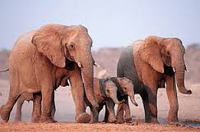
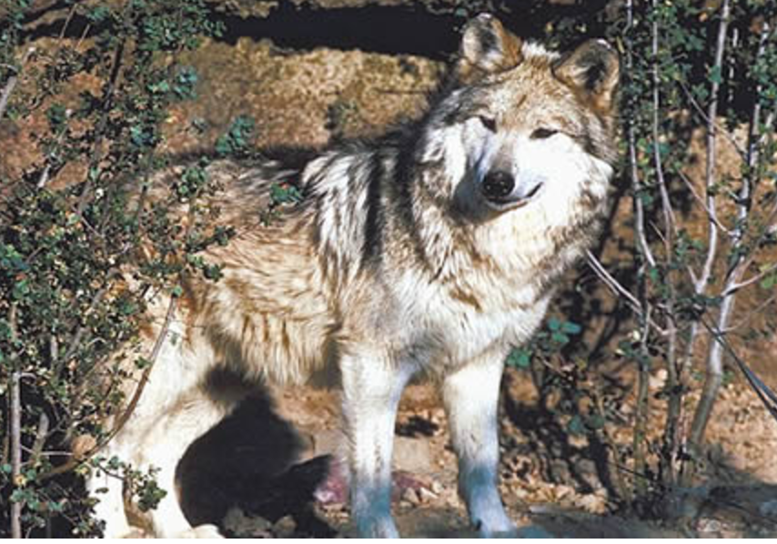

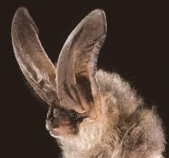
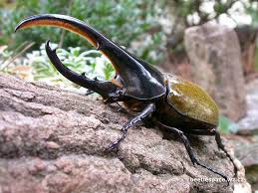
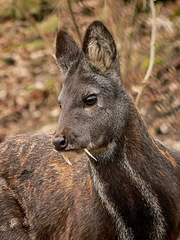
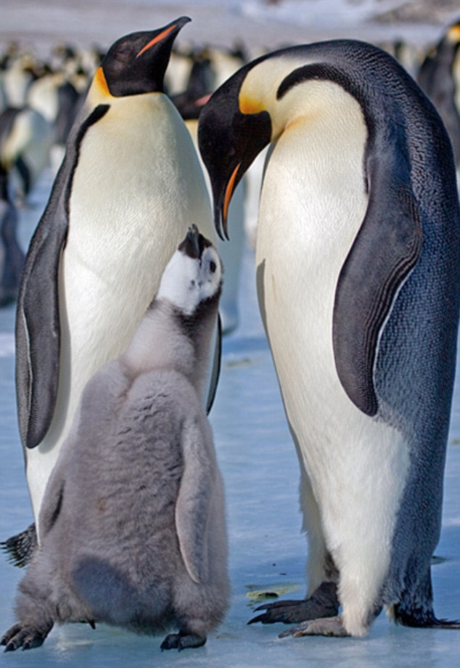

Animals Here, Animals There
By Ruth Kriteman

Animals here, animals there,
Animals, animals everywhere.

Colorful animals camouflaging cleverly,
Mother animals defending fiercely,
Powerful animals hunting stealthily,
And, solitary animals burrowing deeply.

Animals in the grassland biome,
Animals in the rainforest biome,
Animals after a long sleep,
And animals at dawn.

Animals here, animals there,
Animals, animals everywhere,
Animals! Animals! Animals!

Animal Adaptation Cadence
By Ruth Kriteman and Diana Pinkston-Stewart

We all know what we’ve been told,
Animals can grow to be quite old.
It takes a long time for them to adapt,
Both physically and behaviorally, let’s learn about that.

Sound off – Physical,
Sound off – Behavioral,
Sound off – 1-2-3-4 –Adaptations!

Bodies adapt in different ways,
Webbed feet, big ears, are here to stay.
Scaly skin, sharp claws, and extra fat,
Physical adaptations help animals survive - that’s a fact.

Sound off – Physical,
Sound off – Behavioral,
Sound off – 1-2-3-4 --Adaptations!

Behavioral adaptations help animals survive,
Movement and protection keep them alive.
Getting food and water is always a chore,
Climbing, hunting, hiding and so much more.

Sound off – Physical,
Sound off – Behavioral,
Sound off – 1-2-3-4—Adaptations!

Wildlife Biologist Bugaloo
By Ruth Kriteman

I’m a wildlife biologist and here to say,
I study wild animals every day.
Sometimes I study their habitats or what they do,
To stay alive and flourish. There’s much to learn – Whew!

Animals, habitats, adaptations, too
Doing the wildlife biologist bugaloo!

We study how animals’ bodies help them survive,
These physical adaptations are more than just their size.
Their feet, their teeth, body-coverings and beaks,
Protect them, help them move and decide what to eat.

Hooved feet, sharp teeth, fluffy feathers, too
Doing the wildlife biologist bugaloo!

Other animal adaptations are more about behavior,
How they move, protect themselves and get food or water.
Some hide in deep, dark burrows, others soar through the sky,
Some save food in their cheeks, others don’t even try.

Chewing grass, storing water, hunting prey, too
Doing the wildlife biologist bugaloo!

I Know an Aero-Dynamic Antarctic Ave
By Rhonda Lopez

I Know an aero-dynamic Antarctic Ave,
An attractive aero-dynamic Antarctic Ave,
An attractive aero-dynamic Antarctic Ave,
That lives in the southern hemisphere.

With solid bones for diving deep,
Flightless wings that serve as flippers,
Swallowing crustaceans and fish,
And swimming to and fro.

I Know an aero-dynamic Antarctic Ave,
An Attractive aero-dynamic Antarctic Ave,
An Attractive aero-dynamic Antarctic Ave,
It’s called the Emperor penguin!

Adaptations
From Songs for Teaching, Using Music to Promote Learning
http://www.songsforteaching.com/hood/adaptations.htm

Marine mammals like whales and otters
Have adapted to the cold ocean waters
Real thick fur or a blubbery skin
Doesn't let much cold ocean water in
Plants and animals have different needs
Developing features that will help them be
In their environment
In their environment
In the deserts things get hotter
Plants and animals must conserve water
Plant stems and leaves are waxy and thick
While being nocturnal is an animal's trick
Plants and animals have different needs
Developing features that will let them be
In their environment
In their environment

ADAPTATION?…YES, MA’AM!
By Laura Curry and Lori Klaus
Forest Grove School District

Do living things adapt? Yes, ma’am!
Do living things adapt? Yes, ma’am!
Well, how do you know? It’s easy to observe.
So how do you know? Living things are so diverse.

And why are they diverse? To help them catch and eat their prey.
Why else are they so different? To let them move a certain way.
Are there any other reasons? Camouflage so they won’t be caught.
Are there any other reasons? To survive a climate, cold or hot.

Can you give me some examples? Whiskers for sensing objects.
Can you give me some more? White fur in the snow.
What else do you know? Sharp teeth for tearing meat.
What more can you tell? Big ears to beat the heat.

Well, why do they adapt? They need to fit their habitat.
Well, why do they adapt? They need to change so they can thrive.
And if they don’t do it? Their population will diminish.
What if they don’t do it? They will cease to survive.

Animales aquí, allá
Por R. López, A. Perea, K. Krishna, D. Pinkston-Stewart

Animales aquí, animales allá,
Animales, animales, ra, ra, ra.

Animales herbívoros pastando pacíficamente,
Animales carnívoros cazando ferozmente,
Animales omnívoros consumiendo indiscriminadamente,
Y, animales hambrientos comiendo rápidamente.

Animales dentro del bosque,
Animales bajo el océano,
Animales después de un largo sueño,
Y animales durante la noche.

Animales aquí, animales allá,
Animales, animales, ra, ra, ra.
¡Animales! ¡Animales!. ¡Animales!

Conozco un ave
Escrito por Ruth Kriteman

Conozco un ave,
Un ave que cuida a su bebé,
A pesar del viento y del frío,
Que vive en Antártida.

Tiene voz de trompeta,
Aguanta mucho tiempo sin comer,
Tiene un parche de cría protegido y calientito,
Donde esconde su huevo durante meses.

Conozco un ave,
Un ave aerodinámico,
Un ave que nada y desliza sobre el hielo,
Que es el pingüino Emperador.

Canto de un biólogo
por
Lily D’Amour y Diana Pinkston-Stewart

Soy un biólogo, y quiero decir,
De los animales, yo sé compartir.
Adaptación es lo que hacen para persistir,
Les ayuda a ellos a sobrevivir.

El ambiente es fundamental, voy a decir,
La importancia de la ecología, no se puede discutir.
Relación con el mundo y otros animales también,
Refleja en cómo ellos cambian, ¿ya ven?

Mantener, crecer y reproducir,
Adaptación es lo que hacen para persistir,
Les ayuda a ellos a sobrevivir.

Reptiles habitan los continentes,
Absorben el calor de sus ambientes.
Moviéndose de la sombra al sol se ajustan,
Sus temperaturas a lo que les gustan.

Mantener, crecer y reproducir,
Adaptación es lo que hacen para persistir,
Les ayuda a ellos a sobrevivir.

Los mamíferos tienen la sangre caliente,
Ellos se adaptan a su ambiente.
Con garras poderosas, la presa capturan,
Y con piel gruesa, el frío aguantan.

Mantener, crecer y reproducir,
Adaptación es lo que hacen para persistir,
Les ayuda a ellos a sobrevivir.

Name: ________________________________ Date:_______________

Home to School Connection #1
Animal Adaptations

Describe the habitat that you and your family live in. What adaptations have humans developed to survive in our habitats?

Describe el hábitat en que vives con tu familia. ¿Cómo nos hemos adaptado como seres humanos para sobrevivir en nuestros hábitats?

________________________________ _______________________________
parent (padre de familia) student (estudiante)

Name: ____________________________ Date:_______________

Home to School Connection #2
Animal Adaptations

Explain to someone in your family what you have learned about physical and behavioral adaptations. Together decide what behavioral adaptations you have developed to live in your biome. Sketch and write what you’ve decided.

Explícale a alguien de tu familia lo que has aprendido acerca de las adaptaciones físicas y de comportamiento. Juntos decidan cuáles adaptaciones de comportamiento han desarrollado para poder vivir en el bioma donde viven. Dibuja y escribe lo que han decidido.

________________________________ _______________________________
parent (padre de familia) student (estudiante)

Name: ______________________________ Date__________________

Home to School Connection #3
Animal Adaptations

Tell a family member about the narrative story of The Penguin Chick . What are some physical and behavioral adaptations that help the Emperor penguin survive in Antarctica? Discuss with a family member. Sketch or write the information.

Cuenta a un miembro de la familia el cuento narrativo de El polluelo de pingüino. ¿Cuáles son las adaptaciones físicas y de comportamiento que le ayudan al Pingüino Emperador sobrevivir en el Antártida? Comparte con alguien de tu familia. Dibuja o escribe la información.

________________________________ _______________________________
parent (padre de familia) student (estudiante)

Name: _________________________ Date:_______________

Home to School Connection #4
Animal Adaptations

In this unit we have learned that there are different biomes in the world. How are they different? Where are the biomes located? Share what you have learned with a family member. Then, sketch and write what you shared.

Hemos aprendido acerca de los biomas diferentes del mundo. ¿Cómo son diferentes? ¿Dónde se localizan? Comparte con un familiar lo que has aprendido. Luego, dibuja y escribe lo que compartiste.

________________________________ ______________________________
parent (padre de familia) student (estudiante)

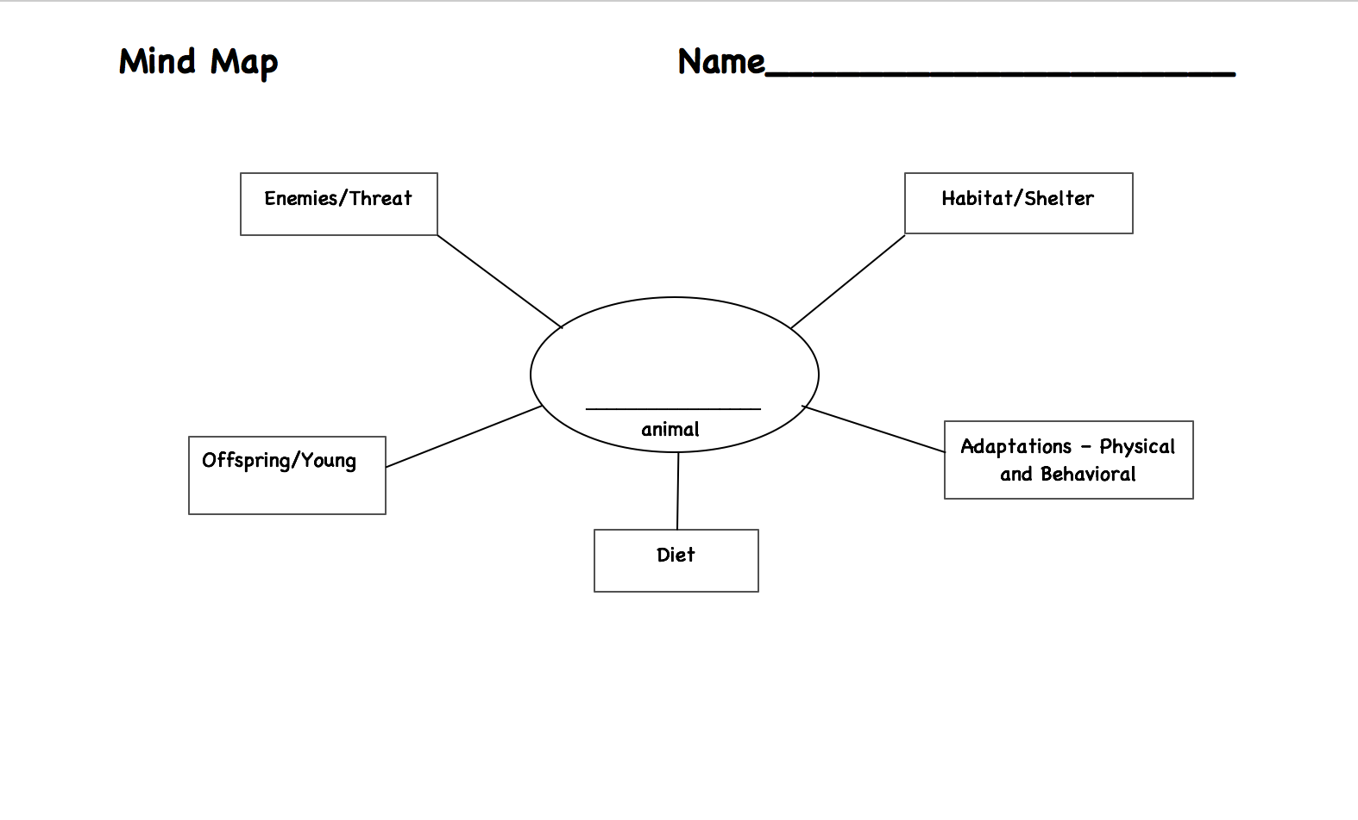

Name: _____________________________________________ Date: __________________
Expert Group
African Elephant
Kingdom: Animalia
Phylum: Chordata
Class: Mammalia

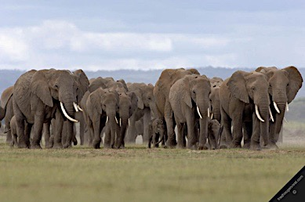
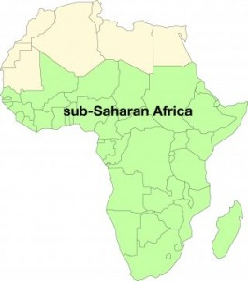
Habitat and Shelter
The African Elephant is a terrestrial animal that lives in the grasslands of sub-Saharan Africa. Female elephants (cows) live in family herds with their young, but adult males (bulls) tend to roam on their own.
Figure 1: Families are called herds
Figure 2: Grassland of the sub-Saharan Desert in the continent of Africa

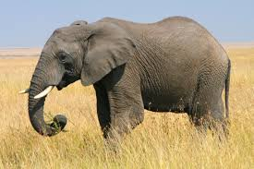
Adaptations: Physical and Behavioral
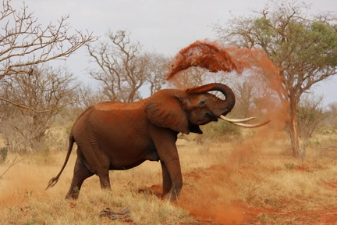
The African elephant is the largest land animal on Earth. They have large ears that help keep them cool in the heat. An elephant's trunk is actually a long nose used for smelling, breathing, trumpeting, picking up things, and drinking. They have tusks they use to dig for food and water and strip bark from trees. They travel great distances while foraging for the large quantities of food that they require to sustain their massive bodies. Elephants enjoy showering by sucking water into their trunks and spraying it all over themselves. Then, they spray themselves with dirt to protect their skin from the hot sun and stay cool.
Figure 3: Adult African Elephant
Figure 4: Elephant spraying itself with dirt

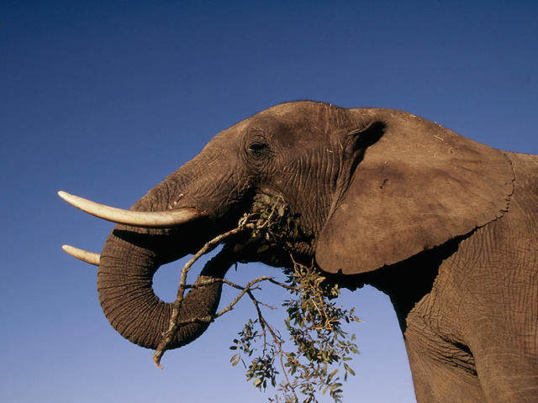

Diet
Elephants are herbivores, which means they feed on plants. They eat roots, grasses, fruit, and bark, and they eat
Figure 5: Eating tree branches
a lot of these things. An adult elephant can consume up to 300 pounds of food in a single day.

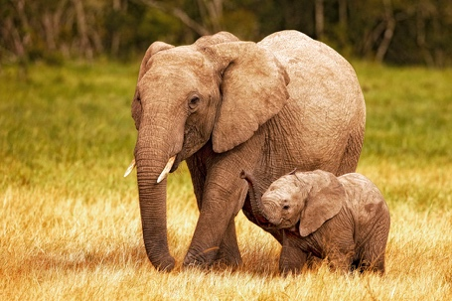
Offspring/Young
Elephants have a longer pregnancy than any other mammal—almost 2 years. Cows usually give birth to one calf every two to four years. At birth, elephants already weigh around 200 pounds and stand about 3 feet tall. Elephants can live over 70 years.
Figure 6 Baby African elephant and mother

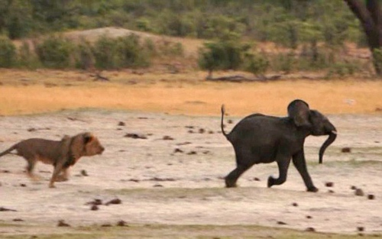
Enemies/Threats
Adult African elephants have no enemies because of their massive size. However, infant and young elephants can be prey to lions, crocodiles and juveniles.
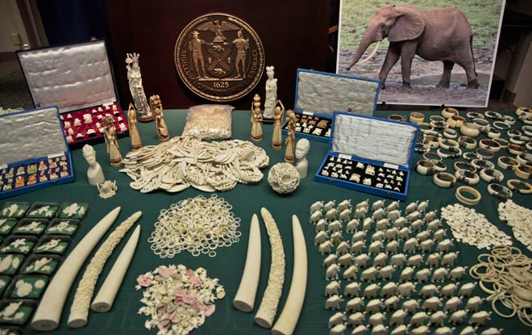
Figure 7: Lion chasing young elephant

Humans pose the largest threat to African elephants because the ivory from
their tusks is seen as valuable to some humans and many elephants have been killed for their tusks. It is illegal to kill elephants today, but it has not been completely eliminated, and some African elephant populations remain endangered.
Figure 8: Ivory products sold illegally

Name: __________________________________________ Date: __________________
Expert Group
Big-Eared Bat
Kingdom: Animalia
Phylum: Chordata
Class: Mammalia

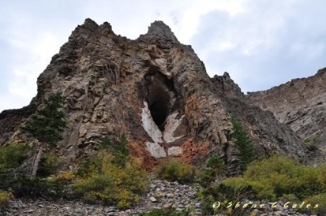
Habitat and Shelter
Big-Eared bats are terrestrial animals that live in the temperate forest biome. They live in caves close to woods and forests and do not migrate. Once they find a cave to live in, they don’t move. They live in colonies.
Figure 1: Bat cave in a Temperate Forest

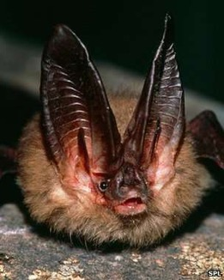
Adaptations: Physical and Behavioral
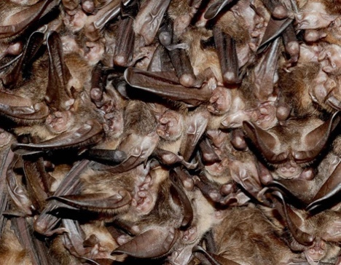
Big-Eared bats are one of the largest bats in its habitat. They are dark brown and have long, soft fur and very big ears. Their big ears allow them to develop extremely sensitive hearing. This extra-sensitive hearing is called echolocation. Sound waves bounce off of flying insects. These bats also store extra fat. During hibernation, the bats’ body-fat helps them stay alive. When they hibernate, they hang together from the cave ceiling in tight clusters to guard against changes in temperature. They hunt and feed at twilight when the sun is going down. Their echolocation helps them to locate their prey in the dark.
Figure 2: Big-eared Bat
Figure 2: Big-eared Bat

Figure 7: Bat roost

Figure 8: Echolocation

Diet
Bats are carnivores. They eat insects that live in the woods and forests near their caves. The bats mostly eat moths, but will also eat butterflies, beetles, crickets, spiders, flies and bees.
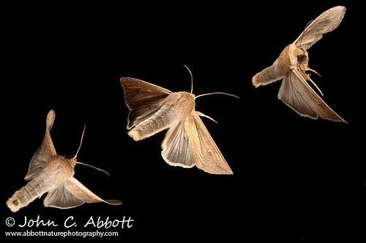

Figure 9: Moths are big-eared bats favored meal

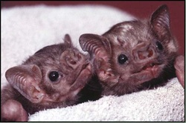
Offspring/Young
Pups are born between May and July. Mothers only have one pup at a time. A pup will fly on its own in 3 weeks. Big-Eared bats live an average of 10 years.

Figure 10: Baby bats have no hair when born.

Enemies/Threats
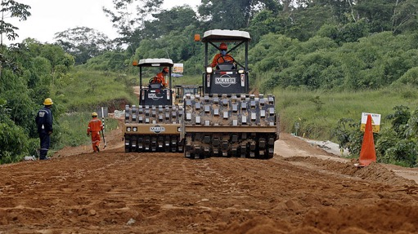
Animals such as snakes, owls, wild cats, raccoons, and hawks prey on Big-Eared bats.
Big-eared bats are an endangered species. One of the reasons is deforestation, the cutting down of trees in a forest. Deforestation has destroyed moths’ habitat, which bats moths mean that the bats have less food. Another reason is a deadly fungal disease called White Nose syndrome. White Nose syndrome has killed over 5 million bats in North America.
Figure 11: Humans clearing a forest for building roads

Name: __________________________________________ Date: __________________
Expert Group
Hercules Beetle
Kingdom: Animalia
Phylum: Anthropada
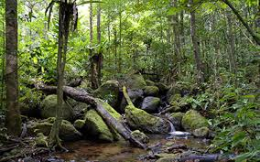
Class: Insecta

Habitat and Shelter
The Hercules beetle is a terrestrial animal that lives the tropical rainforests of South America. They spend most of their life on the forest floors in decaying wood and leaf-litter. Hercules beetles are solitary animals. They live alone.
Figure 1: Tropical rainforests of South America

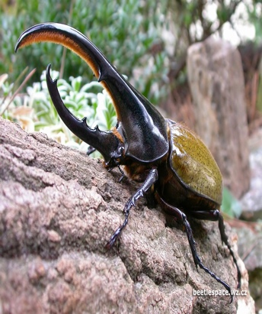
Adaptations: Physical and Behavioral
The Hercules beetle range from 1-7 inches in length, making them one of the largest species of beetles. They have a strong shell, which acts as an outer skeleton. Their shell color acts as camouflage can be black, brown, green blue, white, or yellow.
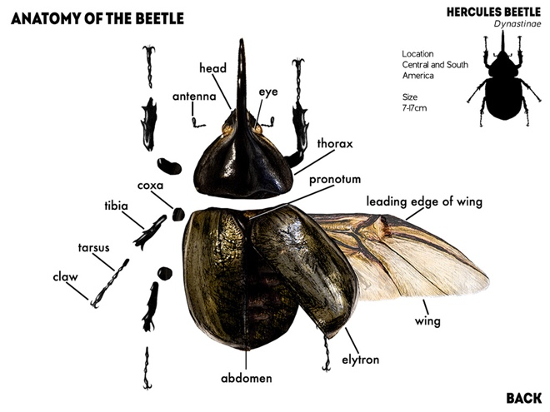
They have enormous horn-like pincers which stick out from the forehead of the males. These horns are not used for biting nor are they poisonous. Only males have horns and are used to fight with other males. Hercules beetles are said to be the strongest creature on earth for their size, able to carry 850 times its own body weight. They use their strength to carry and move their food.
Figure 2: Hercules Beetle in its habitat

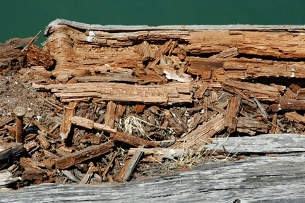
Figure 3: Body parts of a typical beetle

Diet
Hercules beetles forage through leaf-litter on the forest floor in search of something to eat. They mostly eat rotting wood.
Figure 4: Decaying wood

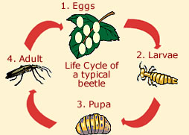
Offspring/Young
Female beetles lay their eggs directly into soil during warm months. Females can lay up to 100 eggs at a time. Hercules beetles experience a complete metamorphosis (change) from egg, to larvae, pupa and transform into an adult insect. This process takes about a year.

Figure5: The four stages of a beetles life

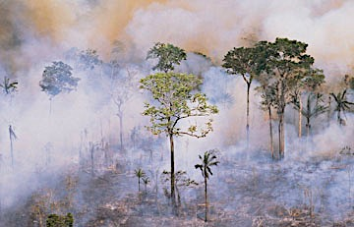
Enemies/Threats
Bats, rats and birds are the main predators of the Hercules beetle along with reptiles and omnivorous mammals.
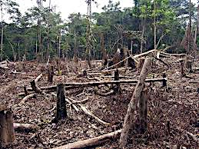

Figure 6: Pollution caused by deforestation

Today, the Hercules beetle is threatened because much of it's natural habitat has been lost to deforestation or been affected by both air and water pollution.
Figure 7: Deforestation of the Amazon Rainforests

Name: ________________________________________ Date: __________________
Expert Group
Siberian Musk Deer
Kingdom: Animalia
Phylum: Chordata
Class: Mammalia

Habitat and Shelter
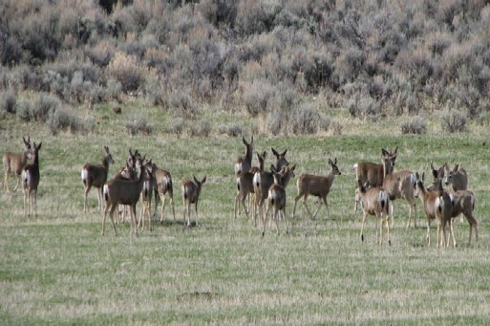
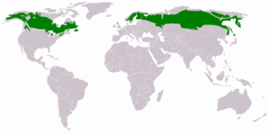
The Siberian musk deer is a terrestrial animal that lives the Taiga biome in eastern Eurasia. They live in mountainous areas. Deer live in herds or can be solitary, which means they live alone. Sometimes herds are segregated: males (bucks) live in one herd, the females (does) in another and their offspring (fawns), in another.
Figure 8: Taiga biomes in the world
Figure 1: Deer in a herd

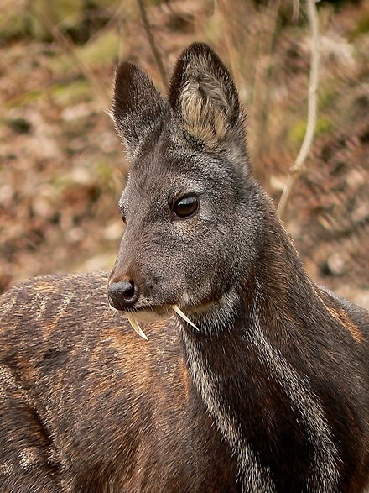
Adaptations: Physical and Behavioral
The Siberian musk deer is one of the smaller species of deer. It weighs about 30 pounds. Its small size helps it hide in the crevices of mountains. It has a stocky body with short, thin front legs and a little longer hind legs. Its hooves are long, wide and pointed. Together, its legs and hooves help it move around better in the snow. Male Siberian musk deer grow long tusks instead of antlers. They used these to attract females and compete with other males. Males also have a gland in their body that releases a “musk” scent, which also attracts females. Both males and females are nocturnal, active at night. They feed from dusk to dawn and spend the day resting.
Figure 2: Adult male Siberian Musk Deer

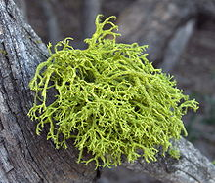
Diet
Siberian musk deer are herbivores. Their main source of nutrients is lichen.

Figure 3: Lichen can grown on trees and rocks

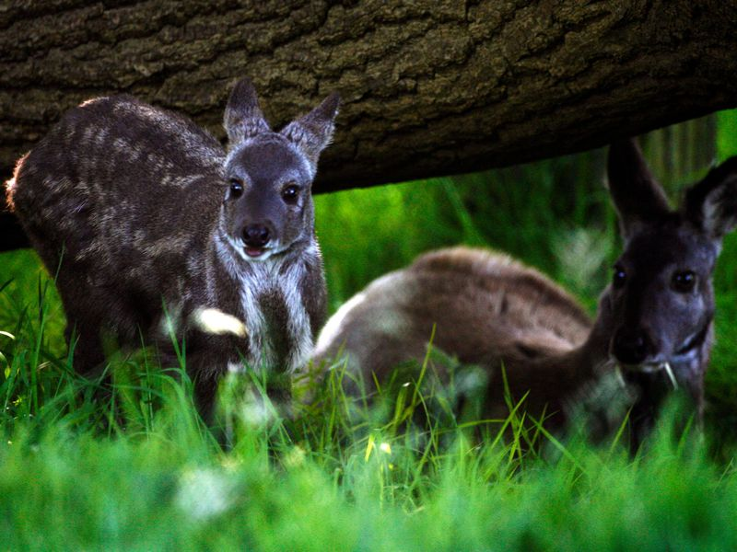
Offspring/Young
Fawns are born within 6 months between May through June. Does usually give birth to 1-3 fawns at at time. It takes a fawn about one year to reach maturity. Deer can live an average life of 12 years.
Figure 4: Fawns in the Taiga

Enemies/Threats
Lynx and wolverines are the main predators of the Siberian musk deer. However, the main threat for the Siberian musk deer is the Musk Trade. Humans hunt the deer for it musk scent to put in perfumes and some medicines used in eastern Eurasia.
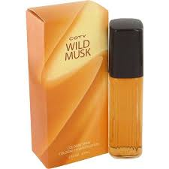

Figure 5: Musk scented Perfume

Process Grid - Empty

Animal  (Classification) | Habitat and Shelter | Adaptations – Physical and Behavior | Diet | Offspring/ Young | Enemies/  Threat
Mexican Gray Wolf

African Elephant

Big Eared Bat
Hercules Beetle
Siberian Musk Deer

Process Grid – Complete
Animal  Kingdom  Phylum  Class | Habitat and Shelter | Adaptations  Physical/ Behavioral | Diet | Offspring/  Young | Enemies/  Threat
Mexican Gray Wolf  Animalia  Chordata  Mammalia | - Desert biome  - High Desert  - Used to live in SW USA & Central Mexico  - Live in packs  - Dens | - Long pointy ears to hear danger & prey  - Whiskers to sense objects  - Long legs to run fast  - Thick brown/tan fur camouflage  - Superior small catch prey | - Carnivore  - Hooved mammals (elk deer)  - Small mammals (rabbits, squirrels) | - Pups born to alfa female  - Litters  - All pack care for pups  - Some stay with pack some pups leave to form new pack | - Humans  - Trapped & Poisoned  - Endangered  - Biologist Recovery Program
African Elephant  Animalia  Chordata  Mammalia | - Grasslands biome  - Sub-Saharan Africa  - Live in herds | - largest land animals on Earth  - 2-7 tons  - Trunk- smell, drink and grasp  - Tusks- dig for food Big ears to cool off  - Shower with water and dirt- cool off | - Herbivore  - Roots, grass, fruit and bark | - Almost 2 years to be born  - Calves 200 lbs.  - Stay with herd  - Live about 70 years | - Calves prey for lions, crocodiles and javelinas  - Humans- ivory trade
Big Eared Bat  Animalia  Chordata  Mammalia | - Temperate Forest biome  - Caves  - Live in colonies | - Echolocation- catch prey  - Store fat- warmth  - Roost together- protection of temperature | - Carnivore  - Insects – moths, beetles, flies | - Pups born May to July  - One pup at a time  - 3 weeks can fly  - Live 10 years | - Deforestation- lack of food  - White Nose syndrome
Hercules Beetle  Animalia  Anthropada  Insecta | - Tropical Rainforest Biome  - Rainforest floors  - Inside decayed wood  - Solitary | - Hard shell- skeleton  - Different colors- camouflage  - Pincers (horns)- fight males  - Strong- to carry and move food | - Herbivore  - Leaf-litter  - Rotting wood | - Females lay 100 eggs in soil  - Metamorphosis- egg, Larvae, pupa, and adult beetle  - Takes 1 year | - Predators- Bats, rats, birds  - Deforestation  - Air/Land pollution
Siberian Musk Deer Animalia  Chordata  Mammalia | - Tiaga Biome  - Mountainous Forest (rocky crevices)  - Solitary or herds | - Small body- hide in rocks  - Short, stocky legs  - Pointy hooves- walk in snow  - Males tusks- attract females & compete other males  - Males must scent- attract females  - Nocturnal | - Herbivore  - Lichen | - Fawn born May- July  - 1-3 fawns at a time  - 1 year to mature  - Can live average 12 years | - Predators- Lynx and wolverines  - Musk Trade

Writing Prompt
DIRECTIONS:

Think about all the animals we have studied in this unit including those you may have learned about during your team or individual research time. Choose one animal and write a paragraph about how the physical and behavioral characteristics of this animal help it survive in its habitat.

In your writing, be sure to clearly state a main idea through the use of a topic sentence. You must provide at least three supporting sentences that support your topic sentence. Write a conclusion that restates and expands on your topic sentence and supports your main idea.

This essay has 4 assignments due when submitting your final draft:

- Prewriting Activities ________ 3. Rough Draft ________
- Topic Sentence ________ 4. Final Draft ________

Writing Rubric
Paragraph Grading Rubric

Grading Scale
4 Exceeds Standards
3 Meets Standards
2 Approaching Standards
1 Below Standards
0 Nonexistent
Yes/No
- Prewriting Activities:
Are all prewriting activities included and attached to the final?
Score ________
- Topic Sentence:
Does it state the main idea of your essay?
Score ________
- Evidence Used:
Are there three or more details that support the main idea?
Score ________
- Information and organization:
Is the information explained correctly and coherently?
Score ________
- Conclusion:
Does your conclusion strengthen the main idea?
Score ________
- Conventions:
Does the writing include correct spelling, capitalization and punctuation? __________
Score _________

Score Total = ÷ 6 = __________________

Final Score

ACTION PLAN
Deforestation
Action Plan: Solutions to the problem of deforestation
Deforestation is the destruction of a forest ecosystems by the cutting, clearing, and removal of large areas of trees.

- As a class we will study deforestation beginning with the information on this website: http://kids.mongabay.com/lesson_plans/lisa_algee/deforestation.html
We will focus on:
- Causes
- Environmental Consequences
- Societal Consequences
- Possible Solutions
- With your team, brainstorm what could be done in Virginia or the United States to address this issue.
- With your team, create an action plan presentation on the issue of deforestation. (paper slides, video, power point, report, letter, play, poem, etc.)
- Present your action plan to the class.
- Revise and edit your action plan presentation based on class input.
- Find contact information for your school, neighborhood or community. Submit a formal request to share your presentation. Follow-up your request and await a response.

*Objective of Action Plan:
This action plan is a working graphic organizer to be constructed with the students as the topic develops.

*Assessment: Teacher should provide students with a rubric for Action Plan including grade level standards and school and/or classroom goals. (21st Century Goals) This could be created with student input.

Graffiti Wall Questions

True/False

Animal adaptations are what humans do to help animals survive. T F
Why is this true or false?

Match the word with its definition

hibernate - an animal that hunts another animal
camouflage - when an animals body slows down for a long period of time
predator to save energy
prey - an animal that is hunted by another animal
- when an animal is able to blend into its environment and
not be seen easily

Pictorial Chart

Draw a picture of the Mexican Gray Wolf and label its physical adaptations.

Formación de oraciones

Escriban una oración interesante acerca de los animales usando todos las partes de la oración.

Historia narrativa

Dibujan una escena (algo importante que pasó) del cuento “El polluelo pingüino”. Escriban una oración describiendo lo que está pasando en la escena.

Open Response

Explain how humans have threatened some animal species.

Fill in the blank

An adaptation the Mexican Gray Wolves have ________________________ which help them to _____________________________.

Animal Adaptation Test Name_____________________________

- A scientist who studies and works with animals in their habitats is called a ____________________.

- An adaptation is
  - an animal
  - a plant
  - a scientist
  - a physical or behavioral change

- A place where an animal lives is called its
  - diet
  - physical features
  - habitat
  - behavior

- Write about the physical adaptations of an animal we studied in this unit.

- Write about the behavioral adaptations of an animal we studied in this unit.

- Which part of speech is an action word such as swims, eats, and hibernates?
  - verb
  - adjective
  - adverb
  - noun

- Which word is an example of an adverb?
  - seals
  - on the rocks
  - quickly
  - none of the above

- Write a sentence about animals using all the parts of speech from the Sentence Patterning Chart.

- How do physical and behavioral adaptations help animals survive in their habitats?

- On the back, write a paragraph about the impact of humans on animal habitats. Remember to begin with a topic sentence.

