ANCIENT INDIA
(Level 6) NM
IDEA PAGES
I. UNIT THEME
- Physical geography was important to the development of Indian civilizations.
- India’s great empires brought significant changes to its political, religious, economical social and artistic life
- Hinduism and Buddhism originated in Ancient India and have had world-wide impact
- Examining older civilizations gives us new insights for today’s world

II. FOCUS/MOTIVATION
- Observation charts
- Cognitive content dictionary
- Inquiry chart
- Indian music and art
- Big Book
- Video clips

III. ASSESSMENT/FEEDBACK
- Chapter test
- Personal exploration with rubric
- Team Big Books
- Expository, narrative and poetry pieces of writing

IV. CONCEPTS

NEW MEXICO’S SOCIAL STUDIES STANDARDS
History – Content Standard I: Students are able to identify important people and events in order to analyze significant patterns, relationships, themes, ideas, beliefs and turning points in New Mexico, United States and world history in order to understand the complexity of the human experience. Students will:
World: compare and contrast major historical eras, events, and figures from ancient civilizations to the age of exploration
6-1 Describe and compare the characteristics of the ancient civilizations of Egypt, Mesopotamia and China and explain the importance of their contributions to later civilizations, to include:
1.c - effect on world economies and trade
6-2 Describe and analyze the geographic, political, economic, religious, and social structures of early civilizations of India, to include:
2.a - location and description of the river systems and other topographical features that supported the rise of this civilization;
2.b - significance of the Aryan invasions;
2.c - structure and function of the caste system;
2.d - important aesthetic and intellectual traditions (e.g., Sanskrit literature, medicine, metallurgy, mathematics including Hindu-Arabic numerals and the number zero);
6-4 Describe major religions of the world to include Hinduism, Buddhism, Judaism, Christianity and Islam (e.g., founding leaders, traditions, customs, beliefs);
Skills : Research historical events and people from a variety of perspectives:
6-1 - organize information by sequencing, categorizing, identifying cause-and-effect relationships, comparing and contrasting, finding the main idea, summarizing, making generalizations and predictions, drawing inferences and conclusions;
6-2 - identify different points of view about an issue or topic; and
6-3 - use a decision-making process to identify a situation that requires a solution; gather information, identify options, predict consequences and take action to implement that solution.

Geography-Content Standard II: Students understand how physical, natural, and cultural processes influence where people live, the ways in which people live, and how societies interact with one another and their environments. Students will:
2-A: analyze and evaluate the characteristics and purposes of geographic tools, knowledge, skills and perspectives and apply them to explain the past, present and future in terms of patterns, events and issues:
6-1. identify the location of places using latitude and longitude; and
6-2. draw complex and accurate maps from memory and interpret them to answer questions about the location of physical features.
2-B: explain the physical and human characteristics of places and use this knowledge to define regions, their relationships with other regions, and their patterns of change:
6-1. explain how places change due to human activity;
6-2. explain how places and regions serve as cultural symbols and explore the influences and effects of regional symbols;
2-D: explain how physical processes shape the earth’s surface patterns and biosystems:
6-1. describe how physical processes shape the environmental patterns of air, land, water, plants and animals.
2-E: explain how economic, political, cultural and social processes interact to shape patterns of human populations and their interdependence, cooperation and conflict:
6-3. explain how cultures create a cultural landscape, locally and throughout the world, and how these landscapes change over time.

Civics and Government- Content Standards III: Students understand the ideals, rights, and responsibilities of citizenship and understand the content and history of the founding documents of the United States with particular emphasis on the United States and New Mexico constitutions and how governments function at local, state, tribal, and national levels. Students will:
3-D: explain how individuals have rights and responsibilities as members of social groups, families, schools, communities, states, tribes and countries:
6.1 understand that the nature of citizenship varies among societies

Economics - Content Standard IV: Students understand basic economic principles and use economic reasoning skills to analyze the impact of economic systems (including the market economy) on individuals, families, businesses, communities, and governments. Students will:
4-C: describe the patterns of trade and exchange in early societies and civilizations and explore the extent of their continuation in today’s world:
6-1. compare and contrast the trade patterns of early civilizations; and
COMMON CORE STATE STANDARDS – English Language Arts

Key Ideas and Details:
ELA-History/Social Studies. 6-8.1 - Cite specific textual evidence to support analysis of primary and secondary sources.
ELA-H/SS.6-8.2 - Determine the central ideas or information of a primary or secondary source; provide an accurate summary of the source distinct from prior knowledge or opinions.

Craft and Structure:
ELA-H/SS.6-8.4 - Determine the meaning of words and phrases as they are used in a text, including vocabulary specific to domains related to history/social studies.
ELA-H/SS.6-8.5 - Describe how a text presents information (e.g., sequentially, comparatively, causally).
ELA-H/SS.6-8.6 - Identify aspects of a text that reveal an author's point of view or purpose (e.g., loaded language, inclusion or avoidance of particular facts).

Integration of Knowledge and Ideas:
ELA-H/SS.6-8.7 - Integrate visual information (e.g., in charts, graphs, photographs, videos, or maps) with other information in print and digital texts.
ELA-H/SS.6-8.9- -Analyze the relationship between a primary and secondary source on the same topic.

Range of Reading and Level of Text Complexity:
ELA-H/SS.6-8.10 - By the end of grade 8, read and comprehend history/social studies texts in the grades 6-8 text complexity band independently and proficiently.

Text Types and Purposes:
ELA-Writing.6-8.2 - Write informative/explanatory texts, including the narration of historical events, scientific procedures/ experiments, or technical processes.
ELA-Writing.6-8.2.a - Introduce a topic clearly, previewing what is to follow; organize ideas, concepts, and information into broader categories as appropriate to achieving purpose; include formatting (e.g., headings), graphics (e.g., charts, tables), and multimedia when useful to aiding comprehension.
ELA-Writing.6-8.2.b - Develop the topic with relevant, well-chosen facts, definitions, concrete details, quotations, or other information and examples.
ELA-Writing.6-8.2.c - Use appropriate and varied transitions to create cohesion and clarify the relationships among ideas and concepts.
ELA-Writing.6-8.2.d - Use precise language and domain-specific vocabulary to inform about or explain the topic.
ELA-Writing.6-8.2.e - Establish and maintain a formal style and objective tone.
ELA-Writing.6-8.2.f - Provide a concluding statement or section that follows from and supports the information or explanation presented.

Production and Distribution of Writing:
ELA-Writing.6-8.4 - Produce clear and coherent writing in which the development, organization, and style are appropriate to task, purpose, and audience.
ELA-Writing.6-8.5 - With some guidance and support from peers and adults, develop and strengthen writing as needed by planning, revising, editing, rewriting, or trying a new approach, focusing on how well purpose and audience have been addressed.
ELA-Writing.6-8.6 - Use technology, including the Internet, to produce and publish writing and present the relationships between information and ideas clearly and efficiently.

Research to Build and Present Knowledge:
ELA-Writing.6-8.7 - Conduct short research projects to answer a question (including a self-generated question), drawing on several sources and generating additional related, focused questions that allow for multiple avenues of exploration.
ELA-Writing.6-8.8 - Gather relevant information from multiple print and digital sources, using search terms effectively; assess the credibility and accuracy of each source; and quote or paraphrase the data and conclusions of others while avoiding plagiarism and following a standard format for citation.
ELA-Writing.6-8.9 - Draw evidence from informational texts to support analysis, reflection, and research.

Comprehension and Collaboration:
ELA-Speaking/Listening.6.1 - Engage effectively in a range of collaborative discussions (one-on-one, in groups, and teacher-led) with diverse partners on grade 6 topics, texts, and issues, building on others' ideas and expressing their own clearly.
ELA-S/L.6.1.a - Come to discussions prepared, having read or studied required material; explicitly draw on that preparation by referring to evidence on the topic, text, or issue to probe and reflect on ideas under discussion.
ELA-S/L.6.1.b - Follow rules for collegial discussions, set specific goals and deadlines, and define individual roles as needed.
ELA- S/L.6.1.c - Pose and respond to specific questions with elaboration and detail by making comments that contribute to the topic, text, or issue under discussion.
ELA-S/L.6.1.d - Review the key ideas expressed and demonstrate understanding of multiple perspectives through reflection and paraphrasing.
CCSS.ELA-Literacy.SL.6.2 - Interpret information presented in diverse media and formats (e.g., visually, quantitatively, orally) and explain how it contributes to a topic, text, or issue under study.
CCSS.ELA-Literacy.SL.6.3 - Delineate a speaker's argument and specific claims, distinguishing claims that are supported by reasons and evidence from claims that are not.

Presentation of Knowledge and Ideas:
CCSS.ELA-Literacy.SL.6.4 - Present claims and findings, sequencing ideas logically and using pertinent descriptions, facts, and details to accentuate main ideas or themes; use appropriate eye contact, adequate volume, and clear pronunciation.
CCSS.ELA-Literacy.SL.6.5 - Include multimedia components (e.g., graphics, images, music, sound) and visual displays in presentations to clarify information.
CCSS.ELA-Literacy.SL.6.6 - Adapt speech to a variety of contexts and tasks, demonstrating command of formal English when indicated or appropriate. (See grade 6 Language standards 1 and 3 for specific expectations.)

English Language Arts Standards – Reading – Literature (6)

Key Ideas and Details:

CCSS.ELA-Literacy.RL.6.1
Cite textual evidence to support analysis of what the text says explicitly as well as inferences drawn from the text.
CCSS.ELA-Literacy.RL.6.2
Determine a theme or central idea of a text and how it is conveyed through particular details; provide a summary of the text distinct from personal opinions or judgments.
CCSS.ELA-Literacy.RL.6.3
Describe how a particular story's or drama's plot unfolds in a series of episodes as well as how the characters respond or change as the plot moves toward a resolution.

Craft and Structure:
CCSS.ELA-Literacy.RL.6.4
Determine the meaning of words and phrases as they are used in a text, including figurative and connotative meanings; analyze the impact of a specific word choice on meaning and tone
CCSS.ELA-Literacy.RL.6.5
Analyze how a particular sentence, chapter, scene, or stanza fits into the overall structure of a text and contributes to the development of the theme, setting, or plot.
CCSS.ELA-Literacy.RL.6.6
Explain how an author develops the point of view of the narrator or speaker in a text.

Integration of Knowledge and Ideas:
CCSS.ELA-Literacy.RL.6.7
Compare and contrast the experience of reading a story, drama, or poem to listening to or viewing an audio, video, or live version of the text, including contrasting what they "see" and "hear" when reading the text to what they perceive when they listen or watch.
CCSS.ELA-Literacy.RL.6.8
(RL.6.8 not applicable to literature)
CCSS.ELA-Literacy.RL.6.9
Compare and contrast texts in different forms or genres (e.g., stories and poems; historical novels and fantasy stories) in terms of their approaches to similar themes and topics.

Range of Reading and Level of Text Complexity:
CCSS.ELA-Literacy.RL.6.10
By the end of the year, read and comprehend literature, including stories, dramas, and poems, in the grades 6-8 text complexity band proficiently, with scaffolding as needed at the high end of the range.

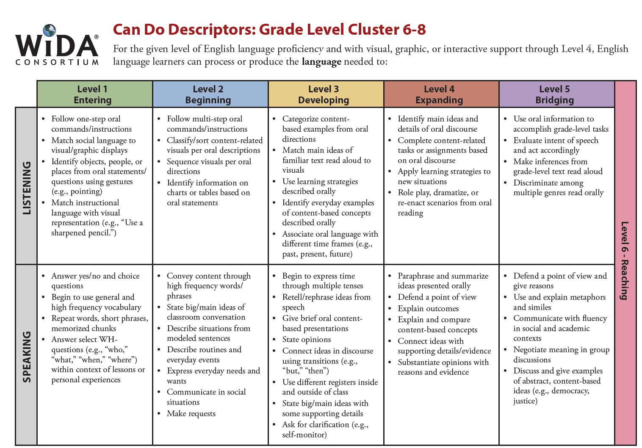
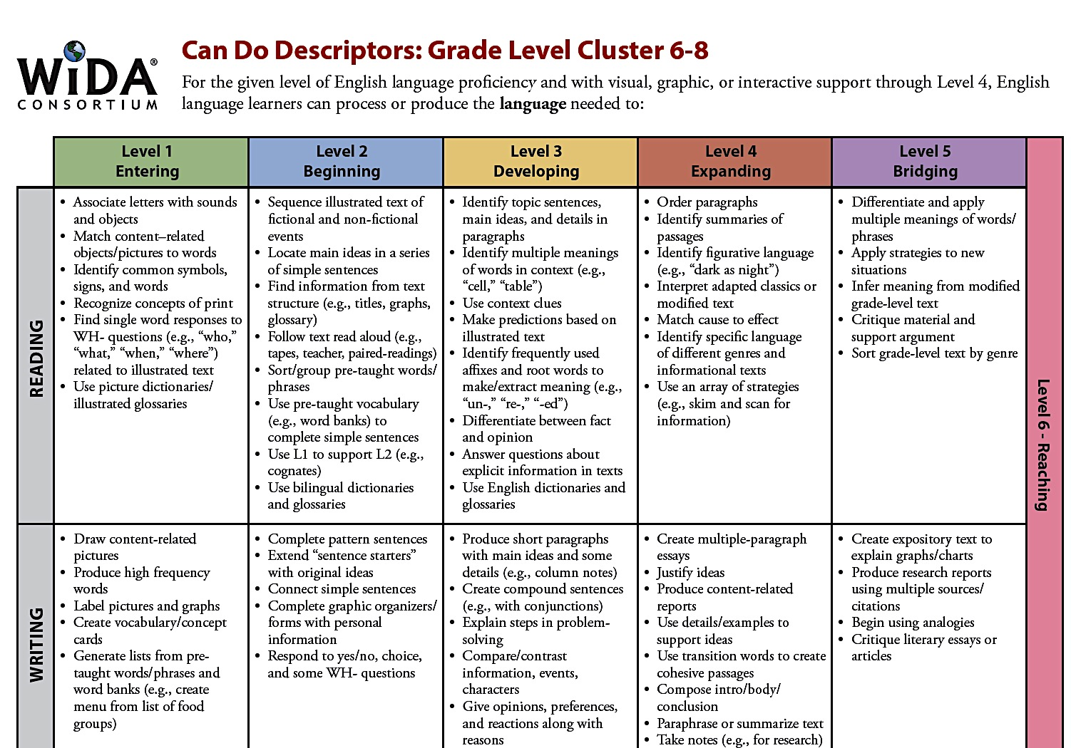

V. VOCABULARY
Tier 2 Vocabulary Tier 3 Vocabulary
civilization  invasion  egalitarian  dynasties  agriculture  artisanship  flooding  arid  religion  beliefs  East Indian  crops  meditate  infantry  cavalry  fertile  chariots | geography  exodus  currency  wisdom  conflict  unity  subcontinent  migration  empire  invade  settle  reign  tolerance  trade  nomads  social class | commoners  finance  security  merchants  sacred | caste  monsoon  Buddhism  Hinduism  nirvana  Aryan  Indo-European  Sanskrit  Karma  dharma  Brahmans  reincarnation  raja  cinnamon  adz  untouchables  ginger  cardamom

VI. RESOURCES

TEACHER RESOURCES
National geographic Vol 167, No 4, April 1985
India’s Gupta Dynasty, (Cultures of the Past Series), Katherine Hinds, Benchmark Books, ISBN 0-7614-0071-0
The Adventures of Archaeology, National Geographic Society
Milestones in History: Ancient Empires, Newsweek Books, ed. SGF Brandon
Old World Civilizations: The Rise of Cities and States, Vol 3 – Landmark Series, American Museum of Natural History, Harper San Francisco

LITERATURE
The Gifts of Wali Dad Retold by A. Shepard, illus. D San Souci, Atheneum Books for Young Readers, ISBN 0 – 684 – 19445 - 7
Folktales from India, edited by AK Ramanujan, Pantheon Books,
ISBN 0-394-55479-5
The Five Sons of King Pandu: The Story of the Mahabharata, Retold by E. Seeger & illus. by G. Laite
Buddha by Demi

Prince Siddhartha: The Story of Buddha by Jonathan Landaw

The Fantastic Adventures of Krishna by Demi

Elephant Prince: The Story of Ganesh by Amy Novesky and Belgin K. Wedman

WEBSITES
The Mauryan Empire (http://www.allempires.com)

Mauryan Empire (http://www.history-forum.com/index)

The Mauryan Empire from Britannica (http://www/brotammoca/com/eb/article-9051518)

Ashoka and Buddhism (http://buddhistcouncil.org/Asoka.html)

Maurya Empire(http://en.wikipedia.org/wiki/Maurya_Empire)

Kingdoms of Southern India http://nabatawa.net/sinia.html

Maurya Empire http://en.wwikipedia.org/wik/Maury_Empire

The Age Of Empires Daily –Life
http://members.aol.com/Donnclass/Indialife.html#ARYAN

The Chalukyan Dynasty:
http://www.newworldencyclopedia.org/entry/Chalukya_dynasty

http://www.historydiscussion.net/history-of-india/the-chalukyas-kingdom-rule-and-culture-of-chalukyas/2533
http://www.historydiscussion.net/history-of-india/the-chalukyas-kingdom-rule-and-culture-of-chalukyas/2533
http://tapioca.xyz/chalukya-dynasty
http://www.newworldencyclopedia.org/entry/Chalukya_dynasty#Land_governance
http://www.scaruffi.com/politics/indians.html
http://www.historydiscussion.net/history-of-india/the-chalukyas-kingdom-rule-and-culture-of-chalukyas/2533
http://www.historyforkids.net/ancient-asian-architecture-for-kids.html
http://www.culturalindia.net/indian-architecture/ancient-architecture/
https://sites.google.com/site/1ancientcivilizationsforkids/ancient-india
http://www.kidsdiscover.com/shop/issues/ancient-india-for-kids/
http://www.hinduwebsite.com/history/indus.asp

ANCIENT INDIA
(Level 6)
UNIT PLANNING PAGES

- I. FOCUS/MOTIVATION
- Cognitive Content Dictionary with Signal Word
- Important Big Book
- Observation Charts
- Literacy/Historian Awards
- Poetry
- Inquiry Charts
- Guest speakers
- Videos, movies, filmstrips
- Field trips
- Pre/post tests

II. INPUT
- Map of Asia with India inset – Graphic Organizer
- Pictorial Input Chart – Indus Valley Civilization
- Comparative Input Chart – Buddhism/Hinduism
- 10/2 lecture with primary language
- Newspaper interest pieces
- Videos

- GUIDED ORAL PRACTICE
- T-graph/processing
- Team co-op group evaluation
- Open Sort with textbook Picture File Cards
- Closed Sort with Picture File Cards - classify, compare, order
- Exploration Report
- Inquiry Chart
- Mind Mapping, list-group-label
- Heads Together/Process Grid
- Poetry
- Sentence Patterning Chart

- READING/WRITING
A. Total Group
• Group Frames (Teacher uses info. from students to model appropriate frame)
- Big Book - The Important Book
Cooperative Strip Paragraph - multiple paragraphs Information
- Poetry Frames
B. Small Group Reading/Writing Activities
• Ear-to-Ear Reading
• Textbook pairs of pairs reading, tutoring, worksheets
• Co-op interpretations of literature legends poetry
• Focused Reading
• Flexible Reading Groups
• Expert Groups
• Team Tasks
• Reader's Theater
• Team Writing Workshop
• Group Process Grids
• Farmer-in-the-Dell/Sentencing Patterning Chart
• Interactive Reading
• Book Sharing
C. Individual Activities - Portfolio
• Paragraph writing
• Poetry writing
• Interactive Journal Writing
• Learning Logs
• Individual Tasks
- Writer's Workshop
• Mini Lesson
• Writing/planning
• Conferences
• Author's Chair
V. EXTENDED ACTIVITIES FOR INTEGRATION
• Poetry with musical instruments
• Read Aloud
• Newspaper interest pieces

VII. ASSESSMENT AND FEEDBACK
• Focused Reading
• Process Inquiry Charts
•Vocabulary Strips - Where's My Answer
• Reading Big Books, share individual poetry
• Personal Exploration with Rubric
• Student Generated Text
• Student portfolios and presentations
• Student action plan
• Teacher-created exam

SAMPLE DAILY LESSON PLAN
NOTE: Italicized strategies are used frequently in the classroom. Each day is the equivalent of 1 to 1 ½ weeks of instruction.

DAY 1:
FOCUS/MOTIVATION
- Three Personal Standards and Literacy Awards
- Cognitive Content Dictionary w/Signal Word
- Observation Charts
- Prediction Reaction Guide
- Inquiry Chart
- Big Book - Teacher made
- Portfolios

INPUT
- Graphic Organizer Input Chart Map of Asia/India inset and timeline – Big Picture
10/2 lecture with primary language
Learning log
ELD Review & Primary Language Preview/Review
- Pictorial Input Chart—Indus Valley Civilization
10/2 lecture with primary language
Learning log
ELD review

GUIDED ORAL PRACTICE
- Chants
- T-graph for social skills – Team Points
- Picture File Cards
-Free Exploration
-open sort – list, group, label
-closed sort – provide categories
- Exploration Report

READING/WRITING
- Listen & Sketch
- Interactive Journals

ASSESSMENT/FEEDBACK
- Home/School Connection
- Process inquiry charts, chants and input charts
SAMPLE DAILY LESSON PLAN
NOTE: Italicized strategies are used frequently in the classroom. Each day is the equivalent of 1 to 1 ½ weeks of instruction.
DAY 2:
FOCUS/MOTIVATION
- Cognitive Content Dictionary w/Signal Word
- Process Home/School Connection
- Three Personal Standards and Literacy Awards
- Process Chant (TPR, highlight, sketch, picture file cards)

GUIDED ORAL PRACTICE
- Graphic Organizer Input Chart Review with word cards

INPUT
- Narrative Input - Buddha
10/2 lecture with primary language
Learning log
ELD review & primary language preview/review

GUIDED ORAL PRACTICE
- Chants (TPR, highlight, sketch, picture file cards)
- Pictorial Input Chart Review with word cards (emphasize concept words)
- Review T-Graph for Social Skills
Team Tasks

READING/WRITING
- Expert Groups
Team Share & Process T-graph

GUIDED ORAL PRACTICE
- Narrative Input - Review with word cards and conversation bubbles
Learning Log
- Chants

READING/WRITING
- Sentence Patterning Chart (AKA Farmer-in-the-Dell)
Reading Game and Trading Game
- Writer’s Workshop
Mini-lesson: Using the comparative input chart to write a compare/contrast
Writing
Author’s Chair
ASSESSMENT/FEEDBACK
- Process charts/ chants
- Home/School Connection
SAMPLE DAILY LESSON PLAN
NOTE: Italicized strategies are used frequently in the classroom. Each day is the equivalent of 1 to 1 ½ weeks of instruction.
DAY 3:
FOCUS/MOTIVATION
- Cognitive Content Dictionary w/Signal Word
- Process Home/School connection
- Three Personal Standards and Literacy Awards

GUIDED ORAL PRACTICE
- Mind Map
- Process Grid Game

- READING/WRITING
- Cooperative Strip Paragraph
-read, respond, revise, edit
- Found Poetry

GUIDED ORAL PRACTICE
- Narrative Input - Review with story map
- Poems/Chants
- Sentence Patterning Chart (AKA Farmer-in-the-Dell) – change verb to –ing

READING/WRITING
- Flip Chant
- Team Tasks
- Read Aloud
- Reading/Writing Workshop
-Mini-lesson based on Narrative Input Chart
-Author’s Chair
- Interactive Journals

ASSESSMENT/FEEDBACK
- Process Inquiry Chart
- Home School Connection
SAMPLE DAILY LESSON PLAN
NOTE: Italicized strategies are used frequently in the classroom. Each day is the equivalent of 1 to 1 ½ weeks of instruction.
DAY 4:

FOCUS/MOTIVATION
- Cognitive Content Dictionary with “stumper word” (student self-selected vocabulary)
- Process Home School Connection
- Three Personal Standards and Literacy Awards

GUIDED ORAL PRACTICE
- Poetry/Chants

READING/WRITING
- Process T-Graph & Oral Evaluation
Team tasks

- Flexible Groups Reading- leveled, skill, heterogeneous, homogeneous, ELD
- Coop Strip Paragraph group- struggling/emergent readers
- Clunker and Links- at or above grade level with SQ3R
- ELD Group Frame-- Story or Chart Retell

- Team Presentation
- Ear-to-Ear Reading with Poetry Booklet
- Read the Walls with individual CCD
- Team Writing Workshop, topic based on narrative input chart

ASSESSMENT/FEEDBACK
- Interactive Journals
- Process Inquiry Chart

SAMPLE DAILY LESSON PLAN
NOTE: Italicized strategies are used frequently in the classroom. Each day is the equivalent of 1 to 1 ½ weeks of instruction.
DAY 5:

FOCUS/MOTIVATION
- Cognitive Content Dictionary with “stumper word” (student self-selected vocabulary)
- Process Home School Connection
- Three Personal Standards and Literacy Awards
- Poetry/Chants

READING/WRITING
- Action Plan
- Team Tasks
-Living Walls
-Individual tasks
-ELD Group Frame with Pictorial Input Chart
- Process T-graph
Written Evaluation
Team Presentation
- Interactive Journals
- Listen and Sketch
- Flexible group reading
- Guided reading
Team Tasks:
- Team Big Book Page "The Most Important Thing About…"
- Team Evaluation
- Team Presentation

ASSESSMENT/FEEDBACK
- Personal Exploration w/the Inquiry Chart
- Expert Group Presentations
- Share Team Big Book
- Evaluate Week (letter)
- Jeopardy with Process Grid
- Metacognition of learning

India’s First Cities  http://quatr.us/india/architecture/harappanarchitecture.htm  The villages that began to develop along the Indus River Valley are among the oldest in the world. At first, almost ever villager was a farmer. As farming methods improved, farmers produced enough food to feed thousands of people. This allowed some of them to do other kinds of work. They became merchants, traders, and craftsmen. Villages turned into towns and some towns turned into large cities. By 2500 BCE, the Indus civilization was large enough to have two major cities: Mohenjo-Daro and Harappa.  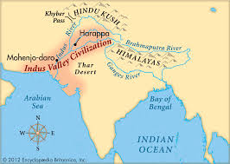  Look at the map. On the back write about why you think these two cities grew in this location. Sign you name and read your explanation to a classmate. | HARAPPA and MOHENJO-DARO  http://quatr.us/india/architecture/harappanarchitecture.htm  The earliest large-scale buildings in India were built by the Harappan people in the Indus River valley, about 2500 BCE in the cities of Harappa and Mohenjo-Daro. The Harappan buildings included high brick walls around their cities to keep out enemies. Most of the buildings were ordinary houses, with rooms arranged around a small courtyard. Probably some families owned a whole house (and lived in it with their slaves, while others rented only one room in a house, and the whole family lived together in the one room.  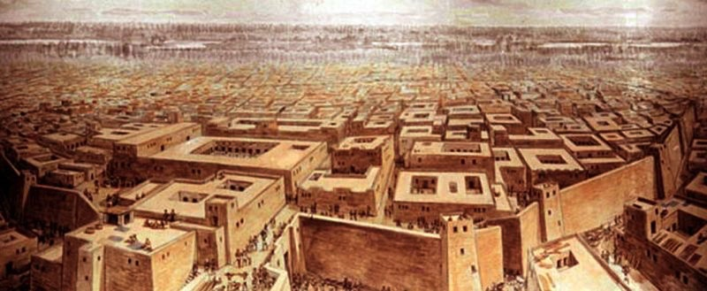On the back, write or sketch about how your home compares to that of the Harrapan people. Sign you name and share your comparison with a classmate. | HARAPPA and MOHENJO-DARO  http://quatr.us/india/architecture/harappanarchitecture.htm  Harappa and Mohenjo Daro were expertly planned cities built with a grid pattern of wide, straight streets. Thick walls surrounded the cities. Many people lived in sturdy brick houses that had as many as three floors. Some houses had bathrooms and toilets that connected to the world’s first sewer system. An irrigation system of canals provided a reliable source of water for growing wheat and barley. There is also evidence that people herded sheep, cattle and goats.  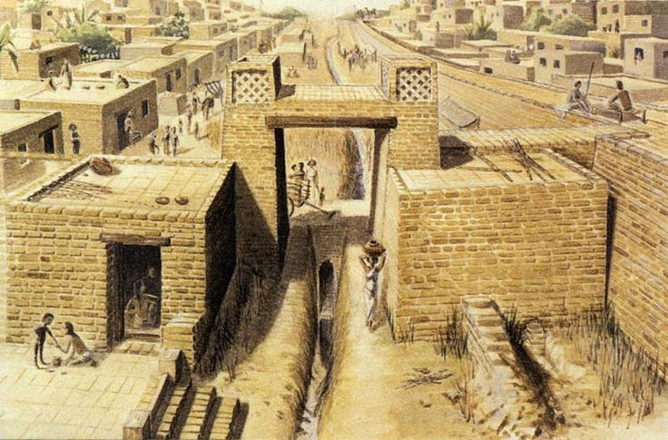  On the back, write and or sketch your interpretation of what these cities looked like. Sign you name and share your depiction with a classmate.

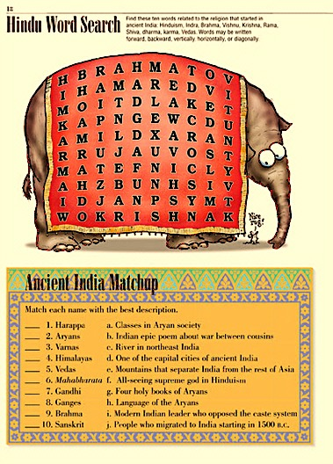
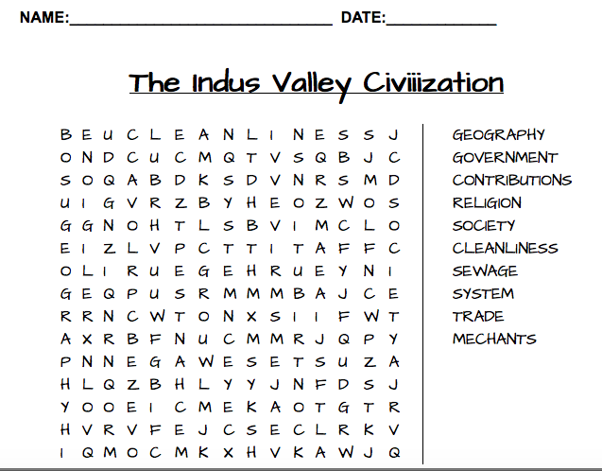
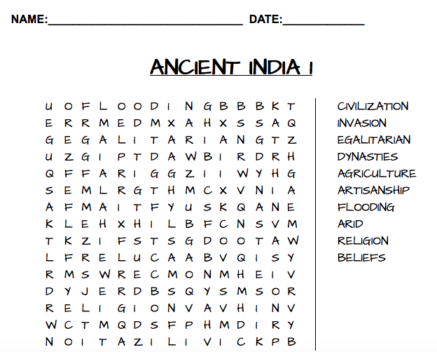

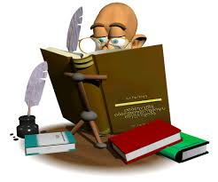  SUPER HISTORIAN AWARD | SUPER HISTORIAN AWARD  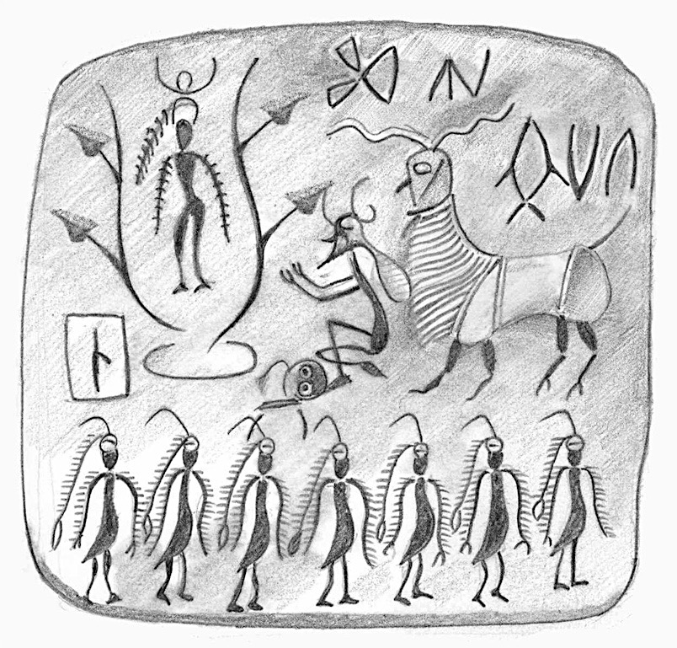
SUPER HISTORIAN AWARD  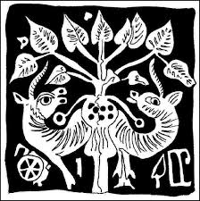 | SUPER HISTORIAN AWARD  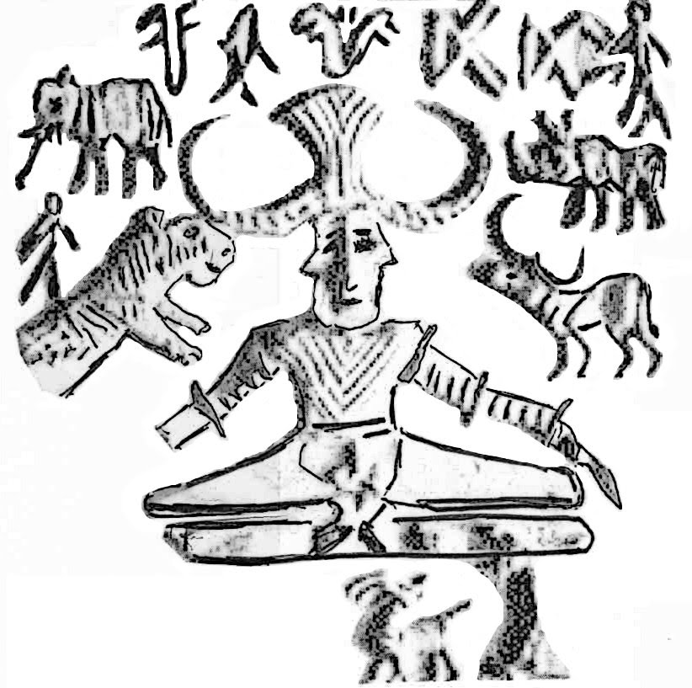

Prediction Reaction Guide
Respond to each question by sketching and writing.

- Why would people settle near a river?
Prediction
Reaction

- What important world religions come from India?
Prediction
Reaction

- Why are monsoons important to India’s climate?
Prediction
Reaction

- What kinds of things did ancient Indian merchants trade
Prediction
Reaction

Big Book Text
The Most Important Thing About Ancient India
By Ruth Kriteman and Diana Pinkston-Stewart

Table of Contents

1: The civilizations of Ancient India

2: Geography/Climate

3: Frequent change of rulers

4: Society

5: Hinduism

6: Buddhism

7: Contributions

Glossary

(Page 1) The most important thing about Ancient India is that its civilizations were shaped by its geography, the frequent change of leaders and religious beliefs.

The timeline for Ancient India’s great civilization begins in 2500 BCE and lasts until 1190 CE
- The Indus Valley Civilization began in the Indus River Valley where the soil was rich. Food was plentiful so the people had time to build homes and make tools.
- Then, the Aryan people invaded and settled throughout India. Soon, a civilization grew. The Aryans were skilled ironworkers and farmers. They brought a new language to India and began a new religion: Hinduism!
- In 322 BCE the Mauryan Empire began in northern India. Until 185 BCE every ruler came from the Maurya family. The Mauryan era was peaceful thanks especially to the ruler Ashoka, who brought Buddhism to India.
- In 315 BCE the Gupta family came into power. They remained the leaders of India until 535 CE. During their reign important mathematical concepts were developed.
- From 550 to 1190 CE the Chalukyan dynasty ruled India. There was great religious tolerance and extensive land and sea trade

But, the most important thing about Ancient India is that its civilizations were shaped by its geography, the frequent change of leaders and religious beliefs.

(Page 2) The most important thing about Ancient India is that its civilizations were shaped by its geography, the frequent change of leaders and religious beliefs.

- If you look at a map, India looks like a diamond hanging from the bottom of Asia.
- It is a subcontinent because the Himalaya Mountains, the highest mountains in the world, make a barrier between India and the rest of Asia.
- There are now five nations that occupy the Indian subcontinent: India, Pakistan, Nepal, Bhutan and Bangladesh.
- India has two fertile river valleys that are fed by the snowmelt off of the Himalayas: The Ganges River and the Indus River.
- Monsoons are important to India’s climate. A monsoon is a strong wind that blows one direction in the winter and the opposite direction in the summer. The winter monsoon brings cold, dry air from the mountains. The summer monsoon brings warm, wet air from the Arabian Sea, which brings heavy, daily rain.

But, the most important thing about Ancient India is that its civilizations were shaped by its geography, the frequent change of leaders and religious beliefs.

(Page 3) The most important thing about Ancient India is that its civilizations were shaped by its geography, the frequent change of leaders and religious beliefs.

India’s many gifts made it an attractive land to rule. Many people wanted to be its raja, or prince.
- Most of India’s rulers developed a strong military to help to keep them in power.
- There was the infantry, or soldiers on foot, the cavalry, soldiers on horseback and the elephant corps, elephants that were trained and guided by humans for combat.
- Some of India’s rulers came from the same family. These are called dynasties. The most important dynasties came from the Maurya family and the Gupta family.
- The Chalukyan Dynasty was actually 3 closely related, but individual dynasties.
- The most important and unique ruler was from the Mauryan Dynasty. His name was Emperor Asoka. Unlike other rulers, he was the first Buddhist ruler. He stopped waging war and promoted peace throughout India.

But, the most important thing about Ancient India is that its civilizations were shaped by its geography, the frequent change of leaders and religious beliefs.

(Page 4) The most important thing about Ancient India is that its civilizations were shaped by its geography, the frequent change of leaders and religious beliefs.

Beginning with the Indus Valley civilization, Indian society has developed in large cities as well as smaller towns and villages.
- People settled in areas with available water for personal use and for irrigation of crops.
- Artisanship was promoted: people learned how to make useful iron tools as well as beautifully carved toys for the children.
- Temples were built for religious ceremonies that still stand today.
- Universities grew and provided access to higher education.
- Extensive trade routes were established by land and by sea with other Asian
- There was trade with other countries. Merchants traveled by land and by sea.

But, the most important thing about Ancient India is that its civilizations were shaped by its geography, the frequent change of leaders and religious beliefs.

(Page 5) The most important thing about Ancient India is that its civilizations were shaped by its geography, the frequent change of leaders and religious beliefs.

Two of the world’s most important religions got their start in Ancient India.
Hinduism grew out of the religious customs of many people over thousands of years.
- Hindus believe in many gods and goddesses. Lord Vishnu is the preserver of the world. Lord Shiva is the destroyer. Ganesha is the lord of living things and Lakshmi is the goddess of light and beauty.
- The gods and goddesses are part of one universal spirit called Brahman.
- Hindus believe that a person must pass through many lives to be united with Brahman. This is called reincarnation.
- To earn the reward of a better life, Hindus law says people must perform their duty. This law is called dharma.
- How a person lives is called karma. If a Hindu lives a good life, they will have good karma. This will move them closer to Brahman in their next life.

But, the most important thing about Ancient India is that its civilizations were shaped by its geography, the frequent change of leaders and religious beliefs.

(Page 6) The most important thing about Ancient India is that its civilizations were shaped by its geography, the frequent change of leaders and religious beliefs.

Buddhism began with the birth of Siddhartha Gautama in a small kingdom near the Himalaya.
- Siddhartha spent much of his early life meditating on why people suffer and how he could end their suffering.
- Then, he spent the rest of his life sharing what he learned. His teachings are contained in the Four Noble Truths.
- He became known as the Buddha, or ‘Enlightened One’.
- The Buddha taught that the only way to find the truth was to give up all desires. Once desire was gone, pain and suffering would vanish.
- If a person gave up all desires, like money and fame, they would reach nirvana. Nirvana is a state of wisdom, not a place.

But, the most important thing about Ancient India is that its civilizations were shaped by its geography, the frequent change of leaders and religious beliefs.

(Page 7) The most important thing about Ancient India is that its civilizations were shaped by its geography, the frequent change of leaders and religious beliefs.

The civilizations of Ancient India contributed many important things to the world.
- Trade between India and the rest of the world brought new spices and flavors to food.
- Early ironwork brought important tools like the adz to farmers and the first chariot to travelers.
- Merchants developed the first standard weights and measures.
- Hindu and Buddhist art and architecture can still be visited and enjoyed.
- Hindu poetry and narratives, like the Upanishads and the Bhagavad Gita are important to world literature.

But, the most important thing about Ancient India is that its civilizations were shaped by its geography, the frequent change of leaders and their religious beliefs.

Glossary
artisan: a person skilled at making things by hand
cavalry: a group of soldiers fighting on horseback
civilization: a condition of human society in which agriculture, trade, government, art and science are highly developed
dharma: an person’s duty fulfilled by observance of custom or law
dynasty: a series of rulers who belong to the same family
empire: a group of countries, lands or peoples under one government or ruler
enlightened: having or showing a good understanding of how people should be treated
fertile: able to produce crops or plants easily and plentifully
geography: the science that deals with the surface of the earth and the plant, animal and human life on it
infantry: soldiers trained and equipped to fight on foot
invade: to enter a place in order to take control by military force
karma: the force created by a person’s actions that will determine what that person’s next life will be
meditate: to spend time in quiet thought for religious purposes
monsoon: a strong wind that blows, in the summer, from the ocean to the land, and from the land toward the ocean in the winter
nirvana: the state of perfect happiness and peace in Buddhism where there is release from all forms of suffering
plentiful: in a large amount, more than enough
preserve: to keep from being lost, damaged or decayed; protect
reign: the period of time that a ruler rules
reincarnation: the idea or belief that people are born again with a different body after death
settle: to move to a place and make it your home
subcontinent: a large area of land that is a part of a continent
tolerance: the willingness to respect the customs, ideas or beliefs of others
trade: the business of buying and selling goods

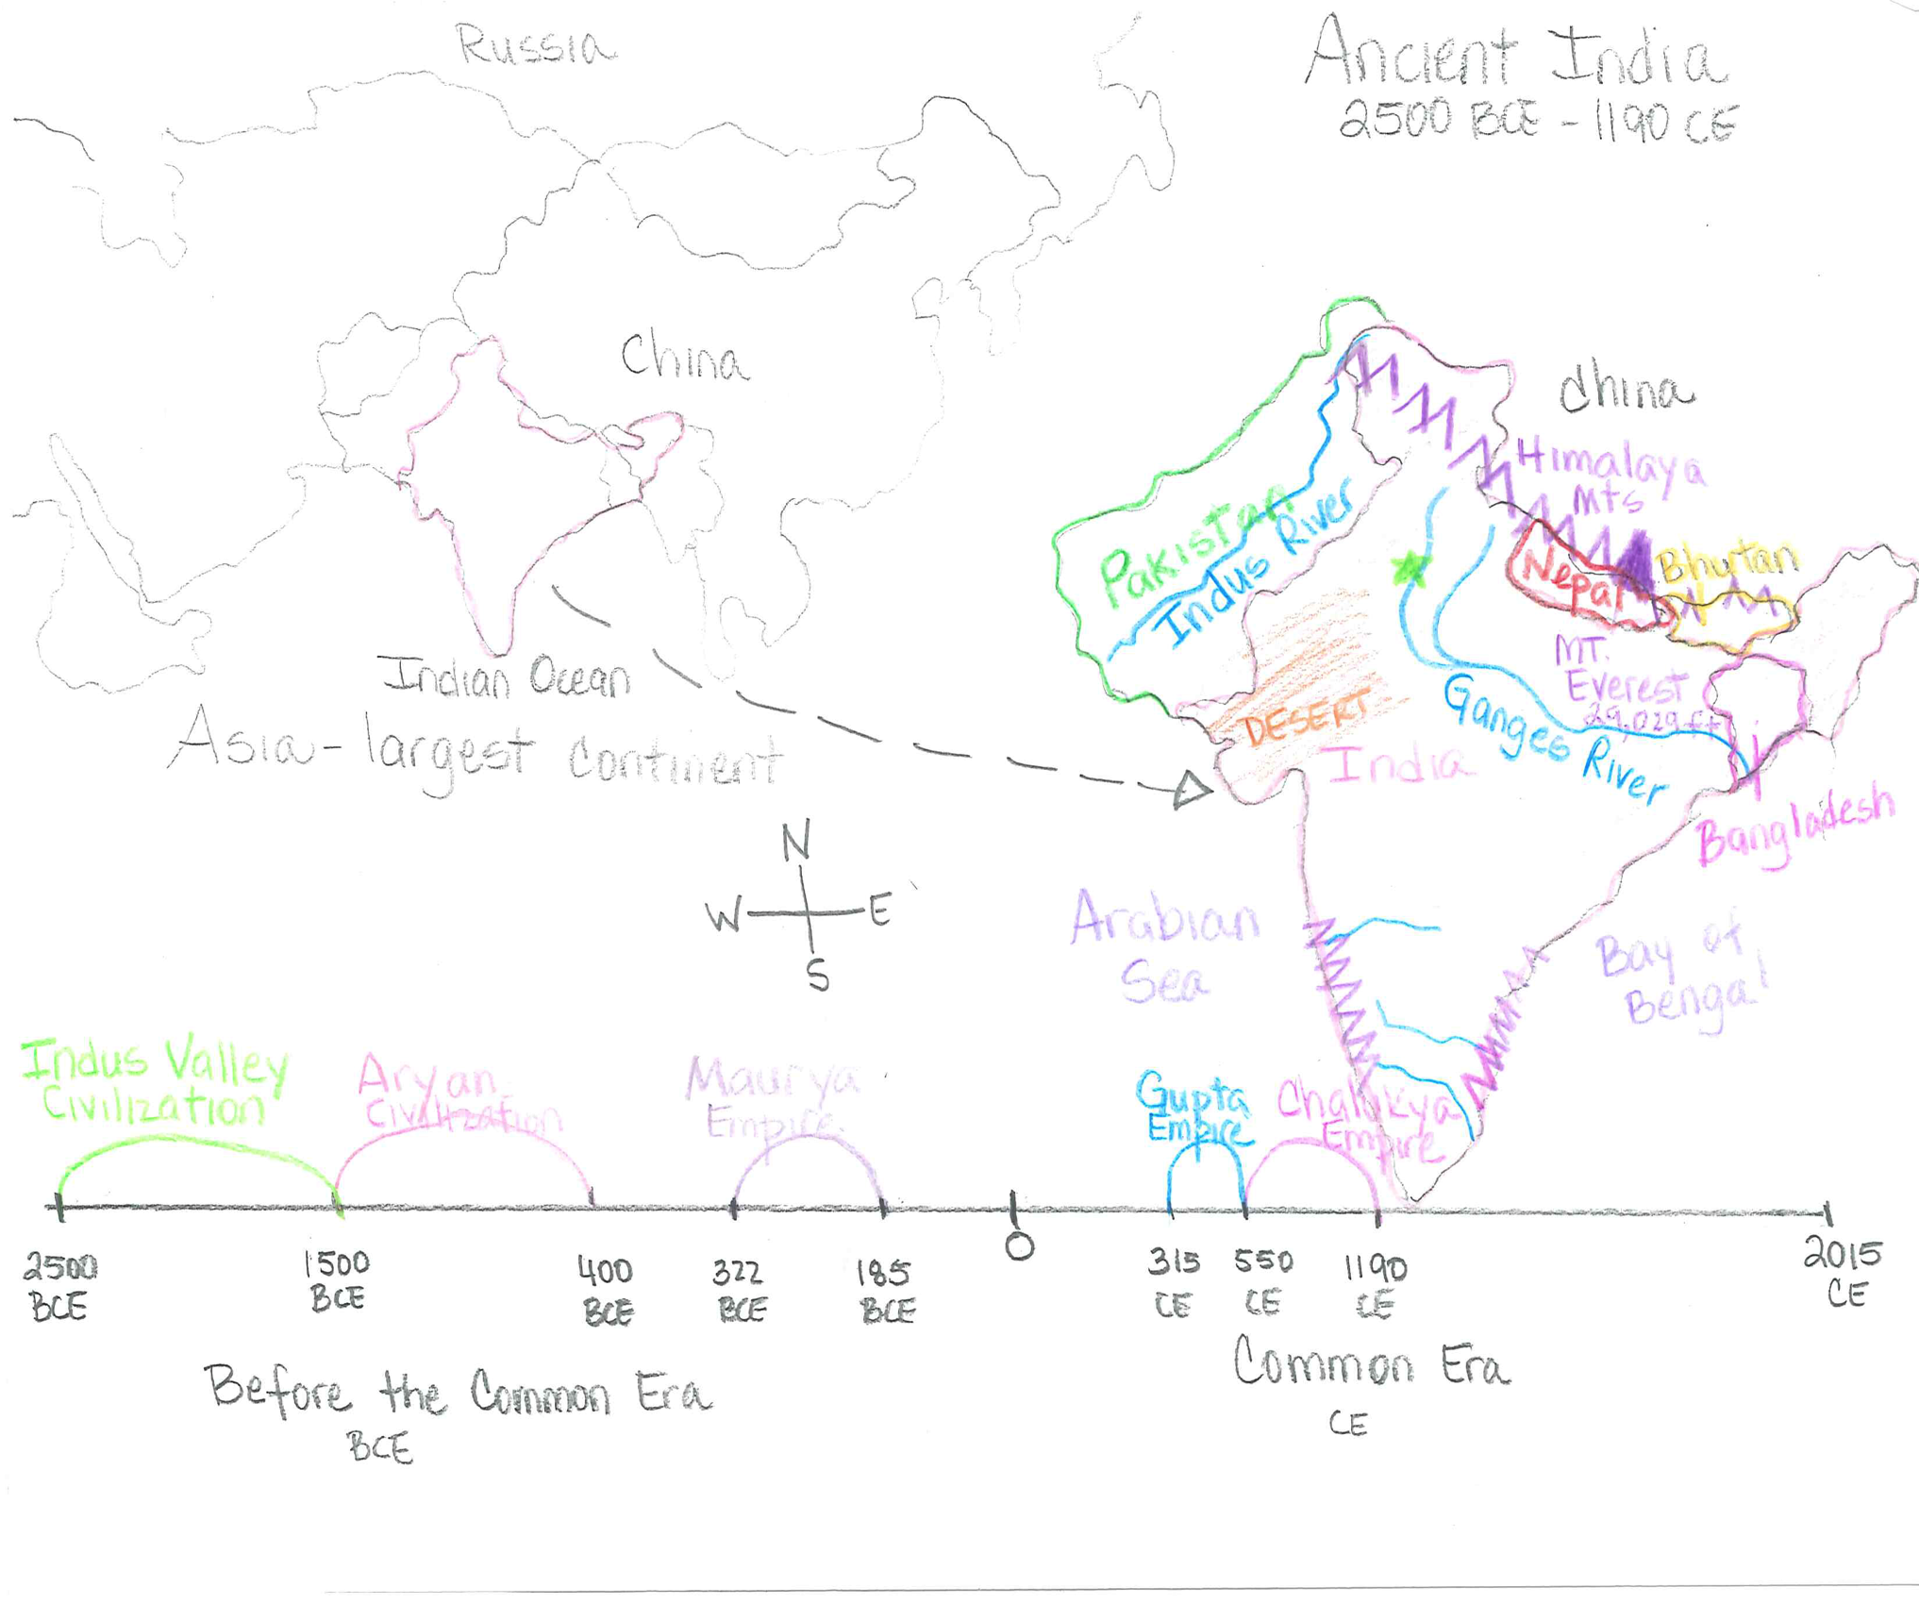
GRAPHIC ORGANIZER

QUESTION GRID - Unit title - Ancient India Strategy name - Graphic Organizer
Language Objective
Sentence Stems | N/A
Thinking and Language Grid | Level 1 Entering  Listening/Speaking | Level 2 Beginning  Listening/Speaking | Level 3 Developing  Listening/Speaking | Level 4 Expanding  Listening/Speaking | Level 5 Bridging  Listening/Speaking
KNOWLEDGE  Arrange, order, define,  duplicate, label, list, name,  recognize, relate, recall, repeat,  Reproduce  COMPREHENSION  Classify, describe, discuss,  explain, express, identify,  indicate, locate, recognize,  report, restate, review, select,  translate | • Show me the Indus River  • Is this continent Asia or Europe? | • Point to the mountains that are in northern India.  • What is this (pointing to the India subcontinent)? | - Name the major rivers on our map of India. | • What bodies of water are on the coasts of India? | • From the timeline, describe the changes in Indian civilizations.
APPLICATION  Apply, choose, demonstrate,  dramatize, employ, illustrate,  interpret, operate, practice,  schedule, sketch, solve, use ANALYSIS  Analyze, appraise, calculate,  categorize, compare, contrast, criticize, differentiate,  distinguish, examine, experiment,question, test | - Which has the highest peak, the mountains of the north or the mountains of the south | • Tell me the difference between the length the Indus Valley Civilization and the Guptan Empire. | - I’m thinking of the countries that border modern day India. What are 2 of them?  . | • Explain the difference between. Before the Common Era and the Common Era. . | . .  • Compare. the size of India with Nepal and China. .
SYNTHESIS  Arrange, assemble, collect,  compose, construct, create,  design, develop, formulate,  manage, organize, plan,  prepare, propose, set up  EVALUATION  Appraise, argue, assess, attach,  choose, compare, defend,  estimate, judge, predict, rate,  select, support, value, evaluate | • Show me why India is often called the diamond of Asia. | • Show me the part you are most interested in. | • Show me the part you are most interested in.  Why are you most interested in it? | • How would you describe India? | - What would happen if the Himalaya Mountains were not there?

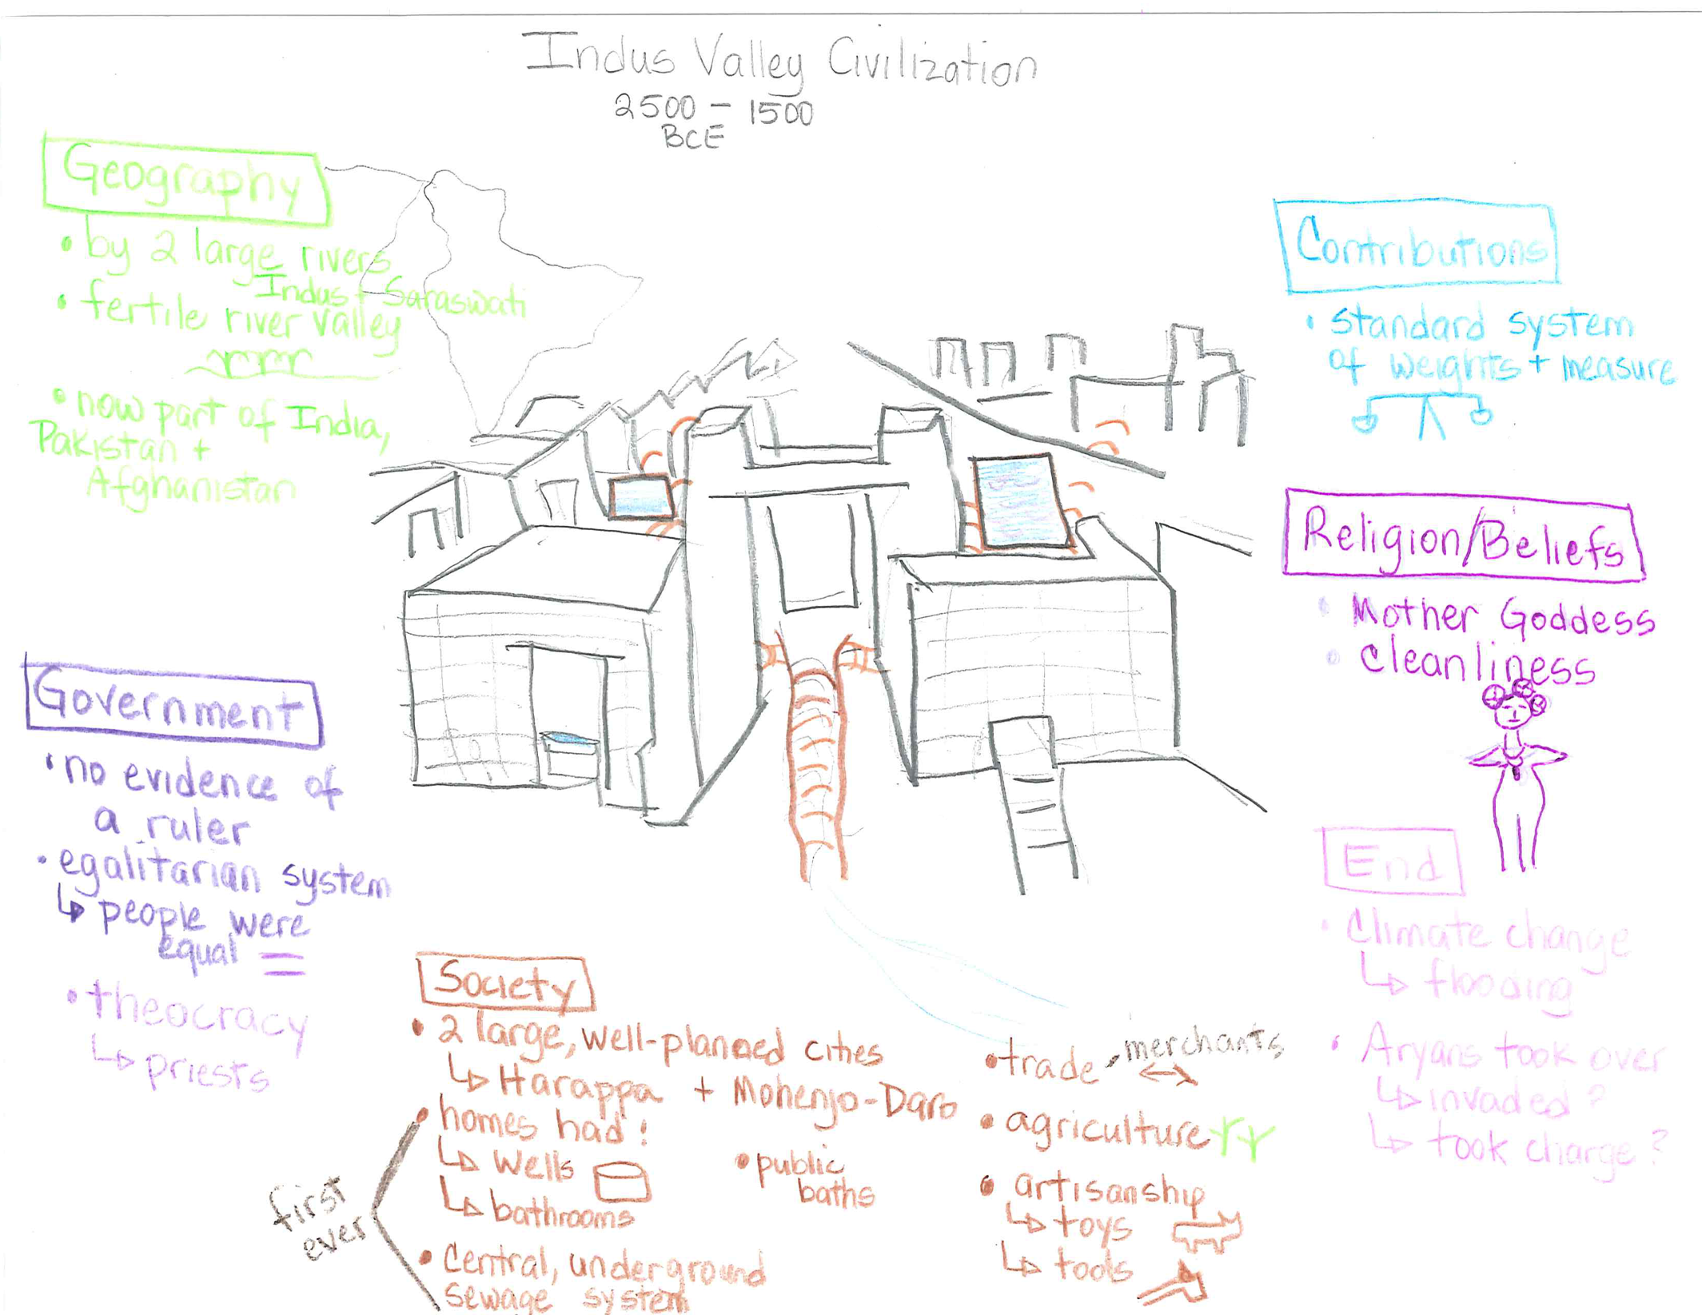
PICTORIAL INPUT
QUESTION GRID - Unit title – Ancient India Strategy name – Indus Valley Civilization Pictorial Input Chart
Language Objective
Sentence Stems | N/A
Thinking and Language Grid | Level 1 Entering  Listening/Speaking | Level 2 Beginning  Listening/Speaking | Level 3 Developing  Listening/Speaking | Level 4 Expanding  Listening/Speaking | Level 5 Bridging  Listening/Speaking
KNOWLEDGE  Arrange, order, define,  duplicate, label, list, name,  recognize, relate, recall, repeat,  Reproduce  COMPREHENSION  Classify, describe, discuss,  explain, express, identify,  indicate, locate, recognize,  report, restate, review, select,  translate | • Show me the public baths.  • Point to the sewage system. | • Is this a river or a sewage system?  • Is the Indus Valley a fertile area? | •What are the beliefs of the Indus Valley Civilization? | • What are two important features of the Indus Valley government? | • Explain. . .  • Describe. . . .
APPLICATION  Apply, choose, demonstrate,  dramatize, employ, illustrate,  interpret, operate, practice,  schedule, sketch, solve, use ANALYSIS  Analyze, appraise, calculate,  categorize, compare, contrast, criticize, differentiate,  distinguish, examine, experiment,,question, test | • Point to the entity that the Indus Valley people worshipped.  • Point to important information about Indus Valley homes. | • Show me what merchants used to weigh and measure what they were selling.  • Tell me two explanations for how the Indus Valley Civilization ended. | • Show me something that proves that the people had time to be creative. | How do we know that the Indus Valley was an egalitarian system? | • Summarize. . .  • Compare. . .
SYNTHESIS  Arrange, assemble, collect,  compose, construct, create,  design, develop, formulate,  manage, organize, plan,  prepare, propose, set up  EVALUATION  Appraise, argue, assess, attach,  choose, compare, defend,  estimate, judge, predict, rate,  select, support, value, evaluate | • Point to the most important information about the Indus Valley Civilization. | • Show me evidence of the people’s belief in cleanliness. | • Show me the part you are most interested in.  Why are you most interested in it? | • Why do you think the people settled in this area? | • What role might climate change have played in the end of the Indus Valley Civilization?

Notes for the Pictorial Input Chart – The Indus Valley Civilization

Geography:
The two large rivers that created the Indus Valley straddle present day India, Pakistan and Afghanistan.
The monsoon rains would flood the area and enrich the soil.

Government:
Historians and archeologists have found no proof of any kind of secular leadership in this civilization. It appears that there was a sense of egalitarianism among the people. The priests, however, did play an important role in society, which is why many have characterized the government as more of a theocracy.

Society:
The two large cities, Harappa and Mohenjo-Daro, that characterize the Indus Valley Civilizations were remarkable places! For the first time, cities were built on a grid with large streets and common meeting areas. The most important were the public baths. These baths, and the bathrooms that were included in every home, drained into sophisticated underground pipes that sent the sewage outside of the city walls. Each home also had its own well to supply the households with water for cooking and personal use.

Trade was largely internal. Cities traded with other communities within the area. There is no evidence of external trade. Merchants developed a standard system of weights and measure to ensure that items being traded or bought were of the same size or weight as other areas. In this way, buyers were assured of receiving a good deal.

Indus Valley farmers planted winter crops, such as wheat, barley, peas, lentils, linseed and mustard. In summer, they grew millet, sesame and probably cotton. Experts are not sure if rice was grown.

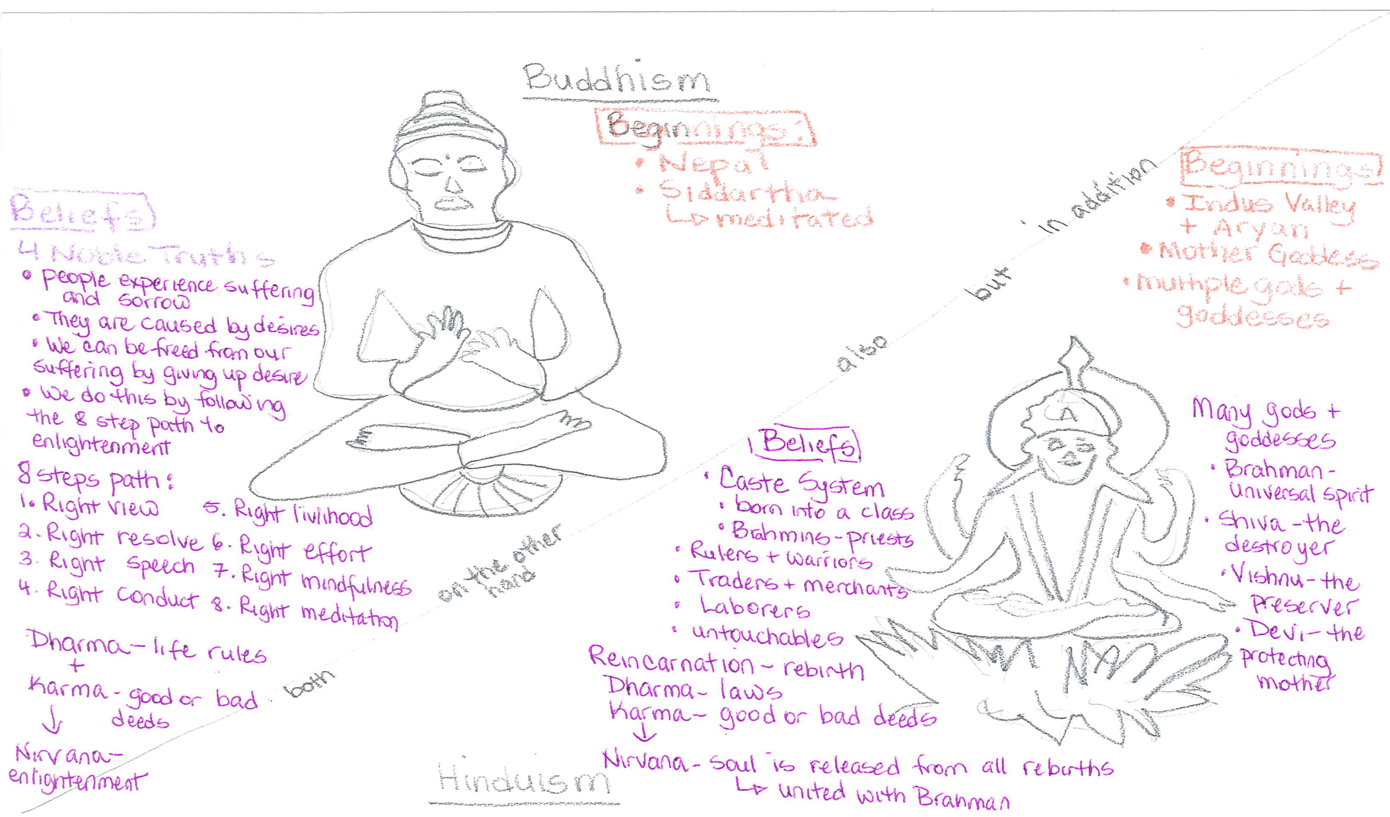

Ancient India
Poetry
Booklet

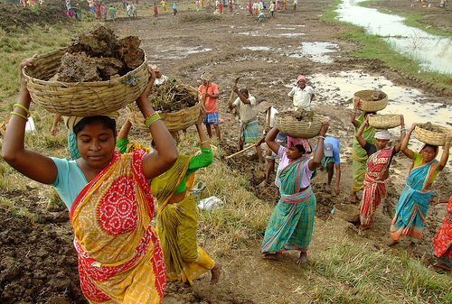

Name: ______________________________

Historians Here and There
By Ruth Kriteman

Historians here, historians there,
Historians, historians everywhere.

Educated historians researching diligently,
Curious historians searching eagerly
Excited historians discovering patiently,
And, modern historians writing purposefully.

Historians throughout the ages,
Historians around decorated temples,
Historians in libraries
And, historians of ancient civilizations.

Historian here, historians there,
Historians, historians everywhere.

Historians! Historians! Historians!

Ancient India Bugaloo
By Ruth and Ben Kriteman

I’m from the Gupta Empire as you can see,
The Golden Age of India has come to be.
We’ve got some great things going, we’re pretty proud of that.
Let me tell you all about it, settle back on your mat.

Civilization, Empires, Dynasties, too
Doing the Ancient India Bugaloo!

Hinduism’s making a comeback, but religious freedom’s fine,
There’s peace and stability. Scholars are having a great time.
Poetry is being written and temples are being built,
Trade and travel are improving. We’re going full tilt!

Civilization, Empires, Dynasties, too
Doing the Ancient India Bugaloo!

Our mathematicians are working to develop something new.
Nine digits, the zero, and place value - who knew?
We’re starting to use algebra, to make sense of our lives,
The idea of Infinity has recently arrived.

Civilization, Empires, Dynasties, too
Doing the Ancient India Bugaloo!

Ancient India Sound Off

By Marcia Brechtel, adapted by Ruth Kriteman

We all know and we’ve been told
Indian civilization is very old,
Starting by the rivers blue.
Planting and building, they grew and grew.

Sound off – Before the Common Era
Sound off – Contributions
Sound off – 1-2-3-4 They evolved!

The Indus River Valley was fertile and green,
It supported cities, as we have seen.
Houses, sewage systems, baths and parks,
Harappa and Mohenjo-Daro left their marks.

Sound off – pre-Hinduism
Sound off – Mother Goddess
Sound off – 1-2-3-4 Artisanship and trade!

The Aryans are not so clear,
Invaded or emerged, historians argue here,
Their impact on India, they agree,
The Sanskrit language, only one of these.

Sound off – Caste system
Sound off – Hinduism
Sound off – 1-2-3-4 Iron tools!

El emperador Asoka
Escrito por Ruth Kriteman

Conozco un emperador
Un emperador fuerte y energético
Un emperador que siguió el camino de Buda
Que dejó de ser militar.

Cuidó de su gente
Estableció rutas de comercio
Construyó hospitales y universidades
Y, mostró compasión para todos los seres vivos.

Conozco un emperador
Un emperador fuerte y energético
Que mejoró la vida de la gente de India
Un emperador llamado Asoka.

Narrative Input
Buddha
By Demi

(1)In the kingdom of Kapilavatsu in the foothills of the Himalayan Mountains, Queen Mahamaya had a marvelous dream. In it, a white elephant with six golden tusks touched her right side with a lotus flower. In the center of the blossom was a brilliant jewel.

En el reino de Kapilavatsu al pie de las montañas Himalaya, la reina Mahamaya tuvo un sueño maravilloso. En el, un elefante blanco de seis colmillos de oro tocó su lado derecho con una flor de loto. En el centro de la flor había una brillante joya.

(2)When she woke she described her dream to King Suddodana and all the wise men, who agreed that it foretold a miracle. The wise men predicted, “A son will be born to you. And if the new prince remains in the royal household, he will become a great king and rule the world. But if he leaves the household, he will find the Truth and become a holy man, the savior of the world.”

Cuando se despertó describió su sueño al rey Sudodana y a todos los sabios, quienes coincidieron en que predecía un milagro. Los sabios le dijeron, "Le nacerá un hijo. Si este nuevo príncipe permanece en la casa real, llegará a ser un gran rey y gobernará al mundo entero. Pero si sale de la casa, encontrará la Verdad y llegará a ser un hombre santo, el salvador del mundo".

(3)The king became alarmed at this prophecy about his child. In those days, holy men were poor, wandering teachers who begged for food. This was not a suitable life for a prince, King Suddodana thought. He vowed that somehow he would prevent this fate for his son.

El rey se alarmó de esta profecía. En aquellos días, los hombres santos eran pobres mendigos que pedían comida de todos. Esto no le pareció al Rey Sudodana una vida adecuada para un príncipe. Prometió que de alguna manera se evitaría este destino para su hijo.

(4)One day when Queen Mahamaya was walking in the garden, the earth began to shake. She grasped the branch of a flowering tree, and from her right side came a baby boy. Streams of heavenly water bathed his head, and lotus flowers rained down from the skies. His parents named him Siddhartha, which means, “every wish fulfilled”.

Un día, cuando la reina Mahamaya estaba caminando en el jardín, la tierra comenzó a temblar. Ella agarró la rama de un árbol en flor, y desde su lado derecho le salió un bebé. Corrientes de agua celestial le bañaron la cabeza, y las flores de loto llovieron del cielo. Sus padres lo llamaron Sidarta, que significa, "cada deseo cumplido".

(5)There was great rejoicing at the birth of the new prince. But another prediction disturbed the king. One of the wise men told him, “There will be four signs: an old man, a sick man, a dead man, and a monk. When the prince has seen these signs, he will leave the kingdom and pursue the life of a holy man.”

Hubo gran regocijo por el nacimiento del nuevo príncipe. Pero otra predicción perturbó al rey. Uno de los hombres sabios le dijo: "Habrá cuatro señales: un anciano, un enfermo, un muerto y un monje. Cuando el príncipe ha visto estos signos, dejará el reino y seguirá la vida de un hombre santo ".

(6)King Suddodana was determined that his son would never encounter these four signs. So, he surrounded Siddhartha with luxury to ensure his happiness, providing everything the child would ever need or want.

El Rey Sudodana decidió que su hijo nunca encontraría estos cuatro señales. Le rodeó Siddhartha con una vida lujosa para asegurar su felicidad, proporcionándole con todo lo que el niño necesitaría o desearía.

(7)Siddhartha was a serious child. He excelled in math, science and languages. He wrote poetry, won debates and was an excellent athlete. But, despite all of his gifts,
he often meditated on the true meaning of life.

Sidarta era un niño serio. Se destacó en matemáticas, ciencias y lenguas. Escribió poesía, ganó debates y fue un excelente atleta. Pero, a pesar de todos sus dones,
a menudo meditaba sobre el verdadero significado de la vida.

(8)After thirteen years of living in the most beautiful surroundings, Siddhartha became curious about what lay outside his sheltered world. He asked his charioteer, Chandaka, to take him for a ride outside the kingdom and for the first time in his life he saw human suffering: an old man, a sick man, a dead man.
“Does everyone become sick and old?” Do we all die?” Siddhartha wondered. “And what then? Where do we go?”
“We all die,” Chandaka told him.
Siddhartha was overcome with sorrow. How could people laugh and enjoy themselves, knowing that one day they would die?

Después de trece años de vivir en el más bello entorno, a Sidarta le llegó el deseo de saber lo que había fuera de su mundo protegido. Le pidió a su cochero, Chandaka, que lo llevara a dar un paseo fuera del reino y por primera vez en su vida vio el sufrimiento humano: en forma de un anciano, un enfermo, y un hombre muerto.
"¿Las personas se enferman y envejecen?" ¿ Todos morimos? "Sidarta preguntó. "¿Y qué entonces? ¿A dónde vamos?"
"Todos morimos," Chandaka le dijo.
Sidarta fue vencido por el dolor. ¿Cómo podría la gente reír y disfrutar, sabiendo que un día va a morir?

(9)The next day Siddhartha asked Chandaka to take him on another ride. On this journey, he met a man in a saffron robe, who seemed completely at peace.
“Who are you?” asked the prince.
The man, who was a monk, replied, “I am a seeker of the Truth, of life over death. And to find it I have given up everything on this earth.

Al día siguiente Sidarta le pidió a Chandaka que lo llevara en otro paseo. En este viaje, conoció a un hombre vestido de un túnico de color azafrán, que parecía completamente a paz.
"¿Quién eres tú?", le preguntó el príncipe.
El hombre, que era un monje, respondió: "Yo soy un buscador de la verdad, de la vida sobre la muerte. Y para encontrarla he dejado todo en esta tierra.

(10)Prince Siddhartha thought, I must also seek the Truth of life over death, if I am to find peace. He decided to leave the palace, his riches, his family and follow in the monk’s footsteps.

Príncipe Sidarta pensó, también debo buscar la verdad de la vida sobre la muerte, si he de encontrar la paz. Decidió abandonar el palacio, sus riquezas, su familia y seguir los pasos de los monjes.

Note: If the narrative input is to be presented in Spanish, then the story map and retell should also be done in Spanish.

HOME-SCHOOL CONNECTION 1
INDIA

The Indus Valley was fertile enough that not all people were needed for farming and gathering of food. This allowed some people to become artisans and craftsmen. Compare the civilization that we live in to that of the Indus Valley. Sketch and/or write your answer.

El valle del Indo era lo suficientemente fértil que no era necesario que todas las personas trabajaron en la agricultura y la recolección de alimentos. Esto permitió que algunas personas llegaron a ser artesanos y trabajadores de metal y cerámica . Compara la civilización en que vivimos a la del valle del Indo . Dibuja y / o escribe tu respuesta.

Parent Signature _______________________ Student Signature________________________
HOME-SCHOOL CONNECTION 2
INDIA

The early Indian civilizations were amazing. Tell someone in your home about two things that you thought were the most interesting about these civilizations. Make a sketch for them. Record their response.

Las primeras civilizaciones de la India eran impresionantes. Habla con alguien en tu casa acerca de las dos cosas que te parecieron más interesantes de estas civilizaciones. Haz un dibujo para ellos. Registra tu respuesta.

Parent Signature ________________________ Student Signature___________________________

HOME-SCHOOL CONNECTION 3
INDIA

Using writing and/or sketches, retell the story of how Siddartha became the Englightened One (Buddha) to someone in your home.

Usando escritura y/o dibujos, vuelve a contar la historia de cómo se convirtió Sidarta en el Iluminado (Buda) a alguien en tu casa.

Parent Signature _________________________ Student Signature_______________________
Aryan Civilization Expert Group Name:_____________________

There is great controversy about the Aryans. Some people confuse the word with the Nazi idea of an Aryan race. But, the word Aryan is really a Sanskrit term used for a group of people who share a common background and language. Some historians think that the Aryan people migrated from other places in eastern Europe; others believe that they evolved from the Indus Valley civilization. No matter where they came from, historians agree that they left a lasting impression on the future of India.

The Aryan people were war-like nomads. They rode horses and herded cattle. Their weapons were made of iron. They spoke Sanskrit but they did not have a written language. They organized themselves into tribes with a raja, or ruler. There was a lot of conflict between the tribes.

As they settled in India they stopped their wandering. People had many kinds of jobs. Instead of iron weapons, they began to make iron tools like the adz. One side of the adz was used as an axe and the other was used for shaping wood. They also drove two-wheeled chariots that had sturdy wheels with spokes. They continued to raise cattle but soon believed that cattle were sacred and should not be killed. They focused on agriculture, growing spices like cinnamon and ginger in the south and grains like wheat and rice in the north.
In the beginning, the Aryans had a social system with three classes or castes. The caste system defined social status and job direction at birth. The priests, or Brahmans, became the highest class, the Kshatyras, the raja and his warriors were the second class, and the Vaisyas, or commoners were the third class. Each group had their job and took care of everyone in their class. Eventually, more classes emerged. The Sudras were the unskilled laborers or servants and the Varna were the untouchables who did the dirty work, like collecting trash, skinning animals and handling dead bodies. Life for those in this last caste was very hard. People refused to be near the Varna, so their lives were separate and lonely. Everyone was born into a caste and could never move from it.

The Aryans religious beliefs and way of life were first told, and then written in a series of sacred hymns and poems called the Vedas and Upanishads. This information was memorized and passed on to the people by the priests. They Aryans believed that there were many gods and goddesses who controlled the forces of nature and were part of a universal spirit called Brahman. In order to unite with Brahman a person must pass through many lives. This is called reincarnation. A soul must be reborn into a higher life. To do that people must perform their duty according to divine law, called dharma. If they live well and do their duty, then they will have good karma. They will move closer to Brahman in their next life. This religion is called Hinduism and is still practiced in India today.
The Aryans ruled India from 1500 BCE to 400BCE. By 400BCE, India was invaded by the Persians and Alexander the Great. As the people fled these invaders it created a power vacuum, or power hole that others soon filled.

The Maurya Empire Expert Group Name:_____________________

The Maurya Empire was India’s first dynasty. Chandragupta Maurya founded the largest and most powerful political and military empire in 321 BCE. He ruled every part of Ancient India except for the southernmost tip. Every ruler until 185 BCE came from the Maurya family. They built a single and efficient system of finance, administration and security.

Under one ruler, the people paid taxes and were served by a civil service that provided justice and security for merchants, farmers and traders. The Maurya expanded internal and external trade. They exported silk and other textiles, spices and exotic food and traded as far away as Europe and Western Asia. They Maurya maintained public places, including markets, temples and roads. They began universities and encouraged religious freedom. It was a time of peace and stability.

The focus on trade prompted the development of standardized weights and measures. The trade business must be fair and honest. Buyers and traders must know that the amount of product that they pay for is the same from one seller to another. Standard weights and measures ensure that they are not being cheated. The Maurya Dynasty also created a single currency, or form of money, called Panas.

At the beginning of the Mauryan Dynasty, Hinduism was still the most important religion, but soon people began to question some of its ideas. The Brahman priests seemed to care more about their temples and not about the needs of the people. Many found what they needed in Buddhism, a new religion founded by Siddhartha Gautama. He became known as the Buddha, or the Enlightened One. Buddhism acknowledges that life is difficult and that many people suffer. The Buddha teaches that the only way to stop suffering is to stop desiring things, to give up worldly things and not harm other living beings. If you stop committing evil and do good work in the world then you have a chance of reaching Nirvana, a state of wisdom.

Chandragupta Maurya’s grandson became the ruler of India in 273 BCE. His name was Ashoka and he is considered to be one of the greatest rulers of India. He was a general until he began to follow the teachings of Buddha. Then, he renounced war and violence and promoted peace. He gave the people the freedom to worship as they pleased. He built hospitals for people and for animals. He supported trade by building great roads and put shelters and trees along them so that travelers could rest in the shade. Buddhism spread across India and many temples and shrines, called stupas, were built.
After Ashoka died, other members of the Maurya Empire became India’s rulers, but none were as strong as he was. Finally, in 183 BCE the last Mauryan ruler was killed by a general. What followed was a time of conflict. The first empire of Ancient India began to fall apart and a new empire began.

The Gupta Empire Expert Group Name:_____________________

Many different rulers brought India into the Common Era (CE). There was little unity and much conflict. Finally, in 315 CE a new family, or dynasty, came into power to create the next great empire. The Gupta Empire began with Chandra Gupta. It was focused on the northern part of the subcontinent of India, from the Ganges River Valley and Arabian Sea to the Bay of Bengal. The Gupta Dynasty led India for only a few hundred years, but they were important years for the country and the world.

During the Gupta Empire, Hinduism came back into prominence but religious freedom was still encouraged. The rulers relied on the Hindu caste system to make sure that everyone did what was necessary for society and government. The caste system is built on the concept of dharma or divine law. Everyone is expected to do their duty and live a good life in order to have good karma. In addition to the caste system, new guilds began with skilled workers, craftspeople and merchants. Each guild lived in its own part of town. They were organized by craft or trade, so the potters had their own guild, as did the weavers and other craftspeople.

The economy flourished. People traded with elephant and ox-driven carts by land, and cargo ships by sea. They exported luxury goods like gems, cotton cloth, red dye, exotic wood like teak and ebony, perfumes and spices. They imported gold from Rome, silk from China and horses from Saudi Arabia. Universities grew and more people were able to attend.

The resurgence of Hinduism brought new writings like the epic poems, Mahabharata and the Bhagavad Gita written in Sanskrit. The Mahabharata is the longest poem in any written language! There are 88,000 verses that tell the story of a great war for control of India about 1000 years earlier. The best-known section of the Mahabharata is the Bhagavad Gita. Krishna, the teacher of the world, preaches a sermon before an important battle. He talks about how noble it is to do one’s duty even if it is difficult and painful. New Hindu statues and temples were built. Because of the religious tolerance, Buddhist statues and temples were also built.

The Gupta Empire is best known for its advancement in science. They knew that the earth was a sphere and that it rotated around the sun. They also knew that there were 365.358 days in the solar year. Gupta mathematicians gave us the number system that we use today. It features nine digits, a zero and the decimal. Aryabhata, the leading mathematician, was the first known to have used algebra and developed the concept of infinity – something without end.

The Gupta Empire is known as the Golden Age of Ancient India. In 458 CE, the Huns invaded India from the steppes of Northern Asia. The Gupta warriors could not control their advances, and by 535 CE, the Gupta Empire ended.

The Chalukya Empire Expert Group Name:_____________________

The Chalukyan Empire was actually several small kingdoms that came together to form a large kingdom. Three closely related, but individual dynasties ruled the Empire: the Badami, the Eastern and the Western. They concentrated their power in central and southern India and ruled from 550 CE to 1190 CE.

The Chalukyan Dynasty had a strong military presence. They controlled a large navy with ships that could protect India in the Arabian Sea and the Bay of Bengal. They also had a large infantry, soldiers on foot, and a large cavalry with soldiers on horseback. The elephant corps used elephants that were trained and guided by humans for combat. Elephants’ large size and loyal temperament allowed them to travel across difficult terrain to protect their guides.

The economy continued to flourish. Agriculture included crops like rice, cotton and sugar cane. There was extensive land and sea trade. Mining products like iron ore and gems were traded, as were spices such as cardamom, saffron and cinnamon. The rulers required that tolls be paid for those traveling the roads and the seaways and taxes were levied on all products, including horses and textiles. The economy grew with these funds.

The Chalukyan Empire marks an important time of religious tolerance. Land grants were given to Buddhist monks, Jaina Arahatas and the Brahmans of Hinduism. Ancient religions like Vedic and Jainism once again were practiced. Buddhism was on the decline, but the Hindu caste system continued. More epic poetry and narratives were written and elaborate temples and statues were built.

While the caste system was supported by the Chalukyan rulers, this was a time of expanding rights for women. Women in the royal and more affluent class were able to attend university and participate in the fine arts, like music and dance. Marketplaces were places where people would meet to buy things for their household, but also to discuss local events. They were often built close to religious temples. The art and architecture of this time reflect the fusion of cultures from Northern and Southern India.

The Chalukyan Empire ended like many other Indian empires have ended. There was warring between the various kingdoms and invading forces took advantage of the power vacuum. The Chalukyan Empire ended in 1190 CE.

FOUND POETRY
FOR INDIA

The Guptas brought a welcome order to the lawlessness in the country. They were a dynasty of remarkable rulers who unified northern India. Under the Guptas, India experiences a golden age of prosperity, law and justice, scientific advance, and artistic and literary achievement. The first of the dynasty, Chandra Gupta, married the princess Kumaradevi. Their wedding was a great and splendid occasion – special gold coins were minted to commemorate it. With this marriage, Chandra Gupta’s rise to power was assured. He took the title Maharajadhiraja, which means “great king over kings”. Chandra was so renowned for learning that his reign was still being celebrated for the artists, scientists, writers and musicians, known as the “jewels” of his court. During an elaborate royal audience, he turned the kingdom over to his second son, who conquered many lands.
Samudra, the son, stretched his great power across northwestern India. He also encouraged a thriving import-export business with many far away countries. Countries such as Malaysia, Indonesia, and Sri Lanka paid him tribute. The Gupta court was so splendid that its culture was imitated even in kingdoms that were not under Gupta rule. One Chinese traveler, who spent nine years there, wrote of the peace and prosperity and said the people were rich and happy and constantly strove to live righteously and do good works.

From:
Cultures of the Past: India’s Gupta Dynasty
Katherine Hinds
Benchmark Books

Contributions
How it ended
Religion/ Beliefs
Government/ Rulers
Geography
_________________________
Civilization
Mind Map

Society/ Services

Civilizations | Geography | Government/  Rulers | Society/  Services | Religion/  Beliefs | Contributions | Ended
Indus Valley
2500-1500 BCE

Aryan
1500-400 BCE

Mauryan
322–185 BCE

Gupta
315 - 535 CE

Chalukyan
550–1190 CE

Writing Prompt
Brief Constructed Response

https://gtm-media.discoveryeducation.com/
Look at the photograph below.

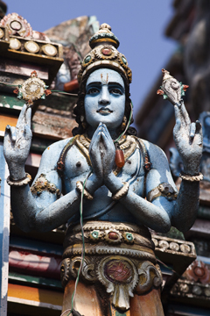

Hinduism is a religion with a set of beliefs, rituals, and practices. India’s caste system is a centuries-old practice that divides people into four hereditary classes.

How do the beliefs of Hinduism influence the caste system? Be sure to provide details and examples in your answer.

Scoring Rubric for Brief Constructed Response
EXEMPLARY
An exemplary response reveals comprehensive understanding of the content.
The response:
-takes a clear position on the relationship between Hindu beliefs and the caste system
-provides a plausible, clear, and thorough explanation of how Hindu beliefs influence the caste system
-provides relevant, insightful, and complete justification of positions taken
-contains no misconceptions or content errors

PROFICIENT
A proficient response reveals some understanding of the content.
The response:
-takes a clear position on the relationship between Hindu beliefs and the caste system
-provides a plausible and clear explanation of how Hindu beliefs influence the caste system
-provides relevant and accurate justification of positions taken
-contains no misconceptions or content errors

BASIC
A basic response reveals knowledge of the content.
The response:
-takes a clear position on the relationship between Hindu beliefs and the caste system
-provides a basic explanation of how Hindu beliefs justify the caste system
-provides some relevant justification of the positions taken
-contains minimal interfering misconceptions or content errors

UNSATISFACTORY
An unsatisfactory response reveals minimal knowledge of the content.
The response
-features an incomplete or uneven argument about relationship between Hindu beliefs and the caste system
-provides some information relevant to the topic of the question
-contains significant misconceptions or content errors

NO RESPONSE/IRRELEVANT RESPONSE
The student provides a completely incorrect or irrelevant response or does not respond at all

Action Plan

Many locations on Earth experience winds that blow in one general direction for long periods of time, but then change course. This seasonal shift in the wind’s direction is called a monsoon. Perhaps the most famous monsoon of all takes place in India, but even here in Albuquerque we experience summer monsoons. This changing of the direction of the wind can have a dramatic effect on both the weather and a population’s way of life.

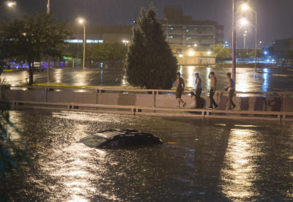

This picture shows what can happen during the summer monsoons here in Albuquerque, when warm, wet air moves north from the coast of South America into New Mexico.

Watch this video clip from Discovery Education’s Social Studies Techbook to discover some of the problems caused by the changing monsoon winds in India:

Geography of the World: South Asia: Land and Resources Segment 3 of 5 Weather Patterns of Asia
This program looks in detail at the geographic regions of the Indian subcontinent, which includes the countries of Pakistan, Bangladesh, Nepal and India. It highlights the positive and negative effects of shifting winds called monsoons. The relationship between weather and agriculture is given special attention, as viewers learn how rice, sugar cane, and pepper are grown and harvested. Also shown is the use of irrigation and reservoirs in dry areas. In each region featured, the people of South Asia work to make the most of their natural resources. The diversity of the landscape and the ingenuity of the people produce what is needed to live, grow, and thrive.

As a class, we will define some of the problems caused by the summer monsoons in Albuquerque:

And brainstorm solutions:
Solutions | Pros (+) | Cons (-)

As a team, choose one solution and write a plan of action for you and your team.
Solution | Reason

Create a learning poster describing the problem and your solutions. Make sure to reference all your resources. As a team, present your poster to the class and facilitate a discussion.

